**1. Prima conexiune -> oracle**

create user sistemclienti identified by oracle;

grant connect, resource, dba, unlimited tablespace to sistemclienti;

create user oditemp_serbanmadalina identified by oracle;

grant connect, resource, dba, unlimited tablespace to oditemp_serbanmadalina;

//grant: acorda permisiuni

//revoke: retrage permisiunile

create user serbanmadalina identified by oracle;

grant connect, resource, dba, unlimited tablespace to serbanmadalina;

**2. A doua conexiune -> sistem clienti**

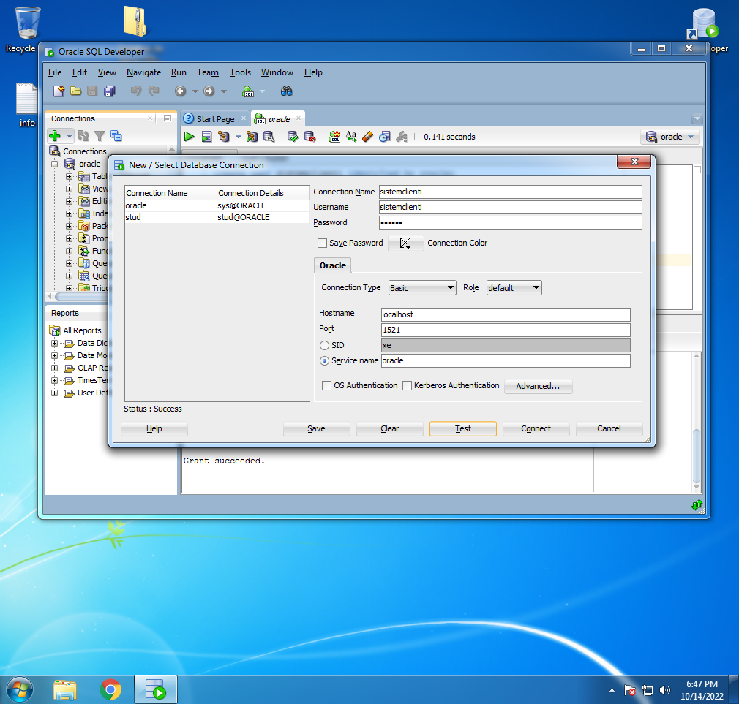

1. New connections
2. password: oracle
3. test
4. connect

CREATE TABLE "CLIENTI_MASTER" ("CLIENTID" NUMBER PRIMARY KEY, "PREFIX" VARCHAR2(10), "NUME" VARCHAR2(30), "PRENUME" VARCHAR2(30), "ADRESA" VARCHAR2(80), "ORAS" VARCHAR2(20), "IDTARA" NUMBER, "TELEFON" VARCHAR2(20), "DATA_NASTERE" DATE, "ID_PARTENER" NUMBER, "ID_VANZATOR" NUMBER);

desc clienti_master; //afisare atribute tabela

Insert into CLIENTI_MASTER (CLIENTID,PREFIX,NUME,PRENUME,ADRESA,ORAS,IDTARA,TELEFON,DATA_NASTERE,ID_PARTENER,ID_VANZATOR) values (1,'Mr','Roberts','John','4 Diagonal Alley','London',1,'0754689752',to_date('21-MAR-44','DD-MON-RR'),1,1);

Insert into CLIENTI_MASTER (CLIENTID,PREFIX,NUME,PRENUME,ADRESA,ORAS,IDTARA,TELEFON,DATA_NASTERE,ID_PARTENER,ID_VANZATOR) values (2,'Mr','Smith','Paul','7 Borley','Manchester',1,'0754689752',to_date('15-MAY-90','DD-MON-RR'),1,3);

Insert into CLIENTI_MASTER (CLIENTID,PREFIX,NUME,PRENUME,ADRESA,ORAS,IDTARA,TELEFON,DATA_NASTERE,ID_PARTENER,ID_VANZATOR) values (3,'Miss','Fey','Tina','No 5 dorchas','London',1,'0754689752',to_date('07-MAR-84','DD-MON-RR'),2,4);

Insert into CLIENTI_MASTER (CLIENTID,PREFIX,NUME,PRENUME,ADRESA,ORAS,IDTARA,TELEFON,DATA_NASTERE,ID_PARTENER,ID_VANZATOR) values (5,'Mrs','Watson','Emma','4 Picadilly','New York',2,'0754689752',to_date('15-JUL-89','DD-MON-RR'),2,1);

Insert into CLIENTI_MASTER (CLIENTID,PREFIX,NUME,PRENUME,ADRESA,ORAS,IDTARA,TELEFON,DATA_NASTERE,ID_PARTENER,ID_VANZATOR) values (6,'Dr','Cumberbatch','Benedict','4 Upper East Side','New York',2,'0754689752',to_date('21-MAR-90','DD-MON-RR'),1,5);

Insert into CLIENTI_MASTER (CLIENTID,PREFIX,NUME,PRENUME,ADRESA,ORAS,IDTARA,TELEFON,DATA_NASTERE,ID_PARTENER,ID_VANZATOR) values (7,'Dr','Holmes','Robert','Trafalgar','Miami',2,'0754689752',to_date('01-SEP-68','DD-MON-RR'),2,1);

commit;

select * from clienti_master;

**3. A treia conexiune -> serbanmadalina**

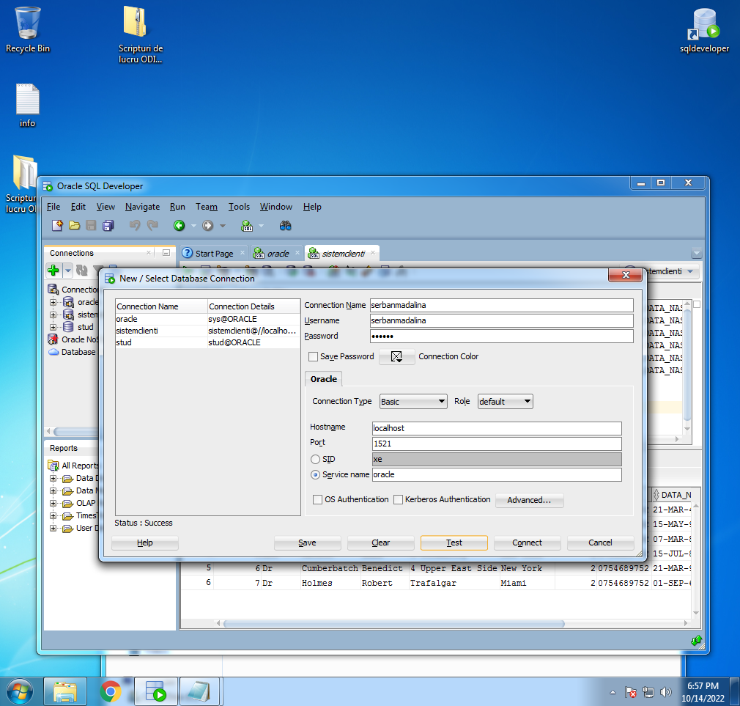

Pass: oracle

CREATE TABLE "CLIENTI"

( "ID_CLIENT" NUMBER PRIMARY KEY,

"PREFIX" NUMBER,

"NUME" VARCHAR2(30),

"PRENUME" VARCHAR2(30),

"ADRESA" VARCHAR2(80),

"ORAS" VARCHAR2(30),

"ID_TARA" NUMBER,

"TELEFON" VARCHAR2(30),

"VARSTA" NUMBER,

"ID_PARTENER" NUMBER,

"ID_VANZATOR" NUMBER,

"DATA_CREARE" DATE NOT NULL,

"ULTIMA_ACTUALIZARE" DATE NOT NULL

);

CREATE TABLE "PRODUS"

( "IDPRODUS" NUMBER(15,0) PRIMARY KEY,

"NUME_PRODUS" VARCHAR2(50),

"TIP_PRODUS" VARCHAR2(30),

"TIP_PRODUS_PARINTE" VARCHAR2(30),

"PRET_COST" NUMBER(8,2),

"PRET_LISTA" NUMBER(8,2),

"ULTIMA_ACTUALIZARE" DATE NOT NULL

);

CREATE TABLE "INVENTAR"

( "IDPRODUS" NUMBER(15,0) PRIMARY KEY,

"NUME_PRODUS" VARCHAR2(50),

"CANT_STOC" NUMBER(8,0),

"ULTIMA_ACTUALIZARE" DATE NOT NULL

);

1. **Deschidere ODI STUDIO**

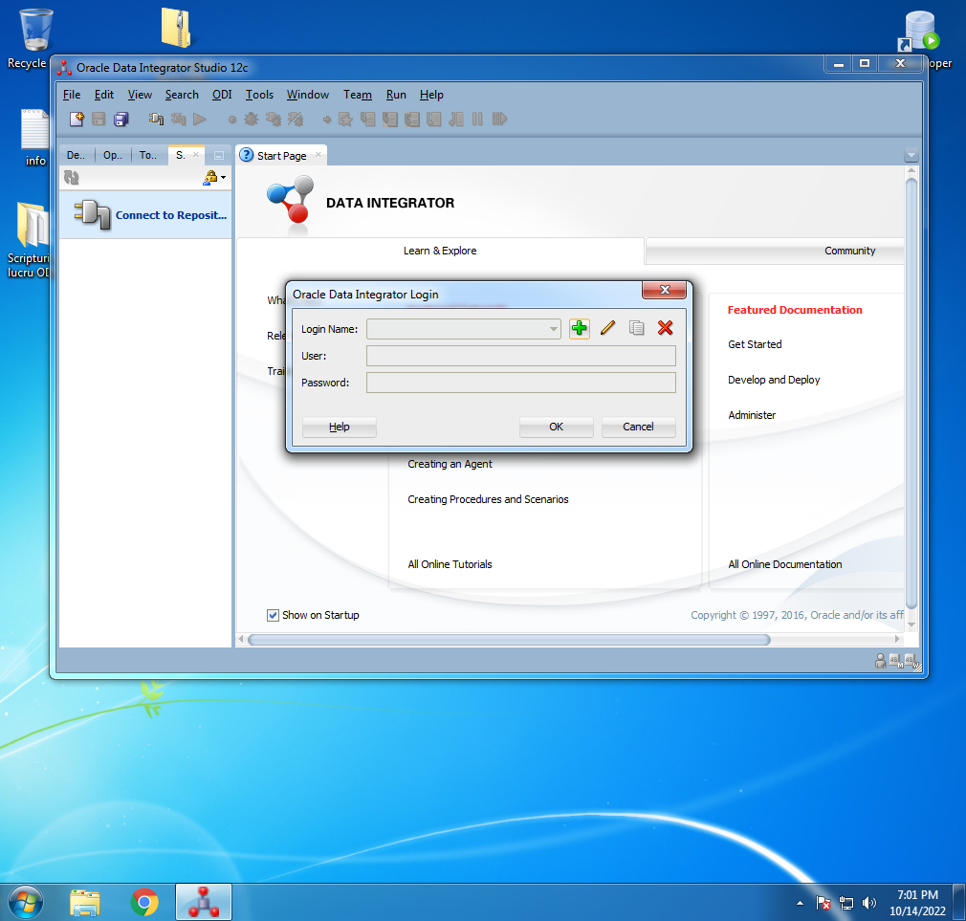

new connection -> pagina 4 Seminar 2

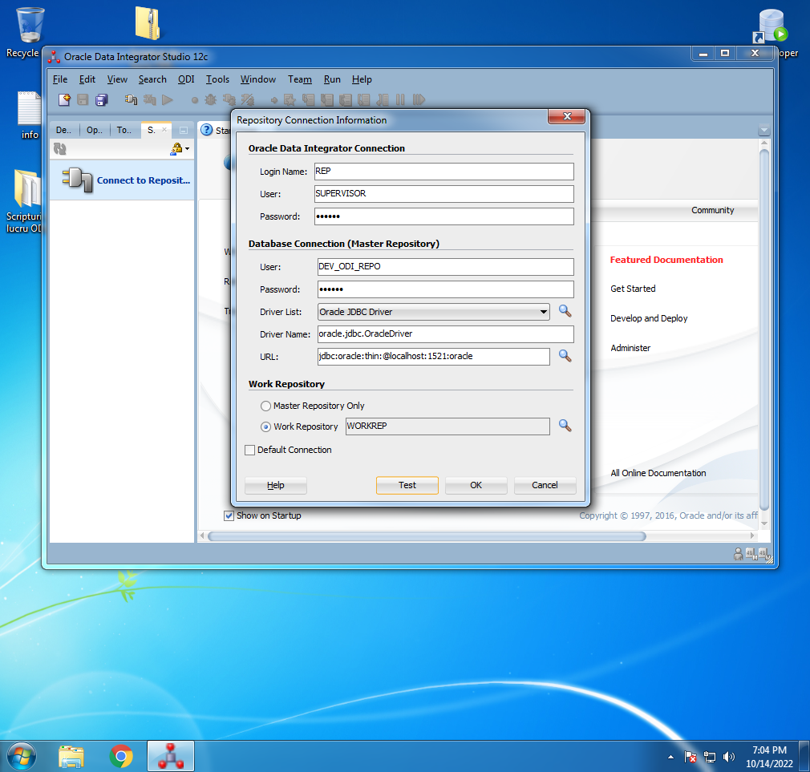

Pass: oracle

