Flight Arena Wiring
  - Tuthill lab flight arena rig. SCB-68A screw terminal block on the NI PCIe-6321 (Dev1). September 2026.
Every wire between the wingbeat analyzer, arena controller, EMG amplifier, LED driver, the two Basler cameras, the Phantom KT810 and the NI DAQ, as used by run_session_unified.m. Screw-terminal numbers on the SCB-68A equal the 68-pin connector pins (NI-DAQmx Device Pinouts, PCIe-6321). All analog inputs run single-ended (RSE).

Diagram
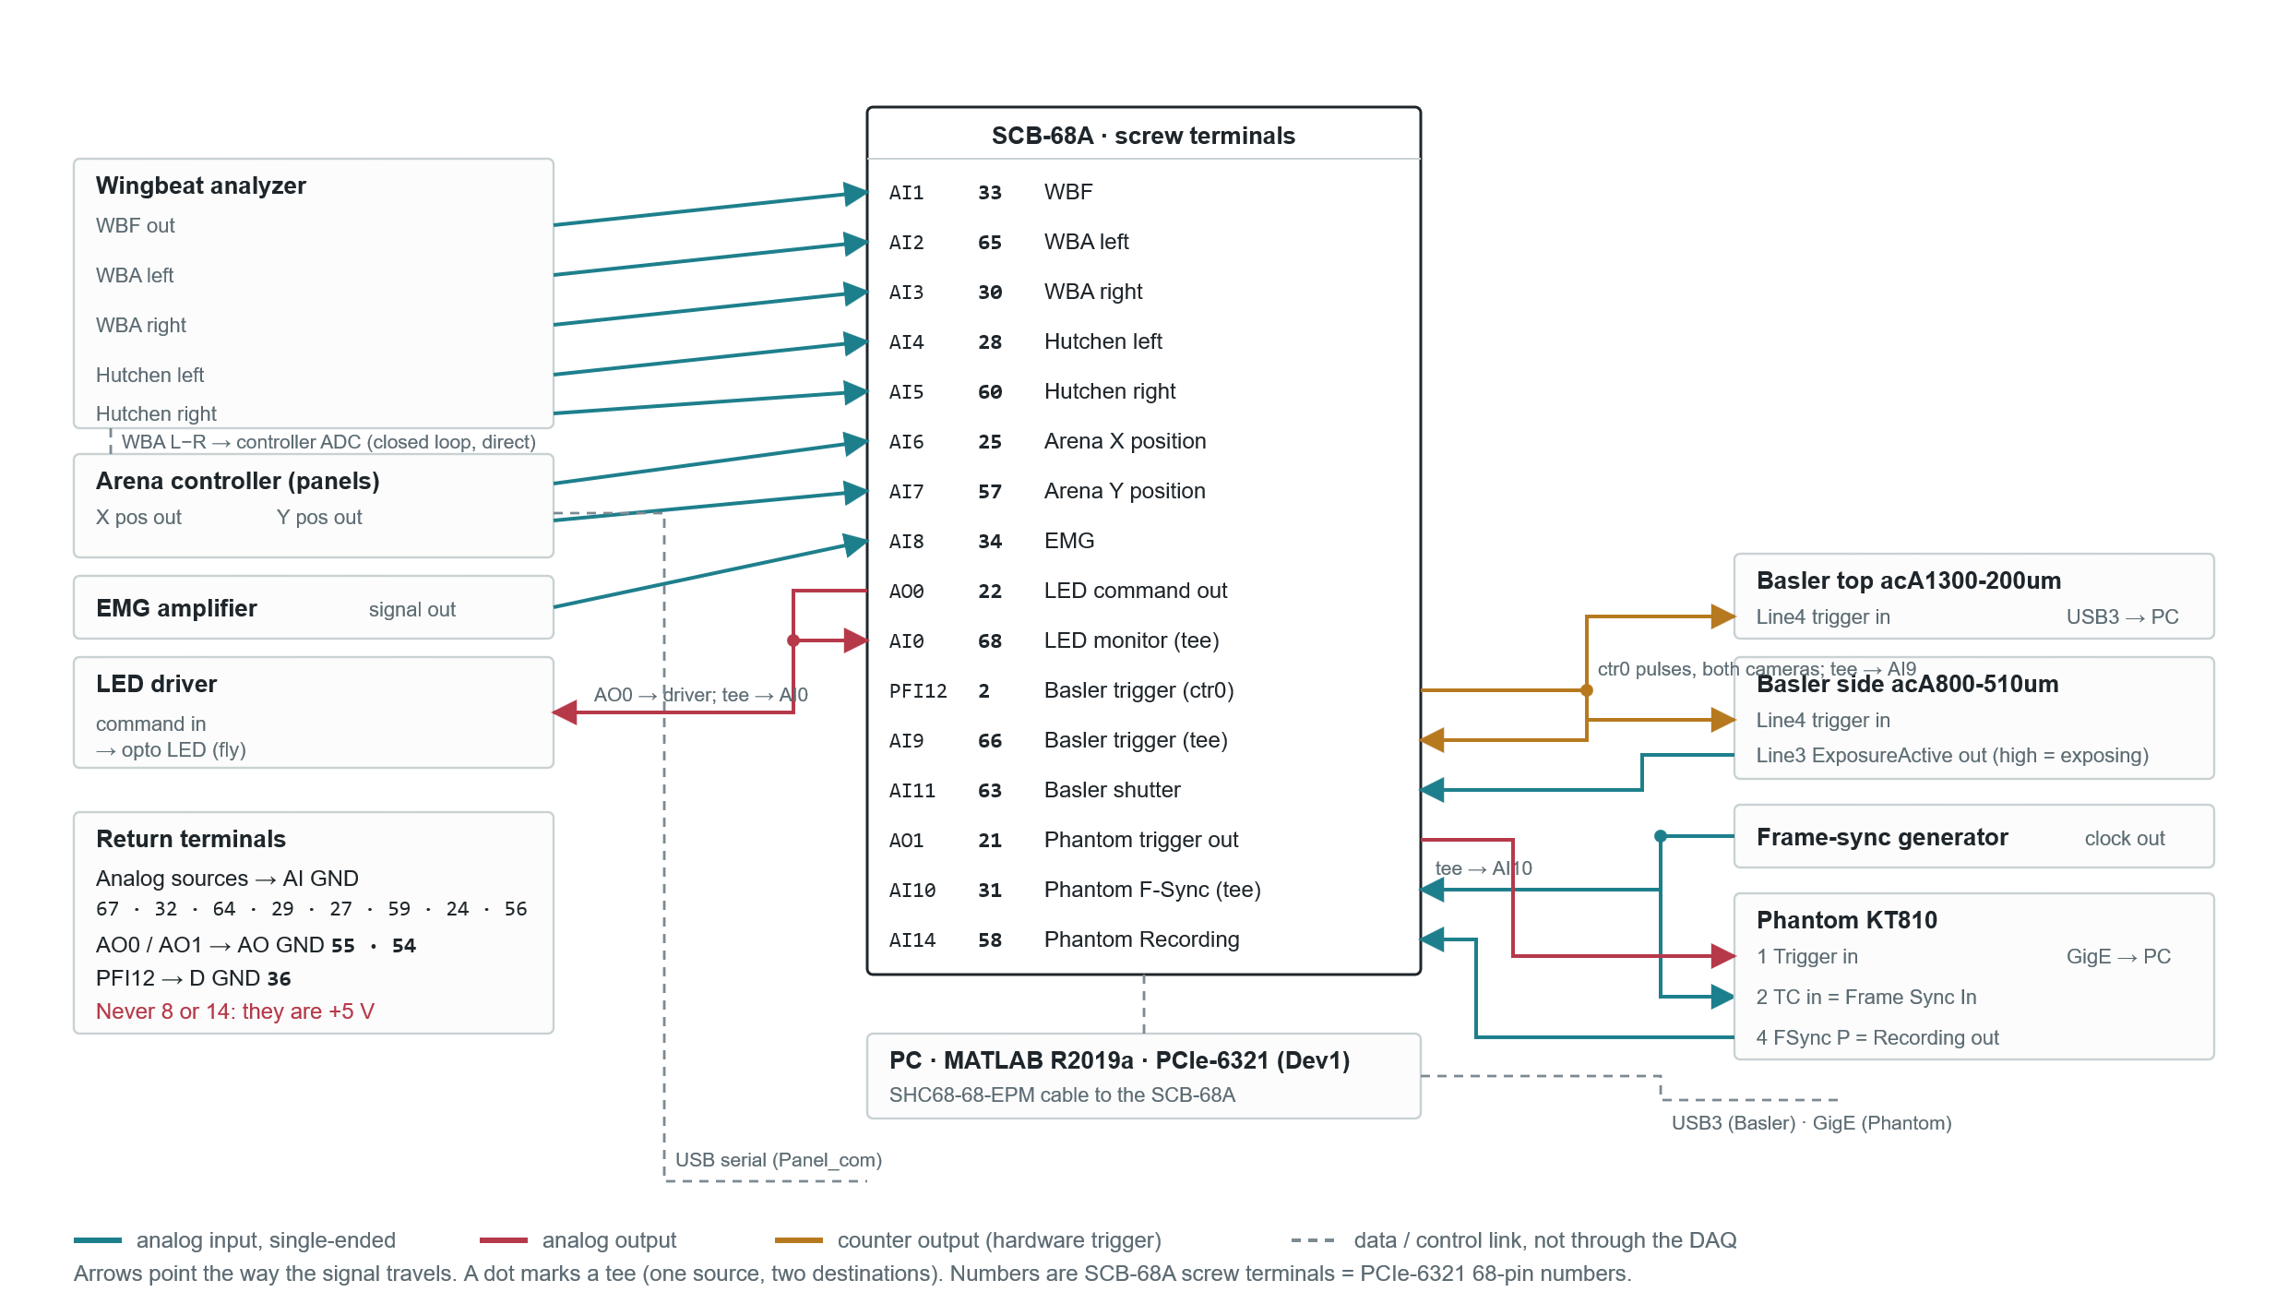
Arrows point in the direction the signal travels. A dot marks a tee (one source feeding two destinations). Colours: teal = analog input (single-ended), crimson = analog output, amber = counter output (hardware trigger), dashed grey = data or control link not through the DAQ.

Wire by wire
Signal | From | To | Channel | Terminal | Return
Fly and arena signals into the DAQ
Wingbeat frequency | Wingbeat analyzer | DAQ | AI1 | 33 | AI GND
Wingbeat amplitude, left | Wingbeat analyzer | DAQ | AI2 | 65 | AI GND
Wingbeat amplitude, right | Wingbeat analyzer | DAQ | AI3 | 30 | AI GND
Hutchen left | Wingbeat analyzer | DAQ | AI4 | 28 | AI GND
Hutchen right | Wingbeat analyzer | DAQ | AI5 | 60 | AI GND
Arena X position | Arena controller | DAQ | AI6 | 25 | AI GND
Arena Y position | Arena controller | DAQ | AI7 | 57 | AI GND
EMG | EMG amplifier | DAQ | AI8 | 34 | AI GND
Optogenetic LED
LED command (pulse train) | DAQ | LED driver input | AO0 | 22 | AO GND 55
LED command monitor | Tee on the AO0 wire | DAQ | AI0 | 68 | AI GND
Basler cameras
Frame trigger, 100 Hz pulses | DAQ counter 0 | Top camera Line4 and side camera Line4, in parallel | PFI12 | 2 | D GND 36
Frame trigger monitor | Tee on the PFI12 wire | DAQ | AI9 | 66 | AI GND
Shutter, high while exposing | Side camera Line3 | DAQ | AI11 | 63 | AI GND
Phantom KT810
Store trigger, 5 V pulse | DAQ | Phantom pin 1 "Trigger" | AO1 | 21 | AO GND 54
Frame-sync clock | Frame-sync generator | Phantom pin 2 "TC in", set to Frame Sync In | - | - | generator ground to camera I/O ground
Frame-sync clock monitor | Tee on the generator output | DAQ | AI10 | 31 | AI GND
Recording status | Phantom pin 4 "FSync P", set to Recording | DAQ | AI14 | 58 | AI GND
Data and control links, not through the DAQ
Closed-loop feedback | Wingbeat analyzer, WBA L minus R | Arena controller ADC | - | - | -
Arena commands | PC (Panel_com, USB serial) | Arena controller | - | - | -
Video | Basler cameras (USB3), Phantom (GigE) | PC | - | - | -

Notes that matter when touching the wiring

Single-ended, not differential
AI8 to AI14 are the negative halves of the pairs AI0 to AI6. Because they now carry their own signals, every source ground goes to an AI GND terminal and the script sets all inputs to referenced single-ended. Do not wire anything to a channel's minus terminal.

Terminals to avoid
Terminals 8 and 14 are +5 V. Terminal 14 sits next to P0.7 (48) and terminal 8 next to PFI 3 (42). AI12 (61) and AI13 (26) are unused and free.

Sample rate
The PCIe-6321 has a 250 kS/s aggregate analog-input limit. With 13 channels the maximum is 19230 Hz; the script runs at 10 kHz and stops with an error if the requested rate is above the limit for the channel count.

What the script drives and reads
- AO0 carries the opto pulse train; AO1 the single Phantom store pulse, both queued in one waveform so their timing is sample-exact.
- Counter 0 on PFI12 runs the Basler frame clock for as long as a block is acquiring.
- AI14 above 1.5 V counts as "Phantom recording"; AI9 pulses mark Basler recording. Both appear as bands in the live plot.

Camera-side settings to confirm in PCC
- Pin 2 "TC in" assigned to Frame Sync In, and the camera sync source set to external when running frame-sync mode.
- Pin 4 "FSync P" assigned as an output with function Recording. If AI14 floats, that output needs a pull-up.
- Camera I/O ground tied to the DAQ ground, or the logic levels will not read.

