**InnoHotel**

Makseev Ildar

Razipovich  
Russia, Yamal-Nenets Autonomous district  
Muravlenko, Pionerskaya 26-9  
+7(927)241-00-68

i.makseev@innopolis.ru

Khadeev Kamil

Tabrisovich

Russia, Tatarstan  
Kazan, Alanlyk 6-B  
+7(965)5825343

k.khadeev@innopolis.ru

**INTRODUCTION**

In our work, we applied knowledges given us on lectures and seminars. We created database on PostgreSQL and we used primary keys, foreign keys, constraints and triggers.

Besides, we benefited:

* Spring MVC
* Spring Security
* Apache Tomcat
* FreeMarker
* Java Script

Our project you can find on github: https://github.com/camelot729/Dmd

In this project, we developed a complete Hotel management system with a mobile friendly web-application front end.

At first, we drew ER-diagram using just the basic: that is, entities, relationships, and attributes. Further we transformed schema into a database with PostgreSQL.

That’s what we got:

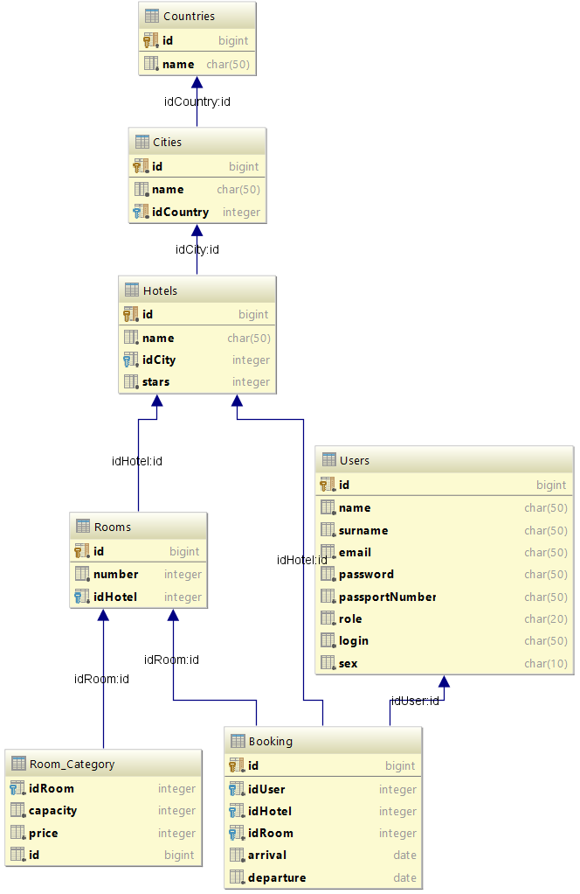

It is our database, which we believe optimal for solution the tasks of this project.

We added thirty countries and forty-five cities of different countries:

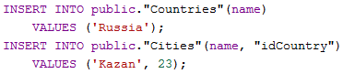

And we generated five thousand hotels, hundred rooms of every hotel and category of every room:

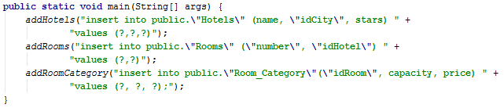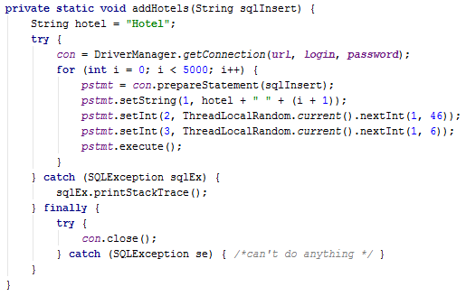

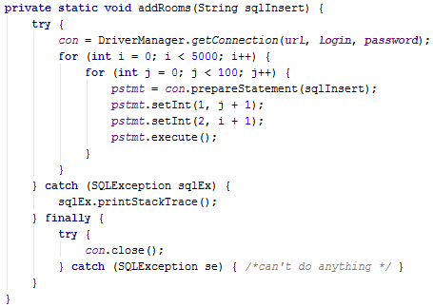

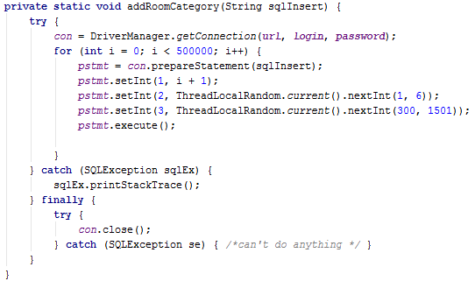

After developing a database, we develop front-end and back-end. We used

* Spring MVC
* Spring Security
* Apache Tomcat
* FreeMarker
* Java Script

Spring MVS easy in use and has good productivity. Spring Security all hashed passwords to be encrypted in the database.

../Desktop/screenshots/Снимок%20экрана%202016-11-18%20в%2018.33.05.jpg

**The SQL commands using to obtain the statistics:**

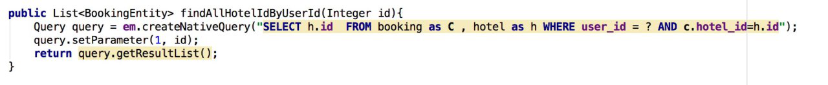

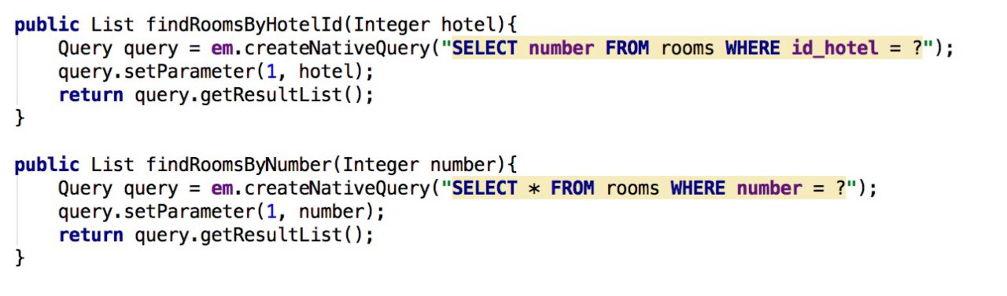

**Novel Ideas**

* Function online-booking of any rooms in any hotel in every country of the world.
* Manager of hotel can look who are booking room and when man will depart.
* Work with the Big database

**Work Process and What problem was at developing time**

At first, we installed Spring and read Spring documentation. After it, we thought that Framework approach to us. Then we learned Spring MVC, Maven and Tomcat, it was difficult, but very interesting process. When we understood this Frameworks, we started learn FreeMarker(FreeMarker is a Java-based Template Engine, originally focusing on dynamic web page generation with MVC software architecture).

And when we started learn FreeMarker we are faced with a first problem: “How import java object to FreeMarker?” We asked many people, searched in Google and after some time we found solution of this problem. Ok, we started developing Hotel Management System. All SQL query we wrote themselves with help PostgreSQL. We met a lot of problem at work with library to pgSQL. When we wrote SQL code, we used constraints, triggers and other special forms.

We make a good looking front-end with JS and BootStrap , using validation and take ready template.

Many problem was when we work with back-end. We have many Entities, Repositories, Services and they linked together. We write many SQL-queries and at the beginning not all of them worked work good. But we fixed all code and done our application.

**Let us examine some code.**

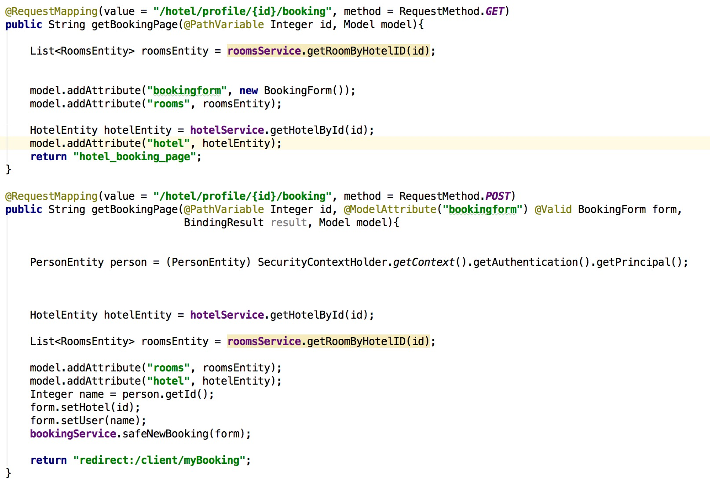

Here we can see some peace of ClientController and how we take data from BD.

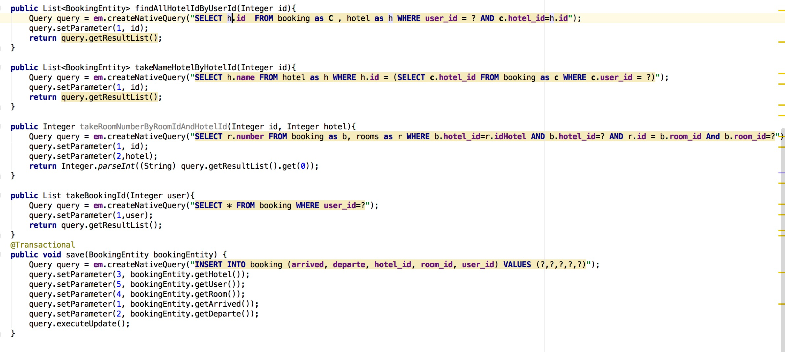

Here we can see how entity transmitted to FreeMarker like ${room}

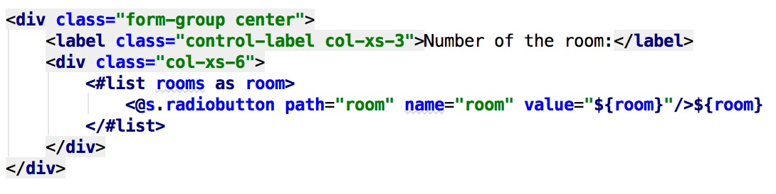

Now we show some SQL code from PostgreSQL:

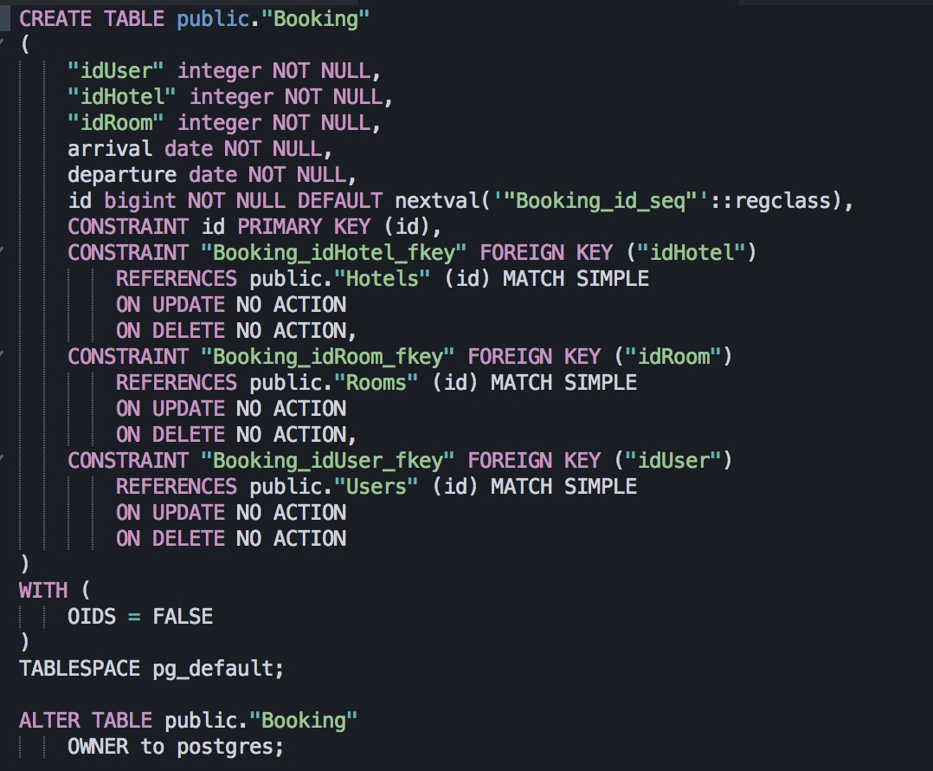

Triggers:

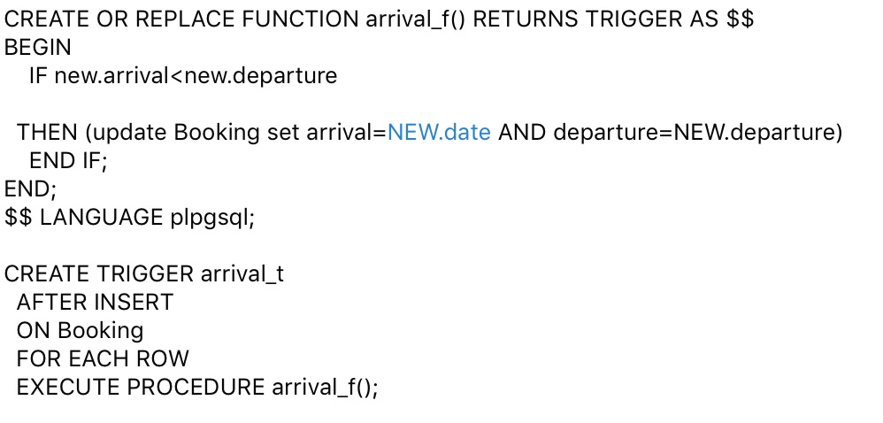

**Distribution of duties:**

Kamil Khadeev:

-write back-end (Spring MVC, Spring Security)

-write front-end (FreeMarker, CSS, JS)

-write SQL queries that take data from DataBase

Ildar Makseev:

- Create database table

- write trigger and constraint

- fill database

**Mobile Friendly app**

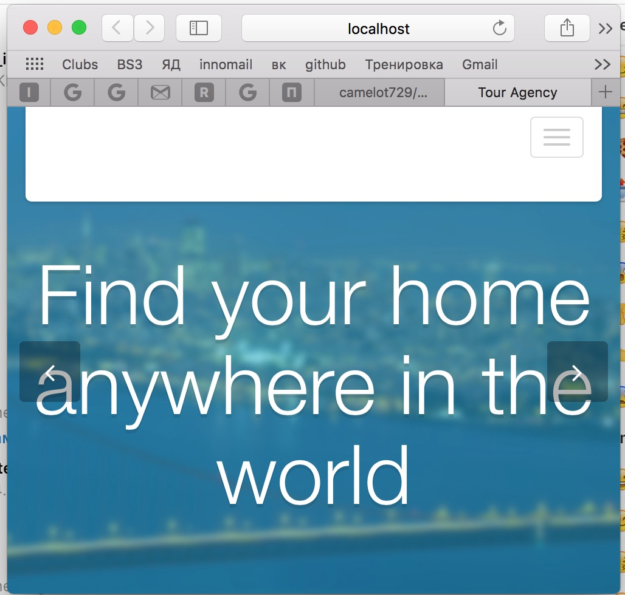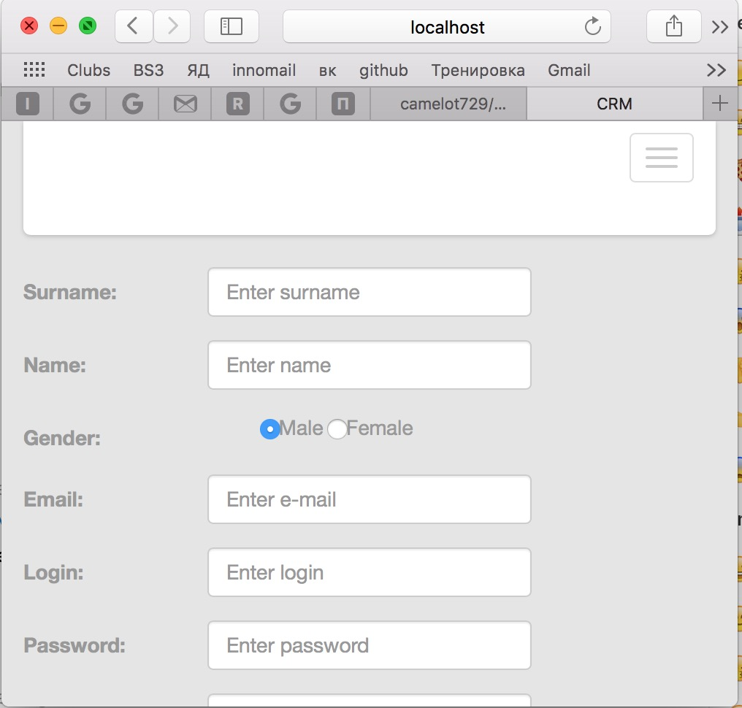

**Conclusion.**

According to the project tasks you can see that we complete most of them. We make app with clear and simple interface with nice design, our app can used by many people(client, manager, site administration).