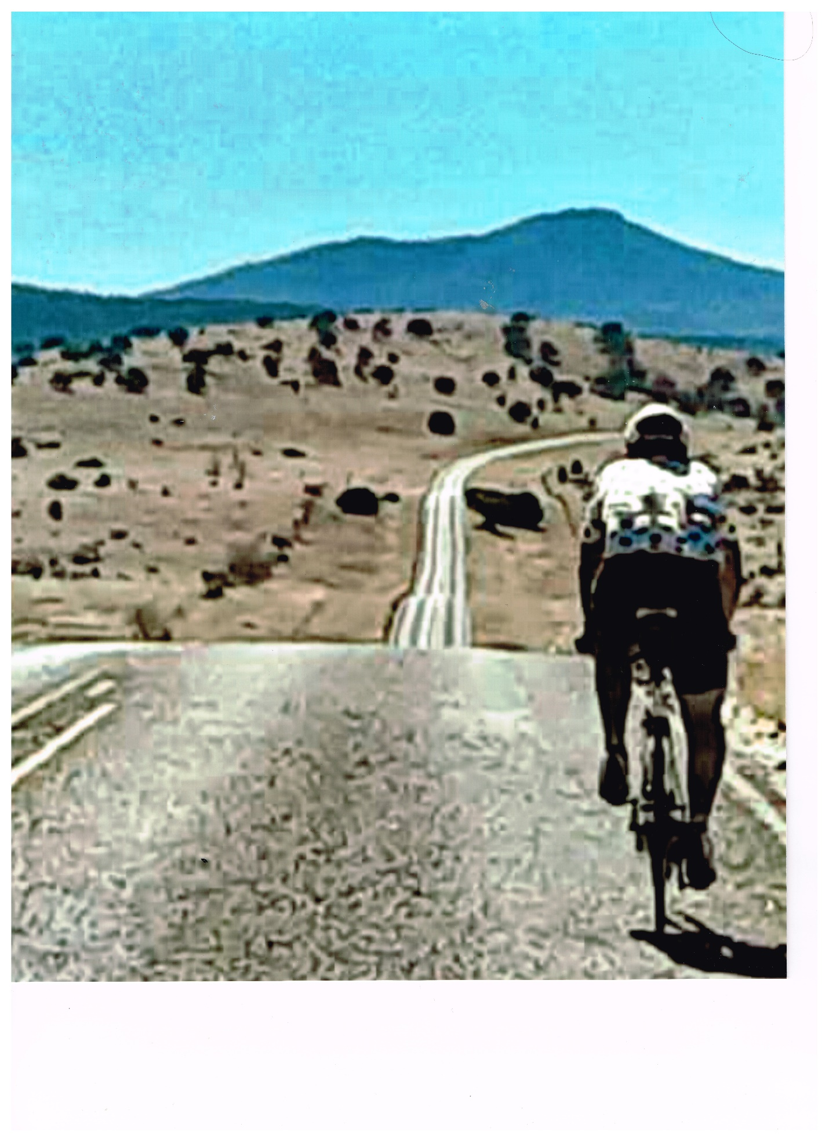

Contents

SPONSORSHIP PROPOSAL 1

Why Race Across America? 1

Endurance Accomplishments 1

The Event: Race Across America 2

Benefits of Sponsorship 2

Cost 3

My Crew 3

About the Candidate 3

Contact Information 3

**APPENDIX A** 4

**APPENDIX B** 8

**APPENDIX C** 10

SPONSORSHIP PROPOSAL

Why Race Across America?

Thank you for considering me for sponsorship. Race Across America (RAAM) is a coast-to-coast bicycle race beginning on June 11, 2024, in Oceanside, CA and ending in Annapolis, MD. It must be completed within 13 days, but the plan is to break the age group record.

My purpose for racing in RAAM is to secure a foundation to share my story and provide hope for people who suffered trauma and abuse. My story is not an easy one to tell. It is one of pain, but also one of redemption and second chances. Despite the anguish and trauma I endured as a child, I always found hope and peace in cycling. I got my first bike when I was 11 years old, and it carried me through the heartache of my brokenness. It wasn’t much of a bike, but it gave me the foundation for being resilient and never giving up on a dream for a better life. I have attained that better life over the years.

Now that I have retired from public service, I have the platform of Race Across America to provide hope and healing for people who have suffered trauma and abuse-people who have nothing to lose. I will show them that it is possible to heal and overcome. It is possible to achieve their dreams. I have been training my entire life for this race. I will conquer it like I conquered my fears. I will win because I have won a new life. I am blessed to have the capacity to train full time. My cycling coach is Marko Baloh, world renowned ultra-cyclist, (Baloh Coaching) who will provide the winning strategies. I have a solid team and a string of specialized state-of-the-art bicycles that will clinch our victory. Our team motto is **BELIEVE.** (See **Appendix A**, for complete story)

Endurance Accomplishments

* 10-time half marathon finisher
* 7-time marathon finisher
* 1 50K ultramarathon finisher
* 5-time 50-mile ultramarathon finisher
* 2-time 100-mile ultramarathon finisher
* 3-time Ironman finisher
* 4th place RAAM qualifying race

# The Event: Race Across America

June 11, 2024 - June 25, 2024. (See **Appendix B** for press release.)

**Benefits of Sponsorship**

**A cyclist winning Race Across America-**Everyone loves a success story and wants a piece of it. My journey, much like the story of the Phoenix, symbolizes renewal and resurrection. I rose from the ashes to become a success, see my story Appendix A. Your sponsorship of a success story will increase your sales.

**Motivational speaker**-An achievement such as finishing RAAM, see my story, Appendix A, is one of overcoming insurmountable obstacles. I will come to your organization and offer this story of success and of “embracing the suck,” to keep moving forward when every ounce of being wants to quit. Motivation is not about feeling good; it is about setting goals, preparing for the hardships that show up, overcoming them, achieving the goal, and sharing the experience with others. The path to success is helping someone else find that path.

**Brand Visibility during the race and video footage**- Your logo will be present on all of our vehicles. Beginning in Oceanside, California under one of the longest piers in California, our vehicles will travel over 3000 miles, climb 175,000 feet in elevation, span 12 states, and finish at City Dock in Annapolis, Maryland, the east coast sailing mecca. The route traverses three major mountain ranges (Sierra, Rocky and Appalachian), crosses the Great Plains, and four of America’s longest rivers (Colorado, Mississippi, Missouri and Ohio). We also pass through iconic American landmarks as the Mojave and Sonoran Deserts, Monument Valley, Great Plains, and Gettysburg. We will have three vehicles, two mini vans and an RV, making this trip. Each vehicle will be decorated with RAAM information as well as our sponsor’s brand logos. Your logo will be visible for all of America to see. All video footage will display your brand logo again for people interested in watching our documentary of this amazing adventure.

**Social media exposure –** Anytime we are online giving interviews and/or updated your brand logo will be present. We will plug your product as much as we can. We want you to get recognition because your sponsorship has made this adventure possible, and America and the rest of the world need to know it.

Cost

$60,350.00 (See Appendix C expense list)

My Crew

We have an 8-person crew consisting of: Crew chief, nutritionist, masseuse, and navigators.

# About the Candidate

Dr. Robert H. Woods, PhD is a father of 5, grandfather of 10, and a survivor of childhood trauma and abuse. He is retired from public service, holds a PhD in educational leadership, and is a licensed educational administrator and academic teacher. His doctoral studies focused on transformative learning and synchronicity. Robert is inspired by athletes such as ultramarathoner Scott Jurek, and bicyclist, Greg LeMond. Robert’s life ambition has been to offer hope, love and support to children and adults who have had to endure the horrors of abuse and trauma.

# Contact Information

Robert Woods

845-978-3441

[contact@thewaytovictory.org](mailto:contact@thewaytovictory.org)

# **APPENDIX A**

I was a high school dropout with a chip on my shoulder and nothing to lose. I was addicted to any substance that crossed my path, and I was a father of four by the time I was twenty-two. How I raised my boys as a single dad with sole custody, overcame addiction, became a licensed NYS Education Supervisor with a PhD, and developed into an accomplished endurance athlete is nothing short of a miracle. A guy like me should have ended up either dead or in prison. Instead, I share my story to inspire those who have nothing to lose. Because when you have nothing to lose you have everything to gain.

I failed the seventh and ninth grades, was expelled from high school, and began having problems with the law. So, my alcoholic father decided I should live with him thinking that would be the solution. I ran away from home at fifteen and did not go back until my dad got sober and I had nothing left. My father’s love allowed me to experience a full life when I was headed for a life filled with emptiness and self-destruction.

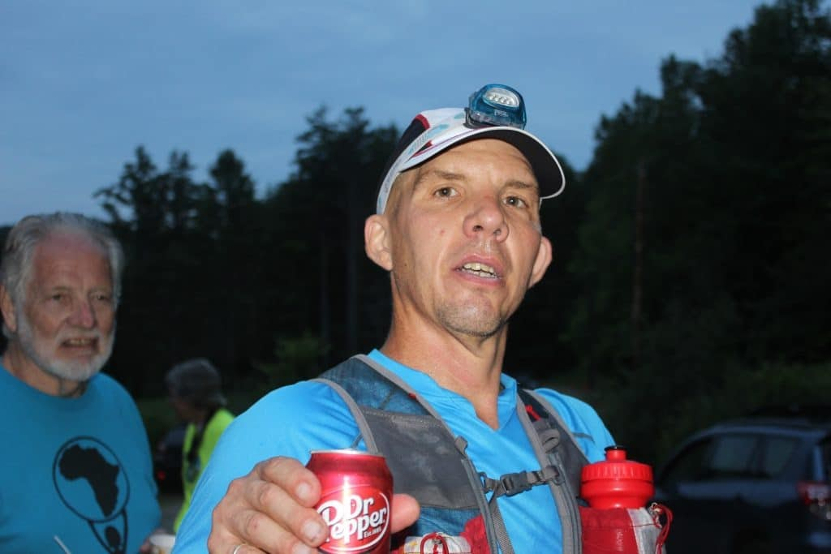

That’s me, mile 70, at Vermont 100 with my dad, my number 1 fan, in the background.

My transformation began when my dad helped me get into a drug and alcohol rehabilitation center. I spent eighteen months there. While in treatment, I got my GED and I realized school was a bridge to a new life full of opportunities. I applied for a program called LINK and was accepted. They paid for one full time semester of college.

Soon after I was successfully discharged from the treatment center, my ex-wife asked me to take custody of our four boys. There was no other answer but “yes.” I was now a single dad. I worked a full-time job and had no idea how I’d manage it all. But I did. I requested the night shift at work and was able to study there. People close to me looked after the boys at night.

I’ll never forget one day I was giving a presentation in one of my college classes. My palms were sweaty, I was filled with anxiety, and had nervous chatter in my head. The professor called my name and I nervously stood up in front of the class and began my presentation. Then I heard, “Dad.” I looked over and my six-year-old twin son John walked up to me and said, “Can I sharpen my pencil?” My boys always sat in the hall doing their homework outside my college classrooms. We still laugh about that experience. Life was a struggle, but we lived it together.

Over the years, I completed several college programs. I received an AS in human services, a BA in education, an MS in reading, an advanced degree (CAS) in educational leadership, and a PhD in educational leadership. For twelve years, I supervised academic teachers, vocational instructors, and oversaw a college program. I went from hating school to spending my entire professional career motivating unwilling students to appreciate the value of learning.  The bigger miracle is that I can help students like I was to see a future for themselves through education because I can identify with their reality.

My passion and my gifts have always been to redirect troubled souls. As a director of education in a maximum secure prison I would have problem students in my office a lot. My teachers always said, “I don’t know what you say to them, but they always come back to class with a different mindset.” It was never about what I said. It was about identifying with their reality. One day, the head cook stopped me in the hallway and said, “Dr. Woods, when you go into the yard, it’s like watching Moses parting the Red Sea. The men cut a path for you. They love you.” That means a lot to me because sometimes I felt like I wasn’t making a difference.

Outside of my professional world, I went from 300 pounds down to 190 pounds**.** I had always been active, but after an unexpected surgery to fuse discs in my neck, my active life screeched to an indefinite halt. I was devastated. I was no longer able to work out my feelings and emotions through exercise so, the natural thing for me to do was to eat them. So, I did. I was almost 300 lbs. and going to therapy, I realized I had another major life choice to make if I wanted to be healthy again. I had to learn to deal with my feelings in healthy ways and learn a new way to exercise that wouldn’t hurt my neck.

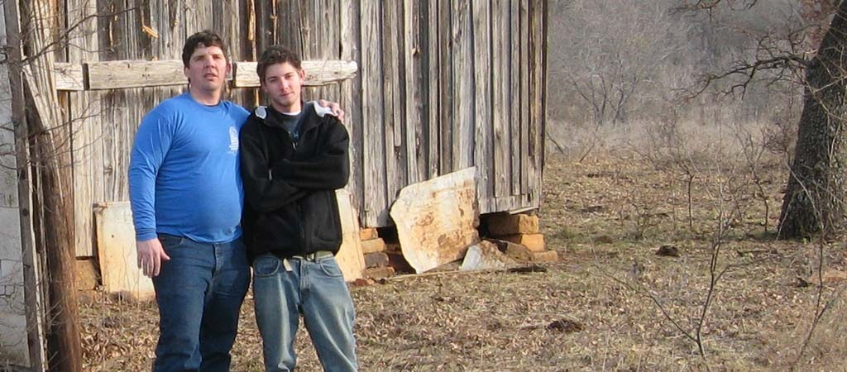

I'm the round one on the left pushing almost 300 lbs. at age 45.

I began my journey back to health by training for a half marathon. Now I run 100-mile ultra-marathons, compete in Ironman competitions, and race my bicycle in ultra-cycling events. I am currently qualified to compete in a bicycle race called Race Across America. I am faced with a lot of naysayers that think I’m crazy. But my personal pursuits guide me into the depths of my being and help me to become the best human being possible. That means using my gifts to help others. My dear friend, Very Rev. Fr. Maduawuchi S. Ogbonna, CSSP, PhD an Igbo from South-Eastern Nigeria reminds me often that I cannot harbor my gifts, or my story, and I must share them with the world.

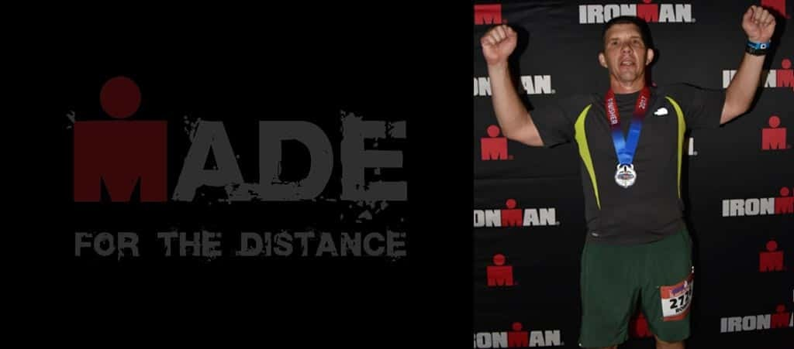

That's me, 190 lbs. strong in Lake Placid, after completing the 2017 Ironman Triathlon at age 54.

Now that I have retired from public service, I have the platform of Race Across America to provide hope and healing for people who have suffered trauma and abuse-people who have nothing to lose. I will show them that it is possible to heal and overcome. It is possible to achieve their dreams. I have been training my entire life for this race. I will conquer it like I conquered my fears. I will win because I have won a new life. My boys are all grown with healthy families of their own. I’m now raising a young daughter with my new wife, and I have a great relationship with my mother and siblings. I am blessed to have the capacity to train full time. My cycling coach is Marko Baloh, world renowned ultra-cyclist, (Baloh Coaching) who will provide the winning strategies. I have a solid team and a string of specialized state-of-the-art bicycles that will clinch our victory. Our team motto is **BELIEVE.**

I have spent many hours in deep conversation about the direction of my life with Fr. Maduawuchi. One day, I asked him, “Father, what is my Igbo name?” And he said, “Chukwuemeka. It means ‘God has done so much’.”

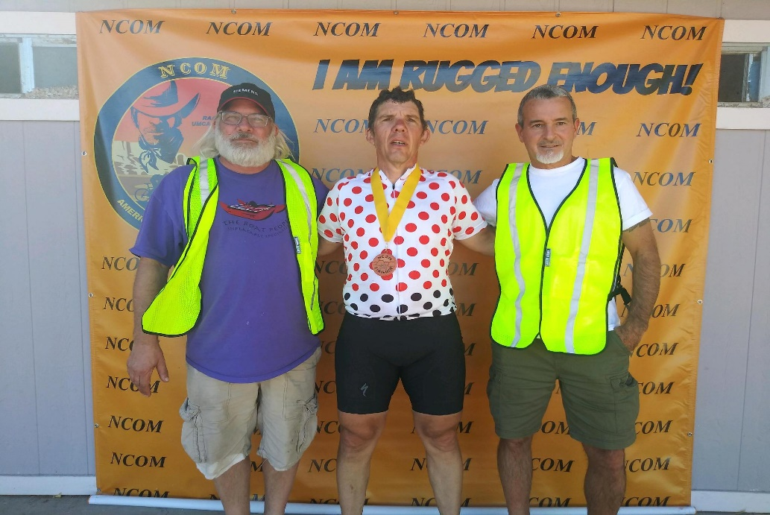

NCOM 2020 4th place with my crew

# **APPENDIX B**

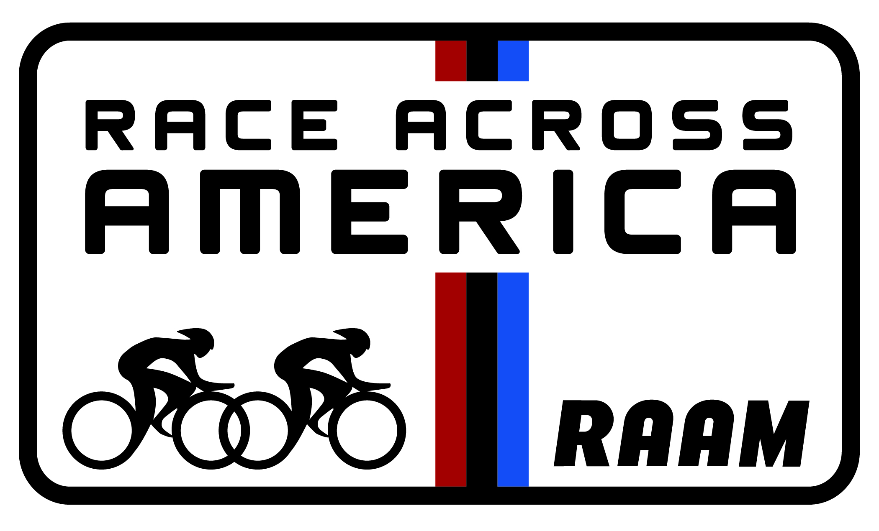

FOR IMMEDIATE RELEASE

**Contact: Robert Woods**

**Contact@thewaytovictory.org**

**Rick Boethling, RAAM**

**media@raceacrossamerica.org**

Liberty, New York’s **Robert Woods** prepares for Bicycle Race of a Lifetime – Across the USA Robert Woods will Race 3,000 Miles from California to Maryland.

Beginning June 11, 2024, **Robert Woods, of Liberty, New York** will embark on an extraordinary journey that will test his physical limits and mental toughness and commitment to a cause. As a competitor in [Race Across America (RAAM)](http://www.raceacrossamerica.org), Robert will endure 3,000 on his bicycle across the length of the North American Continent, from Pacific Ocean to Atlantic Ocean.

I have been training my entire life for this race. My goal is to finish RAAM in under nine days and sixteen hours, breaking the record for my age group. I want to win RAAM to show people like me who have been traumatized that there is hope and we are all champions. I want to win RAAM for myself to make amends to my inner child for all the years I self-sabotaged any possibility that existed to do something spectacular. And I want to win RAAM to show the world that no matter how much evil there is in this world and how much harm it does, love prevails.

“To promote hope and healing to people who have suffered from abuse and trauma”

The toughest endurance event in the world, RAAM offers long-distance cyclists the opportunity to challenge themselves to the height of their abilities. Fewer than 2,500 cyclists have completed RAAM since its first edition in 1982. Solo winners complete the course in under 9 days, and winning teams complete the journey in less than 6 days. These modern-day heroes brave the desert, plains and mountain weather, lead a crew and a mini organization of support, and raise thousands of dollars for charities around the world.

“This year, RAAM celebrates 37 years of uniting people from around the world with a shared love for cycling and adventure through team bonding, struggle and a strong sense of accomplishment,” says Fred Boethling, owner of RAAM and Solo and two-man team finisher. “It’s man against the elements, the road, and ultimately, him or herself.”

To follow **Robert Woods’** progress in this year’s Race Across America, visit [RAAM](http://www.ridefarther.com) online.

**More About RAAM**

RAAM and TEAM GET OUTDOORS are world leaders in the sport of endurance bicycle racing. The team is responsible for the Race Across America (RAAM), the world’s premier ultra-bicycle race, a 3000-mile coast-to-coast race across the USA, as well as the Race Across the West (RAW), an 930-mile race across the Western US, the RAAM Challenge Series, and the 6-12-24 World Time Trial Championships. In addition, they offer seminars on endurance bicycle racing and sanction endurance races worldwide.

[www.raceacrossamerica.org](http://www.raceacrossamerica.org)

# **APPENDIX C**

**RAAM Budget Worksheet**

|  |  |  |
| --- | --- | --- |
| **EXPENSE** | **ESTIMATED COST** | **ACTUAL COST** |
| Entry Fee | $3450.00 |  |
| Follow Vehicle # 1 | $3500.00 |  |
| Follow Vehicle # 2 | $3500.00 |  |
| RV/Camper | $3500.00 |  |
| Fuel for Vehicles | $3000.00 |  |
| Communication System | $800.00 |  |
| Race Food | $1000.00 |  |
| Crew Food | $3000.00 |  |
| Racer Flight | $600.00 |  |
| Crew Flight | $4000.00 |  |
| Lodging | $7000.00 |  |
| Bicycle Equipment | $2000.00 |  |
| Training | $5000.00 |  |
| Salary | $15000.00 |  |
| Miscellaneous | $5000.00 |  |
| **Total Budget** | **$60,350.00** |  |