How to use PySong Library Manager:

Upon opening pysong.exe you will be presented with this interface.

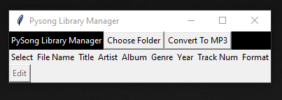

**Choose Folder:**

Choosing a folder allows you to view the attributes of all the mp3 files in the folder.

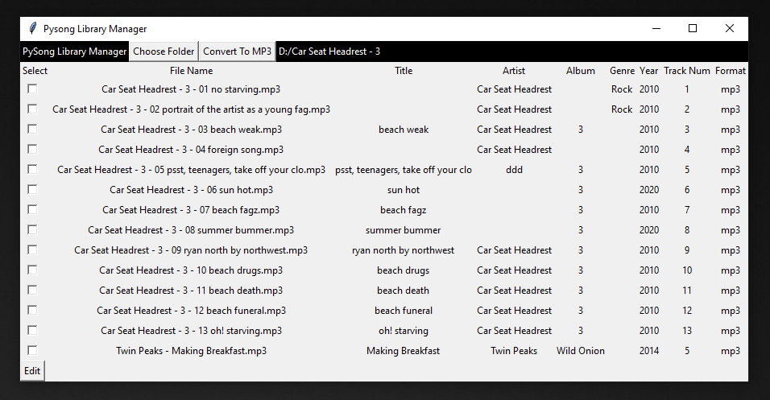

At the top on the right you will see the currently chosen folder. It shows all of the attributes of the file. If you select files on the left using the checkboxes and click “Edit” in the bottom left, it will let you change these values.

**Edit Mode:**

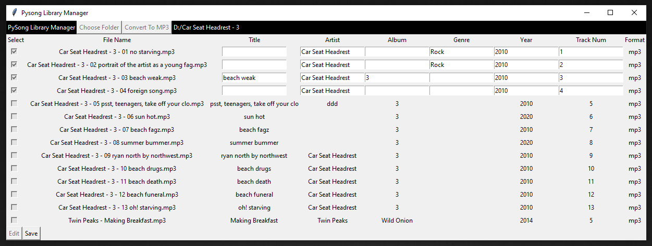

After switching to edit mode, you can use the text entry boxes to set new values for all of the attributes (except File Name). When you are done making changes, click “Save” in the bottom left.

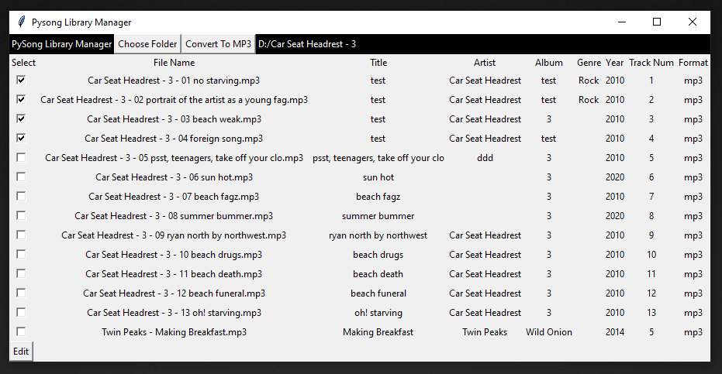

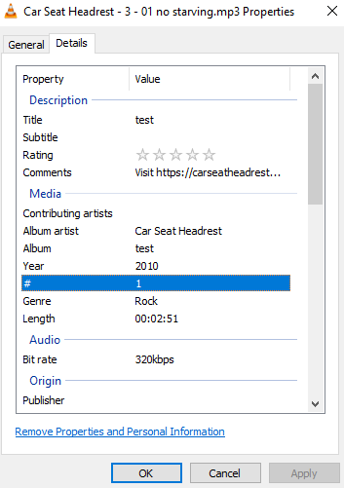

Now your new attributes have been saved to the file! You can also view these changes from the file explorer.

**Converting Files:**

You can enter convert mode when you are not in edit mode by clicking “Convert to MP3”, from there you can choose WAV, FLAC, or OGG files to convert into MP3 files using FFMPEG. This requires an installation of FFMPEG or for “ffmpeg.exe” to be in the same directory as PySong.

**Successful Conversion**

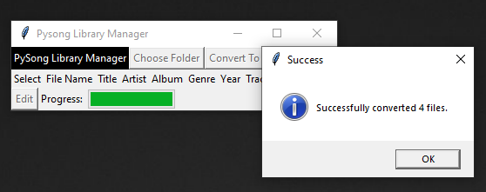

**Needs FFMPEG:**

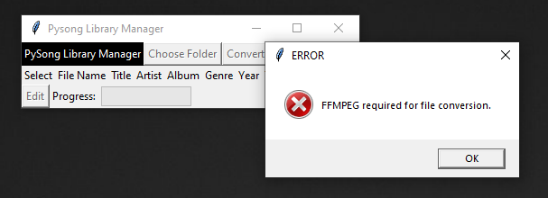

Converted files will be outputted into the same folder as the source files with the same file names as the originals.