

**Deliverable:** User Manual

**Team:** Pistachio

**Members:** Cameron Dziurgot, Luke Brodowski, Travis Moretz

**Submission Date:** 10th December 2015

**1. Installation and deployment:**

Put on device. Open?

**2. Main Features:**

**Creating a passkey**: Once a user has the system deployed on their device, they will be able to create a passkey. Creating a passkey involves entering a tap sequence into your device, and repeating the sequence several times.

**Attempting a passkey replication**: After a user has created a passkey, the user may attempt to replicate the that tap sequence they entered into the system. Using a comparison formula, the application will decide whether the passkey was entered by the original creator of the passkey, or someone attempting a false entry.

**Deleting an existing passkey**: If a user is having difficulty replicating their own passkey, they will be able to delete their existing passkey and re-enter a new one.

**Checking statistics**: A user will be able to check a variety of statistics. These include; the number of passkey attempts, the number of accepted passkeys, the dissimilarity score needed for a successful passkey attempt, and the average rate of acceptance.

**3. Main Feature Walkthrough:**

**Creating a new passkey tap sequence**:

*Step 1*: From the Home/Menu screen, a list of three buttons will be displayed; Login, Statistics, and Register. Select the “Register” button.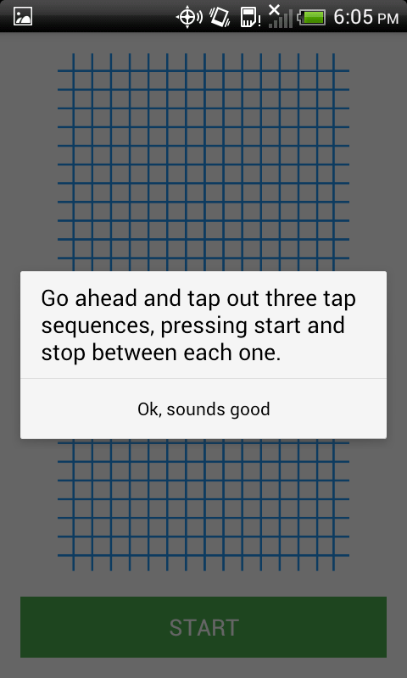

*Step 2*: After selecting the register button, a new screen will appear prompting the user to tap out 3 sequences. Press Ok to continue.

*Step 3*: As indicated in the prompt, to begin a sequence, press the “START” button, and to end a sequence, press the “STOP” button.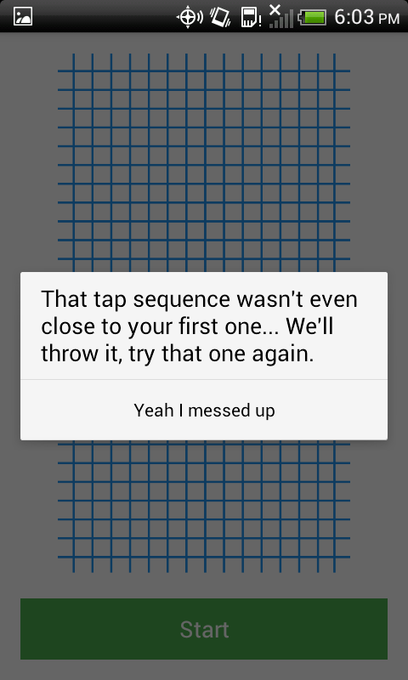

*Step 4*: Repeat step 3 two more times. If you try to create a tap sequence that is different than the first entered sequence, you will be prompted to re-enter that last attempt.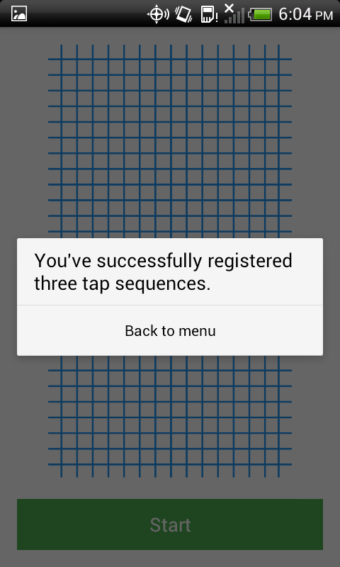

*Step 5*: Once you have completed all new tap sequence, the application will send you back to the Home/Menu screen, and the sequence you enter will be the new login passkey.

**4. Additional Features Walkthrough:**

**Attempting a passkey replication**:

*Step 1*: First a passkey must be saved on the phone. If this has not been done yet, follow the steps in Main Feature Walkthrough.

*Step 2*: After a passkey is created, on the Home screen, press the “Login” button. Pressing this button will bring you to a screen similar to the screen from the Register page.

*Step 3*: On the Login screen, to press the “START” button.

*Step 4*: Tap the passkey attempt into the grad on the screen.

*Step 5*: When finished, press the “STOP” button.

*Step 6*: After the stop button has been pressed, the application will tell you whether the entered passkey was within the limits of similarity of the currently saved passkey.

**Deleting an existing passkey**:

*Step 1*: First a passkey must already be saved.

*Step 2*: When a passkey is already saved, click on the register button.

*Step 3*: Follow the instructions for creating a passkey. The system is setup to override any existing passkey when a new passkey is registered.

**Viewing Statistics**

*Step 1:* From the home/ menu screen press the Statistics button.

**Deleting Statistics**

*Step 1:* View the statistics

*Step 2:*  Press the Delete Statistics button. This will reset all statistics to zero.

