Cameron Dziurgot
CS253 - Data Structures and Algorithms
7 May 2015
Research Paper
Solving the Knight’s Tour
The knight’s tour has been a puzzle for mathematicians, and past time for chess enthusiasts for centuries. As computational speed and capability increased over the last century, researchers and academics in computer science start looking more deeply into the puzzle. Several algorithms have been explored, and while knight’s tours started on small eight by eight chess boards, methods have been developed to efficiently discover knight’s tours on boards larger than one thousand by one thousand in size. Before going into further detail, a brief definition of a knight’s tour ought to be given.
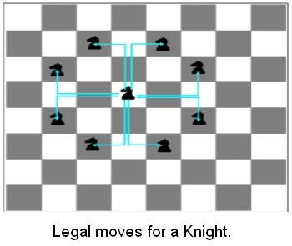
Classically, the knight’s tour occurs on an eight by eight square chessboard. The knight’s move in chess appears as an “L” shape on the board. It moves one space in one axis and two spaces on the other axis. The tour for the knight is when the piece is place at a square on the board, any square, and is moved around the entire board landing on every space without landing on a space twice. At the end of the knight’s tour, if the knight is within one move from the origin of the tour, the tour is considered closed. Other wise, it is considered an open tour. While the description of the tour may make the puzzle solution sound unique and rare, there are trillions of open knight’s tours that have been discovered. A closed knight tour is by definition a Hamiltonian circuit, or Hamiltonian cycle. That definition is a graph where every vertex on the graph is visited exactly once, except the first and last vertices.
With the immense amount of research into the knight’s tour, several different methods have been discovered in creating the closed tour. A more obvious method is the depth-first search (DFS) with backtracking for when the algorithm comes to a dead end before completing the tour. DFS is considered the brute-force method way of computing a tour. While this is an obvious method, the shear size of the graph being search does make this algorithm incredibly inefficient. There is the Neural Network algorithm. This algorithm sets every possible move as a neuron, which is set to either active of inactive. A set of rules govern how a neuron is considered stable or not. Through this method, a tour can created for boards much larger than the standard eight by eight chess board. A fall back to this method is that it is very complex, and it does not always create a tour. It can sometimes create several circuits, and any program implementing this method needs to take this into account. There is also the divide-and-conquer method of solving a knight’s tour. While this implementation is not used for eight by eight boards, it is for large boards to be divided into smaller boards, creating Hamiltonian paths on the smaller boards, which are all interconnected. The most efficient algorithm, and for that reason most popular for solving the knight’s tour puzzle, is Warnsdorf’s algorithm.
Warnsdorf’s algorithm is not only simple and efficient, but it will solve a knight’s tour in a Hamiltonian cycle in linear time on an eight by eight chess board. Warnsdorf created the algorithm in 1823. The algorithm is simple, and the structures required for it are not complex. The algorithm’s concept is as follows: start at a point on the board, which is considered a vertice. From that vertice, the next move will be determined by checking each possible move for the knight. Each available move is given a score based on possible moves if the knight proceeds to that vertice. The vertice with the least possible moves is where the knight moves. The idea behind this is that all the vertices with the most moves are saved to be used at the end of the tour.
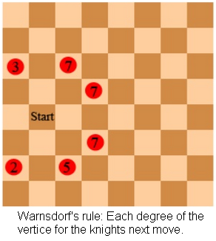
Implementation for this algorithm is very simple, and the structures needed are not complex. The chess board is constructed as a 2 dimensional array. You can use two arrays of integer. One array will hold the squares position in the knight’s tour. The other array will hold the degree for the vertices at the end of the non-origin edge. When the algorithm decides which vertice to traverse next, it first calculates all the possible moves for the knight. It does this by either adding or subtracting one from one dimension of the array, then adding or subtracting two from the other dimension of the array. Two conditions have to be met in order for a vertice to be a possible move for the knight. One is if the position is in the array, which means between zero and seven. The other condition is that the step in the tour has yet to be marked, which can be represented as zero in the tour array. If these two conditions are met, the algorithm then calculates the degree for each possible move. Which ever degree is the lowest degree is the next move for the knight. If there is a tie for lowest score, the algorithm can pick randomly to break the tie. It will not cause the algorithm to fail on a board as small as a standard eight by eight chess board. After each move is calculated, a counter is puts the move number is put nto the correct array spot in the tour array, and the counter is incremented. This is done 63 times, since the first position can be chosen randomly by a user or by the machine running the algorithm. Once all 64 moves are calculated, the cycle can be printed in an output screen. The tour will be a complete Hamiltonian cycle.
There are multiple ways to compute a knight’s tour on a small eight by eight chess board. Using Warnsdorf’s heuristic approach of moving to the vertice with the least accessible adjacent edges is an efficient linear approach of solving the knight’s tour problem. Using java and the idea of graphs, array, and stacks, modern computing can easily and quickly solve the problem that has trouble mathematicians for millennia.

Works Cited
Goodaire, Edgar. Parmenter. Discreet Mathematics with Graph Theory. 2nd ed. Prentice Hall. 2002. PDF.
Goodrich, Micheal. Tamassia. Goldwasser. Data Structures and Algorithms in Java. 6th ed. Wiley. 2014. PDF.
Hingston, Philip. Kendall. “Ant Colonies Discover Knight’s Tour”. G.I. Webb and Xinghuo Yu (Eds.): AI 2004, LNAI 3339, pp. 1213–1218, 2004. Online. May 2015. PDF.
Parberry, Ian. “An efficient algorithm for the Knight’s tour problem”. Discrete Applied Mathematics 73 (1997) 251-260. Online. May 2015. PDF.
Sasank, P. “Knights tour”. Slideshare.net. Sasank123. 7 Feb 2015. Online. May 2015.
Squirrel, Douglas. Cull. “A Warnsdorff-Rull Algorithm for Knight’s Tours on Square Chessboards”. 1996. University of Oregon. Online. May 2015. PDF.

