

Rental Valuation
Insert Tenancy Name Here
Address

DRAFT REPORT MARKET VALUATION | | 8 Hoariri Way, Tauranga South, Tauranga
“This document is a DRAFT report and is provided for the sole purpose of allowing discussion and comment between you, as the client, and PRP Tauranga Limited (PRP) only. As such, this document is not to be disclosed or discussed with any third parties and nor is it to be relied upon by you or any third parties.

This DRAFT report is not to be taken, in any way, as being or forming part of the Valuation Report that PRP has agreed to provide to you.

On this basis of the above, PRP do not accept any responsibility (legal or otherwise) or any liability for any loss and damage arising out of yours or any third parties’ reliance on this DRAFT report.”

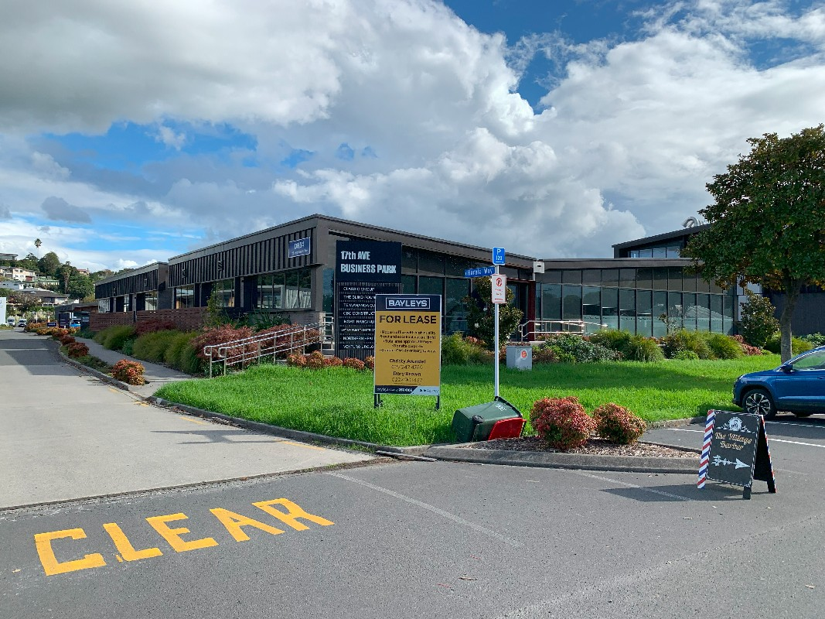
Source: (Valuer)
TABLE OF CONTENTS
1.0 Executive Summary 3
2.0 Scope of Work 5
3.0 SWOT Analysis 8
4.0 Risk Analysis and Asset Overview 9
5.0 Record of Title 11
6.0 Location 12
7.0 Site Details 13
8.0 Planning and Land Use 15
9.0 Improvements 18
10.0 Sustainability (ESG) 22
11.0 Environmental Details 23
12.0 Occupancy Details 24
13.0 Financial summary 26
14.0 Market Commentary 27
15.0 Market Conditions and Sales History 29
16.0 Rental Evidence and Market Rental Assessment 30
17.0 Sales Evidence 37
18.0 Valuation Considerations 44
19.0 Valuation Reconciliation 49
20.0 Valuation Summary 50
21.0 Glossary 51
22.0 Appendices 52

Executive Summary
This executive summary must be read in context of and in conjunction with the full valuation report of which this executive summary forms part. All comments, terms and conditions contained in the full valuation report relate directly to this Executive Summary.

8 Hoariri Way, Tauranga South, Tauranga

Instructed By: | Mr Daniel Watkins
Client: | 17th Avenue Consolidated Limited
Other Intended User: | TBC
Intended Use: | Market Value for Mortgage Lending
Basis of Valuation: | Market Value ‘As Is’ - subject to existing leases
Valuation Methods: | Income Capitalisation and Discounted Cashflow Analysis
Date of Valuation: | 2 May 2025
Report Issue Date: | INSERT HERE
Reassignment Policy: | PRP cannot extend liability to any party beyond 90-days from the date of valuation due professional indemnity policy restrictions. Reliance this report beyond 90 days may require reinspection and an update fee.
GST Statement: | The valuation figures herein are exclusive of Goods and Services Tax (if any).

MARKET VALUE: | $6,100,000 plus GST (if any)  (Six Million, One Hundred Thousand Dollars)

Property Overview

The subject property is located on the northern corner of Hoariri Way and Harata Way and fronts Seventeenth Avenue within the Seventeenth Avenue Business Park.
The property supports a single-level office building providing three office tenancies with open plan accommodation space and some partitioned meeting rooms, toilet facilities, staffroom, and 23 onsite carparks.

Total Land Area: | 0.2398 hectares
Total Lettable Area: | 1,052.0 m²
Zoning: | Commercial Zone under the Tauranga City Plan
Highest and Best Use: | Existing use
Assessed Interest: | Freehold
Prior Sale: | None that we are aware of in the last three years
Current/Proposed Sale: | No current or proposed sales that we are aware of

Occupancy Overview

Occupancy Overview: | 100% occupied
Net Passing Rental Per Annum: | $322,799 p.a. plus GST
Net Market Rental Per Annum: | $378,231 p.a. plus GST
WALE: | 2.06 yrs

This valuation report has been prepared by:
Matthew Fenton  Registered Valuer, Director  Inspecting Valuer | Cameron Speirs-Hutton  Assistant Valuer

Valuation Analysis

Initial Yield (Passing Income): | 5.29% | 10 Year IRR: | 7.87%
Initial Yield (Fully Leased): | 5.29% | 5 Year IRR: | 7.71%
Equivalent Initial Yield: | 5.39% | 10 Year Cash on Cash: | 6.28%
Equivalent Market Yield: | 6.15%
Market Yield: | 6.20%
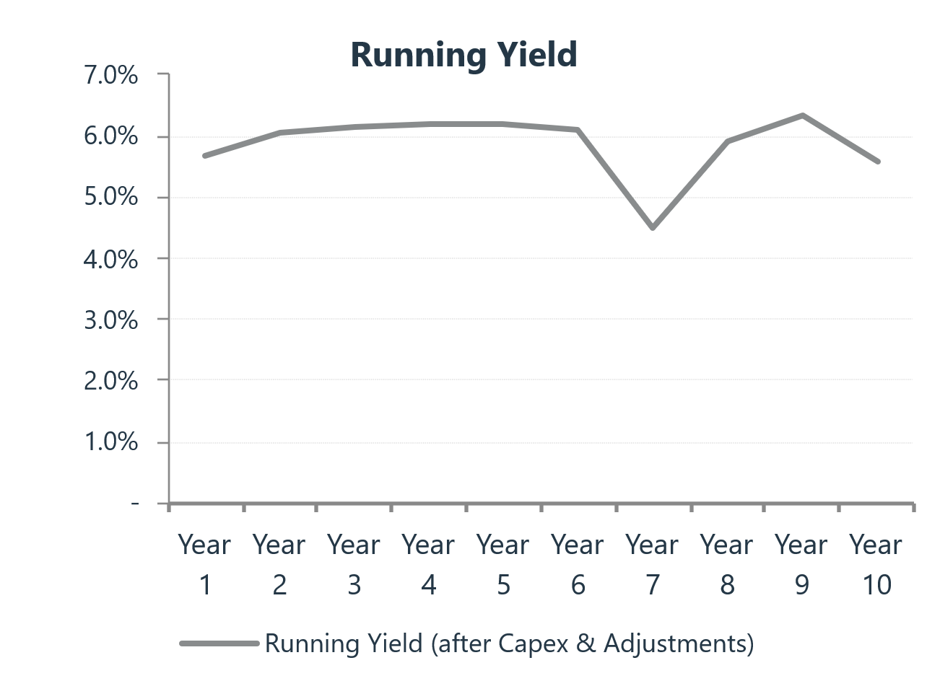 |  | 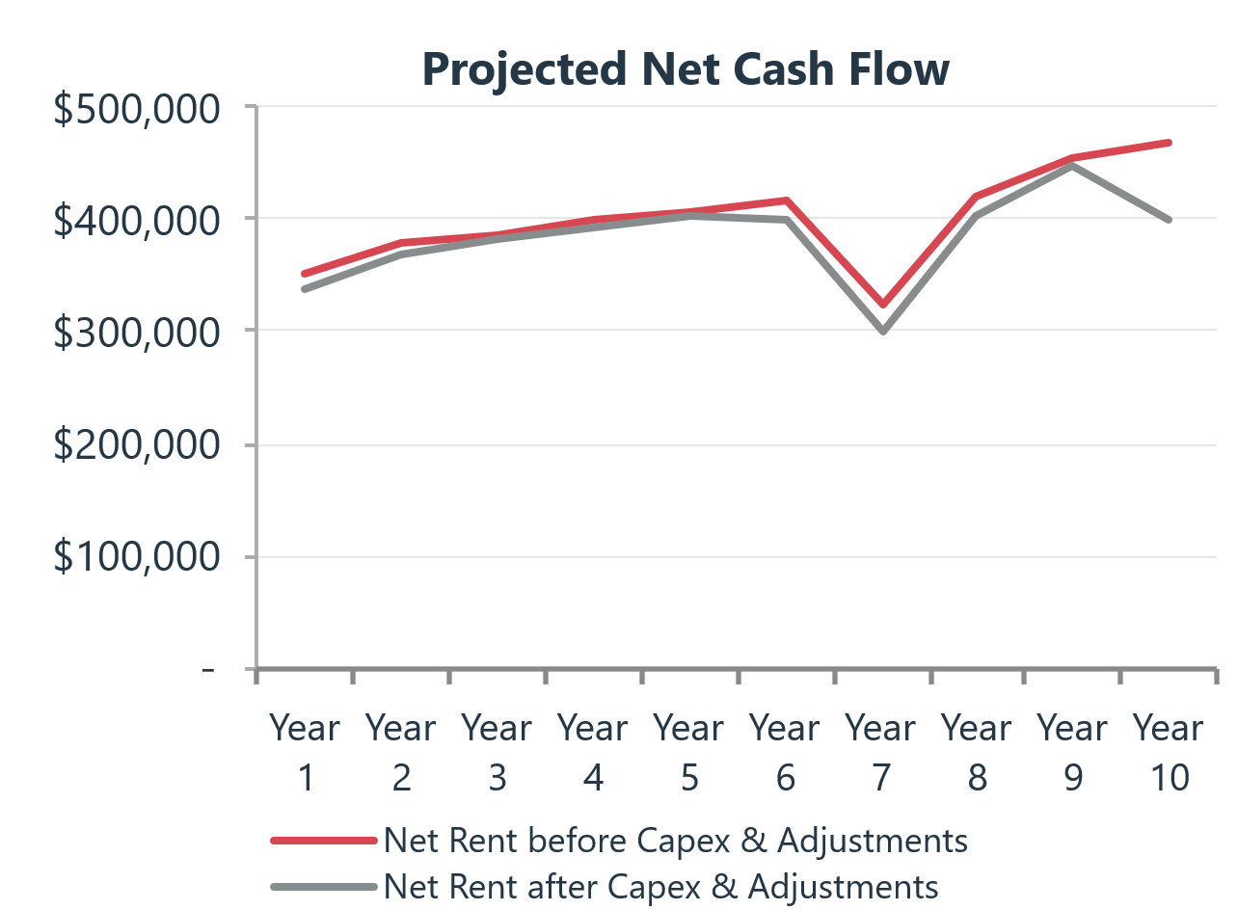

Valuation Considerations

Current BWOF: | Yes Expires: 04/06/2025
NBS (if known): | Given the age of the building, we have assumed the seismic rating is no less than 100% NBS.
HAIL: | Not registered as a HAIL (Hazardous Activities and Industries List) site.
Sustainability Rating: | N/A | Asset Risk: | Low-medium
Environmental Factor: | Positive | Cashflow Risk: | Medium
Social Factor: | Positive | Management Risk: | Low-medium
Governance Factor: | Positive | Market Segment Risk: | Medium

Financial Overview

Gross Passing Income: | $384,741 | Net Passing Income (p.a.): | $322,799
Gross Market Income: | $440,174 | Net Market Income (p.a.): | $378,231
Adopted Outgoings $/m²: | $55.9/m² | Occupied: | 100%
CAPEX (PV over 10 years): | $109,827 | Over/Under Rented: | 3.1%
WALE (by income): | 2.06 yrs | WALE in Year 10 (by income): | 2.89 yrs
WALE (by area): | 2.22 yrs | WALE in Year 10 (by area): | 2.88 yrs
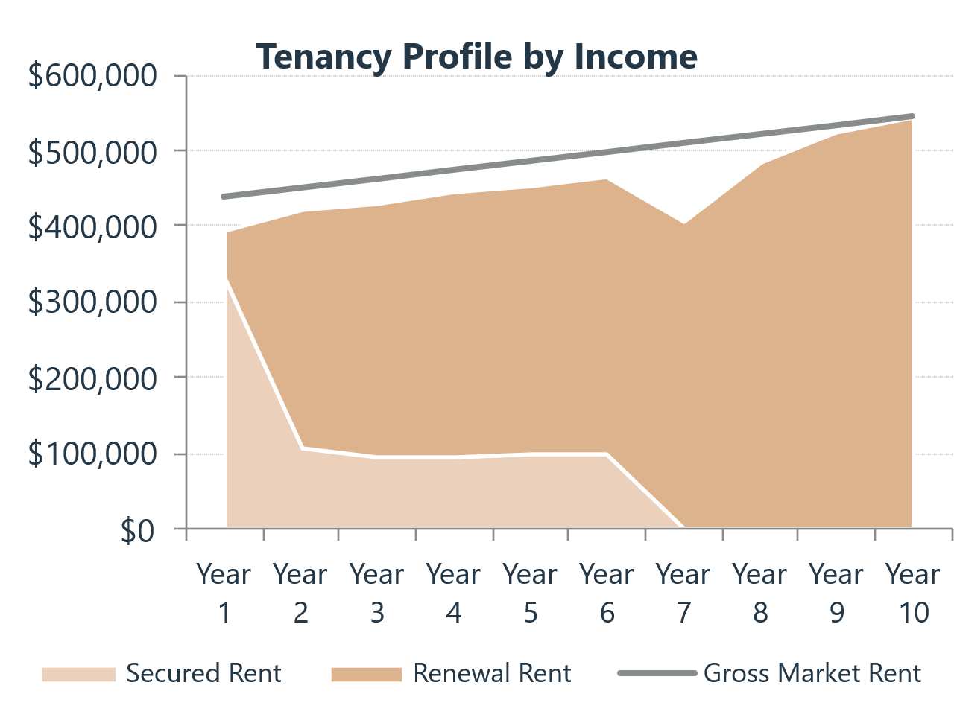 |  | 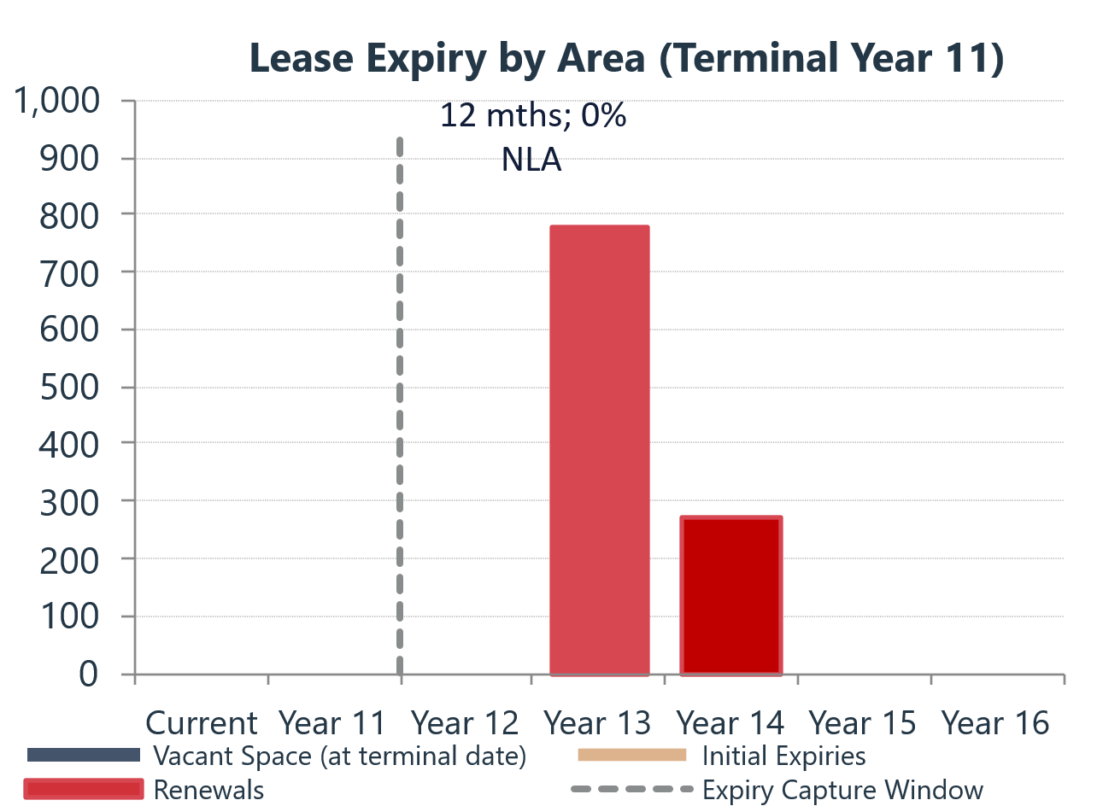

Scope of Work

PINZ and NZIV Compliance

Identification and Status of the Valuer: | We confirm the following:  - The valuation has been completed by Matthew Fenton, Registered Valuer, MPINZ of Preston Rowe Paterson Tauranga Limited. The Registered Valuer signing this report holds a current annual practicing certificate and is a member of the New Zealand Institute of Valuers.  - We confirm that neither Preston Rowe Paterson Tauranga Limited nor, any of its directors or employees has any pecuniary interest that could conflict with the proper valuation of this property or, could reasonably be regarded as being capable of affecting their ability to give an unbiased opinion. We further confirm that the Valuer’s fee is not contingent upon any aspect of the report.  - Preston Rowe Paterson Tauranga Limited holds Professional Indemnity Insurance appropriate to the value level in the report. We confirm that the Registered Valuer(s) who are signatories of this report are covered by the Professional Indemnity Insurance.  - The Registered Valuer(s) who are signatories of this report have satisfied professional education requirements and have the required knowledge, skill, expertise and competence to complete a valuation report of the subject asset(s) in the location and category of the property in accordance with the agreed instructions.

Instructions

Instructed By: | Mr Daniel Watkins
Client: | 17th Avenue Consolidated Limited
Other Intended User: | TBC
Property Address of Asset Valued: | 8 Hoariri Way, Tauranga South, Tauranga
Interest To Be Valued: | Freehold Interest, subject to any Special Instructions, Significant/Special Assumptions, Terms and Conditions as noted in this report.
Valuation Currency: | New Zealand Dollars (NZD)
Intended Use: | Market Value for Mortgage Lending
Basis of Valuation: | Market Value ‘As Is’ - subject to existing lease
Restrictions on Use, Distribution and Publication: | The Valuation is provided by Preston Rowe Paterson Tauranga Limited and responsibility in connection with this valuation is limited to the client to whom the report is addressed, as well as any additional authorised reliant parties confirmed in our report. We disclaim all responsibility and will accept no liability to any other party. See our Term and Conditions for further details.  You cannot reproduce this report, or any part of it, in any publication without first obtaining our written consent.

Valuation Dates

Date of Instruction: | 16 April 2025
Date of Inspection: | 2 May 2025
Date of Valuation: | 2 May 2025
Report Issue Date: | INSERT HERE

Investigation

Nature and Extent of Valuers Work and Limitations: | - A full site and internal inspection of any improvements on the subject property has been carried out by the registered inspecting valuer responsible for this report. However, we confirm that this report is not a building, environmental, planning or land survey. If there are any doubts in this regard, independent professional advice should be sought.  - The statements of fact presented in this report are correct to the best of the Valuer’s knowledge and the analysis and conclusions are limited only by the reported assumptions and conditions.  - This valuation is current as at the date of valuation only. The value assessed herein may change significantly and unexpectedly over a relatively short period (including as a result of general market movements or factors specific to the particular property). We do not accept liability for losses arising from such subsequent changes in value. We do not assume any responsibility or accept any liability where this valuation is relied upon after the expiration of 90 days from the date of the valuation, or such earlier date if you become aware of any factors that have any effect on the valuation.

Information

Nature and Source of Information Relied upon: | We have been provided with the following information:  - GIS and other mapping information sourced from public records.  - Local Authority Rating and Planning Information sourced from public records.  - Unless otherwise noted all confirmed sales and leasing information has been sourced from REINZ, third-party sales database, or property market participants, including real estate agents.  - Lease documentation sourced from Client  - Tenancy schedule sourced from Client  - Outgoings Schedule sourced from Client
Recommended Documents to Sight: | As part of our valuation process, we have attempted to source and review documents relating to the subject property. Some of these documents have the potential to have an adverse impact on marketability and value. We recommend the following Documents should be sighted by those parties expressly named and relying upon this Valuation Report:  - Nil

Assumptions

Significant Assumptions: | A Significant Assumption is an assumption made by the valuer regarding uncertain or unknown facts. These assumptions often result where there are limitations to the extent of investigation and enquiry made by the valuer.  - Nil
Special Assumptions: | A Special Assumption is an assumption where the facts differ from what is known at the Date of Valuation. It often presumes certain hypothetical conditions or changes that may not currently exist but are necessary for the purpose of the valuation.  - The Bay of Plenty District Health Board has signed and agreement to lease tenancy 3, but is paying a deferral fee, equal to the contract rent, to defer the commencement of the lease. We have assumed the commencement date of the lease is the date of valuation.  - Venturo Limited pay fitout rent which we have calculated to be $19,862 plus GST per annum.

Standards and Definitions

Report Format and Valuation Standards: | - We have prepared a formal valuation report to convey our findings. The report must be read in conjunction with Preston Rowe Paterson Tauranga Limited Terms and Conditions within, and linked to, this report.  - The Valuer responsible for this report considers the valuation process followed and valuation report prepared is compliant with the International Valuation Standards effective date 31 January 2025, Australian and New Zealand Valuation and Property Standards, Guidance Papers for Valuers and Property Professionals as well as the PINZ and NZIV Code of Ethics. Measurements are in accordance with PCNZ/PINZ Guide for the Measurement of Rentable Areas.
Definitions: | Market Value as stipulated by the International Valuations Standards and endorsed by The Property Institute of New Zealand is:  Market Value is the estimated amount for which an asset or liability should exchange on the valuation date between a willing buyer and a willing seller in an arm’s length transaction, after proper marketing and where the parties had each acted knowledgeably, prudently and without compulsion.

SWOT Analysis

Strengths
Positive internal factors or characteristics of an asset that enhance value
- Size and quality of the improvements
- Modern improvements with little maintenance requirements
- Commercial zoning
- Strong demand for medical related offices in this location
- Strong lease covenant
- Close to key arterial routes and Tauranga Hospital which is forecasted to expand long-term underpinned by significant population growth in the Tauranga region.
- CPI+1% reviews
- Multi-tenanted hedging against full vacancy risk
- Proximity to the Tauranga Hospital

Opportunities
External factors that if leveraged, could enhance value of an asset
- Future surrounding development further strengthening car park demand and land values
- Monetary easing cycle improving liquidity in the market
- A-grade offices offering an affordable option to the CBD
- Tenants renew to increase lease security

Weaknesses
Negative internal factors or characteristics of an asset that diminish value
- Secondary office location, albeit evolving
- Low lying land with a flood overlay
- Reduced market review provisions
- Multi tenanted requiring greater management
- WALE of 2.22 years secured
- Ministry of Education is a gross lease be less favourable to investors

Threats
External factors that could negatively impact value of an asset
- Low lying Land
- Reduced confidence in the commercial investor segment of the market
- Increased outgoings putting pressure on rental growth throughout Tauranga
- Tenants don’t renewal

Risk Analysis and Asset Overview
Risk ratings are intended to highlight factors that may impact the value of the asset. Each rating should be viewed in the context of the report's comments, terms, and conditions. In some instances, ratings are based on observations made during inspection or upon review of available documentation. Should new information arise that could affect the valuation and risk ratings assessment, we reserve the right to revise the risk ratings profile and valuation accordingly.
Asset | Low | Low-Medium | Medium | Medium-High | High
Record of Title: | Freehold title with three registered consent notices
Location: | Positive locational factors for current use
Site: | We note the subject property has high liquefaction vulnerability overlay. The site has recently been developed, and we assume suitable ground works have been completed to mitigate the risk of liquefaction.
Planning and Land Use: | The property is subject to several planning overlays
Improvements: | Modern, single-level commercial building providing A-grade office
Sustainability (ESG): | The subject property supports a positive ESG profile
Environmental: | Based on our enquiries, investigations, and physical inspection, we did not identify any significant environmental hazards, site contamination, or asbestos-related issues that would adversely impact the marketability or market value of the property

Cashflow | Low | Low-Medium |  | Medium | Medium-High | High
Occupancy Overview: | Multiple tenancies
Tenancy Profile: | Based on our enquiries, investigations and review of the supplied lease documentation, we are of the opinion there is no pre existing relationship between the lessee and lessor parties and that the subject lease agreements have been negotiated on an 'arms length' basis
Tenancy Areas: | 1,052.0 m²
Leased Tenancies: | 3 |  | or, 100 % of total tenancy areas
Vacant/Owner-occupied Tenancies: | Nil |  | or, 0 % of total tenancy areas
Net Passing Rental Per Annum: | $322,799 |  | or, $307 per square metre
Net Market Rental Per Annum: | $378,731 |  | or, $360 per square metre
WALE: | By Area: 2.22 years |  | By Rent: 2.06 years
Lease Terms and Conditions: | Two of the tenancies are on standard commercial lease terms and conditions for this type of property. The Ministry of Education is on a Gross lease.
Next Market Rent Review: | 17 January 2026
Letting Up Incentives: | Incentives required to secure a tenant
Letting Up Period: | 6 months
Capital Expenditure Requirement: | Minimal CAPEX in the foreseeable future
Vacancy: | Securely leased on an arm’s length commercial lease agreement
Tenancy Supply: | Limited leasing activity in general for this type of property
Tenancy Demand: | Limited leasing activity in general for this type of property

Management | Low | Low-Medium | Medium | Medium-High | High
Asset Complexity: | Moderate
Asset Management Experience: | Competently managed by a management company
Asset Management Comment: | Multi tenanted with a mix of net and gross leases

Market Segment | Low | Low-Medium | Medium | Medium-High | High
Asset Supply: | Under supply at this price point
Asset Demand: | Steady demand at this price point
Volume of Sales: | Low levels of sales activity at this price point
Recent Market Direction: | Steady
Marketability: | Stable to improving market
Selling Period: | 3 – 6 months
Volatility: | Emerging signs at this price point
Purchaser Profile: | Most probable buyer profile for this property is an investor
Market Segment Comment: | Market uncertainty remains throughout all commercial property market segments

Record of Title

Search Details

Title Search Date: | 30 May 2025

Title Particulars

Title: | 1 | Identifier: | 1041044
Estate: | Fee Simple | Area: | 2,398 square metres more or less
Legal Description: | Lot 2 Deposited Plan 572280
Registered Owners: | 17th Avenue Consolidated Limited
Interests of Note on Title: | Consent Notice 11419797.2, Consent Notice 12005325.5, Consent Notice 12434826.3
Comment on Interests: | We have reviewed all interests and do not believe they have a detrimental impact on the marketability of this property given the property is fully developed

Title Comment

Freehold title with three registered consent notices

Statement

Search Details: | We have relied on a copy of title(s) which were searched as at the date(s) stated above. Should any notations have been placed on the title(s) since the date of search which affect the Valuation or Valuation Services, we reserve the right to reconsider our valuation findings herein.
Title Particulars: | This valuation has been prepared on the understanding that no notations, encumbrances, easements, rights of way or encroachments exist by or on the subject property other than those detailed herein.
Full title documentation can be found appended to this report.

Location

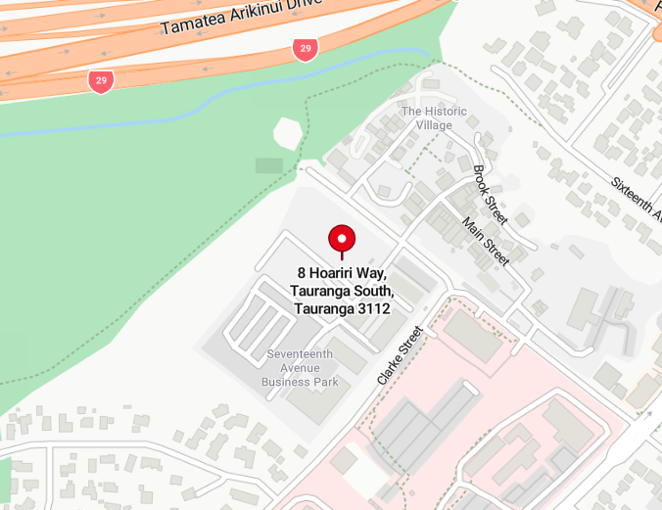
Source: (Bing Maps)

Physical Location

Side of Street: | North
Nearest Main Intersection: | Located east of subject with Seventeenth Avenue and Clarke Street
Immediate Surrounds: | Developing commercial precinct
Suburb Type: | Inner metropolitan suburb
Nearest Commercial Activities: | Tauranga Central Business District
Location Overview: | The Seventeenth Avenue Business Park is a prominent commercial hub strategically located opposite the Historic Village and in close proximity to Tauranga Hospital, the largest in the Bay of Plenty region. Established in 2012, the park spans approximately 4.2 hectares and currently comprises nine completed buildings, with plans for seven additional structures.

Surrounding Development

Land Uses: | Commercial
Businesses in Surrounding Area: | Medium-large business enterprises

General Features and Trends with the Surrounding Development

Positive Features: | Generally modern development with low vacancy
Negative Features: | Secondary office location, albeit evolving
Positive Trends: | High growth area
Negative Trends: | None obvious within the immediate vicinity

Location Comment

Positive locational factors for current use

Site Details

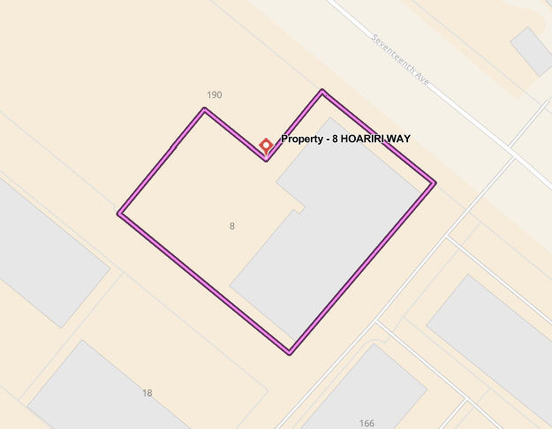
Source: (Local Government Authority Mapping Information)

Site Identification and Measurements

Site Area:
  Title/Lot: | Area:
  1 | 0.2398 hectares

Site Description

Shape: | Irregular
Topography: | Flat in contour and raised slightly above road level
Frontage: | Front site
Services Connected to Land: | Power, water, sewerage, gas, telecommunications, and stormwater
Sub Soil Type: | Not known
Other known Characteristics: | We note no unusual or high-risk land or site issues that would have a negative effect on the marketability or market value of this property

Road System

Road Access: | Vehicle access is available via Harata Way
Road Design: | Bitumen sealed road
Resumption and Acquisition Plan: | None identified

Geotechnical Details

Liquefaction Potential: | High liquefaction vulnerability planning overlay
Geotechnical Comment: | We have not been provided with a site-specific geotechnical report and are therefore unable to comment on the suitability of the foundations for this property.

Site Comment

We note the subject property has high liquefaction vulnerability overlay. The site has recently been developed, and we assume suitable ground works have been completed to mitigate the risk of liquefaction.

Statement

Registered Valuers are not qualified to provide a land survey or geotechnical survey and have not done so. We have not sighted boundary markers, and, for the purposes of this assessment have assumed that the improvements described herein are contained within the legal confines of the land. We further assume that the land is as described in the report and that buildings are constructed on firm and suitable ground for the existing and/or potential development, and do not require significant additional retaining, remediation, or drainage.

Planning and Land Use

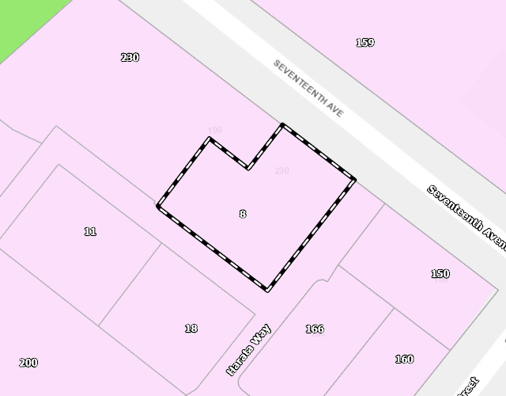
Source: (Local Government Authority Mapping Information)

Planning Zoning

Local Government Area: | Tauranga City Council
Planning Scheme: | Tauranga City Plan
Zoning: | Commercial Zone
Zoning Objective: | The Commercial Zone is designed to support vibrant, well-functioning centres that provide a mix of commercial services for both local and wider communities. It encourages high-quality development that fits the character of each area, supports public transport, and promotes economic growth. Policies aim to ensure new development is appropriately scaled, enhances the streetscape, and avoids negative effects on nearby residential zones. Mixed-use development is supported where suitable, helping to create lively, accessible, and sustainable commercial areas.
Permissible Land Uses without Consent: | Activities ancillary to health or disability services, ancillary retail and offices, business activities, community facilities, emergency services, homestay, minor public recreational facilities and activities, places of assembly, schools and tertiary education premises and visitor accommodation.
Permissible Land Uses with Consent: | Residential activities
Prohibited Land Uses: | None identified
Planning Permits/Development Approvals/Resource Consents: | We have not been provided with a copy of any planning permits for the subject property. However, we have assumed that all necessary permits have been obtained.
Planning/Development Constraints: | The Valuer is not aware of any significant or onerous planning or development constraints that would negatively affect the marketability or market value of this property.
Proposed Planning Amendments: | The Valuer is not aware of any proposed planning amendments that would negatively affect the marketability or market value of this property.

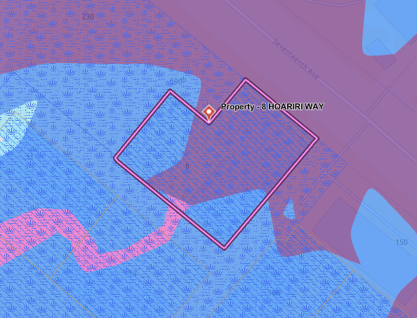
Source: (Local Government Authority Mapping Information)

Planning Overlays

Overlays: | - Consent Notice  - Stormwater Reticulation  - Flood Risk  - High liquefaction vulnerability
Overlays Comment: | Our enquiries, investigations and physical inspection identified this property to be within an area identified as having possible flooding / inundation issues.  Clarity on flooding / inundation risk issues should be confirmed by our instructing client and all reliant parties prior to reliance on this valuation report and opinion of value. Our valuation report and opinion of value herein is provided on the basis that issues associated with flooding / inundation risk do not have a detrimental effect on the marketability or market value of this property.  Should our instructing client or a reliant party’s independent report identify any issues associated with flooding / inundation risk then we reserve the right to review our valuation report and opinion of value for this property.
Heritage/Archaeological Notations  or Issues: | Outside of LIM reports, there is generally sparse information able to be found relating to cultural, heritage or archaeological overlay(s). Please note that unless otherwise stated we have not been able to source information relating to these and we encourage parties relying on this report to make their own enquiries of this nature through a LIM report or by contacting Heritage New Zealand or New Zealand Archaeological Association. Cultural, heritage or archaeological overlay(s) are a commonly noted feature in the Tauranga area in our experience.  In the vast majority of instances these overlays do not prevent the owners of the property from quiet enjoyment of the property and of future development potential however, this may involve an authority being required for development that would involve removal of these features. We confirm that we have not discounted our valuation due to the possible presence of any overlay(s) and reserve the right to reconsider our valuation should we be advised of any further information that could have an effect on value.
Protected Trees: | None identified

Land Use

Existing Use: | Conforms with the Local Government Area Planning Scheme zoning
Highest and Best Use: | Existing use considered to represent the highest and best use of this property

Planning and Land Use Comment

The property is subject to several planning overlays

Statement

LIM Report: | Unless otherwise stated, we have not been provided with a Land Information Memorandum for the subject property. Our valuation is conditional upon the buildings conforming with By-Laws and that there are no outstanding Territorial Authority/regulatory requirements over this property. Should a Land Information Memorandum show this not to be correct, we reserve the right to reconsider our valuation.
Reliance on Planning Information: | We have assumed that the publicly available information provided by the relevant Territorial Authority is correct. We are not qualified town planners, and we recommend that expert advice be sought in this respect if required.

Improvements

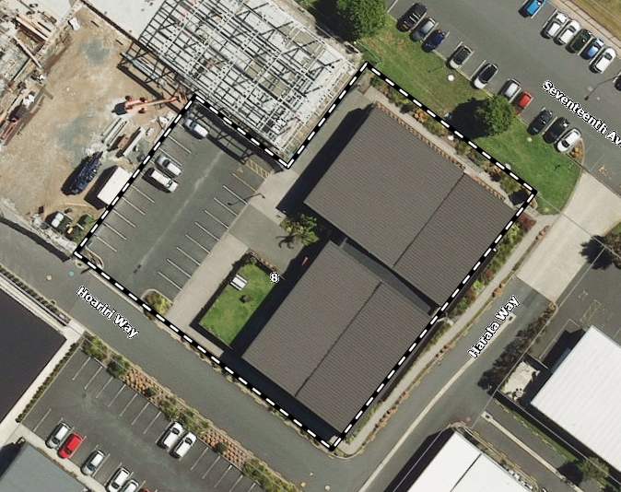
Source: (Local Government Authority Mapping Information)

Overview

Property Type: | Commercial
Space Use: | Office
Improvements Overview: | Modern, single-level commercial building providing three A-grade office tenancies

Building Areas

Building Area Verification: | Inspecting valuer
Adopted Building Area Measurement Standard: | PCNZ/PINZ Guide for the measurement of lettable areas. (Rev 2023)
Method of Building Area Measurement: | Method 1 – Office type buildings
Building | Area
Ground Floor | 1,052.0 | m²
Total Net Lettable Area | 1,052.0 | m²

Building Area Comment: | The building areas have been measured by the inspecting valuer

Building 1

Building Description: | Single level office building with a mix of open plan and partitioned meeting rooms

Building Construction

Foundations: | Raft foundation
Flooring: | Reinforced concrete
Structure: | Structural steel beams, purlins, columns, steel framing, timer internal framing with steel studs
External Walls: | Brick veneer, metal craft and fibre cement board
Access Points: | 5 (pedestrian)
Roof: | Metalcraft
Window Frames: | Aluminium powder coated
Year of Construction (circa): | 2020
Year of Most Recent Refurbishment (circa): | 2020
Year of Most Recent Extension  (circa): | 2020

Building Services

Cooling/Heating: | Mix of ducted and highwall
Emergency Lighting: | Compliant at all building exit points
Fire Services: | Fire detection  Alarm
Security: | Alarm
Current BWOF: | Yes | Expires: 04/06/2025
Building Services Comment: | We confirm that in the course of our inspection we have not attempted to test all of the systems within the property and have assumed that all hot and cold-water systems, electric systems, ventilating systems and other devices, fittings, installations, or conveniences, including lifts and escalators are in proper working order and functioning for the purposes for which they were designed.

Internal Finishes

Walls: | Painted plasterboard
Ceilings: | Plasterboard and suspended ceilings
Floor Coverings: | Carpet tiles to offices, vinyl to wet areas and polished concrete to kitchen
Light Fittings: | LED

Fitout

Lessor or Lessee Owned Fitout: | Lessor
Fitout Description: | Ceilings, lighting, HVAC, floor covering, plumbing and drainage and kitchen

Building Design, Features, State of Repair and Suitability of Use

Design: | Modern
Floor Plan: | Open plan with partitioned meeting rooms
Internal Repair and Condition: | As new
External Repair and Condition: | As new
Economic Obsolescence of Existing Improvements: | Not applicable in this instance as subject is a new building
Functional Obsolescence of Existing Improvements: | Not applicable in this instance as subject is a new building
Upgrade Requirements: | None known
Statement: | We have assumed the buildings described in our report are structurally sound and do not have any weathertightness concerns including any damage that has resulted from previous water penetration. Our inspection has been undertaken for valuation purposes only and does not constitute a structural or weathertightness survey. Verification that the buildings are sound and weathertight can be obtained from a suitably qualified building engineer or inspector. We are not qualified to provide such an opinion and do not purport to do so.

Seismic Strength

Seismic Assessment Completed: | None known
National Risk Zone: | Medium
Seismic Strength Comments: | Given the age of the building, we have assumed the seismic rating is no less than 100% NBS.
Statement: | We are not qualified to assess or comment on the seismic strength or structural integrity of the subject property. An “earthquake-prone building” is defined as one that is assessed to be less than 34% of the New Building Standard (NBS). Unless a formal seismic assessment has been provided to us by a suitably qualified structural engineer, no conclusions regarding the seismic rating of the property have been made in this valuation. We recommend that interested parties obtain independent structural advice if seismic performance is a matter of concern.

Other Main Improvements

Car Parking

Type of Car Parking: | Open
Car Parking Description: | Bitumen sealed car parking onsite
Number of Car Parking Spaces: | 23
Car Parking Condition: | Good condition

Landscaping

Type of Landscaping: | Front and side garden to streetscape
Landscaping Condition: | Adequately maintained

Photographs

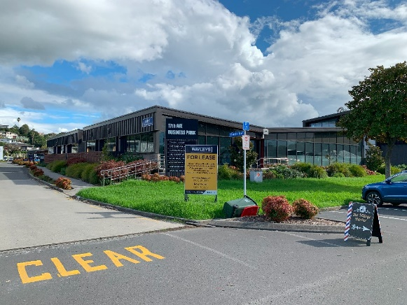 | 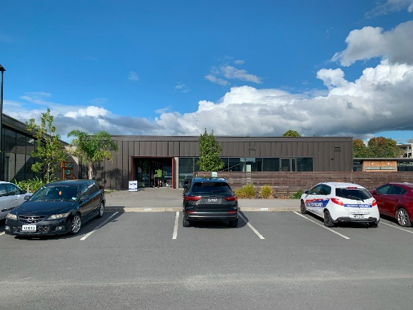 | 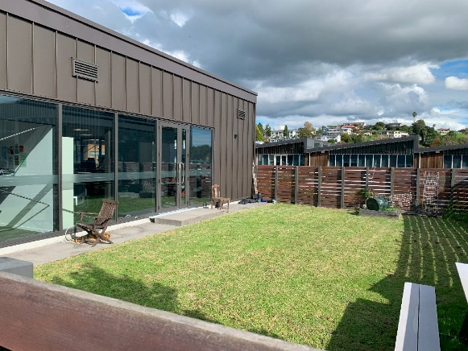 | 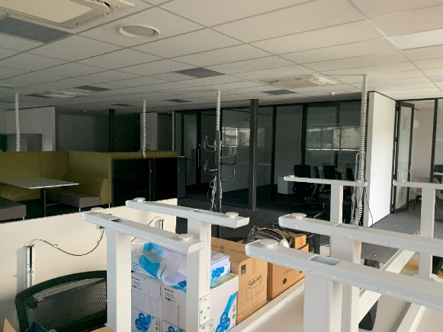
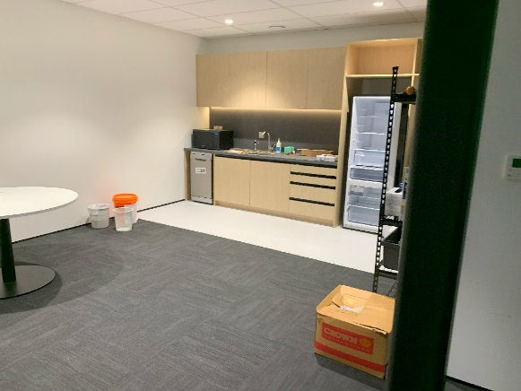 | 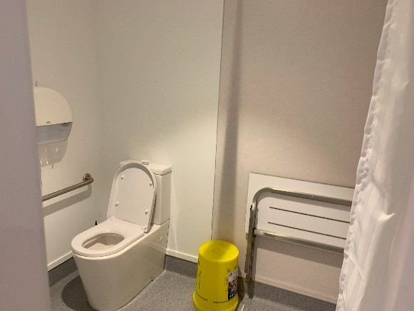 | 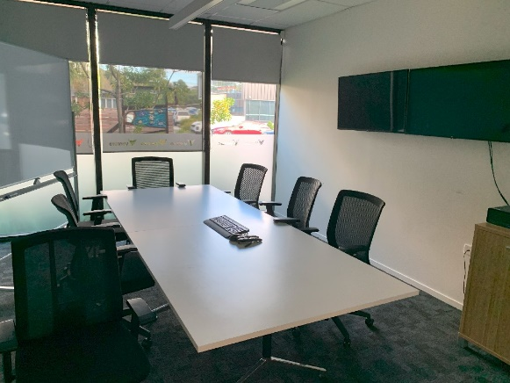 | 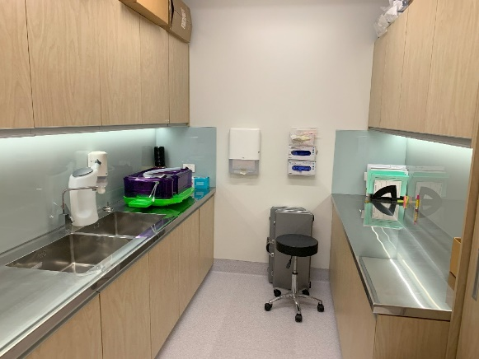
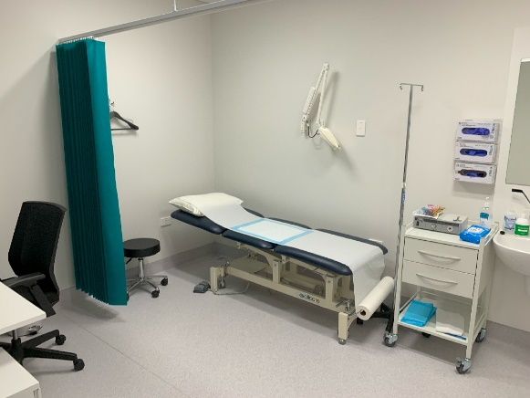 | 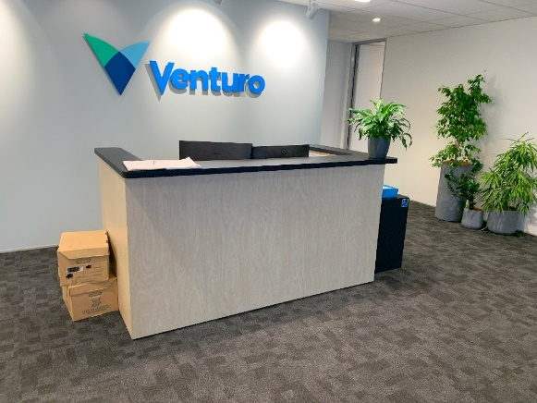 | 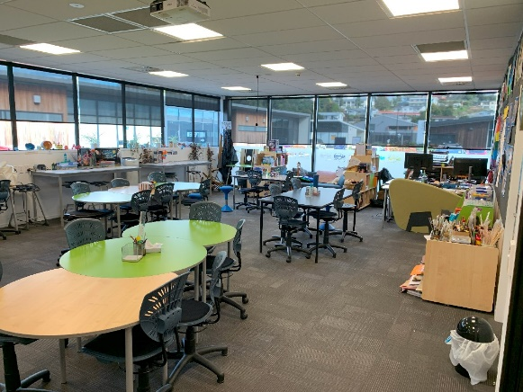 | 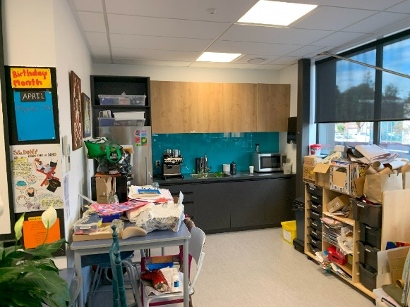

Sustainability (ESG)

Ratings and Accreditations

Comment: | We have not sourced any information relating to NABERS, Greenstar, or Carbon Neutral ratings or accreditations for the subject property. Should any detail relating to ESG ratings and accreditations be provided subsequent to the issue of this valuation report, we reserve the right to amend our assessment of value and findings contained herein if deemed appropriate.

Sustainability Factors and Attributes

Positive Environmental Factors or Attributes: | - Very low operational energy demand (no mechanical plant)  - Opportunity to install EV chargers in future  - The building appears to incorporate energy efficient components  - Timber first floor being a sustainable product
Positive Social Factors or Attributes: | - Modern building with well-ventilated areas  - High level of natural light
Positive Governance Factors or Attributes: | - The property is owned and occupied by a corporate entity governed by the New Zealand Companies Act and Health and Safety at Work Act 2015
Negative Environmental Factors or Attributes: | - Large asphalt area increases storm-water runoff
Negative Social Factors or Attributes: | - There are no known factors or attributes that would have a detrimental effect on the market value of the subject property
Negative Governance Factors or Attributes: | - There are no known factors or attributes that would have a detrimental effect on the market value of the subject property

ESG Risk Factors

Physical Climate Based Risks (Current): | - Low lying land with risk of flooding or harbour inundation in severe weather events
Physical Climate Based Risks (Transitional): | - Low lying land with risk of flooding or harbour inundation in severe weather events
Tenancy Risk (Net Zero Goals or Commitments): | - There are no known factors or attributes that would have a detrimental effect on the market value of the subject property

ESG Government or Legislative Requirements or Issues

Central Government Legislation: | - The buildings are governed by the Resource Management Act and Building Act 2004  - Both Landlord and Tenant are governed by the New Zealand Health and Safety at Work Act 2015
Local Government Regulation: | - The property is governed by the November 2024 Tauranga City Plan and any amendments

Sustainability (ESG) Comment

The subject property supports a positive ESG profile.

Environmental Details

Site Contamination

Current Use: | Commercial development
Historical Use: | Vacant
Man Made Hazard Planning Overlay: | No
HAIL Site Status: | Our visual inspection did not reveal any obvious signs of site contamination. In addition, we note as per our online enquiry with BOPRC HAIL Site Viewer, the subject site is not registered as a HAIL (Hazardous Activities and Industries List) site.
Site Contamination Comments: | We are not environmental experts, nor do we know the extent of contamination (if any). Our valuation therefore assumes that the site is free from elevated levels of contamination, and we have therefore made no allowance in our valuation for site remediation. However, if this is a concern to the user, then further investigation may be required.

Asbestos

Has asbestos been identified onsite? | No
Is asbestos known to be present? | No
Could improvements date pre-1990? | No
Asbestos Contamination Comments: | Based on our enquiries, investigations, and physical inspection, we did not identify any significant asbestos risk issues considered to negatively affect the marketability or market value of this property.

Environmental Comment

Based on our enquiries, investigations, and physical inspection, we did not identify any significant environmental hazards, site contamination, or asbestos-related issues that would adversely impact the marketability or market value of the property

Environmental Statement

You acknowledge and recognise that We are not expert in identifying environmental hazards and compliance requirements affecting properties. We have, however, endeavoured to superficially identify all matters of environmental concern and the effect they might have on the value of the property. However, We will not be held liable nor responsible for any failure to identify all such matters of environmental concern and the impact, which any environmental related issue has on the property and its value including loss arising from; Asbestos; site contamination; or the non-compliance with any environmental laws; or costs associated with the clean-up of a property in which an environmental hazard has been recognised, including action by the Ministry for the Environment, Environmental Protection Authority, the relevant Territorial Local Authority (TLA) or any other entity to recover clean-up costs pursuant to the Resource Management Act 1991, or any other applicable laws or by-laws.

Occupancy Details

Occupancy Overview

Occupancy Overview: | Multiple tenancies
Tenancy Verification: | Arm’s length
Net Rental Per Annum – Passing: | $322,799 p.a.
Other Income: | $19,862 p.a. (fitout income)
Tenancy Areas: | 1,052.0 m²
Leased Tenancies: | 3 | 100 %
Vacant/Owner-occupied Tenancies: | Nil | 0 %

Tenancy Profile

Lease Terms and Conditions: | Two of the tenancies are on standard commercial lease terms and conditions for this type of property. The Ministry of Education is on a Gross lease.
Likely Lease Term: | 6 – 8 years
Tenancy Profile Comment: | Single tenancy subject to an arm’s length commercial lease agreement with standard market-based lease terms and conditions

Vacancy Profile

Vacancy Length: | N/A
Estimated Letting-up Period: | 3 – 9 months
Likely Tenant Industry: | Corporate and small businesses
Vacancy Trends: | Vacancy rates have been traditionally low for good quality office

Tenancy Schedule

Further Occupancy Details

Tenancy 1 – Ministry of Education
Lease Document: | Deed of Lease
Rent Review Terms: | CPI+1% on 17th January 2024, 2028 and 2031 with market reviews on renewal
Ratchet Clause: | Soft

Tenancy 2 – Venturo Limited
Lease Document: | Deed of Lease (sixth edition 2012)
Rent Review Terms: | Two (2) yearly CPI+1% with market reviews on renewal
Ratchet Clause: | Soft
Bank Guarantee: | Six (6) months annual rent and outgoings plus GST
Fitout Rent: | $19,862 per annum (refer to special assumptions)

Tenancy 3 – Bay of Plenty District Health Board
Lease Document: | Agreement to Lease (ADLS Fifth Edition), Variation of Lease 2020 (unsigned)
Rent Review Terms: | Two (2) yearly CPI+1% with market reviews on renewal
Ratchet Clause: | Hard
Further Terms: | The variation grants the tenant rights to defer the commencement date of the lease for a deferral payment of $6,233.75 plus actual outgoings incurred plus GST (refer to special assumptions)

Financial summary

Weighted Average Lease Expiry (WALE)

WALE (By Area): | 2.22 years
WALE (By Rent): | 2.06 years
WALE Comment: | Short term lease security

Operating Expenditure

Operating Expense Budget Provided: | Yes
Adopted (estimated) OPEX: | $61,942.54 plus GST p.a. | $58.88/m²

Capital Expenditure

Planned Capital Expenditure: | None known
Capital Expenditure Requirements: | None known
Cost of Capital Expenditure Requirements: | Nil
Verification of Capital Expenditure Requirements: | Nil
Comment: | The subject property has modern improvements with limited CAPEX in the short to medium term

Statutory Valuations and Charges

Address: | 8 Hoariri Way
Valuation Roll Number: | 6606/11615
Land Value: | $1,410,000
Improvements Value: | $4,450,000
Capital Value: | $5,860,000
Rates: | $35,035.32 inclusive of GST
Effective Date: | 01 May 2023

Statement: | We point out that the rating valuations are assessed under statutory criteria and may not reflect the market value at any point in time.

Market Commentary

General Economic Outlook

Investment Market Comment

Recent market conditions have shown constrained liquidity, adversely impacting both yields and transaction success rates. Assets that have entered the market have attracted varying levels of interest, with prolonged sale periods driven by a persistent gap between vendor expectations and buyer pricing levels.
In response, the Reserve Bank of New Zealand has commenced a monetary easing cycle, with further reductions to the Official Cash Rate (OCR) anticipated to enhance liquidity and stimulate economic activity. While this is expected to translate into increased property market activity over time, there is, as yet, limited evidence of a tangible uplift in transaction volumes.
The risk profile has shifted from concerns around the cost of capital and debt servicing capacity to a greater focus on tenant strength and sectoral exposure. Rising operating costs and a subdued revenue outlook for businesses are exerting downward pressure on rental growth, while vacancy rates are projected to rise. In the short term, these dynamics may counteract the yield compression typically associated with a lower cost of capital.
 | Recent market activity within Tauranga's industrial sector has been subdued, reflecting softer economic conditions. Industrial rents have plateaued following significant prior growth, currently stabilising within a range of $120 - $165, with landlords now facing moderated rental increases amid rising operating costs and restrained tenant demand. Higher yields have been evident, moving prime industrial yields to between 5.0%–6.0%; with secondary industrial yields ranging from 6.0%–7.0%.
 | Tauranga’s office market remains relatively stable, supported by sustained demand for prime, well-located office space, though clear divergence persists between premium and secondary-grade assets. Yields range from 5.5%–6.5%, reflecting the higher interest rate environment of recent years. Vacancy rates for modern, A-grade spaces with quality amenities remain low, whereas older or lower-quality buildings face weaker tenant interest, prompting landlords to offer significant leasing incentives. Prime office rents have held firm around $400–$525 per sqm net, underpinned by consistent tenant demand and new developments setting higher benchmark rental levels. While larger tenants remain cautious in their leasing decisions, ongoing CBD investments and a gradually improving economic outlook indicate steady market conditions moving forward into 2025.
 | Retail market performance in Tauranga remains mixed, with suburban and large-format retail properties demonstrating resilience, while CBD locations continue to face elevated vacancy driven by subdued consumer spending and weak foot traffic. Prime retail assets in areas like Mount Maunganui and successful bulk retail centres are experiencing stable rents, contrasting sharply with secondary CBD sites, which see rental stagnation and higher vacancies. Retail yields, now stabilising around 6.0%–7.0%, reflect past economic pressures but show signs of firming as investor confidence gradually returns and interest rates ease. Although short-term retail conditions remain challenging due to cautious consumer sentiment, improvement in tenant demand for quality locations is expected.
 | Commercial building consents were up 9.5% for the April 2025 year compared with the April 2024 year and residential building consents were down 8.6% for the same period.

Market Conditions and Sales History

Market Conditions

Asset Supply: | Under supply at this price point
Asset Demand: | Steady demand at this price point
Volume of Sales: | Low levels of sales activity at this price point
Recent Market Direction: | Steady
Marketability: | Stable to improving market
Selling Period: | 3 – 6 months
Volatility: | Emerging signs at this price point
Purchaser Profile: | Most probable buyer profile for this property is an investor
Market Segment Comment: | Market uncertainty remains throughout all commercial property market segments

Sales History

Last Recorded Sale Price: | According to Property Guru records, there is no sales history recorded for the subject property

Rental Evidence and Market Rental Assessment

Rental Evidence

In assessing the Current Market Rental for the subject property, we have considered several factors when making comparisons with recent leases and reviews of similar properties. This involves comparing rental rates for physical improvements on a per square meter basis with properties in close proximity to the subject as well as surrounding locations. We make appropriate adjustments to our adopted market rental rates to account for differences in factors such as time, size and shape of the premises, ownership of fixtures and fittings, as well as lease terms and conditions. Current market conditions are also considered to ensure the final rates used reflect the unique characteristics of the subject property. While the degree of comparability of some rental evidence may vary overall, we include it in our analysis as it possesses certain attributes that provide meaningful comparability and valuable insights in relation to the subject property.

We have also taken into consideration the judgment by Cooke P in the Court of Appeal decision in MODICK RC LTD v MAHONEY (1992) 1 NZLR150.

The decision clearly indicates that new leasing agreements should be prioritized over the previously common practice of giving equal weighting to rent reviews and arbitration award levels. On page 155 of the judgment, Cooke P refers to the willing vendor - willing purchaser test, stating:

“The question is what figure would be notionally agreed upon by the parties, acting freely and adequately informed. Figures fixed by arbitration or rent reviews between captive parties are not necessarily a reliable guide, since they do not represent the unfettered play of market forces, but rather the arbitrator’s assessment “assuming that he has applied himself to the task correctly” of what market forces should produce. It is only a freely negotiated rent on a new letting that can confidently be taken to be truly comparable provided of course that there are also sufficient similarities in site and otherwise”.

Therefore, the highest importance should be given to new direct leasing transactions, where possible, when assessing the current market rental.

Rental evidence considered of relevance is summarised overleaf:

Rental Summary

In concluding rental parameters, we have particularly taken note of the following:

- Location being a secondary office location, albeit evolving
- Size and quality of the accommodation
- Fitout ownership
- Current lease terms and conditions
- Current market conditions
- Supply and demand at this size quantum

The leasing evidence reported herein provides the most recent and relevant available evidence from within Tauranga which we are aware of at the time of undertaking our assessment. There have been limited examples of new office leases of a similar size in recent times. We have been mindful of the supply and demand for properties of this quality in secondary locations.

- We have summarised the evidence noted above as rental value ranges in the table below. The lower end of the range typically reflects older accommodation in less desirable locations or large floorplates. Whereas the upper end of the range typically pertains to more recent transactions of modern accommodation with quality fitout offerings and sought after locations.

- The most recent lease transaction is a confidential new lease for a similar quality office building in the immediate vicinity. The lease was struck on a gross basis and we have estimated a net rental rate of $325/m² after and allowance for outgoings and $20 per week for car parks. This is a strong comparable for the location with adjustment for size and quality.
- A rent review was agreed at 116 Cameron Road for a ground floor office with basement carparks. A superior building with dated fitout situated in a superior location. The net rental rate achieved was $340/m².
- A confidential new lease was agreed in the CBD reflecting a net effective rental rate of $358/m² after an adjustment for a rent free period. This property provides an inferior building with comparable high quality office fitout, inclusive of partitioning. It is in superior location and a similar size to the smaller tenancies 2 and 3.
- 525 Cameron Road signed a new lease at $305/m². This is an older but superior building with basement carparking situated in a secondary location. The tenancy is a similar size to the smaller tenancies 2 and 3

Car park rates from within the Seventeenth Avenue Business Park suggests a rate range of $15.0 - $25.0 per car park per week. Several of these are recently agreed new leases providing the best evidence for market rates of car parks in this area.

Car park rates within proximity to the subject, like the majority of Tauranga, see a high demand for car parking albeit inferior to the subject given the high demand for car parks in the subject area due to the ongoing development of the Seventeenth Avenue Business Park, as well as the proximity to the Tauranga Hospital. This demand can be somewhat offset due to the number of parks available in comparison to the car park rates in surrounding areas that offer fewer car parks as part of their lease.

Office:
With consideration to the various attributes of the subject office and the rental evidence outlined earlier, we consider an appropriate rental rate to range between $320/m² - $330/m².

Carparks:
In summarising, given the number of car parks in the subject property and given the commercial nature of the leases for a large amount of car parks, we are of the opinion an appropriate rental rate for the subject car parks to be at or around $20.0 per car park per week.

Market Rental Assessment

After due consideration of the attributes of the subject property and market evidence as detailed, we assess market rental as follows;

We have assessed the market rental to be $378,231 per annum plus GST and operating expenses. This reflects an increase over the contract rent of $25,821 per annum or 7.33%.

Sales Evidence

Investment Sales Evidence

In order to assess the market value of the subject property, we have considered a range of investment sales within the wider Tauranga area. We have summarised the sales of the most relevance below:

Sales Evidence: | Where sales data has been obtained from a government sourced or commercially available database (such as Valbiz/Property Guru/REINZ) we have considered it to be the most current sales data available. However, sales which have occurred during the last three months of sales, which have been the subject of deferred settlement terms, may not necessarily appear immediately in available records. Accordingly, with this type of transaction, we only rely on separate enquiries to attempt to obtain all available sales data.  It is noted that we have relied on sales data information services as being a true and correct reflection of the terms of any sale considered at arm’s length. We have not sighted copies of transfer notices, nor have we sighted copies of contract documents between the vendor and purchaser which may reveal matters that affect the sale price and necessitate adjustment to apply to the subject property. If contract documents reveal matters that necessitate adjustment of the sales evidence, we reserve the right to reconsider our valuation herein.
GST Approach: | When analysing the sales and/or leasing evidence relied upon for this valuation, we have attempted to ascertain whether or not the sale price/rental is inclusive or exclusive of Goods and Services Tax (GST). The sales and/or leasing evidence does not generally identify whether or not the sale price/rental is inclusive or exclusive of GST. Where we have not been able to verify the matter of GST, we have assumed that the sale price is inclusive of GST (if any) for residential properties and plus GST (if any) for non-residential properties. Should this not be the case for any sale and/rental evidence relied upon, we reserve the right to reconsider our valuation.

Investment Sales Table

Sales Evidence Conclusions

In concluding valuation parameters, we have particularly taken note of the following:
- Size and quality of the improvements
- Modern improvements with little maintenance requirements
- WALE of 2.22 years secured
- Commercial zoning
- Strong demand for medical related offices
- Strong lease covenant
- Multi tenanted
- Close to key arterial routes and Tauranga Hospital which is forecasted to expand long-term underpinned by significant population growth in the Tauranga region.
- CPI+1% reviews
- Amortizing fitout rent

Market conditions continue to reflect constrained liquidity, which has negatively affected both yield performance and the rate of successful transactions. Assets brought to market are experiencing varied levels of interest, with extended sale timeframes largely due to a persistent mismatch between vendor price expectations and buyer valuations.

In response to the broader economic slowdown, the Reserve Bank of New Zealand has initiated a monetary easing cycle, with further cuts to the Official Cash Rate (OCR) anticipated. These measures are expected to support liquidity and encourage renewed investment activity. Early signs of this are emerging, with increasing investor interest in high-quality assets underpinned by strong lease covenants. The trend towards quality remains evident, as lower-risk, income-secure properties continue to outperform, while assets perceived as higher-risk are facing reduced demand and slower turnover.

The market's risk assessment has evolved. While earlier concerns focused on the rising cost of capital and debt-servicing ability, attention has now shifted toward tenant covenant strength and sector-specific exposures. Elevated operating expenses and a muted business revenue outlook are placing downward pressure on rental growth, contributing to a forecast rise in vacancy levels. In the near term, these headwinds may offset the yield compression typically associated with a declining interest rate environment.

- The above sale evidence typically reflects older commercial buildings and inferior lease covenant, albeit some are located in superior locations.
- There has been a shortage of sales for good quality investment stock at this price point. Those that have sold are reflecting a yield range of 5.50% - 6.25%.
- 166 Seventeenth Avenue is the most recent property to sell in the Seventeenth Avenue Business park. It is of a similar value quantum but sold in a stronger market to a sitting tenant. We have seen yields soften since the date of this transaction.
In summary, the above sales reflect an initial yield range of 4.66% - 7.63%, and a market yield range of 4.82% - 8.43% with an IRR range of 5.59% - 9.53%, with exceptions. The upper end of these ranges reflects less desirable investment property, whereas the lower end of these ranges reflects sought after property underpinned by strong lease covenant, future rental growth expectations and/or lower value quantum.

We are of the opinion that the subject property qualifies as a high-quality investment asset underpinned by strong lease covenant, well-positioned to attract strong interest from both high-net-worth investors and property syndication groups.

Adopted Valuation Parameters

In conclusion, with consideration towards the overall view of the asset, we have adopted the following valuation parameters; -
Market Capitalisation Rate: | 6.25%
Discount Rate: | 7.75%
Terminal Yield: | 6.50%

Valuation Considerations

Introduction

The International Valuation Standards outline that the Valuer must give consideration to the relevant appropriate valuation approaches. One or more valuation approaches may be used in order to arrive at the value in accordance with the basis of value. Each of these valuation approaches include different, detailed methods of application.
The principal valuation approaches are:
- The Income Approach: The income approach provides an indication of value by converting future cash flow to a single current value. Under the income approach, the value of an asset is determined by reference to the value of income, cash flow or cost savings generated by the asset.
- The Market Approach: The market approach provides an indication of value by comparing the asset with identical or comparable (that is similar) assets for which price information is available.
- The Cost Approach: The cost approach provides an indication of value using the economic principle that a buyer will pay no more for an asset than the cost to obtain an asset of equal utility, whether by purchase or by construction, unless undue time, inconvenience, risk, or other factors are involved. The approach provides an indication of value by calculating the current replacement or reproduction cost of an asset and making deductions for physical deterioration and all other relevant forms of obsolescence.

Valuation Approach

In considering the Market Value of the subject property we have adopted the following valuation approach(es):
- The Income Approach
- The Market Approach

Valuation Methodology

To consider our valuation of the subject property we have utilised the following valuation method(s):
- Income Capitalisation Approach
- Discounted Cashflow
Each method is considered overleaf.

Income Capitalisation Method

INCOME CAPITALISATION METHOD
We have considered value on an Income Capitalisation method whereby the net income receivable (current, market or notional) from the property has been capitalised into perpetuity from the valuation date, at an appropriate market related capitalisation rate. The adopted capitalisation rate reflects the nature, location, and financial profile of the property together with current market criteria, as evidenced by the sales previously detailed.
Overall, we consider the appropriate capitalisation rate for the subject property to lie in the range of 6.00% - 6.50%, accordingly we have adopted a midpoint of 6.25%.
CAPITAL ADJUSTMENTS
In addition to the above parameters, the following capital adjustments have been applied to the core value for the following items:
- Present value of rental reversions (underage/overage rent)
- Present value of fitout rent remaining
Our income capitalisation calculations are as follows:

The above valuation is plus GST (if any).

Discounted Cashflow Method

The discounted cashflow analysis allows an investor or owner to make an assessment of the long-term return that is likely to be derived from a property with a combination of both rental and capital growth over an assumed investment horizon. In undertaking this analysis, a wide range of assumptions are made including a target or pre-selected internal rate of return, rental growth, sale price of the property at the end of the investment horizon, costs associated with the initial purchase of the property and also its disposal at the end of the investment period.
Having regard to these factors, we have carried out a discounted cashflow analysis over a ten-year investment horizon in which we have assumed that the property is sold at the commencement of the eleventh year of the cashflow.
Our discounted cashflow analysis is undertaken using the following assumptions:
Expense Growth
- Annual expenses have been projected with inflation adjustments based on Consumer Price Index (CPI) forecasts over the investment period. A long-term average inflation rate within the Reserve Bank of New Zealand’s target band of 1.0% to 3.0% has been adopted for this purpose.
Rental Growth
- Annual market rental growth projections are derived from research and analysis undertaken by PRP, incorporating current market sentiment. A rental growth rate of 2.50% per annum has been adopted for the subject property.
Capital Expenditure
- To preserve the appeal, integrity, and long-term value of the subject asset, a capital expenditure (CAPEX) allowance has been included. A minimum annual CAPEX provision equivalent to 1.0% of gross income has been applied.
Future Vacancy(ies)
- An allowance has been made for future vacancy costs upon lease expiries, including loss of income, outgoing expenses, and associated re-letting costs such as agent fees. Assumptions regarding vacancy periods and lease terms have been adopted in line with prevailing market benchmarks.
Make Good
- A make good allowance of $50.0 per m² (in today’s dollars) over the floor area.
General Refurbishment
- General refurbishment allowance of $25.0 per m² (in today’s dollars) over the total floor area of the building in the terminal year.
Terminal Yield
- The terminal yield represents the expected capitalisation rate at the end of the investment holding period and is used to estimate the resale value of the property. It reflects the market's expectations for future income risk, asset condition, and broader economic conditions at the time of sale. Our adopted terminal yield of 6.50% has been determined with reference to current market evidence, asset-specific characteristics, and anticipated shifts in market sentiment and risk over the holding period of the asset. It is a subjective forecast of the most likely sale conditions at the time.
Discount Rate
- The discount rate reflects the required rate of return for an investor, incorporating both the risk profile of the asset and broader market conditions. It is used to convert future income streams into present value within a discounted cash flow (DCF) analysis. Our adopted discount rate of 7.75% has been derived from our analysis of comparable sales evidence, with specific consideration given to the asset’s location, lease profile, tenant covenant strength, and physical condition.
Our discounted cashflow analysis is as follows overleaf.

Valuation Reconciliation

Adopted Value

The above valuation figures are exclusive of Goods and Services Tax (if any).

Adopted Value Analysis

Initial Yield (Passing Income): | 5.29% | 10 Year IRR: | 7.87%
Initial Yield (Fully Leased): | 5.29% | 5 Year IRR: | 7.71%
Equivalent Initial Yield: | 5.39% | 10 Year Cash on Cash: | 6.28%
Equivalent Market Yield: | 6.15%
Market Yield: | 6.20%

Valuation Summary

Valuation Conclusion

Preston Rowe Paterson Tauranga Limited confirms that we undertook an inspection of the property at 8 Hoariri Way, Tauranga South, Tauranga for Market Value for Mortgage Lending as of 02 May 2025. Having regard to the above approach(es) and the available market evidence, we conclude the Market Value ‘As Is’ - subject to existing lease of the property to be:

$6,100,000
(Six Million, One Hundred Thousand Dollars)

The above valuation is subject to:
- The assumption that the valuation figures herein are exclusive of Goods and Services Tax (if any); and
- The comments, assumptions and qualifications contained herein; and
- The terms and conditions contained and linked to herein. Our full Terms and Conditions can be found at: https://prpnz.nz/terms-conditions/registered-banks/.

Mortgage Recommendation

The Australia and New Zealand Valuation and Property Standards require that, unless specifically requested by a lender, the valuation report should make no specific numerical mortgage recommendation or suggest the maximum loan amount expressed as a percentage of value. We consider that the subject property is suitable for first mortgage lending subject to the risks identified in our report. This report can be relied upon for first mortgage lending by the client and their specific mortgage insurers (if applicable) as well as any other reliant parties identified in our report.

Valuer Signatories

Signed on behalf of Preston Rowe Paterson Tauranga Limited
Matthew Fenton  Registered Valuer, Director  Inspecting Valuer | Cameron Speirs-Hutton  Assistant Valuer
The opinion of value expressed herein is confirmed by the Registered Valuer indicated above who undertook the inspection. Where an Assistant Valuer has been identified, the report has been jointly prepared by an Assistant Valuer, under the supervision of the Registered Valuer who is solely responsible for the report. Where a Peer Review valuation has been completed for internal quality control purposes, the Peer Reviewer has also been identified above.

Glossary
Capitalisation Rate | The Capitalisation Rate (Cap Rate) is the ratio of a property’s net operating income, excluding adjustments for vacancy, rental reversion, and capital expenditures, to its market value. It is used to assess the expected rate of return on an investment in the property or to determine its value
Building Warrant of Fitness (BWOF) | A Building Warrant of Fitness (BWOF) is an annual certificate demonstrating that a building's specified systems, outlined in the building's compliance schedule, have been inspected, maintained, and are operating as intended
Discount Rate | The rate of return used to convert future cash flows into a present value, reflecting the time value of money and the risks associated with those cash flows
Equivalent Yield | A market yield which reflects additional adjustments for the present value of rental reversions, capital adjustments and letting up assumptions after the capitalisation of income
Fair Value | The price that would be received to sell an asset or paid to transfer a liability in an orderly transaction between market participants at the measurement date
Highest And Best Use | The use of an asset that maximizes its value and is physically possible, legally permissible and financially feasible
Initial Yield | The annualised net income at a specific date, expressed as a percentage of the asset’s market value
Internal Rate Of Return (IRR) | The discount rate that makes the net present value of all future cash flows from an investment equal the acquisition cost of the investment
Market Rent | The estimated amount for which an interest in real property should be leased on the valuation date between a willing lessor and a willing lessee on appropriate lease terms in an arm’s-length transaction, after proper marketing and where the parties had each acted knowledgeably, prudently and without compulsion
Market Value | The estimated amount for which an asset or liability should exchange on the valuation date between a willing buyer and a willing seller in an arm’s-length transaction, after proper marketing and where the parties had each acted knowledgeably, prudently and without compulsion
Market Yield (Reversionary Yield) | The assessed, annualised net market income at the date of valuation, expressed as a percentage of the asset’s market value
Net Passing Income | The total income from a property that is currently being received under existing leases, after accounting for direct operating costs such as property management fees, maintenance, and other recurring expenses, but before considering any vacant space or potential rent increases at lease renewal
Terminal Yield | Terminal Yield is the capitalisation rate applied to the projected income of a property at the end of the investment period, used to estimate its exit value. It reflects the expected return at the time of sale or reversion. We note, estimating an appropriate terminal yield for future market conditions is subjective.
Weighted Average Lease Expiry (WALE) | The weighted average time remaining on all leases within a property, weighted by either the rental income or lettable area

Appendices

APPENDIX A – RECORD OF TITLE

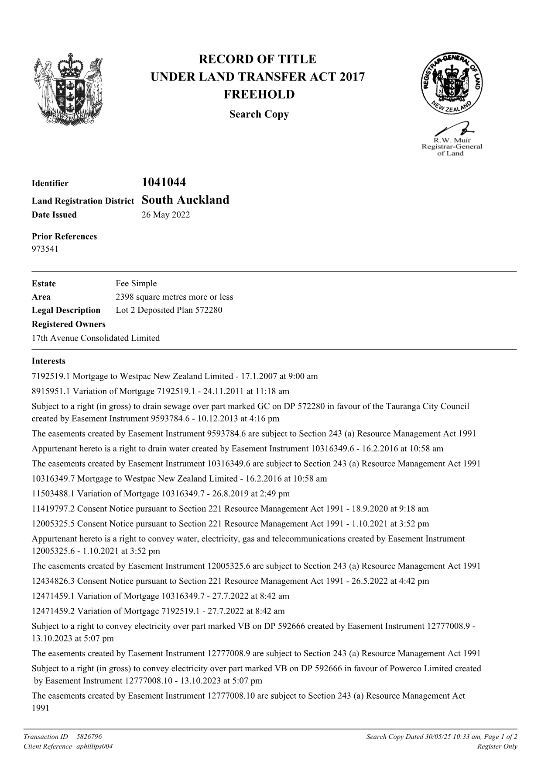 | 