Reclamation Review of Stochastic Streamflow Simulation at Interannual and Interdecadal Time Scales and Implications to Water Resources Management

I. Interannual Scale

Research Questions
This component of the project is concerned with how to generate streamflow scenarios at seasonal to interannual time scales across the Basin that are consistent with large-scale climate features (ENSO, PDO, etc.). We propose to further explore the possibility of maximizing operational efficiency by combining improved forecasts with a range of adaptive management strategies in both the Upper Basin and Lower Basin. At the seasonal timescale, greater efficiency is sought via exploration of flexibility of operations within the interim guidelines.

The work involved has two components, (1) provide skillful long lead ensemble streamflow forecast throughout the Basin, and (2) using these forecasts to drive a to-be-developed midterm operational model (Probabilistic Midterm Model). With this we hope to investigate what potential policy alternatives or adjustments can be made to improve the system efficiency with an improved seasonal forecast capability?

Previous Work
The forecasting component of the project will leverage off of work done by Cameron Bracken in the summer of 2007 during a Research Experience for Undergraduates program under Balaji Rajagopalan. This work was effectively a proof-of-concept seasonal forecasting framework. The framework incorporated the following:
- A set of large-scale climate predictors was identified for aggregated streamflow in the Upper Colorado River Basin.
- Aggregate spring seasonal ensemble streamflow forecasts are developed using nonparametric multi-model regression techniques (Regonda et al., 2006).
- The ensembles are disaggregated spatially to all the Basin locations and temporally to the four months (April through July) in the season, using a nonparametric space-time disaggregation technique (Prairie et al., 2007).
- The forecasts are validated at several lead times starting from early fall.

Findings and Publications
Bracken et al. 2009 (In review) outlines the proof of concept seasonal forecasting framework that can generate skillful forecasts at long lead times. The work is in review for publication in Water Resources Research. The paper compares the generated forecasts with both the Colorado Basin River Forecast Center’s (CBRFC) Ensemble Streamflow Prediction (ESP) and the National Resource Conservation Service’s, ‘coordinated’ forecast, which is a combination of the ESP, Statistical Water Supply (SWS), a principal component regression technique, and modeler knowledge. Figure 1 shows an example of one such comparison. Most importantly these comparisons show that the forecasts generated with this framework are comparable if not better than existing models.
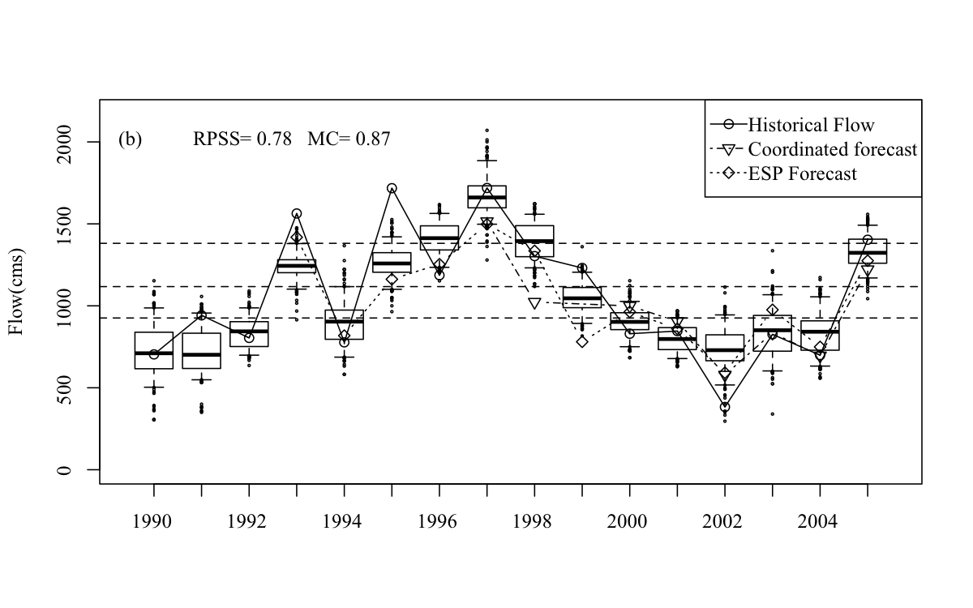
Figure 1: Example of ensemble seasonal forecast at Lees Ferry after spatial disaggregation.

Next Steps
The main work on the forecasting component involves expanding the seasonal forecasting framework to produce “second-year” forecasts to drive the Probabilistic Midterm Model. Currently the Colorado Basin River Forecast Center provides seasonal forecasts for the first year of the 24-Month Study. The second year of the 24-Month Study uses climatology to drive the model. The “second-year” forecasts will use a new disaggregation method (Nowak et al. 2009) and knowledge of past-observed flows (including paleo reconstructed flows) to intelligently predict second year behavior, providing better operational guidelines to water managers.

The modeling component involved development of a new midterm operational forecast model, the Probabilistic Midterm Model. The model will feature an enhanced ruleset to reflect Upper Basin operating rules. Any development of the 24-Month Study model will be done in coordination with the Reclamation Colorado River Technical Modeling Team.

References
Bracken, C., B. Rajagopalan, J. Prairie (2009), A multi-site seasonal ensemble streamflow forecasting technique, Water Resources Research, In Review.

Nowak, K., J. Prairie, B. Rajagopalan, U. Lall (2009), A non-parametric stochastic approach for multisite disaggregation of annual to daily streamflow, Water Resources Research, In Review.

Prairie, J., B. Rajagopalan, U. Lall, and T. Fulp (2007), A stochastic nonparametric technique for space-time disaggregation of streamflows, Water Resources Research, 43, 10 pp.

Regonda, S. K., B. Rajagopalan, M. Clark, and E. Zagona (2006), A multimodel ensemble forecast framework: Application to spring seasonal flows in the Gunnison River Basin, Water Resources Research, 42, 14 pp.

(1) brief summary of the research questions you are indenting to answer.
(2) what has been done to-date to answer these questions
(3) findings that have been made listing any relevant publications or presentations that came out of the research
(4) and a brief outline of the next steps.

