**Multisite monthly ensemble forecast: Application to twenty sites in the Upper Colorado River Basin**

Cameron Bracken, Balaji Rajagopalan, Edith Zagona

**Abstract**

The generation of forecasts at a large number of sites is crucial for operations of the Upper Colorado River Basin. We show that the framework of *Bracken et al.* (2010) can be extended to generate monthly peak season (April-July) forecasts at twenty sites in the Upper Colorado River Basin at long lead times. We also improve the framework to incorporate the flexible disaggregation method of *Nowak et al.* (2010) into the framework to perform spatial and temporal disaggregation. With few exceptions, skills are positive for all sites, months and lead times. The November 1 forecasts show an average 11% increase in skill over climatology for all the sites considered.

**1 Introduction**

In the last ten years water supply management in the Upper Colorado River Basin (UCRB) has come under increasing scrutiny and regulation. Drought (*Fulp*, 2005), climate change (*Rajagopalan et al.*, 2009), environmental flows and increasing demands (*US Department of the Interior*, 2008) have all put the reliability of the system into question. In 2007 the “Interim Guidelines” were passed as a response to some of these factors (*US Department of the Interior*, 2007). These guidelines lay a framework for coordinated operations of Lake Powell and Lake Mead, which depend heavily on water supply forecasts. These factors all underscore the need for skilful forecasts at long lead times at many locations throughout the UCRB.

The generation of forecasts at a large number of sites is crucial for operations of the Upper Col­orado River Basin. The “24-Month Study” is the Bureau of Reclmation’s primary water supply forecast model in the Upper (and since January 2010) and Lower Colorado River Basin. This model is run monthly and requires inflow forecasts at 12 locations throughout the Upper Basin. Op­erators use these inflow forecasts to generate reservoir outflows that are then run through the “24-Month Study” model to obtain a picture of water resources for the next 24 to 36 months. Be­yond initial reservoir states, the predictive capability of the model largely on the skill of the inflow forecasts.

The nonparametric multisite ensemble forecast framework developed by *Bracken et al.* (2010) was able to show skill at long lead times in forecasts generated for four key sites in the Upper Colorado River Basin (Colorado River near Cisco, Utah, Green River at Green River, Utah, San Juan River near Bluff, Utah, and Colorado River at Lees Ferry, Arizona). The framework of *Bracken et al.* (2010) is similar to many recent studies (*Moradkhani*, 2010; *Opitz-Stapleton et al.*, 2007; *Regonda et al.*, 2006; *Grantz et al.*, 2005). This framework generated forecasts of an ``index’’ gauge that is composed of the flow at all the sites in the network. The form of the forecast model is

(1)



where is the index gauge seasonal flow, is a matrix of predictors and is the residual assumed to be normally distributed. This framework includes (1) identifying large scale climate predictors for index gauge flow, (2) calibrating the model by selecting the best sets of predictors of seasonal flow volume for each lead time and estimating , (3) generating ensemble forecasts of index gauge seasonal flow and (4) disaggregating these forecasts in space and time to four sites in the UCRB. While promising, these results leave open the question of this skill translating to a larger number of sites on the same river network.



**2 Study Area**

The Upper Colorado River Basin has drains 279,300 square kilometers. The terrain varies over 4000 m from east to west. Lees Ferry is located at the outlet of the Upper Basin. The sites used in this study are all the natural flow nodes in the upper basin. Figure 1 (b) shows the UCRB with natural flow node location. Figure 1 (a) shows the network relationship of the nodes. This network structure is exploited in the conversion from total flow to intervening flow.

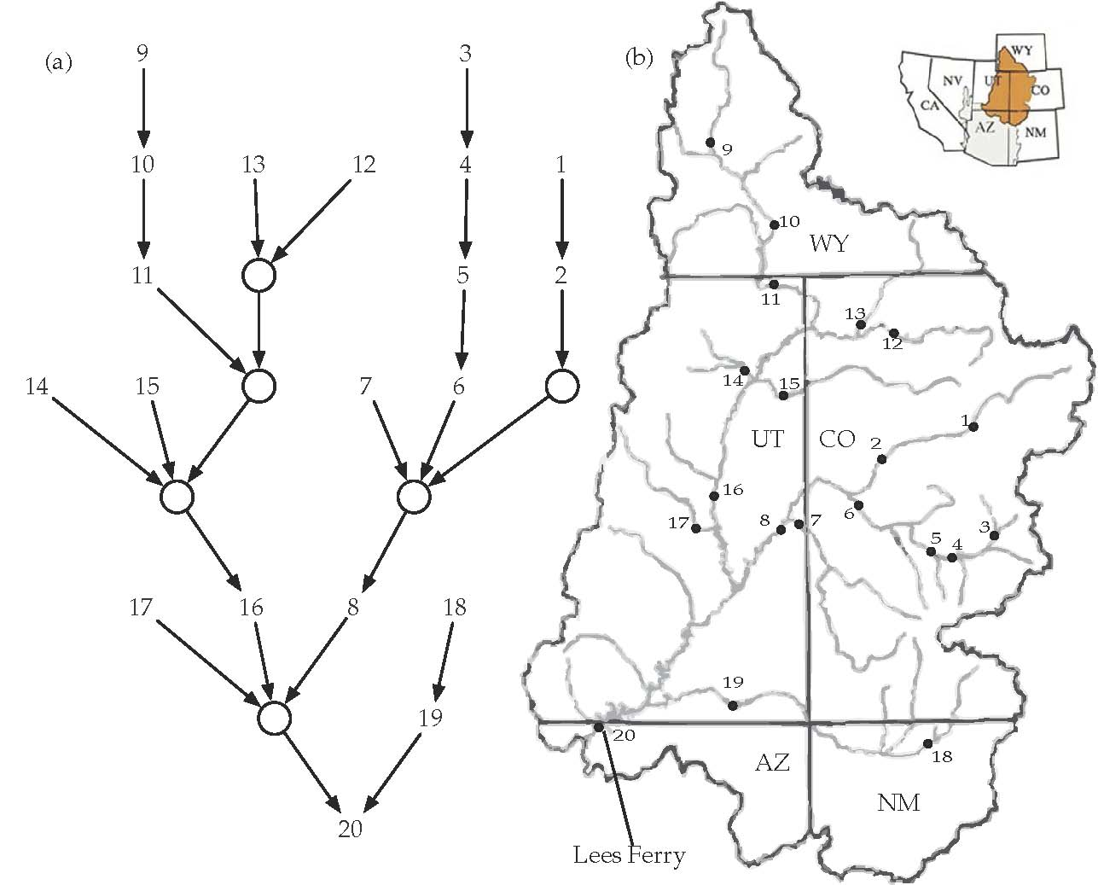

Figure 1: Map of Upper Colorado River Basin with site numbers

**3 Data**

The data inputs are the same as (*Bracken et al.*, 2010) though we obtained the most recent observa­tions for all of the predictors (through 2010 where available). We use zonal and meridonal wind, SST and geopotential height from the NOAA Earth Science Research Laboratory as predictors of large scale climate. Regions of high correlation with Index gauge flow are determined using the [ESRL linear correlation tool (http://www.esrl.noaa.gov/psd/data/correlation/). The vari­](http://www.esrl.noaa.gov/psd/data/correlation/)ables are averaged over these regions and the resulting timeseries is used as a predictor. This analysis is repeated for each lead time to obtain a suite of predictors. Soil moisture data was ob­[tained by climate division and averaged over a region covering the UCRB (http://www.esrl. noaa.gov/psd/data/timeseries/). Snow water equivalent (SWE) data was obtained from Nat­](http://www.esrl.noaa.gov/psd/data/timeseries/))[ural Resources Conservation Service (NRCS) (http://www.wcc.nrcs.usda.gov/snow). The most](http://www.wcc.nrcs.usda.gov/snow) recent data was obtained for the ten sites used in (*Bracken et al.*, 2010).

We obtained the most recent natural flow data developed by the Bureau of Reclamation in the UCRB that cur­rently extends to 2007. The data is available from http://www.usbr.gov/lc/region/g4000/ NaturalFlow/index.html. The data is provided as both intervening (gains since the last upstream gauge) or as total flow (sum of all upstream intervening flow at a gauge). We use the intervening data but convert to total flow internally for reasons described in the methodology section.

Table 1: Site Information. Key sites are listed in bold.

|  |  |  |
| --- | --- | --- |
| Node | USGS Gauge | Site Name |
| 1 | 09072500 | Colorado River At Glenwood Springs, CO |
| 2 | 09095500 | Colorado River Near Cameo, CO |
| 3 | 09109000 | Taylor River Below Taylor Park Reservoir, CO |
| 4 | 09124700 | Gunnison River Above Blue Mesa Reservoir, CO |
| 5 | 09127800 | Gunnison River At Crystal Reservoir, CO |
| 6 | 09152500 | Gunnison River Near Grand Junction, CO |
| 7 | 09180000 | Dolores River Near Cisco, UT |
| **8** | **09180500** | **Colorado River Near Cisco, UT** |
| 9 | 09211200 | Green R Bel Fontenelle Res, WY |
| 10 | 09217000 | Green R. Nr Green River, WY |
| 11 | 09234500 | Green River Near Greendale, UT |
| 12 | 09251000 | Yampa River Near Maybell, CO |
| 13 | 09260000 | Little Snake River Near Lily, CO |
| 14 | 09302000 | Duchesne River Near Randlett, UT |
| 15 | 09306500 | White River Near Watson, UT |
| **16** | **09315000** | **Green River At Green River, UT** |
| 17 | 09328500 | San Rafael River Near Green River, UT |
| 18 | 09355500 | San Juan River Near Archuleta, NM |
| **19** | **09379500** | **San Juan River Near Bluff, UT** |
| **20** | **09380000** | **Colorado R At Lees Ferry, AZ** |

**4 Methodology**

We use the same framework as *Bracken et al.* (2010) with some notable changes. Most importantly we (1) expand the disaggregation to include all 20 natural flow nodes in the UCRB, (2) We include the disaggregation method of *Nowak et al.* (2010) instead of the disaggregation method of *Prairie et al.* (2007), (3) we make forecasts in total flow space but then convert to intervening for the final result.

This disaggregation method of *Nowak et al.* (2010) is known as ‘proportion disaggregation‘ is a flexible nonparametric that preserves the sumability criteria of the network (upstream gauges sum to downstream gauges). The method is able to simultaneously conduct space and time disaggregation through the use of proportion matricies (matricies whose contents sum to unity). Figure 2 shows schematically how the index gauge is split simultaneously to in space and time to all twenty sites. In space-time disaggregation there is one proportion matrix for each year in the historical record. For a given seasonal flow value to be disaggregated, the method identifies K nearest neighbors of the flow value and multiplies the proportion matrix by the flow value to disaggregate. The process is then repeated to generate ensembles for each value to be disaggregated. For more details, the interested reader is referred to *Nowak et al.* (2010).

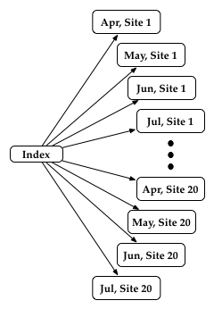

Figure : Schematic of disaggregation process using proportion disaggregation

Concerning the third change, *Nowak et al.* (2010) suggest performing disaggregation of total flow as opposed to intervening flow. This eliminates incorrect weighting of negative intervening values (losing reaches). Streamflow forecasts as intervening flow are also more useful as input to other models (such as planning models) so we perform disaggregation on the total flow then transform back for the final results. The transformation is done by exploiting the network structure of the 20 sites. Total flow is computed by summing all the upstream intervening flow at a given site. Intervening flow is computed by subtracting the total flow at the next upstream gauge from a given site.

We now describe the framework in its entirety, for details of specific components

1. Create a total flow index gauge by summing all the total seasonal flow at each site to create an index gauge (*Bracken et al., 2010*).
2. Identify large scale climate predictors of index gauge total flow (*Grantz et al., 2005*).
3. Identify a set of the best locally weighted polynomial models (*Loader,* 1999) for for each lead time. The best models are defined as those that minimize the gen­eralized cross validation value (GCV) (*Craven and Wahba*, 1979) and do not exhibit multicolinearity (*Regonda et al.*, 2006).



1. Generate ensemble forecasts (*Hagedorn et al.*, 2005; *Krishnamurti et al.*, 2000; *Rajagopalan et al.*, 2002; *Regonda et al.,* 2006) of index gauge flow by weighting the best models according to their GCV value (lower GCV gets higher weight). Predictions are made by randomly selecting a model based on the given weights, predicting from the model, resampling the model standard error and repeating the process.



1. Disaggregate the total seasonal flow at Less Ferry to total monthly flow at each site using the method of *Nowak et al.* (2010).
2. Convert the total flow at each site to intervening flow to obtain a final forecast.

**5 Validation**

We validate the results using the same methods as *Bracken et al.* (2010). Leave-one-out cross validation, “retroactive” validation was carried out. Leave-one-out cross validation removes the current year form the model, and then predicts that year using the remaining data. Retroactive verification only uses the data available prior to the forecast year, as would be the case in real operations. This way it is possible to compare directly to operational forecasts of the Colorado Basin River Forecast Center. The ranked probability skill score (RPSS) (*Wilks*, 1995) was computed for each year in the history and then the median value is presented. The median correlation, the correlation between the historical data and the median of the ensembles for each year, was also computed for each site/month combination.

**6 Results**

When this analysis was repeated with the most recent flow data, some of the correlation regions were slightly but not notably different than those using the four site index gauge from *Bracken et al.* (2010) so we will not reproduce them here. Interestingly enough, the results with the slight modifications described in the methodology are somewhat different than those from *Bracken et al.* (2010). For instance the RPSS values for the index gauge in this study are slightly lower except for the earliest lead times where they are slightly higher (Table 2). One reason for this may be that we saw slightly different models being selected during predictor identification.

Table 3 gives the results in terms of the RPSS after spatial and temporal disaggregation. The retroactive results show similar trends with slightly lower skills. In general we see the skills decreasing as lead time increases. Some sites such as the Duchesne River Near Randlett, UT (14) have consistently positive skill back to the Nov 1 lead time. June had the highest overall skill of any month, likely because the average peak flow occurs in June. The sites included in the original study (8, 16, 19 and 20, outlined in bold) all tend to do very well. These “key” gauges represent the major contibutions to Lees Ferry flow. This makes intuitive sense because these are the largest tributaries and will have a stronger response to large-scale climate. Another trend we see is that the skills tend to be better as we move toward the outlet of the basin. That is consistent with the result that the larger tributaries perform better. Magnitudes of the disaggregated skills tend to be less that those seen in *Bracken et al.* (2010). Its seems that some of the skill is “distributed” among the new sites. One possible extension to improve skills in smaller tributaries would be disaggregate in chunks based on regions (such as the San Juan basin) to better capture regional behavior.

Table 1: RPSS values for the index gauge for each lead time.

|  |  |  |  |  |
| --- | --- | --- | --- | --- |
|  | Apr1 | Feb1 | Jan1 | Nov1 |
| Leave-one out | 0.85 | 0.74 | 0.49 | 0.30 |
| Retroactive | 0.62 | 0.58 | 0.55 | 0.52 |

Figure 2 shows some sample ensemble forecasts for three sites and months. These plots show the general trend that applies across most sites, ensemble variability increases and skill decreases as lead time increases. Figure 4 shows the forecasts in retroactive mode at Duchesne River Near Randlett, UT. In this example, skill does not greatly decrease with lead time but we can see that the variance of the forecasts is much smaller for Apr1 than for any other lead time.

Table 2: RPSS and MC (in parentheses) after disaggregation and drop-one cross validation for each lead time. At 95% confidence 0.21 is a significant correlation.

|  |  |  |  |  |  |  |  |  |  |  |  |  |
| --- | --- | --- | --- | --- | --- | --- | --- | --- | --- | --- | --- | --- |
|  | Apr1 | | | | Jan1 | | | | Nov1 | | | |
| Site | April | May | June | July | April | May | June | July | April | May | June | July |
| 1 | 0.16 (0.22) | 0.17 (0.59) | 0.62 (0.76) | 0.51 (0.64) | 0.01 (0.07) | 0.15 (0.51) | 0.44 (0.66) | 0.32 (0.51) | -0.16 (0.16) | 0.07 (0.37) | 0.11 (0.39) | 0.23 (0.48) |
| 2 | 0.08 (0.41) | 0.33 (0.61) | 0.82 (0.76) | 0.78 (0.64) | 0.00 (0.27) | 0.20 (0.50) | 0.52 (0.74) | 0.53 (0.56) | 0.04 (0.36) | 0.05 (0.48) | 0.18 (0.53) | 0.40 (0.51) |
| 3 | 0.13 (0.00) | 0.28 (0.56) | 0.63 (0.77) | 0.61 (0.63) | 0.06 (-0.00) | 0.13 (0.39) | 0.29 (0.67) | 0.42 (0.50) | 0.03 (-0.17) | 0.01 (-0.06) | 0.12 (0.38) | 0.31 (0.38) |
| 4 | 0.14 (0.45) | 0.46 (0.65) | 0.83 (0.79) | 0.73 (0.68) | 0.11 (0.43) | 0.29 (0.60) | 0.52 (0.68) | 0.51 (0.54) | -0.02 (0.16) | 0.22 (0.38) | 0.13 (0.44) | 0.27 (0.41) |
| 5 | 0.03 (0.44) | 0.23 (0.55) | 0.49 (0.63) | 0.25 (0.44) | 0.12 (0.41) | 0.27 (0.64) | 0.36 (0.64) | 0.06 (0.40) | 0.00 (0.31) | 0.15 (0.48) | 0.19 (0.53) | -0.04 (0.42) |
| 6 | 0.10 (0.39) | 0.60 (0.74) | 0.76 (0.73) | 0.79 (0.61) | 0.06 (0.46) | 0.41 (0.69) | 0.49 (0.57) | 0.41 (0.46) | 0.01 (0.39) | 0.40 (0.54) | 0.42 (0.50) | 0.29 (0.42) |
| 7 | 0.41 (0.64) | 0.41 (0.66) | 0.51 (0.69) | 0.53 (0.66) | 0.22 (0.51) | 0.25 (0.58) | 0.34 (0.52) | 0.43 (0.51) | 0.16 (0.34) | 0.28 (0.50) | 0.29 (0.48) | 0.40 (0.43) |
| **8** | **0.10 (0.04)** | **0.07 (0.13)** | **0.04 (0.28)** | **0.21 (0.20)** | **0.07 (0.19)** | **0.12 (0.27)** | **0.06 (0.41)** | **0.10 (0.30)** | **0.05 (0.15)** | **-0.07 (0.20)** | **-0.05 (0.15)** | **0.04 (0.31)** |
| 9 | 0.37 (0.55) | 0.46 (0.62) | 0.40 (0.47) | 0.29 (0.50) | 0.23 (0.45) | 0.31 (0.52) | 0.16 (0.23) | -0.06 (0.36) | 0.12 (0.10) | 0.10 (0.29) | -0.16 (-0.05) | -0.05 (0.23) |
| 10 | 0.02 (0.34) | 0.16 (0.26) | 0.24 (0.49) | 0.20 (0.50) | 0.09 (0.18) | 0.10 (0.16) | 0.07 (0.32) | 0.12 (0.28) | 0.07 (0.09) | 0.08 (0.16) | -0.18 (0.12) | 0.11 (0.15) |
| 11 | 0.22 (0.50) | 0.53 (0.73) | 0.47 (0.58) | 0.23 (0.31) | 0.20 (0.48) | 0.38 (0.72) | 0.21 (0.45) | 0.23 (0.31) | 0.07 (0.42) | 0.29 (0.60) | 0.15 (0.21) | 0.16 (0.33) |
| 12 | 0.19 (0.45) | 0.43 (0.71) | 0.65 (0.74) | 0.57 (0.62) | 0.03 (0.38) | 0.36 (0.61) | 0.43 (0.63) | 0.38 (0.51) | -0.04 (0.33) | 0.28 (0.49) | 0.15 (0.46) | 0.27 (0.47) |
| 13 | -0.08 (0.18) | 0.46 (0.60) | 0.44 (0.71) | 0.29 (0.44) | -0.02 (0.14) | 0.35 (0.53) | 0.37 (0.69) | 0.24 (0.26) | 0.11 (0.31) | 0.31 (0.55) | 0.12 (0.53) | 0.07 (0.21) |
| 14 | 0.40 (0.58) | 0.65 (0.71) | 0.50 (0.72) | 0.44 (0.45) | 0.27 (0.60) | 0.37 (0.63) | 0.33 (0.60) | 0.33 (0.45) | 0.18 (0.44) | 0.27 (0.55) | 0.25 (0.48) | 0.20 (0.28) |
| 15 | 0.06 (0.35) | 0.29 (0.63) | 0.70 (0.79) | 0.78 (0.62) | 0.09 (0.35) | 0.24 (0.59) | 0.40 (0.71) | 0.44 (0.55) | 0.11 (0.41) | 0.15 (0.52) | 0.13 (0.55) | 0.40 (0.59) |
| **16** | **0.08 (0.30)** | **0.25 (0.45)** | **0.20 (0.49)** | **0.63 (0.64)** | **0.05 (0.23)** | **0.18 (0.37)** | **0.18 (0.47)** | **0.27 (0.58)** | **-0.12 (-0.15)** | **0.05 (0.16)** | **0.10 (0.33)** | **0.22 (0.52)** |
| 17 | 0.27 (0.51) | 0.40 (0.54) | 0.78 (0.76) | 0.20 (0.56) | 0.11 (0.51) | 0.31 (0.58) | 0.46 (0.64) | 0.14 (0.48) | 0.07 (0.36) | 0.24 (0.40) | 0.20 (0.47) | 0.07 (0.42) |
| 18 | 0.21 (0.54) | 0.44 (0.62) | 0.38 (0.69) | 0.32 (0.54) | 0.07 (0.45) | 0.26 (0.53) | 0.23 (0.52) | 0.36 (0.46) | -0.29 (0.23) | 0.15 (0.35) | 0.04 (0.27) | 0.22 (0.23) |
| **19** | **0.26 (0.52)** | **0.43 (0.58)** | **0.37 (0.68)** | **0.57 (0.55)** | **0.18 (0.42)** | **0.36 (0.50)** | **0.27 (0.51)** | **0.25 (0.43)** | **0.06 (0.24)** | **0.21 (0.34)** | **0.19 (0.36)** | **0.18 (0.46)** |
| **20** | **0.42 (0.55)** | **0.29 (0.15)** | **0.16 (0.22)** | **0.76 (0.62)** | **0.22 (0.40)** | **0.25 (0.21)** | **0.14 (0.29)** | **0.42 (0.55)** | **0.10 (0.34)** | **0.21 (0.40)** | **0.13 (-0.02)** | **0.28 (0.56)** |

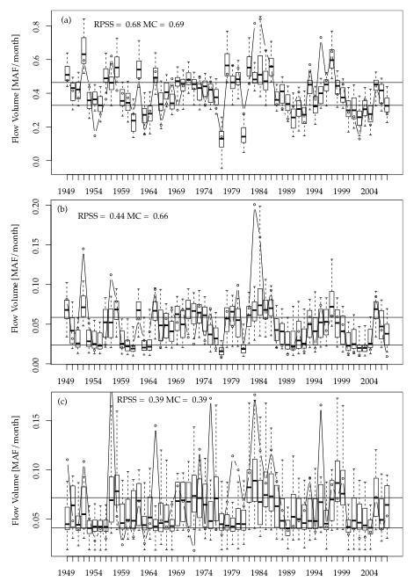

Figure 3: Sample ensemble forecasts for (a) Apr1 June flow at Colorado River Near Cameo, CO, (b) Feb1 June San Rafael River Near Green River, UT and (c) Nov1 July Dolores River Near Cisco, UT. The horizontal lines represent the 33rd and 66th percentiles of the historical data; boxplots extend to the 5th and 95th percentiles of each ensemble. MC stands for the median correlation, the correlation of the median of the ensembles with the historical record.

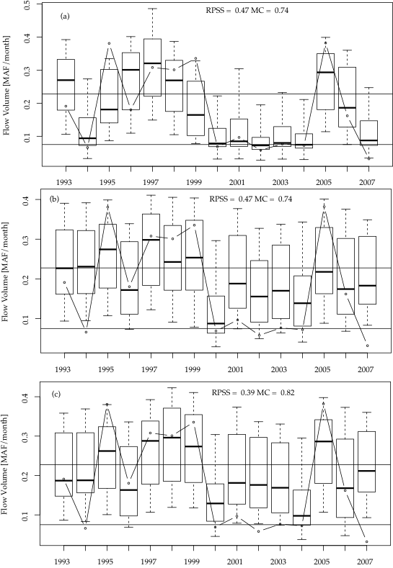

Figure : Same as figure 3 but for June flow at Duchesne River Near Randlett, UT (site 14) for (a) Apr1, (b) Jan1 and (c) Nov 1.

**6 Conclusions**

We have shown that the framework of *Bracken et al.* (2010) can be extended successfully to twenty sites in the Upper Colorado River Basin. This method is parsimonious and requires very little data input compared to existing physically based forrecast models. We make slight modifications to the method including incor­porating the disaggregation method of *Nowak et al.* (2010). The modifications and the incorpora­tion of the most recent data caused out results to differ slightly but not notably from the original method.

To a large extent the skills are positive even after spatial and temporal disaggregation. We see a degradation of the skill as lead time increases which is to be expected. June has the highest predictability because that is the peak flow month in the UCRB on average. We also see that larger tributaries tend to have higher skill. While individual sites do show negative skills, taken as a whole, we see a vast improvement over climatology. Even greater improvement in skill could likely be gained by combining this method with existing forecasts such as the CBRFC corrdinated forecast.

The only remaining step to make these forecasts truly useful would be to provide them as un­regulated flow. The 24-Month Study takes input as unregulated flow to avoid explicitly modeling demands. In many cases this is as simple as subtracting a constant but in others it requires intimate knowledge of regional consumptive use. Using these forecasts as input to a decision model, the operational impacts of improved forcasts could be assesed.

**References**

Bracken, C., B. Rajagopalan, and J. Prairie (2010), A multisite seasonal ensemble streamflow fore­casting technique, *Water Resour. Res*, *46*(3), W03,532, doi:10.1029/2009WR007965.

Craven, P., and G. Wahba (1979), Smoothing noisy data with spline functions: estimating the cor­rect degree of smoothing by the method of generalized cross-validation, *Numerical Mathematics*, *31*, 377–403.

Fulp, T. (2005), How low can it go, *Southwest Hydrology*.

Grantz, K., B. Rajagopalan, M. Clark, and E. Zagona (2005), A technique for incorporating large-scale climate information in basin-scale ensemble streamflow forecasts, *Water Resour. Res*.

Hagedorn, R., F. J. Doblas-Reyes, and T. N. Palmer (2005), The rationale behind the success of multi-model ensembles in seasonal forecasting. part i: Basic concept, *Tellus, Ser. A*, *57*, 219–233.

Krishnamurti, T. N., C. M. Kishtawal, Z. Zhang, T. E. LaRow, D. R. Bachiochi, C. E. Williford,

S. Gadgil, and S. Surendran (2000), Multimodel ensemble forecasts for weather and seasonal climate, *Journal of Climatology*, *13*, 4196–4216.

Loader, C. (1999), *Local Regression and Liklihood*.

Moradkhani, H. (2010), Long-lead water supply forecast using large-scale climate predictors and independent component analysis, *Journal of Hydrologic Engineering*.

Nowak, K., J. Prairie, B. Rajagopalan, and U. Lall (2010), A nonparametric stochastic approach for multisite disaggregation of annual to daily streamflow, *Water Resour. Res*, *46*(8), W08,529, doi:10.1029/2009WR008530.

Opitz-Stapleton, S., S. Gangopadhyay, and B. Rajagopalan (2007), Generating streamflow forecasts for the yakima river basin using large-scale climate predictors, *Journal of Hydrology*, *341*, 131–143.

Prairie, J., B. Rajagopalan, U. Lall, and T. Fulp (2007), A stochastic nonparametric tech­nique for space-time disaggregation of streamflows, *Water Resour. Res*, *43*, 1–10, doi:10.1029/ 2005WR004721.

Rajagopalan, B., U. Lall, and S. Zebiak (2002), Optimal categorical climate forecasts through mul­tiple gcm ensemble combination and regularization, *Monthly Weather Review*, *130*, 1792–1811.

Rajagopalan, B., K. Nowak, J. Prairie, M. Hoerling, B. Harding, J. Barsugli, A. Ray, and B. Udall (2009), Water supply risk on the colorado river: Can management mitigate, *Water Resour. Res*, *45*(8), W08,201.

Regonda, S. K., B. Rajagopalan, M. Clark, and E. Zagona (2006), A multimodel ensemble forecast framework: Application to spring seasonal flows in the Gunnison river basin, *Water Resour. Res*,

*42*.

US Department of the Interior, U. (2007), Final environmental impact statement Colorado river interim guidelines for lower basin shortages and coordinated operations for lakes Powell and mead, *Bureau of Reclamation, Boulder City, Nev.*

US Department of the Interior, U. (2008), Upper Colorado river basin consumptive uses and losses report: 2006–2010 (provisional), *Bur. of Reclam., Salt Lake City, UT*.

Wilks, D. (1995), Statistical methods in the atmospheric sciences: an introduction, *Elsevier, New York*.