# USBR and CBRFC Natural Flow Comparison Report

Cameron Bracken

October 2009

## Background and Motivation

One of the goals of the research project titled “Reclamation Review of Stochastic Streamflow Simulation at Interannual and Interdecadal Time Scales and Implications to Water Resources Management,” is to build a new midterm operational forecast model for the Upper Colorado River Basin (CRB). This model will be titled the Probabilistic Midterm Model (PMM). This model will improve upon the existing operational forecast model in the CRB, the 24-month study, in several ways:

* **Multiple traces** – or ensemble forecasts
* **Second year forecasts** – the 24-month study uses climatology for the second 12 months
* **Demands** – the 24-month study uses mostly unregulated flow inputs and so has very few demands
* **Operational rules** – reservoir releases are input by operators and so no policy is explicitly represented

If demands are explicitly represented in the PMM model, unregulated flow inputs will no longer be sufficient, natural flow must be used. Currently, unregulated flow forecasts at 9 sites are generated by the Colorado Basin River Forecast Center (CBRFC) and input directly in the 24-month study. The CBRFC modifies its model output (via regression) for at 3 sites where regulation is not fully accounted for.

In order to use natural flow as an input to the PMM, water use must be represented in real time. As a first step, the consumptive use that is currently represented by the CBRFC must be understood. This report details the preliminary comparison between the CBRFC calibration flows and Reclamation’s natural flow data set (which incorporates all known uses).

## Data and Methods

The CBRFC data set used in the comparison was the monthly observed streamflow.[1] This data set is used in flow forecast model calibration. The Reclamation data set used was the Colorado River Basin Natural Flow.[2] This data set incorporates all known consumptive uses in the CRB. A comprehensive source of consumptive use data is the Bureau of Reclamation’s Consumptive Uses and Losses (CUL) reports[3]. These data go into Reclamations natural flow computations.

Six sites with overlapping records in both data sets were used in the comparison. The sites are shown in Table 1. A set of sites was initially identified for comparison based on the 24-month study flow input locations. Sites were not considered which did have data available in both sets. For example Morrow Point (MPSC2) is available in the CBRFC data set but not in the Reclamation data set.

Table : Sites used in this comparison.

|  |  |  |  |
| --- | --- | --- | --- |
| **USGS Site Name** | **USGS gauge** | **Abrev. Name** | **RFC Name** |
| Gunnison River Above Blue Mesa Reservoir, CO | 09124700 | BlueMesa | BMDC2 |
| Gunnison River At Crystal Reservoir, CO | 09127800 | Crystal | CLSC2 |
| San Juan River Near Archuleta, NM | 09355500 | Navajo | NVRN5 |
| Green River Below Fontenelle Res WY | 09211200 | Fontenelle | GBRW4 |
| Green River Near Greendale, UT | 09234500 | FlamingGorge | GRNU1 |
| Colorado River At Lees Ferry, AZ | 09380000 | LeesFerry | GLDA3 |

A few different methods were used in the comparison of these data sets. The relationship between natural, unregulated, consumptive use, regulation (storage) and gauge flow is:

Natural – CUL = Unregulated

Unregulated – Regulation = Gauge

Or

Natural = Gauge + Regulation + CUL

These relationships were used in this analysis. Specifically the comparison includes:

* Cumulative difference between the two data sets compared to the CUL at each site. If the CBRFC data includes no consumptive uses (i.e. unregulated), then the cumulative difference should match up with the cumulative CUL.
* Median cumulative difference over a single year at each site. This is good for magnitude comparison at each site and for median magnitude of total difference during any month.
* Cumulative difference over a single year at Lees Ferry. This is useful for identifying the range of differences over the period of record.
* Percent difference at each site. This is useful for identifying which sites have the largest differences.
* Monthly (noncumulative) difference at each site. This is useful for identifying the months during which the largest differences occur.

## Results

The two raw data sets, plotted against each other are shown in Figure 1. At first glance, both data sets appear very similar. Further analysis shows that important differences are present

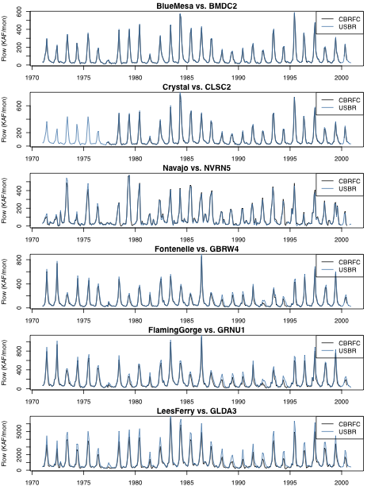

Figure 1. Time series of CBRFC and USBR natural flow at six comparison sites.

Figure 2 shows the differences (Reclamation less CBRFC) plotted against the total CUL and the Agricultural CUL. At sites near or at the top of basins (Fontenelle, Blue Mesa) the differences between the data is almost entirely accounted for by the Ag CUL. This makes sense because the remaining use is mostly municipal and industrial which are typically gauged uses. Theoretically the difference series should not be higher than the Total CUL, this means that in the cases of Crystal and Flaming Gorge, more than the total use is being accounted for by the CBRFC. The differences at Navajo are also interesting. This is the only site where the CBRFC flows were consistently higher than Reclamation’s. This result may be due to the uncertainty of input data at Navajo.

Figure 3 shows the percent differences between the two sets. This figure primarily illustrates that the largest differences occur during the high flow seasons (when use is the highest). Also, differences are relatively small at Blue Mesa and Crystal (where agricultural use is low).

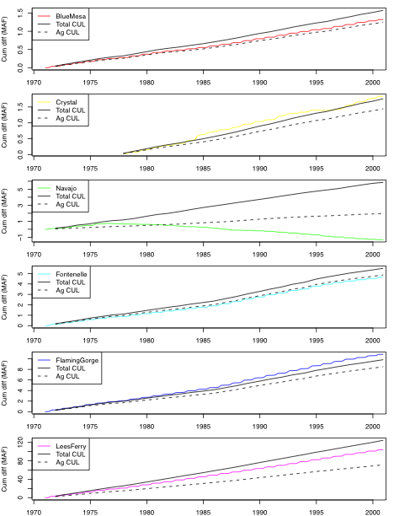

Figure 2. Cumulative natural flow differences plotted with cumulative total consumptive uses and losses and agriculture and irrigation consumptive use.

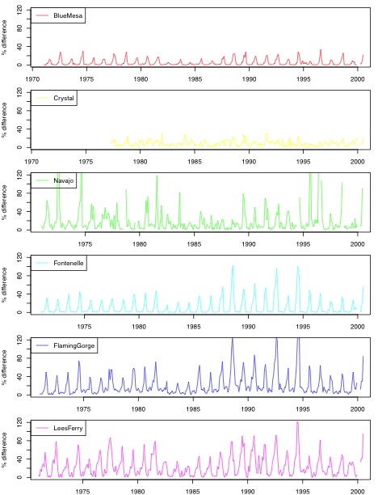

Figure 3. Relative percent difference at each comparison site.

Figure 4 shows the monthly spread of differences for each site. This figure emphasizes that the largest differences occur during the high flow season and differences are by no means constant from year to year. For example, at Lees Ferry during June the differences range from ~ 0.5 – 1.5 MAF over the period of record. The anomalous behavior at Navajo can also be observed here.

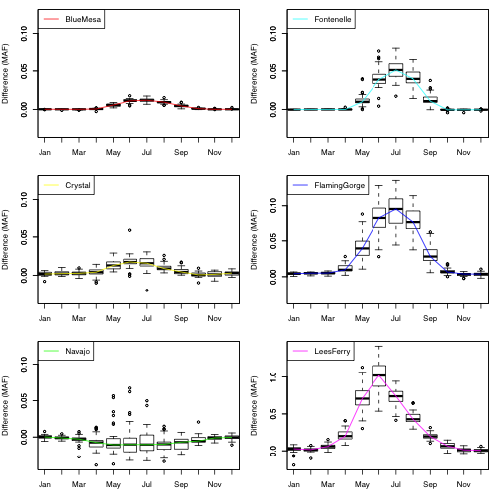

Figure 4: Monthly differences at each comparison site. Box plots represent the spread of model differences over the 1971-2000 period for each month with line connecting the medians. Note the difference in scale of the Lees Ferry plot.

Figure 5 shows the median cumulative difference at each of the sites over all the years in the record. Differences at Lees Ferry are by far the largest at Lees Ferry because the total CUL is the largest at that site. Figure 6 also show Lees Ferry but with the cumulative range shown (nearly 2 MAF) as box plots. The line for Lees Ferry is the same in both Figure 5 and Figure 6.

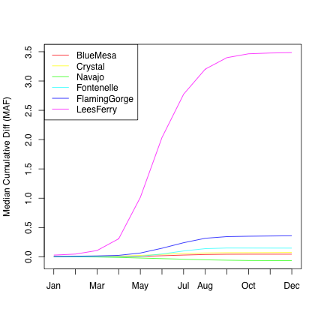

Figure 5. Cumulative median (over 1971-2000 period) natural flow differences at each comparison site.

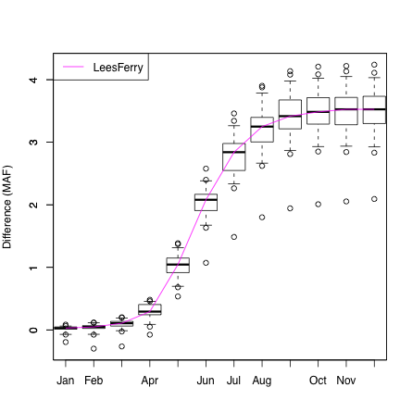

Figure 6. Cumulative (over 1971-2000 period) natural flow for each year at Lees Ferry showing the range of differences.

## Conclusions

The following conclusions can be drawn from this analysis:

* Differences at Navajo most likely point to uncertainty in CUL data.
* Little or no consumptive use is incorporated in the CBRFC monthly observed streamflow data set. Most of the unaccounted for use is agricultural because it is hard to measure in real time. This is not a problem in the CBRFC forecasts because they calibrate to this data.
* As is, the CBRFC data is not sufficient to use as input to the Probabilistic Midterm Model.
* A real time natural flow forecast would require calibrating with Reclamation’s natural flow data such that forecasts are directly produced in natural flow space.
* CBRFC data may be able to be used in the interim by developing regression relationships at each site. This is an undesirable long-term solution because of the extra error it introduces.

1. http://www.nwrfc.noaa.gov/westernwater/index.php?page=data
2. http://www.usbr.gov/lc/region/g4000/NaturalFlow/index.html
3. http://www.usbr.gov/uc/library/envdocs/reports/crs/crsul.html