- What is a spatial precipitation map? Describe two methods for creating one from point precipitation.
- A 2d surface, precipitation as a function of x and y (lat, lon).
- Areal average which results in a constant surface everywhere
- Theissen Polygon method which weights points based on their proximity to others
- Interpolation which estimates each point based on nearby points

- Define: Watershed. Why are watersheds so important in Hydrology?
- Match each situation with either Calibration, Verification, or Validation (more than one may apply)
  - The coefficients of a linearized power law model are calculated with a computer program
- Calibration
  - The output of a TOPMODEL (Flow) is compared with observational data and the Nash-Sutcliffe efficiency parameter is calculated.
- Verification or Validation
  - An evapotranspiration uses parameters that were calculated using data from 1940-1970. The model predictions are then compared against data from 1971-2000 and examined for accuracy and precision.
- Validation
  - Monte Carlo Simulation is used to obtain a starting set of parameters for a river routing model.
- Calibration
  - More?
- A small snowmelt driven basin is heavily logged over a period of 20 years. After logging is stopped, the streamflow at the outlet of the basin is observed to peak earlier in the season with significantly higher magnitudes in the high flow season and lower magnitudes in the low flow season. Describe physically why this could occur.

- Describe changes in land cover which affects melt rates, soil type and distribution. In the wet season runoff occurs more rapidly creating higher peaks and infiltrates less, causing dryer soil conditions in the dry season. As a result more infiltration occurs in the dry season resulting in lower flows.

- Basin Aye (approximately 100 km^2) is a small basin in a tropical latitude. The considerable rainfall in the area drives its runoff. The basin in mostly grassy with some forested area. Most of the land use in the basin consists of grazing and in mostly unimproved. The basin is the subject of a poorly funded project to assess the effects of grazing. The basin monitored for a very short amount of time and enough data is collected to obtain very rough parameter estimates to run TOPMODEL. The results are shown below: 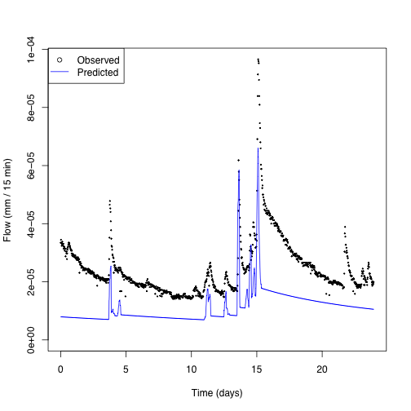
  - The party funding the project has enough money to fund data collection on ONE parameter. As the engineer on the project you narrow down the parameters to choose between: (i) m, the rate of decline of transmissivity in the soil profile (dimensionless), (ii) Srmax, the maximum root zone storage deficit (in meters), or k0, the surface hydraulic conductivity (im meters/hour). Which single parameter would you select to obtain more data about? Explain your reasoning.

Any parameter could be justified but should address the quick recession of the model flow relative to the data.

  - The model has a Nash-Sutecliffe efficiency of -1.151083. A plot of the observed versus predicted values is shown below along with a 1:1 line. Explain why this model is a poor fit to the data.
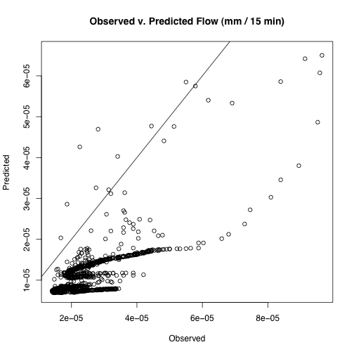
No even scatter around 1:1 line. Scatter is not independent indicating bais in the errors. NSE is negative, should be positive to indicate model with power, otherwise just using the mean is better.

  - A colleague approaches you with data from a basin Bee in southwest Canada. This basin is similarly sized to basin Aye. It is primarily snowmelt driven with predictable peak flows in April. Basin Bee is heavily wooded with some improvement in the form of roads and houses. Your colleague suggests you use basin Bee in a paired catchment study with basin Aye to evaluate the variation in flows when data is not available in basin Aye. This person constructs a paired effect model of the two basins to the linear regression output is shown below along with the model and the data. Explain (politely) why he is wrong the paired catchment method is not suitable here (give at five complete reasons).

The basins are not close in space
The basins have different vegetation patterns
Different land use patterns
Different drivers of streamflow
Model is not statistically significant
No visual trend in the data
Climate of each basin likely very different
Many other possibilities….

Call:
lm(formula = x ~ Qsim)

Residuals:
Min 1Q Median 3Q Max
-3.014e-05 -6.391e-06 1.517e-07 6.613e-06 3.730e-05

Coefficients:
Estimate Std. Error t value Pr(>|t|)
(Intercept) -2.896e-07 4.233e-07 -0.684 0.494
Qsim 7.481e-03 3.251e-02 0.230 0.818

Residual standard error: 9.862e-06 on 2298 degrees of freedom
Multiple R-squared: 2.304e-05, Adjusted R-squared: -0.0004121
F-statistic: 0.05295 on 1 and 2298 DF, p-value: 0.818

