Lecture 24, November 11, 2010 (Key Points)

STATISTICAL VARIABILITY IN SPACE-TIME RAINFALL AND ITS
PHYSICAL ORIGINS

In developing a physical understanding of scaling parameters of floods explained in Lectures 20-23, the spatial rainfall variability did not play any role because GCEW is only 21 km² in area. As basin size increases, spatial rainfall variability exerts a much greater influence on runoff generation and transport than in GCEW. A comprehensive understanding of space-time rainfall variability is necessary for developing a physical understanding of scaling in floods as discussed in Lectures 18-23. Research along this line is being undertaken in the Iowa River Basin at the Iowa flood center, University of Iowa.
One of the most important and widely observed features of rainfall intensities is its extreme variability in space and time. A statistical and physical understanding of this variability has been a topic of great interest to both hydrological and meteorological communities. In this chapter, I will give a brief overview of the progress that has been made in understanding the statistical variability since the 1970s, and how it may be linked to underlying physical processes. It is similar in sprit to the flood problem, which is the focus for this course. We will explain some basic elements of these developments in this chapter.
The outline for this and the next two lectures on rainfall is as follows. I will briefly explain the problem of estimating rainfall intensity fields in tandem from weather radar and rain gauges. As the size of a region increases, weather radar is required to estimate rainfall intensity fields in addition to rain gauges. A huge literature exists on this topic so my discussion is only a placeholder. Next, I will explain the presence of statistical power laws in space-time rainfall intensity fields, and progress in developing statistical models to understand the structure of these power laws. Again, a huge literature exists on this topic so I will only scratch the surface. Finally, I will make some remarks about the long-standing open problem of understanding the physical origins of statistical rainfall variability including statistical power laws in rainfall. Brutsaert (2005, Ch-3) supplements our lectures on rainfall for the material not covered here.

24.1 Measurement of Rainfall Intensities from Radar and Rain gauges
We will begin with an explanation of how rainfall intensities are measured from radars. Measurement of rainfall from rain gauge is covered in detail in standard hydrology texts, and we assume that the reader is familiar with them.
A radar transmits electromagnetic energy as a beam in a direction determined by a movable antenna. The radiated wave travels at the speed of light and is reflected back to the antenna by the water drops (particles) in clouds and precipitation. The average returned power, 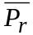 is a measure of radar reflectivity, Z of all particles at a distance r given by,

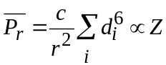 (24.1)

Here, 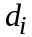 is the diameter of the individual particles. A very large number of studies have been conducted on the relationship between radar reflectivity, Z and the rainfall rate, R, which is expressed in the form,
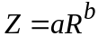 (24.2)

The empirical parameters a and b are obtained either by comparing radar with rain gage measurements or by direct measurement of drop-size distribution (DSD). The Z-R relationship is error prone due to many factors. Porra et al. (1996) gave an excellent review of modeling DSD and its applications to radar rainfall measurements. They showed that various models in the literature for the mean number of drops,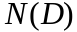, between diameter D and D+dD per unit air volume can be expressed by a general functional scaling relationship,

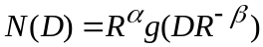 (24.3)

Here, α and β are scaling exponents. Porra et al. (1996) and other literature may be consulted on the progress that has been made on this important topic.

24.2 Dynamic Self-Similarity for Linking Space-Time Variability in Physical Phenomena
Hydrologic processes vary in space and time across multiple scales. In this context, we explained the concepts of geometric and statistical self-similarity in previous lectures. Now will introduce the notion of dynamic similarity and dynamic self-similarity as an orientation to understanding how the multi-scale variability of hydrologic processes in space and time can be linked. The idea of space-time self-similarity based in dynamic considerations has not received much attention in the hydrology literature. It is a new topic of research in hydrologic science and engineering.
As an example, consider a dynamic phenomenon that is governed by the Froud number, 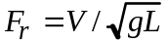. Here, 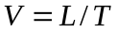 is some characteristic velocity, L is a characteristic length scale, T is a characteristic time scale, and g is the gravitational acceleration. Let us consider two sets of space and time scales that have the same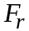,

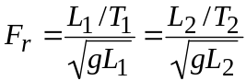 (24.4)

Since g is a constant, it can be cancelled from both sides. It leads to a space-time relationship given by,
or, 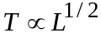 (24.5)

This equation shows that the ratio of temporal variability is related to that of spatial variability in a specific manner. The above idea generalizes to multiple space-time scales provided that is a constant across all these scales. One can regard the exponent 1/2 as a scaling exponent governing space-time variability (Foufoula-Georgiou and Sapozhnikov, 2001). Hunt et al. (2006) have investigated the physical basis of dynamic scaling for braided rivers, and have provided an explanation of how the exponent 1/2 arises due to a constancy of Froud number.
Let us take another example of a very well known scaling law that Kolmogorov (1941) obtained for turbulence,

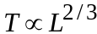 (24.6)

This scaling law was obtained in what is considered to be the most famous paper on turbulence ever published. Turbulence rules planet Earth and Kolmogorov’s paper has had a major impact on sciences and engineering. For example, it is shown to hold for many important atmospheric phenomena. We will briefly explain how the space-time scaling in Eq. (24.6) comes about. Our discussion is taken from Frisch (1995).
Turbulence arises at high Reynold’s number. A qualitative physical picture that has been widely used is that kinetic energy is injected into a fluid medium at some large spatial scale. It is gradually transferred from larger to smaller spatial scales in such a manner that the mean kinetic energy per unit mass per unit time, , is conserved in this process. Finally, the energy is dissipated into heat by molecular viscosity. Kolmogorov’s theory is a scaling theory that predicts the statistics of velocity fluctuations across multiple spatial scales. Let us consider velocity difference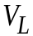 between two points that are separated by a length scale L. Due to the presence of fluctuations in a turbulent fluid, the velocity is a random field. By spatial homogeneity, 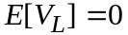, so we consider variance, which is the same as the second moment. Due to the constancy of the mean kinetic energy per unit mass per unit time, , dimensional homogeneity requires that,

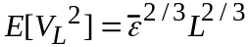 (24.7)

Consider two characteristic time and length scales at which is a constant, and denote the characteristic velocity by L/T. Eq. (24.7) leads to,

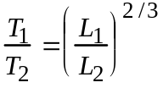, or 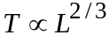 (24.8)

As an example pertaining to rainfall, consider the important problem of area reduction factor (ARF) to scale point rainfall to areal rainfall as briefly discussed in Brutsaert (2005, p. 95). De Michele et al. (2001) applied the concept of dynamic similarity to ARF. To understand their formulation, let denote rainfall intensity parameterized by time T and area, A. write,

or, (24.9)

Here z is a dynamic scaling exponent. Scale the time and space with respect to and λ as, . In view of Eq. (24.9), it can be written as, . Thus, dynamic similarity enables us to reduce a two- dimensional problem with two ratios, (time) and λ (space), to a one-dimensional problem with a single ratio, λ. Further details of the method are beyond the scope of this course.
Our discussion illustrates how ideas of dynamic self-similarity come about in going from space to space-time. Barenblatt (1996) is an excellent pedagogical reference on dynamic similarity and dynamic self-similarity. Future advances in hydrologic theories will need to consider all the three concepts of geometric, dynamic and statistical self-similarity.

24.3 Patterns of Observed Variability in Space-Time Rainfall
Hydrologic investigations have been mostly concerned with the two-dimensional horizontal spatial variability of rainfall, and how this variability evolves with time. A widely observed hierarchical spatial structure of rainfall-intensity fields within synoptic-scale regions, which typically are larger than 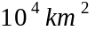, can be described as follows. The smallest spatial structures consist of clusters of regions of high intensity rainfall, called "cells". They are embedded within regions of low rainfall intensity, called small mesoscale areas (SMSAs). These, in turn, are clustered within still larger regions of even lower rainfall intensity, called large mesoscale areas (LMSAs). The LMSAs are clustered within synoptic regions. This organization is shown schematically in Fig. 24.1.

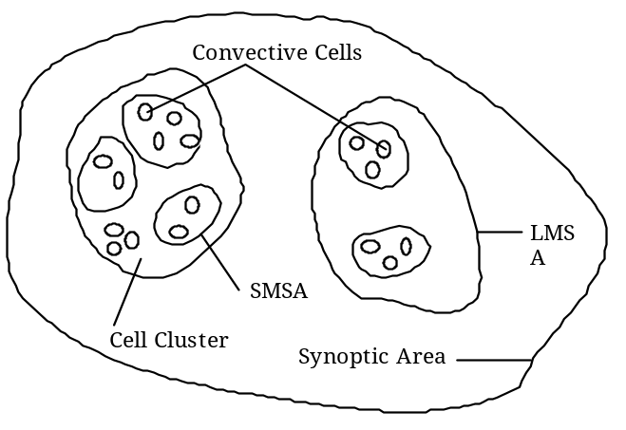
Figure 24.1. A schematic display of hierarchical organization in a spatial rainfall field (Gupta and Waymire, 1979)

Some of the early empirical evidence for this kind of structure came from Austin and Houze (1972), who observed hierarchical structures within storms of a variety of synoptic types occurring in New England. In the Global Atmospheric Research Program (GARP) Atlantic Tropical Experiment (GATE), carried out in the tropic Atlantic in the mid-1970s, precipitation was observed to follow a life cycle that at its peak included clusters of convective cells embedded within stratiform rainfall. It has been found that groups of thunderstorms embedded within a mesoscale system, termed mesoscale convective complexes (MCS's), are major contributors of summertime rainfall over the central US. The regions of distinct rainfall intensities shown in Fig. 24.1 are observed to have distinct life cycles. For example, the rainfall cells typically have a life cycle of about half an hour to an hour. During that period, initially a cell experiences an increase in rainfall intensity, reaching a maximum, and finally it dissipates. Similarly, the SMSAs have life cycles of about 2-4 hours, and the LMSAs last 6-12 hours. The key point to note is that the characteristic space and time scales are connected. Houze (1989) has reviewed the observational evidence for such systems and their effects.
To further elaborate on the variability of spatial rainfall shown in Fig. 24.1 it is interesting to note from Austin and Houze (1972) that, as a rule of thumb, one may expect an approximate "doubling rule" for the intensity of rainfall with decreasing spatial scales. This is shown in Table 24.1. As the area decreases by a factor of ten, the rain rate roughly doubles, until the very small scales are reached where super cells of intensities on the order of 100 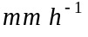 may be found.

Scale | Rain rate
Synoptic ( > 104 km2 )
LMSA ( 103 to 104 km2 ) | Doubling rule
SMSA ( 50 to 103 km2 ) | Doubling rule
CELL ( < 50 km2 ) | Factor of 10 possible

Table 24.1 Increase of rainfall intensity in regions of decreasing spatial scales
(Austin and Houze, 1972)

In the early 1980s, papers on rainfall began to be published that showed that rainfall did not have a characteristic spatial scale. Lovejoy (1981) on area-perimeter relationship (Lecture 8) was among the first along this line. These two sets of features in data (characteristic scales versus scale invariance) instigated development of two different classes of statistical space-time models. The first set of models had too many model parameters, which could not be easily estimated from data. The second set based on ‘statistical simple scaling’ was shown to contradict the intermittency (Regions of zero rainfall) (Kedem and Chiu, 1987). These difficulties finally led to developing another set of stochastic space-time models that were directly motivated by the statistical theories of turbulence. We will give a brief review of these models.

REFERENCES

Austin, PM and R. A. Houze. Analysis of the Structure of Precipitation Patterns in New England. J. Appl. Meteo. 11(6), 926–935, 1972.

Brutsaert, W. Hydrology: An Introduction, Cambridge, 2005.

Barenblatt, G. I. Scaling, Self-Similarity and Intermediate Asymptotics. Cambridge Texts in Applied Mathematics, 14, Cambridge, 1996.

Barndorff-Nielsen, O, V Gupta, V. Perez-Abreu and E. Waymire, (Eds.). Stochastic Methods in Hydrology: Rainfall, landforms and floods, Adv. Series Stat. Sci. and Appl. Prob., V. 7, 207 pp., World Scientific, 1998.

De Michele, C, N. T. Kottegoda, and R. Rosso. The derivation of areal reduction factor of storm rainfall from its scaling properties. Water Resou. Res., 37(12): 3247-3252, 2001.

Foufoula-Georgiou, E., Sapozhnikov, V. Scale invariance in the morphology and evolution of braided rivers. Math. Geol. 33, 273–291, 2001.

Frisch, U., Turbulence: The legacy of A. N. Kolmogorov, Cambridge, 1995.

Gupta, V. K. and E. C. Waymire. A stochastic kinematic study of subsynoptic space-time rainfall. Water Resour. Res. 15(3): 637-634, 1979.

Houze, R. A. Observed structure of mesoscale convective systems and implications for large-scale heating, Q. J. Roy. Meteor. Soc. 115: 425-461, 1989.

Hunt, AG, GE Grant and VK Gupta. Spatio-temporal scaling of channels in braided streams. J. Hydrology, 322(1): 192-198, 2006.

Kedem, B. and L. S. Chiu. Are rain-rate processes self-similar? Water Resour. Res., 23(10): 1816-1818, 1987.

Kolmogorov, A.N. Local structure of turbulence in incompressible fluid at very high Reynolds numbers (in Russian) Dok. Akad. Nauk. SSSR 30, 299–303, 1941 (English translation) Proc. Roy. Soc. Lond., A 434, 9–13, 1991.

Porra, J. M., D. Sempere-Torres and J. D. Creutin. Modeling of drop size distribution and its applications to rainfall measurements from radar. In: Stochstic Methods in Hydrology: Rainfall, landforms and floods, O. E. Barndorff-Nielsen, V. K. Gupta, V. Perez-Abreu, and E. C. Waymire (Ed.), Adv. Series Stat. Sci. Appl. Prob., V. 7, 73-84. World Scientific, 1998.

