CVEN 4333 Final Exam Spring 2010

- What is the fundamental process that drives ET? (Circle 1) (1)
  - Diffusion
  - Conduction
  - Convection
  - a, b and c

- A phase change from solid to liquid: (Circle 1) (1)

Uses Energy Releases energy

- What order stream at point a in Figure 1? (2)

1 2 3 4 5 6 7 8

- Most SW radiation entering our atmosphere is in the visible part of the EM spectrum. What property of the sun determines this? (1)

- Saturation vapor pressure is a function of what? (circle 1 answer) (2)
  - Pressure
  - Temperature
  - moisture content
  - a,b, and c
  - b and c
  - a and b

- Hydraulic conductivity: (Circle 1) (2)
  - Increases with soil moisture
  - Decreases with soil moisture
  - Is not a function of soil moisture

- You have a plot of specific runoff vs. area. If a basin has a larger value of both specific runoff and area on this plot than another what does it mean? (4)

- It would be accurate to calculate the total derivative of velocity and make a prediction at a specific point: (2)

True False Sometimes

  - Why is the time of concentration an important quantity (what does it represent physically)? (3)

  - Table 1 lists a series of relations for determining time of concentration. How would you determine which one to use? (4)

- The Amazon forest is quickly undergoing deforestation mostly being replaced with agricultural and grazing land. Briefly discuss what would likely happen to ET, infiltration the hydrograph for a given channel and net radiation at the land surface where this change had taken place and why (8)

- You are given two data points for discharge vs area. These are: 2.5x10³ cfs for a basin of 12 mi² and 25x10³ cfs for a basin 95 mi² . We know that discharge area curves are often fit to a power law of the form Q=CA^{M} where Q is discharge, A is area and C and M are constants to be determined. Calculate C an M mathematically using the two given data points (6)

- 8.1, 8.9, 8-10, 8-13???

- An X-hour unit hydrograph for a net-rainfall rate of 0.5 in/hr is given below for a basin.

Time (hr) 0 1 2 3 4 5 6 7
Q(cfs) 0 50 200 300 200 150 100 0

  - What is the value of X? (4)

  - What are the first 8 values of the X-hour S-hydrograph? (6)

  - What is the peak discharge rate (cfs) that results from a net rainfall of 2 in/hr for 3 hours? (15)

- A 10 year record of streamflow shows that 60,000 cfs was exceeded three times.
  - What is the return period for this size flow? (2)

  - Based on the length of this record would you want to modify this estimate of return period? Why and how? (2)

- What is a spatial precipitation map? Describe two methods for creating one from point precipitation. (6)

- Define the term Watershed. Why are watersheds so important in Hydrology? (5)

- Match each situation with either Calibration, Verification, or Validation (choose only one but more than one may apply)
  - The coefficients of a linearized power law model are calculated with a computer program

  - The output of a TOPMODEL (Flow) is compared with observational data and the Nash-Sutcliffe efficiency parameter is calculated.

  - An ET model uses parameters that were calculated using data from 1940-1970. The model predictions are then compared against data from 1971-2000 and examined for accuracy and precision.

  - Monte Carlo Simulation is used to obtain a starting set of parameters for a river routing model.

- Basin Aye (approximately 100 km^2) is a small basin in a tropical latitude. The considerable rainfall in the area drives its runoff. The basin in mostly grassy with some forested area. Most of the land use in the basin consists of grazing and in mostly unimproved. The basin is the subject of a poorly funded project to assess the effects of grazing. The basin monitored for a very short amount of time and enough data is collected to obtain very rough parameter estimates to run TOPMODEL. The results are shown in Figure 2 below.

  - The party funding the project has enough money to fund data collection for ONE parameter. As the engineer on the project you narrow down the parameters to choose between: (i) m, the rate of decline of transmissivity in the soil profile (dimensionless), (ii) Srmax, the maximum root zone storage deficit (in meters), or k0, the surface hydraulic conductivity (in meters/hour). Which single parameter would you select to obtain more data about? Explain your reasoning based on the model output and the physics of the problem. (6)

  - The model has a Nash-Sutecliffe efficiency of -1.15. A plot of the observed versus predicted values is shown in Figure 3 along with a 1:1 line. Explain why this model is a poor fit to the data. (6)

  - A colleague approaches you with data from a basin Bee in southwest Canada. This basin is similarly sized to basin Aye. It is primarily snowmelt driven with predictable peak flows in April. Basin Bee is heavily wooded with some improvement in the form of roads and houses. Your colleague suggests you use basin Bee in a paired catchment study with basin Aye to evaluate the variation in flows when data is not available in basin Aye. This person constructs a paired effect model of the two basins to the linear regression output is shown in Figure 4 in along with the model and the data in Figure 5. Explain (politely) why he is wrong the paired catchment method is not suitable here (give at least five distinct reasons). (10)

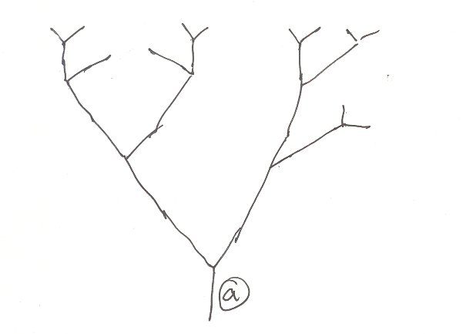
Figure 1

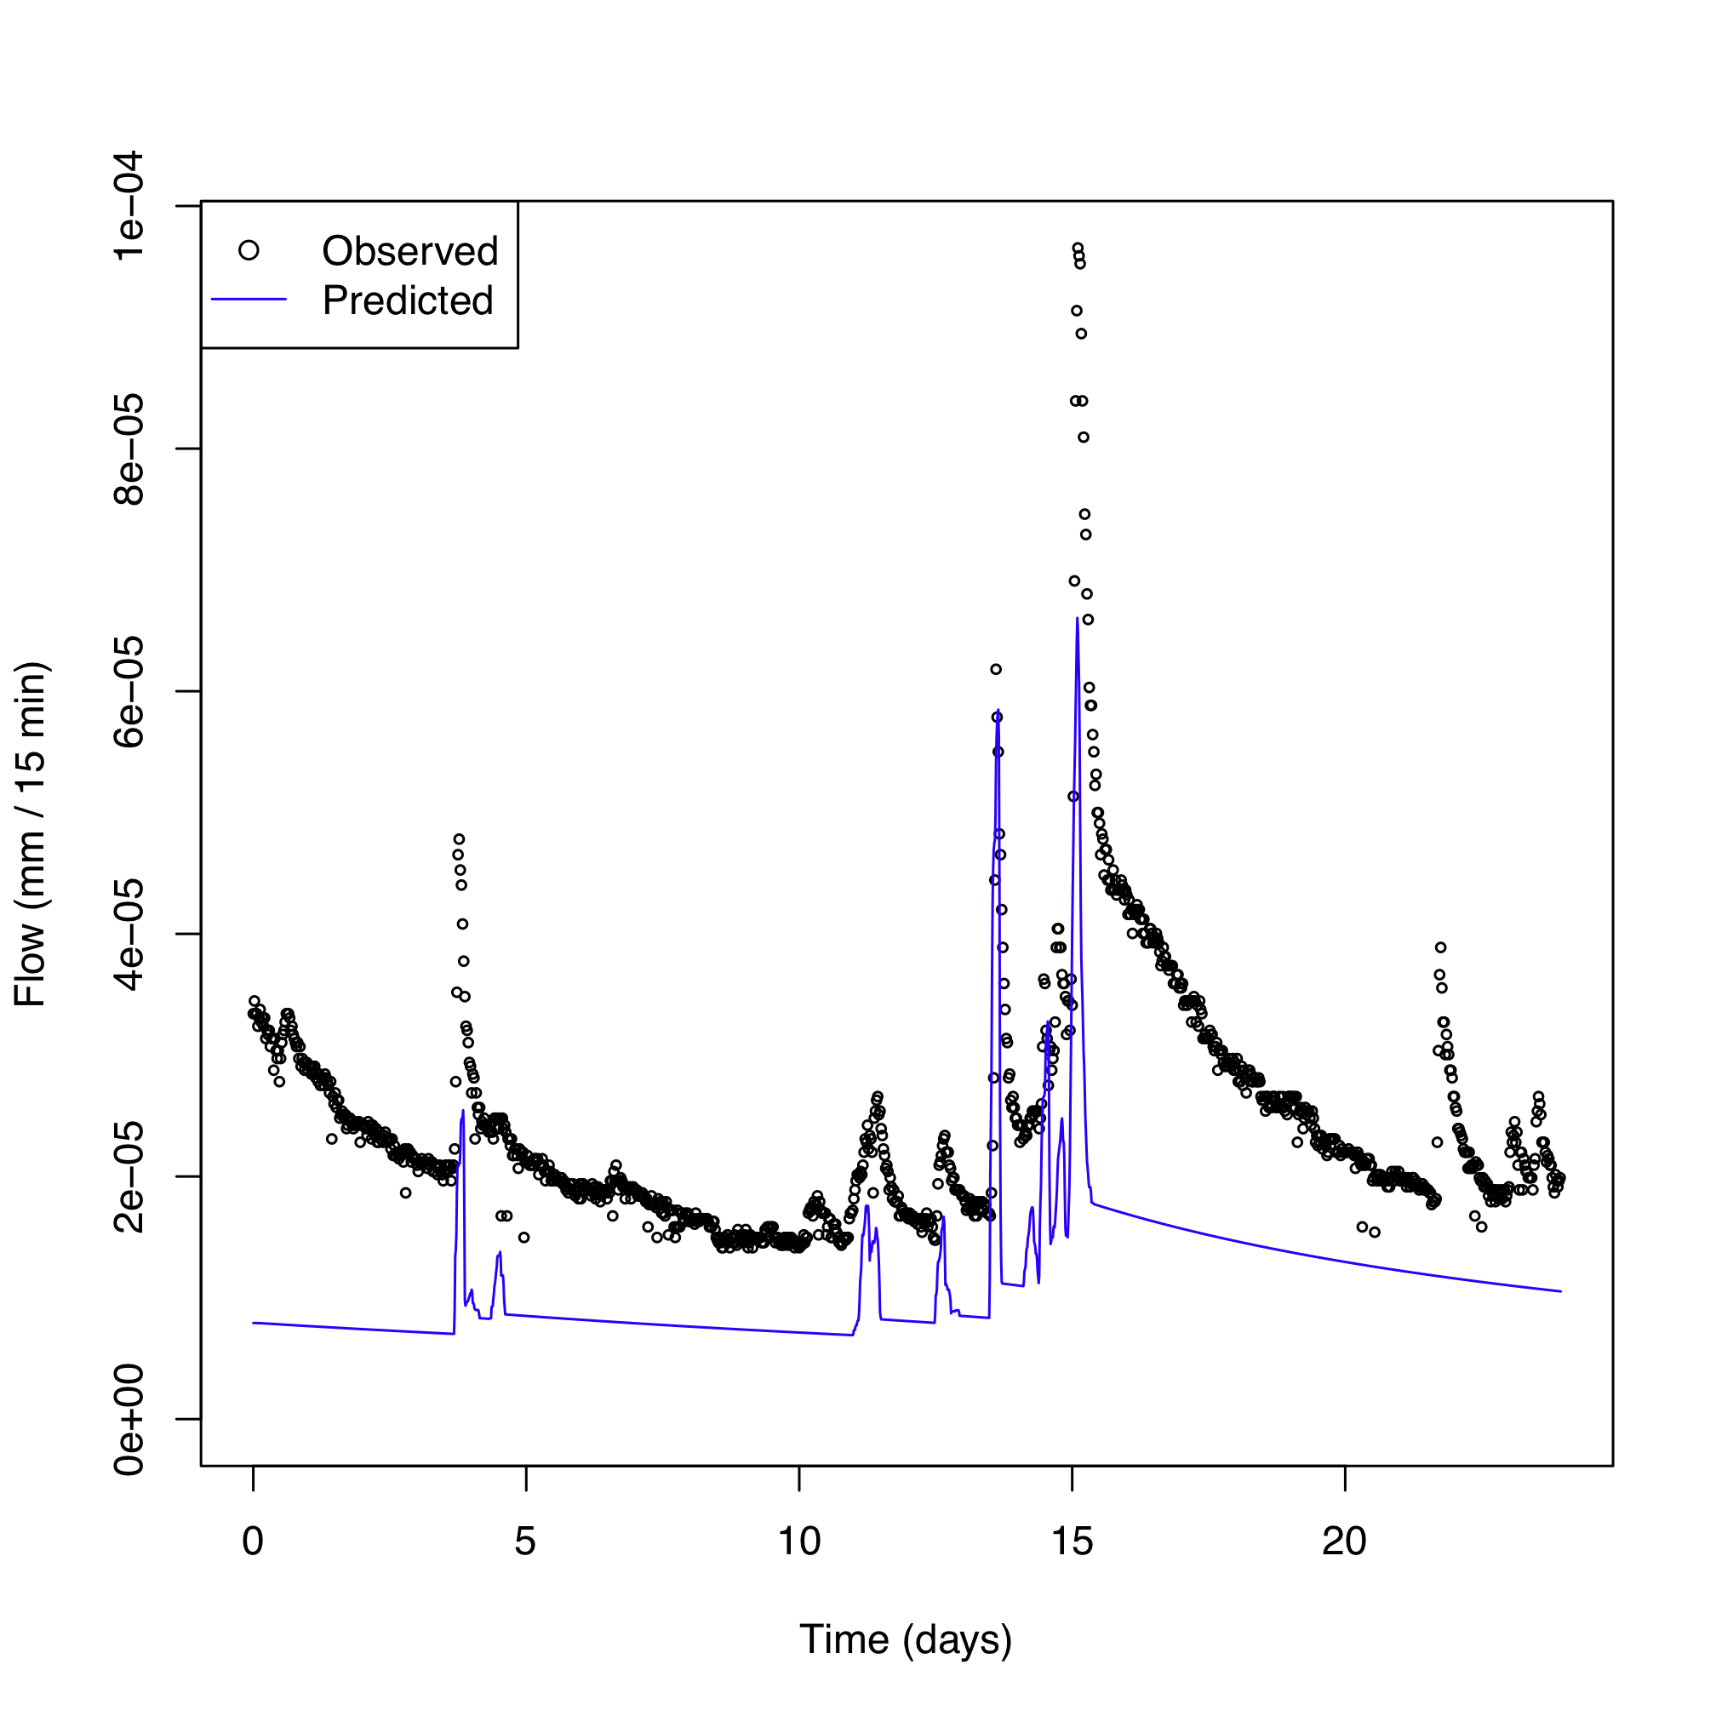
Figure 2

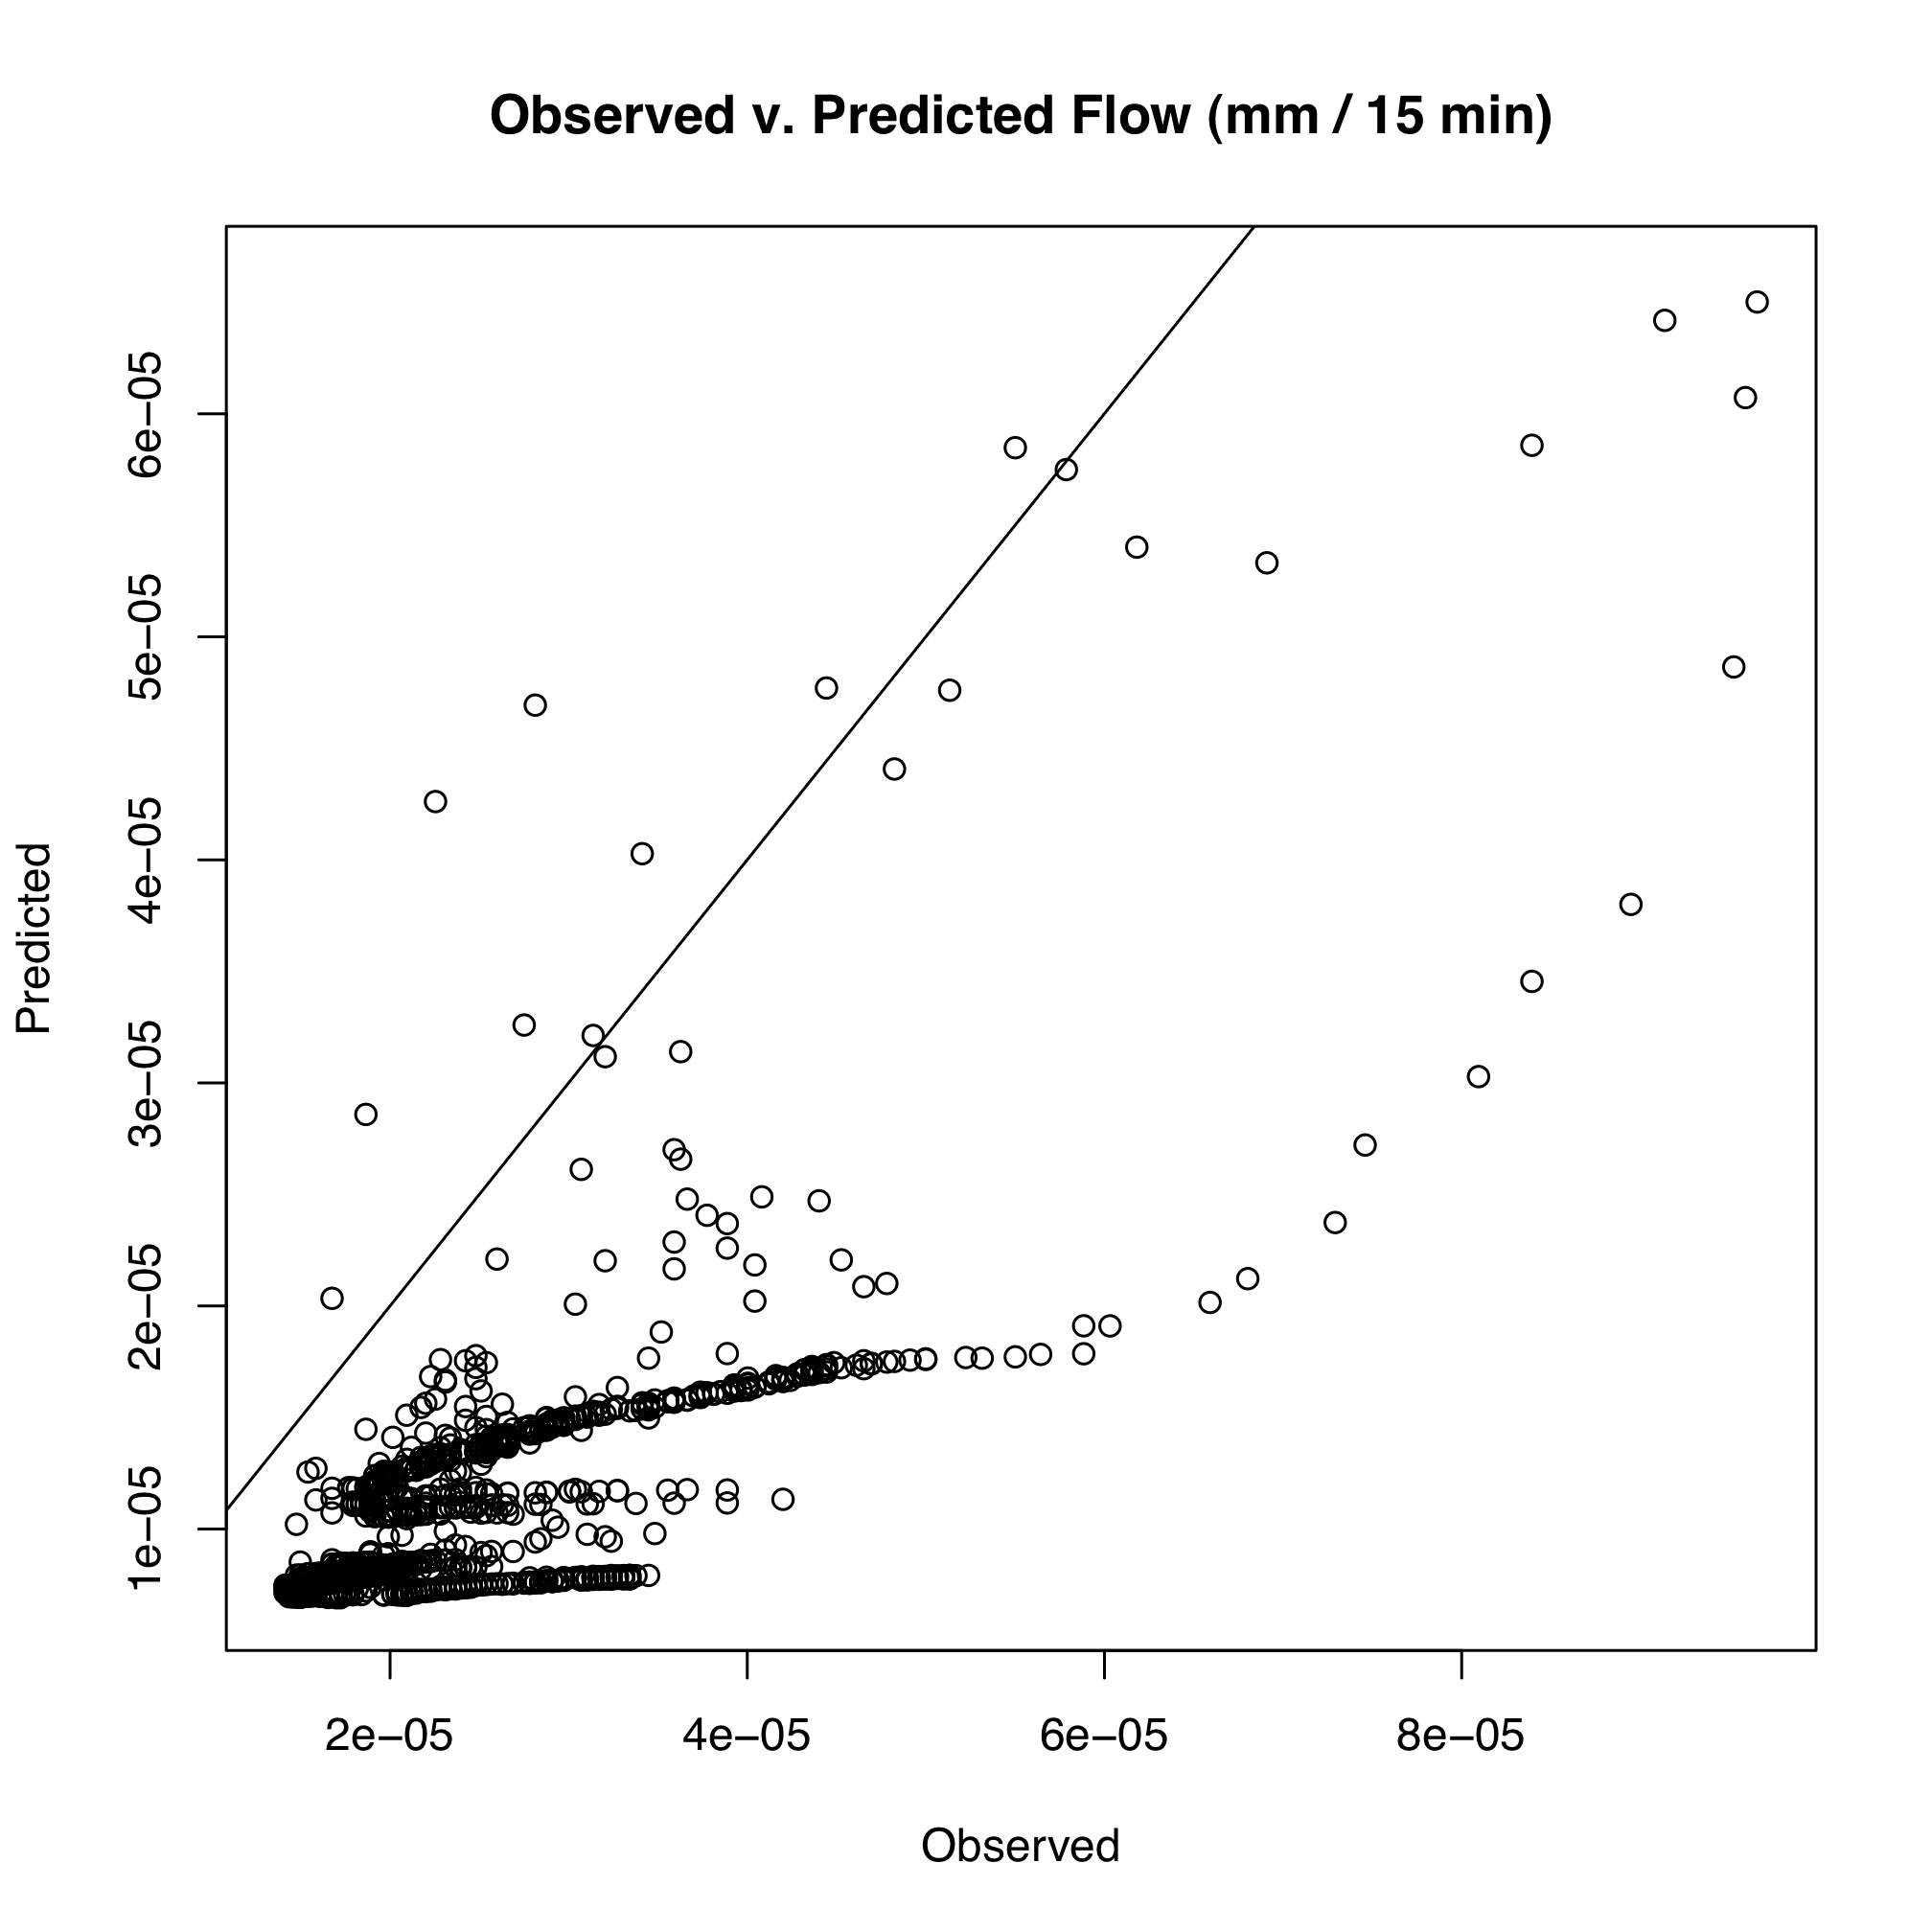
Figure 3

Call:
lm(formula = x ~ Qsim)

Residuals:
Min 1Q Median 3Q Max
-3.014e-05 -6.391e-06 1.517e-07 6.613e-06 3.730e-05

Coefficients:
Estimate Std. Error t value Pr(>|t|)
(Intercept) -2.896e-07 4.233e-07 -0.684 0.494
Qsim 7.481e-03 3.251e-02 0.230 0.818

Residual standard error: 9.862e-06 on 2298 degrees of freedom
Multiple R-squared: 2.304e-05, Adjusted R-squared: -0.0004121
F-statistic: 0.05295 on 1 and 2298 DF, p-value: 0.818
Figure 4

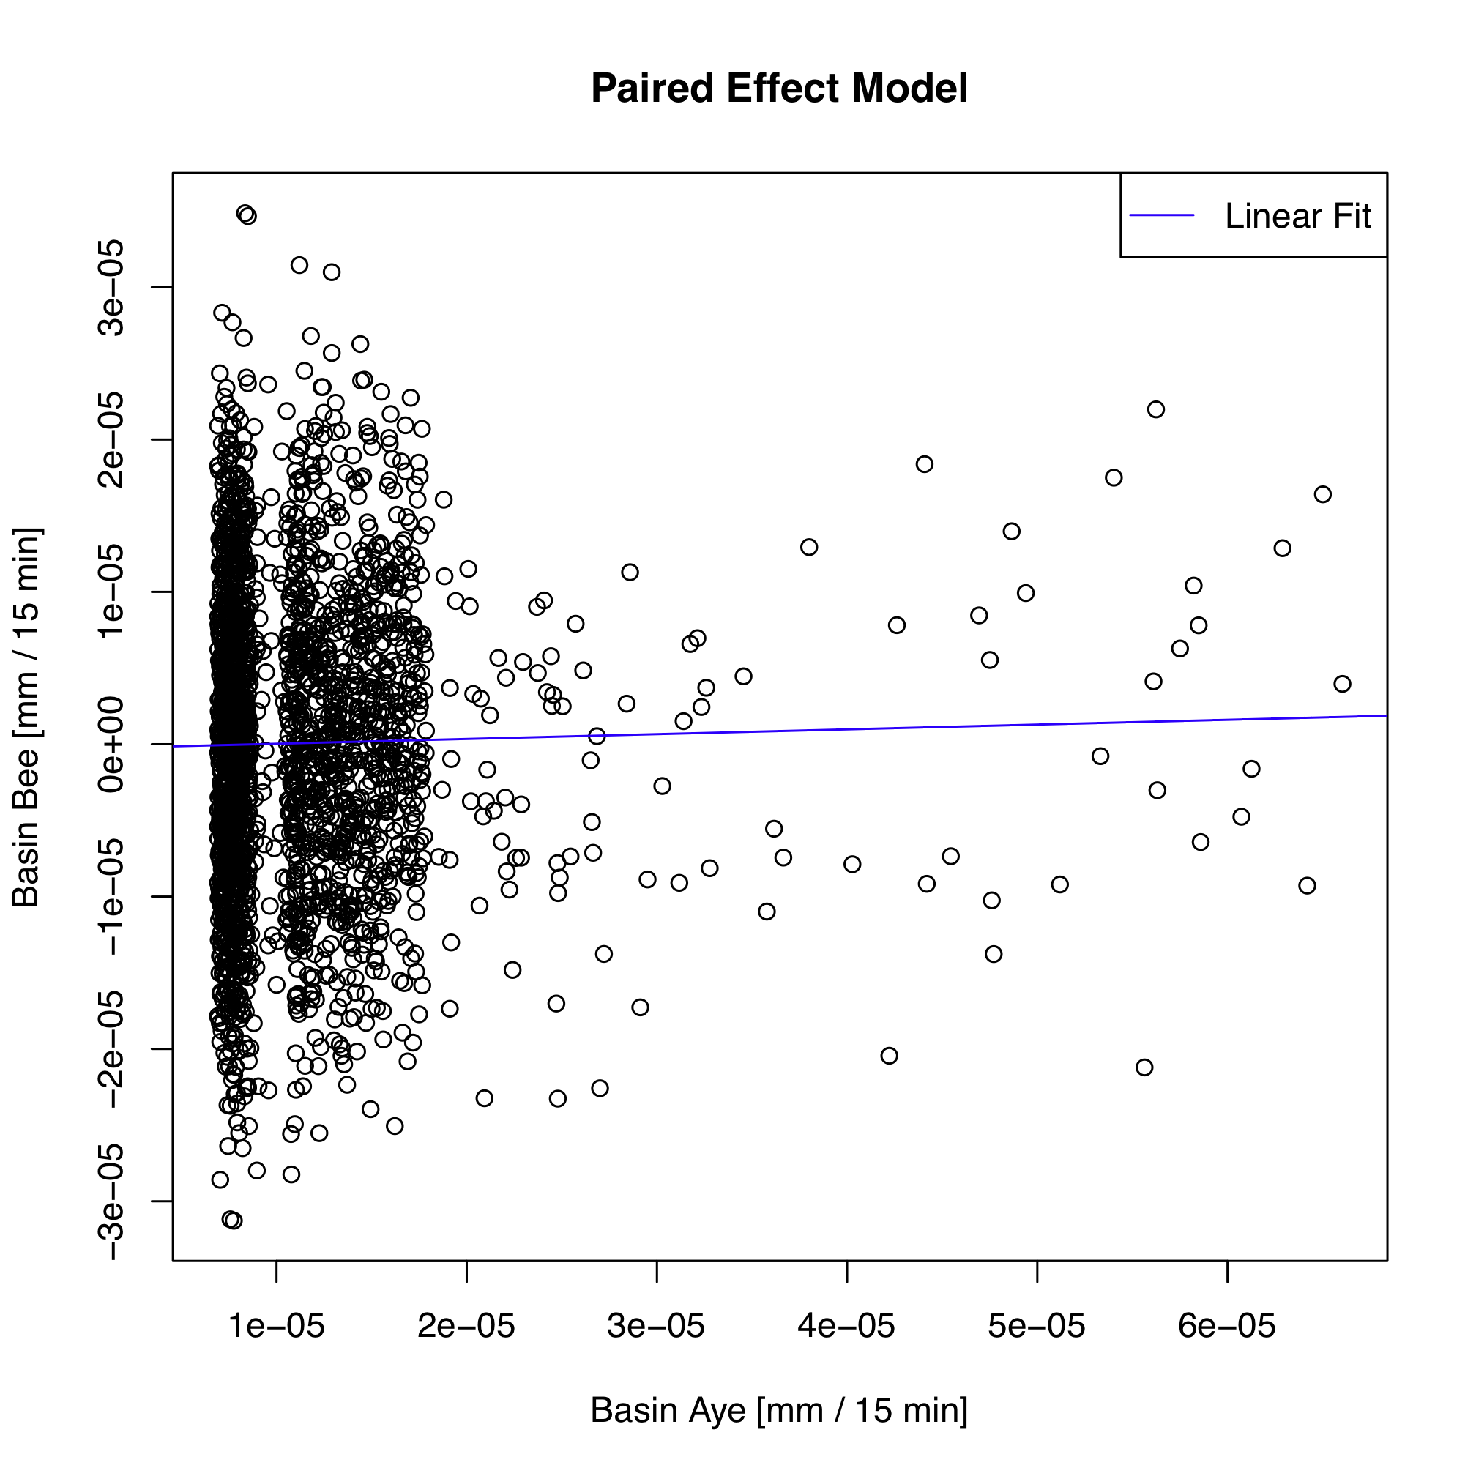
Figure 5
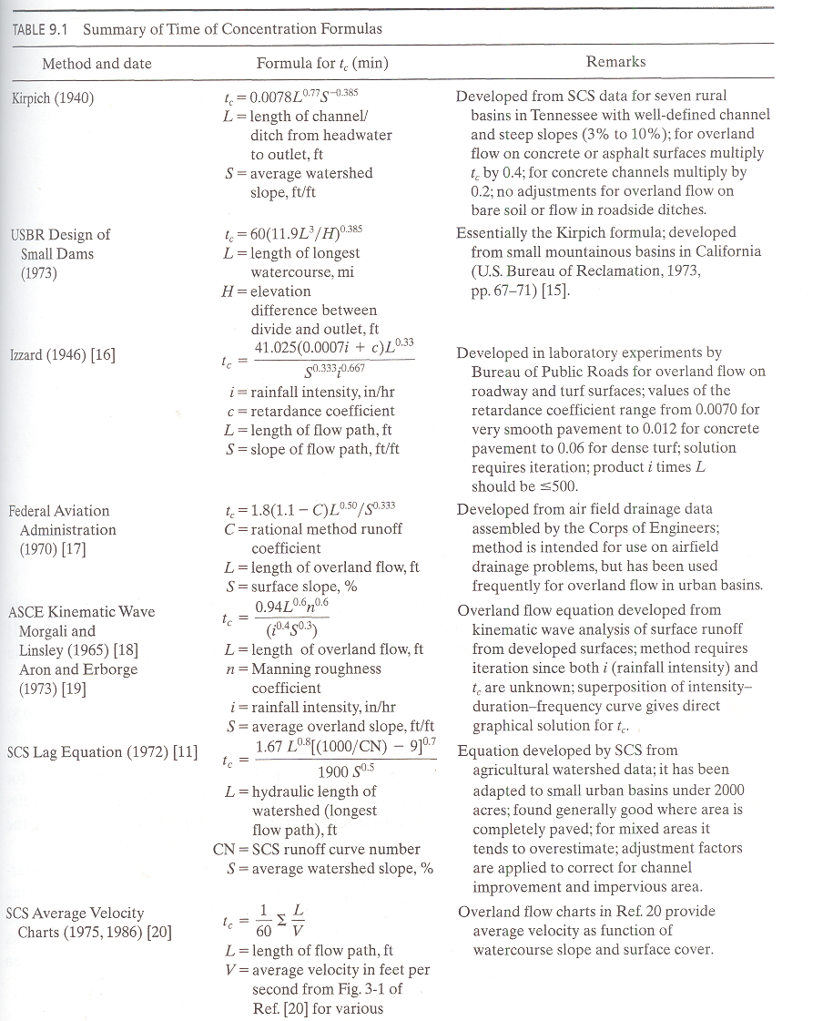
Table 1

