## VLIW Processor (very long instruction word)

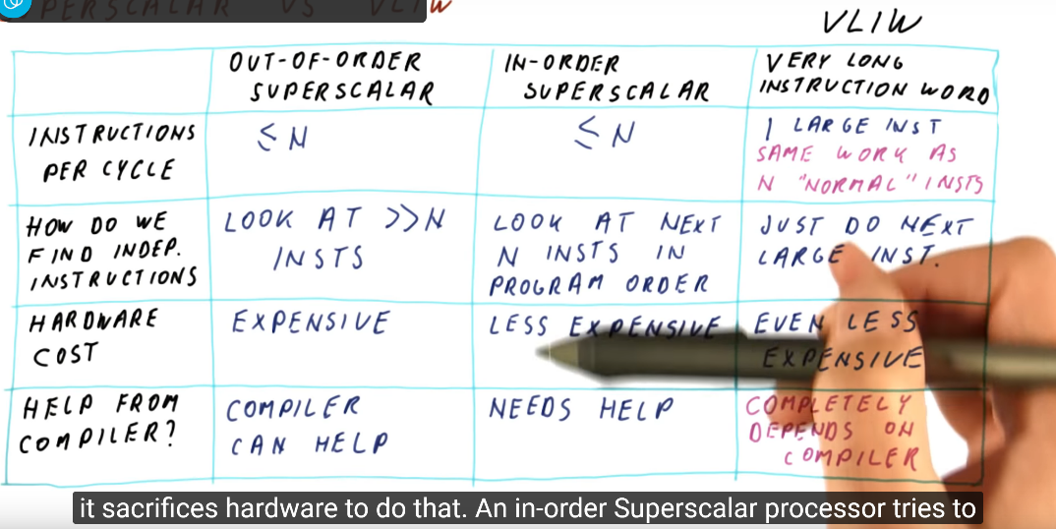

With independent instructions, VLIW will be the same size as superscalar. But if all the instructions are depending on each other, the size is increase to 4 times.

