# Fault Tolerance

Dependability

* Specified Service: what behavior should be
* Delivered Service: actual behavior]
* Fault: module deviates from specified behavior

Programming mistake (latent error, if executed, error will happen)

* Error: actual behavior within system differs from specified behavior

Activated fault (when executed), from latent error to effective error

* Failure: system deviates from specified behavior

Error is resulted by fault. But not every fault results error. For error, if system never use the things related with that error or the error will not cause system working differently, there is no system failure.

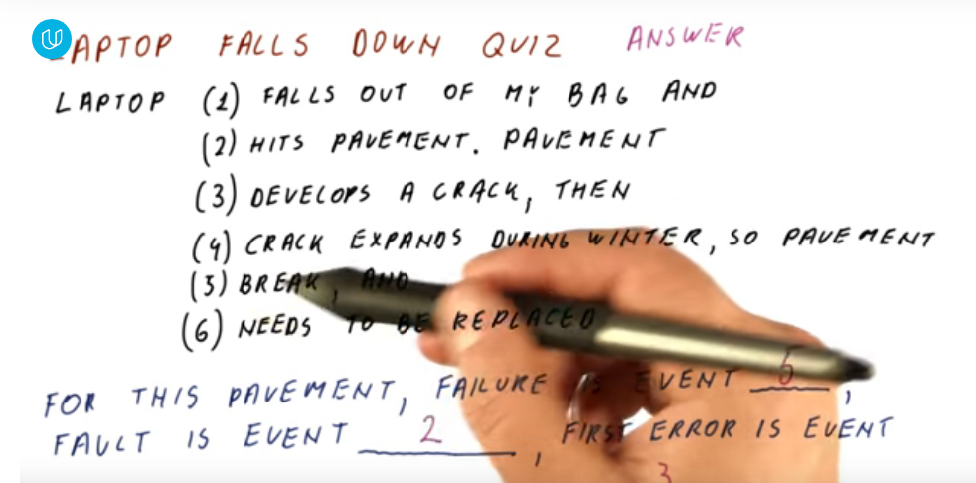

Fault should be latent error. So it is the event might cause problem, which is laptop falling into ground.

## Reliability

System in one of two states:

Service accomplishment: as specified behavior

Service interruption: not expected behavior

Reliability:

* Measure continuous service accomplishment
* Mean time to failure (MTTF):

How long we have service accomplishment until next service interruption

Availability:

* Percentage of overall time that a system is in accomplishment stage
* Mean time to repair (MTTR):

How long it takes to accomplishment once the system is in service interruption

* Availability = MTTF/ (MTTF + MTTR)