## Memory Technology

Arbitrary access any position

* Static Random Access Memory (SRAM): retains data while power supplied (several transistors per bit), typically faster
* Dynamic Random Access Memory (DRAM): lose data if not refresh data (one transistor per bit), typically slower

Trench cell is smaller than capacitor, leading smaller chip size (cheaper)

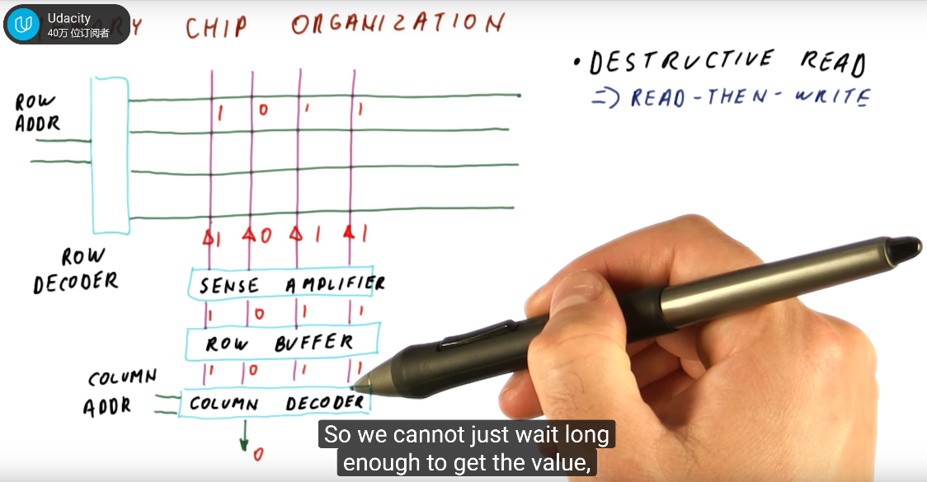

Destructive read: after reading from address, original bits no longer valid. Sense amplifier will reverse the direction and raise those bits to proper level. Also, row need to be refreshed periodically (refresh row counter)

