## horizontal line

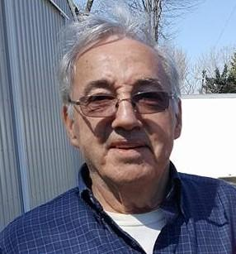

Hassel

USER PERSONA

# Overview

Hassel is a hard-working family-man. He wakes up early to take on the day, you’ll never see him loafing until the sun goes down. At anytime, Hassel has 2-3 dogs in his home, as he frequently watches dogs for neighbors and his family. Hassel does not use technology outside of a TV and playing solitaire on his Gateway computer.

# Likes & Dislikes

1. Helping others. Solving Problems. Fixing Broken Things.
2. People who give up easily, or that are aloof to the detriment of others.