Quest of the Monoliths

Summary

Mummies are reawakening by a mystical artifact brought to Ancient Egyptian ruins. Using the power of the artifact, the mummies slide around in their caskets, with the ultimate goal of regaining control of the decrepit bodies by being reunited with the artifact.

Location

The game is located in the weathered ruins of an ancient Egyptian civilization. The game’s levels will primarily be set outside.

Time of Day

Noon on a hot, sandy, desert day.

History

An artifact is brought to the ruins which partially reawakens mummies. Without contact with the artifact, the mummies can only slide and bounce around in their caskets. To fully be awakened and escape the confines of their caskets the mummies must find the artifact hidden deep within the tomb.

Inhabitants

Mummies

Mechanics

Player controls multiple caskets at a time, each input moving it one space on a grid-like level. Obstructions on the grid prevent caskets from moving.

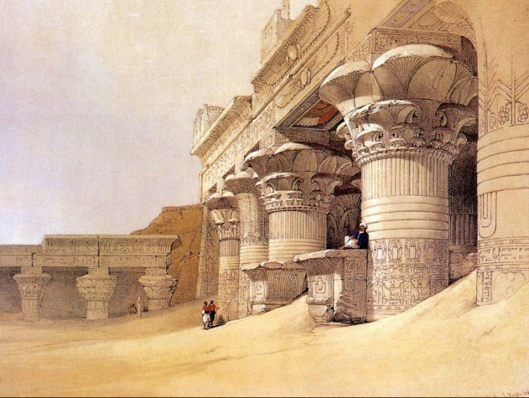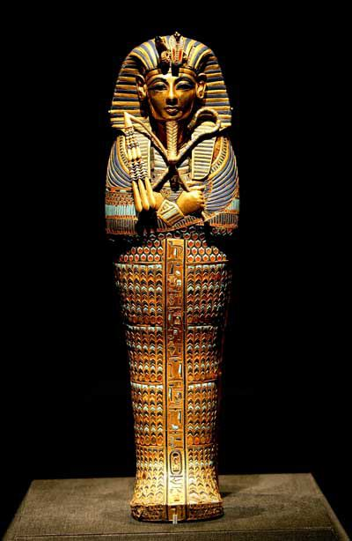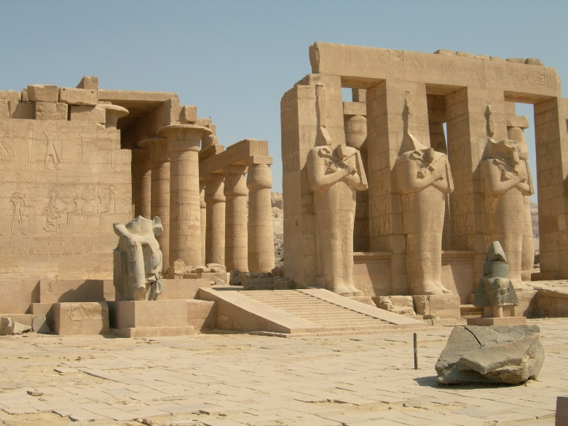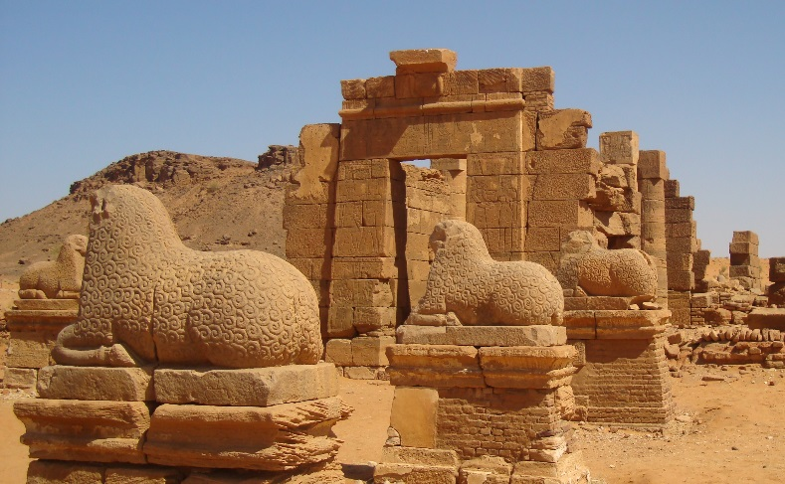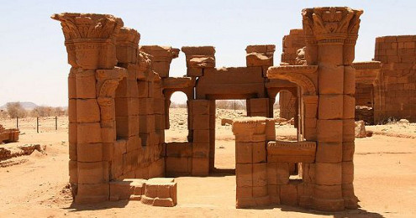Concept Art & Reference