Assembly Instructions for the Sputterizer

S. Vance Greenface Labs

8/10/2019

The Sputterizer comes as three printed circuit boards, referred to as “the selector board”, "the sputterizer board" and "the front panel" in this document.

Front Panel

The only components permanently attached to the front panel are the hex stand-offs (SO1 - SO4) and the associated screws (SC1 - SC4).

Start by attaching the standoffs to the front panel.

Selector Board

1. Install all components except LEDs first. Make sure rotary encoder is flush to board.
2. Place LEDs into stand-offs then screw front panel onto the board before soldering. Note that the long lead goes into the round hole.

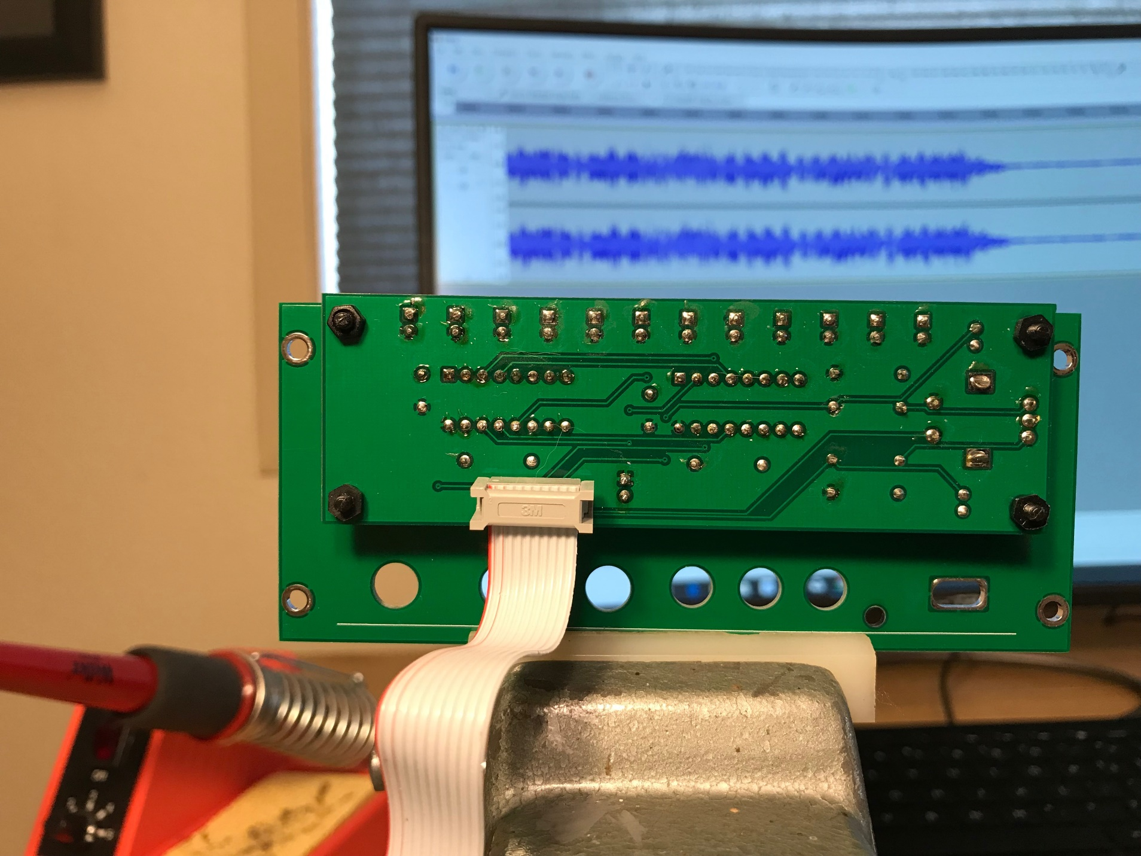

Sputterizer Board

1. Install all components except LED. Try to keep jacks and pots aligned.
2. Temporarily attach Sputterizer board to the front panel.
3. Position LED so that it pokes through the hole on the front panel. Solder into place.
4. Connect the Sputterizer board to the Selector board with the ribbon cable.
5. Test to insure proper operation.
6. Re-attach the front panel. Making sure the fit is snug, solder the USB connector to the front panel from the back.

