|  |
| --- |
| **Create Account** |
|  |
|  |

|  |
| --- |
| **Login** |
|  |
|  |

|  |  |
| --- | --- |
| **Logout** | |
|  | |
|  | |
|  | |
|  | |
| **Manage Account** |
|  |
|  |

|  |
| --- |
| **Delete Account** |
|  |
|  |
|  |

|  |
| --- |
| **Link Financial Account** |
|  |
|  |

|  |
| --- |
| **Create Transaction** |
|  |
|  |
|  |

|  |
| --- |
| **Schedule Transaction** |
|  |
|  |

|  |
| --- |
| **Create Budget** |
|  |
|  |
|  |

|  |
| --- |
| **Calculate Cash Flow** |
|  |
|  |

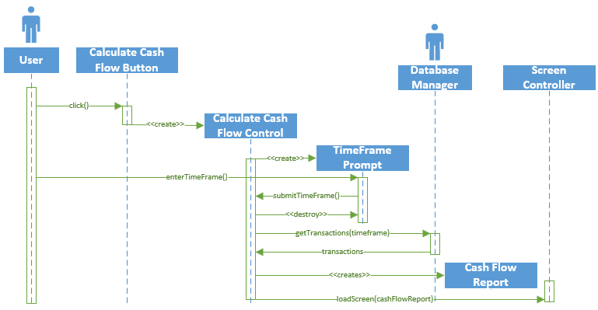

|  |
| --- |
| **Calculate Slippage** |
|  |
|  |
|  |

|  |
| --- |
| **Check Credit Score** |
|  |
|  |

|  |
| --- |
| **Export Data** |
|  |
|  |

|  |
| --- |
| **Print Data** |
|  |
|  |

|  |
| --- |
| **Refresh Data** |
|  |
|  |