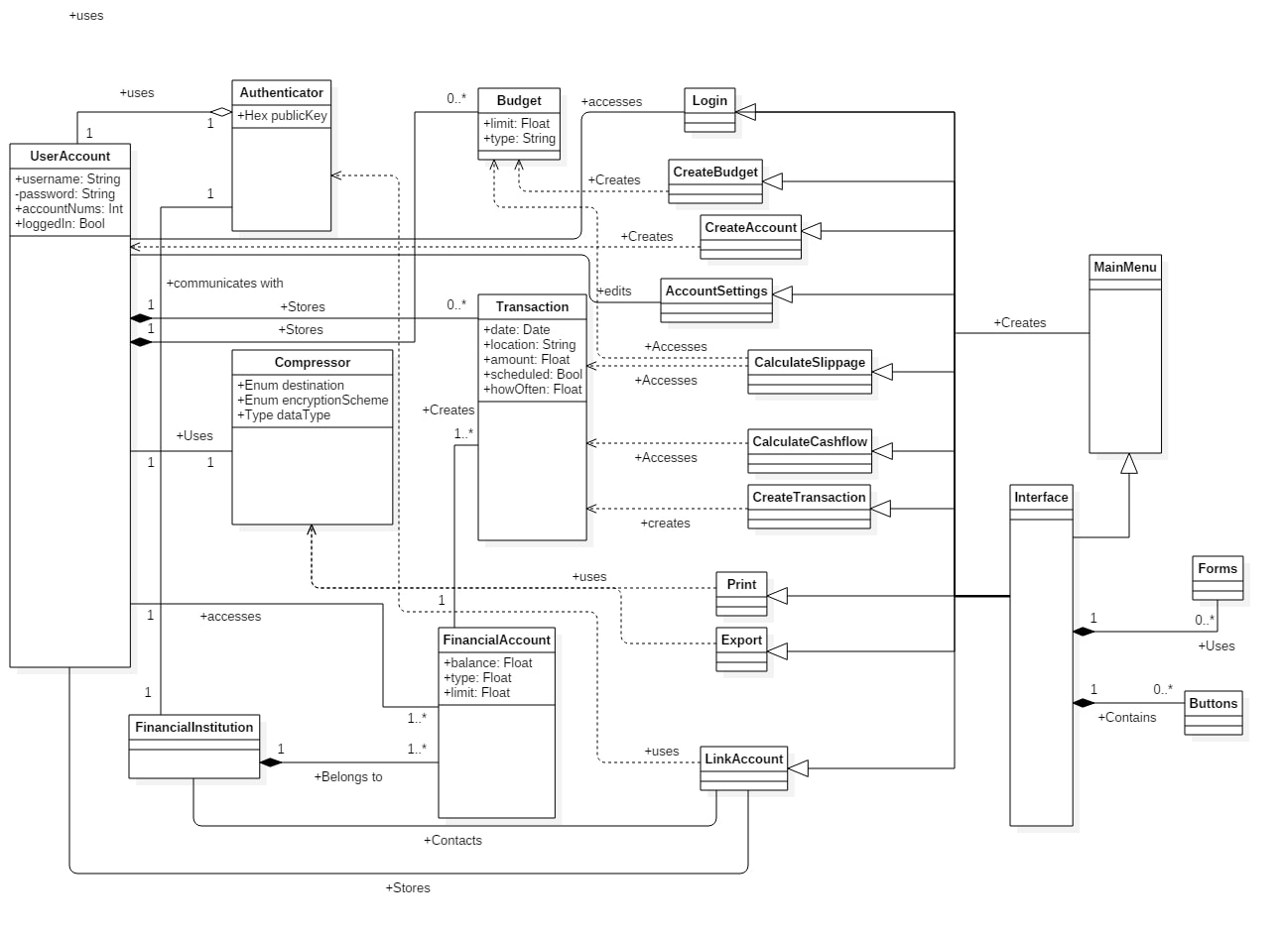

* Context Transaction inv:

self.amount != 0

* Context FinancialAccount inv:

Authenticator.authenticate(FinancialAccount) == Enum “account verified”

* Context Budget inv:

self.limit > 0

self.type != NULL

* Context Login::login()

pre: UserAccount -> forAll(self.loggedIn = false)

post: userAccount.loggedIn = true