**BossDocument.doc – Cameron Meyer**

*Movement Patterns:*

* Patrol: Boss moves randomly between several predetermined locations in the arena

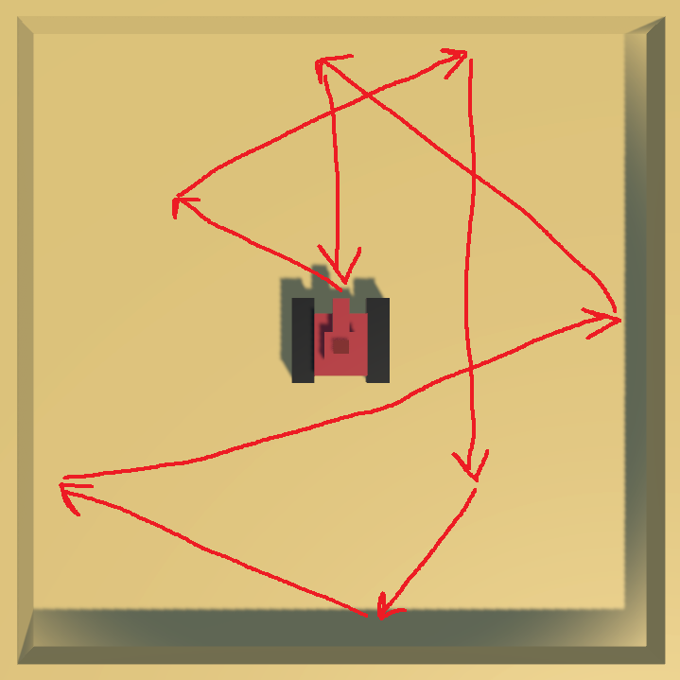

* Rush: Boss revs up, then moves quickly directly towards the player. If the player is hit, they will receive damage (though the player may be damaged by touching the boss during the patrol phase as well)

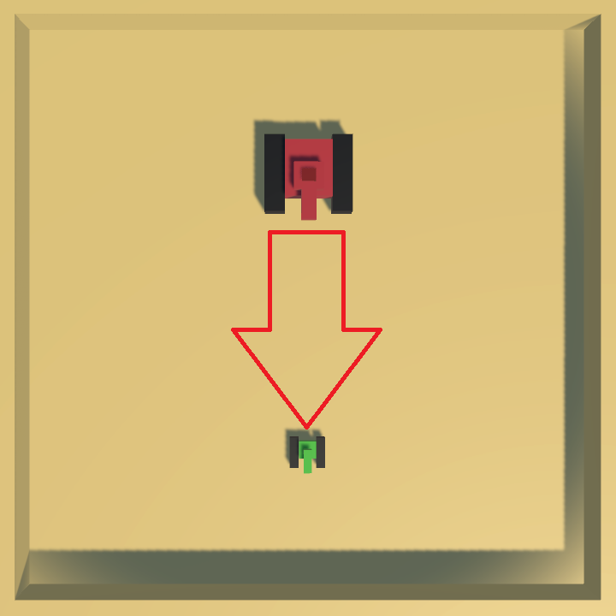

*Damage Attack Patterns:*

*\*Note: The boss always aims its turret towards the player\**

* Burst fire: Boss quickly fires off ~5 small projectiles in quick succession towards the player. Ideally, these projectiles will fan out as they move, acting as a bullet hell-esque attack.

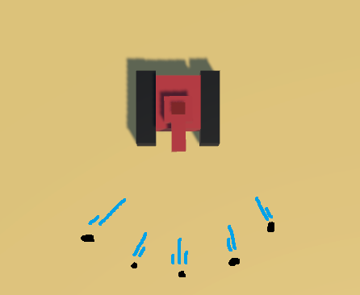

* Laser: The boss will briefly stop moving to charge the laser, then release the concentrated burst towards the player and move its turret slightly in one direction.

