Bring Back the World’s Fair
David Rejeski

Preface: One of my regrets in life was to be born too late to have visited some of the great world’s fairs. Between 1900 and 1940 there were over a hundred of these public spectacles with names like the Exposition universelle et internationale, the British Empire Exhibition, and the Century of Progress International Exposition. By the time I was a kid growing up in the 1950s and 60s, the only way to visit the future was to sit in front of a small box in the living room waiting for someone to tell me that I had just crossed over into the Twilight Zone. When I heard about the 1939 World’s Fair in New York and the Futurama exhibit, I spent a few weeks secretly wishing my parents had met twenty years earlier. Here’s why.

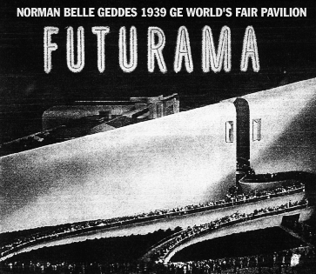
On April 30, 1939, John Ozman, a 48-year old mechanic from Ohio drove across the Tri-Borough bridge in his two-cylinder 1900 Holsman automobile. He had driven 4,350 miles from Santa Monica, California to New York City on 203 gallons of gas, financing his trip by selling 2,300 postcards of his automobile at 10 cents apiece. He had come to see the future. Just a few miles south of Manhattan, 1,200 acres of city dump had been turned into a vast advertisement for tomorrow and a 75-cent ticket would get you in the door, of the World’s Fair. Ozman joined over 240,000 people who walked through the turnstiles on opening day. Just a month and a half earlier, Hitler had invaded Czechoslovakia, but the decaying situation in Europe seemed far away for the hoards of future-seekers at Flushing Meadows.

There was a lot to see at the World of Tomorrow, as the fair was called. Five hundred movies ran every day in over fifty auditoria. Each day opened with a new celebration, May 26th was National Poetry Day, May 28th was Magicians Day, August 31st was Coffee Day, and October 27th was National Pest Control Day. And then there was Norway Day, Canada Day, French Day, and the World Poultry Congress beginning on July 23^{rd.} For the kids there was Candy Day (followed by Dental Day, shortly after). Every major corporation was represented, IBM, Ford, Dunlap, Chrysler, AT&T, even Ex-Lax had brought in an internationally known designer to help hype the palliative effects of its product to the thousands of fair-goers.

But by May, polls done by the American Institute of Public Opinion confirmed what the people standing in lines already knew, the most popular exhibit was Futurama -- General Motors vision of the American landscape in the year 1960. The exhibit, formally called “Highways and Horizons”, was attracting 28,000 people a day. On October 13, when mechanical difficulties caused GM engineers to shut it down for a short period of time, there were 3,000 people waiting in line.

Futurama was a greeting card sent from a future America where sleek automobiles moved frictionlessly between interconnected cities and expansive, tree lined suburbs. It was the creation of New York theater designer Norman Bel Geddes. Bel Geddes was the primary purveyor of what was called the new “stagecraft” that had swept through New York theaters in the 1930s. His set designs had won him international acclaim. In Bel Geddes, General Motors found the person who could, in the words of GM President
William S. Knudsen, “…present a living panorama of what traffic control methods and automobile transportation on the super highways of the future may conceivably be like.” Of course, for GM that meant more cars. Only two years earlier, Miller McClintock, Director of Street Traffic Research at Harvard University had calculated that “the American people need and could buy 5 – 10 million more automobiles than are in use if the country had an efficient street system.”

Bel Geddes was no stranger to Worlds Fairs, having served as an advisor to the Chicago Fair in 1933. But Futurama was to become his opus, a synthesis of technology and hope for a country emerging from a decade of economic and social hardship. In 1932, Bel Geddes had written that, “Industry is the driving force of this age” and he maintained that the U.S. was at the cusp of the machine age, stating that “Although we built the machines, we have not become at ease with them and have not mastered them.” Unlike many of his contemporaries in the design community, his interests went beyond rounding the hard edges of blenders, soda dispensers, and autos. He was fascinated by the convergence of machines, society, art, and the emerging consumer class. Futurama was a once-in-a-lifetime chance to place a compelling vision of the new machine age on a vast public stage.

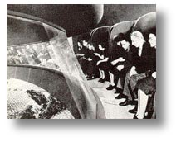
Visitors entering the exhibit sat in six-foot, high-backed chairs -- their own personal opera boxes -- looking down at an expansive and exquisitely detailed diorama that stretched for seven city blocks. It featured over one million trees (with18 varieties), 500,000 buildings, 50,000 autos (with over 10,000 in motion) and was the largest scale model every built at the time. This was Google Earth without the Internet, satellites, or a laptop. A 1,600-foot continuous conveyor belt, moving at 102 feet per minute, whisked people through and around the diorama in just 15 minutes. 15 minutes to go thirty years into the future. At the end, the chairs emerged at a full-scale construction of an intersection, as though you had literally fallen out of the sky and landed safety in mid-town Manhattan in 1960.

But the visual effects were only part of this multimedia extravaganza. As visitors gazed down on the countryside and cityscapes of the future, a complex audio system weighing 20 tons delivered 150 pre-recorded messages to each viewer at exactly the right spot in their journey --- sound bites that explained the vision and the path to this marvelous world of tomorrow.

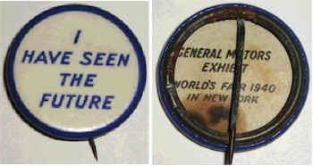
Bel Geddes had created a god’s-eye view of the American landscape of 1960 that people could almost reach out and touch. It was an engineering marvel that transported visitors to the engineered world of tomorrow. The design kept people moving – entertaining and enticing them -- but it kept them largely alone in their seats, grappling with their thoughts. Most visitors emerged mesmerized and silent and, upon exiting, received a button that stated simply “I Have Seen the Future.”

Bel Geddes vision of superhighways that linked major cities and the new suburbs was a radical proposition, not because such highways could not be engineered and built, but because of what many considered the prohibitive costs (estimated at close to $3 billion in 1940). After touring Futurama, New York city planner Robert Mosses commented that, “It is all very beautiful, but I don’t think it would be very practical. Think of the bond issue that would be necessary for a project like that.” Then there was the more vexing question of “Who needs transcontinental highways anyway?” There simply didn’t seem to be any demand. In 1940, the average number of cars that moved daily from the Pacific Coast to points east of Idaho, Arizona, and Nevada was 2,500. Traffic in the other direction was below 400 cars per day -- hardly enough to stimulate a national debate about a new highway system that could cut deep into taxpayer’s pockets.

But people loved the automobile, felt the lure of mobility, and understood that without better roads they would spend their future looking at the rear bumpers of other cars. In 1939, the average speed of autos in New York City was 15 miles per hour, hardly much of an improvement from the 11.5 miles per hour during the horse-and-buggy era. And the economic cost of accidents in the U.S. was estimated at $1 billion annually leading many to begin to seek alternatives that could offer both speed and safety. Futurama put together mobility, safety, and a functioning urban-suburban infrastructure into one neat visual package.
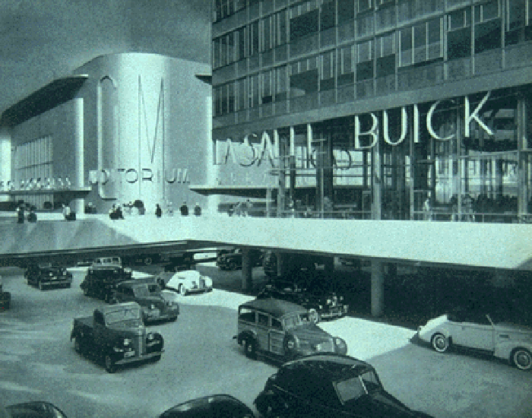
In the end, five million people visited Futurama. Why was it such a success? After all, there were 300 dioramas created for the World’s Fair. Every major automobile manufacturer had something to show the masses and there were technological marvels at every turn, from prototype TV’s to new synthetic plastics. Bel Geddes was competing with the best designers of the day, like Henry Dreyfuss, who had designed the Fair’s iconic Perisphere. But no one achieved the reach and the contagious effect of Bel Geddes’s design.

Futurama was a three-dimensional scenario with a sound track. It changed the way people thought about the world and its possibilities by shifting their perspective, both physically and intellectually. It commoditized the future, something that Disney World and thousands of Hollywood blockbusters would take advantage of decades later. Within a one-year time period, almost 5 percent of the U.S. population had seen Futurama – an amazing feat in a time before television. Think about creating an exhibit that can reach 28,000 people a day and provide them with an intimate and fascinating experience. The Museum of Modern Art drew 19,500 people on its best “free admission” Saturday. Many good web sites will not receive 25,000 unique visitors in a day. Bel Geddes moved almost 30,000 people a day through his vision and he did that with 1939 technologies.

In the end, Futurama glorified the fruits of scientific research and tried to clarify the connections between research, new industries, jobs, and new life styles. When it closed, the U.S. teetered on the edge of war. The Poland and Czechoslovak pavilions still stood at the fair, though the countries were in chains. By the end of World War II, the study of the future would become a serious business, no longer the province of writers, designers, filmmakers, and corporate ad men. It fell to a new cadre of technocrats, engineers, and planners armed with technologies of unbelievable power and reach. But when 1960 rolled around, and people woke up in their suburban bedrooms, they drew the drapes back on an American landscape that looked a lot like what many had seen on a short, 15-minute ride back in 1939.

But how beautiful it was - 'tomorrow'
we'll never have a day of sorrow
we got through the '30's, but our belts were tight
we conceived of a future with no hope in sight
we've got decades ahead of us to get it right
I swear - fifty years after the fair

Amiee Mann
“Fifty Years After the Fair”

