Maximizing Energy Efficiency in IoT Systems for Precision Agriculture

Cameron Thomas

*University of Florida Electrical and Computer Engineering*

*Internet of Things for Precision Agriculture*

Gainesville, FL

cameronthomas@ufl.edu

*Abstract*— Internet of Things (IoT) sensor systems have become a pivotal source of data for both growers and researchers in the domain of precision agriculture. However, the deployment of IoT systems in rural areas is fraught with challenges, including the lack of cellular connectivity, limited access to reliable power, and harsh environmental conditions. This thesis aims to address the critical issue of providing efficient and sustainable power to data collection and network systems in remote agricultural areas, through the design and implementation of a solar harvesting and battery charging module. The proposed system utilizes a maximum power point transfer (MPPT) charger that enables optimal voltage and amperage balance on the power curve of the solar cell, thus ensuring a constant supply of power to the 12-volt lead-acid battery. A novel data-logging system programmed in micropython to receive real-time data on battery and solar panel voltages and currents via I2C to continually monitor power system performance. This thesis deploys a methodology for testing solar power efficiency over time to ensure system longevity and minimize user intervention in a rural environment. The data logging system effectively recorded critical system data and revealed that the power system could provide a sustainable power supply, albeit with an efficiency of up to 80% due to the current draw limitations of the system.

Keywords—IoT, precision agriculture, solar energy

# Introduction

The rapid development of Internet of Things (IoT) technology has led to its integration into various industries, including agriculture. The application of IoT in agriculture, also known as precision agriculture, has transformed traditional farming methods by introducing data-driven decision-making processes, real-time monitoring, and analysis. Precision agriculture involves the application of technology to optimize farming operations by improving decision-making processes, reducing waste, and enhancing crop yields. IoT technology has the potential to transform traditional farming methods by allowing farmers to collect and analyze data from various sources, such as sensors, satellites, and drones. This data can provide insights into soil conditions, weather patterns, crop growth, and pest infestations, enabling farmers to make informed decisions that optimize their resources, reduce costs, and improve overall efficiency.

Power electronics play a crucial role in the development of sustainable and efficient power systems for IoT devices in rural areas, where access to reliable power sources can be limited. The use of renewable energy sources such as solar, wind, and hydroelectric power is becoming increasingly popular in the design of power systems for IoT devices in precision agriculture. Power electronics devices such as maximum power point trackers (MPPTs), DC-DC converters, and inverters are utilized to improve the efficiency of energy conversion and regulate the power output of renewable sources. Imperative to solar power utilization are DC-DC converters. DC-DC converters are electronic circuits that convert one DC voltage level to another DC voltage level, typically with higher or lower voltage, using the principles of electromagnetic induction and electrical energy storage. The buck topology is commonly used in solar-powered systems to regulate the output voltage from the solar panel to a level suitable for charging batteries and powering loads. A buck converter reduces this voltage to a level that is compatible with the battery or load, while also maximizing the power delivered to the load, as opposed to linear regulators and other rectifiers that are much less efficient. This is because of the power MOSFET, characterized by low on resistance and ability to handle high voltage and current, resulting in minimized switching losses. These ideal characteristics are achieved by gate lengths approaching one micron, facilitating current flow, high breakdown voltage, and optimal gate-source capacitance. Gate-to-source capacitance proves to be an influential factor in the efficiency of the converter and will be discussed further. The integration of power electronics and IoT technologies in precision agriculture has the potential to revolutionize traditional farming methods by providing real-time data on crop growth, soil conditions, and weather patterns. The availability of this data can enable farmers to make informed decisions and optimize their resources, resulting in increased crop yield and profitability.

Powering IoT systems for precision agriculture in remote rural areas is a challenging task due to several factors. First and foremost, many rural areas lack reliable access to the electrical grid, making it difficult to provide a constant source of power for IoT devices. Additionally, harsh weather conditions such as extreme temperatures, high winds, and heavy rainfall can damage power infrastructure, leading to power outages that disrupt IoT system operation. Moreover, the placement of IoT devices in remote and dispersed locations makes it challenging to establish reliable data connections and transmit data to the cloud for analysis. Finally, powering IoT systems using traditional fossil fuel generators can be expensive and contribute to environmental pollution. Therefore, the deployment of sustainable and efficient power systems such as solar harvesting and battery charging modules is essential to address the challenges of powering IoT systems for precision agriculture in remote areas.

This design implements maximum power point tracking that optimizes the power output of photovoltaic (PV) solar panels. The power output of a PV panel is a function of the current-voltage (I-V) characteristic, which is influenced by environmental factors such as irradiance and temperature. MPPTs operate by dynamically tracking the maximum power point (MPP) of the PV panel, which corresponds to the intersection of the I-V curve and the maximum power line [6]. This is achieved by implementing a feedback control loop that adjusts the operating point of the PV panel to match the MPP. The MPPT continuously samples the output voltage and current of the panel and uses this information to calculate the power output. Based on this calculation, the MPPT adjusts the output voltage to ensure that the panel operates at the MPP voltage. This results in maximum power transfer from the PV panel to the load or battery while ensuring that the PV panel operates at its maximum efficiency. The use of MPPTs is critical in solar-powered IoT systems for precision agriculture and other applications where efficient use of energy is paramount.

Monitoring power system data of IoT systems for precision agriculture is essential for ensuring reliable and efficient operation. Power system data, such as voltage and current levels, power output, and energy consumption, provide critical insights into the performance and health of the system. By monitoring this data, engineers can detect and diagnose faults, optimize system performance, and identify areas for improvement. Furthermore, power system data can be used to estimate the remaining battery life, which is critical for ensuring the uninterrupted operation of the IoT system. In addition, the data can be used to optimize the power management strategy, ensuring that power is used efficiently and effectively. Overall, monitoring power system data is essential for ensuring the reliable and efficient operation of IoT systems for precision agriculture, enabling growers and researchers to collect accurate and timely data to make informed decisions and improve crop yield and quality.

# Methodology

## Sentinel Power System Design

A block diagram and software flowchart of the power system and is seen in the Appendix. The Sentinel’s power system is made up of a 30-50W solar cell, a 12V lead acid battery, and an commercially available, open-source maximum power point transfer (MPPT) solar charger equipped with an intelligent DC-DC synchronous buck converter design.

1. Solar Charger Block Diagram [1]

### MPPT Design Overview: The MakerPower MPPT Solar Charger equipped with a synchronous buck converter was chosen as a rugged option to handle battery charging. Operation is plug-and-play but can be further configured through a Raspberry Pico connected to the MPPT's digital interface. The processor implements a perturb and observe algorithm in which it adjusts voltage from the solar cell by a small amount, observes whether power increases, and continues to adjust in that direction until power no longer increases [1].

#### Synchronous Buck Converter: The MPPT SCC implements a synchronous DC-DC buck converter topology, where both Q1 (an N-channel MOSFET) and Q2 (a P-channel MOSFET) work together to regulate the voltage output. The converter steps down voltage by a ratio of duty cycle while stepping up current. Q1 acts as the high-side switch while Q2 acts as the low-side switch. When the PWM signal from the microcontroller is high, Q1 turns on, allowing current to flow from the solar panel to the inductor and capacitor. This stores energy in the inductor's magnetic field. At the same time, Q2 is off, preventing current from flowing through it and blocking the current path to the ground. When the PWM signal is low, Q1 turns off, and the inductor tries to maintain current flow, but its magnetic field collapses, forcing current to flow into the load, providing power. At the same time, Q2 turns on, creating a path for current to flow back to the solar panel, completing the circuit [Figure 3]. When Q1 turns on again the body diode D2 will experience reverse recovery resulting in some power loss. In addition to diode reverse recovery, Q2's gate-to-source capacitance can prove problematic by turning Q2 on again due to its stored charge, resulting in oscillations. This is mitigated by the resistor, R6, at the gate of Q1, decreasing , thus decreasing the current to potentially charge up the capacitance [4]. Finally, the inductor and capacitor create an LC circuit, isolating the DC component of the voltage of the switching node, resulting in a stable output voltage directly proportional to the duty cycle, D, and solar panel input voltage, , described using the equation 1, essentially averaging the switching voltage shown in figure 2. The switching period is denoted by , and is proportional to the duty cycle by the factor , switching frequency. It should be noted that the following equations are idealized and don't account for switching losses. [4]

1

2

1. Switching Waveform [4]

1. Solar Input Buck Converter Schematic

#### The use of a synchronous buck converter allows for more efficient power transfer as Q2 conducts while Q1 is off, reducing the voltage drop and power loss compared to a non-synchronous buck converter. However, implementing a synchronous buck on a homemade board comes with problematic switching logistics and for years this topology was a trade secret in the industry[2]. Challenges include a current flow back into the driving MOSFET, causing it to conduct current, and draining the battery. Eventually, as the flow back current increases, the driver MOSFET will be burned. Therefore, it is highly recommended that an application-specific integrated circuit (ASIC) be utilized for synchronous buck converters, which are equipped with flow-back current control to drive the buck seamlessly. Alternatively, the MPPT's firmware may be tailored to take into account the flow back [2]. For the present experiment, the chosen MPPT charger adopted the latter approach as well as over-voltage and over-current protection, and reverse polarity protection.

#### Efficiency vs. Switching Frequency: Switching frequency refers to the rate at which the high-side power MOSFET switches on and off, which in turn controls the voltage and current output of the converter and is usually in the range of several tens of kilohertz to a few megahertz. A higher switching frequency requires smaller inductors and capacitors, but the trade-off is an increased switching loss in the MOSFET. The choice of switching frequency depends on desired efficiency, output ripple, and size constraints of the system. switching frequency and duty cycle are inversely proportional[5]. This means that if the duty cycle is increased, the switching frequency will decrease, and vice versa. This relationship is because the output voltage of the buck converter is determined by the ratio of the on-time of the switch to the switching period(duty cycle), which is equal to 1 divided by the switching frequency. Increasing the duty cycle increases the amount of time that the switch (Q1) is on, which allows current to flow through the inductor (L1) and to the output capacitor (C6). As a result, the output voltage increases. On the other hand, decreasing the duty cycle reduces the amount of time that the switch is on, which reduces the current flow to the output and causes the output voltage to decrease. It's important to note that the duty cycle of a buck converter is limited by the maximum input voltage and the minimum output voltage. The duty cycle cannot exceed the ratio of the output voltage to the input voltage, otherwise, the switch will remain on for too long and overheat or burn out [4]. Therefore, the duty cycle is controlled by the MPPT microcontroller through feedback mechanisms to ensure that the output voltage remains stable while the input voltage and load change. Since the amount of energy captured by the solar panel changes with the position of the sun in the sky, the duty cycle must be adjusted to account for these voltage changes. The goal is to achieve maximum power transfer, which occurs at the point where the area under the solar cell's IV curve is greatest [Figure 5]. The MPPT charger uses voltage feedback to sweep through various PWM settings and determine the optimal duty cycle for the solar cell voltage. The relationship between switching frequency and buck efficiency is shown in figure 4, including the ratio of loss due to variate parasitics.

1. Switching Frequency vs. Efficiency of Buck Converter [5]

The solar charger offers abundant capabilities for IOT-class devices like the Sentinel, those of which can be harnessed in this project's future development, more details in Future Work. Status is always available via the digital interface and a status LED. Blinking patterns indicate if the charger is in the alert state, night mode, or charging is disabled. The charger also offers a maximum 2A at 5V output available via header or USB Type-A, which can be used to power a new pico or sensor. The USB expansion capability is provided with five unpopulated 0805-sized SMD resistor locations on the underside of the PCB.

### Solar Panel and Battery: The key electrical features of a photovoltaic (PV) cell or module can be described by analyzing the relationship between the voltage and current generated by the cell, as depicted in the I-V characteristics curve [Figure 5]. In this curve, the amount of solar radiation or insolation incident on the cell determines the current (I) produced, while any elevation in the solar cell temperature reduces the voltage (V) generated [3]. To achieve maximum power point transfer of a solar cell using a buck converter, the switching frequency can be adjusted based on the input voltage from the solar cell, changing the impedance seen by the cell. The goal is to maintain the converter in continuous conduction mode (CCM) and regulate the output voltage at the maximum power point (MPP) of the solar panel. The I-V characteristic curve is affected by atmospheric conditions such as irradiance and temperature, shown in figure 6.

1. Solar Cell IV and PV Curve

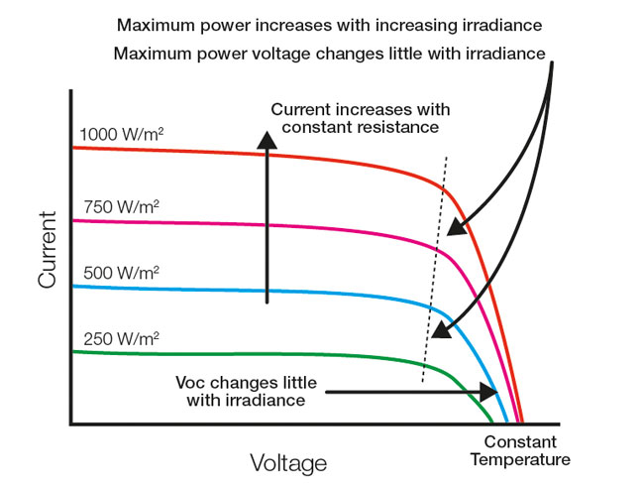

1. Solar Cell Irradiance Characteristic [6]

### To determine the size of the solar panel and battery needed to power the target system, the total energy consumption must be determined. This experiment aims to supply the Sentinal with about 1mA for 24 hours per day and 3A for thirty minutes a day when the Nvidia Jetson Nano is on. Thus, equation 2 results in about 80 WH of energy consumption. The target site of Quincy, Florida experiences 5.38 peak sun hours during the summer when the system will be in use, therefore, including solar panel efficiency of 25%, a 50-watt panel was chosen[Equation 3]. Finally, to determine the size of the battery needed, the amount of energy that needs to be stored to power the system during the night or when sunlight is not available must be considered. Taking into account Florida's risk to hurricanes and other tropical storms, good practice advises 2 to 3 days of autonomous operation, thus an 12V 18AH lead acid battery was chosen[Equation 4]. To optimize sunlight exposure, solar arrays are commonly installed at an angle that is most suitable for a particular location. For properties located in the majority of the United States, the best angle for installing solar panels on a south-facing roof is typically close to the latitude of the property, meaning directing them towards the average position of the sun rays [3]. Quiny's latitude corresponds to about 21 degrees which is used for the systems experimentation as well as the recommendation for deployment.

2

3

4

### Data Logging Software: To assess the efficiency of the MPPT SCC's intelligent PWM adjustment based on the sun's position and monitor key data points, a novel data logging software was developed for autonomous monitoring. Another critical experiment involved determining the number of days of autonomous operation that the battery could provide without sunlight, simulated through software by continuously running the data logging program for several days while covering the solar cell. The power required for running this program would be comparable to the pico's requirements in the Sentinel device, except for the power demands of the Jetson Nano. However, it is assumed that the Nano would seldom be on in these proposed weather conditions.

### The makerPower MPPT solar charger features an I2C interface for detailed operation condition readout and configuration parameter access. The Raspberry Pi Pico communicates with the device via I2C to display battery and solar panel voltage, battery and solar current, current charging state, and more configurable outputs. With 18 registers and 100kHz data rate support, the MPPT includes an important note that current Raspberry Pi computers cause I2C to fail when a slave device stretches the clock [1]. Therefore, the Raspberry Pi Pico I2C bus runs at 50kHz.

### The code defines a set of functions for reading and writing from the MPPT controller, and a real-time-clock(RTC), including the following dat points: date, time, solar voltage and current, battery voltage, battery charging current, and pulse-width modulation (PWM) data. This information is then written to the SD card in a CSV file format, with each new line of data appended to the file. The software mounts a FAT32 file system onto an SD card and writes to CSV files for further analysis.

### The development of the data logging software posed significant autonomy challenges that resulted in a more robust system. The CSV file continuously saves, ensuring that no data is lost due to loss of power or premature ejection. Furthermore, the MPPT's I2C registers posed significant issues that required weeks of debugging, limiting data collection time. Specifically, current values were not consistent with oscilloscope measurements. After contacting the MPPT's designer, the correct method of reading the I2C registers was achieved, the issue being a matter of data encoding.

# Results

#### The solar harvesting and battery charging module proposed in this thesis was implemented and tested on the roof of the University of Florida’s New Engineering Building. The results of the experiment demonstrate the efficacy of the system in providing efficient and sustainable power to data collection and networking systems in a Floridian environment. The performance of the maximum power point transfer (MPPT) charger was evaluated under varying solar irradiance and temperature conditions to determine its efficiency in maintaining a constant supply of power to the battery. Real-time monitoring of the power system's performance using the novel data-logging system revealed the effectiveness of the system in minimizing user intervention in a rural environment. The experimental setup was consistently operated over several days at varying sun exposure, temperature, and weather patterns. Of particular interest were the daily variance in solar voltage and the corresponding duty cycle requisite for optimal power transmission. Drawing from Equation 1, which serves as a benchmark for maximum efficiency, an assessment was undertaken to compare the output power of the maximum power point tracker (MPPT) to its actual performance. Ultimately, the experiment was run in perpetuity until the load could no longer be sustained by the battery.

## Performance Over Time

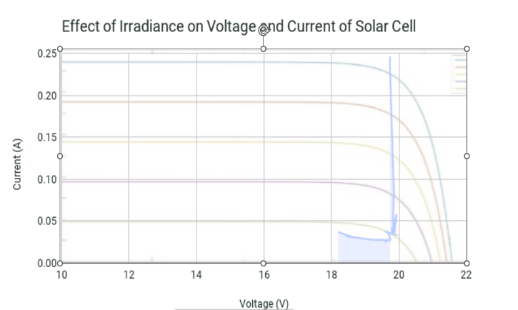

1. Solar Cell Irradiance Characteristic

The solar cell’s I-V characteristic was measured throughout the day, undergoing changes in the sun’s position [Fig. 7]. A notable observation is a proportional increase in the maximum power point, or the "knee" of the and characteristic curve of the solar cell, as solar irradiance increases. This phenomenon can be attributed to the fixed physical properties of solar voltage and the function of solar current, which is determined by the number of excited electrons generated by the incident solar energy. Consequently, an increase in solar irradiance causes a significant rise in solar current, while the voltage output remains relatively constant. However, high temperatures can adversely affect the performance of solar cells. Specifically, increased temperatures can result in decreased efficiency, as the higher thermal energy may cause the recombination of excited electrons and holes to occur at a faster rate. Consequently, the voltage and current output may deviate from the maximum power point, reducing the generation of electrical energy. This effect can have a significant impact on the overall performance of solar cells and should be carefully considered in their design and operation.

Subsequently, an examination was conducted on the MPPT SCC's performance during the day. As anticipated, the solar cell's voltage demonstrated a fluctuation from 0 volts during the night to approximately 20 volts during daylight hours. Correspondingly, the current generated by the photocell displayed a rise parallel to the voltage elevation; however, once the voltage stabilized, the current would recede to its steady state due to the constant load. In the case of a constant load current drawing from the solar panel, the solar current may remain relatively unchanged over time if the panel is generating sufficient power to fulfill the load requirements, resulting in solar current average of 29.6 mA. This circumstance is applicable to the MPPT solar charger since its design aims to sustain a consistent output voltage, irrespective of the solar panel's input current. Power output drops below zero at night when battery current flows in the opposite direction as it discharges. Power is also negative when the MPPT SCC is in its idle state, when it is not nighttime, but the solar panel is not harvesting enough energy yet to commence charging. The peaks seen from the brown power plot represent periods of time that the charger was in a floating state of maintaining battery charge. 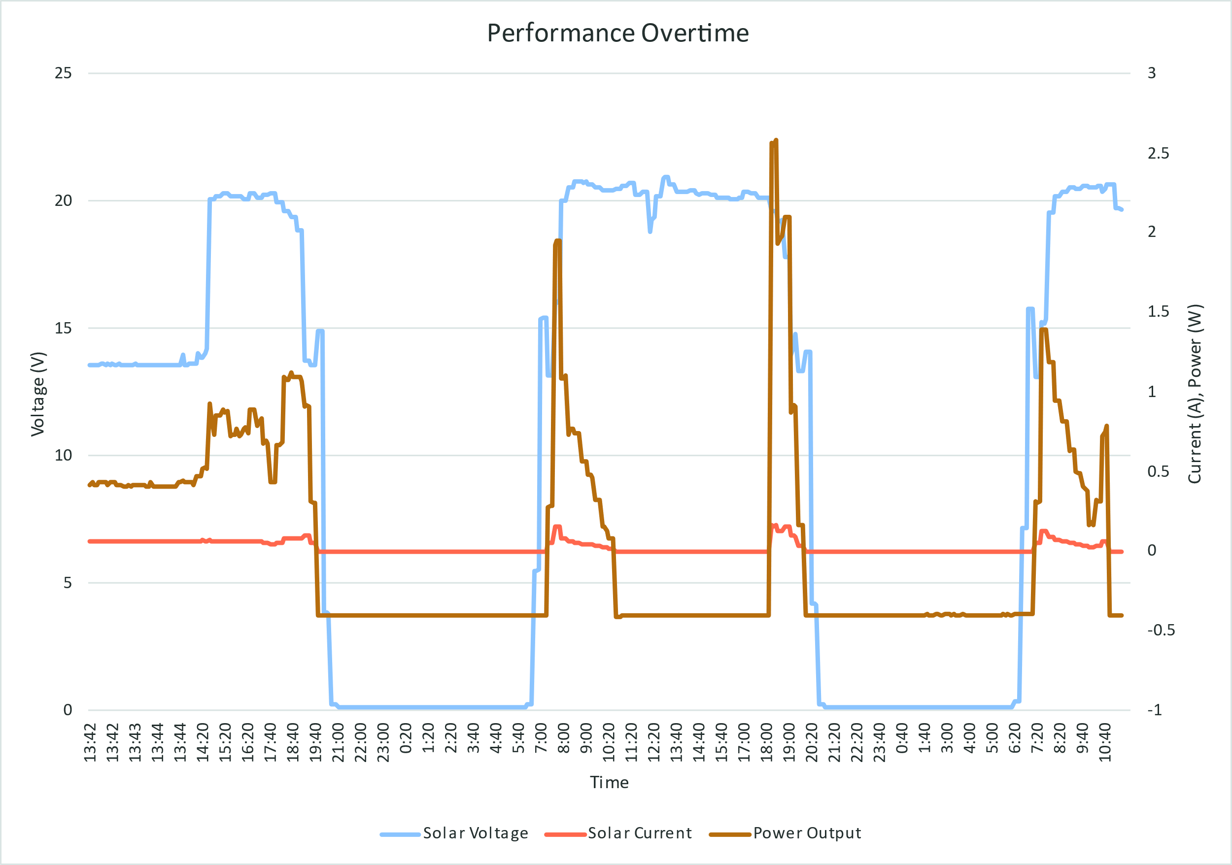

1. Solar performance overtime (several days shown)

## Effect of Duty Cycle

Once again, the duty cycle is the ratio of the time the power MOSFET on (conducting) to the total switching period, represented as a percentage. The duty cycle of a buck converter is directly proportional to the output voltage of the converter, which in turn affects the output power of the converter. This relationship can be described mathematically using Equation 1, which shows that the output power is equal to the input power multiplied by the duty cycle. Therefore, as the duty cycle increases, the output voltage of the converter increases, resulting in a corresponding increase in output power. This characteristic linear relationship is displayed in Figure 9.

The power output of a buck converter, which is a type of DC-DC converter that steps down the voltage level of a DC input, is directly proportional to the duty cycle of the converter, as given by Equation 1. This relationship is depicted in Figure 8, where we can observe the characteristic step-down nature of the buck converter by examining the downward shift of the input power trendline (blue) to the output power trendline (red). This trend can be attributed to the fact that the output voltage of the buck converter is a function of the duty cycle, which is defined as the ratio of the time period during which the power MOSFET is conducting to the total time period of one switching cycle. As the duty cycle increases, the output voltage of the buck converter increases in proportion, resulting in a positive slope of the power output trendline. In summary, the power output of a buck converter is linearly related to the duty cycle, as shown in Equation 1 and Figure 8. The step-down nature of the buck converter is a result of the voltage being reduced by a factor of the duty cycle, with higher duty cycles resulting in higher output voltages and a positive slope of the power output trendline.

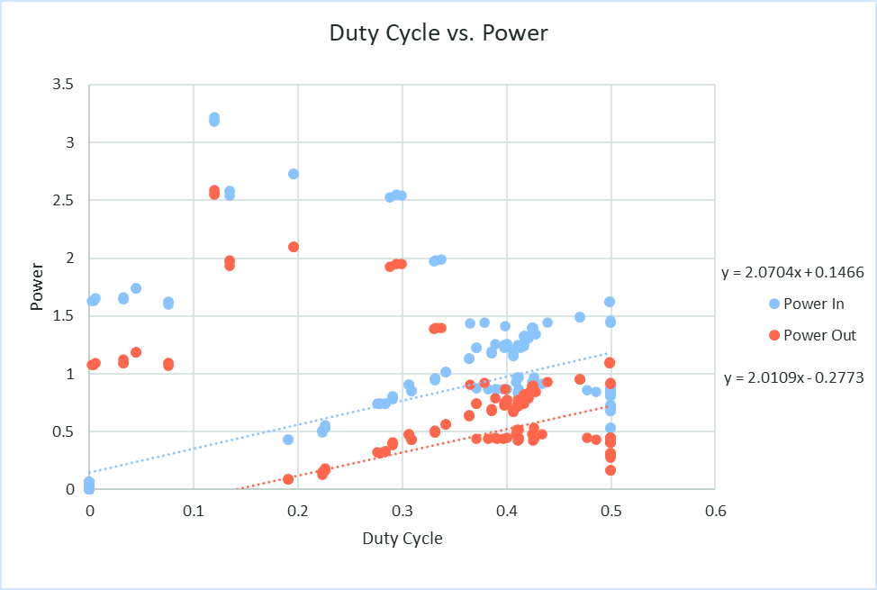

1. Effect of Duty Cycle on Input and Output Power of Buck Converter

Moreover, besides the direct proportionality between duty cycle and power transmission, the charger incorporated a feedback mechanism to regulate the duty cycle according to the load current demands. Figure 10 illustrates the duty cycle of the buck converter increasing with load current because the converter needs to maintain a constant output voltage, and as the load current increases, the output voltage decreases. To compensate for this decrease in voltage, the duty cycle of the converter is increased to increase the amount of time the input voltage is applied to the inductor, allowing it to store more energy and maintain the required output voltage.

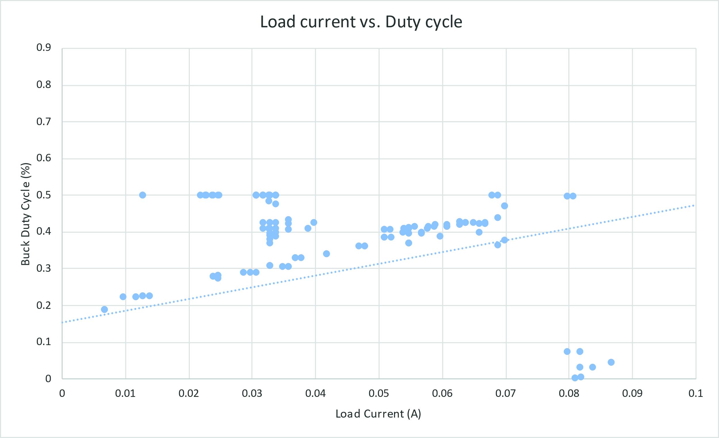

1. Duty cycle reaction to increased current

## Analysis of Output Current

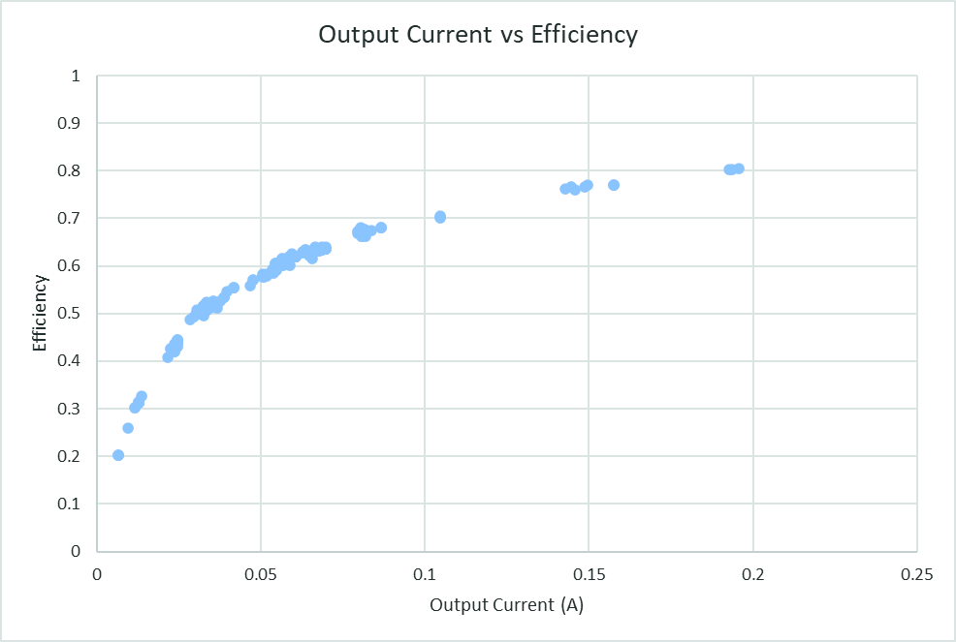

1. The effect of load current on buck efficiency

Conduction losses occur due to the resistance of the power components, such as the MOSFET, inductor, and diode, which leads to a voltage drop across these components during the operation of the converter. As the current output of the buck converter increases, the voltage drop across these components also increases, resulting in higher conduction losses. However, at the maximum current output, the voltage drop across these components reaches a minimum value, resulting in reduced conduction losses and improved efficiency. The efficiency of a buck converter is typically higher at its maximum current output due to the reduced conduction losses and switching losses that occur at this operating point.

A consideration while implementing the power system in the Sentinel device is its current consumption. The maximum output current rating of the MPPT utilized in this design is approximately 2.75 amperes, which is considerably higher than the maximum current draw of the experiment, which is 200 mA. As a result, the efficiency of this power system is expected to be approximately 80%. However, the incorporation of the Nvidia Jetson Nano in the system may lead to an increase in its current consumption, and subsequently, higher efficiency of the power system.

Curiously, in addition to an increase in buck efficiency, an increase in power loss is seen [Fig. 10]. Power loss is defined as the difference between power out and power in. However, the increase is only in a matter of 0.3 watts while the increase in efficiency is nearly 4-fold. This may be contributed to the increased conduction and switching losses because as the load current increases, the switching frequency of the buck converter also increases [Fig. 10]. Conduction losses occur due to the resistance of the power components, such as the MOSFET, inductor, and diode, which leads to a voltage drop across these components during the operation of the converter. As the current output of the buck converter increases, the voltage drop across these components also increases, resulting in higher conduction losses. At the maximum current output, the voltage drop across these components reaches a minimum value, resulting in reduced conduction losses and improved efficiency. To reconcile these two factors, load current was compared to the power loss as a ratio of input power. Observed is an inversely proportional relationship, seen in Fig. 14.

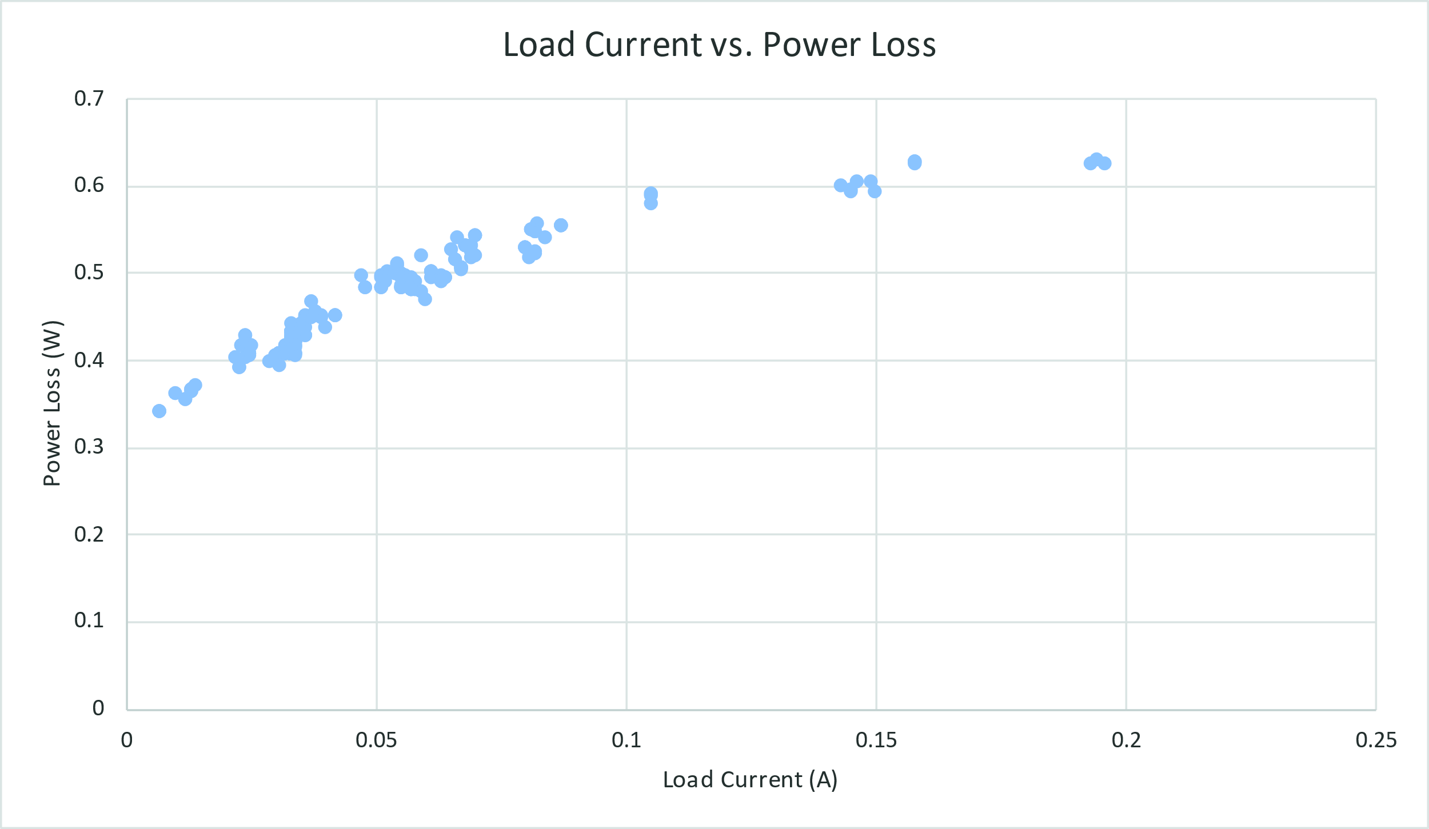

1. The effect of load current on loss of power from input to output



1. The effect of load current on loss of power from input to output

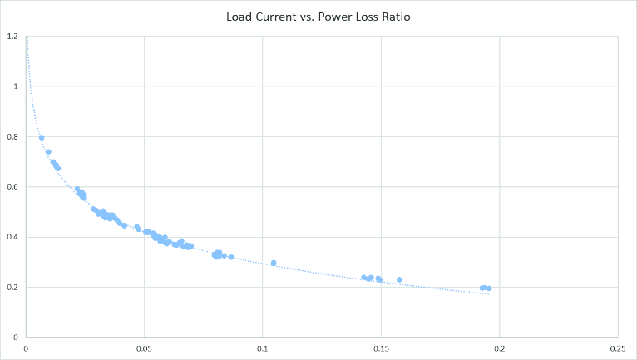

1. The effect of load current on loss of power from input to output

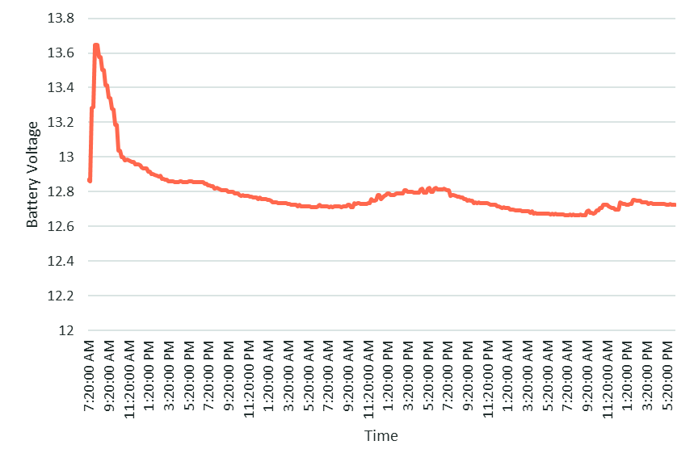

1. Battery discharge over time

# Discussion

In this study, a solar harvesting and battery charging module was designed and implemented on the roof of the University of Florida's New Engineering Building, and its performance was evaluated. The system was found to be up to 80% efficient in providing sustainable power to data collection and networking systems in a Floridian environment. The maximum power point transfer (MPPT) charger's performance was assessed under varying solar irradiance and temperature conditions to determine its efficiency in maintaining a constant supply of power to the battery and external circuitry. Real-time monitoring of the power system's performance using a novel data-logging system demonstrated its effectiveness in reducing user intervention in a rural environment.

The results indicated that the maximum power point increased proportionally with solar irradiance, but high temperatures had an adverse effect on the solar cells' performance, leading to decreased efficiency. The MPPT SCC's performance was analyzed, and the buck converter's power output was found to be directly proportional to the converter's duty cycle with power losses varying with load current. The efficiency of the buck converter was highest at its maximum current output, primarily due to reduced conduction losses when voltage across comments are mnimized. Additionally, the incorporation of the Nvidia Jetson Nano into the system may lead to increased current consumption and subsequently higher efficiency of the power system.

Overall, this study provided valuable insights into the design and operation of solar harvesting and battery charging modules, which can enhance the efficiency and sustainability of power systems for various applications. The findings of this study can guide future research on the development of solar energy harvesting systems for practical use.

Software and documentation for this project can be found at: https://github.com/camnthomas/Datalogging-Software-for-MakerPower-MPPT-SCC

# Future work

Recommendations for future work include the following:

* Greater load current for system or different MPPT rated for less than 1A to improve efficiency.
* In harsh weather conditions, disable MPPT digital interface and Jetson Nano operations for power conservation.
* Due to lack of time, testing battery charge time from a nearly fully discharged battery was not evaluated by could prove useful data.
* Experiment with panel angles and reflector angles to find maximum output.
* Explore solar tracking implemented in software and perhaps integrate mechanical tracking.
* Night mode can be used to turn off entire Sentinel at night to conserve power

##### Acknowledgments

Thank you to Mr. Michael Stapleton, Dr. William Eisenstadt, and Mr. Eric Liebner for their invaluable expertise and guidance throughout this project. Thank you to my mom, Jocelyn Thomas, and partner, Edward Scott, for their unconditional support during this challenging and ultimately rewarding process.

##### References

1. D. Julio, “Danjulio/MPPT-Solar-Charger: Supporting documentation and software for the MPPT solar charger,” *GitHub*. [Online]. Available: https://github.com/danjulio/MPPT-Solar-Charger. [Accessed: 23-Apr-2023].
2. A. Casimiro, “1KW ARDUINO MPPT Solar Charge Controller (esp32 + WIFI),” *Instructables*, 11-Jul-2022. [Online]. Available: https://www.instructables.com/DIY-1kW-MPPT-Solar-Charge-Controller/. [Accessed: 23-Apr-2023].
3. A. E. Tutorials, “Solar cell I-V characteristic and the solar cell I-V curve,” *Alternative Energy Tutorials*. [Online]. Available: https://www.alternative-energy-tutorials.com/photovoltaics/solar-cell-i-v-characteristic.html. [Accessed: 23-Apr-2023].
4. R. Erickson, “Power Electronics (Full Course),” in *Introduction to Power Electronics*.
5. “Efficiency of Buck Converter - Rohm,” 2016. [Online]. Available: https://fscdn.rohm.com/en/products/databook/applinote/ic/power/switching_regulator/buck_converter_efficiency_app-e.pdf. [Accessed: 25-Apr-2023].
6. Afghan, Syeda Adila & Almusawi, Husam & Husi, Géza. (2017). Simulating the electrical characteristics of a photovoltaic cell based on a single-diode equivalent circuit model. MATEC Web of Conferences. 126. 03002. 10.1051/matecconf/201712603002.

# Appendix

1. Power System Hardware Block Diagram