**Name: Cameron Peterson-Zopf Student ID: 5799719**

# Programming Assignment 2

Discussion on a high level with your colleagues is encouraged. Make sure the work submitted is your own. When in doubt, ask a TA or the instructor. If you are not sure what constitutes academic dishonesty, please refer to the AISC web site: <https://aisc.uci.edu/>.

You can fill out your answers below in text, paste screenshots, and/or include images (make sure the image is right side up & legible).

This homework covers:

* LC-3 Machine Language to Assembly – Part 1

## AISC

Please initial here to indicate you understand UCI’s Academic Integrity Policy and confirm that this is your own work you are submitting (this counts for points): CPZ

## Updated Code Screenshot

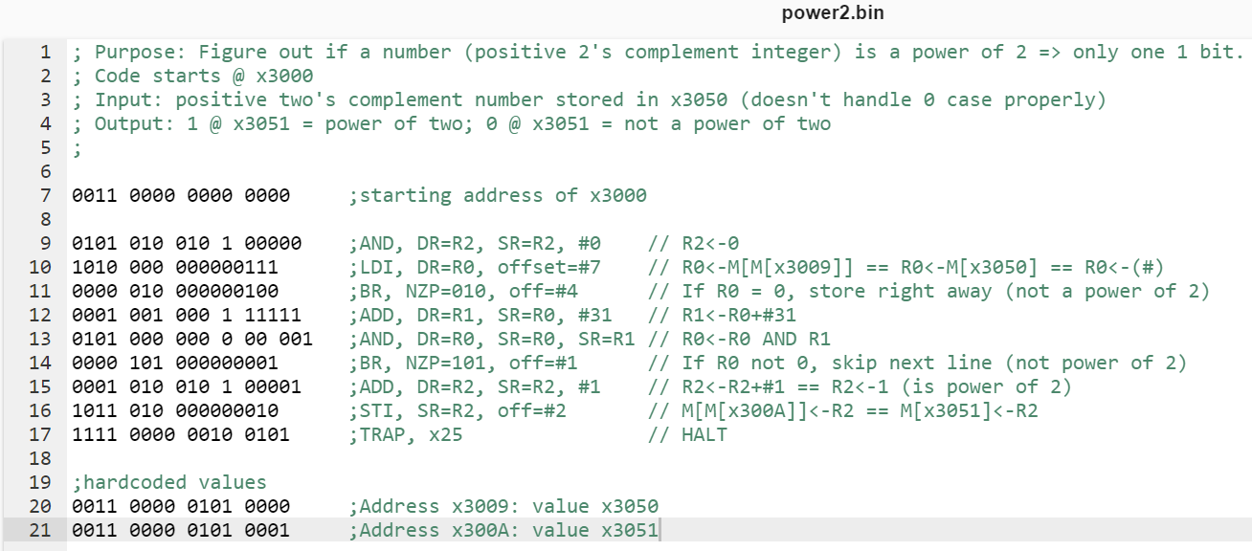

## screenshot of positive number that is a power of 2

Be sure to show values @ x3050 & x3051 as well as registers just before halt instruction

**First test 4, which is a power of 2**

R2 = 1 as we wanted.

The value stored in x3051 is 1, indicating it is a power of 2.

## screenshot of positive number that is NOT a power of 2

Be sure to show values @ x3050 & x3051 as well as registers just before halt instruction

**Next test 5, which is not a power of 2**

R2 = 0 as we wanted.

The value stored in x3051 is 0, indicating it is not a power of 2.

## screenshot of 0 case

Be sure to show values @ x3050 & x3051 as well as registers just before halt instruction

**Finally test 0, which is not a power of 2**

R2 = 0 as we wanted.

The value stored in x3051 is 0, indicating it is not a power of 2.

