Introduction
For the first half of MP1 you will start by comparing two real world processors. You will compare their intended purpose, their instruction sets, their architecture, performance etc. This step will help you understand other possibilities for instruction sets and instruction set formats. It will also help you understand the architecture behind real world processors. This first part may be more challenging if you pick an obscure processor or a proprietary processor that does not have much information available about it online.

Fill out the answers to your work directly in this document and submit it on blackboard on the due date.

For the second half of MP1
- You will decide on what type of processor you want to target (e.g. general purpose or special purpose dedicated processor: e.g. graphics, a.i., dsp, etc.)
- You will design a new, original instruction set (i.e. assembly language) for this type of processor that can run non-trivial programs.
- You will then design the machine code format for your instruction set.
- You will write an assembler program that uses your new, original, assembly language (for testing purposes).
- You will create an assembler to convert text based assembly language into a hex code machine format.
- You will “assemble” (i.e. convert) each of these programs into your machine code.

Preview of future MP labs: This lab sets the stage for the next project where you design the ALU and DPU for your original processor. Your group must create an original processor / control unit / data path unit and do NOT simply copy an existing processor design that you find out on the Internet.
Processors of the World Comparison
Compare the hardware architectures and assembly/machine languages for any two different processors (groups of two) and three different processors (groups of 3) of your choice. Decide on the specific application area you want your processor to focus on. Are you interested in general purpose? audio? graphics? encryption? security? We suggest that you pick at least one processer that you are interested in learning more about. Below are some suggestions that have information for them online. Each person in the group is responsible for ONE different processor and will be graded on that individually.

- Old Style Intel 8080 or 8085 Architecture
  - http://en.wikipedia.org/wiki/Intel_8080
  - http://www.intel-vintage.info/intelotherresources.htm#906748189

- Old Style Motorola 6502 Architecture
  - http://www.visual6502.org/welcome.html
  - http://en.wikipedia.org/wiki/MOS_Technology_6502
  - http://opencores.org/project,t65

- Modern General Purpose ARM Architecture
  - http://en.wikipedia.org/wiki/ARM_architecture
  - https://www.scss.tcd.ie/~waldroj/3d1/arm_arm.pdf

- Modern Application Specific NVIDIA Architecture (Graphics Processor)

- Modern AMD Architecture (e.g. Ryzen)

- Other processor of your own choice (other than MIPS) that you can find information for.

Comparing Processors
- Identify the application area of each processor you are comparing (e.g. is it general purpose or special purpose processor? If special purpose, what is the application area?) Be sure and put the name of the person that did the research for each processor. Each person in the group is responsible for one processor. You may edit each other’s processor reports.

http://hron.fei.tuke.sk/~adam/cas/Digital%20Design%20and%20Computer%20Architecture%20(2nd%20Ed).pdf

- Processor 1: Graphics Core Next (GCN) - Cameron Rutherford
  - Graphics Core Next is a micro architecture and instruction set developed by AMD for use in their GPUs
  - http://developer.amd.com/wordpress/media/2012/12/AMD_Southern_Islands_Instruction_Set_Architecture.pdf
  - https://openwall.info/wiki/john/development/GCN-ISA#GCN-microcode-tutorial
  - http://developer.amd.com/wordpress/media/2012/10/AMD_Intermediate_Language_(IL)_Specification_v2.pdf
  - http://developer.amd.com/wordpress/media/2013/06/2620_final.pdf
- Processor 2: Intel 8080 - Jude Battista
  - https://computerarchive.org/files/comp/manuals/intel/8080-8085_Assembly_Language_Programming_(Intel).pdf
- Processor 4: Old Style Motorola 6502 - Julia Abbott
  - http://www.obelisk.me.uk/6502/registers.html
  - http://archive.6502.org/books/mcs6500_family_programming_manual.pdf
  - https://www.masswerk.at/6502/6502_instruction_set.html
  - https://www.google.com/url?sa=i&source=images&cd=&cad=rja&uact=8&ved=2ahUKEwiF1rbm547hAhXJup4KHZ3NCycQjRx6BAgBEAU&url=http%3A%2F%2Fwww.baltissen.org%2Fnewhtm%2Fttl6502.htm&psig=AOvVaw1EM2lZXJOuWiLo3xRCWkeK&ust=1553105716406345
  - https://www.xtof.info/blog/?p=714

- Register Set Architecture for each processor.

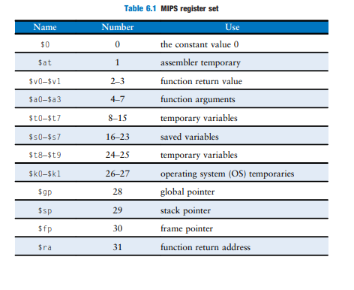

Table 1A: Processor A Register Set: Define the major registers and their names.

Common Registers: b#, c#, i#, a#, aL, and r#
Vertex Shader: v#, oPos#, oPriColor#, oSecColor#, oT#, oInterp#, oFog, oSprite, vBaryCood, vPrimIndex,
vQuadIndex
Pixel Shader: vPriColor#, vSecColor#, vT#, vInterp#, vFog, vSprite, vFace, vWinCoord, oC#, oDepth

More information about the specifics of each register can be found here: http://developer.amd.com/wordpress/media/2012/10/AMD_Intermediate_Language_(IL)_Specification_v2.pdf#page=34&zoom=100,0,185

Table 1B: Intel 8080 Register Set Table: Define the major registers and their names. Make a table similar to Table 6.1 MIPS Register Set on page 300 of your book
8-bit registers:
111=A (Accumulator)
000=B (Common register)
001=C (Common register)
010=D (Common register)
011=E (Common register)
100=H (Common register)
101=L (Common register)
110=M (Memory reference through address in H:L)
Flags: (S)ign, (Z)ero, (P)arity, (C)arry, Auxiliary Carry (AC)

Similarly to modern MASM, pairs of registers may be addressed as a single register to permit the
use of 16-bit data:
Registers B and C may be addressed as B
Registers D and E may be addressed as E
Registers H and L may be addressed as H or as M as a memory address

Table 1D: (groups of 3 only) Processor C Register Set Table: Define the major registers and their names. Make a table similar to Table 6.1 MIPS Register Set on page 300 of your book
Motorola Old Style 6502
16-bit registers:
Program Counter
Special:
0 0 0 0 0 0 0 1 = Stack Pointer, supports a 256 byte stack. Pointer itself is an 8 bit register.
8-bit registers:
A (Accumulator)
X (Index register)
Y (Index Register)
Flags: Carry Flag, Zero Flag, Interrupt Disable, Decimal Mode, Break Command, Overflow Flag,
Negative Flag

- Machine Code Format and Operation for four different types of instructions – Pick four instructions from each processor to compare.

Table 2A: Processor A Instructions and Binary Format (see appendix B and figs 6.10, 6.12 for examples)
  - A conditional instruction: show the binary format and what the instruction does.
    - S_CBRANCH_SCC0 - Conditional Branch
      - SOPP Opcode = 4 (0x4) = 100 in binary
        - Also has a leading 0111111
      - if scc == 0 then the program will branch, otherwise it will nop
  - A mathematical instruction: show the binary format and what the instruction does
    - V_LOG_F32 - Base2 log function
      - VOP1 Opcode = 39 (0x27) = 100111 in binary
        - Also has a leading 101111111
      - the destination register will take the result of taking the base 2 logarithm or the source
  - A jump instruction: show the binary format and what the instruction does
    - S_BRANCH - Unconditional branch is equivalent to a jump
      - SOPP Opcode = 2 (0x2) = 10 in binary
        - Also has a leading 101111111
      - This will unconditionally branch the program based on the immediate value
  - Some other instruction of your choice: show the binary format and what the instruction does
    - S_MEMTIME - Returns the current 64 bit timestamp
      - SMRD Opcode = 30 (0x1E) = 11110 in binary
        - Also has a leading 11000
      - Returns the current time to the destination register; this “time” is a free-running clock counter based on the shader core clock
    - V_RSQ_F64 - Double reciprocal square root
      - VOP1 Opcode = 49 (0x31) = 110001 in binary
        - Also has a leading 0111111
      - Inputs from two consecutive general purpose registers. The result is written to two consecutive general purpose registers. dest = 1 / sqrt(src)
Table 2B: Processor B Instructions and Binary Format (see appendix B and figs 6.10, 6.12 for examples)
  - conditional instruction:
Jump Not Zero: J000 JumpLocation = 11000010
If the prior calculation did NOT result in zero (so the zero flag is 0), jump to JumpLocation
JumpLocation can be a relative to the current instruction by using $±X where X is the difference from
the current program counter
By replacing the 000 with other binary codes, we can change the jump condition
  - mathematical instruction:
Add: ADD VVV = 10000RRR where RRR is the binary code for another register
Add the value in another register to the accumulator. Unlike many modern assembly languages, we can increment any register but only add arbitrary values to A.
  - A jump instruction:
Unconditional Jump: JMP JumpLocation = 11000011
Jump to JumpLocation.
JumpLocation can be a relative to the current instruction by using $±X where X is the difference from
the current program counter
  - Some other instruction of your choice:
Increment register: INR RRR = 00RRR100
Increment the register specified by the three bits of RRR

Source: original 8080 Assembly Language manual
Table 2C: (groups of 3 only) Processor B Instructions and Binary Format (see appendix B and figs 6.10, 6.12 for examples)
  - A conditional instruction: show the binary format and what the instruction does.
  - A mathematical instruction: show the binary format and what the instruction does
  - A jump instruction: show the binary format and what the instruction does
  - Some other instruction of your choice: show the binary format and what the instruction does

Table 2D: (groups of 3 only) Processor B Instructions and Binary Format (see appendix B and figs 6.10, 6.12 for examples)
  - A conditional instruction: show the binary format and what the instruction does.
    - BEQ -- Branch if Equal
      - Description: Branch on: Zero = 1
      - Opcode: F0
        - binary: 1111 0000
      - Addressing: relative
      - bytes: 2
      - Cycles: 2**
  - A mathematical instruction: show the binary format and what the instruction does
    - ADC -- Add with Carry
      - Description: Add memory to Accumulator with Carry
      - Immediate addressing:
        - Opcode: 69
          - binary: 0110 1001
        - bytes: 2
        - cycles: 2
      - zeropage addressing:
        - Opcode: 65
          - binary: 0110 0101
        - bytes: 2
        - cycles: 3
      - zeropage, x addressing :
        - Opcode: 75
          - binary: 0111 0101
        - bytes: 2
        - cycles: 4
      - absolute addressing:
        - Opcode: 6D
          - binary: 0110 1101
        - bytes: 3
        - cycles: 4
      - absolute, x addressing:
        - Opcode: 7D
          - binary: 0111 1101
        - bytes: 3
        - cycles: 4*
      - absolute, Y addressing:
        - Opcode: 79
          - 0111 1001
        - bytes: 3
        - cycles: 4*
      - (indirect, X) addressing:
        - Opcode: 61
          - binary: 0110 0001
        - bytes: 2
        - cycles: 6
      - (indirect), Y addressing:
        - Opcode 71
          - binary: 0111 0001
        - bytes: 2
        - cycles: 5*
  - A jump instruction: show the binary format and what the instruction does
    - JSR -- Jump to Subroutine
      - Description: Jump to new location saving return address
      - Opcode: 20
        - binary: 0010 0000
      - addressing: absolute
      - bytes: 3
      - cycles: 6
  - Some other instruction of your choice: show the binary format and what the instruction does
    - TAX -- Transfer A to X
      - Description: A -> X
      - OpCode: AA
        - Binary: 1010 1010
      - Addressing: Implied
      - Bytes:1
      - Cyles: 2

Source: https://www.masswerk.at/6502/6502_instruction_set.html

- High level block diagram of each processor’s design and discussion – Compare and contrast the design of each processor your group chose. You may not be able to find the answer to all of the questions for both processors, do you best. I am expecting short concise answers for each of the questions to which you can find the answers. Each person in the group is responsible for one processor. You may however discuss and edit each other’s reports.

Processor A
- : What does the data path look like for each processor? Find a high level architecture diagram that shows the data path for each processor. Insert these diagrams here:
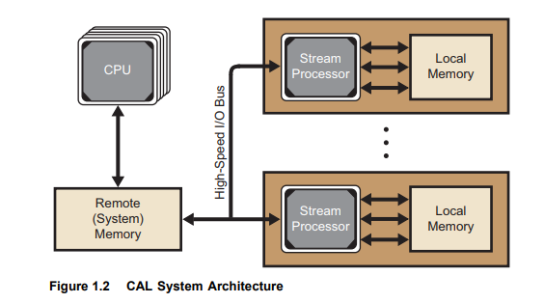

- Since GPUs tend to have many cores, the specifics of the data path can be difficult to follow. As a result, I have included a simplified picture of the design that highlights the important details. This higher level of abstraction is very useful in order to understand what is happening, before delving into the intricacies. Here is a more detailed block diagram:

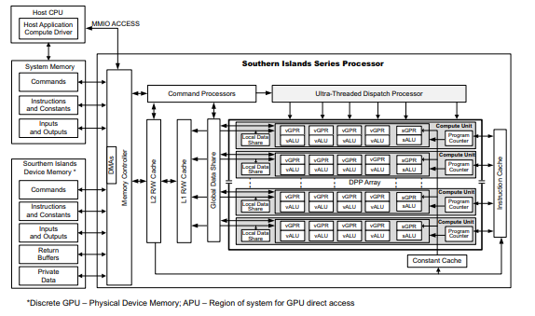
- What types of memory (register, cache, etc.) does each processor contain or access?
- This is more difficult to get the specifics of, but in general, each processor has access to it’s own registers, a set of shared local data between rows of processors, cache memory shared between all the processors in the GPU, and then global memory from the main device that can be loaded onto the device through the memory controller. There is also a constant cache and an instruction cache that can be seen on the diagram above.

- How is the ALU connected to the registers (refer to the diagram in part a)?
- The information regarding the individual ALUs in the cored was impossible to find. I would assume that the architecture within each core is as simple as possible in order to fit as many cores into as little space as possible. Thus, the ALU is presumably connected to the registers directly to be as fast and efficient as possible.

- How are instructions fetched and executed? Is there an instruction cache?
- There is a global instruction cache that is shared across all the cores on the GPU. This instruction cache stores the instructions to be executed by all the cores simultaneously. This simultaneous instruction execution is controlled by the ultra threaded dispatch processor, that can control all of the cored simultaneously.

- Does the processor pipeline instructions?
- I am unsure about this as it is more difficult to figure out the specifics of how the individual cores are created. I would assume that it is not pipelined in order to minimize the hardware in favor of having more cores, but I could be wrong.

- What is the clock speed of the processor?
- “There is no supported way to find out the frequency of the counter. There is no way to correlate this shader internal counter with external timers such as asynchronous time queries. If the GPU speed changes (for power saving), there is no way to know this happened, or its effect on cycle measurements.” - this statement from the documentation basically states that there is no way to check the speed of the onboard clock, and that also the speed of the clock dynamically changes in order to do things such as conserve power.

Processor B
  - : What does the data path look like for each processor? Find a high level architecture diagram that shows the data path for each processor. Insert these diagrams here:
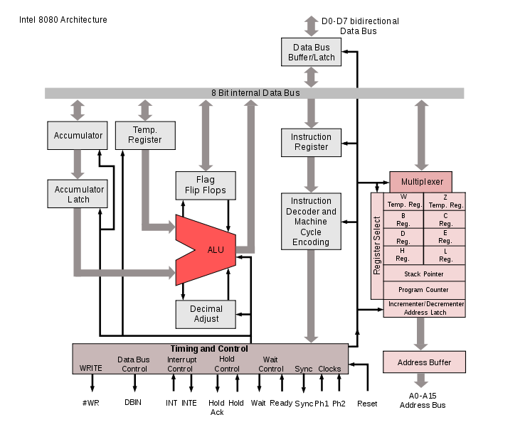

Source: https://en.wikipedia.org/wiki/File:Intel_8080_arch.svg
  - What types of memory (register, cache, etc.) does each processor contain or access?
As described above, the 8080 contains six general purpose 8-bit registers, an 8-bit accumulator, and and 8-bit flag register. It also has internal registers not available to programmers like the program counter, and the temp register. Like many students, this processor is devoid of cache.

  - How is the ALU connected to the registers (refer to the diagram in part a)?
The ALU output is put on the 8-bit data bus where the registers can access it. Any input from the registers is sent along the data bus to either the accumulator or the temp register that feeds the ALU.

  - How are instructions fetched and executed? Is there an instruction cache?
The instruction is pulled from the memory location indicated by the instruction pointer, then passed through the decoder. There is no cache.

  - Does the processor pipeline instructions?
Haha. No.

  - What is the clock speed of the processor?
2 MHz, though there was an upgraded version, the 8080A-1 that climbed to the dizzying heights of 3.125
MHz.

Processor C (Groups of 3 Only)
- : What does the data path look like for each processor? Find a high level architecture diagram that shows the data path for each processor. Insert these diagrams here:

- What types of memory (register, cache, etc.) does each processor contain or access?

- How is the ALU connected to the registers (refer to the diagram in part a)?

- How are instructions fetched and executed? Is there an instruction cache?

- Does the processor pipeline instructions?

- What is the clock speed of the processor?
Processor D (Groups of 4 Only)
- : What does the data path look like for each processor? Find a high level architecture diagram that shows the data path for each processor. Insert these diagrams here:
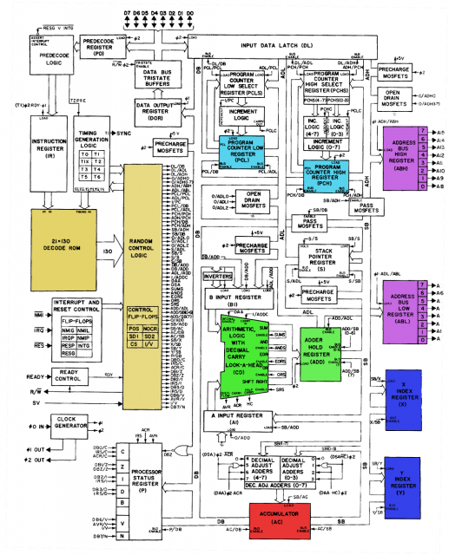
Fig 1 ^
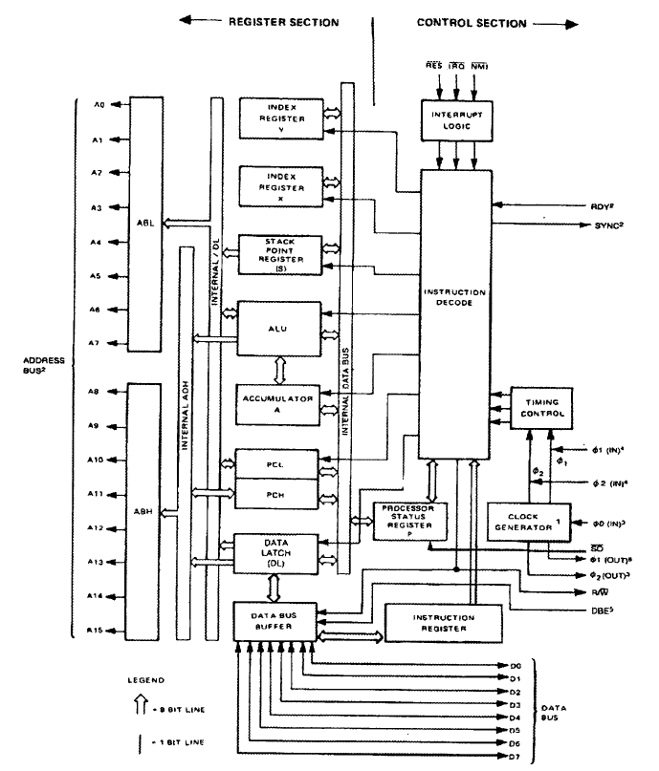
Fig 2 ^

- What types of memory (register, cache, etc.) does each processor contain or access?
  - Registers
    - Two index registers, X and Y
    - One accumulator
    - B Input register
    - A input register
    - Data Output Register
    - Preprocessor Status Register
    - Adder Hold- Register
    - Address bus high and low registers
    - Stack Pointer Register
- How is the ALU connected to the registers (refer to the diagram in part a)?
  - The ALU connects to the X and Y registers through an internal data bus (Figure 2)
  - The ALU connects to the accumulator through the internal data bus (Figure 2)
  - The ALU connects to the processor status register through an internal data bus (Figure 2)
  - The ALU connects to eh stack pointer register through the internal /DL path (Figure 2)

- How are instructions fetched and executed? Is there an instruction cache?
  - There is no instruction cache in this processor
  - Instructions are pulled from a data bus into the data bus buffer. From there, they are pulled into the instruction register, and then into the instruction decode. From there the instructions are executed among the other registers, including the ALU, the accumulator, and the X and Y registers.

- Does the processor pipeline instructions?
  - No

- What is the clock speed of the processor?
  - Max rate: 1 MHz to 3 MHz

Processor Language Design
Design the programmer’s view of the architecture for your processor (as a group). Just like in part 1, you will make two tables. The first table will be the registers and the second table the instructions for your processor.

- TABLE 2A: A diagram of the registers (and their purposes) for your custom processor

Purpose | Count | Name | Notes
Stack Pointer | 1 | $spt
Instruction Pointer | 1 | $ipt
Zero | 1 | $zer
Frame Pointer | 1 | $fpt
Counter Register | 1 | $ctr | Mostly not modifiable by programmer
Element Size Register | 1 | $esr | Mostly not modifiable by programmer
Data Registers | 20 | $d00-$d19
Function Return Address | 1 | $fra
Flags | 1 | $flg | Not directly modifiable by programmer

- TABLE 2B: A list of the instructions that you are going to build into the processor.
  - Don’t start with too many instructions!
  - Have some stretch instructions as well as basic instructions.
  - Each person in the group (after group consultation) must be personally responsible for at least one instruction.

Instruction | Param1 | Param2 | Count | opcode
2 Reg
Mov | Destination Reg | Source Reg | 0 | 00000000
Add | Destination Reg | Second Op Register | 1 | 00000001
Sub | Destination Reg | Second Op Register | 2
Mult | Destination Reg | Second Op Register | 3
Reg + Imm
Movi | Destination Reg | Immediate Value | 0 | 10000000
Addi | Destination Reg | Immediate Value | 1 | 10000001
Subi | Destination Reg | Immediate Value | 2
Multi | Destination Reg | Immediate Value | 3
lw | Destination Reg | Memory Address | 4 | 10000100
sw | Source Reg | Memory Address | 5 | 10000101
loop | Size of array element (bits) | Loop Counter value | 6 | 10000110
Branch
beq | Label |  | 0 | 01000000
bne | Source Register 1 | Source Register 2 | 1
List Ops
Ladd | Reg w/Mem Address 1 | Reg w/Mem Address 2 | 0 | 00010000
Lsum |  |  | 1
Lalu |  |  | 2
Jump
jmp | Offset from current position |  | 0 | 00100000

- Your processor will need enough instructions to do useful work You must have enough instructions to be able to run a useful program (e.g. something of the complexity of generating the Fibonacci sequence)
- Check the evaluation rubric for how the number of instructions you implement will be evaluated.

Assembler for Your Processor
Create an assembler for your processor. Put your assembler code in your CS401 folder on CS1. Use pair / group programming to develop the assembler. Do not work individually.

You have several choices here…
- Create a simple program that reads your assembly language program word by word and then converts each line to machine code. Here is some possible pseudo code for a simple assembler:

Read in the variable definitions from the top of the program.
For each variable in the definitions list:
Determine the size of memory required
Insert the variable into a dictionary that stores the assigned memory address of the variable.
Compute the memory location for the next variable.
For each line of assembly
NextHexCode = “”
Strip comments from the line of code read
If line of code has a label,
store memory location of the label in a dictionary
Determine the assembly keyword on the line of code
Based on keyword update NextHexCode
If line of code has arguments
Based on argument types (register, variable, immediate) and instruction type update NextHexCode
Write NextHexCode to the output machine code file.

- Define a grammar for your assembly language and build a recursive descent parser (https://en.wikipedia.org/wiki/Recursive_descent_parser )

- Use the utilities Lexx and Yacc (you will have to learn these on your own)

Include your assembly language code program here (make sure your program includes comments)

import re
# Information holds the opcode and argument lengths for every instruction
information = {}
information["movi"] = ('10000000', 5, 16)
information["mov"] = ('00000000', 5, 5)
information["add"] = ('00000001', 5, 5)
information["addi"] = ('10000001', 5, 16)
information["ladd"] = ('00001000', 5, 5)
information["beq"] = ('01000000', 24, 0)
information["jmp"] = ('00100000', 24, 0)
information["loop"] = ('00010000', 19, 5)
information["lw"] = ('10000100', 5, 16)
information["sw"] = ('10000101', 5, 16)
# Registers maps the english name for the register to the binary value representing the
# register internally
registers = {
"$spt" : bin(0)[2:].zfill(5),
"$ipt" : bin(1)[2:].zfill(5),
"$zer" : bin(2)[2:].zfill(5),
"$fpt" : bin(3)[2:].zfill(5),
"$ctr" : bin(4)[2:].zfill(5),
"$esr" : bin(5)[2:].zfill(5),
"$d00" : bin(6)[2:].zfill(5),
"$d0" : bin(6)[2:].zfill(5),
"$d1" : bin(7)[2:].zfill(5),
"$d2" : bin(8)[2:].zfill(5),
"$d3" : bin(9)[2:].zfill(5),
"$d4" : bin(10)[2:].zfill(5),
"$d5" : bin(11)[2:].zfill(5),
"$d6" : bin(12)[2:].zfill(5),
"$d7" : bin(13)[2:].zfill(5),
"$d8" : bin(14)[2:].zfill(5),
"$d9" : bin(15)[2:].zfill(5),
"$d10" : bin(16)[2:].zfill(5),
"$d11" : bin(17)[2:].zfill(5),
"$d12" : bin(18)[2:].zfill(5),
"$d13" : bin(19)[2:].zfill(5),
"$d14" : bin(20)[2:].zfill(5),
"$d15" : bin(21)[2:].zfill(5),
"$d16" : bin(22)[2:].zfill(5),
"$d17" : bin(23)[2:].zfill(5),
"$d18" : bin(24)[2:].zfill(5),
"$d19" : bin(25)[2:].zfill(5),
"$fra" : bin(26)[2:].zfill(5),
"$flg" : bin(27)[2:].zfill(5)
}
# Data will hold the name and information of all our variables
data = {}
# lines holds the contents of the assembler code file
lines = []
# Translate variable types into number of bits
data_size_identifiers = { "dword" : 32, "word" : 16, "byte" : 8, "nibble" : 4, "bit" : 1}
# Get all the code without the comments
with open("input.asm") as f:
for line in f:
line = line.partition('#')[0].strip()
if line != '':
lines.append(line)
binary_tracker = ''
# If there is a data section, consume it and convert it to hex
if lines[0] == ".data":
del lines[0]
while lines[0] != ".code":
line = lines.pop(0)
things = line.split(' ')
var_name = things.pop(0)
var_size = things.pop(0)
var_elements = things
offset_from_start = len(binary_tracker) + 32 # maybe don't calculate this every time?
for x in var_elements:
binary_tracker += format(int(x), '0%db' % data_size_identifiers[var_size])
data[var_name] = (data_size_identifiers[var_size], offset_from_start)
# contains the lines to be written to the machine code file
hex_output = []
total_chars = ((len(binary_tracker) // 32) + 1) * 32
binary_tracker = binary_tracker.ljust(total_chars, '0')
# This works - appends all the data to hex_output as nice hex strings in order
while binary_tracker != '':
current = binary_tracker[:32]
binary_tracker = binary_tracker[32:]
to_add = hex(int(current, 2))[2:]
hex_output.append(to_add.ljust(8, '0'))
# Add the jump instruction at the start of our code
def jump(offset_from_current):
opcode = information["jmp"][0]
arg = bin(offset_from_current)[2:].zfill(24)
return hex(int(opcode + arg, 2))[2:]
tbj = jump(len(hex_output) + 1)
hex_output.insert(0, tbj)
# start assembling the code
if lines[0] == '.code':
del lines[0]
else:
print("NO CODE SECTION!")
# Walk through the code and consume all the labels, adding them to the label dictionary
# Labels are addressed by their name, and we return the offset from the start of the code section
labels = {}
count = len(hex_output)
for i, line in enumerate(lines):
# Labels are on their own line starting with a colon, and only use the first word
if line[0] == ':':
label = line.split(' ')[0][1:]
labels[label] = count
del lines[i]
continue
count += 1
for line in lines:
next_hex = ''
# Process the current instruction
things = line.split()
instr = things[0]
args = things[1:]
opcode = information[instr][0]
# if we know about the instruction...
if instr in information.keys():
current_bin = ''
# giant case statement
if instr in ['mov', 'add']:
current_bin = opcode + registers[args[0]] + registers[args[1]]
elif instr in ['movi','addi']:
current_bin = opcode + registers[args[0]] + bin(int(args[1]))[2:].zfill(19)
elif instr in ['lw', 'sw']:
arg2 = args[1]
arg2_bin = ''
# If we are dealing with an exact memory location
if arg2[0:2] == '0x':
arg2 = arg2[2:]
arg2_bin = bin(int(arg2, 16))[2:].zfill(19)
# If we are dealing with an exact memory location
elif arg2[0].isdigit():
arg2_bin = bin(int(arg2))[2:].zfill(19)
# We are dealing with a variable
else:
matches = re.split('[\[ \]]', arg2)
if len(matches) > 1: # we have a variable with an index
variable = matches[0]
offset = int(matches[1]) * data[variable][0] + data[variable][1]
arg2_bin = str(bin(offset)[2:].zfill(19))
else: # plain old variable
arg2_bin = str(bin(data[arg2][1])[2:].zfill(19))
current_bin = opcode + registers[args[0]] + arg2_bin
elif instr in ['jmp', 'beq']:
jLoc = args[0]
# if we're jumping to a label
if jLoc in labels.keys():
print(jLoc)
jLoc = (labels[jLoc] - len(hex_output)) * 4
print(jLoc)
else: # otherwise we're jumping a set number of instructions
jLoc = int(jLoc) * 4
if jLoc < 0:
jLoc = (2 ** 24) + jLoc
arg = bin(jLoc)[2:].zfill(24)
print(arg)
current_bin = opcode + arg
if current_bin != '':
next_hex = hex(int(current_bin.ljust(32, '0'), 2))[2:].zfill(8)
hex_output.append(next_hex.upper())
else:
print("The function " + instr + "does not exist!")
with open("output.txt", "w") as f:
for x in hex_output:
f.write(x + '\n')

Assembly Code Program and resulting Machine Code
Write an assembly language program using the language that you designed. Use your assembler from exercise 3 to compile the assembly language into hex based machine code.

Include your machine code program here:

Here is the code that we assembled:

.data
# Change the arrays to be variable length
error bit 1
list dword 1 2 3 4 5 6 7
.code
# Labels are on their own line starting with a colon, and only use the first word
:start <- This is the start
mov $d0 $zer # mov zero into the first data register
jmp loaddata # skip to the load data section
movi $ipt 1234 # change the instruction pointer to 1234. This should never execute
:loaddata # load data from memory
lw $d1 list # copy the first element from list into $d1
lw $d1 list[4] # copy the fifth element from list into $d1
lw $d2 0x34578 # copy the element in memory location 0x34578 into $d2
:addloop # add some stuff
add $d0 $d1 # add $d1 to $d0 and store in $d1
beq addloop # if the result of the prior calculation was 0, loop
addi $d0 15 # add 15 to $d0 and store it in $d0
Here is our assembled hexcode:
20000009
80000000
80000001
10000000
80000002
20000000
80000003
30000000
80000000
00308000
20000004
800804D2
84380021
843800A1
84434578
0131C000
40FFFFF4
8130000F

Exercise 5: Design/Code Walkthrough MP 1 Presentations

On the due date for this design, groups of two will take 5 minutes (max) and present their assembly language designs to the class. You will be graded on whether you present the following items. Do not use more than 4 or 5 slides to summarize your algorithm.

Minute 1: What type of processor do you want to build and why?
Minute 2: What instruction set did you decide on and why?
Minute 3: How did you design your assembler? Did you allow for labels and variable definitions? Show your assembly language program and the assembled machine code file.
Minutes 4: Summary.
- What went well? What not so well?
- What issues did you run into in writing an assembler?
- Did you do anything above and beyond the requirements (not required)?

What to Hand In:
- Place all of the required items in this text document (i.e. word / pdf) called MP1_Language_Design. Submit this document on blackboard. Also be sure to save a copy in your folder on CS1.
- Be sure to check the evaluation rubric given here.
- In general A work will go above and beyond the basic requirements given in the document and rubric.

CATEGORY | Poor or missing attempt | Beginning | Satisfactory | Excellent
Exercise 1: Comparing Processors | Missing or extremely poor quality. | Low quality comparison of processors. Only compared 1-2 instructions with limited discussion and questions answered poorly and instructions not followed. | Adequate comparison of both processors architecture, machine code, and assembly language with adequate comparison of 3 instructions and answers to majority of the questions. Both Table I and Table II completed adequately. | Excellent comparison of both processors architecture, machine code, and four or more assembly language instructions and format.  Includes high level circuit design (block diagrams) for both processors.  Includes an excellent comparison and discussion of pros and cons of each processor and answers to questions given in the problem description.
Exercise 2: Assembly Language Design | Missing or extremely poor quality. | 4 instructions total and 2 points for each part of each table and other answers. | 6 instructions total and 2 points for each part of each table and other answers. | 8 instructions total and 2 points for each part of each table and other answers.
Exercise 3: Assembler | Missing or extremely poor quality. | Hard coded assembler with few comments. No variables or labels (values are hard coded in the instructions) | Adequate assembler with one of either variables or labels. Adequately commented. | 1 well commented, comprehensive assembler program that supports labels and variables.
Exercise 4: Assembly Language and Machine Code | Missing or extremely poor quality. | 1 hex listing without assembly language | Adequate assembly language program and associated working machine code. | Excellent assembler with comments, excellent assembly language program

