|  |  |
| --- | --- |
| Facility name: _______________________ Region/District name: ________________  Facility type: _______________________ Facility hours: ______________________ | Facility supervisor:  ___________________  Reviewer:  ___________________  Date: ___________________ |
| New HTN patients registered in prior month (N):____ Avg daily HTN patients seen (N):___  Total HTN patients registered (N) to date:____ Total Catchment population (N):___ |
| Is the HTN treatment protocol displayed for staff to reference? □ Yes □ No  Is the BP measurement protocol displayed on the wall/desk? □ Yes □ No |

**Hypertension Health Care Facility Checklist (follow-up visits)**

|  |  |  |  |  |  |  |  |
| --- | --- | --- | --- | --- | --- | --- | --- |
| **1** | **BP measurement** | | | | | | |
| 1.1 | Number of functional BP devices in the facility (N) | | | | | Digital: __ Aneroid: __ Mercury: __ | |
| 1.2 | Observe 3 patient BP measurements (refer to BP checklist below): | | | | | Circle # out of 3 meeting criteria: | |
| 1.2.a | BP measured with patient at rest (sitting quietly) | | | | | 0 1 2 3 | |
| 1.2.b | Proper positioning (back support, arm at heart level, feet on ground) | | | | | 0 1 2 3 | |
| 1.2.c | Correct cuff size used | | | | | 0 1 2 3 | |
| 1.2.d | Exact BP recorded, not rounded (i.e., 142/92 not 140/90) | | | | | 0 1 2 3 | |
| 1.2.e | If patient’s initial BP is >140/90, repeat BP measured after 3-5min | | | | | 0 1 2 3 N/A (N): ___ | |
| 1.2.f | If patient’s repeat BP is >140/90, refer to medical officer | | | | | 0 1 2 3 N/A (N): ___ | |
| **2** | **Treatment (based on review of 5 patient records)** Circle # out of 5 meeting criteria: | | | | | | |
| 2.1 | Blood pressure measurement is documented | | | | | 0 1 2 3 4 5 | |
| 2.2 | Medication (names/doses) are documented | | | | | 0 1 2 3 4 5 | |
| 2.3 | If BP>140/90, HTN medication is prescribed/intensified per protocol | | | | | 0 1 2 3 4 5 N/A (N): ___ | |
| 2.4 | If HTN medication is prescribed, prescription length is ≥30 days | | | | | 0 1 2 3 4 5 N/A (N): ___ | |
| 2.5 | Follow up visit scheduled for the patient | | | | | 0 1 2 3 4 5 | |
| **3** | **Medication Availability** | | | | | | |
| Drug name*  *Modify names per hypertension protocol | | Current stock  (number of tablets) | Any stock outs in last 3 months? (Y/N) | Monthly consumption (number of tablets) | Is stock sufficient for next quarter, i.e., current stock > monthly consumption x 3 months? (Y/N) | | Info not available  (X) |
| Amlodipine | |  |  |  |  | |  |
| HCTZ | |  |  |  |  | |  |
| Lisinopril | |  |  |  |  | |  |
| Others (specify)_________­­­­_____ | |  |  |  |  | |  |
| **4** | **Service delivery (interview 3 patients who were prescribed meds)** Circle # out of 3 meeting criteria: | | | | | | |
| 4.1 | Did the patient receive all prescribed medications at this visit? | | | | | 0 1 2 3 | |
| 4.2 | Does the patient understand how to take his/her medicines? | | | | | 0 1 2 3 | |
| **5** | **Patient Follow up (consult register or ask staff)** | | | | | Check here if: | |
| 5.1 | Total number of overdue* hypertension patients at the facility (N)___ | | | | | Unable to assess __ No system in place ___ | |
| 5.2 | Number of overdue* patients who received outreach phone call (N)___ | | | | | Unable to assess __ No system in place ___ | |
| *As per local definition of “overdue”, e.g., no visit in the past 1 month, no visit in the past 3 months, etc. | | | | | | | |

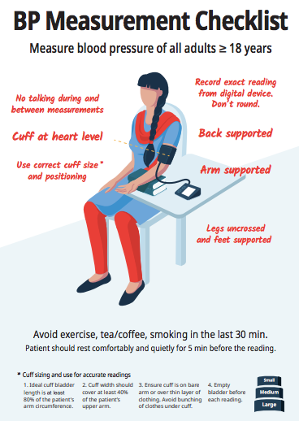

**Summary of visit**

|  |  |  |
| --- | --- | --- |
| **Indicators** | **Observations** | **Recommendations** |
| BP measurement |  |  |
| Treatment |  |  |
| Medication Availability |  |  |
| Service delivery |  |  |
| Patient follow up |  |  |
| Other |  |  |