**Hypertension Health Care Facility Checklist (baseline visit)**

|  |  |
| --- | --- |
| Facility name: _______________________ Region/District name: ________________  Facility type: _______________________ Facility hours: ______________________ | Facility supervisor:  ________________  Reviewer:  ________________  Date:  ________________ |
| Facility staffing (N=number)  Physicians/Med Officers (N):___ Nurses (N):____ Pharmacists (N):____ CHWs (N):____ |
| New HTN patients registered in prior month (N):____ Avg daily HTN patients seen (N):___  Total HTN patients registered (N) to date:____ Total Catchment population (N):___ |
| Is the HTN treatment algorithm displayed for staff to reference? □ Yes □ No |

|  |  |  |  |  |  |  |  |
| --- | --- | --- | --- | --- | --- | --- | --- |
| **1** | **BP measurement** | | | | | | |
| 1.1 | Number of functional (F) and non-functional (NF) BP devices | | | | | Digital: F_____ NF_____  Manual: F_____ NF_____ | |
| 1.2 | Frequency of BP device inspection (digital) / calibration (manual) | | | | | □ 6-monthly □ Annually □ Not done | |
| 1.3 | BP measured for all adult outpatients who come to the clinic | | | | | □ Yes □ No | |
| 1.4 | Location of BP measurement in facility | | | | | □ Registration area □ NCD clinic □ Exam room □ Other | |
| 1.5 | Observe 5 patient BP measurements (refer to BP checklist below): | | | | | Circle # out of 5 meeting criteria: | |
| 1.5.a | BP measured with patient at rest (sitting quietly) | | | | | 0 1 2 3 4 5 | |
| 1.5.b | Proper positioning (back support, arm at heart level, feet on ground) | | | | | 0 1 2 3 4 5 | |
| 1.5.c | Correct cuff size used | | | | | 0 1 2 3 4 5 | |
| 1.5.d | Exact BP recorded, not rounded (i.e. 142/92 not 140/90) | | | | | 0 1 2 3 4 5 | |
| 1.5.e | For patients with initial BP>140/90, repeat BP measured after 3-5min | | | | | 0 1 2 3 4 5 | |
| 1.5.f | For patients with repeat BP>140/90, referred to medical officer | | | | | 0 1 2 3 4 5 | |
| **2** | **Information systems** | | | | | | |
| 2.1 | Type of information system used | | | | | □Paper □Electronic □Both □Neither | |
| 2.2 | Patients given unique identifiers (IDs) | | | | | □ Yes □ No | |
| **3** | **Treatment (based on review of 5 patient records)** Circle # out of 5 meeting criteria: | | | | | | |
| 3.1 | Blood pressure measurements are documented | | | | | 0 1 2 3 4 5 | |
| 3.2 | Medication (names/doses) are documented | | | | | 0 1 2 3 4 5 | |
| 3.3 | If BP>140/90, HTN medication was prescribed/intensified per protocol | | | | | 0 1 2 3 4 5 | |
| **4** | **Medication Availability** | | | | | | |
| 4.1 | Number of days for which HTN medication prescriptions dispensed | | | | | 7 10 30 60 90 Other__ | |
| 4.2 | Drug inventory register maintained and updated | | | | | □ Yes □ No | |
| 4.3 | Drug name*  *Modify drug names for region | | Current stock  (number of tablets) | Any stock outs in last 3 months? (Y/N) | Monthly consumption (number of tablets) | | Is stock sufficient for next quarter, i.e.,  is current stock > monthly consumption x3 months? (Y/N) |
| Amlodipine | |  |  |  | |  |
| HCTZ | |  |  |  | |  |
| Lisinopril | |  |  |  | |  |
| Others (specify)_________­­­­_______ | |  |  |  | |  |
| **5** | **Laboratory Testing Availability on Site** | | | | | | |
| 5.1 | Creatinine Y / N Electrolytes (Na+/K+) Y / N Urine protein Y / N Other ____________________ | | | | | | |
| **6** | **Task Sharing (Circle all that apply)** | | | | | | |
| 6.1 | BP measurement performed by | Nurses Health Worker/Asst. Physician Other_____________ | | | | | |
| 6.2 | HTN medication initiated by | Nurses Health Worker/Asst. Physician Other_____________ | | | | | |
| 6.3 | Medication refilled by | Nurses Health Worker/Asst. Physician Other_____________ | | | | | |
| **7** | **Referral Network and Follow-Up** | | | | | | |
| 7.1 | Hospital refers hypertension patients to health centers/posts | | | | | □ Yes □ No | |
| 7.2 | Resistant HTN* patients are referred to specialist | | | | | □ Yes □ No | |
| 7.3 | Follow up appointments are systematically scheduled | | | | | □ Yes □ No | |
| 7.4 | System in place to identify and outreach to patients lost to follow-up | | | | | □ Yes □ No | |

*Resistant HTN=Uncontrolled BP (>140/90) after completing all protocol steps or adherent on 3 HTN meds

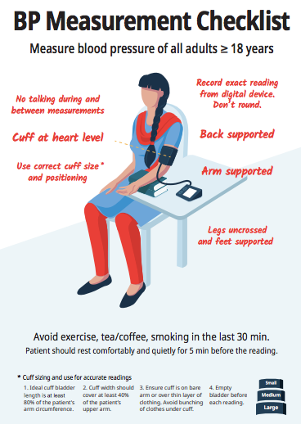

**Summary of Supportive Supervision visit**

|  |  |  |
| --- | --- | --- |
| **Indicators** | **Observations** | **Recommendations** |
| BP measurement |  |  |
| Information systems and patient data recording |  |  |
| Treatment |  |  |
| Medication Availability |  |  |
| Lab Availability |  |  |
| Task Sharing |  |  |
| Referral Network and Follow-up |  |  |
| Other |  |  |