开发信带图版
2026.6.24更新最新版本的介绍信
注意：
高亮内容自由发挥
置灰内容不要动

Dear xxx,

I hope you are doing well.
My name is xxx, and I am responsible for the xxx market at GRADO Contract.
I have been following XXX’s impressive portfolio across workplace, hospitality, retail, and commercial fit-out projects throughout the region.

GRADO focuses on public space furniture and collaborative area furniture. We provide stable quality, reliable delivery, and long-term project support.
We are specialist of public spaces, hospitality spaces, education spaces, bank spaces, automotive retail showrooms, and healthcare spaces.
We have provided furniture for public spaces of leading international brands and Fortune Global 500 companies, helping people work better, connect better, and feel inspired.
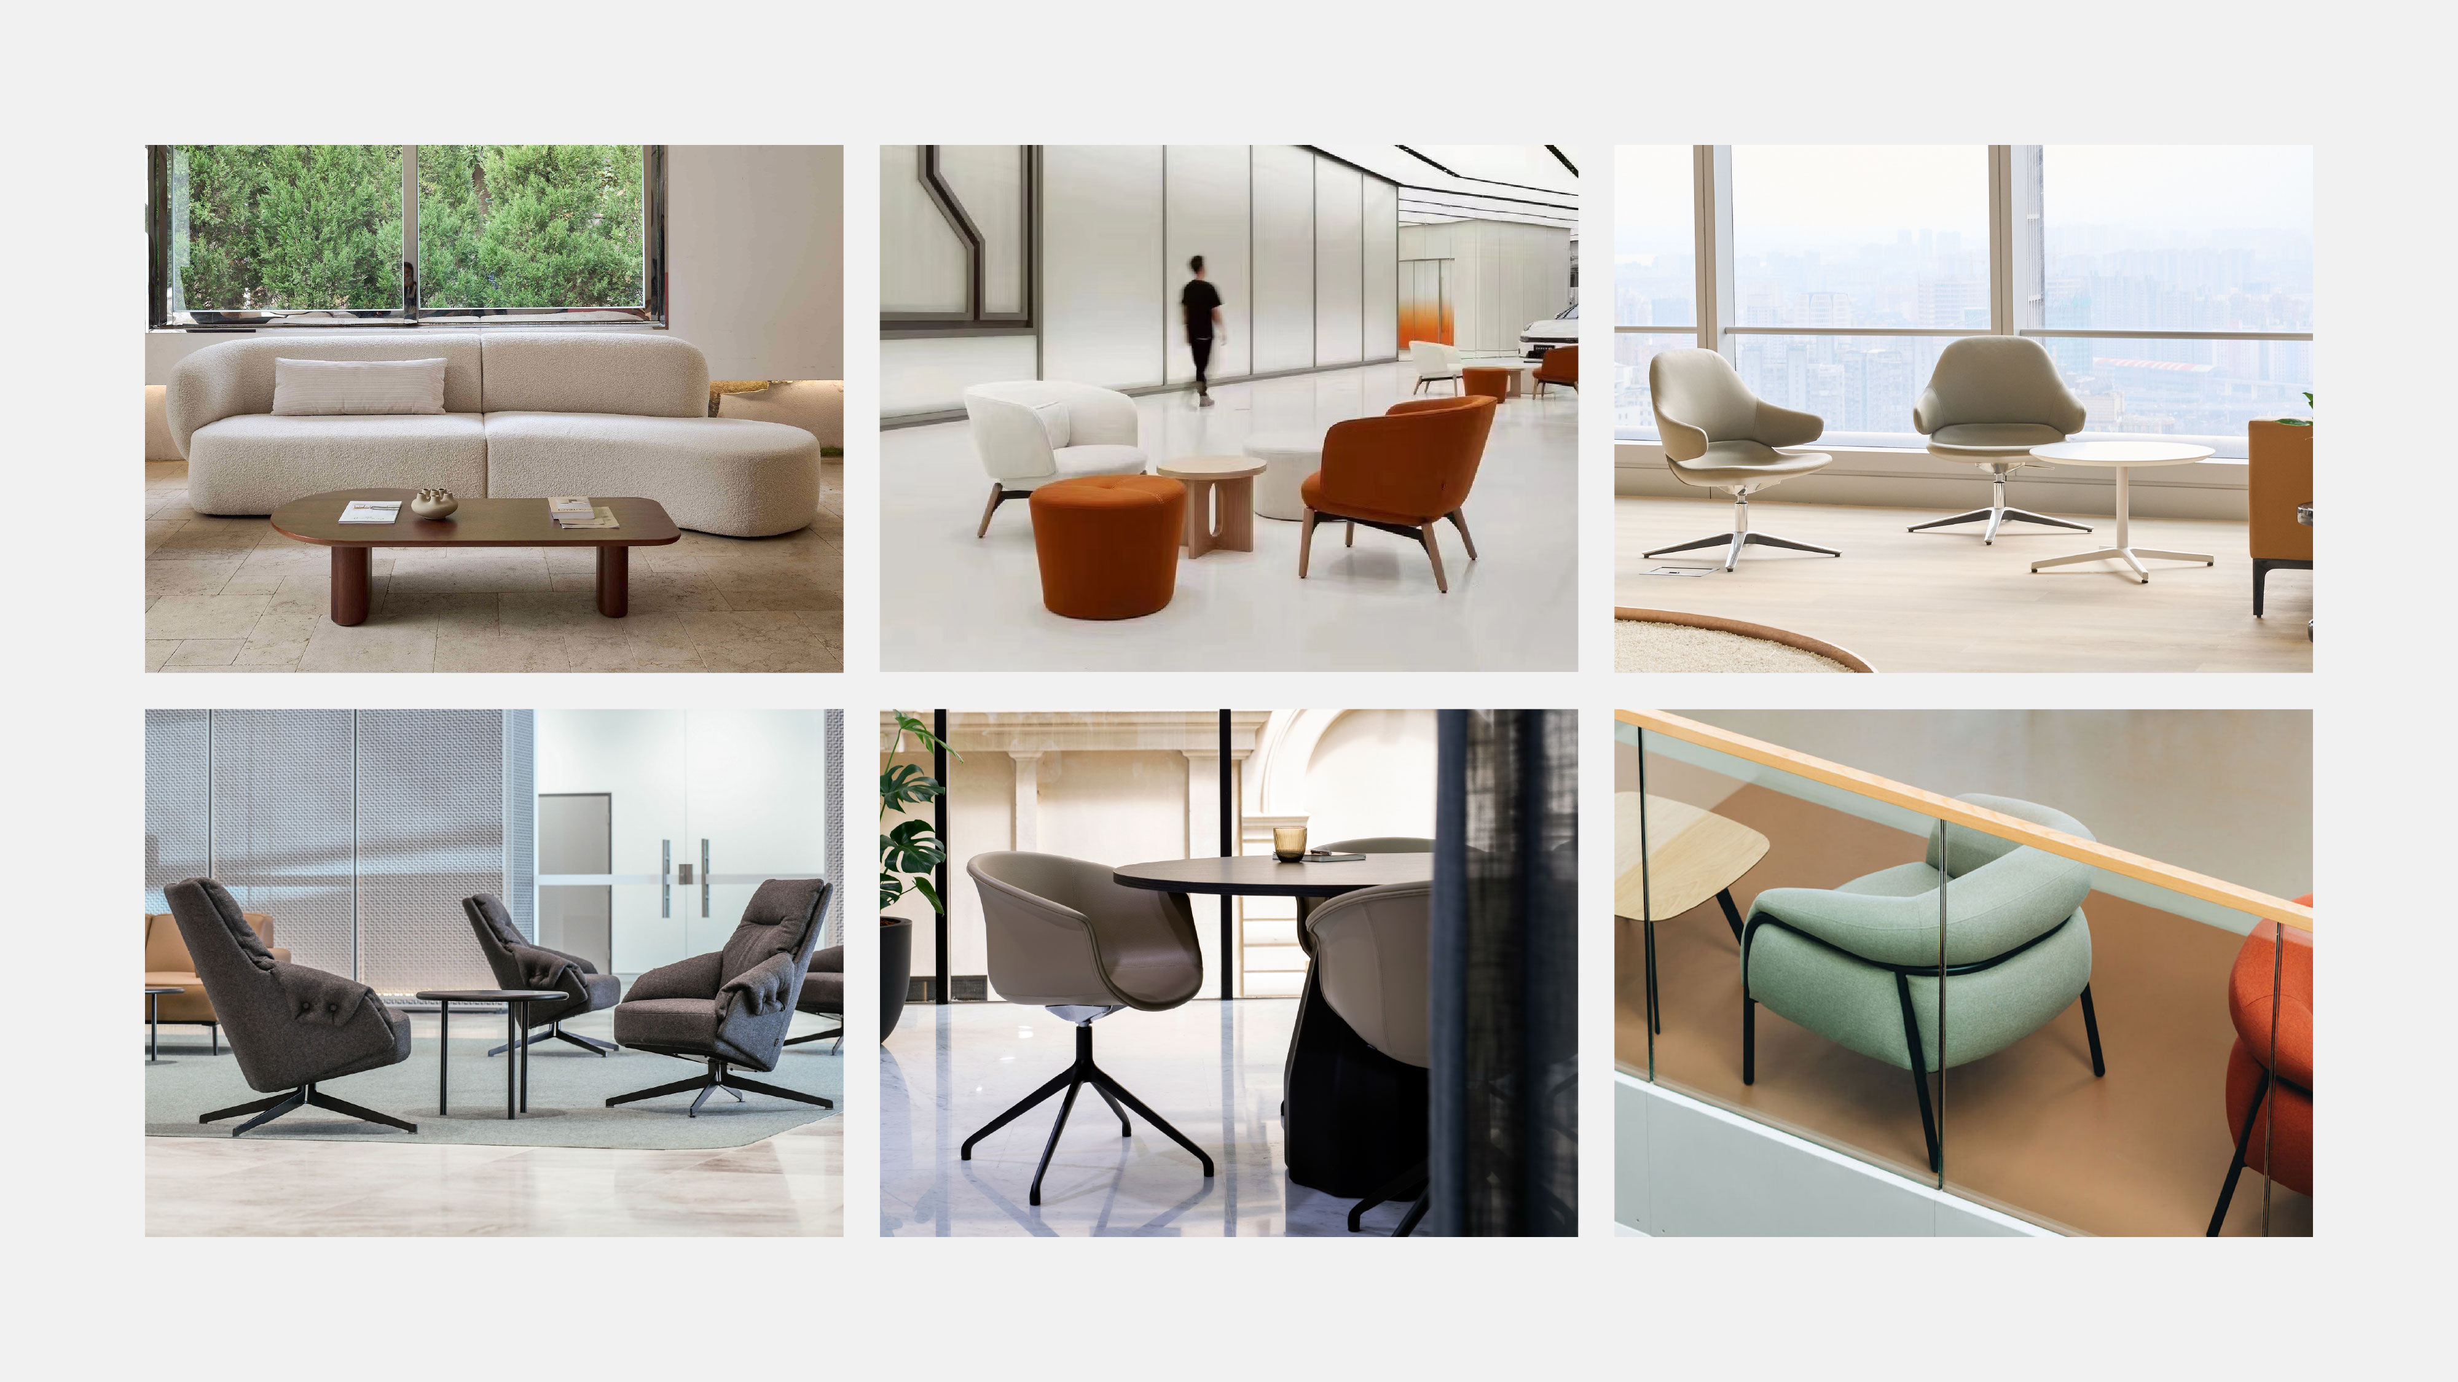

Given XXX’s strong presence in delivering high-quality interior projects, I believe there may be opportunities where GRADO could support your team with project-ready furniture solutions that balance design, durability, customization, and commercial requirements.
I would welcome the opportunity to introduce GRADO and learn more about XXX’s current project focus and procurement approach for furniture packages.
Thank you for your time and consideration.

Best regards,
xxx
xxx Market- GRADO Contract


