School of Engineering and Physical Sciences  Electrical Electronic and Computer Engineering | 

Basic Image Processing with Matlab

Matlab scripts a01images.m and b01neighbours.m demonstrate how to load and image, get some image information, display an image, and perform some simple manipulations with an image. Run these scripts on various images. Use matlab help if necessary. In addition you can use matlab_1.basic.doc and matlab_2.program.doc for a quick introduction to matlab and its main constructions needed for image processing.

If you feel yourself comfortable with these simple image processing manipulations and matlab programming in general, you can start working on the following programming assignment.

ASSESSED EXERCISE (3% of the final mark) Please show your work to either an instructor or teaching assistant by Wednesday 25th January 2017
Given an grey-scale image I(x,y), consider the following non-linear iterative process:

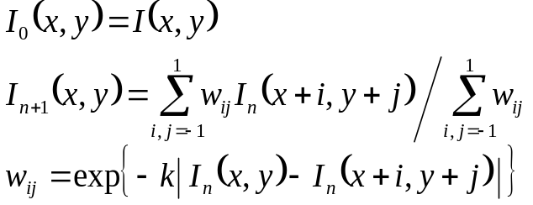

where k is a positive constant. Note that the weights {w_{ij}} depend on the pixel positions (x,y) and the iteration number n. After a certain number of iterations you should get results similar to those shown in the picture below: small-scale image details are removed while salient image edges are sharpened. Your task is to implement the above non-linear iterative procedure, perform a number of experiments (with different images, different numbers of iterations, and various values of k).

A matlab script aver.m implements the above iterative scheme in the simplest case when all the weights are equal to one: 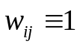.

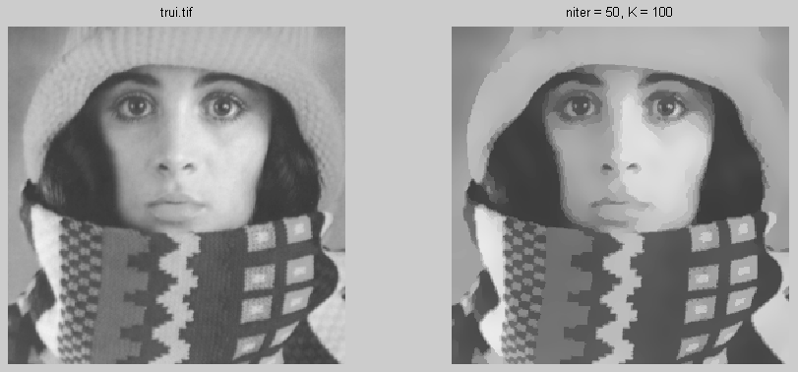

The above non-linear image filtering scheme can be considered as a simplified version of the nonlinear diffusion approach proposed in the seminal paper of Pietro Perona and Jitendra Malik: “Scale-space and edge detection using anisotropic diffusion”, IEEE Transactions of Pattern Analysis and Machine Intelligence, Vol. 12, No. 7, July 1990.

