**Wonderfresh**

User’s Manual – Communication Controller, Track Circuit, and Train Antenna

COE 1186 – Software Engineering

Instructor: Joseph A. Profeta III, Ph.D.

Spring 2017

Kayla Walker

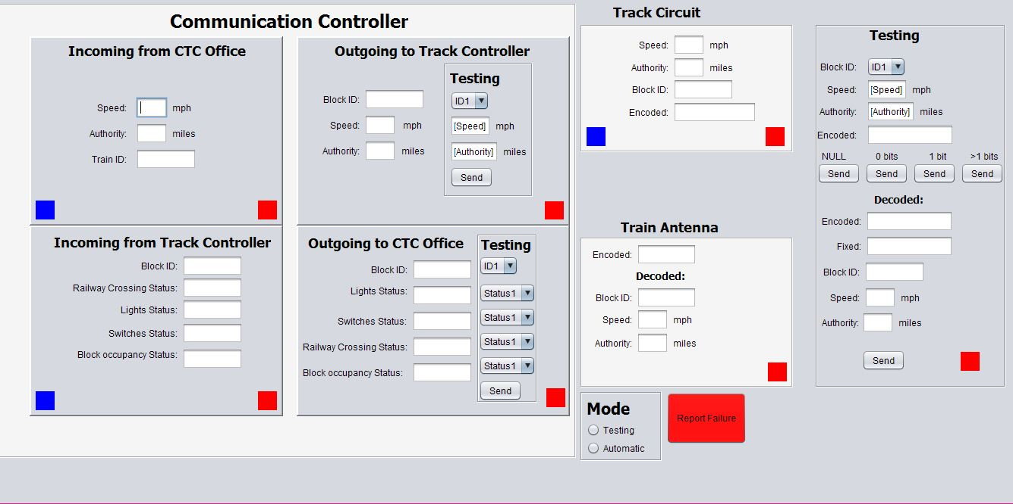

The Communication Controller, Track Model, and Train Antenna User Interface is one joint module that displays all information received by the CTC office, the Track Controller, the Track Circuit, and the Train Antenna; it also displays all information sent to the CTC Office, the Track Controller, and the Train Model. The following is a detailed description of each aspect of this user interface.

**Note:** Indicator squares are shown as blue and red in the picture to show the user what color the indicator square will be when activated. The squares will initially be white when running the user interface.

**Mode**

Select “Testing” only if you want to test the functionalities of the user interface and for debugging purposes. If “Testing” is selected, then all information manually inputted will not affect the information sent or received via “Automatic” mode.

Select “Automatic” only if you want the user interface to receive and send information automatically. Testing mode will be disabled if this mode is selected.

**Communication Controller**

**Incoming from CTC Office**

The incoming speed (in miles per hour), authority (in miles), and Train ID from the CTC Office will all be displayed in this section. When new data comes in from the CTC Office, the indicator square in the bottom left corner will flash from white to blue three times. If any incoming information is not received (i.e. received null information), then the indicator square in the bottom right corner will flash from white to red three times indicating a failure occurred.

**Outgoing to Track Controller**

The Block ID, speed, and authority that will be sent to the Track Controller will be displayed here. This information will be automatically displayed as soon as it is received from the “Incoming from CTC Office” section. A sub-section for testing labeled “Testing” is also included to allow for the user to manually select a Block ID, to manually type in a speed and authority, and to press the “Send” button if all information is ready to be sent to the Track Controller. The “Send” button will only be usable if “Testing” mode under the Mode section is selected. A square indicator is also included in the bottom right corner of the entire section to indicate that no information will be sent (i.e. sending null information); this will flash from white to red three times when activated.

**Incoming from Track Controller**

The Block ID, railway crossing status, lights status, switches status, and block occupancy status will be displayed in this section. When new data comes in from the Track Controller, the indicator square in the bottom left corner will flash from white to blue three times. If any incoming information is not received (i.e. received null information), then the indicator square in the bottom right corner will flash from white to red three times indicating a failure occurred.

**Outgoing to CTC Office**

The Block ID, lights status, switches status, railway crossing status, and block occupancy status that will be sent to the CTC Office will be displayed here. This information will be automatically displayed as soon as it is received from the “Incoming from Track Controller” section. A sub-section for testing labeled “Testing” is also included to allow for the user to manually select a Block ID, lights status, switches status, railway crossing status, and block occupancy status, and to press the “Send” button if all information is ready to be sent to the CTC Office. The “Send” button will only be usable if “Testing” mode under the Mode section is selected. A square indicator is also included in the bottom right corner of the entire section to indicate that no information will be sent (i.e. sending null information); this will flash from white to red three times when activated.

**Track Circuit**

The incoming speed, authority, and Block ID from the Track Model will all be displayed in this section. The resulting encoded data will be shown as a 17-bit binary number. When new data comes in from the Track Model, the indicator square in the bottom left corner will flash from white to blue three times. If any information is not sent (i.e. send null information), then the indicator square in the bottom right corner will flash from white to red three times indicating a failure occurred.

**Train Antenna**

The 17-bit encoded data that was received by the Track Circuit will be displayed at the top. Under the word “Decoded:”, the Block ID, speed, and authority that was decoded from the 17-bit number will be displayed. This information will be automatically displayed as soon as it is received from the “Track Circuit” section. A square indicator is also included in the bottom right corner of the section to indicate that no information was sent or received (i.e. sending or receiving null information); this will flash from white to red three times when activated.

**Testing**

This section is for testing the Track Circuit and Train Antenna. This will only work when “Testing” mode is selected under “Mode”. This section manually gets the Block ID, speed, and authority from the user; the resulting encoded 17-bit binary number will then be shown. The user is then given the option to select either one of the following “Send” buttons: NULL, 0 bits, 1 bit, or >1 bits. If either the user does not input the Block ID, speed, or authority, the “Send” buttons will not be functioning.

**Under “Decoded:”:**

If the NULL “Send” button is selected, the “Encoded:”, “Fixed:”, Block ID, speed, and authority data will be listed as NULL.

If the 0 bits “Send” button is selected, then the exact same 17-bit binary number sent will be listed as the received encoded number. This same number will be listed by “Fixed:”, and the resulting decoded Block ID, speed, and authority will be displayed.

If the 1 bit “Send” button is selected, then one bit shall be changed in the 17-bit binary number determined before; the resulting number shall be listed beside “Encoded:”. The corrected 17-bit binary number will be listed next to “Fixed:”, and the resulting decoded Block ID, speed, and authority will be displayed.

If the >1 bits “Send” button is selected, then more than one bit shall be changed in the 17-bit binary number determined before; the resulting number shall be listed beside “Encoded:”. This same number will be listed next to “Fixed:”, and the resulting decoded Block ID, speed, and authority will be displayed.

The last “Send” button under Authority is used to send the data to the Train Model. It is functional only if there is test data to send.

A square indicator is also included in the bottom right corner of the section to indicate a failure within testing (i.e. no signals received under “Decoded:” and NULL messages sent to Train Model); this will flash from white to red three times when activated.

**Report Failure**

This is a red button that can be pressed by the user if a failure shall be reported.