Part I. Prepare count matrix

(base) [user_31@biot01 zhangjiaying]$ ln -s /data/2022-bioinfo-shared/data/quiz-I/exRNA-long .
(base) [user_31@biot01 zhangjiaying]$ ln -s /data/2022-bioinfo-shared/data/quiz-I/exRNA-short .
(base) [user_31@biot01 zhangjiaying]$ ls -l
total 8
lrwxrwxrwx 1 user_31 tmp 48 Jun 24 20:30 exRNA-long -> /data/2022-bioinfo-shared/data/quiz-I/exRNA-long
lrwxrwxrwx 1 user_31 tmp 49 Jun 24 20:30 exRNA-short -> /data/2022-bioinfo-shared/data/quiz-I/exRNA-short
-rw-r--r-- 1 user_31 tmp 169 Jun 24 14:42 runscana.sh
-rwxr--r-- 1 user_31 tmp 1147 Jun 24 15:33 scana.sh
(base) [user_31@biot01 zhangjiaying]$ ls exRNA-long
bam genome metadata.txt notes.md

#对longRNA进行featureCounts的bash脚本
#!/bin/bash
#SBATCH --job-name=featureCounts_job
#SBATCH --output=featureCounts_%j.out
#SBATCH --error=featureCounts_%j.err
#SBATCH --ntasks=4
#SBATCH --partition=CN_BIOT

export PATH=/data/2022-bioinfo-shared/softwares/subread/subread-2.0.3-Linux-x86_64/bin:$PATH

ANNOTATION_FILE="exRNA-long/genome/gff/gencode.v38.annotation.gff3"
BAM_DIR="exRNA-long/bam"
OUTPUT_DIR="featureCounts_output"

mkdir -p $OUTPUT_DIR

SAMPLES_INFO="/data/2022-bioinfo-shared/data/quiz-I/exRNA-long/metadata.txt"

while IFS=$'\t' read -r sample_id label source sex library dataset; do
if [[ $sample_id == "sample_id" ]]; then
continue
fi

if [[ $library == "reverse" ]]; then
STRAND_OPTION="-s 2"
elif [[ $library == "forward" ]]; then
STRAND_OPTION="-s 1"
else
echo "Unknown library direction for sample $sample_id: $library"
continue
fi
BAM="${BAM_DIR}/${sample_id}.bam"
OUTPUT_PREFIX="${OUTPUT_DIR}/${sample_id}_counts"
featureCounts --countReadPairs -O -M $STRAND_OPTION -p -t exon -g gene_id -a $ANNOTATION_FILE -o ${OUTPUT_PREFIX}.txt $BAM
done < $SAMPLES_INFO

#对smallRNA进行counts的bash脚本，利用scripts里面的count-transcripts
#!/bin/bash
#SBATCH --job-name=smallCounts_job
#SBATCH --output=smallCounts_%j.out
#SBATCH --error=smallCounts_%j.err
#SBATCH --ntasks=4
#SBATCH --partition=CN_BIOT

eval "$(/data/2022-bioinfo-shared/softwares/miniconda3/bin/conda shell.bash hook)"
conda activate python-env

SCRIPTS_DIR="/data/2022-bioinfo-shared/data/quiz-I/scripts"
DATA_DIR="/data/2022-bioinfo-shared/data/quiz-I/exRNA-short/bam"
OUTPUT_DIR="/data/zhangjiaying01/smallRNAoutput"

mkdir -p $OUTPUT_DIR

for SAMPLE_DIR in $DATA_DIR/*; do
if [ -d "$SAMPLE_DIR" ]; then
SAMPLE_NAME=$(basename $SAMPLE_DIR)

echo "$(date "+%H:%M:%S"): 开始处理样本 $SAMPLE_NAME"

SAMPLE_OUTPUT_DIR="$OUTPUT_DIR/$SAMPLE_NAME"
mkdir -p $SAMPLE_OUTPUT_DIR
for BAM_FILE in $SAMPLE_DIR/*.bam; do
RNA_TYPE=$(basename $BAM_FILE .bam)

echo "$(date "+%H:%M:%S"): 处理 $SAMPLE_NAME 的 $RNA_TYPE 文件"

COUNTS_FILE="$SAMPLE_OUTPUT_DIR/${RNA_TYPE}_counts.txt"
STATS_FILE="$SAMPLE_OUTPUT_DIR/${RNA_TYPE}_stats.txt"
python $SCRIPTS_DIR/count-transcripts.py --bam $BAM_FILE --counts $COUNTS_FILE --stats $STATS_FILE -s forward

echo "$(date "+%H:%M:%S"): 完成 $SAMPLE_NAME 的 $RNA_TYPE 文件处理"
done

echo "$(date "+%H:%M:%S"): 完成样本 $SAMPLE_NAME 处理"

fi
done

echo "$(date "+%H:%M:%S"): 所有样本处理完成"

conda deactivate

#将longRNA所得counts结果进行merge的bash脚本
#!/bin/bash
#BATCH --job-name=mergelongcounts_job
#SBATCH --output=mergelongcounts_%j.out
#SBATCH --error=mergelongcounts_%j.err
#SBATCH --ntasks=4
#SBATCH --partition=CN_BIOT

eval "$(/data/2022-bioinfo-shared/softwares/miniconda3/bin/conda shell.bash hook)"
conda activate python-env

DATA_DIR="/data/zhangjiaying/featureCounts_output"
METADATA_FILE="/data/2022-bioinfo-shared/data/quiz-I/exRNA-long/metadata.txt"
SAMPLE_IDS_FILE="/data/zhangjiaying01/sample_ids.txt"
OUTPUT_FILE="/data/zhangjiaying01/count.matrix.txt"

awk 'NR>1 {print $1}' $METADATA_FILE > $SAMPLE_IDS_FILE

while IFS= read -r sample_id; do
file_path="$DATA_DIR/${sample_id}_counts.txt"
if [[ ! -f "$file_path" ]]; then
echo "$file_path does not exist" >&2
missing_files=$((missing_files + 1))
elif [[ ! -s "$file_path" ]]; then
echo "$file_path is empty" >&2
empty_files=$((empty_files + 1))
else
line_count=$(wc -l < "$file_path")
if [[ $line_count -le 1 ]]; then
echo "$file_path has insufficient lines" >&2
empty_files=$((empty_files + 1))
fi
fi
done < $SAMPLE_IDS_FILE

python /data/2022-bioinfo-shared/data/quiz-I/scripts/summarize-table.py \
--indir $DATA_DIR \
--formatter '{}_counts.txt' \
--sample-ids $SAMPLE_IDS_FILE \
--row-field 0 \
--row-name gene_id \
--first-line 2 \
--value-field 6 \
--fillna \
--output $OUTPUT_FILE

echo "Count matrix has been created at $OUTPUT_FILE"

conda deactivate

#因为磁盘空间不足，有部分文件夹是空的，故进行re-count
#!/bin/bash
#SBATCH --job-name=recountfeature_job
#SBATCH --output=recountfeature_%j.out
#SBATCH --error=recountfeature_%j.err #SBATCH --ntasks=4
#SBATCH --partition=CN_BIOT export PATH=/data/2022-bioinfo-shared/softwares/subread/subread-2.0.3-Linux-x86_64/bin:$PATH ANNOTATION_FILE="/data/2022-bioinfo-shared/data/quiz-I/exRNA-long/genome/gff/gencode.v38.annotation.gff3"
BAM_DIR="/data/2022-bioinfo-shared/data/quiz-I/exRNA-long/bam" OUTPUT_DIR="data/zhangjiaying01/recountfeature_output" SAMPLES_TO_RECOUNT="/data/zhangjiaying01/samples_to_recount.txt"

mkdir -p $OUTPUT_DIR

while IFS= read -r sample_id; do
bam_file="$BAM_DIR/${sample_id}.bam"
output_file="$NEW_OUTPUT_DIR/${sample_id}_counts.txt"

if [[ -f "$bam_file" ]]; then
echo "Running featureCounts for $bam_file..."
featureCounts --countReadPairs -O -M $STRAND_OPTION -p -t exon -g gene_id -a $ANNOTATION_FILE -o $output_file $bam_file

if [[ $? -ne 0 ]]; then
echo "Error occurred during featureCounts for $bam_file" >&2
exit 1
fi

#对小RNA进行merge的bash脚本
#!/bin/bash
#SBATCH --job-name=mergesmall_job
#SBATCH --output=mergesmall_%j.out
#SBATCH --error=mergesmall_%j.err
#SBATCH --ntasks=4
#SBATCH --partition=CN_BIOT

eval "$(/data/2022-bioinfo-shared/softwares/miniconda3/bin/conda shell.bash hook)"
conda activate python-env

SCRIPT_PATH="/data/2022-bioinfo-shared/data/quiz-I/scripts/summarize-table.py"
INPUT_DIR="/data/zhangjiaying01/smallRNAoutput"
OUTPUT_DIR="/data/zhangjiaying01/merged_smallRNA_output"

mkdir -p $OUTPUT_DIR

declare -a RNA_TYPES=("miRNA_counts.txt" "piRNA_counts.txt")

TMP_DIR=$(mktemp -d)
SAMPLE_IDS_FILE="$TMP_DIR/sample_ids.txt"

for SAMPLE_DIR in $INPUT_DIR/*; do
if [ -d "$SAMPLE_DIR" ]; then
SAMPLE_ID=$(basename $SAMPLE_DIR)
echo $SAMPLE_ID >> $SAMPLE_IDS_FILE
for RNA_TYPE in "${RNA_TYPES[@]}"; do
RNA_FILE="$SAMPLE_DIR/$RNA_TYPE"
if [ -f "$RNA_FILE" ]; then
cp "$RNA_FILE" "$TMP_DIR/${SAMPLE_ID}_${RNA_TYPE}"
fi
done
fi
done

for RNA_TYPE in "${RNA_TYPES[@]}"; do
echo "Merging $RNA_TYPE..."
RNA_OUTPUT_FILE="$OUTPUT_DIR/${RNA_TYPE%.txt}.merged.txt"
python $SCRIPT_PATH --formatter "{}_${RNA_TYPE}" --indir $TMP_DIR --sample-ids $SAMPLE_IDS_FILE --value-field 1 --row-field 0 --row-name "${RNA_TYPE%.txt}_id" --output $RNA_OUTPUT_FILE --fillna
done

rm -rf $TMP_DIR

echo "All RNA types merged successfully. Output saved in $OUTPUT_DIR."

conda deactivate

#用python脚本将miRNA和piRNA的count matrix进行合并

import pandas as pd

miRNA_counts = pd.read_csv('/data/zhangjiaying01/merged_smallRNA_output/miRNA_counts.merged.txt', sep='\t', header=0, index_col=0)
piRNA_counts = pd.read_csv('/data/zhangjiaying01/merged_smallRNA_output/piRNA_counts.merged.txt', sep='\t', header=0, index_col=0)

piRNA_counts = piRNA_counts[miRNA_counts.columns]

merged_counts = pd.concat([miRNA_counts, piRNA_counts], axis=0)

merged_counts.to_csv('/data/zhangjiaying01/merged_smallRNA_output/mipi_counts.merged.txt', sep='\t')

print("合并完成，结果保存在 /data/zhangjiaying01/merged_smallRNA_output/mipi_counts.merged.txt")

运行的bash脚本不再赘述。

Part II. Matrix processing

#filter和normalization的script
编写R脚本对matrix进行filter和normalization，以下是filter和normalization小RNA的R script：
library(edgeR)

count_matrix_path <- "/data/zhangjiaying01/merged_smallRNA_output/mipi_counts.merged.txt"
count_matrix <- read.table(count_matrix_path, header=TRUE, row.names=1, sep="\t")

y <- DGEList(counts=count_matrix)

keep <- filterByExpr(y)
y <- y[keep, , keep.lib.sizes=FALSE]

filtered_count_matrix_path <- "/data/zhangjiaying01/matrixprocessing/mipi_counts.filtered.txt"
write.table(y$counts, file=filtered_count_matrix_path, sep="\t", quote=FALSE, col.names=NA)

print(paste("Filtering complete. Filtered matrix saved at:", filtered_count_matrix_path))

y <- edgeR::calcNormFactors(y,method="TMM")
cpm_matrix <- edgeR::cpm(y,log=TRUE)

normalized_count_matrix_path <- "/data/zhangjiaying01/matrixprocessing/mipi_counts.TMM_log_normalized.txt"
write.table(cpm_matrix, file=normalized_count_matrix_path, sep="\t", quote=FALSE, col.names=NA)
print(paste("Normalization complete. Normalized matrix saved at:", normalized_count_matrix_path))

提交的bash脚本：
#!/bin/bash
#SBATCH --job-name=filter_counts_job
#SBATCH --output=filter_counts_%j.out
#SBATCH --error=filter_counts_%j.err
#SBATCH --ntasks=1
#SBATCH --partition=CN_BIOT

eval "$(/data/2022-bioinfo-shared/softwares/miniconda3/bin/conda shell.bash hook)"
conda activate r-env
Rscript /data/zhangjiaying01/matrixprocessing/filter_counts.R
conda deactivate

以下是filter和normalization长RNA的R script:
library(edgeR)

count_matrix_path <- "/data/zhangjiaying01/count.matrix.txt"
count_matrix <- read.table(count_matrix_path, header=TRUE, row.names=1, sep="\t")

y <- DGEList(counts=count_matrix)

keep <- filterByExpr(y)
y <- y[keep, , keep.lib.sizes=FALSE]

filtered_count_matrix_path <- "/data/zhangjiaying01/matrixprocessing/long_counts.filtered.txt"
write.table(y$counts, file=filtered_count_matrix_path, sep="\t", quote=FALSE, col.names=NA)

print(paste("Filtering complete. Filtered matrix saved at:", filtered_count_matrix_path))

y <- edgeR::calcNormFactors(y,method="TMM")
cpm_matrix <- edgeR::cpm(y,log=TRUE)

normalized_count_matrix_path <- "/data/zhangjiaying01/matrixprocessing/long_counts.TMM_log_normalized.txt"
write.table(cpm_matrix, file=normalized_count_matrix_path, sep="\t", quote=FALSE, col.names=NA)
print(paste("Normalization complete. Normalized matrix saved at:", normalized_count_matrix_path))

提交的bash脚本：
#!/bin/bash
#SBATCH --job-name=filter_long_job
#SBATCH --output=filter_counts_%j.out
#SBATCH --error=filter_counts_%j.err
#SBATCH --ntasks=1
#SBATCH --partition=CN_BIOT

eval "$(/data/2022-bioinfo-shared/softwares/miniconda3/bin/conda shell.bash hook)"
conda activate r-env
Rscript /data/zhangjiaying01/matrixprocessing/filter_long.R
conda deactivate

在本地进行可视化，以smallRNA为例，如下图：

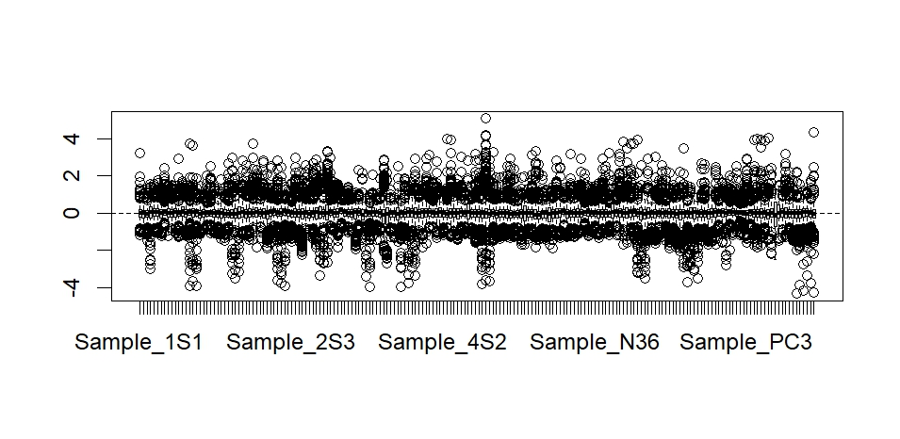
#上面是smallRNA各个sample之间normalization结果的可视化，可见normalization达到效果
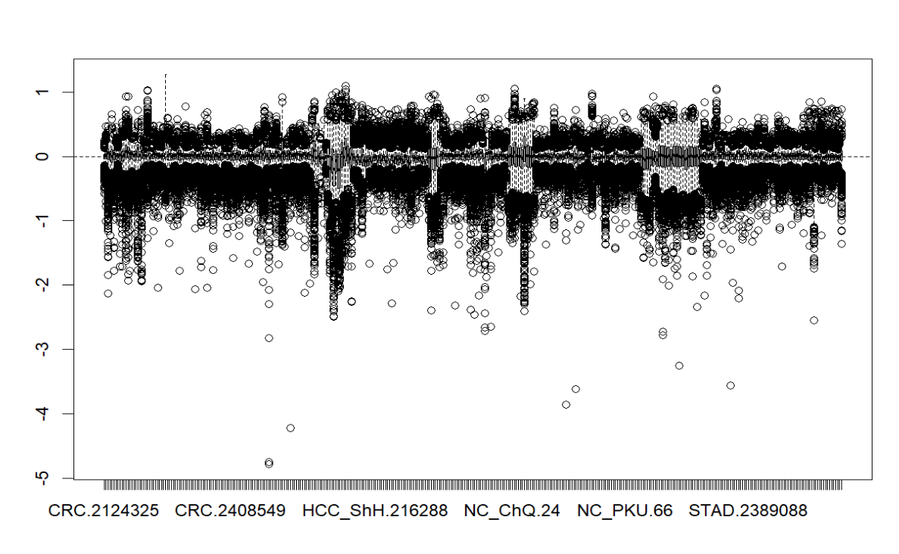
#上面是longRNA的normalization可视化效果，可见也达到了预期效果

#去除batch effect
library(sva)

long_normalized_data <- read.table("/data/zhangjiaying01/matrixprocessing/long_counts.TMM_log_normalized.txt", header=TRUE, row.names = 1, sep="\t")

long_normalized_data <- as.matrix(long_normalized_data)

metadata <- read.table("/data/2022-bioinfo-shared/data/quiz-I/exRNA-long/metadata.txt",sep="\t",row.names = 1,header = TRUE)

colnames(long_normalized_data) <- gsub("\\.", "-", colnames(long_normalized_data))

long_normalized_data <- long_normalized_data[,row.names(metadata)]

common_samples <- intersect(row.names(metadata), colnames(long_normalized_data))

long_normalized_data.combat <- ComBat (long_normalized_data, batch=metadata$source)
write.table(long_normalized_data.combat,"/data/zhangjiaying01/matrixprocessing/long.TMM_log_normalized.combat.txt",sep="\t",quote = F)

提交的脚本：
#!/bin/bash
#SBATCH --job-name=batcheff
#SBATCH --output=batcheff_%j.out
#SBATCH --error=batcheff_%j.err
#SBATCH --ntasks=4
#SBATCH --partition=CN_BIOT

eval "$(/data/2022-bioinfo-shared/softwares/miniconda3/bin/conda shell.bash hook)"
conda activate r-env
Rscript /data/zhangjiaying01/matrixprocessing/batcheff.R
conda deactivate

对longRNA进行scale和可视化如下
data <- read.table("C:/Users/86199/Downloads/long_counts.TMM_log_normalized.txt", header=TRUE, row.names = 1, sep="\t")
data_combat <- read.table("C:/Users/86199/Downloads/long.TMM_log_normalized.combat.txt",header = TRUE, row.names = 1, sep="\t")
library("Rtsne")
> library("ggplot2")
> data <- as.matrix(data)
> data_combat <- as.matrix(data_combat)

#注意取转置！！！
data <- t(data)
data_combat <- t(data_combat)

data_sc <- scale(data, center = TRUE, scale = TRUE)
data_combat_sc <- scale(data_combat, center = TRUE, scale = TRUE)
tsne.res <- Rtsne(data_sc, dims = 2, check_duplicates = F)
metadata_long$tSNE1 <- tsne.res$Y[,1]
> metadata_long$tSNE2 <- tsne.res$Y[,2]
ggplot(metadata_long, aes(x=tSNE1, y=tSNE2, color=source)) + geom_point() + theme_bw()
可视化如下图，可见明显根据source的不同分成几团：
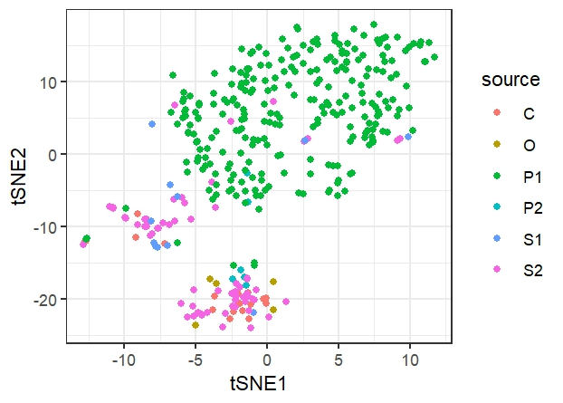
对去除batch effect后的作可视化如下，可见去除batch effect基本达到预期：
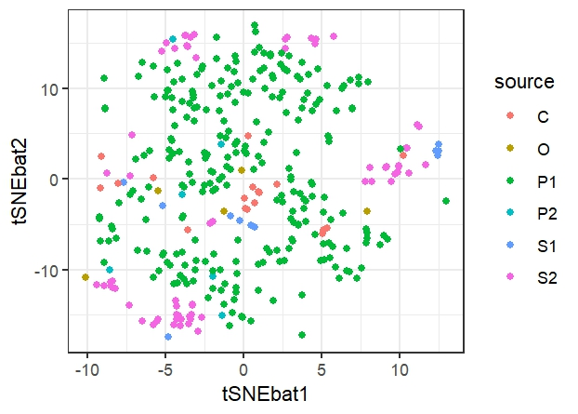
smallRNA用相同的方法可以得到：
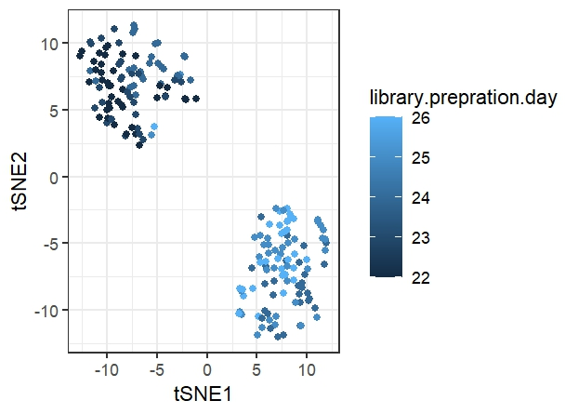
#上面是没有经过batcheffect校正的
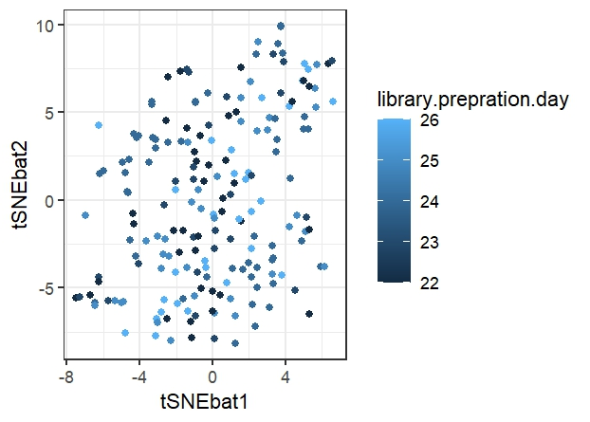
#上面是经过batcheffect校正的

Part III. Machine Learning
> short_log_normalized_data <- read.table("C:/Users/86199/Downloads/mipi_counts.TMM_log_normalized.txt", header=TRUE, row.names = 1, sep="\t")
> short_log_normalized_data.matrix <- as.matrix(short_log_normalized_data)
> library(sva)
载入需要的程序包：mgcv
载入需要的程序包：nlme
This is mgcv 1.9-1. For overview type 'help("mgcv-package")'.
载入需要的程序包：genefilter
载入需要的程序包：BiocParallel
> short_metadata <- read.table("C:/Users/86199/Downloads/short_metadata.txt", header=TRUE, row.names = 1, sep="\t")
> View(short_metadata)
> short_log_normalized_data.matrix <- short_log_normalized_data.matrix[,row.names(short_metadata)]
> save.image("D:/.R/batch.RData")
> short_log_normalized_data.matrix.combat <- ComBat(short_log_normalized_data.matrix, batch=short_metadata$library.prepration.day)
Found5batches
Adjusting for0covariate(s) or covariate level(s)
Standardizing Data across genes
Fitting L/S model and finding priors
Finding parametric adjustments
Adjusting the Data
write.table(short_log_normalized_data.matrix.combat,"mipi_log_normalized_combat.txt",sep="\t",quote = F)
short_log_normalized_data.matrix.combat <- scale(short_log_normalized_data.matrix.combat, center=TRUE, scale=TRUE)
> metadata_selectec <- short_metadata[short_metadata$label %in% c("CRC", "HD"), ]
> View(metadata_selectec)
> train.indices <- createDataPartition(metadata_selectec$label, p = 0.8, list = TRUE)$Resample1
> trainData <- metadata_selectec[train.indices, ]
> testData <- metadata_selectec[-train.indices, ]
testdata <- testData$label
traindata<-trainData$label
y_test <- as.factor(testdata)
y_train <- as.factor(traindata)
selected_samples <- row.names(metadata_selectec)
selected_x_data.matrix <- x_data.matrix[selected_samples, ]
x_train<-selected_x_data.matrix[train.indices,]
x_test<-selected_x_data.matrix[-train.indices,]

rfe.results <- rfe(x_train, y_train, sizes=1:20, rfeControl = rfectrl, metric="ROC")
selected.features <- predictors(rfe.results)
> selected.features
[1] "hsa-mir-125a" "piR-hsa-158839" "piR-hsa-171879" "piR-hsa-343608" "piR-hsa-154568"
[6] "hsa-mir-495" "piR-hsa-723374" "hsa-mir-543" "piR-hsa-161487" "hsa-mir-1343"
[11] "hsa-mir-28" "piR-hsa-133584" "hsa-mir-30b" "piR-hsa-397901" "piR-hsa-810073"
[16] "hsa-mir-381" "piR-hsa-338004" "hsa-mir-139"
最终得到18条mi/piRNA。

params.grid <- expand.grid(mtry = c(2, 4, 6, 8, 10))
cv.fitted <- train(x.train[,predictors(rfe.results)],y.train,
method="rf",
metric = "ROC",
tuneGrid = params.grid,
preProcess = NULL,
trControl = tr.ctrl )

roc.curve <- roc(y_test,y_test.pred.prob[,2])
plot(roc.curve,print.auc=T)
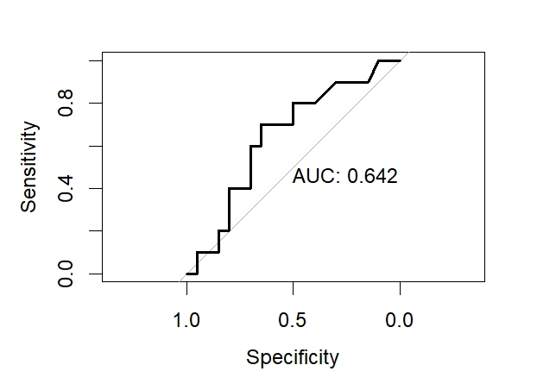
预测效果并不算好，randomforest超参数调整较有限，或许尝试回归算法调整超参数会有改善？

lasso_model <- train(x_train,y_train,method="glmnet",tuneGrid= expand.grid(alpha=c(0,0.5,1),lambda=c(0,0.001,0.01,0.1,1)),family="binomial",metric="ROC",tuneGrid=params.grid,preProcess=NULL)

重新进行rfe，尝试进行size调整，得到：
rfectrl <- rfeControl(functions=rfFuncs,
verbose = TRUE,
method="boot",number=10)

rfe.results <- rfe(x_train,y_train,
sizes=2:9,
rfeControl=rfectrl,
metric = "ROC")
selected.features <- predictors(rfe.results)
> selected.features
[1] "hsa-mir-543" "hsa-mir-125a" "hsa-mir-139" "piR-hsa-171879" "hsa-mir-1343"
[6] "hsa-mir-92b" "hsa-mir-885" "hsa-mir-381" "piR-hsa-158839"

对比前面rfe找出来的特征，寻找重合的smallRNA
[1] "hsa-mir-125a" "piR-hsa-158839" "piR-hsa-171879" "piR-hsa-343608" "piR-hsa-154568"
[6] "hsa-mir-495" "piR-hsa-723374" "hsa-mir-543" "piR-hsa-161487" "hsa-mir-1343"
[11] "hsa-mir-28" "piR-hsa-133584" "hsa-mir-30b" "piR-hsa-397901" "piR-hsa-810073"
[16] "hsa-mir-381" "piR-hsa-338004" "hsa-mir-139"
看起来所选择的特征里重合的miRNA比piRNA要多。

调参：
params.grid <- expand.grid(alpha = c(0,0.5,1),lambda = c(0,0.01,0.1,1))
tr.ctrl <- trainControl(method="cv",
+ number = 5,
+ summaryFunction = twoClassSummary,
+ classProbs = TRUE)
> cv.fitted <- train(x_train[,predictors(rfe.results)],y_train,
+ method="glmnet",
+ family="binomial",
+ metric = "ROC",
+ tuneGrid = params.grid,
+ preProcess = NULL,
+ trControl = tr.ctrl )
> cv.fitted$bestTune
alpha lambda
3 0 0.1
y.test.pred.prob <- predict(cv.fitted,newdata=x_test,type="prob")
roc.curve <- roc(y_test,y.test.pred.prob[,2])
Setting levels: control = CRC, case = HD
Setting direction: controls < cases
> plot(roc.curve,print.auc=T)

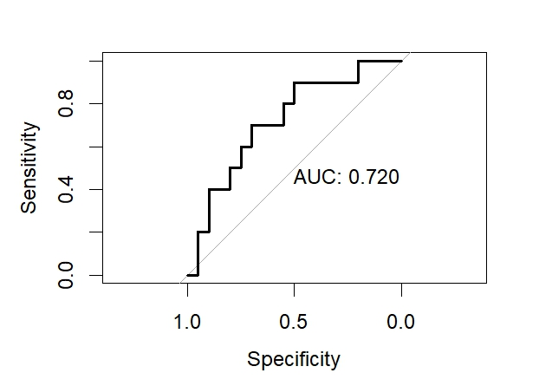
可见其效果比randomforest稍好一些。

用下文尝试不同特征数量的方式对小RNA进行尝试
以下是尝试最多20条特征数量：
"hsa-mir-125a" "hsa-mir-543" "hsa-mir-139" "hsa-mir-1343" "piR-hsa-171879"
[6] "piR-hsa-810073" "hsa-mir-885" "hsa-mir-92b" "hsa-mir-381" "hsa-mir-935"
[11] "piR-hsa-158808" "piR-hsa-133584" "hsa-mir-28" "hsa-mir-455" "hsa-mir-128-2"
[16] "piR-hsa-158839" "hsa-mir-149" "hsa-mir-212" "piR-hsa-143717" "hsa-mir-361"

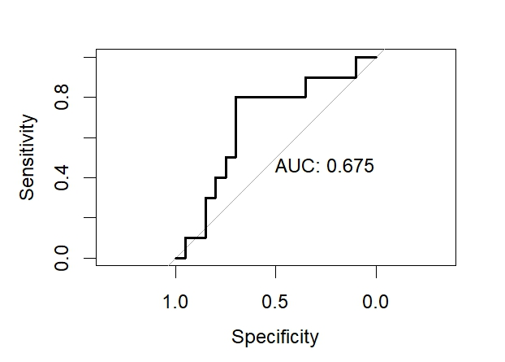

同样尝试其他数量。如30，15

#尝试30，ROC曲线更差
[1] "hsa-mir-125a" "hsa-mir-543" "hsa-mir-139" "piR-hsa-171879" "hsa-mir-935"
[6] "hsa-mir-1343" "hsa-mir-455" "hsa-mir-885" "hsa-mir-92b" "piR-hsa-810073"
[11] "piR-hsa-158808" "hsa-mir-34b" "hsa-mir-149" "hsa-mir-381" "piR-hsa-133584"
[16] "piR-hsa-154568" "piR-hsa-723374" "piR-hsa-158839" "hsa-mir-128-2" "hsa-mir-28"
[21] "hsa-mir-212" "piR-hsa-162879" "piR-hsa-2678961" "hsa-mir-7-3" "hsa-mir-30b"
[26] "hsa-mir-132" "piR-hsa-132040" "hsa-let-7c" "piR-hsa-157188" "hsa-mir-222"

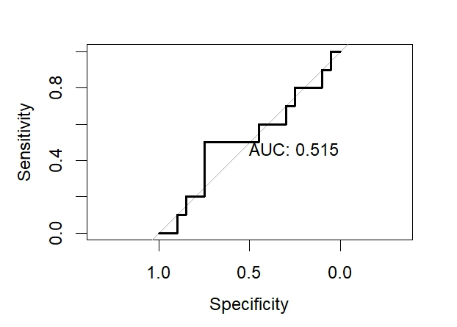

尝试15，曲线也并不太好
print(selected.features)
[1] "hsa-mir-125a" "hsa-mir-139" "hsa-mir-543" "hsa-mir-1343" "piR-hsa-171879"
[6] "hsa-mir-92b" "hsa-mir-935" "piR-hsa-810073" "hsa-mir-885" "hsa-mir-381"
[11] "hsa-mir-28" "hsa-mir-128-2" "piR-hsa-2678961" "hsa-mir-212" "piR-hsa-158808"

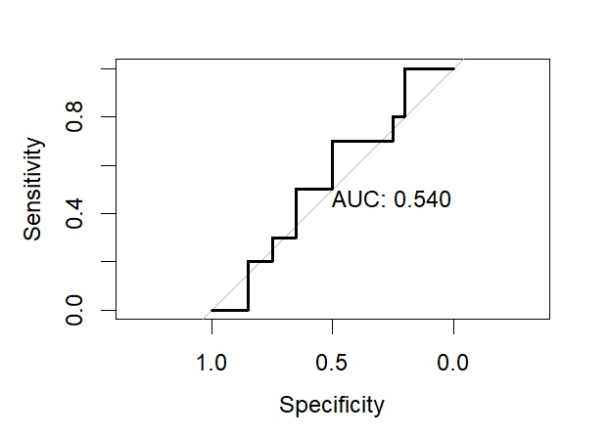
因此综合上述，还是18~20条左右的特征数目预测能力最好。
对上述多次选取出来的特征取交集，去数据库查询资料进行分析。
在上述所有尝试中所有所选取特征的交集如下:
"hsa-mir-125a", "hsa-mir-139", "piR-hsa-171879", "hsa-mir-1343", "hsa-mir-381”, "hsa-mir-543"
此外，在多次尝试中重复出现的还有
"piR-hsa-158839"

以下是对long_RNA进行batch处理的Rscript：
library(sva)

long_normalized_data <- read.table("/data/zhangjiaying01/matrixprocessing/
long_counts.TMM_log_normalized.txt", header=TRUE, row.names = 1, sep="\t")

long_normalized_data <- as.matrix(long_normalized_data)

metadata <- read.table("/data/2022-bioinfo-shared/data/quiz-I/exRNA-long/metadata.txt",
sep="\t",row.names = 1,header = TRUE)

colnames(long_normalized_data) <- gsub("\\.", "-", colnames(long_normalized_data))

long_normalized_data <- long_normalized_data[,row.names(metadata)]

common_samples <- intersect(row.names(metadata), colnames(long_normalized_data))

long_normalized_data.combat <- ComBat (long_normalized_data, batch=metadata$source)
write.table(long_normalized_data.combat,"/data/zhangjiaying01/matrixprocessing/
long.TMM_log_normalized.combat.txt",sep="\t",quote = F)

metadata_long$status <- ifelse(metadata_long$label %in% c("CRC", "ESCA", "HCC", "LUAD",
"STAD"), "MAL", "NC")
library(glmnet)
> library(caret)
> library(pROC)
> set.seed(123)
train.indices <- createDataPartition(metadata_long$status, p = 0.8, list = TRUE)$Resample1
trainData <- metadata_long[train.indices, ]
> testData <- metadata_long[-train.indices,]
> testdata <- testData$status
> traindata <- trainData$status
> y_test <- as.factor(testdata)
> y_train <- as.factor(traindata)
x_train <- data_combat_sc[train.indices,]
> x_test<-data_combat_sc[-train.indices,]
#由于在本地运算量太大，转移到cluster上进行运算

#R脚本
“
library(glmnet)
library(caret)
library(pROC)

x.test <- read.table("/data/zhangjiaying01/machinelearning/x_test.txt", header = TRUE,
sep=" ")
x.train <- read.table("/data/zhangjiaying01/machinelearning/x_train.txt", header = TRUE,
sep=" ")
y.test <- read.table("/data/zhangjiaying01/machinelearning/y_test.txt", header = TRUE,
sep=" ")
y.train <- read.table("/data/zhangjiaying01/machinelearning/y_train.txt", header = TRUE,
sep=" ")

y.test <- as.factor(y.test[,1])
y.train <- as.factor(y.train[,1])

rfFuncs$summary <- twoClassSummary

rfectrl <- rfeControl(functions=rfFuncs,
verbose = TRUE,
method="boot",number=10)
rfe.results <- rfe(x.train,y.train,
sizes=2:9,
rfeControl=rfectrl,
metric = "ROC")
selected.features <- predictors(rfe.results)
print("the selected features are:")
print(selected.features)

print("feature selection done.")

params.grid <- expand.grid(alpha = c(0,0.5,1),lambda = c(0,0.01,0.1,1))

tr.ctrl <- trainControl(method="cv",
number = 5,
summaryFunction = twoClassSummary,
classProbs = TRUE)

cv.fitted <- train(x.train[,predictors(rfe.results)],y.train,
method="glmnet",
family="binomial",
metric = "ROC",
tuneGrid = params.grid,
preProcess = NULL,
trControl = tr.ctrl )

print("the fitted besttune is:")
print(cv.fitted$bestTune)

y.test.pred.prob <- predict(cv.fitted,newdata=x.test,type="prob")
print("y.test.pred.prob generated")
write.table (y.test.pred.prob, "/data/zhangjiaying01/machinelearning/y.test.pred.prob.txt", quote = FALSE, row.names = FALSE)
print("txt written in /data/zhangjiaying01/machinelearning.")
“

#提交sbatch的bash脚本

#!/bin/bash
#SBATCH --job-name=glmnet_pred
#SBATCH --output=pred_%j.out
#SBATCH --error=pred_%j.err
#SBATCH --ntasks=4
#SBATCH --partition=CN_BIOT

eval "$(/data/2022-bioinfo-shared/softwares/miniconda3/bin/conda shell.bash hook)"
conda activate r-env
Rscript /data/zhangjiaying01/machinelearning/glmnet.R
conda deactivate

#输出文件在作业文件夹中可见，为y.test.pred.prob.txt
#此外在输出日志中可以看到所选择的特征和优化后的参数
#发现选择特征仍然太多了，尝试通过重新调整参数和方法进行重新选择
[1] "the fitted besttune is:"
alpha lambda
7 0.5 0.1
在本地绘制ROC Curve如下图
y.test.pred.prob<- read.table("C:/Users/86199/Downloads/y.test.pred.prob.txt",
header = TRUE, sep = " ")
library(pROC)
roc.curve <- roc(y_test,y.test.pred.prob[,2])
plot(roc.curve,print.auc=T)
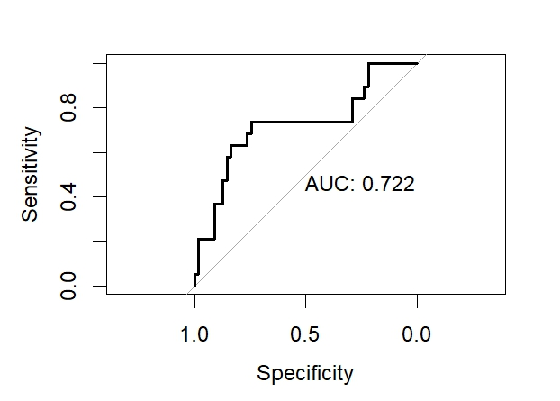

#更改Rscript尝试其他方法和参数。
library(glmnet)
library(caret)

x.test <- read.table("/data/zhangjiaying01/machinelearning/x_test.txt", header = TRUE,
sep=" ")
x.train <- read.table("/data/zhangjiaying01/machinelearning/x_train.txt", header = TRUE,
sep=" ")
y.test <- read.table("/data/zhangjiaying01/machinelearning/y_test.txt", header = TRUE,
sep=" ")
y.train <- read.table("/data/zhangjiaying01/machinelearning/y_train.txt", header = TRUE,
sep=" ")

y.test <- as.factor(y.test[,1])
y.train <- as.factor(y.train[,1])

#强制最多选择20条特征，否则无法进行手动分析
rfFuncs$selectSize <- function(x, metric, maximize) {
bestSize <- x$size[which.max(x[, metric])]
return(min(bestSize, 20))
}

rfFuncs$summary <- twoClassSummary

#在这里换了一种method
rfectrl <- rfeControl(functions=rfFuncs,
verbose = TRUE,
method="cv",
number=10,
repeats = 5,
returnResamp = "all",
saveDetails = TRUE,
allowParallel = TRUE)

#尝试不同的size参数
rfe.results <- rfe(x.train,y.train,
sizes=c(2,10,15,20),
rfeControl=rfectrl,
metric = "ROC")

selected.features <- predictors(rfe.results)
print("the selected features are:")
print(selected.features)

print("feature selection done.")

params.grid <- expand.grid(alpha = c(0,0.5,1),lambda = c(0,0.01,0.1,1))

tr.ctrl <- trainControl(method="cv",
number = 5,
summaryFunction = twoClassSummary,
classProbs = TRUE)

cv.fitted <- train(x.train[,predictors(rfe.results)],y.train,
method="glmnet",
family="binomial",
metric = "ROC",
tuneGrid = params.grid,
preProcess = NULL,
trControl = tr.ctrl )

print("the fitted besttune is:")
print(cv.fitted$bestTune)

y.test.pred.prob <- predict(cv.fitted,newdata=x.test,type="prob")
print("y.test.pred.prob generated")
write.table (y.test.pred.prob, "/data/zhangjiaying01/machinelearning/y.test.pred.prob.txt",
quote = FALSE, row.names = FALSE)
print("txt written in /data/zhangjiaying01/machinelearning.")

"the selected features are:"
[1] "ENSG00000184260.6" "ENSG00000249119.1" "ENSG00000102317.18"
[4] "ENSG00000124614.16" "ENSG00000257599.3" "ENSG00000112335.15"
[7] "ENSG00000279738.1" "ENSG00000198134.3" "ENSG00000270800.3"
[10] "ENSG00000156508.19" "ENSG00000147162.14" "ENSG00000229344.1"
[13] "ENSG00000141293.16" "ENSG00000168497.5" "ENSG00000078618.22"
[16] "ENSG00000248527.1" "ENSG00000280852.2" "ENSG00000100129.18"
[19] "ENSG00000198034.11" "ENSG00000225972.1"
[1] "feature selection done."
[1] "the fitted besttune is:"
alpha lambda
4 0 1
强制限定特征数后模型的预测能力变得很差；故尝试增加所限定的特征数目

#在这一部分修改minbestsize进行多轮尝试
rfFuncs$selectSize <- function(x, metric, maximize) {
bestSize <- x$size[which.max(x[, metric])]
return(min(bestSize, 20))
}

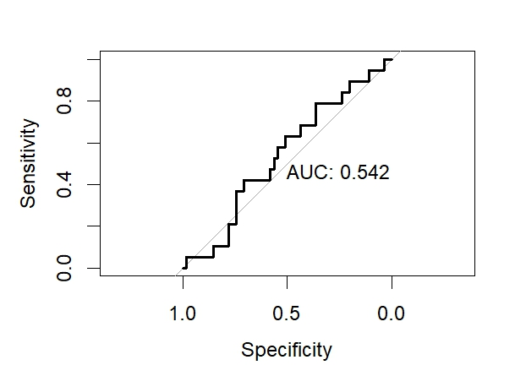
#20个特征数，可见几乎不能预测
#尝试15个特征，同样预测能力很差
[1] "the selected features are:"
[1] "ENSG00000102317.18" "ENSG00000078618.22" "ENSG00000124614.16"
[4] "ENSG00000147403.18" "ENSG00000198168.9" "ENSG00000198134.3"
[7] "ENSG00000249119.1" "ENSG00000112335.15" "ENSG00000102879.16"
[10] "ENSG00000146376.11" "ENSG00000257599.3" "ENSG00000184260.6"
[13] "ENSG00000248527.1" "ENSG00000229344.1" "ENSG00000168497.5"
[1] "feature selection done."
[1] "the fitted besttune is:"
alpha lambda
3 0 0.1
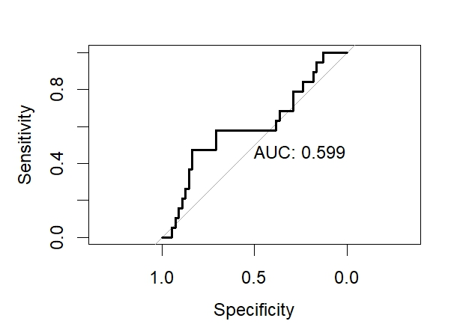

#这一次尝试了50个特征，得出的ROC曲线预测能力良好。
[1] "the selected features are:"
[1] "ENSG00000184260.6" "ENSG00000102317.18" "ENSG00000078618.22"
[4] "ENSG00000112335.15" "ENSG00000249119.1" "ENSG00000248527.1"
[7] "ENSG00000198134.3" "ENSG00000270800.3" "ENSG00000146376.11"
[10] "ENSG00000141293.16" "ENSG00000198034.11" "ENSG00000102879.16"
[13] "ENSG00000233927.5" "ENSG00000131171.13" "ENSG00000156508.19"
[16] "ENSG00000124614.16" "ENSG00000120727.13" "ENSG00000119636.16"
[19] "ENSG00000161960.16" "ENSG00000161016.18" "ENSG00000142937.12"
[22] "ENSG00000229344.1" "ENSG00000147403.18" "ENSG00000166710.21"
[25] "ENSG00000163479.14" "ENSG00000279738.1" "ENSG00000198744.5"
[28] "ENSG00000148484.18" "ENSG00000075415.15" "ENSG00000225972.1"
[31] "ENSG00000169100.14" "ENSG00000215021.10" "ENSG00000187514.17"
[34] "ENSG00000187109.15" "ENSG00000257599.3" "ENSG00000175390.15"
[37] "ENSG00000138326.21" "ENSG00000198168.9" "ENSG00000175470.20"
[40] "ENSG00000078747.16" "ENSG00000213145.10" "ENSG00000280852.2"
[43] "ENSG00000144579.8" "ENSG00000105193.9" "ENSG00000113558.19"
[46] "ENSG00000198695.2" "ENSG00000168497.5" "ENSG00000125971.17"
[49] "ENSG00000114942.14" "ENSG00000130396.21"
[1] "feature selection done."
[1] "the fitted besttune is:"
alpha lambda
3 0 0.1
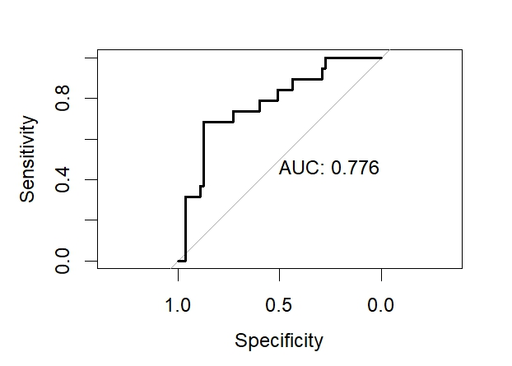

尝试30个特征
[1] "the selected features are:"
[1] "ENSG00000184260.6" "ENSG00000102317.18" "ENSG00000124614.16"
[4] "ENSG00000112335.15" "ENSG00000248527.1" "ENSG00000156508.19"
[7] "ENSG00000249119.1" "ENSG00000229344.1" "ENSG00000175390.15"
[10] "ENSG00000229932.3" "ENSG00000210196.2" "ENSG00000078618.22"
[13] "ENSG00000147403.18" "ENSG00000198134.3" "ENSG00000161960.16"
[16] "ENSG00000113558.19" "ENSG00000105193.9" "ENSG00000270800.3"
[19] "ENSG00000262902.1" "ENSG00000198034.11" "ENSG00000279738.1"
[22] "ENSG00000276141.4" "ENSG00000247627.2" "ENSG00000108946.15"
[25] "ENSG00000168497.5" "ENSG00000187514.17" "ENSG00000225972.1"
[28] "ENSG00000277957.1" "ENSG00000131171.13" "ENSG00000011052.21"
[1] "feature selection done."
[1] "the fitted besttune is:"
alpha lambda
3 0 0.1
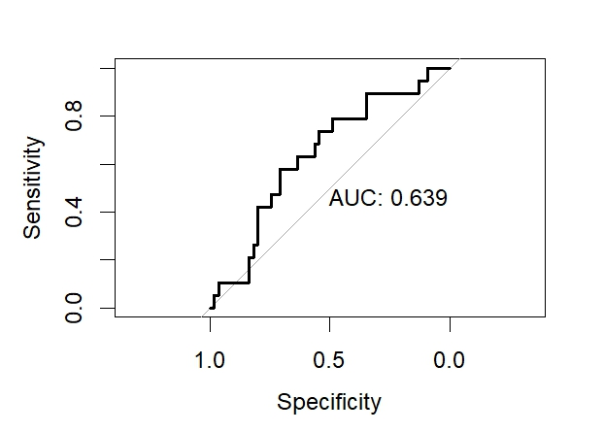

尝试70个特征
[1] "the selected features are:"
[1] "ENSG00000184260.6" "ENSG00000102317.18" "ENSG00000124614.16"
[4] "ENSG00000078618.22" "ENSG00000249119.1" "ENSG00000248527.1"
[7] "ENSG00000100129.18" "ENSG00000112335.15" "ENSG00000257599.3"
[10] "ENSG00000270800.3" "ENSG00000198744.5" "ENSG00000168497.5"
[13] "ENSG00000146376.11" "ENSG00000142937.12" "ENSG00000174748.22"
[16] "ENSG00000198134.3" "ENSG00000229344.1" "ENSG00000156508.19"
[19] "ENSG00000161960.16" "ENSG00000130396.21" "ENSG00000147162.14"
[22] "ENSG00000155463.14" "ENSG00000229932.3" "ENSG00000175390.15"
[25] "ENSG00000276141.4" "ENSG00000210107.1" "ENSG00000141293.16"
[28] "ENSG00000198034.11" "ENSG00000233927.5" "ENSG00000147403.18"
[31] "ENSG00000078747.16" "ENSG00000210196.2" "ENSG00000280852.2"
[34] "ENSG00000114942.14" "ENSG00000172053.18" "ENSG00000102879.16"
[37] "ENSG00000120727.13" "ENSG00000204628.12" "ENSG00000169100.14"
[40] "ENSG00000235162.9" "ENSG00000163479.14" "ENSG00000197629.6"
[43] "ENSG00000210176.1" "ENSG00000257341.5" "ENSG00000131171.13"
[46] "ENSG00000279738.1" "ENSG00000225972.1" "ENSG00000277957.1"
[49] "ENSG00000113558.19" "ENSG00000108946.15" "ENSG00000243678.12"
[52] "ENSG00000161016.18" "ENSG00000198168.9" "ENSG00000105193.9"
[55] "ENSG00000117091.10" "ENSG00000125971.17" "ENSG00000075415.15"
[58] "ENSG00000198695.2" "ENSG00000262902.1" "ENSG00000225630.1"
[61] "ENSG00000148484.18" "ENSG00000134419.15" "ENSG00000198755.11"
[64] "ENSG00000247627.2" "ENSG00000136156.15" "ENSG00000175106.17"
[67] "ENSG00000148303.17" "ENSG00000144579.8" "ENSG00000072736.19"
[70] "ENSG00000238201.1"
[1] "feature selection done."
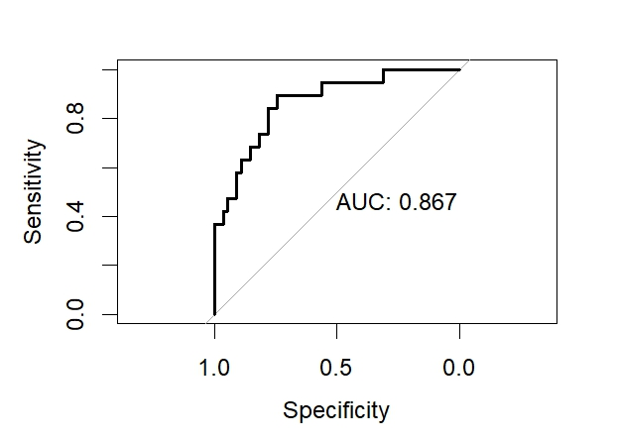
70个特征预测能力表现得很好，继续增加特征的尝试，从而尝试找到合适的特征数目。

100个特征：[1] "the selected features are:"
[1] "ENSG00000184260.6" "ENSG00000249119.1" "ENSG00000102317.18"
[4] "ENSG00000198134.3" "ENSG00000229344.1" "ENSG00000011052.21"
[7] "ENSG00000248527.1" "ENSG00000131171.13" "ENSG00000112335.15"
[10] "ENSG00000257599.3" "ENSG00000233927.5" "ENSG00000124614.16"
[13] "ENSG00000247627.2" "ENSG00000130396.21" "ENSG00000078618.22"
[16] "ENSG00000120727.13" "ENSG00000198034.11" "ENSG00000270800.3"
[19] "ENSG00000168497.5" "ENSG00000210196.2" "ENSG00000229932.3"
[22] "ENSG00000147403.18" "ENSG00000146376.11" "ENSG00000187514.17"
[25] "ENSG00000174748.22" "ENSG00000225972.1" "ENSG00000198168.9"
[28] "ENSG00000155463.14" "ENSG00000175390.15" "ENSG00000161016.18"
[31] "ENSG00000148484.18" "ENSG00000142937.12" "ENSG00000189403.15"
[34] "ENSG00000147162.14" "ENSG00000172053.18" "ENSG00000138378.19"
[37] "ENSG00000125971.17" "ENSG00000075415.15" "ENSG00000133026.13"
[40] "ENSG00000067167.8" "ENSG00000175106.17" "ENSG00000175445.17"
[43] "ENSG00000144579.8" "ENSG00000124813.23" "ENSG00000169100.14"
[46] "ENSG00000156508.19" "ENSG00000163479.14" "ENSG00000215021.10"
[49] "ENSG00000161960.16" "ENSG00000243678.12" "ENSG00000119636.16"
[52] "ENSG00000083845.9" "ENSG00000235162.9" "ENSG00000117091.10"
[55] "ENSG00000078747.16" "ENSG00000148303.17" "ENSG00000280852.2"
[58] "ENSG00000143222.12" "ENSG00000141293.16" "ENSG00000108946.15"
[61] "ENSG00000175470.20" "ENSG00000210154.1" "ENSG00000210151.2"
[64] "ENSG00000114942.14" "ENSG00000134986.14" "ENSG00000276141.4"
[67] "ENSG00000262902.1" "ENSG00000225630.1" "ENSG00000138326.21"
[70] "ENSG00000115484.15" "ENSG00000145555.15" "ENSG00000073712.15"
[73] "ENSG00000196628.20" "ENSG00000198755.11" "ENSG00000167244.21"
[76] "ENSG00000102879.16" "ENSG00000137845.15" "ENSG00000100129.18"
[79] "ENSG00000187109.15" "ENSG00000198744.5" "ENSG00000204435.15"
[82] "ENSG00000210164.1" "ENSG00000136942.15" "ENSG00000134419.15"
[85] "ENSG00000108953.17" "ENSG00000279738.1" "ENSG00000072736.19"
[88] "ENSG00000147604.14" "ENSG00000257341.5" "ENSG00000167526.14"
[91] "ENSG00000026025.16" "ENSG00000105193.9" "ENSG00000232177.1"
[94] "ENSG00000168028.14" "ENSG00000210176.1" "ENSG00000257411.2"
[97] "ENSG00000127920.6" "ENSG00000197629.6" "ENSG00000113558.19"
[100] "ENSG00000210107.1"
#预测能力不如70个特征
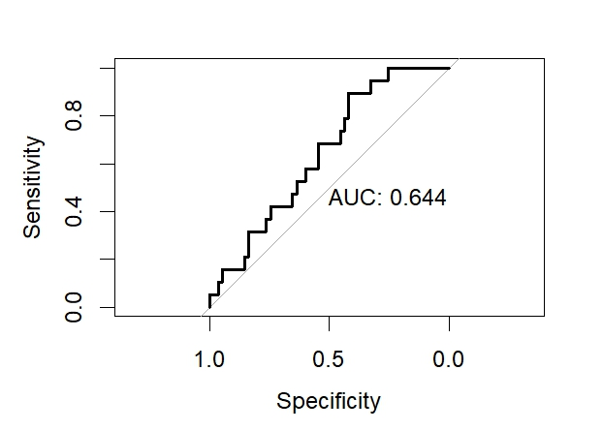

150个特征的情况：
[1] "the selected features are:"
[1] "ENSG00000102317.18" "ENSG00000184260.6" "ENSG00000233927.5"
[4] "ENSG00000124614.16" "ENSG00000112335.15" "ENSG00000198134.3"
[7] "ENSG00000249119.1" "ENSG00000198034.11" "ENSG00000270800.3"
[10] "ENSG00000229344.1" "ENSG00000248527.1" "ENSG00000210196.2"
[13] "ENSG00000100129.18" "ENSG00000210107.1" "ENSG00000168497.5"
[16] "ENSG00000011052.21" "ENSG00000146376.11" "ENSG00000142937.12"
[19] "ENSG00000078618.22" "ENSG00000279738.1" "ENSG00000130396.21"
[22] "ENSG00000175390.15" "ENSG00000161960.16" "ENSG00000105193.9"
[25] "ENSG00000225972.1" "ENSG00000187514.17" "ENSG00000147604.14"
[28] "ENSG00000257599.3" "ENSG00000161016.18" "ENSG00000198168.9"
[31] "ENSG00000148303.17" "ENSG00000131171.13" "ENSG00000115484.15"
[34] "ENSG00000068796.19" "ENSG00000119636.16" "ENSG00000140968.11"
[37] "ENSG00000169100.14" "ENSG00000138378.19" "ENSG00000247627.2"
[40] "ENSG00000102879.16" "ENSG00000175445.17" "ENSG00000175106.17"
[43] "ENSG00000163479.14" "ENSG00000229932.3" "ENSG00000108946.15"
[46] "ENSG00000254772.10" "ENSG00000155463.14" "ENSG00000143222.12"
[49] "ENSG00000101856.10" "ENSG00000213145.10" "ENSG00000122545.20"
[52] "ENSG00000243678.12" "ENSG00000210176.1" "ENSG00000206588.1"
[55] "ENSG00000075415.15" "ENSG00000174748.22" "ENSG00000147403.18"
[58] "ENSG00000198744.5" "ENSG00000117091.10" "ENSG00000276141.4"
[61] "ENSG00000156508.19" "ENSG00000125971.17" "ENSG00000257341.5"
[64] "ENSG00000262902.1" "ENSG00000198712.1" "ENSG00000152601.18"
[67] "ENSG00000108953.17" "ENSG00000172053.18" "ENSG00000072736.19"
[70] "ENSG00000172575.12" "ENSG00000168300.14" "ENSG00000198886.2"
[73] "ENSG00000198755.11" "ENSG00000120727.13" "ENSG00000083845.9"
[76] "ENSG00000198727.2" "ENSG00000136942.15" "ENSG00000127920.6"
[79] "ENSG00000238201.1" "ENSG00000166681.14" "ENSG00000235162.9"
[82] "ENSG00000164116.17" "ENSG00000187109.15" "ENSG00000204304.12"
[85] "ENSG00000133026.13" "ENSG00000110700.7" "ENSG00000147162.14"
[88] "ENSG00000213236.3" "ENSG00000225630.1" "ENSG00000148484.18"
[91] "ENSG00000114942.14" "ENSG00000115268.10" "ENSG00000198898.14"
[94] "ENSG00000180628.15" "ENSG00000284779.2" "ENSG00000140988.16"
[97] "ENSG00000166710.21" "ENSG00000132967.9" "ENSG00000122643.23"
[100] "ENSG00000122862.5" "ENSG00000204628.12" "ENSG00000277957.1"
[103] "ENSG00000144746.7" "ENSG00000113558.19" "ENSG00000089157.16"
[106] "ENSG00000257411.2" "ENSG00000103769.10" "ENSG00000261771.5"
[109] "ENSG00000130313.7" "ENSG00000078747.16" "ENSG00000010803.16"
[112] "ENSG00000168028.14" "ENSG00000215021.10" "ENSG00000169756.16"
[115] "ENSG00000175470.20" "ENSG00000248923.1" "ENSG00000145425.10"
[118] "ENSG00000232177.1" "ENSG00000210164.1" "ENSG00000141293.16"
[121] "ENSG00000123739.11" "ENSG00000156482.11" "ENSG00000196821.10"
[124] "ENSG00000224616.3" "ENSG00000198938.2" "ENSG00000168615.13"
[127] "ENSG00000280852.2" "ENSG00000210154.1" "ENSG00000197744.5"
[130] "ENSG00000100368.14" "ENSG00000212907.2" "ENSG00000189403.15"
[133] "ENSG00000170323.9" "ENSG00000186468.13" "ENSG00000162599.17"
[136] "ENSG00000144579.8" "ENSG00000259781.1" "ENSG00000145555.15"
[139] "ENSG00000063177.13" "ENSG00000115652.15" "ENSG00000067167.8"
[142] "ENSG00000078018.21" "ENSG00000196628.20" "ENSG00000112419.14"
[145] "ENSG00000223551.1" "ENSG00000260916.8" "ENSG00000081059.20"
[148] "ENSG00000198899.2" "ENSG00000125952.20" "ENSG00000171223.6"
[1] "feature selection done."
[1] "the fitted besttune is:"
alpha lambda
3 0 0.1
#预测能力再次提升，接近70个特征时的状况

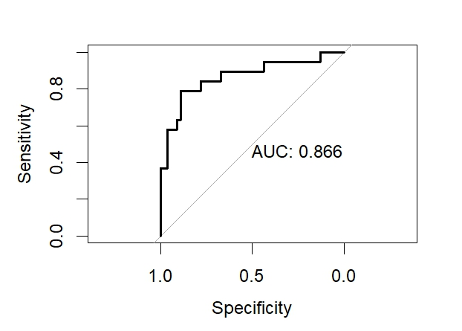
因此，综合上述，我们取这些特征的交集找出重点基因查阅资料进行分析
选择预测能力最好的两次特征选取（70个和150个）的交集绘制热图
选出来的common genes：
[1] "ENSG00000184260.6" "ENSG00000102317.18" "ENSG00000124614.16" "ENSG00000078618.22"
[5] "ENSG00000249119.1" "ENSG00000248527.1" "ENSG00000100129.18" "ENSG00000112335.15"
[9] "ENSG00000257599.3" "ENSG00000270800.3" "ENSG00000198744.5" "ENSG00000168497.5"
[13] "ENSG00000146376.11" "ENSG00000142937.12" "ENSG00000174748.22" "ENSG00000198134.3"
[17] "ENSG00000229344.1" "ENSG00000156508.19" "ENSG00000161960.16" "ENSG00000130396.21"
[21] "ENSG00000147162.14" "ENSG00000155463.14" "ENSG00000229932.3" "ENSG00000175390.15"
[25] "ENSG00000276141.4" "ENSG00000210107.1" "ENSG00000141293.16" "ENSG00000198034.11"
[29] "ENSG00000233927.5" "ENSG00000147403.18" "ENSG00000078747.16" "ENSG00000210196.2"
[33] "ENSG00000280852.2" "ENSG00000114942.14" "ENSG00000172053.18" "ENSG00000102879.16"
[37] "ENSG00000120727.13" "ENSG00000204628.12" "ENSG00000169100.14" "ENSG00000235162.9"
[41] "ENSG00000163479.14" "ENSG00000210176.1" "ENSG00000257341.5" "ENSG00000131171.13"
[45] "ENSG00000279738.1" "ENSG00000225972.1" "ENSG00000277957.1" "ENSG00000113558.19"
[49] "ENSG00000108946.15" "ENSG00000243678.12" "ENSG00000161016.18" "ENSG00000198168.9"
[53] "ENSG00000105193.9" "ENSG00000117091.10" "ENSG00000125971.17" "ENSG00000075415.15"
[57] "ENSG00000262902.1" "ENSG00000225630.1" "ENSG00000148484.18" "ENSG00000198755.11"
[61] "ENSG00000247627.2" "ENSG00000175106.17" "ENSG00000148303.17" "ENSG00000144579.8"
[65] "ENSG00000072736.19" "ENSG00000238201.1"
绘制热图如下：注释annotaion是肿瘤类型和NC
可见列聚类成两大类，左边是在癌症中高表达的基因，右边是在癌症中低表达的基因
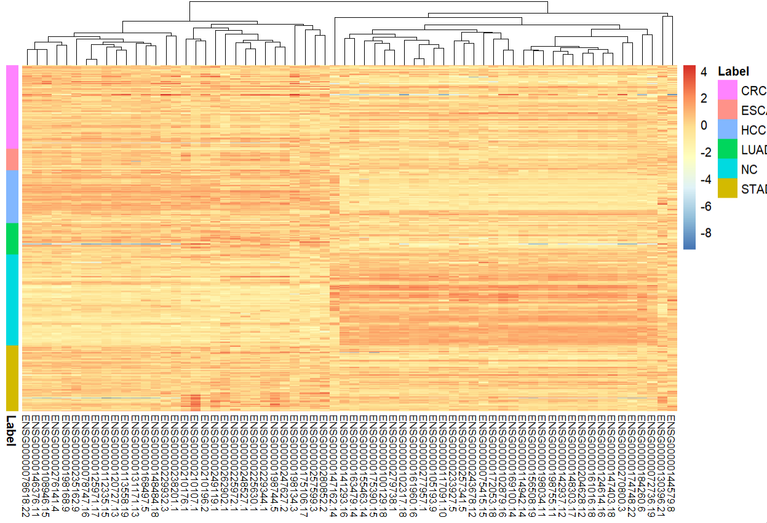

取交集得到以下10条结果，在esembl上寻找它们的记录：根据热图查找，癌症样本黄色高表达，蓝色低表达
"ENSG00000184260.6" "ENSG00000249119.1" "ENSG00000102317.18" "ENSG00000124614.16"
"ENSG00000112335.15" "ENSG00000198134.3" "ENSG00000229344.1" "ENSG00000168497.5"
"ENSG00000078618.22" "ENSG00000248527.1"

ENSG00000184260.6：H2A clustered histone 20，一种组蛋白变体。
通过控制染色质重塑过程，控制细胞增殖；有报道H2A的其中一种变体广泛存在于乳腺癌中，促进增值
但不清楚其在这里所涉及的肿瘤中为何偏向低表达。
如何。
- Monteiro FL, Vitorino R, Wang J, Cardoso H, Laranjeira H, Simões J, Caldas M, Henrique R, Amado F, Williams C,
Jerónimo C, Helguero LA. The histone H2A isoform Hist2h2ac is a novel regulator of proliferation and epithelial-mesenchymal
transition in mammary epithelial and in breast cancer cells. Cancer Lett. 2017 Jun 28;396:42-52.
doi: 10.1016/j.canlet.2017.03.007. Epub 2017 Mar 11. PMID: 28288875.

ENSG00000249119.1
一个假基因，可能参与基因组甲基化过程，从而调控增值等通路。
Pangeni RP, Olivaries I, Huen D, Buzatto VC, Dawson TP, Ashton KM, Davis C, Brodbelt AR, Jenkinson MD, Bièche I,
Yang L, Latif F, Darling JL, Warr TJ, Morris MR. Genome-wide methylation analyses identifies Non-coding RNA genes
dysregulated in breast tumours that metastasise to the brain. Sci Rep. 2022 Jan 20;12(1):1102.
doi: 10.1038/s41598-022-05050-z. PMID: 35058523; PMCID: PMC8776809.

ENSG00000102317.18

一个RNA结合蛋白，RBM3；在前列腺癌中显示为高表达，但是在下面所列的这篇文献中，高度侵袭性的前列腺癌中以及

复发的前列腺癌中表现为低表达，我们的数据中也是低表达。

“RBM3 expression was found to be significantly downregulated in highly aggressive GS ≥ 8 PCa samples compared to other Gleason

scores (P < 0.0001) and significantly down-regulated in recurrent PCa samples compared to non-recurrent samples (P = 0.0377).”

Carleton NM, Zhu G, Miller MC, Davis C, Kulkarni P, Veltri RW. Characterization of RNA-Binding Motif 3 (RBM3) Protein Levels and Nuclear Architecture Changes in Aggressive and Recurrent Prostate Cancer. Cancer Rep (Hoboken). 2020 Jun;3(3):e1237. doi: 10.1002/cnr2.1237. Epub 2020 Jan 29. PMID: 32587951; PMCID: PMC7316183.

ENSG00000124614.16

一个核糖体蛋白：ribosomal protein S10。

NCBI gene database的叙述：Variable expression of this gene in colorectal cancers compared to adjacent normal tissues has been

observed, although no correlation between the level of expression and the severity of the disease has been found

有观测到表达变化与癌症发生相关，但没看到和癌症的严重程度有关系。

ENSG00000112335.15

SNX3：sorting nexin 3

colon cancer中的SNX3高表达改变细胞形态，但未观测到对侵袭性的明显变化。

Yang W, Pan B, Zhang T, Wang Z, Zhang L, Guo Y. [The morphological changes of SW620 cells induced by over-expression of human

sorting nexin 3]. Xi Bao Yu Fen Zi Mian Yi Xue Za Zhi. 2015 Aug;31(8):1057-61. Chinese. PMID: 26271979.

ENSG00000198134.3

假基因，PTMAP9，prothymosin alpha pseudogene 9

没有找到其与癌症相关的资料。

ENSG00000229344.1

假基因，MTCO2P12，MT-CO2 pseudogene 12

没有找到其与癌症相关的资料。

ENSG00000168497.5

胞膜窖相关蛋白CAVIN2， caveolae associated protein 2

一个癌症相关的gene marker，其被甲基化silence可让癌细胞对化疗药物更敏感。

Peng M, Ye L, Yang L, Liu X, Chen Y, Huang G, Jiang Y, Wang Y, Li D, He J, Qiu Z, Xiang T, Guo S. CAVIN2 is frequently

silenced by CpG methylation and sensitizes lung cancer cells to paclitaxel and 5-FU. Epigenomics. 2020 Oct;12(20):1793-1810.

doi: 10.2217/epi-2020-0157. Epub 2020 Oct 5. PMID: 33016107.

Codenotti S, Vezzoli M, Poliani PL, Cominelli M, Monti E, Fanzani A. Cavin-2 is a specific marker for detection of well-differentiated

liposarcoma. Biochem Biophys Res Commun. 2017 Nov 4;493(1):660-665. doi: 10.1016/j.bbrc.2017.08.135. Epub 2017 Sep 1.

PMID: 28865960.

ENSG00000078618.22

NRDC，nardilysin convertase

一种肽酶，可作用于底物nardilysin，与heparin-binding EGF-like growth factor互作，在细胞增值和迁移中有作用

（来自：NCBI gene）

ENSG00000248527.1

假基因，MTATP6P1，MT-ATP6 pseudogene 1

没有找到其与癌症相关的资料。

综合上述，所选取出来的特征中的确有部分是与癌症相关的biomarker，但也有一部分假基因，或许有可能与癌症组织非特异性

的转录激活导致的高表达有关？也有可能其真正有与癌症相关的未阐明的作用。

我们对小RNA进行同样的操作。
对预测效果最好的两次特征选取（18和20个）所选择的特征取并集
#这里取并集是因为所选取的特征数目较少，故绘制热图时可以考虑较多的基因数目
"hsa-mir-125a" "hsa-mir-543" "hsa-mir-139" "hsa-mir-1343" "piR-hsa-171879"
[6] "piR-hsa-810073" "hsa-mir-885" "hsa-mir-92b" "hsa-mir-381" "hsa-mir-935"
[11] "piR-hsa-158808" "piR-hsa-133584" "hsa-mir-28" "hsa-mir-455" "hsa-mir-128-2"
[16] "piR-hsa-158839" "hsa-mir-149" "hsa-mir-212" "piR-hsa-143717" "hsa-mir-361"
[21] "piR-hsa-343608" "piR-hsa-154568" "hsa-mir-495" "piR-hsa-723374" "piR-hsa-161487"
[26] "hsa-mir-30b" "piR-hsa-397901" "piR-hsa-338004"

selected_data <- short_log_normalized_data.matrix.combat[, common_genes]

selected_data <- short_log_normalized_data.matrix.combat[rownames(short_metadata), ]

我们的学习只基于CRC和HD的二分，故将其他filter掉
filtered_annotation <- annotation[!(annotation$Label %in% c("PAAD", "PC")), , drop=FALSE]
filtered_selected_data <- selected_data[rownames(filtered_annotation) ,, drop=FALSE]
然后画热图即可
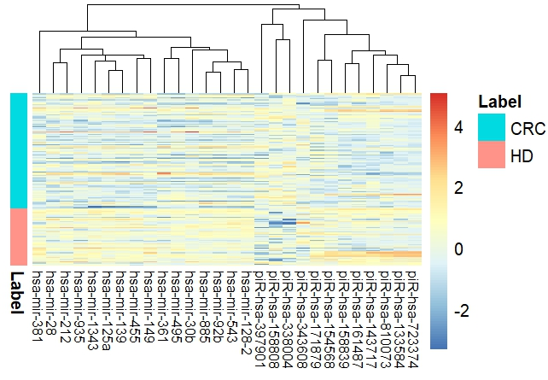

上述多轮特征选取中留下的重要的小RNA如下6条：
从热图中可以看到，选取的六条小RNA在癌症组织中都是下调的。
"hsa-mir-125a", "hsa-mir-139", "piR-hsa-171879", "hsa-mir-1343", "hsa-mir-381”, "hsa-mir-543"
在NCBI-nucleotide查阅上述小RNA的信息，寻找与癌症和肿瘤相关。

#mir-125a
pubmed上文章：mir-125a与肿瘤抑制相关。
“Four miRNAs (miR-125a-5p, miR-99b-5p, miR-382-5p, miR-145-5p) involved in hematopoiesis
(differentiation of progenitor cells, granulocyte function, thrombopoiesis, and tumor suppression)
were significantly downregulated post-HCT。”
- Mohanraj L, Carter C, Liu J, Swift-Scanlan T. MicroRNA Profiles in Hematopoietic Stem Cell Transplant Recipients.
Biol Res Nurs. 2024 May 31:10998004241257847. doi: 10.1177/10998004241257847. Epub ahead of print. PMID: 38819871.
nucleotide数据库中的记录：
REFERENCE 5 (bases 1 to 86)
AUTHORS Chen,F., Zheng,X., Liang,W., Jiang,C., Su,D. and Fu,B.
TITLE Long Noncoding RNA MIR600HG Binds to MicroRNA-125a-5p to Prevent
Pancreatic Cancer Progression Via Mitochondrial Tumor Suppressor
1-Dependent Suppression of Extracellular Regulated Protein Kinases
Signaling Pathway
JOURNAL Pancreas 51 (10), 1434-1443 (2022)
PUBMED 37099789
REMARK GeneRIF: Long Noncoding RNA MIR600HG Binds to MicroRNA-125a-5p to
Prevent Pancreatic Cancer Progression Via Mitochondrial Tumor
Suppressor 1-Dependent Suppression of Extracellular Regulated
Protein Kinases Signaling Pathway.
REFERENCE 1 (bases 1 to 86)
AUTHORS Ghafouri-Fard,S., Hussen,B.M. and Eslami,S.
TITLE Identification of miR-125a and miR-106b signature as a potential
diagnostic biomarker in breast cancer tissues
JOURNAL Pathol Res Pract 256, 155277 (2024)
PUBMED 38579577
REMARK GeneRIF: Identification of miR-125a and miR-106b signature as a
potential diagnostic biomarker in breast cancer tissues.
REFERENCE 4 (bases 1 to 86)
AUTHORS Jin,Y.C., Dong,L.J., Yang,Q.Y., Xiong,W.N., Wang,W.Y., Feng,X.H.,
Yu,W., Huang,W. and Chen,B.F.
TITLE An Investigation of the Effects of B7-H4 Gene rs10754339 and
miR-125a Gene rs12976445 on Cancer Susceptibility
JOURNAL Biomed Environ Sci 36 (9), 814-825 (2023)
PUBMED 37803894
REMARK GeneRIF: An Investigation of the Effects of B7-H4 Gene rs10754339
and miR-125a Gene rs12976445 on Cancer Susceptibility.
REFERENCE 5 (bases 1 to 86)
AUTHORS Chen,F., Zheng,X., Liang,W., Jiang,C., Su,D. and Fu,B.
TITLE Long Noncoding RNA MIR600HG Binds to MicroRNA-125a-5p to Prevent
Pancreatic Cancer Progression Via Mitochondrial Tumor Suppressor
1-Dependent Suppression of Extracellular Regulated Protein Kinases
Signaling Pathway
JOURNAL Pancreas 51 (10), 1434-1443 (2022)
PUBMED 37099789
REMARK GeneRIF: Long Noncoding RNA MIR600HG Binds to MicroRNA-125a-5p to
Prevent Pancreatic Cancer Progression Via Mitochondrial Tumor
Suppressor 1-Dependent Suppression of Extracellular Regulated
Protein Kinases Signaling Pathway.
REFERENCE 6 (bases 1 to 86)
AUTHORS Lui,W.O., Pourmand,N., Patterson,B.K. and Fire,A.
TITLE Patterns of known and novel small RNAs in human cervical cancer
JOURNAL Cancer Res 67 (13), 6031-6043 (2007)
PUBMED 17616659

#hsa-mir-139
同样是肿瘤抑制相关。
3 (bases 1 to 68)
AUTHORS Sun,T. and Liu,Z.
TITLE MicroRNA-139-5p suppresses non-small cell lung cancer progression
by targeting ATAD2
JOURNAL Pathol Res Pract 249, 154719 (2023)
PUBMED 37595446
5 (bases 1 to 68)
AUTHORS Tan,S., Chen,X. and Liu,W.
TITLE Tumor-suppressive role of miR-139-5p in angiogenesis and
tumorigenesis of ovarian cancer: Based on GEO microarray analysis
and experimental validation
JOURNAL Cell Signal 109, 110730 (2023)
PUBMED 37244634
REMARK GeneRIF: Tumor-suppressive role of miR-139-5p in angiogenesis and
tumorigenesis of ovarian cancer: Based on GEO microarray analysis
and experimental validation.
REFERENCE 6 (bases 1 to 68)
AUTHORS Hu,Z., Shu,Y., Chen,Y., Chen,J., Dong,J., Liu,Y., Pan,S., Xu,L.,
Xu,J., Wang,Y., Dai,J., Ma,H., Jin,G. and Shen,H.
TITLE Genetic polymorphisms in the precursor MicroRNA flanking region and
non-small cell lung cancer survival
JOURNAL Am J Respir Crit Care Med 183 (5), 641-648 (2011)
PUBMED 20889907
REMARK GeneRIF: Observational study of gene-disease association. (HuGE
Navigator)

#piR-hsa-171879
未找到相关材料。

#hsa-mir-1343
同样是癌症抑制基因，一些其他癌基因通过sponging的海绵作用抑制其作用
其与多个原癌基因如Bcl3作用而抑制它们
REFERENCE 3 (bases 1 to 84)
AUTHORS Ge,P., Chen,X., Liu,J., Jing,R., Zhang,X. and Li,H.
TITLE Hsa_circ_0088036 promotes nonsmall cell lung cancer progression by
regulating miR-1343-3p/Bcl-3 axis through TGFbeta/Smad3/EMT
signaling
JOURNAL Mol Carcinog 62 (7), 1073-1085 (2023)
PUBMED 37132942
REMARK GeneRIF: Hsa_circ_0088036 promotes nonsmall cell lung cancer
progression by regulating miR-1343-3p/Bcl-3 axis through
TGFbeta/Smad3/EMT signaling.
REFERENCE 4 (bases 1 to 84)
AUTHORS Li,H., Liu,J., Lai,Y., Huang,S., Zheng,L. and Fan,N.
TITLE LINC01559 promotes colorectal cancer via sponging miR-1343-3p to
modulate PARP1/PTEN/AKT pathway
JOURNAL Pathol Res Pract 224, 153521 (2021)
PUBMED 34329839

#hsa-mir-381
同样是抑癌基因，抑制癌症进展。
REFERENCE 3 (bases 1 to 75)
AUTHORS Cui,F., Luo,P., Wu,R. and Meng,J.
TITLE miR-381 Inhibits Proliferation and Invasion of Non-Small-Cell
Cancer Cells by Targeting USP39
JOURNAL Dis Markers 2022, 2195393 (2022)
PUBMED 36046375
REMARK GeneRIF: miR-381 Inhibits Proliferation and Invasion of
Non-Small-Cell Cancer Cells by Targeting USP39.
Publication Status: Online-Only

#hsa-mir-543
抑癌基因，同样的一些癌基因通过sponging它促进癌症进展。
REFERENCE 2 (bases 1 to 78)
AUTHORS Jin Y and Jiang D.
TITLE GATA6-AS1 via Sponging miR-543 to Regulate PTEN/AKT Signaling Axis
Suppresses Cell Proliferation and Migration in Gastric Cancer
JOURNAL Mediators Inflamm 2023, 9340499 (2023)
PUBMED 37273453
REFERENCE 5 (bases 1 to 78)
AUTHORS Wei L, He W, Zhao H and Zhao P.
TITLE Circ_0026123 promotes cisplatin resistance and progression of
ovarian cancer by upregulating RAB1A through sequestering miR-543
JOURNAL Anticancer Drugs 33 (10), 1069-1080 (2022)
PUBMED 36255068
REMARK GeneRIF: Circ_0026123 promotes cisplatin resistance and progression
of ovarian cancer by upregulating RAB1A through sequestering
miR-543.
综合上述，除去其中一个piRNA没有找到文献，其他miRNA都有文献佐证其为抑癌基因，
那么它们在癌症组织中低表达便是合理的。

*所有报告中涉及的图片，以及关键的matrix的txt文件，都保存在作业文件夹中。

