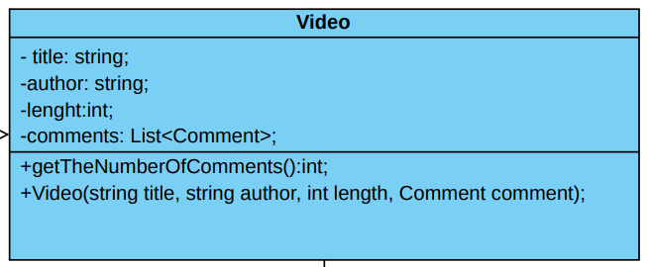

Comment is a class used to store comments with the commenter’s name and text of the comment. The Video class uses the Comment class to store a list of comments of type Comment, The Video class also stores the title, author and length of the video, and it has a getNumberOfComments method that uses the comments list to determine the number of comments in each video.

The Product class stores the details of the product and has a method that gets the total cost of the of the order by adding the product prices and multiplying by their quantity. The Address class stores the 4 parts of an address and has a method to determine if the address is in USA or not, and a method that puts the parts together into a string. The Customer Class stores the name of the customer and their address of type Address, it also has a method that uses the Address method to determine if the customer lives in USA. The Order class stores a Customer and their list of products and it has a method that returns the total cost including shipping, which is determined by if the address is in USA or not.