Project Introduction and Graphical Identity

By Camila Moya

1. Logo

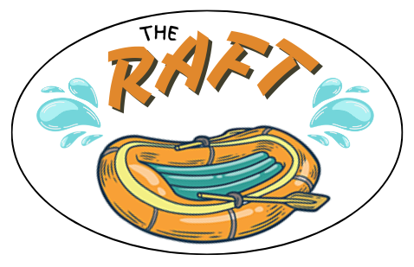

1. Colors
   * primary-color: #E1882C
   * secondary-color: #1D1A05
   * accent1-color: #54A49E
   * accent2-color: #FFFFC5

Fonts

* heading-font: Calistoga
* text-font: Manrope

1. Color palette

<https://coolors.co/e1882c-1d1a05-54a49e-ffffc5>