Table of Contents
0. Intro 2
1. Base Rules 2
A. The goal, base gameplay 2
B. The Map 2
C. Action points 3
D. Attacking 3
E. Upgrades 3
F. Victory 3

0. Intro
The game is supposed to be simple and easy to learn, yet be a bit challenging and harder to master – it should be easy to grasp the basics for a new player, but reward people who put more thought into their actions, by adding a few not-so-obvious elements.

1. Base Rules

A. The goal, base gameplay
Players create accounts, choose their country name (+avatars? Anthems for if they win?) and colour from one of the available ones (first come first serve). After that they choose a starting point, where their country is formed (distance from another country? Fixed starting points?). The server waits for all players to preapare/join (time? Server-chosen?). When all the players are ready the game starts.

B. The Map
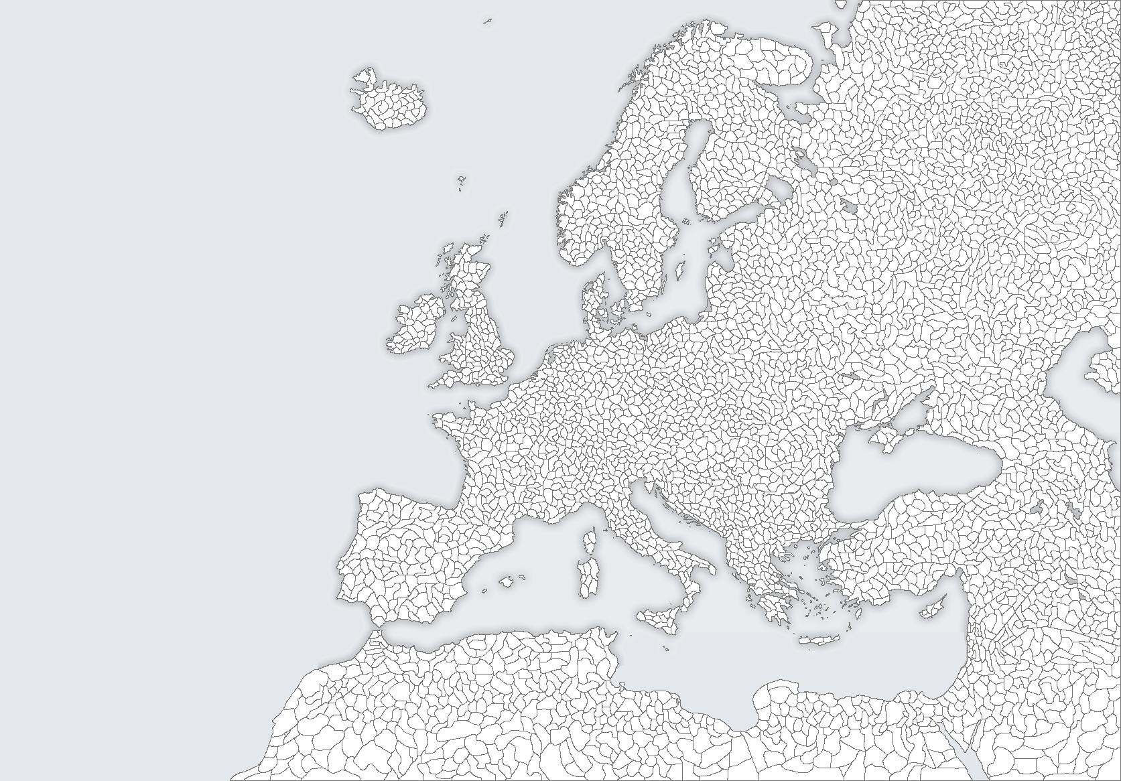
Example picture of a blank map (World? Europe? Chosen by server?):

C. Action points
Players get 'action points' over time (depending on the server- could be every 5 seconds for a single-session game, could be every hour for a game lasting days-weeks). They then use these points to 'attack' territories around their borders. Action points can also be used to buy different upgrades (trading? Treaties? Sending points to other players?).

D. Attacking
Attacking other territories can end in a success or a failure.
-Attacking a region occupied by another nation has a lower chance of success
-The chance of success while attacking a region increases accordingly to neighbouring territories occupied by the attacker (the more neighbours the attacker is in control of, the higher the chance). This increases strategical value of certain territories – sea regions or regions in tight spaces have less neighbours, thus reducing the chance of attacker conquering the territory around and then easily finishing off the desired region
-The chance of success is lowered by the number of neighbouring regions controlled by the defender
-The chance of success can be further modified by different upgrades bought by defenders/attackers
-The chance of success can also be modified by territory-specified upgrades (e.g. Castles, that could be destroyed if the territory gets conquered, removing the bonuses) –do we really want this feature or would it be too much?
-Territorial penalties/rewards? - same as above

E. Upgrades
TBA

F. Politics, player interaction
Simple messaging? Treaties with conditions? Trading territories?

G. Victory
A player wins if they control a certain percentage (of all territories)/(over other players).
Players entering the server at that point are displayed a message with the winner and/or their avatar/anthem/message (depending on what we include).

