Achieving universal energy access while reducing energy demand? Evidence from energy-specific population projections

Camille Belmin $​^{1}$ $​^{2}$ $​^{3}$

Peter-Paul Pichler $​^{1}$

Guillaume Marois $​^{3}$ $​^{4}$

Shonali Pachauri $​^{3}$

Helga Weisz $​^{1}$ $​^{2}$

$​^{1}$ Potsdam Institute for Climate Impact Research, Germany $​^{2}$ 
 Humboldt University Berlin, Germany $​^{3}$ 
 International Institute for Applied Systems Analysis, Wittgenstein Centre (IIASA, OeAW, University of Vienna), Austria $​^{4}$ 
 Asian Demographic Research Institute of the Shanghai University, China

# Abstract

In a climate- constrained world, understanding the energy required to achieve universal access to modern energy is critical. This requires making assumptions on future population trajectories, but the extent of energy access can affect these. Yet, this feedback has never been accounted for in energy models. Access to modern energy leads to fertility declines as it reduces child mortality, improves health, increases women’s access to information, education and employment. In this paper, we assess the household energy requirements to expand energy access while considering the relationship between energy access and fertility, using Zambia as a case study. To do so, we built a microsimulation model to project population, accounting for how fertility depends on access to modern energy and education. We used these population projections to then estimate household energy demand of the Zambian population until 2070, under different scenarios. We find that in 2070, while electricity consumption is higher in a universal access scenario compared to a baseline scenario, total energy demand is 29% lower, partly due to a strong decline in the use of inefficient traditional cooking fuels. We also find that reduced population growth due to expanded energy access contributes to lowering the energy demand by 55% by 2050, and this contribution increases over time. Although the challenge of achieving universal access to modern energy seems daunting, our results suggest that this could have co-benefits with achieving climate goals. Our study also reveals that accounting for the energy-population nexus in energy models will scale down the currently assumed energy needs to ensure a decent life for all.

# 1 Introduction

Access to modern energy provides services that are essential to fulfill basic human needs (GEA 2012; McCollum et al. 2018). Yet, in 2020, around 733 million had no access to electricity and 2.4 billion people had no access to clean cooking energy (IEA et al. 2022). Assessing the energy requirements to achieve this goal is necessary to accurately assess the share of the global carbon budget that needs to be allocated to emerging economies to fulfill the basic needs of their populations.

Projecting the energy requirements to eradicate energy poverty requires making assumptions on future population pathways. Traditionally, energy modelers have attempted to answer this question using existing population projections, like the UN population projections (UNFPA 2019), or the Shared Socio-economic Pathways for populations projections (K. C. and Lutz 2017). However, for a given pathway, the population projection may be inconsistent with the improvements in energy access, resulting in an over or underestimation of population size, and consequently energy demand.

This is particularly relevant because energy access, in addition to female education, has been shown to have a large effect on fertility decline (Grimm, Sparrow, and Tasciotti 2015 ; Grogan 2016 ; Potter, Schmertmann, and Cavenaghi 2002 ; Peters and Vance 2010; Fujii and Shonchoy 2020; Harbison and Robinson 1985). Particularly for women, access to modern energy leads to less time spent on household chores(Das et al. 2020; Wickramasinghe 2011; OXFAM 2017), lower child mortality(Adaji et al. 2019; Ezzati 2005), better health (Das et al. 2020; I. E. A. IEA 2016; WHO 2014), access to information (OXFAM 2017; Das et al. 2020) and education (Winther et al. 2017), all of which contribute to lowering fertility.

Previous empirical studies have quantified the effects of expanded electricity access (Grimm, Sparrow, and Tasciotti 2015 ; Grogan 2016 ; Potter, Schmertmann, and Cavenaghi 2002) and access to modern cooking fuels (Belmin et al. 2022) on fertility, in various countries. For example, Belmin et al. (2022) found that, across 42 countries, achieving universal access to electricity by 2040, coupled with increasing educational attainment, would result in a total fertility rate 19% lower than in a business-as-usual scenario. However, the subsequent implications of this lower fertility for population size, a necessary input to determine energy demand, has not been estimated. Population scenarios that are consistent with the SSP framework are based on assumptions of future developments in educational attainment (K. C. and Lutz 2017). However, these make no assumptions about how energy access would develop concurrently or how this might affect fertility and consequently, population size.

Here, we estimate the energy requirements to eradicate energy poverty in Zambia, while considering the negative effect that access to modern energy has on fertility and population dynamics. To project future population pathways and energy demand in Zambia, we developed a modeling framework in two parts. The first part is a microsimulation model (MSM) that projects population size in Zambia until 2070, accounting for energy access, education, and urbanization. This model endogenously accounts for the relationship between energy access and fertility. The second part of the modeling framework is an energy calculator that estimates the population’s energy demand using disaggregated data on per capita energy use and using population projections from the MSM (Figure 2.1). In this study, we define modern energy for cooking as any energy derived from electricity, liquefied petroleum gas (LPG), natural gas and biogas. All forms of traditional biomass are excluded, namely firewood, charcoal, agricultural crops, animal dung as well as coal and kerosene. Although coal and kerosene do not need to be collected, we excluded these from the basket of modern fuels because of their negative health effects. To assess the impact of different pathways on population size and energy demand, we constructed three scenarios with different assumptions about the evolution of access to electricity, access to modern cooking fuels, education, and urbanization.

We chose Zambia as a case study because of its demographic characteristics, the status of access to modern energy in the country, as well as the availability of data. Zambia is a high-fertility country with most of its population living in rural areas. In 2018 the Total Fertility Rate (TFR), which can be interpreted as the average number of children per women, was 4.63 (UNFPA 2019). The patterns of energy access vary greatly from urban to rural areas. In 2017, 75% of the urban population had access to electricity, while only one tenth of the rural population had access to electricity (Luzi et al. 2019). Zambia’s population is highly dependent on charcoal for cooking, particularly in urban areas where it is used by 60.7% of the population. In rural areas, firewood is used by most households (83.6%), followed by charcoal (14.2%). Electricity is the main modern cooking fuel used in Zambia (32.5% of urban and 1.9% of rural households use electricity as a main cooking fuel)(Luzi et al. 2019). The heavy dependence of Zambia’s electricity sector on hydro-power, also makes electricity supply vulnerable to climate variability and droughts, and has caused electricity outages in 2012 and subsequently, a decline in the use of electricity for cooking (Samboko et al. 2016).

In the next section, we present the methodology and modeling framework used. This includes a comprehensive description of the MSM of population projection, the regression models necessary to predict at each time step the probability of a woman to give birth, and the assumptions about mortality, urbanization, education, and energy access under each scenario. In this section, we also introduce the second part of the modeling framework, the energy calculator, which is used to estimate energy demand using the population projections from the MSM as input. In the following section, we then present our results on population projections and energy demand under the different scenarios. We finally conclude the paper with a discussion of the contribution of population to lowering the energy requirements to reach universal access to modern energy, and the importance of incorporating the feedback between energy access and population dynamics in energy models.

# 2 Methods and data

## 2.1 Overview

The modeling framework has two components: (i) a microsimulation model of population projection that determines at each time step, the size and the distribution of the population by place of residence (rural or urban), education level, electricity and modern cooking fuel access, and (ii) an energy calculator that estimates the population’s energy demand using disaggregated data on per capita energy use and the population projections from the MSM (Figure 2.1). The analysis is carried out for four scenarios. Each scenario is composed of assumptions on mortality, educational attainment, energy access and urbanization pathways created using the Shared Socio-economic Pathways framework (Table 2.1).

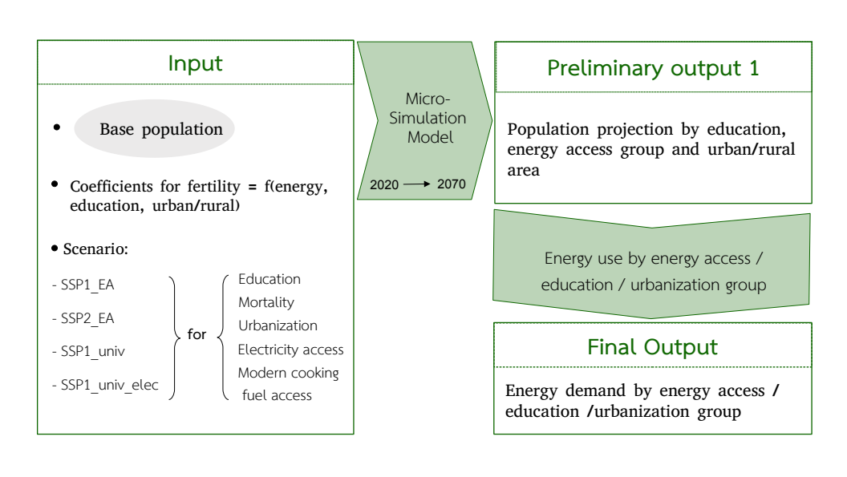

Figure 2.1: Overview of the modeling framework in two steps: the microsimulation model of population population projection and the energy calculator.

## 2.2 Microsimulation model of population projection

To estimate the energy needs of the Zambian population under different scenarios, while taking into account the effect of energy access on population dynamics, we first built a dynamic microsimulation model (MSM) to project the population, which we run from 2020 to 2070 in five-year time steps. The MSM starts with a base population and treats each individual independently. Random experiments are used to simulate the life events of each individual according to some probabilities of life events to occur. The events we simulate in this study are giving birth, death, getting access to electricity, getting access to modern cooking fuels, transitioning to a higher education level, and moving to an urban area. These random experiments, or Monte Carlo processes, work as follows: a random number between 0 and 1 is drawn and compared to the probability of the life event to occur (e.g., giving birth). If the random number is lower than the probability, the event occurs, otherwise it does not.

The probability of surviving, moving to an urban area, transitioning to a higher education level, and getting access to modern energy are directly derived from the input data (see Sections 2.2.3 and 2.2.4). In contrast, the probability that a women gives birth is derived endogenously at each time step, and depends on her age, access to modern energy, level of education, and whether she lives in a rural or urban area and the year (Figure 2.1). Microsimulation models allow to easily run population projections where demographic rates depend on a large number of states (Van Imhoff and Post 1998). Here, fertility depends on five dimensions. With a traditional multi-state cohort component model of population projection, this large number of dimensions would make the estimation of fertility unmanageable.

### 2.2.1 Base population

We used the 2018 Demographic and Health Survey data of Zambia to construct the base population. More specifically, we used the *Person Recode* of the DHS data (ICF 2004), in which all members of interviewed households are included in the sample. This allowed for obtaining data on individuals of both sex and all ages. From the DHS data we extracted the following variables: age, sex, number of education years, whether the individual lives in a rural or urban area, whether they have access to electricity and modern cooking fuels, and for children under 18, the number of years of education of the mother and finally the individual survey weight. From the variable number of education years, we created six categorical variables: *No education*, *Incomplete primary education*, *Completed primary education*, *Lower secondary education*, *Upper secondary education*, and *Post secondary education*). Observations with missing values on these variables were excluded, which resulted in a final sample size of 57960 individuals.

To ensure representativeness of the base population in terms of education, we calibrated the base population using age-specific, education-specific population distribution data for the year 2015 from the Wittgenstein Center for Demography and Human Capital (WIC)(Lutz et al. 2018). Education level is a central variable in the model. However, the DHS data is not a survey specifically meant to create a sample representative of the education distribution in a country. Therefore, our calibration consists of re-weighting the DHS survey weights to ensure that the re-weighted age-education distribution in the base population matches that of the WIC dataset. This also allows avoiding any discontinuity between the education distribution of the base year population and the education distribution in the first time step in our projections. Unfortunately, we could not calibrate the population also in terms of energy access. While the DHS data allows for determining energy access by education, age, and urbanization for the sample, this could only be compared to national energy access indicators distinguishing between rural and urban regions but not the other demographic variables like age or education.

### 2.2.2 Fertility

In our model, the probability that a woman will give birth is endogenously determined at each time step and for each woman of fertile age (between 15 and 49 years old). We used a logistic regression to estimate the parameters allowing us to predict the probability for a woman to give birth, depending on her age group (five-year), level of education, whether her household has access to electricity, to modern cooking fuels and whether she lives in a rural or urban area. The dependent variable is whether the women gave birth in the last year. The data used for the regression is a pool of four Individual Recode files from the DHS data for Zambia, for the years 2002, 2007, 2013 and 2018. This resulted in a sample consisting in 89796 women. In the regression, we added a parameter corresponding to the year in which the data was collected, allowing us to account for the fact that fertility may follow a secular trend. We also added interaction terms between age group and (i) whether the household has access to electricity, and (ii) whether the primary cooking fuel used by the household is modern. The results of the model are displayed in Table 1 and the logistic regression model takes the form:

where $P\left(birth=1\right)$ is the probability that a women gave birth in the past year, $Agecat_{1..6}$ the five-year age group to which the woman belonged at the time of the survey, $Educcat_{1..5}$ the education group to which the woman belongs, $Elec$, $MCF$ and $Urban$ are dummy variables taking the value 1 if the woman has access to electricity, modern cooking fuels, or lives in an urban area, respectively, and $Year$ is the year of the survey. $α$ is the coefficient for the reference category, which corresponds to age group 15-19, for those with no education, no access to electricity, no access to modern cooking fuel and living in rural areas.

Having any level of education other than *No education*, having access to electricity, having access to modern cooking fuels, and living in an urban area all have a negative effect on the probability of giving birth (Table 1). The age categories are also all significant, with age groups 20-24 and 25-29 having the strongest positive effect on the probability of giving birth, relative to the reference age group of 15-19. Age also interacts with access to energy in a significant way. In particular, the effect of access to both electricity and modern cooking fuels seem to have a particularly strong effect on the reference age as well as for the age group 20-24.

### 2.2.3 Mortality, education and urbanization assumptions

The mortality, and educational attainment data were taken directly from the WIC open data repository (Lutz et al. 2018). The WIC has developed a set of population dynamics and characteristics scenarios that are consistent with the Shared Socio-economic Pathways narratives (Riahi et al. 2017). We also used urbanization assumptions that follow the SSP framework from the study of Jiang and O’Neill (2017). Among the different SSP scenarios, we used SSP1, which corresponds to a world shifting towards a more sustainable pathway with low mitigation and adaptation challenges, and SSP2 representing a middle-of-the road scenario. The SSP1 pathway from the WIC for mortality, urbanization and education attainment directly provided us the mortality, urbanization and education assumption for the scenario *SSP1_EA* and *SSP1_univ* developed in this study. Similarly, the WIC projections for mortality, education and urbanization for SSP2 provided us with the inputs for *SSP2_EA* developed in this study (Table 2.1). In this paper, we do not consider international migration and domestic migration is reflected in the different urbanization projections for SSP1 and SSP2.

A few details are important to note about the mortality and education assumptions. The mortality projections are provided by the WIC as survival probabilities. For each scenario, this probability depends on the age group and education level of the individual. Following Marois and KC (2021), the probability of survival for children under the age of 15 depends on the mother’s education level (Fuchs, Pamuk, and Lutz 2010). The education projections are represented in the WIC data as proportions of the population being in a given education group: *No education*, *Incomplete primary education*, *Completed primary education*, *Lower secondary education*, *Upper secondary education*, *Post secondary education*. Our microsimulation model also uses the same education categories. In order to use the WIC education projections as the education assumptions in our model, at each time step we reassign an education category to each individual so that the education distribution of the simulated population matches the education distribution of the WIC projection (Supplementary Figure 3 and 4).

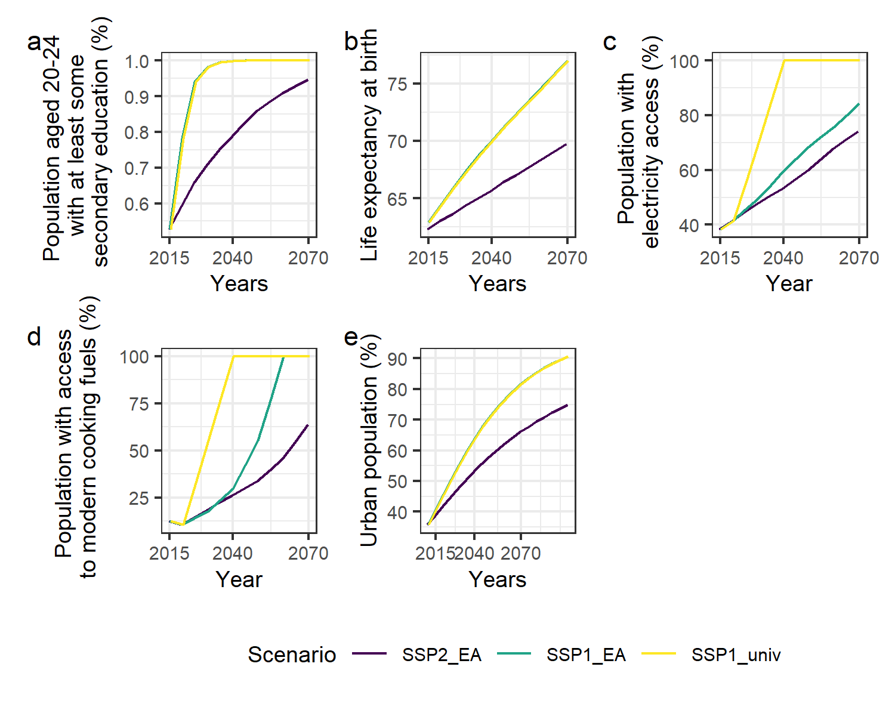

Figure 2.2: Background changes in education (a), life expectancy (b), access to electricity (c), access to modern cooking fuels (d) and urbanization (e) as input of the microsimulation model. In the case of education, life expectancy, and urbanization, the path for the SSP1_univ scenario is the same as for SSP1_EA, which is why the yellow and green lines overlap in plots a, b, and e (but were slightly dodged for visibility).

### 2.2.4 Energy access assumptions

The energy access assumptions we used correspond to future trajectories of the proportion of people having access to electricity and having access to modern cooking fuels. These trajectories are differentiated by rural and urban areas, to account for the important difference in energy access levels and shifts over time between rural and urban areas.

The first two energy access trajectories, used in the scenarios *SSP1_EA* and *SSP2_EA*, are consistent with energy access projection by Poblete-Cazenave et al. (2021) for the SSP1 and SSP2 pathways for the period from 2020 to 2050. These scenarios were developed for the entire region of sub-Saharan Africa, without any distinction at the individual country level. To apply these scenarios to Zambia, we considered the absolute percentage increase in access to electricity (respectively modern cooking fuels) between 2020 and 2030 in sub-Saharan Africa and applied this to the initial level of electricity (resp. modern cooking fuels) access in Zambia, that we determined from the DHS data of 2018. This way we obtained the values of energy access for Zambia in 2040 and 2050. To obtain energy access values for 2060 and 2070, we applied the absolute percentage increase between 2040 and 2050.

The third and last energy access pathway we constructed is used in the scenario *SSP1_univ*, which normatively assumes universal access to both electricity and modern cooking fuels by 2040 with a linear increase in the proportion of the population having access to both forms of energy. After 2040 and until 2070, energy access remains universal. Although this scenario requires quite unrealistic percentage increases in access levels, in particular in rural areas where access to both forms of energy is currently very low, this normative scenario shows what would happen if the Sustainable Development Goals were achieved by 2040.

We then derived, from these trajectories, the probability for an individual to get access to electricity, and to get access to modern cooking fuel. Although, in reality, a household might use multiple cooking fuels at the same time, or revert back to the use of firewood after using mostly modern fuels, in our model the transition can only occur in one direction: from not having access to having access. The formula for the transition probability is as follows:

$$p_{e}=\frac{elec_{t+5}−elec_{t}}{1−elec_{t}}/$$

with $p_{e}$ the probability of getting access to electricity, $elec_{t+5}$ the proportion of the population having access to electricity in time step $t+5$ and $1−elec_{t}$ the proportion of the population not having access to electricity in time step $t$.

Table 2.1: Description of scenario narratives and their assumptions.

Scenario name

Narrative

Education

Electricity access

Modern cooking fuel access

Mortality

Urbanization

Displacement of all traditional fuels by 2040

SSP1_EA

Fast development in education and urbanization. Energy access expands, in particular in urban areas. However, universal energy access is not reached by 2040.

Fast (SSP1-IIASA)

Intermediate (SSP1-Poblete Cazenave et al. 2021)

Intermediate (SSP1-Poblete Cazenave et al. 2021)

Fast decline (SSP1-IIASA)

Fast (SSP1-IIASA)

No

SSP2_EA

Slow development in education and energy access, especially in rural areas. Intermediate urbanization.

Slow (SSP2-IIASA)

Slow (SSP2-Poblete Cazenave et al. 2021)

Slow (SSP2-Poblete Cazenave et al. 2021)

Slow decline (SSP2-IIASA)

Slow (SSP2-IIASA)

No

SSP1_univ

Fast development in education and urbanization. Universal energy access is reached by 2040. However, despite fast electrification, households continue to use some traditional energy even after they get access to modern energy (fuel stacking),

Fast (SSP1-IIASA)

Fast (Universal access by 2040)

Fast (Universal access by 2040)

Fast decline (SSP1-IIASA)

Fast (SSP1-IIASA)

No

SSP1_univ_elec

Fast development in education and urbanization. Universal energy access is reached by 2040. In contrast to SSP1_univ, all traditional energy for cooking is displaced by electricity, with electriity capacity and affordability improving.

Fast (SSP1-IIASA)

Fast (Universal access by 2040)

Fast (Universal access by 2040)

Fast decline (SSP1-IIASA)

Fast (SSP1-IIASA)

Yes

## 2.3 Energy use calculator

The MSM estimates, for three scenarios, the population counts at each time step, broken down by education level, electricity and modern cooking fuel access as well as urbanization level. To derive the energy use of the simulated population at each time step, we multiplied the number of people in any given category by the average per capita energy use of this category. We derived the latter from the study of Baltruszewicz et al. (2021). The study combines the 2015 Living Condition Measurement Survey (LCMS) for Zambia (Central Statistical Office of Zambia 2015) with a multi-regional input-output model to derive the energy footprint of all households surveyed. Since the household survey contains information about the education level, energy access, location of residence (urban or rural areas), we used this information to calculate the average energy use per capita, for households grouped along these variables.

We carried out two pre-processing steps to estimate the average energy use for each population group. First, we re-categorized the variables from the LCMS to match those used in the microsimulation model. The original LCMS contains two variables regarding cooking: the main type of energy used for cooking and the main device used for cooking. We first re-categorized these two variables into two categories - modern and traditional (see Supplementary Table 1 to see the full list of fuels and devices and the re-categorization). Then we assumed that a household uses modern cooking fuels if it uses either a modern fuel or a modern stove. In total, we created four population sub-groups of energy access by combining access to modern cooking fuel (or not) and access to electricity (or not). The second variable that we re-categorized is education. In the LCMS, the education categories are specific to Zambia, so we re-categorized them into *No education*, *Primary education*, *Junior secondary education*, *Senior secondary education* and *Post-secondary education* (see Supplementary Table 2 to see the full list of education levels and the re-categorization). In the data there was only one category for primary education. This is in contrast to the WIC data categorization which has two categories for this level. This resulted in five education groups.

In a second pre-processing step, we combined some categories to increase their sample size. Ideally, considering the distinct average per capita energy use for 40 sub-groups, corresponding to the combination of 5 education levels, 2 residence locations and 4 energy access groups would have allowed for capturing more of the population heterogeneity in energy use. Unfortunately, splitting the data along all 40 categories resulted in samples sizes that were at times too small and combinations that are not very common (e.g., having access to modern cooking fuels but no access to electricity in rural areas for those with post-secondary education) (Supplementary Figure 1). To ensure an adequate sample size, some categories were merged. The categories *No education* and *Primary education* were combined. Then we grouped together all cases corresponding having at the same time *No access to electricity* and *Access to modern cooking fuels* because these cases are very rare across urban and rural areas and across all education levels. This resulted in only one per capita energy use value for this category. The estimates of energy use per capita for each category considered are presented in Figure 2.3.

The combination of the assumptions for mortality, educational attainment, urbanization and modern energy access constitutes our three scenarios *SSP1_EA*, *SSP2_EA* and *SSP1_univ*, as shown in Table 2.1.

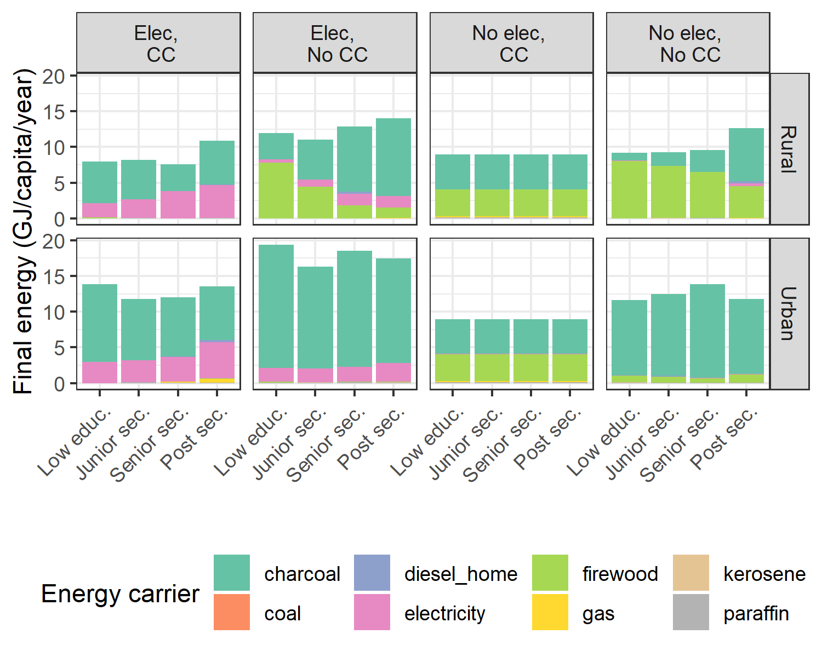

Figure 2.3: Energy footprints for different combination of categories in the energy-extended LCMS dataset (Baltruszewicz et al.,2021)

## 2.4 Scenario electrification for cooking

In low- to middle-income countries, most households do not use only one type of cooking fuel, but often use multiple fuels, a phenomenon known as fuel stacking (Masera, Saatkamp, and Kammen 2000 ; Price, Barnard-Tallier, and Troncoso 2021). This is a way of securing households against shocks (e.g., electricity outages, LPG shortages). This phenomenon is also represented in the data we use to estimate energy use (see section 2.3). Households categorized as having access to modern cooking fuels can still have significant charcoal and firewood consumption (Figure 2.3, first and third columns), with the associated health and well-being costs.

For this reason, we created an additional scenario we refer to as *SSP1_univ_elec*. This second normative scenario reflects a situation in which, in addition to the entire population getting access to electricity and modern cooking fuels as in *SSP1_univ*, all traditional fuel use is displaced by electricity by 2040, in line with the rapid up-scaling of electric capacity occurring concurrently in the country. To create this scenario, we used the same mortality, education, urbanization and energy access assumptions as in *SSP1_univ*, but we added a new energy use assumption. To do so, we modified the energy use data we derived from Baltruszewicz et al. (2021) by converting traditional fuels into the equivalent electricity use, applying conversion efficiency factors of the respective fuels. For example, if 10 GJ per capita of charcoal is the estimated energy use for a particular population group, and the conversion efficiency of an electric stove is 75% while that of a traditional firewood stove is 12%, we estimated that 10*12/75 = 1.6 GJ per capita of electricity is needed to replace the charcoal use. We sourced the conversion efficiencies from Dagnachew et al. (2020) (Table 1 in the original paper) and from the Global Energy Assessment (GEA 2012).

We assumed a linear rate of displacement of traditional fuels by electricity for the period from 2020 to 2040. In other words, we assumed that in 2020, 0% of traditional fuels are displaced, 25% is displaced in 2025, 50% in 2030, 75% in 2035 and 100% in 2040. After 2040, we assume that households keep using only electricity for cooking.

## 2.5 Implementation

The model was implemented in R and follows an Object-Oriented programming style, since microsimulation models operate at the individual level. Each individual in the population is an instance of a class. At each time step and for each individual, the following events were simulated successively through Monte Carlo processes: changing education level, moving to an urban area, getting access to electricity, getting access to modern cooking fuels, death, and reproduction.

## 2.6 Validation

To validate the microsimulation model, we first verified that the population distribution by education category for the age groups affected by the education transition (from 15 to 30 years old) matched the input data (section 2.2.3). We found that for both scenario SSP1 and SSP2, the model reproduces the educational and age distribution of the WIC projections for the population between 15 and 30 years old, for the entire period from 2020 to 2070 (Supplementary Figure 3 and 4, which shows only the period from 2030 to 2050 for clarity).

Second, we ran a simulation of the microsimulation model in which we replaced the fertility module by the age-specific fertility rate projections from the WIC data. We then compared our population projections for SSP1_EA and SSP2_EA with the population projections for the SSP1 and SSP2 scenarios from WIC. We found that our model reproduced the trajectories derived from the WIC macro model (Supplementary Figure 5). However, there are small differences, especially for SSP1 after 2050. This may be due to unavoidable differences in the implementation of the models, one being a micro-level model and the other a macro-level model. However, the similar trends validate the implementation of the microsimulation model.

# 3 Results

## 3.1 Population

We estimate that the population of Zambia in 2070 ranges from 54.6 to 41.5 million, depending on the scenario. In scenarios where the entire population gains access to modern energy and secondary education by 2040 (*SSP1_univ*), we estimate that the population in 2070 is 27% lower than in the baseline scenario (*SSP2_EA*) and 13% lower than in the scenario where the entire population attains secondary education but access to modern energy remains limited (*SSP1_EA*) (Figure 3.1, panel a). This is consistent with the reduction in fertility (3.1, panel c), which drops to 2 in 2070 in the *SSP1_univ* scenario, but only to 2 in the *SSP2_EA* scenario. In other words, achieving universal access to modern energy reduces the population substantially compared to a more moderate expansion of energy access (*SSP1_EA*), holding all other modeling parameters (education and urbanization) constant.

The population growth rate declines in all scenarios, from about 3% in 2025 to 1.21% in 2070 under *SSP2_EA* and to 0.69% under *SSP1_EA* (Figure 3.1, panel b). The population growth rate declines to 0.41% in 2070 under *SSP1_univ*, which is similar to the value projected by WIC under SSP1 (0.34%).

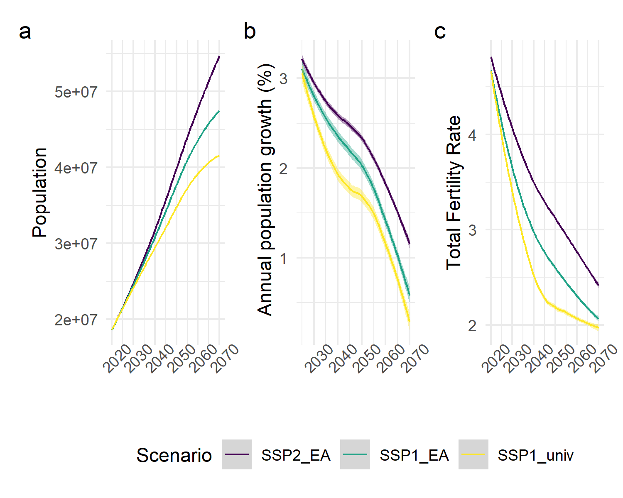

Figure 3.1: Evolution of the population size (a) and annual population growth (b) and total fertility rates (c) in three scenarios.

## 3.2 Energy demand

We estimate that the total household final energy demand of the Zambian population in 2070 ranges from 653 to 268 PJ. Under the *SSP1_univ* scenario, energy demand is estimated to be 29% lower than under the *SSP2_EA* and 11% lower than under the *SSP1_EA*. The energy demand reduction is dramatic in the *SSP1_univ_elec* scenario, with demand being 84% and 68% lower than under the *SSP2_EA* and *SSP1_EA* scenarios, respectively.

In contrast to total energy demand, electricity demand is estimated to increase in all scenarios. In the baseline scenario, electricity demand in 2070 is estimated to be 8-fold higher than in 2020, reaching 109 PJ. Under both *SSP1_EA* and *SSP1_univ*, demand in 2070 is about 12-fold higher than in 2020, and it is 17 times higher in the *SSP1_univ_elec* scenario, reaching 253 PJ (Figure 3.3). This implies the need for a significant development of the country’s installed power generation capacity.

The increase in electricity demand in our model is consistent with model results from the International Energy Agency’s Africa Energy Outlook 2019. They projected electricity demand in sub-Saharan Africa (excluding South Africa) to 2040 under a “Stated Policy” scenario, which simulates a situation in which all current energy policies are implemented, and an “Africa Case” scenario, which reflects a situation with more ambitious goals for sustainability and economic development. They estimate that electricity demand would increase by a factor of 4 compared to 2018 levels under their Stated Policy scenario, and by a factor of 8 under their Africa Case scenario. These magnitudes are similar to our estimates. By 2040, we estimate that electricity demand could be as little as twice the 2020 level or as much as 10 times the 2020 level, depending on the scenario considered (Figure 3.3).

The share of traditional energy in the energy demand also varies strongly in the different scenarios, and in 2070 it ranges from 82% to 59 %. In the *SSP2_EA* scenario, in 2070 82% of the energy demand is traditional energy, the majority of it being firewood and charcoal. In the *SSP1_EA* scenario, 66% comes from traditional energy, and only 59% in the *SSP1_univ* scenario. It can be surprising that in this scenario, still more than half of the energy demand comes from traditional energy. This is explained by the fact that households use multiple fuels, and even when they get access to one source of modern energy, they continue to use some traditional energy on the side (Figure 2.3). When all cooking facilities are replaced by electricity (*SSP1_univ_elec*), all the energy demand is comprised of modern energy from 2040 onward. The share of traditional energy in total household energy demand experiences a small drop around 2035 under *SSP1_univ* and around 2055 under *SSP1_EA*. This coincides with the timing when universal access to modern cooking fuels is achieved, which happens in 2040 under *SSP1_univ*, and in 2055 under *SSP1_EA* (Figure 2.2).

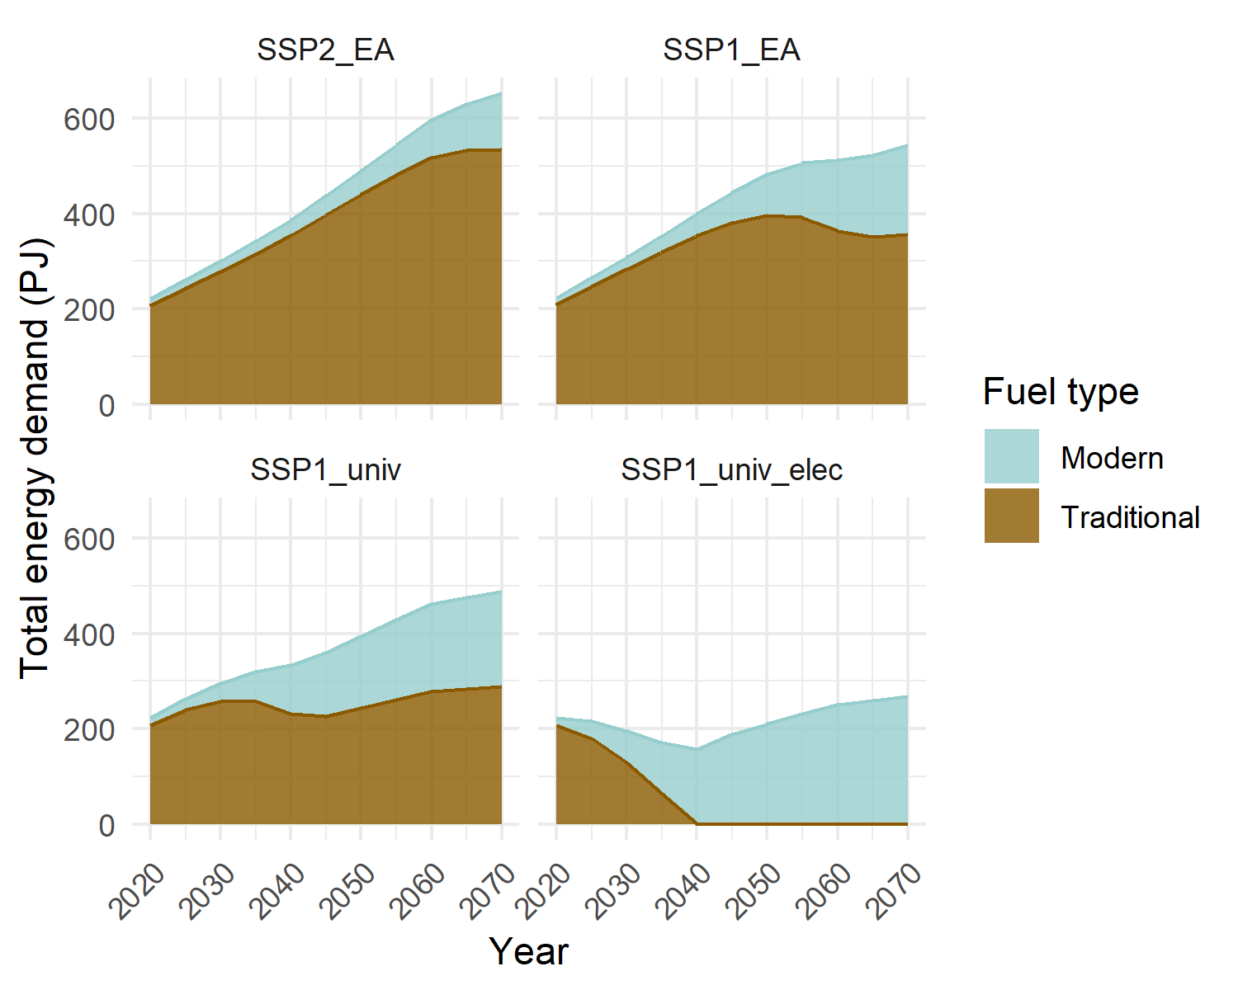

Figure 3.2: Traditional and modern energy demand in the four scenarios. Traditional energy includes firewood, charcoal, coal, kerosene and paraffin. Modern energy includes electricity, gas, LPG, diesel.

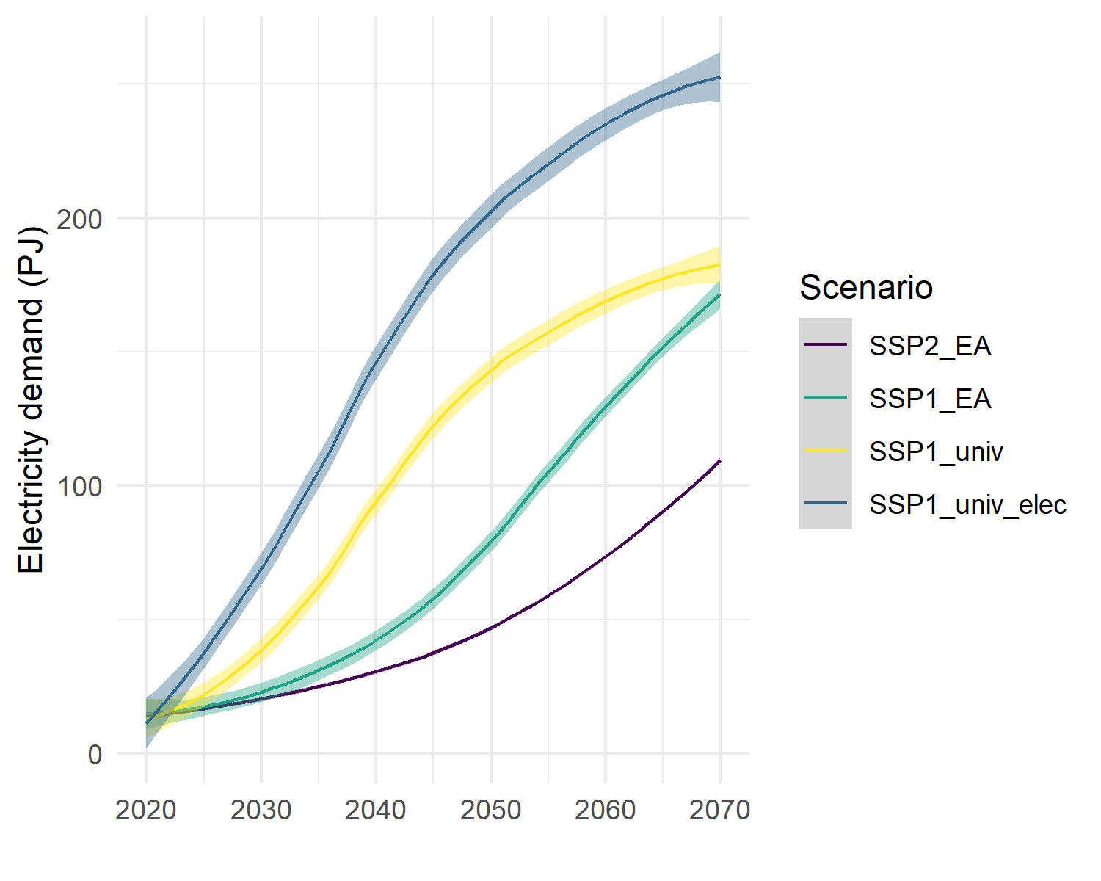

Figure 3.3: Electricity demand demand in the four scenarios.

## 3.3 Decomposing energy demand change by population composition and size effects

The objective of this study is to quantify how projected energy demand in Zambia differs when the feedback between energy access and demographic change is taken into account compared to a case where it is not. To do so, we decomposed the growth in energy demand into the two factors that influence it: population composition and population size. First, we considered the impact on energy demand of the scenario-driven increase in the share of the population with higher education, living in urban areas, and having access to modern energy. This change in population composition affects energy consumption patterns, since energy use per capita differs between groups (Figure 2.3). Second, we considered the effect of changes in population size, which directly affects energy demand.

To distinguish the “population size effect” from the “composition-efficiency effect”, we decomposed the change in energy demand between SSP1_EA and SSP1_univ, the two scenarios that differ only in terms of the energy access pathway, and which is faster under SSP1_univ. However, since the education, urbanization and mortality trajectories are identical under these two scenarios, we were able to factor out the “population size effect” alone.

To decompose the change in energy demand, we calculated energy demand for a hypothetical scenario in which the proportion of the population in each education, energy access, and urbanization group in each time step is kept as in SSP1_univ, but the population size is as in SSP1_EA. This simulates a situation where energy access improves, but the effect of this improvement on population size is not considered. Figure 3.4 shows the results of this decomposition in both relative (panel a) and absolute (panel b) terms. The blue in the graph represents the composition-efficiency effect and the orange represents the population size effect.

We estimate that the “composition efficiency” effect due to expanded energy access contributes 25% of the reduction in energy demand between *SSP1_EA* and *SSP1_univ* in 2030, and 55% in 2050 (Figure 3.4). After 2060, this effect contributes 100% to the total change in energy demand. In other words, if the demographic feedback is not taken into account, the energy demand under *SSP1_univ* would be higher than under *SSP1_EA* from 2060 onwards (Figure 3.4, panel b). Thus, the orange area represents the estimated magnitude of the overestimation of energy demand when the demographic feedback from expanded access to modern energy is not considered.

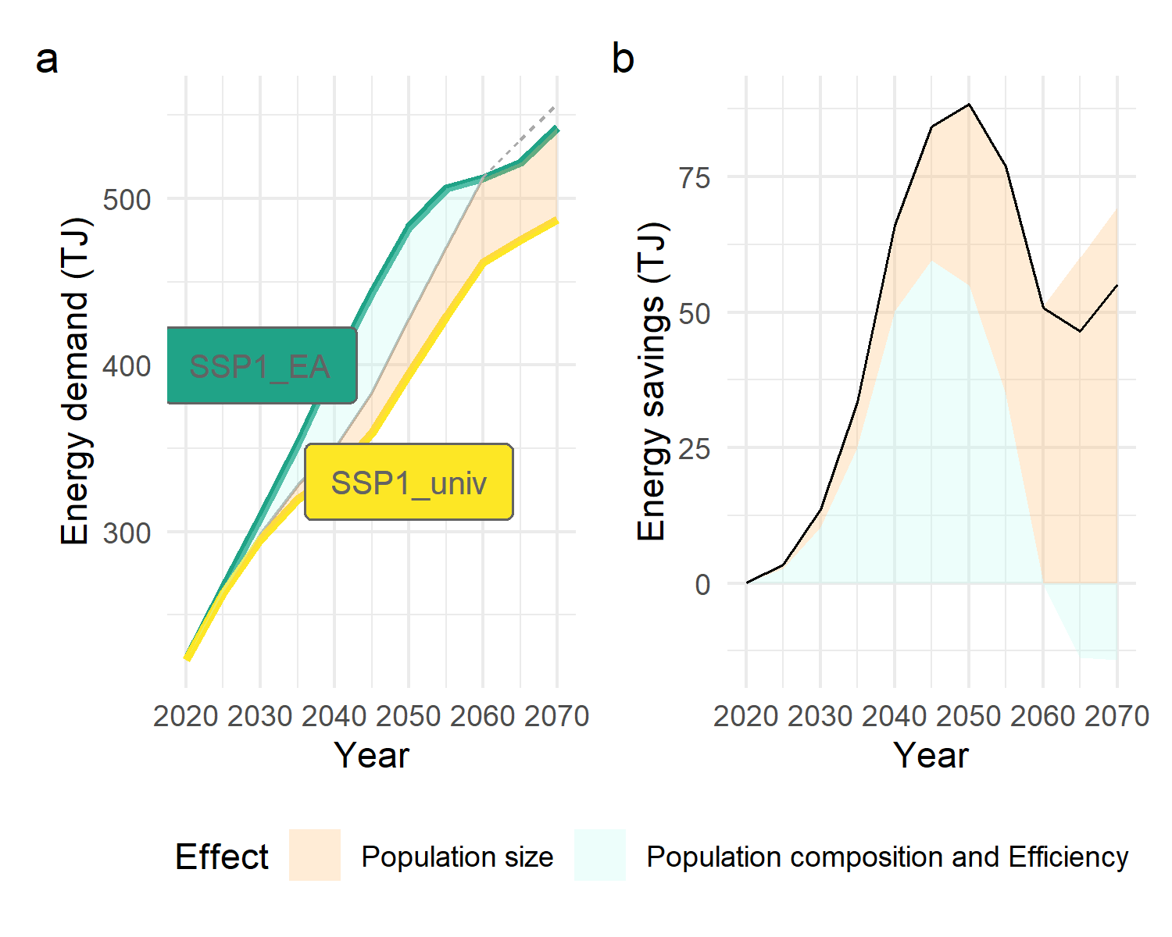

Figure 3.4: Decomposition of the difference in energy demand in absolute (a) and relative terms (b) between the SSP1_univ scenario (yellow) and the SSP1_EA scenario (green). The orange area corresponds to share of the difference in energy demand due to the population size effect (itself due to expanded energy access). The blue area represents the share of the energy demand difference that is due to the composition-efficiency effect.

# 4 Discussion and conclusions

Achieving universal energy access is more urgent than ever. It is a necessary condition for improvements in well-being, health, education, gender equality and climate resilience, and recent studies have also shown its significant impact on reproductive health and fertility patterns. In this article, we quantified the energy demand associated with achieving universal energy access, taking into account the fact that modern energy access spurs fertility decline.

Our results suggest that improvements in living conditions and well-being can be achieved at low energy and carbon costs, and even result in energy and emissions savings. Although electricity demand is higher when the entire population of Zambia has access to modern energy than in the baseline, household energy demand from all fuels is 29% lower. In terms of greenhouse gas emissions, this translates into a 53% reduction by 2050 and a 165% reduction when combined with electrification of cookstoves (Supplementary Method 1, Supplementary Tables 4-6 and Supplementary Figure 2). Implementing policies to achieve universal access to modern energy is a solution that would maximize improvements in well-being while significantly reducing emissions. If combined with climate policies that encourage the deployment of renewable energy, this would further reduce emissions (Dagnachew et al. 2018). This would also allow for the decarbonization of sectors other than the residential sector, which are expected to grow as the population develops.

The specificity of this study is that it quantifies the contribution of the population effect to the observed reduction in energy demand. Typically, studies that aim to quantify the energy required to achieve universal energy access do not explicitly include the impact of energy access on population growth (Dagnachew et al. 2018 ; Kikstra et al. 2021 ; Rao, Min, and Mastrucci 2019). Instead, population projections such as the medium variant of the UN projection or the SSP2 scenario developed by the WIC(K. C. and Lutz 2017) are used. The population size projected for Zambia in 2070 for the SSP2 scenario from the WIC is 47.1 million people, which is 13% lower than the population size we found in the *SSP1_univ* scenario (41.5 million). Our results suggest that the estimated energy requirements for a decent life could be significantly lower if a population scenario consistent with achieving universal energy access were used. The same is true for the associated carbon and investment costs of eradicating energy poverty.

This study makes a significant contribution by being the first of its kind to use a population projection model that endogenizes the effect of energy access on fertility. However, there are a number of limitations that should be kept in mind when interpreting our results, and that are opportunities for future improvements. First, in the model, energy is not a predictor of mortality. This could lead to a small overestimation of the population size in scenarios with rapid improvements in energy access, as child mortality in particular declines with expansion of modern energy access (Adaji et al. 2019). However, as mortality depends on education, and modern energy access is correlated with education, this is unlikely to affect significantly the results.

Second, in our model, energy per capita is static for each education/modern energy access/urbanization category, whereas in reality energy use per wealth segment may change over time. For example, energy use could increase in wealthier categories due to increased demand for air conditioning as part of climate change adaptation. Energy use could also decrease in less affluent groups if economic and social inequalities increase. Especially since the direction of such changes is unclear, a better representation of the dynamics of energy use over time would be needed to better quantify the energy requirements for universal access to modern energy. A third notable limitation is the way in which the cooking energy transition is represented. Although we know that energy-poor households tend to accumulate different fuels rather than switch from one fuel to another (fuel stacking), our model does not represent this characteristic of household energy transitions.

More efforts are needed to incorporate the relationship between energy access and population dynamics into energy models (Kikstra et al. 2021). Such models can reveal novel mitigation solutions that are simultaneously beneficial to achieving other SDGs, such as SDG 7 on energy access, SDG 3 on good health, or SDG 5 on gender equality. While the challenge of rapidly achieving universal access to modern energy may seem daunting, shedding light on the additional climate co-benefits of achieving this goal could help further encourage investments aimed at achieving reliable access to modern energy for all.

# References

Adaji, Enemona Emmanuel, Winifred Ekezie, Michael Clifford, and Revati Phalkey. 2019. “Understanding the Effect of Indoor Air Pollution on Pneumonia in Children Under 5 in Low- and Middle-Income Countries: A Systematic Review of Evidence.” *Environmental Science and Pollution Research* 26 (4): 3208–25. <https://doi.org/10.1007/s11356-018-3769-1>.

Baltruszewicz, Marta, Julia K. Steinberger, Anne Owen, Lina I. Brand-Correa, and Jouni Paavola. 2021. “Final Energy Footprints in Zambia: Investigating Links Between Household Consumption, Collective Provision, and Well-Being.” *Energy Research & Social Science* 73 (March): 101960. <https://doi.org/10.1016/j.erss.2021.101960>.

Belmin, Camille, Roman Hoffmann, Peter-Paul Pichler, and Helga Weisz. 2022. “Fertility Transition Powered by Women’s Access to Electricity and Modern Cooking Fuels.” *Nature Sustainability* 5 (3): 245–53.

Central Statistical Office of Zambia, -. 2015. “World Bank, Zambia Living Conditions Monitoring Survey 2015. Retrieved from Http://Zambia.opendataforafrica. Org/Ssvcmrd.”

Dagnachew, Anteneh G., Andries F. Hof, Paul L. Lucas, and Detlef P. van Vuuren. 2020. “Scenario Analysis for Promoting Clean Cooking in Sub-Saharan Africa: Costs and Benefits.” *Energy* 192 (February): 116641. <https://doi.org/10.1016/j.energy.2019.116641>.

Dagnachew, Anteneh G., Paul L. Lucas, Andries F. Hof, and Detlef P. van Vuuren. 2018. “Trade-Offs and Synergies Between Universal Electricity Access and Climate Change Mitigation in Sub-Saharan Africa.” *Energy Policy* 114 (March): 355–66. <https://doi.org/10.1016/j.enpol.2017.12.023>.

Das, Ipsita, Thomas Klug, PP Krishnapriya, Victoria Plutshack, Raja Saparapa, Stephanie Scott, Erin Sills, Marc Jeuland, Njeri Kara, and Subhrendu Pattanayak. 2020. *A Virtuous Cycle? Reviewing the Evidence on Women’s Empowerment and Energy Access, Frameworks, Metrics and Methods*.

Ezzati, Majid. 2005. “Indoor Air Pollution and Health in Developing Countries.” *The Lancet* 366 (9480): 104–6. <https://doi.org/10.1016/S0140-6736(05)66845-6>.

Fuchs, Regina, Elsie Pamuk, and Wolfgang Lutz. 2010. “Education or Wealth: Which Matters More for Reducing Child Mortality in Developing Countries?” *Vienna Yearbook of Population Research* 8: 175–99. <https://www.jstor.org/stable/23025514>.

Fujii, Tomoki, and Abu S. Shonchoy. 2020. “Fertility and Rural Electrification in Bangladesh.” *Journal of Development Economics* 143 (March): 102430. <https://doi.org/10.1016/j.jdeveco.2019.102430>.

GEA. 2012. *Global Energy Assessment*. Cambridge University Press. <https://ideas.repec.org/b/cup/cbooks/9780521182935.html>.

Grimm, Michael, Robert Sparrow, and Luca Tasciotti. 2015. “Does Electrification Spur the Fertility Transition? Evidence From Indonesia.” *Demography* 52 (5): 1773–96. <https://doi.org/10.1007/s13524-015-0420-3>.

Grogan, Louise. 2016. “Household Electrification, Fertility, and Employment: Evidence from Hydroelectric Dam Construction in Colombia.” *Journal of Human Capital* 10 (1): 109–58. <https://doi.org/10.1086/684580>.

Harbison, Sarah F., and Warren C. Robinson. 1985. “Rural Electrification and Fertility Change.” *Population Research and Policy Review* 4 (2): 149–71. <https://doi.org/10.1007/BF00127549>.

ICF. 2004. “Demographic and Health Surveys [Datasets]. Funded by USAID.” <https://dhsprogram.com/data>.

IEA, International Energy Agency. 2016. “WEO-2016 Special Report: Energy and Air Pollution – Analysis.” <https://www.iea.org/reports/energy-and-air-pollution>.

IEA, IRENA, UNSD, -World Bank, and WHO. 2022. “Tracking SDG 7: The Energy Progress Report (2022).” <https://trackingsdg7.esmap.org/data/files/download-documents/sdg7-report2022-full_report.pdf>.

Jiang, Leiwen, and Brian C. O’Neill. 2017. “Global Urbanization Projections for the Shared Socioeconomic Pathways.” *Global Environmental Change* 42 (January): 193–99. <https://doi.org/10.1016/j.gloenvcha.2015.03.008>.

K. C., Samir, and Wolfgang Lutz. 2017. “The Human Core of the Shared Socioeconomic Pathways: Population Scenarios by Age, Sex and Level of Education for All Countries to 2100.” *Global Environmental Change* 42 (January): 181–92. <https://doi.org/10.1016/j.gloenvcha.2014.06.004>.

Kikstra, Jarmo S., Alessio Mastrucci, Jihoon Min, Keywan Riahi, and Narasimha D. Rao. 2021. “Decent Living Gaps and Energy Needs Around the World.” *Environmental Research Letters* 16 (9): 095006. <https://doi.org/10.1088/1748-9326/ac1c27>.

Lutz, Wolfgang, Anne Goujon, Samir KC, Marcin Stonawski, and Nikolaos Stilianakis. 2018. *Demographic and Human Capital Scenarios for the 21st Century: 2018 Assessment for 201 Countries*.

Luzi, Lucia, Yunhui Lin, Brian Bonsuk Koo, Dana Rysankova, and Elisa Portale. 2019. *Zambia - Beyond Connections: Energy Access Diagnostic Report Based on the Multi-Tier Framework*. ESMAP Papers. World Bank. <https://doi.org/10.1596/32750>.

Marois, Guillaume, and Samir KC. 2021. “‪Microsimulation Population Projections with SAS: A Reference Guide‬.” <https://scholar.google.de/citations?view_op=view_citation&hl=fr&user=UCjfWdcAAAAJ&cstart=20&pagesize=80&citation_for_view=UCjfWdcAAAAJ:RGFaLdJalmkC>.

Masera, Omar R, Barbara D Saatkamp, and Daniel M Kammen. 2000. “From Linear Fuel Switching to Multiple Cooking Strategies: A Critique and Alternative to the Energy Ladder Model.” *World Development* 28 (12): 2083–103. <https://doi.org/10.1016/S0305-750X(00)00076-0>.

McCollum, David L., Luis Gomez Echeverri, Sebastian Busch, Shonali Pachauri, Simon Parkinson, Joeri Rogelj, Volker Krey, et al. 2018. “Connecting the Sustainable Development Goals by Their Energy Inter-Linkages.” *Environmental Research Letters* 13 (3): 033006. <https://doi.org/10.1088/1748-9326/aaafe3>.

OXFAM. 2017. “Energy and Women and Girls: Analyzing the Needs, Uses, and Impacts of Energy on Women and Girls in the Developing World.” [/explore/research-publications/energy-women-girls/](https:///explore/research-publications/energy-women-girls/).

Peters, Jörg, and Colin Vance. 2010. *Rural Electrification and Fertility*. Essen: Rheinisch-Westfälisches Institut für Wirtschaftsforschung. <http://nbn-resolving.de/urn:nbn:de:101:1-20100624181>.

Poblete-Cazenave, Miguel, Shonali Pachauri, Edward Byers, Alessio Mastrucci, and Bas van Ruijven. 2021. “Global Scenarios of Household Access to Modern Energy Services Under Climate Mitigation Policy.” *Nature Energy* 6 (8): 824–33. <https://doi.org/10.1038/s41560-021-00871-0>.

Potter, Joseph E., Carl P. Schmertmann, and Suzana M. Cavenaghi. 2002. “Fertility and Development: Evidence from Brazil.” *Demography* 39 (4): 739–61. <https://doi.org/10.1353/dem.2002.0039>.

Price, Martin, Melinda Barnard-Tallier, and Karin Troncoso. 2021. “Stacked: In Their Favour? The Complexities of Fuel Stacking and Cooking Transitions in Cambodia, Myanmar, and Zambia.” *Energies* 14 (15): 4457. <https://doi.org/10.3390/en14154457>.

Rao, Narasimha D., Jihoon Min, and Alessio Mastrucci. 2019. “Energy Requirements for Decent Living in India, Brazil and South Africa.” *Nature Energy* 4 (12): 1025–32. <https://doi.org/10.1038/s41560-019-0497-9>.

Riahi, Keywan, Detlef P. van Vuuren, Elmar Kriegler, Jae Edmonds, Brian C. O’Neill, Shinichiro Fujimori, Nico Bauer, et al. 2017. “The Shared Socioeconomic Pathways and Their Energy, Land Use, and Greenhouse Gas Emissions Implications: An Overview.” *Global Environmental Change* 42 (January): 153–68. <https://doi.org/10.1016/j.gloenvcha.2016.05.009>.

Samboko, Paul, Cliff Dlamini, Kaala Moombe, and Stephen Syampungani. 2016. “Load Shedding and Charcoal Use in Zambia: What Are the Implications on Forest Resources,” June.

UNFPA. 2019. “World Population Prospects - Population Division - United Nations.” <https://population.un.org/wpp/GlossaryOfDemographicTerms/>.

Van Imhoff, Evert, and Wendy Post. 1998. “Microsimulation Methods for Population Projection.” *Population* 10 (1): 97–136. <https://www.persee.fr/doc/pop_0032-4663_1998_hos_10_1_6824>.

WHO, -, ed. 2014. *WHO Guidelines for Indoor Air Quality: Household Fuel Combustion*. Geneva, Switzerland: World Health Organization.

Wickramasinghe, Anoja. 2011. “Energy Access and Transition to Cleaner Cooking Fuels and Technologies in Sri Lanka: Issues and Policy Limitations.” *Energy Policy*, Clean Cooking Fuels and Technologies in Developing Economies, 39 (12): 7567–74. <https://doi.org/10.1016/j.enpol.2011.07.032>.

Winther, Tanja, Margaret N. Matinga, Kirsten Ulsrud, and Karina Standal. 2017. “Women’s Empowerment Through Electricity Access: Scoping Study and Proposal for a Framework of Analysis.” *Journal of Development Effectiveness* 9 (3): 389–417. <https://doi.org/10.1080/19439342.2017.1343368>.