Analysis of Air-Pollution Linked Mortality Rates

1. Introduction

In this project we examined data from 2019 presented by the World Health Organization (WHO) showing mortality rates attributed to ambient and household air pollution by country. WHO defines ambient air pollution as: “pollution resulting (results) from emissions from industrial activity, households, cars and trucks”. Household was briefly described as fuel used for cooking. The data is broken down into death rates by air pollution linked diseases, including: 1) Lower respiratory infections in general population; 2) Stroke in adults; 3) ischemic heart diseases in adults; 4) Chronic obstructive pulmonary diseases in adults; and 5) Trachea, bronchus, and lung cancers in adults. We found the five countries with the highest and lowest total death rates across both sexes. We determined the average total death rate in both sexes to be 100.77 in 100,000 people. We also examined which illness had the highest mortality rate between sexes.

1. Data

The data we used measure the death rates across the five air-pollution linked illnesses as listed above. The WHO gathered data from most countries excluding Greenland and Svalbard (Norway). There were minimal non applicable areas of Africa. The data was broken down into male, female, and both sexes. For each disease there were values for non-adjusted mortality rates and values for age-standardized mortality rates. To eliminate age distributed bias between countries, our group analyzed only the age-standardized values.

|  |  |
| --- | --- |
| **Variable** | **Description** |
| Continent | Continent name. Nominal |
| Location | Country name. Nominal |
| Year | Year data was collected. Numeric |
| Sex | Male, Female, or Both sexes. Nominal |
| Cause of Death | Pollution-linked illness resulting in death. Nominal |
| Average Death Rate | Death rate across entire country. Numeric |
| Regional Low Deaths | Lowest regional death rate per Country. Numeric |
| Regional High Deaths | Highest regional death rate per country. Numeric |
| Value | Average death rate printed with regional low to regional high. Numeric |

*Table 1*

1. Analysis

We focused our analysis on two main areas. We first wanted to look at the countries with the highest and lowest death rates by all 3 sex groups (male, female, and both sexes). Starting with the five countries with the lowest death rate by both sexes in order from ascending order, we found: Finland, Norway, Sweden, Canada, and Iceland. Sorting through the data, we were able to narrow down the lowest death rates for each individual sex. We found that Finland had the lowest average death rate for both sexes combined as well as females. Norway had the lowest average death rate among males. As illustrated in the graphs below, we found it interesting that of the lowest five countries Finland had the highest mortality rate among men (10.37 per 100,000 people). However, due to Finland’s very low death rate among females (5.09 per 100,000 people) their average death rate for both sexes ended up being the lowest. The average death rate among the lowest five Countries was 7.93 per 100,00 people. The average death rate of all the Countries was much higher at 100.77 per 100,000 people.

Figure Figure

Next, we chose to investigate the Countries with the highest mortality rates of air pollution linked illnesses. We found the five highest death rates in both sexes across all Countries in order: Central African Republic, Lesotho, Solomon Islands, Afghanistan, and Vanuatu. The Country with the highest female average death rate was Afghanistan with a death rate of 265 in 100,000 people. The country with the highest male mortality rate is the Central African Republic with a rate of 364.9 in 100,000 people. The mean mortality rate of the top five countries is 280.04. We found it interesting that Afghanistan is not in the highest five mortality rates for *males*. The mortality rate for males in Afghanistan is 265.2 in 100,000 people, which is almost equivalent to the female death rate in Afghanistan (265).

Figure

Figure

Figure

We wanted to further investigate the mortality rates across the air pollution linked diseases individually. By pulling each disease by gender and summing their death rates across all countries provided, we were able to determine ischemic heart disease as the deadliest disease with a death rate of 41.4%. The least deadly air-pollution related disease was attributed to trachea, bronchus, and lung cancers with a death rate of 2.5%. Shown in the chart below, you can see that lower respiratory infections and stroke had similar summed death rates. One trend we found consistent across our data was that males have higher death rates from air pollution than females do. This is evident across each disease, as well as geographical location.

Figure 8

Figure

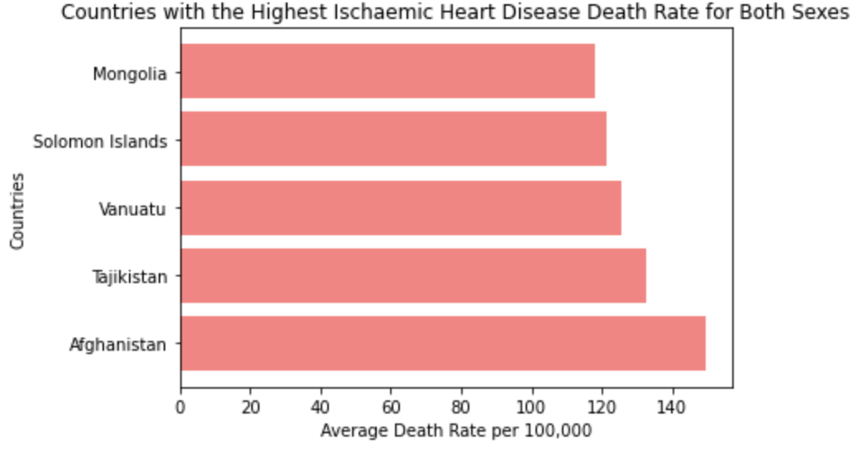

Figure 9 Figure 10

We calculated the summary statistics of both sexes across all Countries:

|  |
| --- |
| **The lower quartile of average death rate is: 31.66** |
| **The upper quartile of average death rate is: 165.45** |
| **The interquartile range of average death rate is: 133.78** |
| **The median of average death rate is: 83.45** |
| **Values below -169.01250000000002 could be outliers.** |
| **Values above 366.1275 could be outliers.** |

`. *Table 2*

Based on these statistics, we can conclude that there are no outliers for mortality rates.

1. Conclusion

Our analysis of WHO’s data on mortality rates attributed to household and ambient air pollution concluded the average death rate among males is greater than the average death rate among females. We also discovered that death rates are higher in countries with limited economic resources. The biggest limitation of this data set is its inability to be filtered by age group. Only one of the five illnesses looks at the general population. The other four only pull responses from persons 25 years and over. We could better understand how specific age demographics are being affected by air pollution linked illness if we could bin our data into age groups.