**General Description:**

This software been designed by a group of four ENAC students in for object oriented programming design synthesis exercise, with the goal to offer a user friendly interface for the calibration of the Magnetometer and Accelerometers.

The software offers real time feedback during the calibration process and indications how to manipulate the IMU during the procedure in order to enhance the quality of the calibration.

The software retrieves the raw data of the accelerometers and magnetometers on the Ivy bus and presents them on a 2D representation of a sphere. Areas of the sphere changes color when enough points have been measured in that area. To have an accurate calibration, a homogenous coverage of the sphere is required.

When enough data has been gathered the points are stored in a log file and a python calibration script is run returning the six calibration parameters in XML format. This should be copy-pasted in your airframe file.

More information on the calibration procedure and the python file can be found on the IMUcalibration page.

The software is a .jar file and runs the python script that can be found in the git reposity under sw/tools/calibration/calibrate.py

**User Manual:**

1. Launch the UAV
2. Launch Paparazzi
3. Launch the software
4. Select UAV ID

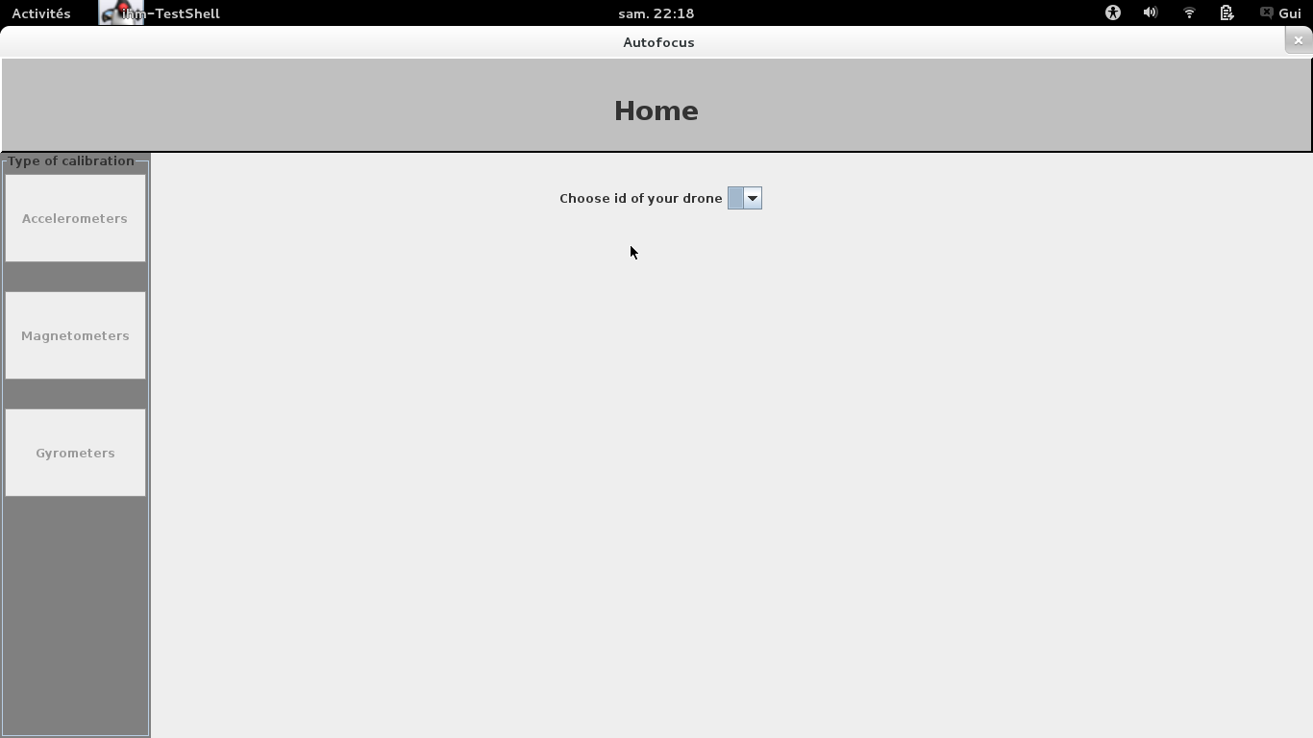

1. Select the telemetry mode which sends the raw data on the ivy bus, the connection should now be established
2. Select which sensor to calibrate
3. Start collecting data, move your IMU/airframe in different positions.
4. Press stop to end collecting data. The calibration should start automatically.
5. An XML file containing the calibration parameters should appear. Copy-paste paste the code into the airframe.

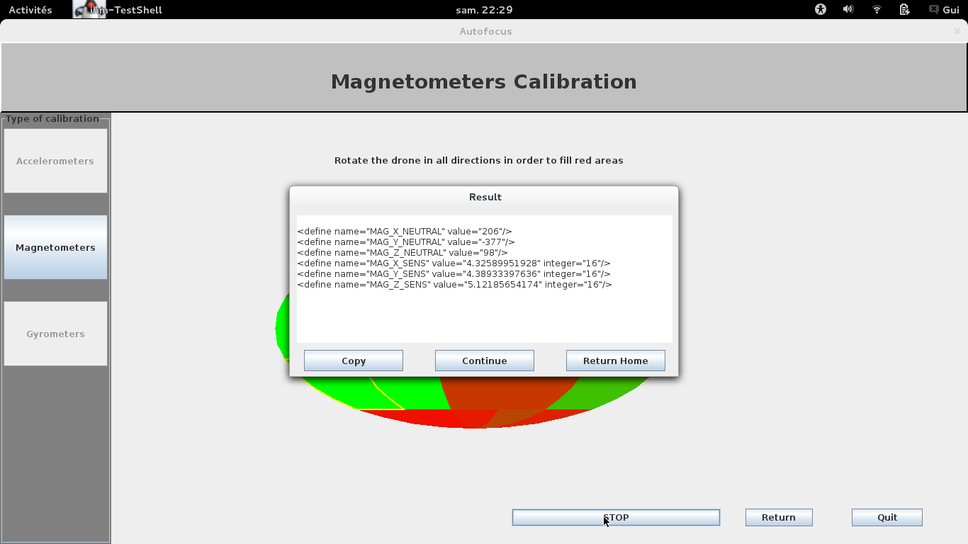

**Accelerometer Calibration**

For the calibration of the accelerometers the IMU/airframe should be turned on its six sides and kept still. The software will record points only if the IMU/airframe is not moving too much. The view of the 2d sphere shows which axes have not yet been covered.

**Magnetometer calibration**

The calibration should be done away from any magnetic source that could bias the calibration.

For the magnetometer calibration, ideally the IMU/airframe should be rotated in all direction to cover a sphere. The Magnetometer is not affected by the rotation of the IMU so you don’t need to keep your IMU completely still at each measurement. 