**Sistemes Dinàmics en Ecologia**

Camille Minaudo

2022-2023

**Building the model, step by step**

All you need is to open the file oxygenModel.Rmd in RStudio.

Either

* you have RStudio already installed in your machine, in that case you can simply download (or “git clone”) to the repository indicated below, and open the file oxygenModel.Rmd.
* or you don’t have RStudio, and in that case you can work on a remote platform called binder. To do that, click on the “launch binder” badge inside the README.md file, visible directly on the GitHub repository indicated below. Then, open a Rstudio notebook and open the file oxygenModel.Rmd.

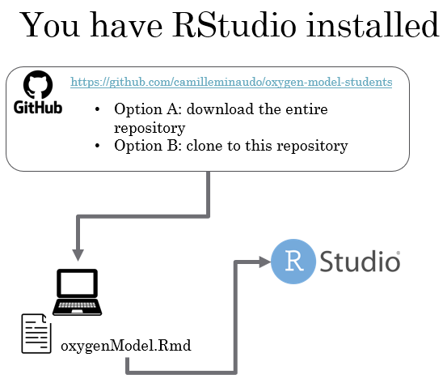

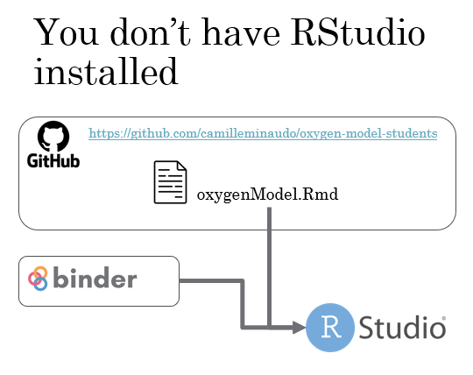

Once you have successfully opened the file oxygenModel.Rmd, follow instructions herein. It is only required to fill in the blanks: add values for constants, and correctly write the equations for the model to run.