CHAPTER 1 INTRODUCTION TO THE STUDY

Background of the Study and Theoretical Framework

The world has reached an era where most of the activities depend on the use of technology. Despite this technological advancement, farmers today still lack capability to improve and strengthen farming activities and routines and rather prefer to go back to their traditional ways of farming.

It is difficult to get hold of information from smallholder farmers. Knowledge in modernized farming methods also is compromised. Most of them lack access to inputs, markets, financing, and training. The opportunity brought by the spread of mobile technology, real-time data collection, distributed computing and storage gave these farmers the opportunity into the broader agri-food system (USAID, 2018).

With the help of the government and private sectors, the country is into the adoption of technology and modernization of farming methods of our agricultural sector to increase harvest and minimize losses.

Embracing technology in farming methods could change the shape of demand for food. With the utilization of effective production systems, big data and other scientific advances allows agriculture to be precise and high yielding (Voegele, 2018). With sustainable food production, it could solve issues regarding food scarcity in a country and could change the food system which may lead to economic development and environmental protection (Folk, 2018).

Over the past 50 years, the agriculture industry has undergone radical transformation. Farm equipment has grown in size, speed, and productivity as a result of technological advancements, allowing for easier cultivation of much more land (Goedde et. al, 2020). Nowadays, highly developed technologies like the internet of things, artificial intelligence, analytics, connected sensors and GPS technology are all part of the present agricultural routine.

Currently, the Department of Agriculture utilizes various technologies that read and analyze agricultural data. One of these is the Farmer’s Guide Map system in which suitable land areas are highlighted based on the chosen crop. The National Color-Coded Guide Map (NACCAG) was launched by the Department of Agriculture in 2017. Its goal is to tell farmers which crops are best for their fields. Also, through NACCAG, the Department gives a chance to ensure the agriculture sector’s resilience to climate change in the Philippines. Another existing software used in farming is the Rice Crop Manager (RCM), a partnership between Department of Agriculture and International Rice Research Institute, that gives farmers at least three recommendations through short messaging services (SMS) to improve boosting their crop management. Farmers around the country have benefited from the recommendations made for their respective crops since RCM was launched in 2013 (International Rice Research Institute, 2021).

With the growing world population, food production and farming must be more productive and capable of producing high yields in a short amount of time. This will require the industry to face adversity of providing improved infrastructure to successfully meet the rising demand and various disruptive trends. The dynamic digital agriculture contributes enormous benefits to modern farms. They provide significant assistance to farmers in their attempt to increase inputs, simplify farm management, and boost yield. Profit margins are raised by higher yields and lower utility costs (Earth Observing System, 2019). Improved efficient real-time monitoring and natural resources management, such as air and water quality, is possible due to robotic technologies. It also reduces the environmental and ecological impact giving the farmers substantial control over a crop with safer growing conditions (National Institute of Food and Agriculture, 2019).Precision agriculture is the solution of agricultural approaches for today's and tomorrow's farmers in the case of smart alternatives (Earth Observing System, 2019).

In the midst of the COVID-19 pandemic that occurred in late 2019, the farm sector is being hailed as the Philippine economy’s savior. The Department of Agriculture remained hopeful about its overall performance in 2020 despite the consecutive typhoons that wreaked-havoc the country near the end of 2020, the sector managed to increase by 0.5 percent in the second quarter of 2020 and 0.7 percent in the third quarter of 2020 at a time when most industries and economic sectors were reeling from lockdowns and reduced activity (Simeon, 2021).

Agricultural households are increasingly reliant on non-farm income to complement their farming incomes while poverty has been decreasing among farming households. The Philippines has enacted one of the world’s most strict quarantine procedures in response to the COVID-19 disaster and this has affected our farmers more than ever before. Agriculture remains the largest source of revenue, and traditional crop production remains the dominating agricultural activity (The World Bank, 2020).

Most of the upland farmers have even increased their farming holdings and taken up higher grounds for cultivation, with the Philippines having 30 million hectares and a land area of 298,170 square kilometers and has a slope of more than 18 percent or more than half of it.

The Philippine Statistics Authority reported that one agricultural sector of Western Visayas named Iloilo with 133.5 thousand farms covering 186.3 thousand hectares of agricultural land. The province accounted for 31.1 percent of the region's total farms and agricultural land accounted for 27.9 percent of the total land area with Rice being the major crop in the province. With the information being said, Iloilo takes pride in being the region’s food basket and rice granary, with its lush lands and oceans that provides a large harvest (ExploreIloilo.com, 2016).

The researchers came up with a study entitled “Crop

Suitability Mapping using Geographic Information System (GIS)”. In this web-based system, the researchers included several features. One feature is a web-based system for gathering and processing data including date, location, agro-climatic (temperature, humidity, and rainfall), and agro geologic data (soil pH and elevation). This feature serves as repository data that researchers manually input into the website. Another feature of the study is the forecasting model using time series analysis to forecast suitable crops to plant at a specific time of the year (e.g., month and quarter). This feature will use the time series analysis to examine the trend and to forecast the crop that is suitable to plant for that time. Apart from these features of the study is a map that plots the potential agricultural land area suitable for farming. Using this feature, it will visualize a certain area which land is appropriate for agricultural activities and farming through gathered data. Lastly, a recommending system for major crops based on area/ municipality. This feature will commend what are the possible plants suitable for a certain place, month, and forecasted weather data. This will help farmers when to plant a certain crop appropriate in the forecasted data.

The proposed system is anchored on the input output process model. As shown in Figure 1, the model emphasizes the approach of the system in analyzing by assuming raw data are processed and transformed by the system functions to generate outcomes. The input of our system will be the location, month, and crop. If a location is given as an input, it will then proceed to the process phase which highlights the location’s recommended crops along with the inputted month as the system analyzes the agro-climatic data through logic scoring preference, a general multicriteria decision making method. With the supplied agro-climatic and agro-geologic data, this will allow the system to illustrate the map of the suitable crop to plant within that location. On the other hand, if crops are chosen to be recommended, it will highlight locations suitable for crop growth within specific date ranges as the system analyzes the afro-geologic data to be shown on the map. Lastly, the output of the system is the crop suitability map that shows the potential agricultural land area suitable for farming and a recommending system for major crops based on the chosen area.

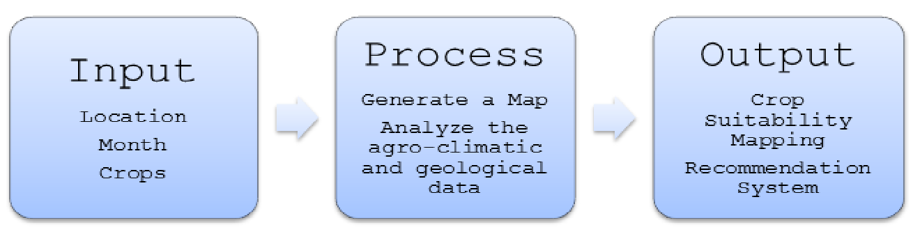

*Figure 1*. IPO Process of the Proposed System

Objectives of the Study

This study was generally intended to develop a Crop Suitability Mapping Using Geographic Information System (GIS).

Specifically, it aims to:

1. Develop a system that collects agro-climatic data(temperature, humidity, and rainfall), agro geologic data (soil pH and elevation), and the location of a particular municipality in the Province of Iloilo.

2. Develop a forecasting model using time series analysis with agro-climatic, agro-geologic, and location data.

3. Develop a web-based system that can generate a visualization of suitable crops in a certain location and specific month of the year using Geographic Information System (GIS).

4. Develop a web-based recommendation system for major crops based on location/municipality on a specific month of the year.

5. Evaluate the quality of the system using ISO 25010:2011.

Significance of the Study

The main focus of this study is to provide crop suitability mapping using geographic information system to those who need it, especially in the field of agriculture. The system can be used for crop management and for monitoring changes in the agricultural areas in terms of the predetermined attributes of crops, soil, and weather. With its capability of assessing and analyzing agro-climatic and agro geologic data in a more convenient and efficient way. Farmers, researchers, and the agricultural sector can determine and compare which crop variant is suitable in the specified location and month.

The people or institutions that can benefit in this study are:

Local Government Units (LGUs). The study is centered towards giving a more convenient, reliable, and effective gathering and processing of crop production based on weather information to the concerned agencies. These agencies include the head office the Department of Agriculture (DA). The department can use or include this system into their agricultural activities.

Farmers. The study may offer a reliable crop suitability map that would be a great help to the farmers in line with their work and diversify the use of land for farming.

Agricultural Researchers. Information gathered will serve as a basis or guide for the researchers and the study can be made available for people studying further about agriculture and its biological components.

Agriculture Students. The data and other sources can offer help to the students, especially those who are practicing their expertise in the field of agriculture and want to know more about studies related to crop production management.

Definition of Terms

For better understanding, the following terms were defined conceptually and operationally:

*Agro-climatic* -- mainly refers to soil types, rainfall, temperature, and water availability which influence the type of vegetation (vikaspedia.in, n.d.).

In this study, Agro-climatic refers to the variables used such as rainfall, humidity, temperature, and pH level.

*Agrogeology* -- ’geology in the service of agriculture’, a study of geological processes that influence the distribution and formation of soils and the application of geological materials in farming and forestry systems as means maintaining and enhancing soil productivity for increased social, economic and environmental benefits (Straaten and Fernandes, 1995).

In this study, Agro- Geologic refers to the soil pH and elevation data being collected.

*ER Diagram* -- is a graphical representation that depicts relationships among people, objects, places, concepts or events within an information technology (IT) system (Biscobing, 2019).

In this study, ER Diagram will show the relationship between entities used and processes indicated in each entity.

*Forecasting* -- refers to the practice of predicting what will happen in the future by taking into consideration events in the past and present. Basically, it is a decision-making tool that helps businesses cope with the impact of the future’s uncertainty by examining historical data and trends (corporatefinanceinstitute.com, 2020).

In this study, forecasting using a time series method will be used to extrapolate future climate data variables used in each location.

*Geographic Information System (GIS) -*- is a framework for gathering, managing, and analyzing data.

Rooted in the science of geography, GIS integrates many types of data. It analyzes spatial location and organizes layers of information into visualizations using maps and 3D scenes (esri.com, n.d.).

In this study, Geographic Information System will be used for mapping, locating places that match specific criteria, and managing agricultural crop data.

*Google Map API --* a set of application programming interfaces that lets us talk to its services. It will allow us to build simple apps to very sophisticated location-based apps for Web, iOS, and Android (softauthor.com, 2021).

In this study, Google Maps API takes a user response and sends it to a system, which then responds to the user.

*Google Maps --* are flat maps that function within a web browser. The [Google Maps](http://maps.google.com/) service was originally created as a means of providing driving directions, and this is the purpose for which Google Maps are most commonly used. Google Maps offer several different views of the landscape, including Street, Traffic, Map, Satellite, and Terrain, which can be selected using buttons in the upper-right ([serc.carleton.edu](https://serc.carleton.edu/introgeo/google_earth/google_maps.html), n.d).

In this study, Google maps were injected to the script to display the GIS function of the system. It serves as the map determining areas that are suitable for the chosen crop to grow.

*Humidity-* is the amount of water vapor in the air. If there is a lot of water vapor in the air, the humidity will be high. The higher the humidity, the wetter it feels outside (National Geographic Society, 2012).

In this study, humidity is an agro-climatic data that is being collected.

*Javascript -*- is a text-based programming language used both on the client-side and server-side that allows users to make web pages interactive (hackreactor.com,

n.d).

In this study, Javascript will be used as a programming language to provide a platform for making the website more interactive, such as by creating dropdown menus and forms along with HTML and CSS.

*Jurors* -- a body of persons legally selected and sworn to inquire into any matter of fact and to give their verdict according to the evidence ([merriam-webster.com](https://www.merriam-webster.com/dictionary/jury), n.d).

In this study, Jurors are the people who are going to evaluate the system.

*MySQL --* is a relational database management system (RDBMS) developed by Oracle that is based on structured query language(SQL) (talend.com,n.d.).

In this study, MySql is the database used to store data.

*PHP --* is a widely used open source general-purpose scripting language that is especially suited for web development and can be embedded into HTML (php.net, n.d).

In this study, PHP is a programming language used to develop dynamic and interactive websites.

*Rainfall -*- is the amount of precipitation, in the form of rain (water from clouds), that descends onto the surface of Earth, whether it is on land or water. It develops when air masses travel over warm water bodies or over wet land surfaces (enclyclopedia.com, 2021).

In this study, rainfall is one of the agro-climatic data that is being collected.

*Soil pH -*- is a measure of the acidity or alkalinity of the soil (usgs.gov, 2017).

In this study, soil pH is one of the geologic data that is being collected.

*Suitability Mapping* -- contributes to the discussion where a given crop can be best produced given prevailing biophysical conditions of soils and climate and the need to use natural resources as efficiently as possible (wur.nl, n.d).

In this study, suitability mapping will be used to map the suitable crop based on predetermined attributes.

*Temperature* -- measure of hotness or coldness expressed in terms of any of several arbitrary scales and indicating the direction in which heat energy will spontaneously flow —i.e., from a hotter body (one at a higher temperature) to a colder body (one at a lower temperature) (britannica.com, n.d).

In this study, temperature is one of the agro-climatic data that is being collected by celcius.

*Web-based System* -- is an application that is accessed via HTTP. The term web-based is usually used to describe applications that run in a web browser. It can, though, also be used to describe applications that have a very small component of the solution loaded on the client PC. The host server for a web-based system could be a local server, or it could be accessed via the internet (aezion.com, 2020).

In this study, a web-based System will be used as a platform where users can input and access the information needed and also recommend some crop suitable within the inputted location.

Delimitation of the Study

The aim of this study is to provide the agricultural sector, the farmers, and researchers with improved productivity, efficiency, and effective crop management using geographic information system. The system consists of: one, a web-based system for gathering and processing data including agro-climatic, geologic, and location data; two, crop management using time series analysis to forecast suitable crops to plant in a specific time of the year (e.g., month and quarter); three, a map that shows the potential agricultural land area suitable for farming, and; four, a recommending system for major crops based on area/ municipality.

The main users of the system are the agricultural sector, the farmers, and local government units. Since sensors were not utilized in this study, the system will allow provincial and municipal administrators to update the database. The provincial administrator will be the one to enroll municipal admins as well as the crops and their requirements to grow. The municipal admin will be the one to update agro-climatic data (minimum and maximum temperature, minimum and maximum humidity, and minimum and maximum rainfall) in the database. The system will generate the analysis of the given input and upon accessing, the user will be given two options, either to choose the location or a specific type of crop. This will both show the user's desired output: (a) if location and date are chosen, the map will point to the specific location and generate the top-recommended crops that can grow in that area, and (b) if a specific type of crop is chosen, the system will show locations suitable for the crop to grow. The location and crop recommendation will be based on the location’s agro-climatic and geologic data and the crop’s requirements to survive

CHAPTER 2 REVIEW OF RELATED STUDIES

Review of Existing and Related Studies

# Economic Impact of Farming in the Philippines

In Western Visayas, Iloilo has the most number of registered farms which covers 186.3 thousand hectares of agricultural land area, and having 31.1% of the overall count in the region (*A Review of the Agriculture Sector in Western Visayas | Philippine Statistics Authority*, 2004). Moreover, Iloilo Province is a top palay producing province ranking fifth in the Philippines in 2014 having 4.5 percent shares in the whole country (Philippine Statistics Authority, 2020).

From 2019 to 2020, the region’s agriculture, fisheries, and forestry (AFF) sector grew at the quickest rate of all the country’s regions at 4.7 percent. Palay and corn were the top gainers in the agriculture sector, with gains of 10.8 and 2.04 percent, respectively. However, the regional economy of Western Visayas shrank by 9.7 percent in 2020, according to the Gross Regional Domestic Product (GRDP). This was in sharp contrast to the 6.3 percent rise experienced in 2019. The main causes of the reduction were massive contractions in the service and manufacturing sectors, considering the restrictions brought by the community quarantine. The country’s Gross Domestic Product (GDP) also dropped. Western Visayas stood as the fifth negative contributor at 0.5 percentage point to the GDP and accounting for 4.7 percent in total. Despite this, the region remains to be the 5th largest economy outside the National Capital Region.

Western Visayas is also considered as the

Philippines' fourth-fastest-growing regional economy in

2017. The region witnessed an economic growth rate of 8.4%, which was greater than the country's 6.7 percent average in the same year. The majority of this tremendous rise can be attributed to the agriculture, hunting, forestry, and fishing (AHFF) sector recovery (National Economic and Development Authority, 2019). Crop production rose by 2.6 percent which contributed 59.1% of total production of the agricultural and fisheries industry. The region's crop production grew at 10.2% in

2020 (Business World Online, 2021). From 5% percent performance in 2019, the region's agricultural, forestry, and fisheries (AFF) industries grew by 6.2 percent contributing 19.9 percent to the region's economy (Philippine News Agency, 2021). At constant 2018 prices, the value of agricultural and fisheries production increased by 0.6 percent in the last quarter of 2021 (Philippine Statistics Authority, 2022).

The government has various programs and strategies to support and expand the capacity of small-scale farmers, from skills training and scholarship grants to individuals who are interested in helping the community. These strategies had helped communities in enhancing their approaches towards crop care and management. However, quick changing technologies and climate change has affected farmers more widely than skills and the capability in farming which resulted in high competition and low trade in the market.

In contrast to numerous other Southeast Asian countries, the integration of Philippines agriculture and fisheries into global value chains has had little impact on rural poverty alleviation. While there have been some breakthroughs in downstream exports, upstream actors continue to face precarious situations (Andriesse, 2018).

Despite the unprecedented challenges, including the pandemic’s logistical nightmare and a series of typhoons that struck significant producing areas across the country, the rice sector continues to grow at its fastest rate ever. The Philippines’ *palay* production is expected to reach 19.44 million metric tons in 2020, according to the Philippine Statistics Authority (PSA), with actual production of 11.9 MMT from January to September and a predicted harvest of 7.54 MMT in the fourth quarter. This unprecedented achievement demonstrates the policies’ accuracy, as Filipino farmers begin to reap the benefits of the Rice Tariffication Law (RTL), particularly the yearly P10-billion Rice Competitiveness Fund (RCEF), which includes the regular rice program and resiliency project.

While it was expected that *palay* farmers would suffer initially from reduced prices as a result of the RTL, the government’s productivity-enhancing aid will lower production costs and boost farmer output, allowing tillers to maintain a solid profit margin (D.A, 2020).

# Modern Agricultural Practices and Technology

Precision agriculture is a form of approach in agriculture where the utilization of modern technologies to improve efficiency and scale production.

The application of precision agriculture provides, processes and analyzes data for decision making and operations in crop production management (Global Food Security, 2016). In addition, the administration of modern technologies can widely improve the production and economic efficiencies of the industry. From the improvement in decision making in seed, fertilizer utilization, crop care, machinery, and improved trade-offs (Tallada, 2019).

Through this technology, farmers have the advantage to improve their planning with the recent information on various environmental factors, such as weather, location information and new crop variety, to increase quality control and production in their agricultural lands.

A study by Selvanayagam et al. (2019) in Sri Lanka, claimed that agriculture is the key industry in their economic development, the demand for modernization in this matter is higher. They utilized deep learning techniques, machine learning and visualization in developing an application to predict crop prices. This allowed them to take action beforehand by implementing necessary activities to draw back crop prices once in trading.

Our study however, utilized crop prediction to assess suitable crops for growing in the future by gathering agro-climatic and agro-geological data of the location then recommending the best fitting crop to be planted. Visualization techniques were implemented through mapping the location.

Armstrong and Nallan (2016) have proposed an agriculture decision support framework for visualization and prediction for crop production. They found out that these methods can improve farmer decision making through seasonal patterns for every district.

# GIS

GIS constitutes a fundamental geo computational approach and tool in the analysis and mapping of past or present processes of the environment, territory, and landscape (Silvia, 2020). It focuses on processing geographical data using the GIS science methods and information technology in order to derive new information and knowledge about landscapes, objects, and phenomena (Tallada, 2019).

A study on suitability mapping for crop production using GIS by Islam et al. (2017) utilized multi-criteria analysis to create a suitable map for crop production through the use of geographic information system. It served information at the local level allowing farmers to understand and select cropping patterns and suitability for land of various crops.

Nabati et al. (2020) developed a system with the integration of GIS and fuzzy inference has advanced the current mapping strategies for agro-ecological zoning for crop suitability. By gathering agro-ecological and various topographic data, it has improved accuracy in spatial data, productive analysis, and enhanced data accessibility.

Similar to this study, our system also developed a map based on agro-climatic and geologic data such as rainfall, temperature, and evaporation data. The use of geographic information system improved visualization techniques for mapping location. The logic scoring preference is the strategy used to determine suitable crops for the desired location.

In agriculture, forecasting is a key factor, supporting farmers in obtaining healthy and abundant yields. The essential weather parameters for agriculture include estimated precipitation and temperatures, as well as historical data, to organize field operations from seeding to harvesting, with fertilizer and herbicide applications in between. Each crop needs a distinct soil ph for planting, some chemicals should be applied on a dry day, while others require moisture to work. Farmers would not be able to achieve best results without reliable weather reports that saves cost and reduces risk.

Weather patterns are changing these days, and one of the key factors to evolving agricultural methods is global climate change, this is why weather analytics is critical in agriculture. Crop production increases are ensured through accurate and reliable data. This helps farmers to adjust and respond in changing conditions, mitigate risks, and organize field events in the most effective way possible.

In this study, a forecasting using time-series analysis is utilized to extrapolate future climatic data variables used in each location.

CHAPTER 3 RESEARCH DESIGN AND METHODOLOGY

Description of the Proposed Study

Small scale farmers who own land cultivate crops repetitively. Usually, they would only cultivate two to three types of crops throughout the year and the basis for farming crops is according to their past experiences due to the absence of knowledge and information. With the rapid take of technology on agriculture, it has helped in maximizing the use of land by determining suitable areas based on the crops factors to grow.

In this study, the researchers aim to develop a web-based crop suitability map that determines crop suitable areas by accessing the factors that could affect crop growth. The system can map locations and determine crops suitable for the farming area through analyzing the factors required for crop growth, such as climate, and geologic properties in the area. It will also forecast climatic data and recommend crops that may be planted at that time of the year.

Methods and Proposed Enhancements

This study is determined to develop a recommendation system that will enhance farming strategies of the agricultural sectors in the country by solely relying on data. Precision farming has upscale the industry especially for large agricultural industries. This system will help small scale farmers and agricultural sectors as this will be implemented to the public.

For the features of the recommendation system, the user aspect of the system is developed as a website so that no particular computer specification is needed to run the system and only requires the user to have access to the internet.

One main feature of the system is to match agro-climatic data with the agro-geologic data. The logic scoring preference is a multicriteria decision making method, and in this proposed system, will be used to match suitable crops and location according to their given data. If the user will choose crops to recommend, it will analyze the agricultural land based on the agro-geologic data and agro-climatic data through matching and will decide which crops are suitable in a given location. If location were to be recommended, the crops data will be analyzed and will go through every location’s data and then will give the most qualified locations.

In the forecasting method, time series analysis using exponential smoothing is used to forecast the agro-climatic data as seen in equation 1.

Exponential smoothing equation:

st = αxt+(1 – α)st-1= st-1+ α(xt – st-1) (1)

Where, st = smoothed statistic, it is the simple weighted average of current observation xt st-1 = previous smoothed statistic α = smoothing factor of data; 0 < α < 1 t = time period

There will be various phases for data collection with different data requirements for each section in the system. The data gathered will allow the system to configure its internal parameters from location admin access to new crop variety.

Admin Enrollment. There will be two kinds of administrators in the system, provincial and municipal admins. There will be only one provincial administrator which has the capacity to enroll new municipal admins and new crop variety into the system. The municipal admin is only limited in logging daily agro-climatic data of their assigned location into the system.

Agro-climatic Data Gathering. The agro-climatic data will be collected through world weather online, a weather website. Three years worth of historical data will be loaded to the system to capture agro-climatic data trends throughout the year and be able to form observations. The municipal admin of every location gathers the minimum and maximum data for temperature, rainfall and humidity daily of their assigned location. Data will be first fed into Microsoft Excel to test the validity of the data and show forecasting trends before feeding the collected data into the system. The agro-climatic data is smoothed by removing high frequency noise that may be caused by unwanted natural disasters which is common to occur in the country. The forecast output will be average temperature, rainfall and humidity.

Agro-geologic data gathering. During the enrollment of the municipal administrator, the provincial administrator collects the agro-geologic data of every location.

Crop Enrollment. The crop’s requirements for growth are gathered during the enrollment of a new crop variety by the provincial administrator. Agro-climatic requirements, minimum and maximum temperature, minimum and maximum humidity, minimum and maximum rainfall. Agro-geologic requirements, elevation and soil pH.

Components and Design

# System Architecture

The system architecture explains the overall system and illustrates how the major components interact.

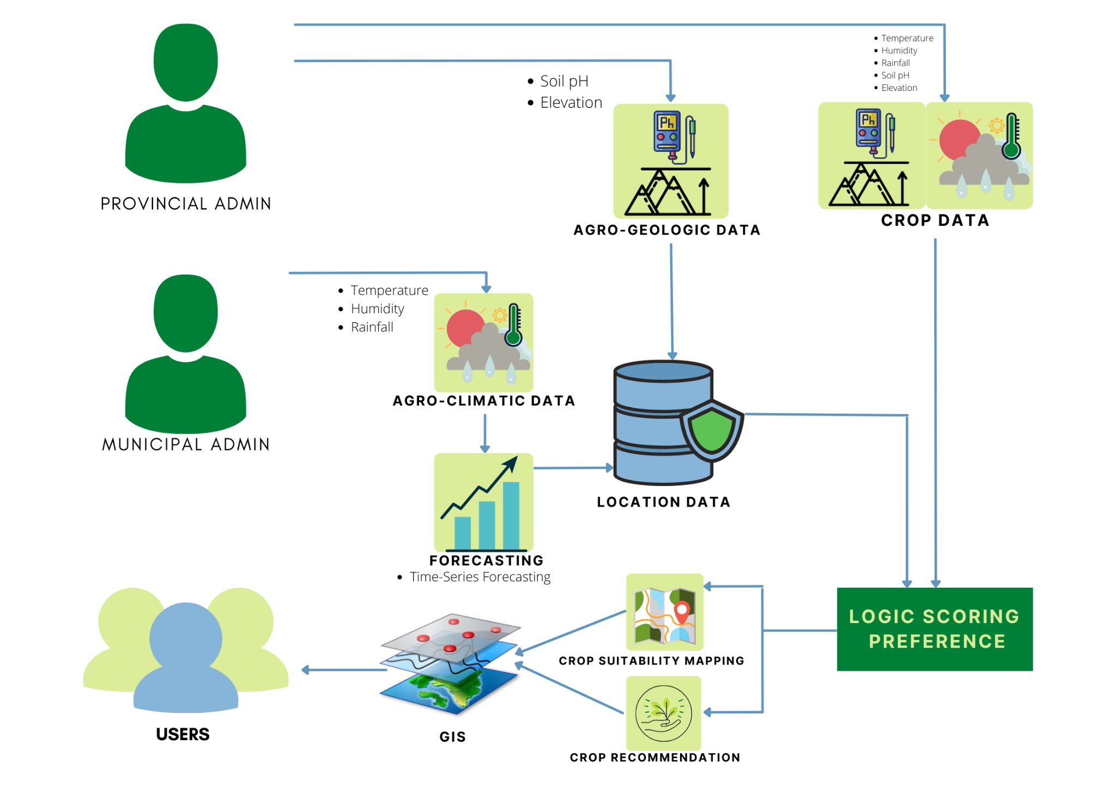*Figure 2*. Crop Suitability Mapping System Architecture

Figure 2 is the system architecture of the crop suitability mapping system. Temperature, rainfall and humidity are categorized and named as Agro- climatic data. This is the climate data captured in the specific location. The data are manually input into the system by the administrator from an online weather application. Elevation and soil pH is captured in the area and soil pH data will depend on the elevation of the area. All this data is then stored in the system’s database. Crop data are the crop’s requirements for growth.

Time series forecasting using exponential smoothing is applied to Agro-climatic data to forecast the data in the area of the chosen month or quarter.

The system uses logic scoring preference to match the location’s agro-climatic and agro-geologic data to match with the crop’s requirements for growth and survival. Logic scoring preference is a general multi-criteria decision-making algorithm widely used in evaluating land capability and suitability for agriculture (Montgomery, 2016).

The system visualizes the data and suitable and recommended crops and locations for farming using a geographic information system (GIS).

# Database Design

The database design explains the structure of the database and the normalization of tables. It consists of four tables namely: Location agro-climatic; Location admin; Location geographic, and Crop data.

Location_agro-climatic

|  |  |  |  |  |  |
| --- | --- | --- | --- | --- | --- |
| No | Municipality | Temperature  (Minimum/  Maximum) | Humidity | Rainfall | Date |
| 1 | Janiuay | 23/27 | 80 | 500 | yyyy-mm-dd |
| 2 | Anilao | 25/29 | 90 | 286 | yyyy-mm-dd |
| 3 | Passi | 22/27 | 91 | 380 | yyyy-mm-dd |
| 4 | Zarraga | 24/30 | 85 | 284 | yyyy-mm-dd |
| 5 | Ajuy | 22/26 | 89 | 477 | yyyy-mm-dd |

*Figure 3.* The Database Design of the Proposed System

Location_admin

|  |  |  |  |  |  |  |  |  |
| --- | --- | --- | --- | --- | --- | --- | --- | --- |
| No | Fullname | Email | Contac t # | Gender | Munici pality | Elevat ion | Soil pH | Date Create d |
| 1 | Ann L.  Gonzalez | ajuy@g mail.c om | +63932  555187  6 | Fema le | Ajuy | 6.8 | 5.6-6.  9 | 2021-1  1-30 |
| 2 | Julie P. Cooper | anilao @gmail  .com | +63909  555859  8 | Fema le | Anilao | 6.8 | 5.6-6.  9 | 2021-1  1-30 |
| 3 | George C.  Miller | passi@ gmail. com | +63932  555187  6 | Male | Ajuy | 6.8 | 5.6-6.  9 | 2021-1  1-30 |
| 4 | Victor C.  Anderson | zarrag a@gmai l.com | +63932  555187  6 | Male | Ajuy | 6.8 | 5.6-6.  9 | 2021-1  1-30 |
| 5 | Mark X. Cox | janiua y@gmai l.com | +63932  555187  6 | Male | Ajuy | 6.8 | 5.6-6.  9 | 2021-1  1-30 |

Location_geographic

|  |  |  |
| --- | --- | --- |
| Municipality | elevation | soil_ph |
| Janiuay | 85 masl | 3.5 |
| Anilao | 577 masl | 5.5- 6.0 |
| Passi | 580 masl | 5.5- 6.0 |
| Zarraga | 79 masl | 6.0-6.5 |
| Ajuy | 451 masl | 6.0-6.5 |

Crop_data

|  |  |  |  |  |  |
| --- | --- | --- | --- | --- | --- |
| crop_name | req_tem p | req_hum | req_rain | req_elev | req_soil_ ph |
| Rice | 20-30 | 60-80 | 450-700 | 900-2000 | 5.5-6 |
| Pineapple | 22-26 | 70-80 | 500-5500 | 150-240 | 4.5-6.5 |
| Mango | 23-45 | 50-95 | 400-3600 | 200-1200 | 5.5-7.5 |
| Tomato | 18-25 | 65-90 | 500-4200 | 1650 | 5.5-8.8 |
| Potato | 18-20 | 50-85 | 500-700 | 100-8000 | 5.0-6.0 |
| Corn | 23-45 | 85-95 | 500-800 | 100-3600 | 5.0-7.0 |
| Banana | 16-38 | 50-95 | 100- 1000 | 1200 | 5.0-7.0 |
| Sugarcane | 22-30 | 50-90 | 125-2500 | 600 | 6.5 |
| Cassava | 25-29 | 80-85 | 100-1500 | 1800 | 4.5-6.5 |
| Coconut | 13-35 | 60-95 | 270-3810 | 600 | 5.0-8.0 |

(cont.)

The crop suitability system uses a non-relational database as there are no relationships within entities.

Location climate is the climate data gathered from the location every day which consists of temperature, humidity, and rainfall.

# Procedural and Object-Oriented Design

Procedural Design

The system follows a data flow from user input to output to generate processes required by the system. Figure 3 shows the procedural design of the web application. The system has three users, the provincial administrator, municipal administrator, and client. The provincial admin has the capacity to enroll new municipal admins, and crop data. Personal information of the chosen municipal admin will be collected as well as their locations’ soil pH and location elevation which as shown in figure 7. Provincial admin has the capacity to enroll new crops by gathering the crop’s agro-climatic and agro geologic data to grow and survive as shown in figure 8. In figure 6, the municipal admin can only enter their location’s climate data such as minimum and maximum temperature of the day, humidity, and rainfall.

The target client of this system will be farmers, agricultural landowners, and agricultural sectors and organizations in the province of Iloilo.

The client user will be able to choose a location or crops to highlight at the given time of the year. If they choose a location, the top suitable crops of that area will be recommended and displayed. If the user chooses the type of crop, the system will display and highlight locations that are suitable for the crop to grow. The decision of the system will be based on the historical agro-climatic and agro-geologic data that matches the factors that affect crop’s growth.

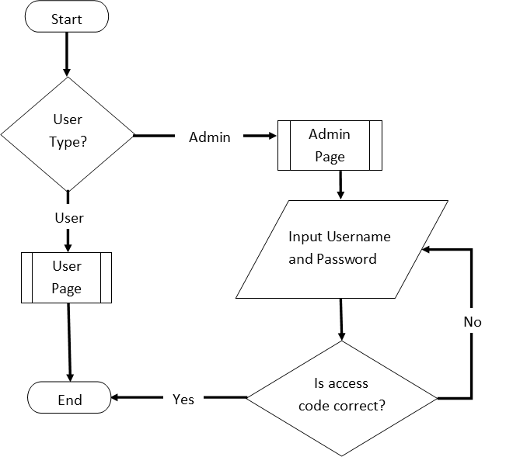

*Figure 3*. The Procedural Design of the Crop Suitability

Mapping using Geographic Information System (GIS)

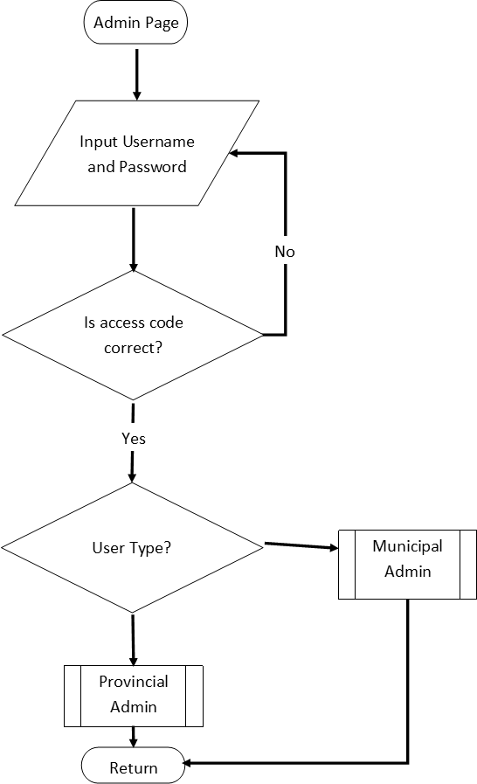

(Cont.)

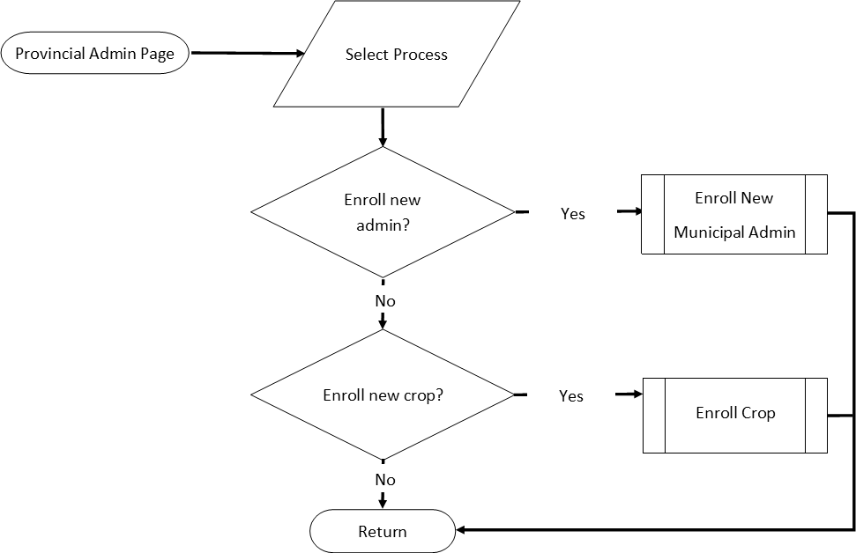

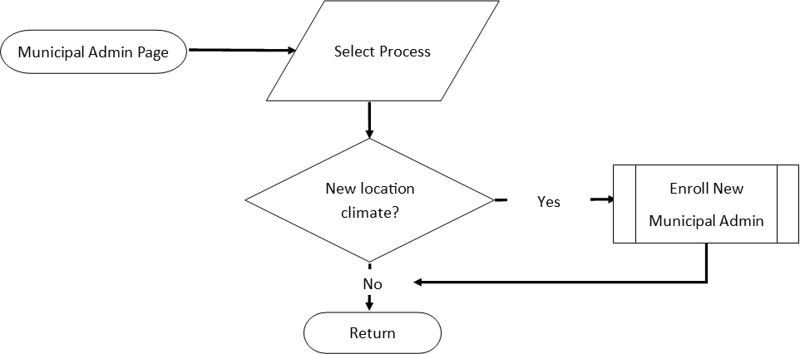

(Cont.)

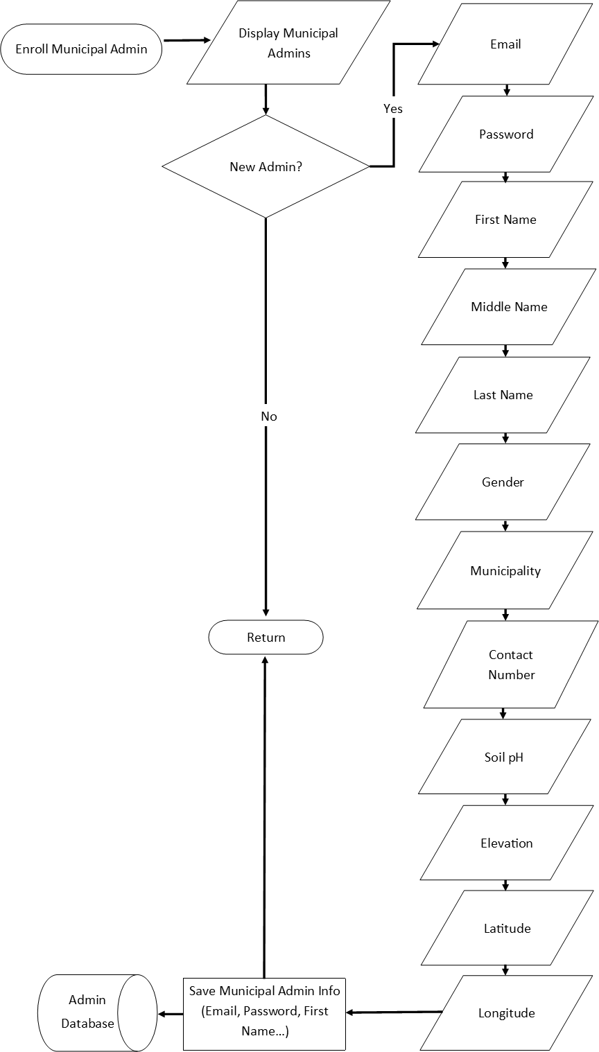

(Cont.)

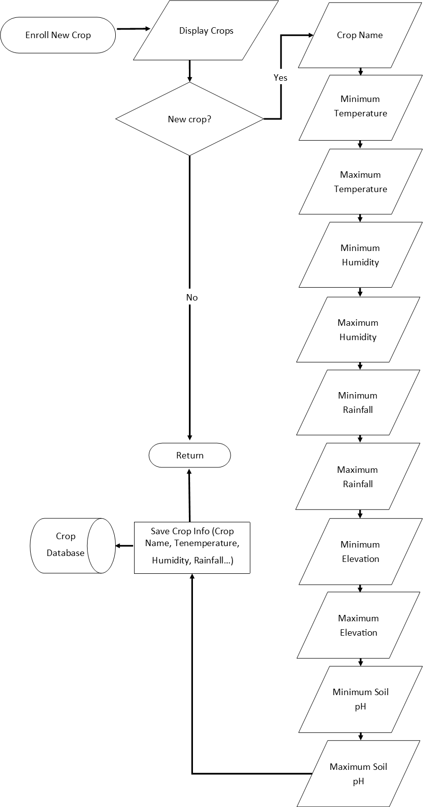

(Cont.)

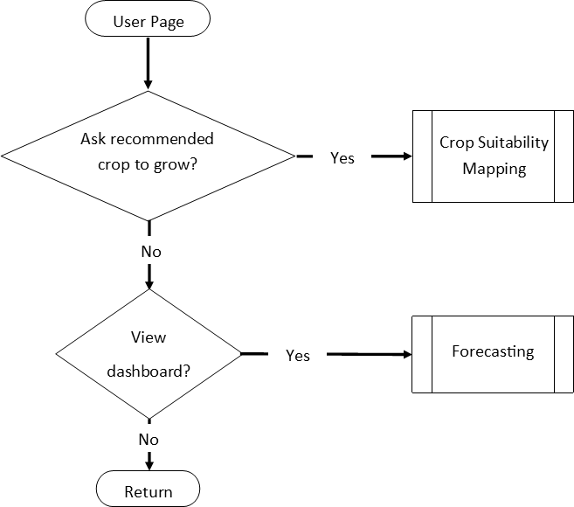

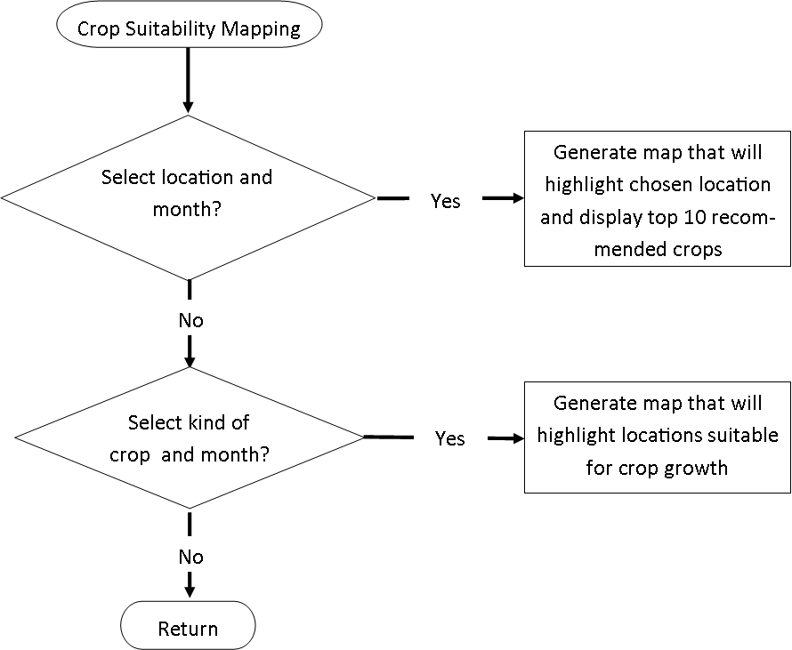

(Cont.)

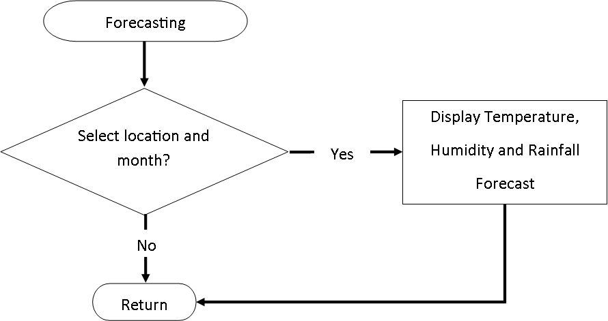

(Cont.)

Object-Oriented Design (UML)

There are multiple levels of users to the crop suitability system, figure 4 shows the users accessing the system and choosing between crop recommendation or suitability mapping. Various data are required by the system for multiple users. This allows the system to have parameters in determining which crop is suitable in the certain area at a given time of the year. The users can forecast on which crop is suitable for the next three years based on the historical agro-climatic and agro geologic data that matches the factors that affect the crop’s growth. The data that is stored in the system is the input of the municipal admin that is enrolled and validated by the provincial admin. For the side of the admin, they are able to enroll and update the agro-climatic data and agro geologic data that would be able to forecast and recommend specific crop or location in the certain month or location that is chosen by the user.

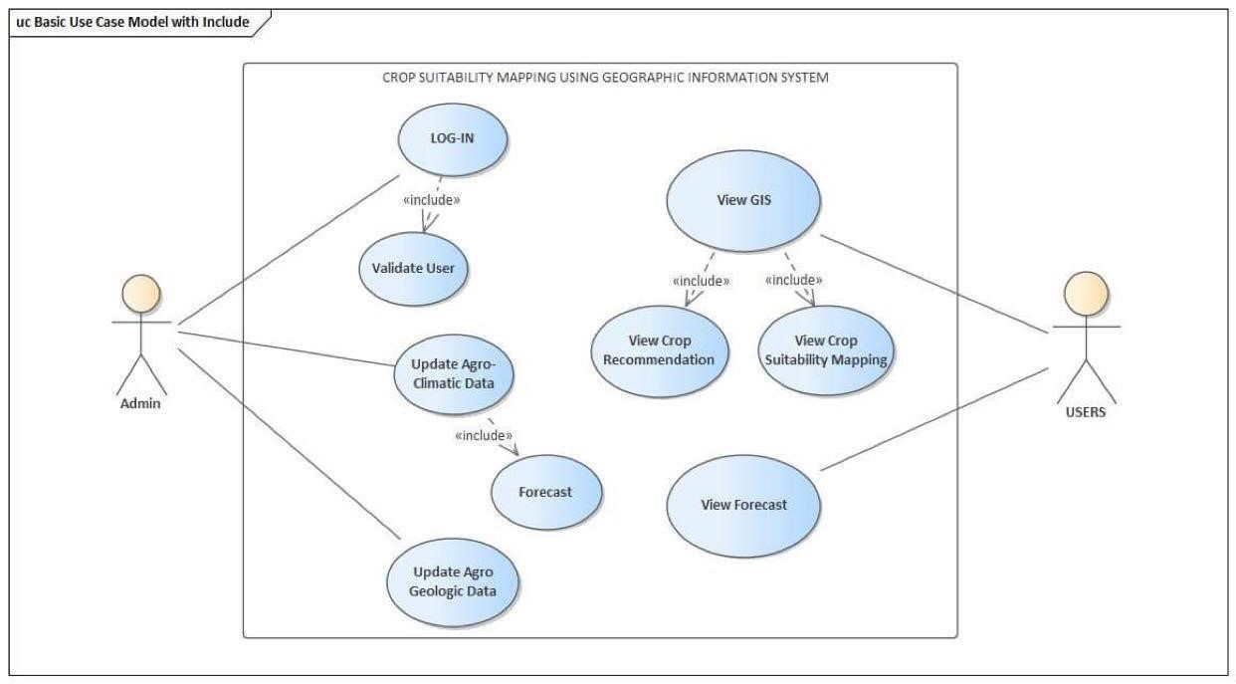

*Figure 4.* UML (Use Case) Diagram of the System

# Process Design

To further illustrate the relationship between the major components present and bounded in the system and how entities interact, Figure 5 shows the process design of the

web application. The system has three users, the provincial administrator, municipal administrator, and client. Both the administrators have the process of logging-in while the clients can freely access the site. The provincial administrator is in charge of enrolling new municipal administrators and crop data. Only enrolled municipal administrators can access their locations account and input their daily agro-climatic data. The agro-climatic data and agro-geological data supplemented by the administrators will undergo logic scoring preference for crop and location matching. The users may: 1) ask to recommend top crops by choosing a location; 2) ask to recommend suitable locations by choosing a crop, and; 3) display the agro-climatic trends of a location.

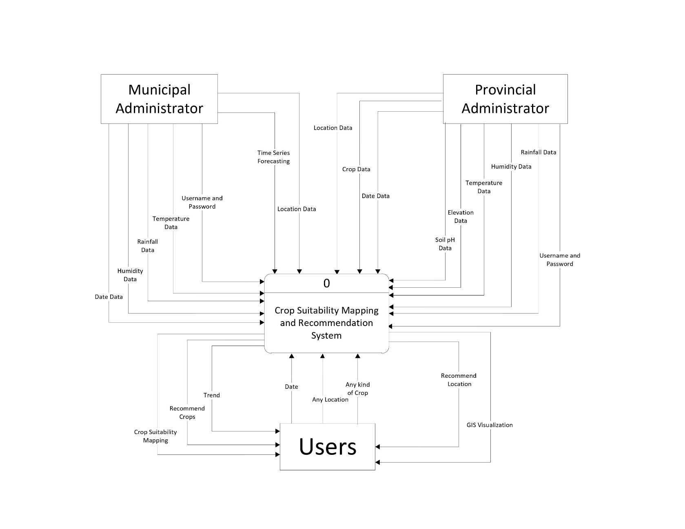

*Figure 5*. Context Diagram of the Crop Suitability Mapping Using Geographic Information System (GIS)

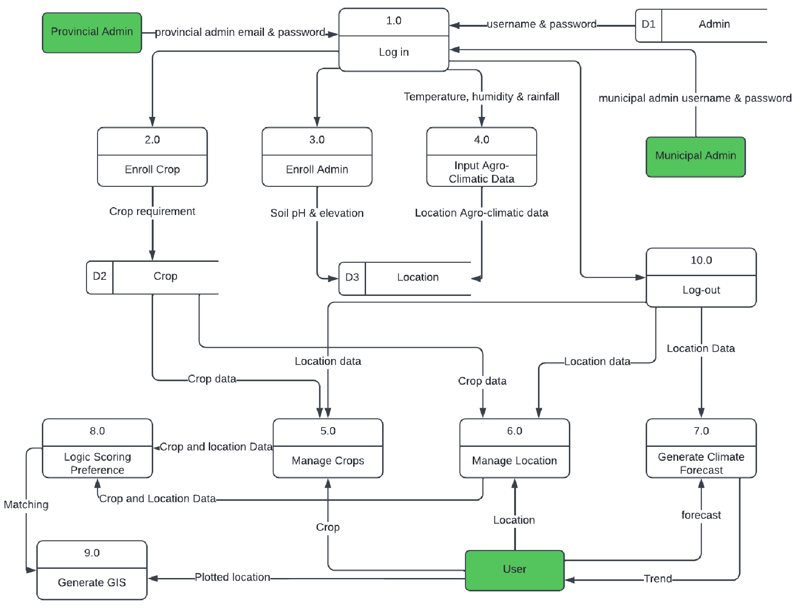

*Figure 6*. Level 0 Diagram

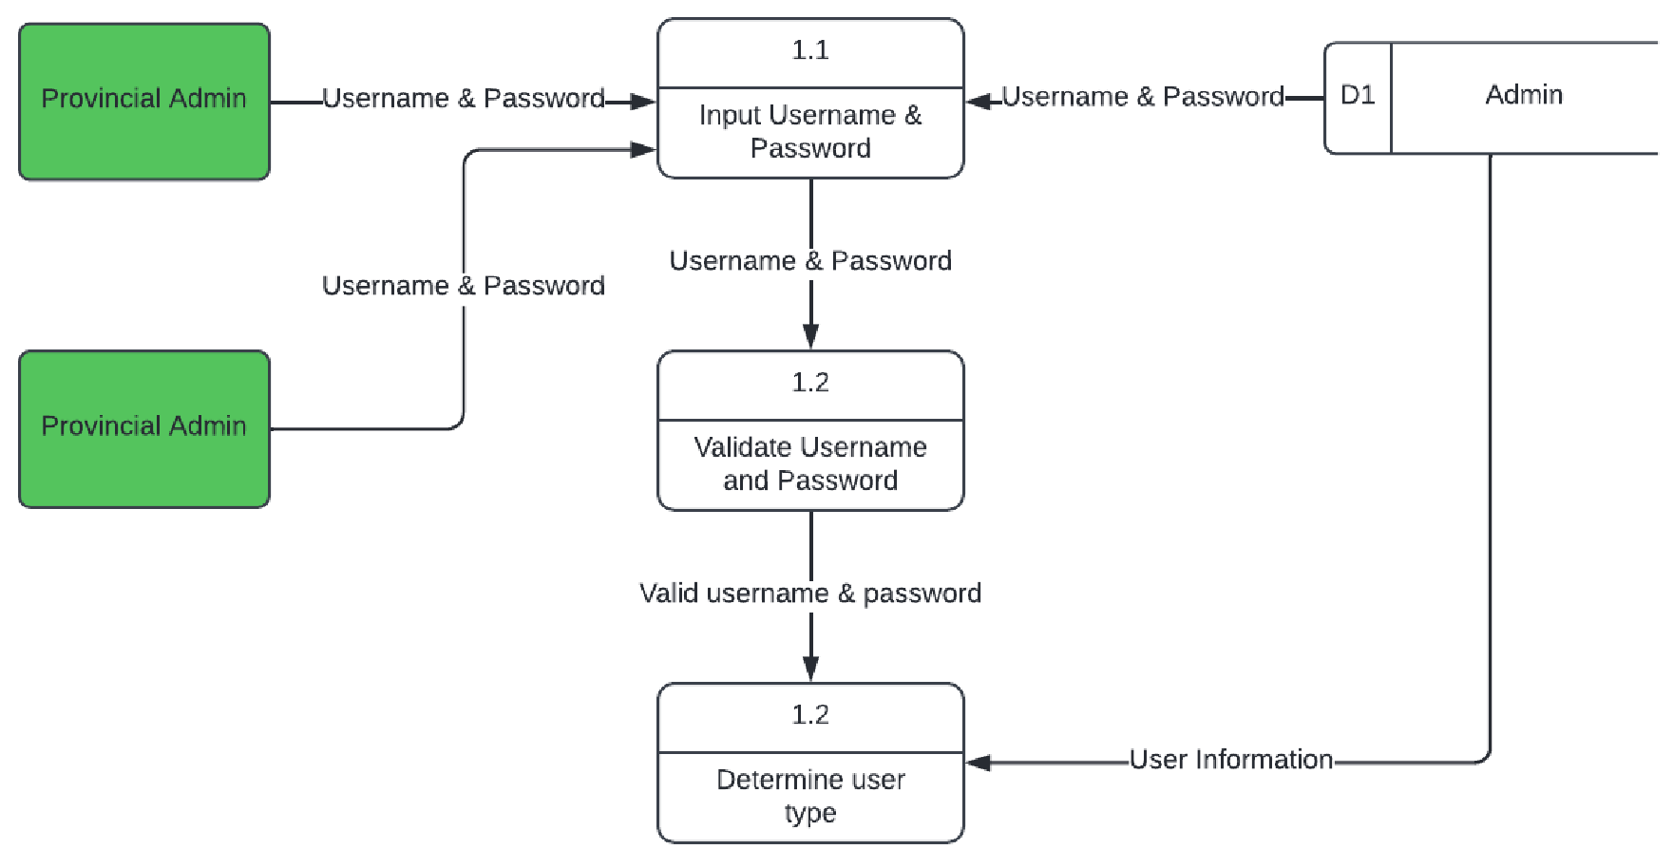

*Figure 7*. Admin Child Diagram

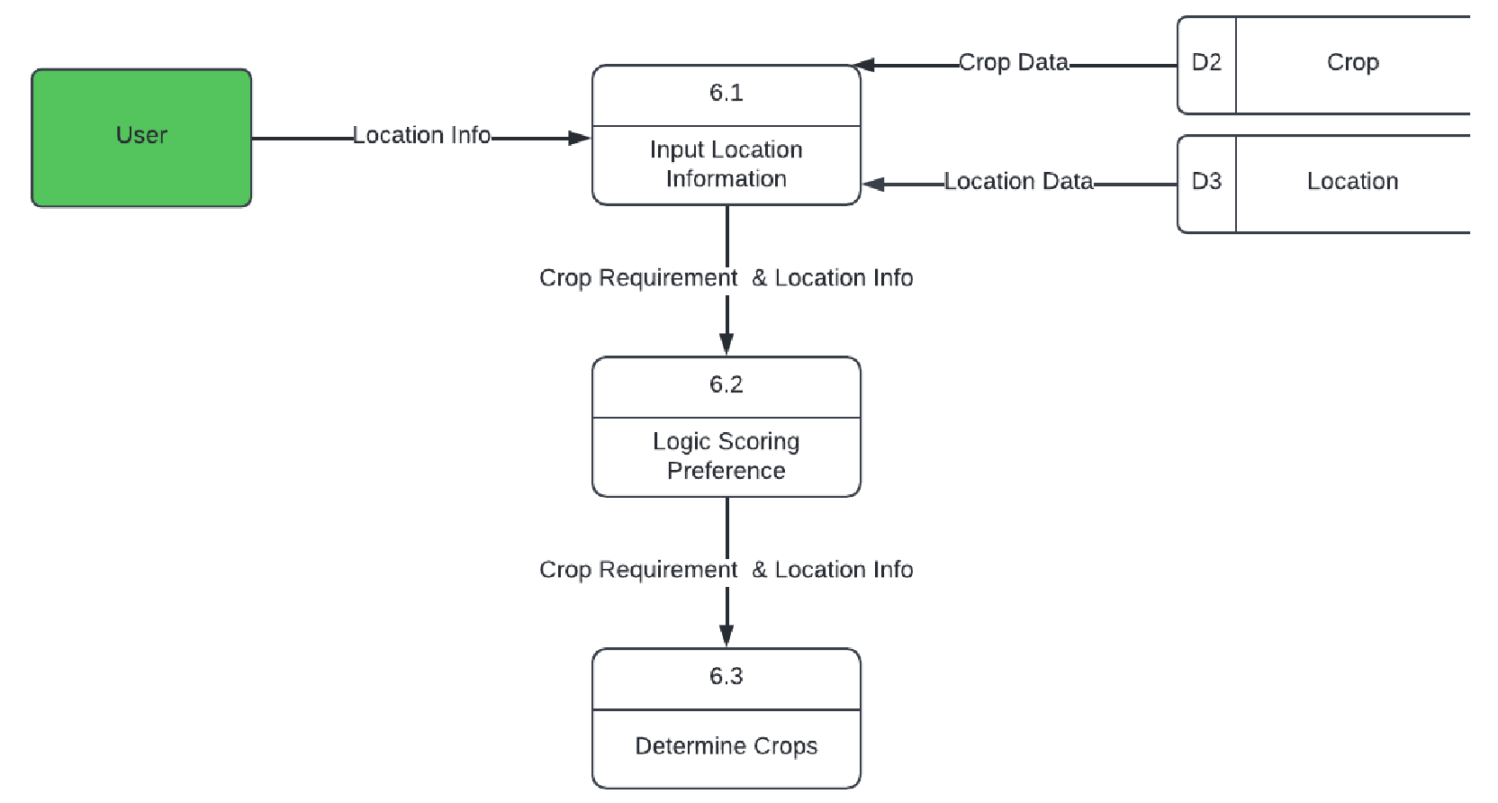

*Figure 8*. Manage Crops Child Diagram

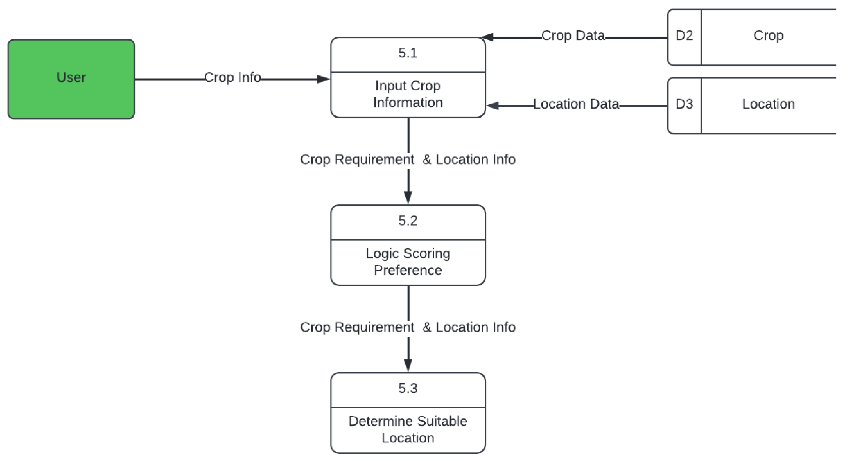

*Figure 9*. Manage Location Child Diagram

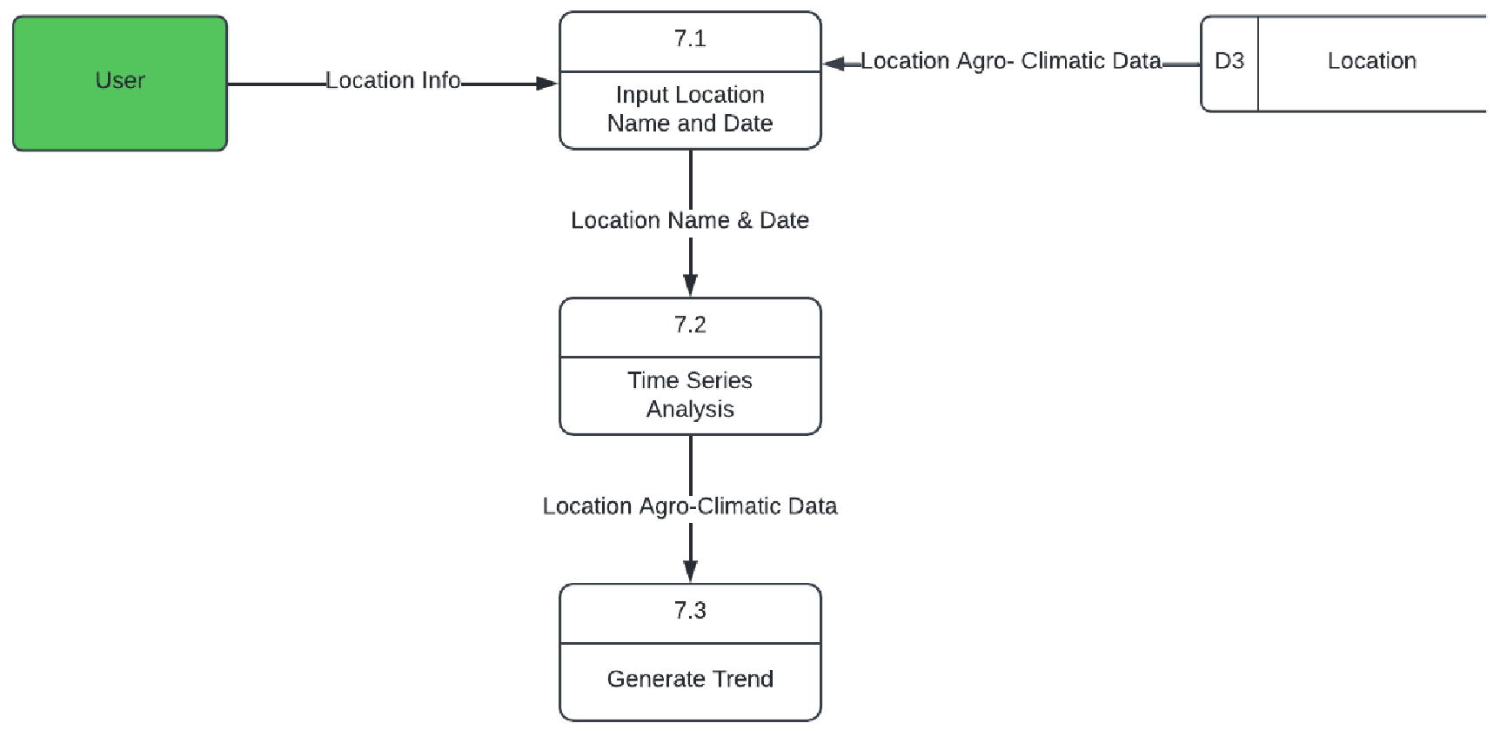

*Figure 10*. Generate Climate Forecast Child Diagram

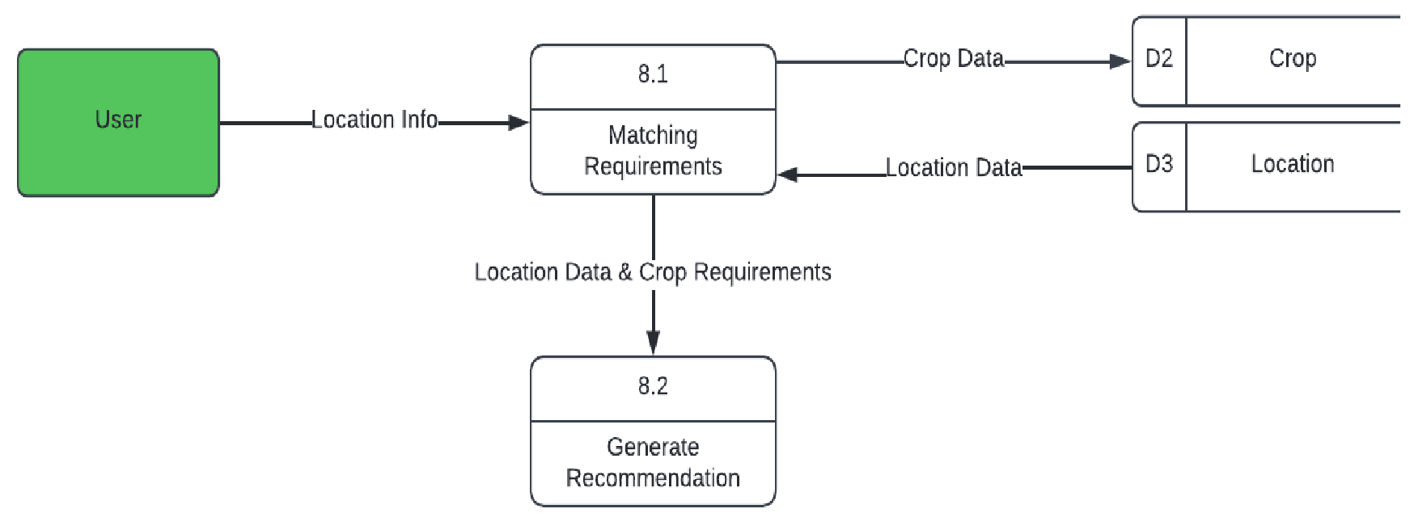

*Figure 11*. Logic Scoring Reference Child Diagram

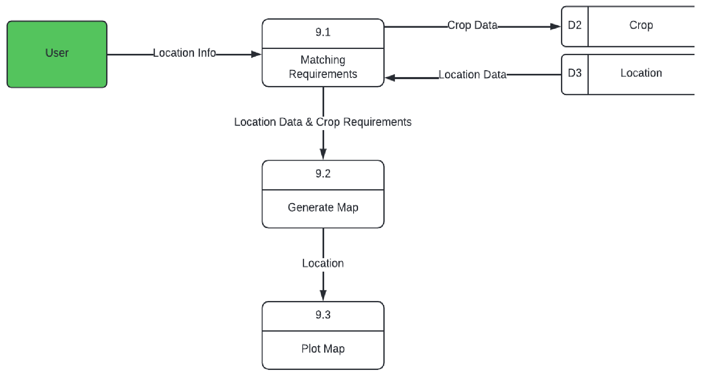

*Figure 12*. GIS Child Diagram

# System Development Life Cycle

The systems development life cycle defines the stages involved to execute the needs of the users from inception to implementation. The development of the system combines the use of the agile development method and the process of data mining. The model consists of seven phases namely: business understanding, data selection, data collection, data preparation, modeling, evaluation, and deployment.

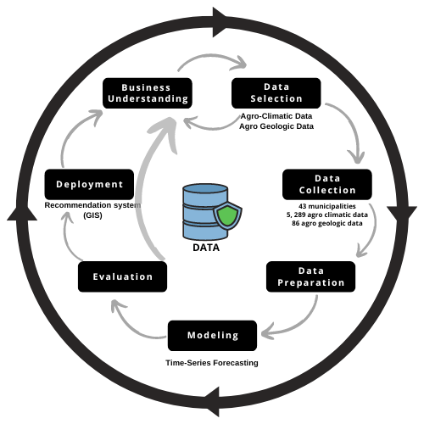

*Figure 13.* System Development Life Cycle

Figure 13 shows the system development life cycle of the Crop Suitability Mapping Using Geographic Information System.

The researchers have identified and observed the target organization, the Department of Agriculture, and agricultural sectors in the Province of Iloilo. The researchers had a better understanding of the potential systems that are needed in the organization.

In the Data Selection and Data Collection phase, the researchers study the potential areas that are significant to crop growth, and these are temperature, rainfall, humidity, soil pH, and elevation. The researchers made use of the World Weather Online, a weather website and collected 5,289 agro-climatic data and 86 agro geologic data with 43 municipalities. With the data gathered, the researchers did a manual input to feed the recommendation system.

In the Data Preparation phase, the researchers separated the data by municipality and analyzed how the user will determine whether the crop is suitable for the location in the certain date, and upon achieving the forecasted data, the researchers used time-series forecasting with three years of historical data that is presented in the modeling phase.

The researchers reviewed and evaluated the technical debt accumulated in early prototyping, improving the implementation to increase stability and maintainability as they finalize the system for deployment.

CHAPTER 4 RESULTS AND DISCUSSION

Implementation

The system was implemented to improve farming methods through low-cost data driven precision farming by recommending suitable crops and location according to agro-climatic and agro- geologic needs of a crop for it to survive. The Provincial Office Administrator will enroll officers and representatives to the site in that way municipal admins may have the access to input all the necessary climate data. Offices are required to have an internet connection to access the site. After setting up all of the requirements, deployment of the system was done to ensure if the system meets its objectives.

The researchers gathered temperature, humidity, and rainfall data or agro-climatic data for three years daily and were loaded into the system. This will allow the forecasting feature of the system to present observations and trends in the future. The system is deployed online in order for the focused users of the system to easily access the website.

For efficient access, the system was hosted and deployed on the Internet through a public domain. The provincial administrator will log in to the website. It has the capacity to enroll new municipal administrators and crops of new variants. Every new municipal administrator, their location’s agro-geologic data, such as soil pH and elevation, are gathered. The municipal administrator can only record the daily climate data of their assigned locations. In the end, the system will use the agro-geologic and agro-climatic data to generate forecasting and a map recommending areas that are suitable for a crop to grow. The system used logic scoring preference to be able to recommend crops to its suitable location, and location with its suitable crops based on their agro-climatic and agro-geologic data.

# Screenshots of the System

The following figures are the screenshots of the system.

Figure 14 shows the Provincial Admin Login Page where they can input the username and password for them to access the website.

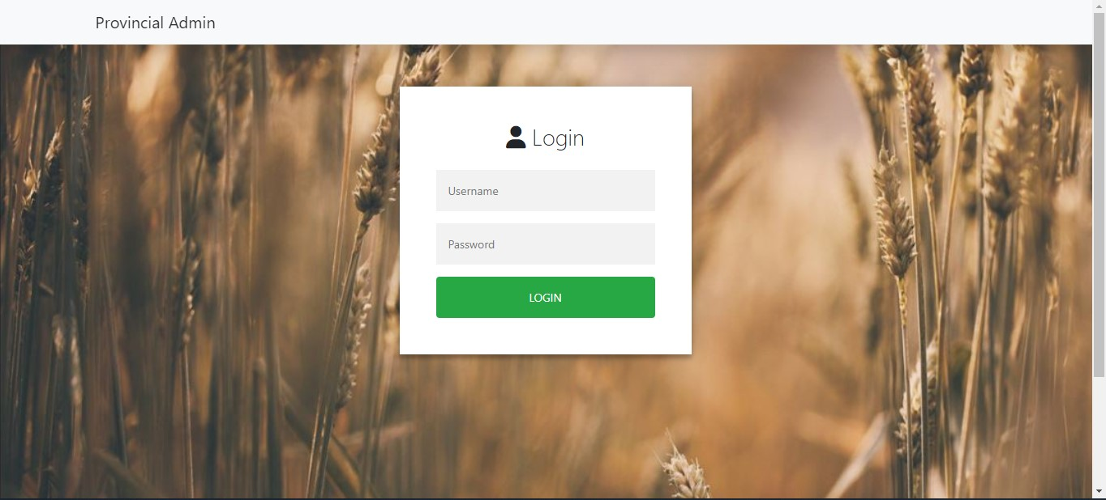

*Figure 14*. Provincial Admin Login Page

Figure 15 shows the list of enrolled municipality admins and their data.

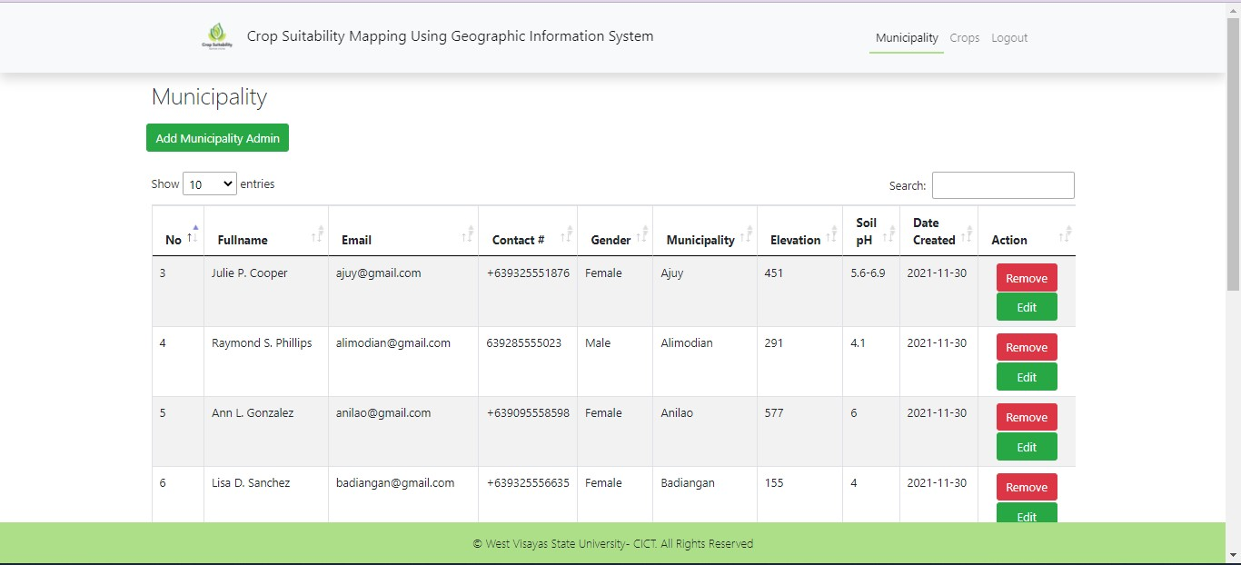

Figure 15. List of Municipal Admins

Figure 16 shows the list of crops enrolled by the Provincial Admin as well as the crop’s requirement to grow.

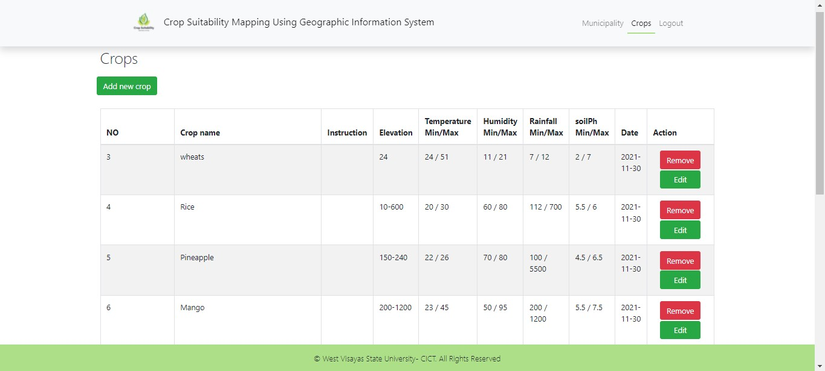

*Figure 16*. List of Crops

Figure 17 and 18 shows the data form. This enables the Provincial Admin to enroll Municipal Admins and crops.

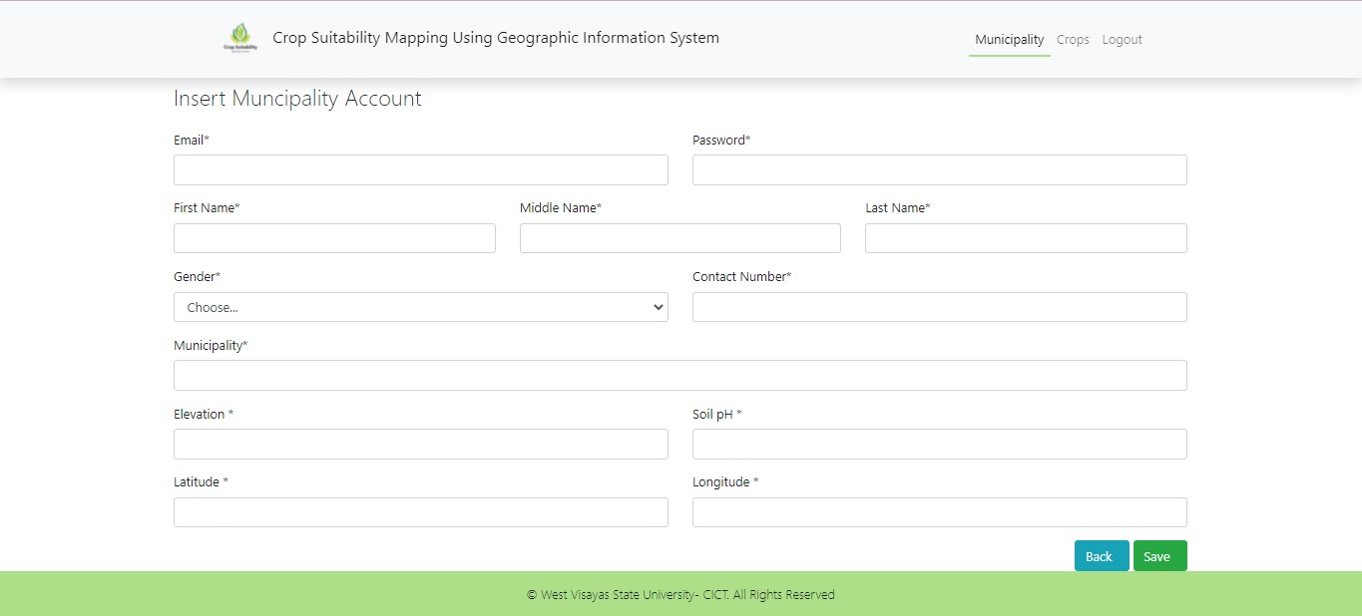

*Figure 17*. Adding of Municipal Admin

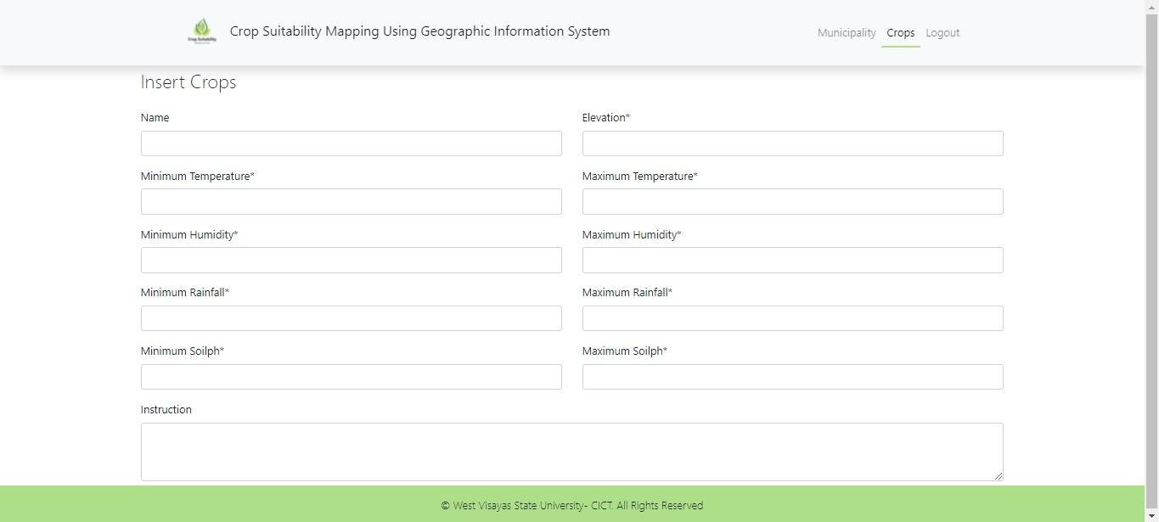

*Figure 18*. Adding Crop Data Form

Figure 19 shows the Municipal Admin Login Page where they can input the username and password for them to access the website.

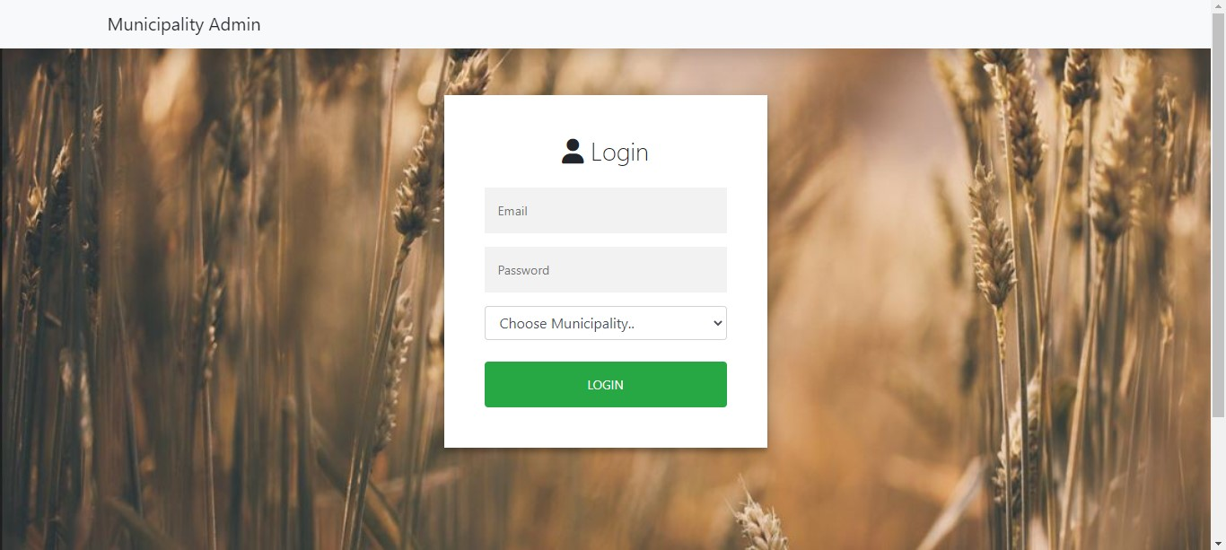

*Figure 19*. Municipal Admin Login Page

Figure 20 shows the agro-climatic data recorded by the municipal admin where users can view the data.

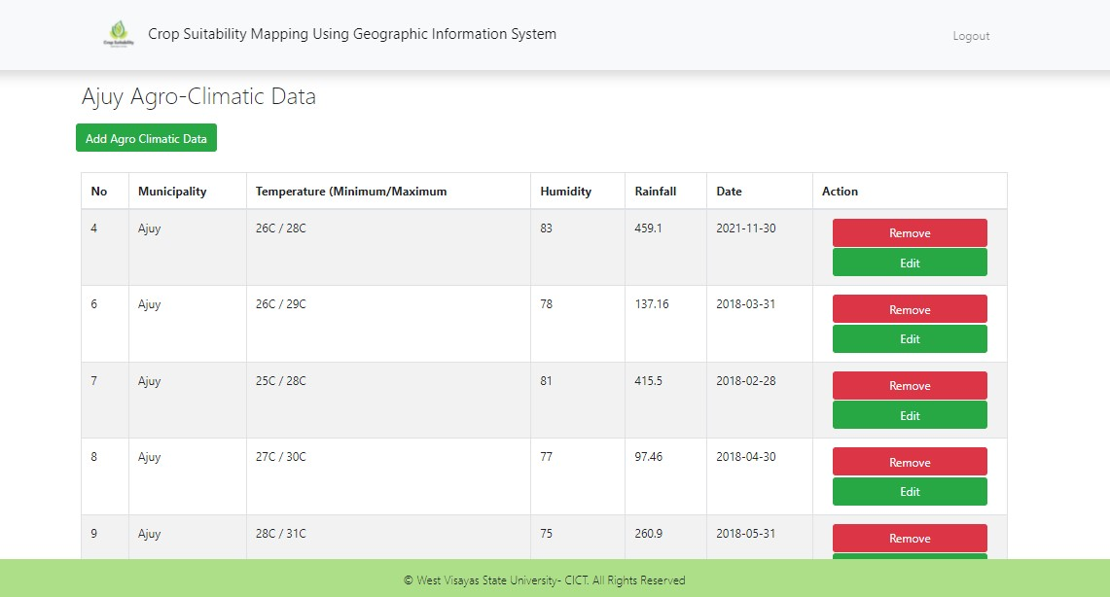

*Figure 20*. Municipality Agro-Climatic Data Page

Figure 21 shows the data form. This enables the Municipal Admin to record its location’s agro-climatic data such as temperature, humidity and rainfall.

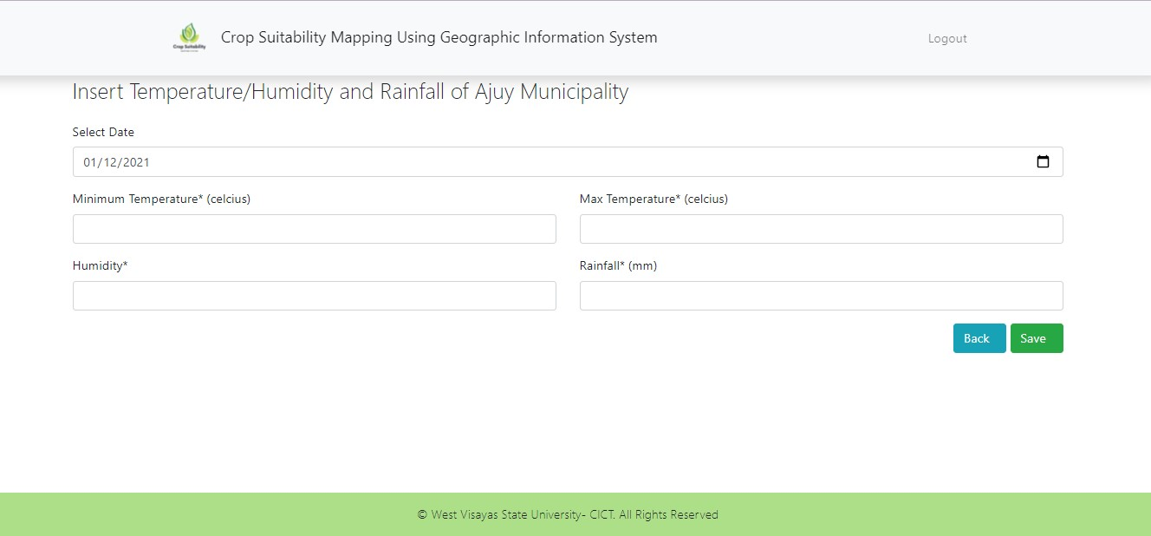

*Figure 21*. Adding Agro-Climatic Data Form

Figure 22 shows the landing page of the website. A brief background of the system is seen and users who will use the system may start by clicking the “Get Started” button.

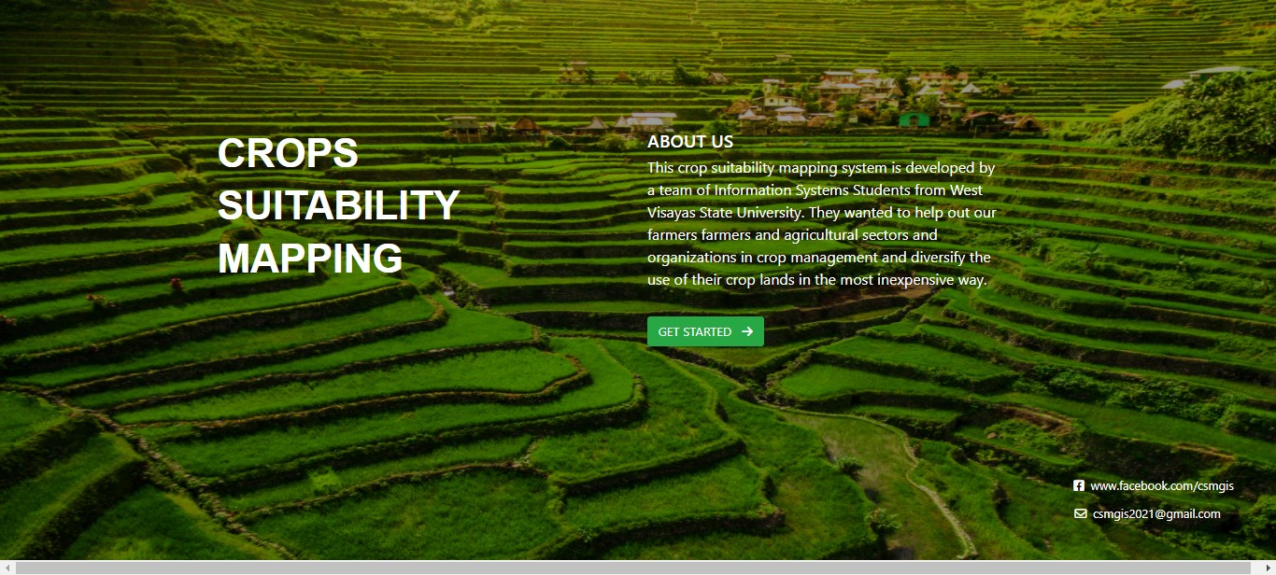

*Figure 22*. Crop Suitability Mapping Homepage

Figure 23 shows the page for recommending location. The page requires users to choose enrolled crops and date of planting to generate a suitable location a crop can grow. Once the user chooses to recommend crops for a location, figure 24 will appear. Here, users are required to select a municipality loaded as a dropbox. Date ranges of the desired location are also collected from the user. The system will display top crops in the left table that are suited within the user’s given parameters for location and date ranges. On the right table is the chosen location’s minimum and maximum temperature, average humidity, and average rainfall. Below the location agro-climatic data table is the map to where the chosen location is situated.

Users are required to choose a municipality and date of planting to be able to generate suitable crops for the location.

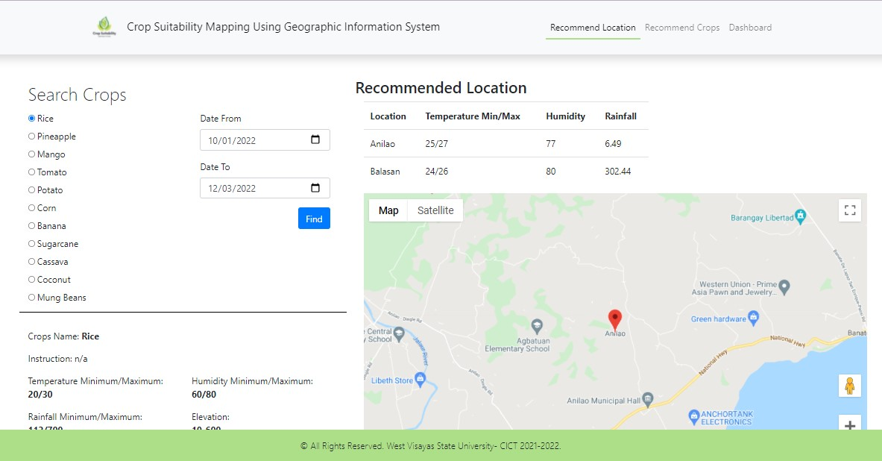

*Figure 23*. Crop Suitability Mapping Page

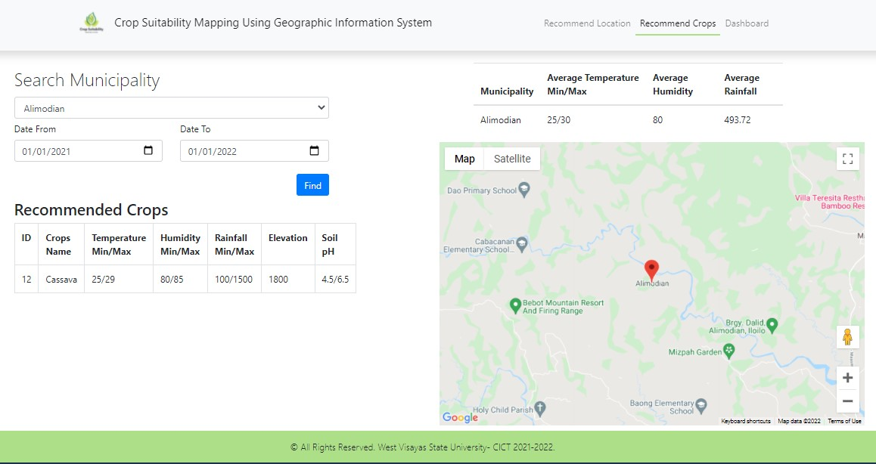

*Figure 24*. Crop Recommendation Page

Lastly, the system will output the forecasted values for agro-climatic data. Figure 25 shows the dashboard for forecasted agro-climatic data of the chosen municipality and date range of the location. The forecasting method used is time series analysis. The system is supplied with three years of agro-climatic data which is manually inputted from worldweatheronline to be able to give observations for forecasting. Historical data is being tested in Microsoft Excel to analyze trends. The data is being smoothed so that it can identify simplified changes in order to help predict different trends and patterns throughout the year. Once the user opens this page, the system requires the user to select a municipality and the date ranges of planting. The system will show trends according through agro-climatic and agro-geologic data calculations through logic scoring. The graph will then show observations for temperature, rainfall, and humidity for the chosen date ranges of the location.

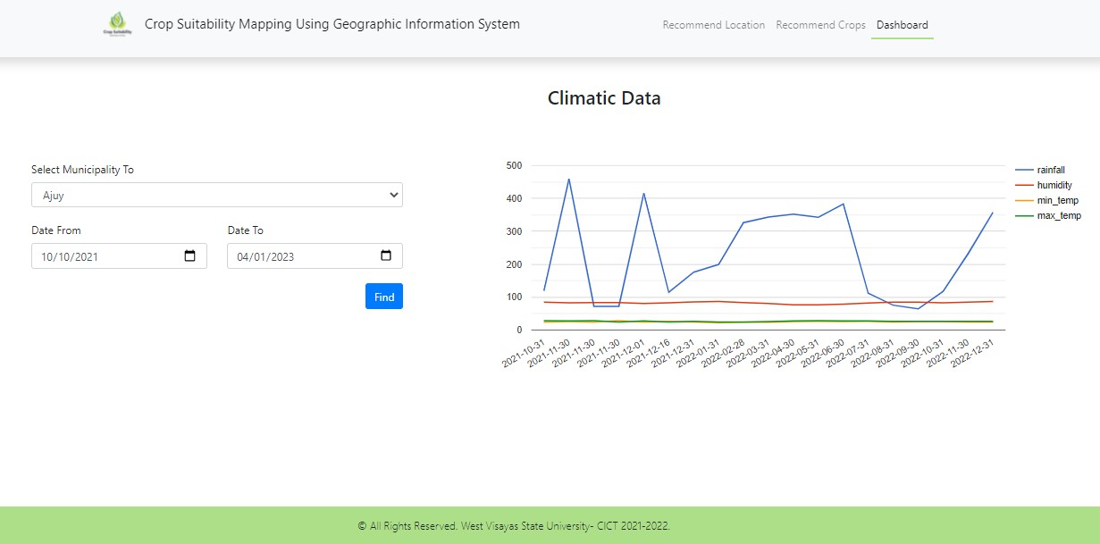

*Figure 25*. Forecasting Page

The dashboard summarizes the agro-climatic data observations within a given time set by the user. From the historical data fed into the system, the dashboard may also illustrate forecast values for agro-climatic data. It has been observed that forecasted temperature, humidity, and rainfall data associates with the trends of the previous years. It highlights which peaks of the year are giving high and low values for agro-climatic data. The dashboard illustrates high temperatures during the second to third quarter of the year, while low to moderate on humidity and rainfall. Low temperatures are experienced in the first and fourth quarter of the year where rainfall and humidity is high.

Results Interpretation and Analysis

Generally, this research aims to develop a web-based system that can provide a crop suitability mapping using geographic information system for the users. The system was implemented for crop management and monitoring changes in agricultural areas based on predetermined crop, soil, and climatic parameters.

In order to deliver efficiency and satisfaction for the users, the researchers developed a recommendation system to easily determine and understand the trends for every crop and location throughout the year. Based on the agro-climatic and agro-geologic data of a crop, the system was able to recommend locations also according to the locations’ agro-climatic data at a certain time of the year, and agro-geologic data through logic scoring preference. It has observed that there are certain crops that may have the capacity to grow on a certain quarter of the year according to its temperature, and humidity and agro-geologic parameters in a certain location, however due to the large amount of rainfall in that period versus the crops’ requirements on the amount for rainfall, the crop is not recommended by the system. Therefore, the system is following the absolute values for agro-climatic and agro-geologic parameters for recommending crops and location. This may also apply if the user is to choose a location to recommend a certain crop at a given period of the year.

The time series forecasting using exponential smoothing is implemented as the forecasting method for the system to understand the seasonality of the data. Through the historical data pre-loaded into the system, it was able to forecast agro-climatic data trends and recommend crops and locations for the next three years. There were seasonal observations on the actual values for agro-climatic data, once the forecasting is applied, it is seen that there are seasonalities to the data given by the forecasting. In the first quarter of the year, temperature slightly increases every month, while rainfall and humidity decreases. In the second and third quarter of the year, temperature and humidity are high, and rainfall increases every month. The last quarter of the year, temperature, humidity and precipitation slowly decreases.

System Evaluation Results

The system is presented to a panel of evaluators related to the field of agriculture and system developers to measure the technicalities and quality of the system. The researchers utilized ISO/IEC 25010 to assess the degree to which the system satisfies the presented requirements of the users and provides function to the research problem.

The criteria for evaluation consists of eight sections which involve the following: Functional Suitability, Performance Efficiency, Compatibility,

Usability, Reliability, Security, Maintainability and Portability. Using a six-point scale, the form comprises thirty-one statements to measure the quality of the system. Evaluators rated each criterion accordingly and the results are compiled into area means.

# Users’ Evaluation

The evaluation showed that in the Functional Stability, the jurors rated functional completeness, functional correctness, and functional appropriateness “very good” with an area mean of 6.0. Performance Efficiency, the jurors rated time behavior, resource utilization, and capacity, “very good”, with an area mean of 5.0. Compatibility, the jurors rated co-existence, and interoperability “very good”, with an area mean of 4.5. Usability, the jurors rated appropriateness, recognizability, learnability, operability, user error protection, user interface aesthetics, and accessibility “very good” with an area mean of 4.67. Reliability, the jurors rated maturity, availability, fault tolerance, and recoverability “very good” with an area mean of 4.92. Security, the jurors rated confidentiality, integrity, non-repudiation, accountability, and authenticity “very good” with an area mean of 5.13. Maintainability, the jurors rate modularity, reusability, analyzability, modifiability, and testability “very good” with an area mean of 4.60. Lastly, for portability, the jurors rated adaptability, installability, and replaceability “very good” with an area mean of 5.13.

**Table 1**

# Evaluation Results for the Proposed System

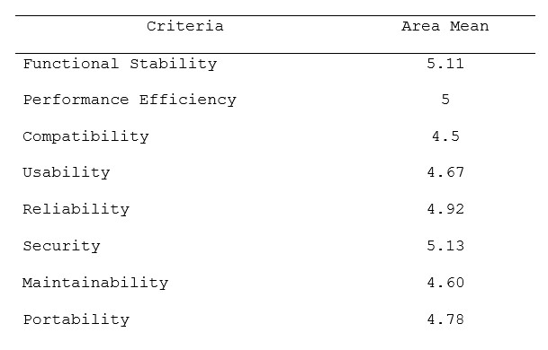

**_____________________________________________**

*Scale.* 6.00-5.20 = Excellent; 5.19-4.30 = Very Good;

4.29-3.50 = Good; 3.49-2.70 = Fair; 2.69-1.80 = Poor;

1.79-1.00 = Very Poor.

CHAPTER 5 SUMMARY, CONCLUSION, AND RECOMMENDATIONS

Summary of the Proposed Study Design and Implementation

This study aimed to develop a web-based system that will provide users with crop suitability mapping using geographic information system. The system can be used for crop management and for monitoring changes in the agricultural areas in terms of the predetermined attributes of crops, soil, and weather.

This study aims to provide the agricultural sector, the farmers, and researchers with improved productivity, efficiency, and effective crop management using geographic information system. The study is limited to the gathering and processing of data including municipal administrator, date, location, agro-climatic and agro geologic data, forecasting of the agro-climatic data to match suitable crops to grow, map that shows the potential agricultural land area suitable for farming and a recommending system for major crops based on area/ municipality.

The recommendation system is based on the location’s agro-climatic and agro-geologic data that will match the crop's requirements for growth. This recommendation system uses Logic Scoring. Logic scoring preference is a general multi-criteria decision-making algorithm widely used in evaluating land capability and suitability for agriculture. Through the numeric agro-climatic data and agro-geologic data gathered by the system, once the data falls into the ranges of the crop requirements and location data, the system automatically recommends which crop or location matches.

The system also can forecast three years worth of agro-climatic data through historical data pre-loaded into the system. The forecasting method used is the time series forecasting method using exponential smoothing. This feature will allow users to see trends for agro-climatic data in their chosen location and time of the year.

Summary of Findings

Crop management has been a renowned problem for most traditional farmers when it comes to planting on their lands. Their decisions are fairly based on repetitive farming done the whole year round. There is a lack of taking advantage of the farmland’s capacity to accommodate various crops based on the crops requirements to grow. Sensor based farming is also a way to improve crop management however development and maintenance are expensive. These advanced devices and precision agriculture and robotic systems allow businesses to be more profitable, efficient, safer, and more environmentally friendly.

The researchers developed a system named “Crop Suitability Mapping Using Geographic Information System” to help improve the integration and support of the Agricultural Offices, such as the Department of Agriculture to agricultural organizations, students, farmland owners, and farmers in crop management and implement data driven decisions for smarter, accurate and inexpensive farming.

This study aims to help farmers and people involved in the agricultural sector to recommend and map a certain location and crop suitable given its factors to survive, and forecast a location’s climate data, to help in the improvement and decision in farming management.

Conclusions

The researchers were able to achieve the objectives set for the study after the evaluation and certain observations were done. The following conclusions were drawn from the results of this study:

A system that collects agro-climatic data (temperature, humidity, and rainfall), and agro-geologic data (soil pH, and elevation of every municipality in the province of Iloilo. Therefore, the system was able to implement a recommendation system through logic scoring preference in matching crops to their suitable location according to its requirements for growth in a given time of the year. The system also was able to forecast agro-climatic data using time series analysis to foresee and recommend crops suitable to be planted at the chosen location and time. The system can be a tool for precision farming at a lower cost and is available to the public. The system is evaluated through the ISO 25010 to determine the quality of the system in terms of its usability, more particularly in effectiveness, efficiency, and satisfaction in assessing and analyzing crop information by developers and the target users of the system.

The system will aid farmers and local agricultural sectors to have a data driven approach in their traditional farming methods. Enhance farming activities by maximizing land usage according to climate and geographic properties of the location to lessen losses and improve costs.

Recommendations

Considering the results previously presented and the conclusion drawn and discussed the following are the recommendations for the improvement of the system.

1. Implement as a mobile application or an adaptive website.

2. Explore various time series forecasting methods.

3. Use a different matching technique to determine suitability for crops to the user’s desired location.

4. Automate weather data collection through APIs or sensors which can automatically feed weather data into the system in real time.

5. Gather location data at a micro scale, such as at barangay level, to heighten accuracy in farming.

6. Scrutinize various requirements for crop growth aside from agro-climatic and agro-geological requirements.

References

*A Review of the Agriculture Sector in Western Visayas | Philippine Statistics Authority*. (2004, November 11).

Https://Psa.Gov.Ph/Content/Review-Agriculture-Sector -Western-Visayas. Retrieved November 23, 2021, from https://psa.gov.ph/content/review-agriculture-sector -western-visayas

AFRI 2019 Annual Review | National Institute of Food and

Agriculture. (2019). National Institute of Food and Agriculture. Retrieved April 16, 2022, from https://nifa.usda.gov/afri-2019-annual-review

Andriesse, E. (2018). Primary Sector Value Chains,

Poverty Reduction, And Rural Development Challenges

In The Philippines. Geographical Review, 108(3),

345–366. https://doi.org/10.1111/gere.12287

Armstrong, L., & Nallan, S., (2016). “Agricultural decision support framework for visualization and prediction of Western Australian crop production.” Retrieved January 15, 2021, from https://ieeexplore.ieee.org/document/7724598/

Biscobing, J. (2019). What is an Entity Relationship Diagram (ERD)? - Definition from WhatIs.com. Retrieved March 15, 2021, from https://searchdatamanagement.techtarget.com/definiti on/entity-relationship-diagram-ERD

Climate Change: In Context (2021). Encyclopedia.com Retrieved March 15, 2021, from https://www.encyclopedia.com/environment/energy-gove rnment-and-defense-magazines/rainfall

Crop Manager. (2021). International Rice Research Institute. Retrieved January 20, 2022, from https://www.irri.org/crop-manager

*Data-Driven Agriculture: The Future of Smallholder Farmer Data* (2018). USAID. Retrieved September 6, 2021, from https://www.usaid.gov/digitalag/documents/data-drive n-agriculture

Department of Agriculture. (2020). *2020 Year-end Report*.

https://www.da.gov.ph/wp-content/uploads/2020/12/202

0-Year-end-RepoFolkGoeddert.pdf

ExploreIloilo.com. (2016, May 13). About Iloilo. Explore Iloilo. Retrieved January 21, 2022, from https://www.exploreiloilo.com/guide/iloilo-profile/

Folk, E. (2018). *How sustainable food production can change developing countries*. The Ecologist. Retrieved August 23, 2021, from https://theecologist.org/2018/jun/12/how-sustainable -food-production-can-change-developing-countries Forecasting - Overview, Methods and Features, Steps. (2020). Retrieved from https://corporatefinanceinstitute.com/resources/know ledge/finance/forecasting/

Fuglie, K. (2016), The growing role of the private sector in agricultural research and development world-wide. Global Food Security. Volume 10. Pages 29-38. ISSN 2211-9124. Retrieved from <https://doi.org/10.1016/j.gfs.2016.07.005>

Geologic Data. (n.d.). Retrieved March 15, 2021, from https://www.lawinsider.com/dictionary/geological-dat a#:~:text=Geological Data

How to use the National Color-Coded Agricultural Guide (NACCAG) Map | Systems-Wide Climate Change Office. (2017, August 2). GOV.PH. Retrieved January 20, 2022, from http://amia.da.gov.ph/index.php/2017/08/02/how-to-us e-the-national-color-coded-agricultural-guide-naccag -map/

Islam, M., Ahamed, T., & Noguchi, R. (2017). Suitability

Mapping for Crop Production Sites Using GIS and Multi-criteria Analysis. Retrieved January 4, 2021, from https://www.researchgate.net/publication/317344483_S uitability_Mapping_for_Crop_Production_Sites_Using_G IS_and_Multi-criteria_Analysis

JavaFX Scene Builder. (n.d.). Retrieved April 2, 2021, from https://www.oracle.com/java/technologies/javase/java fxscenebuilder-info.html

Jury. (n.d.). The Merriam-Webster.Com Dictionary. Retrieved April 20, 2021, from https://www.merriam-webster.com/dictionary/jury

Land suitability mapping. (n.d.). Retrieved April 15, 2021, from https://www.wur.nl/en/project/Land-suitability-mappi ng-1.htm#:~:text=

Learn Java Programming. (n.d.). Retrieved April 20, 2021, from https://www.programiz.com/java-programming

Lena, P. (2021, April 29). *W. Visayas records growth in agri-fishery, forestry in 2020*. Philippine News Agency. https://www.pna.gov.ph/articles/1138481

Mapa, D. (2022, January 26). *Philippine Statistics Authority | Republic of the Philippines*. Philippine Statistics Authority. https://psa.gov.ph/ppa-main/id/165700

Montgomery, B., Dragićević, S., Dujmović, J. ,& Schmidt, M. (2016). “A GIS-based Logic Scoring of Preference method for evaluation of land capability and suitability for agriculture”, Computers and Electronics in Agriculture,Volume 124. 2016. Pages

340-353. ISSN 0168-1699.https://doi.org/10.1016/j.compag.2016.04.0 13.

N. (2021). *Western Visayas tops regions in 2020 agrigrowth*. BusinessWorld Online. https://www.bworldonline.com/western-visayas-tops-re gions-in-2020-agri-growth/

Nabati, J., Nezami, A., Neamatollahi, E., & Akbari, M.

(2020). GIS-Based Agro-ecological Zoning for Crop

Suitability Using Fuzzy Inference System in

Semi-arid Regions. Ecological Indicators, 117, 106646.https://www.sciencedirect.com/science/article

/abs/pii/S1470160X20305835

*National Economic and Development Authority -Region VI Western Visayas*. (2019, April 29). National Economic and Development Authority. https://nro6.neda.gov.ph/western-visayas-economy-gre w-by-6-1-percent-in-2018/

National Geographic Society. (2012). Humidity. Retrieved April 4, 2021, from https://www.nationalgeographic.org/encyclopedia/humi dity/

*New smart farm to help the Philippines achieve sustainable agriculture goals*. (2018). Oxford Business Group. Retrieved August 20, 2021, from https://oxfordbusinessgroup.com/news/new-smart-farmhelp-philippines-achieve-sustainable-agriculture-goa ls

PHP: What is PHP? - Manual. (n.d.). PHP. Retrieved April 22, 2021, from https://www.php.net/manual/en/intro-whatis.php

Philippine Statistics Authority (2020). Palay and corn outlook in iloilo 2018- 2019. Date released: April 2, 2020.

Selvanayagam, T., Suganya, S., Palendrarajah, P., Manogarathash, M., Gamage, A., & Kasthurirathna, D.

(2019). “Agro-Genius: Crop Prediction using Machine Learning.” Retrieved January 2, 2021, from https://ijisrt.com/assets/upload/files/IJISRT19OCT18 80.pdf.pdf

Silvia, P. (2020). Geographic Information Systems.

10.1007/978-3-030-42439-8_6.

Simeon, L. M. (2021). Farm sector likely grew 1% in 2020.

Philstar.Com. Retrieved January 20, 2022,from [https://www.philstar.com/business/2021/01/04/2067915 /farm-sector-likely-grew-1-202](https://www.philstar.com/business/2021/01/04/2067915/farm-sector-likely-grew-1-2020)0.

Tallada, J. (2019). Precision agriculture for rice production in the Philippines. Food and Fertilizer Technology Center for the Asian and Pacific Region. Retrieved January 20, 2022, from <https://ap.fftc.org.tw/article/1416>.

Starting Point-Teaching Entry Level Geoscience (n.d.). Retrieved April 20, 2021, from https://serc.carleton.edu/introgeo/google_earth/goog le_maps.html

Temperature. (n.d.). Retrieved April 4, 2021, from https://www.britannica.com/science/temperature

The Benefits of Web-Based Systems for Business. (2020). Retrieved April 4, 2021, from https://www.aezion.com/blogs/the-benefits-of-web-bas ed-systems-for-business/van

The World Bank (2020). Transforming Philippine Agriculture. Transforming Philippine Agriculture During Covid-19 and Beyond. https://doi.org/10.1596/34012

Tromp (eds.) Sub-Saharan Economic Geology. Geol. Soc. Zimbabwe Spec. Publ. 3, Balkema Publishers, Netherlands, 103-118.

Straaten V., P. & Fernandes, T.R.C. (1995). Agrogeology in Eastern and Southern Africa: a survey with particular reference to developments in phosphate utilization in Zimbabwe. In T.G. Blenkinsop & P.L. Tromp, eds. Sub-Saharan economic geology, pp.

103-118. Geol. Soc. Zimbabwe Spec. Publ. No. 3.

Netherlands, Balkema Publishers.

Vikaspedia Domains. (n.d.). Retrieved March 15, 2021, from https://vikaspedia.in/agriculture/crop-production/we ather-information/agro-climatic-zones-in-india#:~:te xt=Agro-climatic conditions mainly refer,and length of growing period.

Voegele, J. (2018). *How technology can make our food system more sustainable*. ITU News. Retrieved August 22, 2021, from https://news.itu.int/technology-food-system-sustaina ble/

What is GIS? (n.d.). Retrieved April 2, 2021, from https://www.esri.com/en-us/what-is-gis/overview

What is Google Maps API?. (2021). Retrieved April 20, 2021, from https://softauthor.com/what-is-google-maps-api/

What is JavaScript used for? (n.d.). Retrieved April 20, 2021,from https://www.hackreactor.com/blog/what-is-javascriptused-for/

What is MySQL? Everything You Need to Know. (n.d.).

Talend - A Leader in Data Integration & Data Integrity. Retrieved April 21, 2021, from https://www.talend.com/resources/what-is-mysql/

*Weather In Agriculture: A Critical Factor For Farming Success*. (2021, August 17). EARTH OBSERVING SYSTEM. https://eos.com/blog/weather-in-agriculture/#:%7E:te xt=Precise%20Forecasts&text=Accurate%20and%20reliabl e%20reports%20ensure,in%20the%20most%20efficient%20w ay

*Western Visayas Agriculture, Fishery and forestry sector posts fastest growth in the country in 2020 despite* 9.7 percent GRDP contraction. NEDA Region VI. (2021,May 17). Retrieved March 27, 2022, from https://nro6.neda.gov.ph/western-visayas-agriculturefishery-and-forestry-sector-posts-fastest-growth-in-t he-country-in-2020-despite-9-7-percent-grdp-contraction/

Yang, A. (2021, April 28). *Western Visayas tops regions in 2020 agri growth*. BusinessWorld Online.

https://www.bworldonline.com/western-visayas-tops-re gions-in-2020-agri-growth