starckc5

Camille Starck

4/5/2021

## Introduction

An insurance company has 1,000 policies that each have a premium of $2,000. There is a 1.5% chance that a claim will be made for a life insurance payout of $1,000,000. We use a simulation with 10,000 examples to show the company what earnings on each policy might look like for a typical year, and decide whether or not the premium is high enough.

## Analysis

Here we set up the simulation of 10,000 example years with 1,000 policies per year.

# Possible outcomes for each policy  
x <- c(2000, -998000)   
  
# Simulation  
allYears <- replicate(10000, { # 10000 examples  
 # outcomes of 1000 policies  
 sampleYear <- sample(x, 1000, prob=c(.985,.015), replace = TRUE)   
 # net profit of all the 1000 policies  
 sum(sampleYear) } )

The net profit per year is calculated by summing the earnings of all 1,000 policies. The following are a few sample net profits of the 10,000 example years.

## [1] -1.4e+07 -6.0e+06 -1.6e+07 -1.4e+07 -1.7e+07 -1.7e+07

Next, we calculate the average yearly earnings on 1,000 policies.

## [1] -13067200

Finally, we calculate the expected earnings per policy.

## [1] -13000

## Visualization

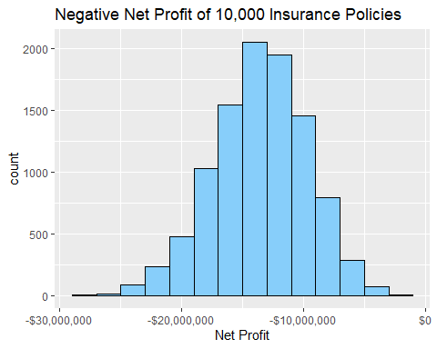

## Conclusion

From the histogram and the analysis, we can see that in a simulation with 10,000 example years and 1,000 policies per year, the insurance company will consistently lose money. More often than not, the company will lose millions of dollars per year. The company should increase the premium to avoid negative net profit.