MTE 203 - Advanced Calculus

Project 2

Multiple Integration

Name: Camille Walters

Student ID: 20716280

December 2, 2019

Section 1: Summary of Analysis

**1a)** To plot the body and neck, the fsurf function was used. The constants were declared at the top of the program, then the equation of a sphere was plotted:

$$x=\sqrt{R^{2}-x^{2}-y^{2}}$$

Next, the equation of an elliptic cone was rearranged to plot the neck on the same plot:

$$z=\sqrt{x^{2}+y^{2}}tanϕ$$

The cone needed to be offset for it to be visible above the plot. The cone was plotted at $z+R-D-\sqrt{R^{2}-{\left(R-D\right)}^{2}}tanϕ$. To cut off the top of the cone, the zlim function was used. The upper cut-off point was at $Htanϕ+R-D-\sqrt{R^{2}-{\left(R-D\right)}^{2}}tanϕ$. The justification for these values can be seen in the image below:

The plots of the two cases can be seen below:

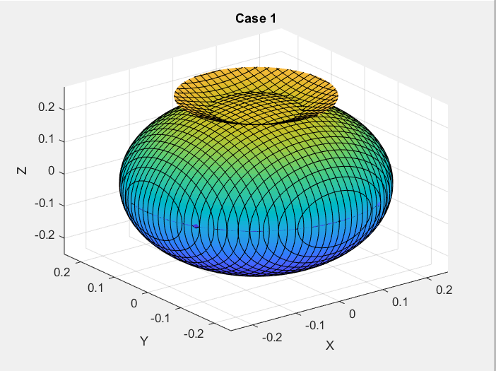

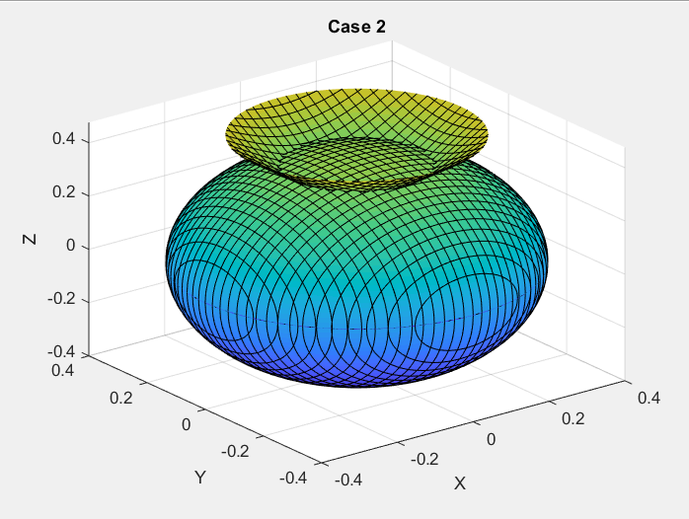

Following is the Matlab code for this section:

syms x y

axis equal

z=sqrt(R^2-x^2-y^2);

fsurf(z)

hold on

fsurf(-z);

hold on

z=sqrt(x^2+y^2)*tan(PHI*pi/180);

fsurf(z+R-D-(sqrt(R^2-(R-D)^2)*tan(PHI*pi/180)));

UL=H*tan(PHI*pi/180);

zlim([-R H*tan(PHI*pi/180)+R-D-(sqrt(R^2-(R-D)^2)*tan(PHI*pi/180))]);

hold on;

**1b)** To find the volume of the body, the volume of the solid sphere was found, then the negative space was subtracted. This was calculated in just the positive octant, then multiplied by 8 to give the volume of the full sphere.

$$8\left(\int_{0}^{π/2}{\int_{0}^{R}{\int_{0}^{\sqrt{R^{2}-r^{2}}}{rdzdrdθ}}}-\int_{0}^{π/2}{\int_{0}^{R-T}{\int_{0}^{\sqrt{{(R-T)}^{2}-r^{2}}}{rdzdrdθ}}}\right)$$

Where R is the radius of the body and T is the thickness of the hollow sphere. To find the volume of the head was calculated similarly to the body. Since it is half of a sphere, it was multiplied by 4 instead of 8.

$$4\int_{0}^{π/2}{\int_{0}^{H}{\int_{0}^{\sqrt{H^{2}-r^{2}}}{dzrdrdθ}}}$$

Where H is the height of the head. To find the volume of the neck, a truncated cylinder is used. We must first find the height of the upper bound.

This is given as $Htanϕ$. Next, using similar triangles, $C_{2}=\sqrt{R^{2}-{\left(R-D\right)}^{2}}tanϕ$. Thus, we get the following integral:

$$\int_{0}^{2π}{\int_{\sqrt{R^{2}-{\left(R-D\right)}^{2}}tanϕ}^{Htanϕ}{\int_{0}^{z/tanϕ}{rdrdzdθ}}}$$

To calculate the volume of the socket, the volume was found of the upper cap of the body. Thus, the radius was isolated based on this location from the top of the sphere, giving $\sqrt{R^{2}-{\left(R-D\right)}^{2}}$. The equation of the integral is:

$$\int_{0}^{2π}{\int_{0}^{\sqrt{R^{2}-{\left(R-D\right)}^{2}}}{\int_{R-D}^{\sqrt{R^{2}-r^{2}}}{rdzdrdθ}}}$$

Finally, the total volume was found by adding the volumes of the body, head and neck and subtracting the volume of the socket. The Matlab code for this section is:

syms r theta z real

%solving for body volume

Pi=sym('pi');

I1=int(r,z,0,sqrt(R^2-r^2));%z integral outer

I2=int(I1,r,0,R);%r integral outer

I3=int(I2,theta,0,Pi/2);%theta integral outer

I4=int(r,z,0,sqrt((R-T)^2-r^2));%z integral inner

I5=int(I4,r,0,R-T);%r integral inner

I6=int(I5,theta,0,Pi/2);%theta integral iner

IBod=8*(I3-I6)

volBody=double(IBod)

%solving for head volume

I7=int(r,z,0,sqrt(H^2-r^2));%z integral

I8=int(I7,r,0,H);%r integral ne

I9=int(I8,theta,0,Pi/2);%theta integral

IHead=4*I9

volHead=double(IHead)

%solving for neck volume

I10=int(r,r,0,z/tan(PHI*pi/180));

I11=int(I10,z,sqrt(R^2-(R-D)^2)*tan(PHI*pi/180),H*tan(PHI*pi/180));

I12=int(I11,theta,0,2*Pi)

volNeck=double(I12)

%solving for socket volume

I13=int(r,z,R-D,sqrt(R^2-r^2));

I14=int(I13,r,0,sqrt(R^2-(R-D)^2));

I15=int(I14,theta,0,2*Pi)

volSock=double(I15)

%solving total volume

Vtotal=volBody+volHead+volNeck-volSock

**1d)** By looking at the graphs, Case 1 appears to be more stable for the head. Since the neck is shorter compared to the size of the body, the center of mass of the head will be lower, and will thus be more stable. Moreover, the radius of the head is smaller compared to the body in Case 1, so the head will have less mass compared to the body. This way, the head is less likely to cause instability to the whole system.

**2a)** Since this is a composite body, the center of mass of BB-8 can be calculated as follows:

$$\frac{\sum{Mass Moment of Inertia}}{\sum{Mass}}$$

The center of mass will be calculated from the center of the body sphere. First, the mass moment of inertia and mass of the head need to be calculated. For the z coordinate of the center of mass, first the center of mass is calculated from the bottom of the head. Since $z=rsinθ$, the following equation is used to find the x coordinate of the center of mass:

$$\tilde{x_{H}}=\frac{\int_{0}^{π}{\int_{0}^{H}{ρr^{2}sinθdrdθ}}}{\int_{0}^{π}{\int_{0}^{H}{ρrdrdθ}}}$$

Once this has been calculated, this is added to the distance from the center of the sphere to the bottom of the head. This distance is:

$$R-D+\left(\frac{H}{2}-\sqrt{R^{2}-{\left(R-D\right)}^{2}}\right)tanϕ$$

From symmetry, the x coordinate of the center of mass is 0. The Matlab code can be found below:

I22=int(r*density,r,0,H);

I23=int(I22,theta,0,pi);

MassHead=double(I23)

zBar=double((I17/I23)+(R-D)+(H/2-sqrt(R^2-(R-D)^2))*tan(PHI*pi/180))

Next, the center of mass of the counterweight and the body is calculated with the following equations:

$$\tilde{x_{B}}=\frac{D_{H}×50}{Mass of Body+50}$$

$$\tilde{y_{B}}=\frac{D_{V}×50}{Mass of Body+50}$$

Finally, the center of mass of BB-8’s body can be calculated. The following equations are used:

$$\overline{x}=\frac{\tilde{x_{B}}×(Mass of Body+50)}{Mass of Body+50+Mass of Head}$$

$$\overline{y}=\frac{\left(\tilde{x_{B}}×\left(Mass of Body+50\right)\right)+(\tilde{x_{H}}+Mass of Head)}{Mass of Body+50+Mass of Head}$$

The Matlab code can be found below:

massBody=volBody*325;

%Case 1 (ensure that case 1 values are uncommented above)

xBarBody1=-0.225*50/(massBody+50)

zBarBody1=-0.1*50/(massBody+50)

xBarTotal1=(xBarBody1*(massBody+50))/(massBody+50+MassHead)

zBarTotal1=(zBarBody1*(massBody+50)+zBar*MassHead)/(massBody+50+MassHead)

%Case 2 (ensure that case 2 values are uncommented above)

xBarBody2=-0.375*50/(massBody+50)

zBarBody2=-0.125*50/(massBody+50) xBarTotal2=(xBarBody2*(massBody+50))/(massBody+50+MassHead) zBarTotal2=(zBarBody2*(massBody+50)+zBar*MassHead)/(massBody+50+MassHead)

**2c)** Using the fact that $T=F×D$, we will multiply the forces by the *perpendicular* distance from the center of mass. From the diagram below, the following equation for torque is derived:

$$T=N×\overline{x}-F×\left(R-\overline{y}\right)$$

$$T=N×\overline{x}-μN×\left(R-\overline{y}\right)$$

$$T=(Total Mass×9.81)×\overline{x}-μ(Total Mass×9.81)×\left(R-\overline{y}\right)$$

It is important to note that the absolute value of the coordinates of the center of mass must be used, since the value of the coordinates might be negative. The Matlab code can be found below:

NetTorque1=(massBody+50+MassHead)*9.81*abs(xBarTotal1)-0.25*((massBody+50+MassHead)*9.81*(R-abs(zBarTotal1)))

NetTorque2=(massBody+50+MassHead)*9.81*abs(xBarTotal2)-0.25*((massBody+50+MassHead)*9.81*abs(R-abs(zBarTotal2)))

Section 2: Summary of Results

**Summary of Values**

Note: Values of center of mass use center of body as origin.

|  |  |  |
| --- | --- | --- |
|  | **Case 1** | **Case 2** |
| **R(m)** | 0.250 | 0.4 |
| **h(m)** | 0.150 | 0.275 |
| **d(m)** | 0.015 | 0.035 |
| $$ϕ(°)$$ | 30 | 45 |
| **Volume of Body [m^3]** | 0.0145 | 0.0382 |
| **Volume of Head [m^3]** | 0.0071 | 0.0436 |
| **Volume of Neck [m^3]** | 0.0017 | 0.0172 |
| **Volume of Socket[m^3]** | 1.731e-4 | 0.0015 |
| **Total volume [m^3]** | 0.0230 | 0.0975 |
| $\overline{x}$**body[m]** | 0 | 0 |
| $\overline{y}$**body[m]** | 0 | 0 |
| $\overline{z}$**body[m]** | 0 | 0 |
| $\overline{x}$**head[m]** | 0 | 0 |
| $\overline{y}$**head[m]** | 0 | 0 |
| $\overline{z}$**head[m]** | 0.2927 | 0.4556 |
| $\overline{x}$**total[m]** | 0 | 0 |
| $\overline{y}$**total[m]** | -0.1770 | -0.2035 |
| $\overline{z}$**total[m]** | -0.0380 | 0.0790 |
| **Body torque output[N*m]** | 77.3219 | 111.4173 |

**1b)** These values make realistic sense. The y value of the center of mass is only influenced by the counterweight. Since the horizontal distance of the counterweight is higher in case 2, the value is higher. For the z value, since the size (and thus mass) of the head is larger compared to the body in case 2, and the head is situated in the positive z direction of BB-8, it makes sense that this value is larger. As discussed in part 1d), the larger values of the center of mass lead to less stability in this case.

**1e)** Case 1 was considered for this question. A torque of 77.3219 Nm was required, with 1000 RPM. Due to the size of BB-8, a trade-off was required between having a large enough torque and fitting inside BB-8’s body. Since BB-8 can still operate with a lower torque, fitting inside BB-8 was given higher priority. The Teco AESV2E/AESU2E motor with frame sizes 160 L and 132M models were considered. Frame size 160L provides a torque of 93.61 Nm with 1765 RPM. The length is 0.653 m, the height is 0.477 m and the width is 317 m. This is too large to fit into BB-8. Frame size 132M provides a torque of 48.98 Nm with 1460 RPM. The length is 0.504 m, the height is 0.348 m and the height is 0.216 m. This fits better into BB-8’s body and thus is the better choice of motor.

Appendix-Teco AESV2E/AESU2E Motor Specifications

