**Installation Instructions:**

1. Download Eclipse and install Maven & TestNG.
2. Set System Environment Variables (Add M2_Home and JAVA_HOME)
3. Import Maven project jar
4. Search for the XML test suite, execute and explore.

**Step by Step guide:**

* Set Environment Variables (Add M2_Home and JAVA_HOME)

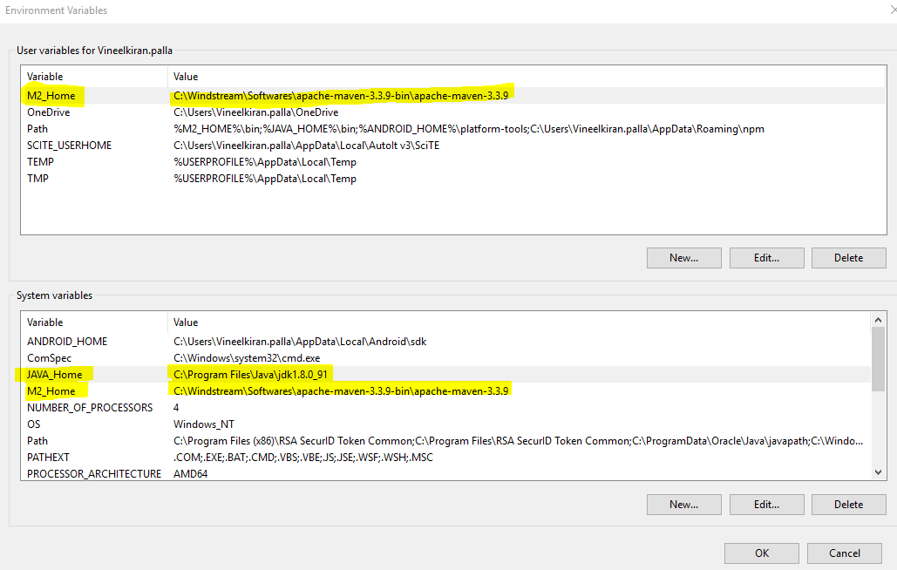

* Import Maven project jar

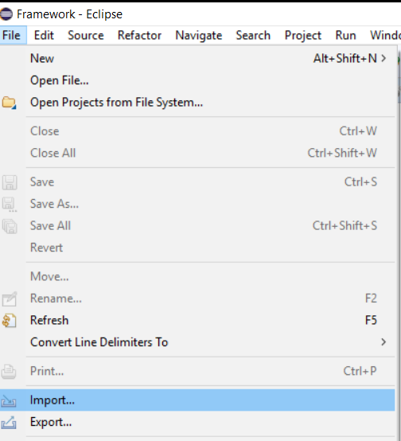

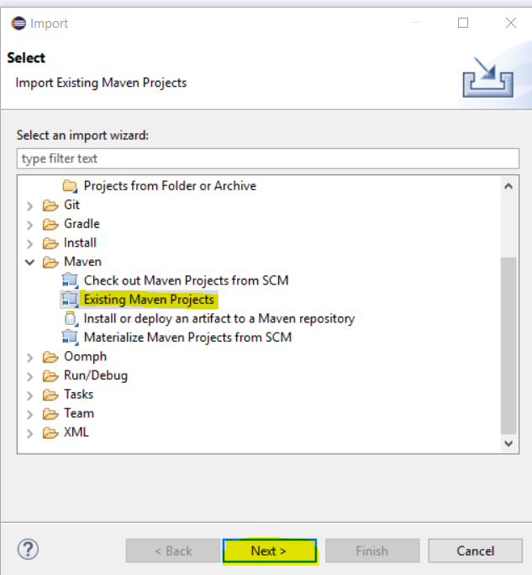

* Select project path

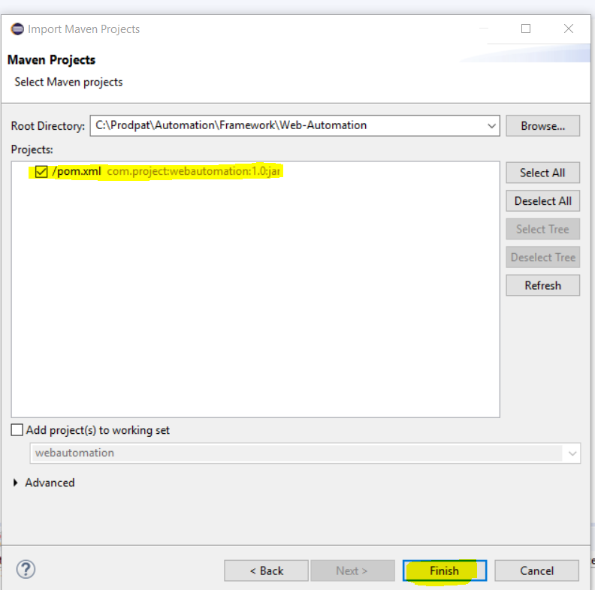

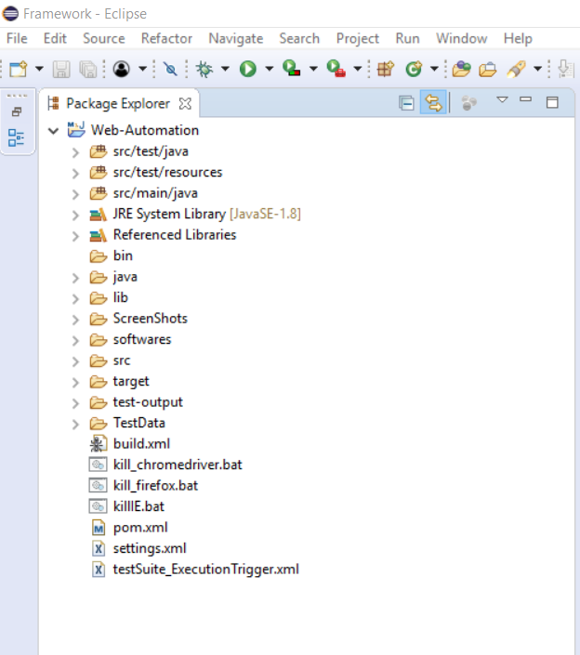

* Refer “**testSuite_ExecutionTrigger.xml**”

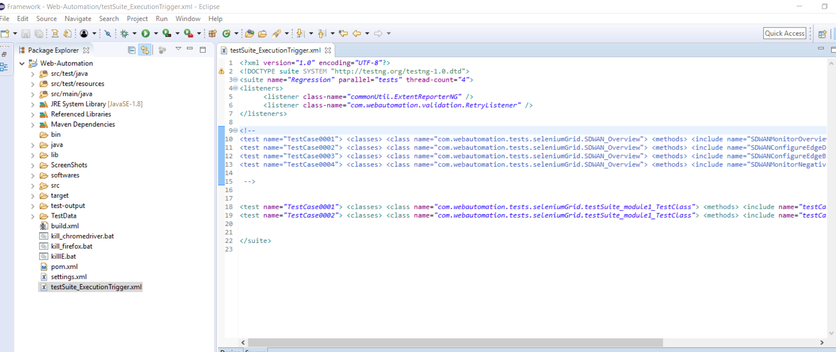

* Press “**Ctrl+Shift+R”** and search for **config.properties,** if required you can change the URL and browser values accordingly.

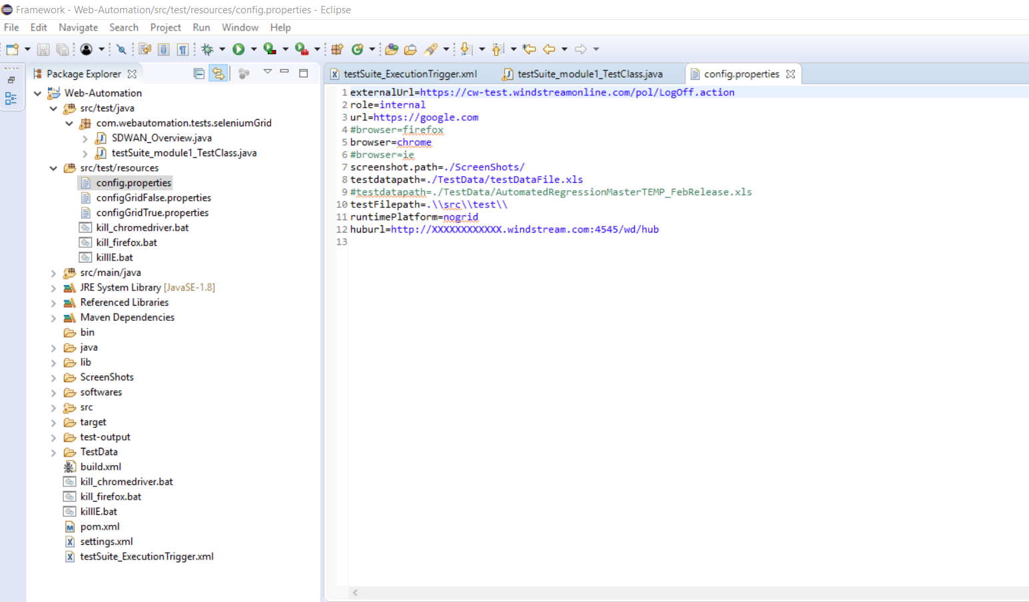

* Press “**Ctrl+Shift+R”** and search for **testSuite_module1_TestClass,** and explore the Test Class and Page Objects.

