13.27 Write a simple program that can read a host name and convert it to an IP address.

Clase Ejercicio27.java

package co.ejercicios.e27;

/*
* Write a simple program that can read a host
* name and convert it to an IP address.
*
* Escriba un programa simple que pueda leer un
* host name y convertirlo en una direccion IP
*
*/

import java.net.InetAddress;
import javax.swing.JOptionPane;

public class Ejercicio27 {
public static void main(String[] args) {

String hostName = JOptionPane.showInputDialog("Favor ingrese el host name");

try {

InetAddress address = InetAddress.getByName(hostName);
String ip = address.getHostAddress();

JOptionPane.showMessageDialog(null, "Host Name: " + hostName + "\nIP: " + ip);

} catch (Exception e) {
e.printStackTrace();
}

}
}

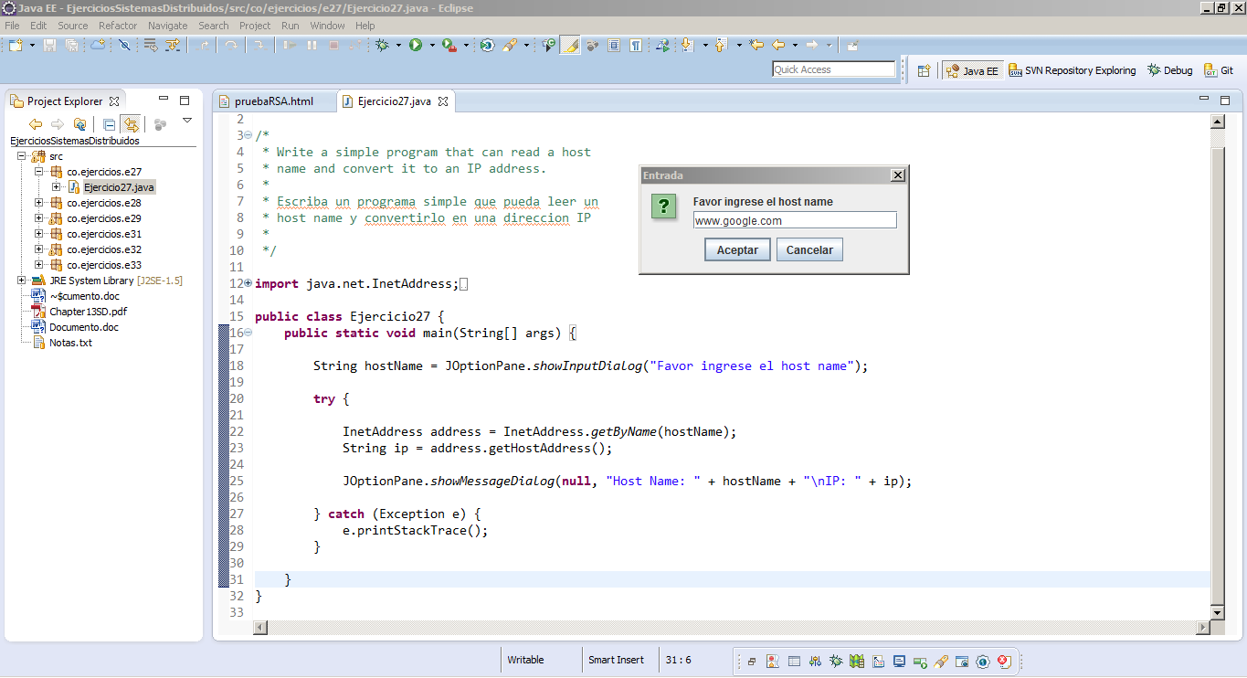

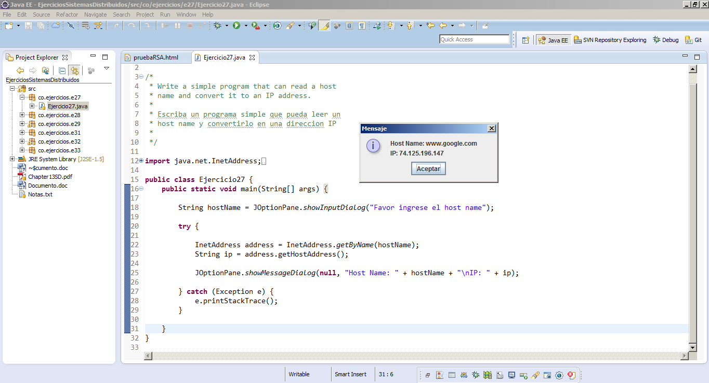

13.28 Write a URL-based program that pulls content from www.buyya.com.

Clase Ejercicio28.java

package co.ejercicios.e28;

/*
* Write a URL-based program that pulls content from www.buyya.com.
*
* Escriba un programa basado en URL que muestre contenido
* de una pagina web
*
*/

import java.io.*;
import java.net.*;

import javax.swing.JOptionPane;

public class Ejercicio28 {

public static void main(String[] args) {

String consultaPagina = JOptionPane.showInputDialog("Ingrese la página a consultar");

try {

URL url = new URL(consultaPagina);
URLConnection urlConnection = url.openConnection();

InputStream is = urlConnection.getInputStream();
BufferedReader br = new BufferedReader(new InputStreamReader(is));

String linea = null;
String pagina = "";

while ((linea = br.readLine()) != null)
pagina += linea + "\n";

JOptionPane.showMessageDialog(null, pagina);

} catch (Exception e) {
e.printStackTrace();
}
}

}

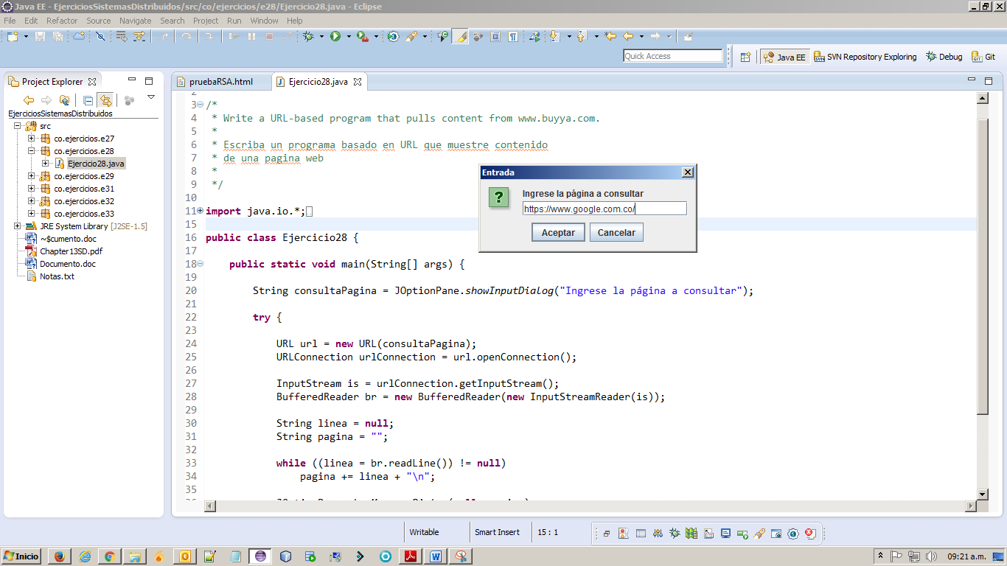

13.29 Write a ping-pong client and server application. When a client sends a ping message to the server, the server will respond with a pong message. Other messages sent by the client can be safely dropped by the server.

Clase Cliente.java

package co.ejercicios.e29;

import java.io.DataInputStream;
import java.io.InputStream;
import java.net.Socket;

/*
* Write a ping-pong client and server application.
* When a client sends a ping message to the server,
* the server will respond with a pong message.
* Other messages sent by the client can be safely
* dropped by the server.
*
* Escriba un "ping-pong" cliente/servidor, cuando
* el cliente envie un mensaje al servidor, el
* servidor debera responder con un mensaje.
*
*/

public class Cliente {

static final String HOST = "localhost";
static final int Puerto = 6000;

public Cliente() {

try {

System.out.println("Programa cliente.");

Socket skCliente = new Socket(HOST, Puerto);
ConexionSocket cn = new ConexionSocket(skCliente, this.getClass().getSimpleName(), false);
cn.start();

} catch (Exception e) {

}
}

public static void main(String args[]) {
new Cliente();
}

}

Clase Servidor.java

package co.ejercicios.e29;

import java.net.ServerSocket;
import java.net.Socket;

/*
* Write a ping-pong client and server application.
* When a client sends a ping message to the server,
* the server will respond with a pong message.
* Other messages sent by the client can be safely
* dropped by the server.
*
* Escriba un "ping-pong" cliente/servidor, cuando
* el cliente envie un mensaje al servidor, el
* servidor debera responder con un mensaje. O
*
*/

public class Servidor {
static final int PUERTO = 6000;

public Servidor() {
try {

System.out.println("SERVIDOR, Escucho el puerto " + PUERTO);

ServerSocket skServidor = new ServerSocket(PUERTO);

while(true){
Socket skCliente = skServidor.accept();
ConexionSocket cn = new ConexionSocket(skCliente, this.getClass().getSimpleName(), true);
cn.start();
}

} catch (Exception e) {
System.out.println(e.getMessage());
}
}

public static void main(String[] arg) {
new Servidor();
}

}

Clase ConexionSocket.java

package co.ejercicios.e29;

import java.io.DataInputStream;
import java.io.DataOutputStream;
import java.io.IOException;
import java.net.Socket;
import java.util.Scanner;

public class ConexionSocket extends Thread {

private Socket socket;
private DataInputStream entradaDatos;
private DataOutputStream salidaDatos;

private boolean conectado = true;
private boolean hablar = true;

private String rol;

public ConexionSocket(Socket socket, String rol, boolean hablar) {

this.socket = socket;
this.hablar = hablar;
this.rol = rol;

try {
entradaDatos = new DataInputStream(socket.getInputStream());
salidaDatos = new DataOutputStream(socket.getOutputStream());
} catch (IOException e) {
e.printStackTrace();
}

}

@Override
public void run() {

while (conectado) {

try {

if (hablar) { // Enviar Mensaje

salidaDatos.writeUTF( leerTeclado() );
hablar = false;

} else { // Escuchar

System.out.println("Esperando respuesta...");
System.out.println( "Msg Recibido: " + entradaDatos.readUTF() );
hablar = true;
}

} catch (IOException e) {

conectado = false;

try {
entradaDatos.close();
salidaDatos.close();
socket.close();
} catch (IOException e1) {
e1.printStackTrace();
}

System.out.println("Termino la comunicacion.");
}

}

}

private String leerTeclado(){

System.out.println (rol + ", que mensaje vas a enviar?");
String entradaTeclado = "";
Scanner entradaEscaner = new Scanner (System.in);
entradaTeclado = entradaEscaner.nextLine ();

return entradaTeclado;
}

}

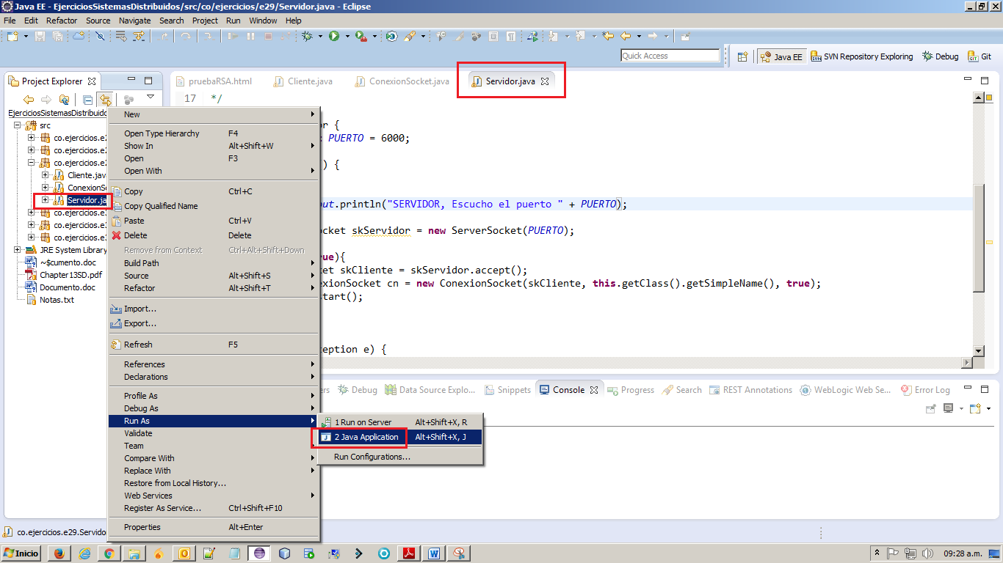

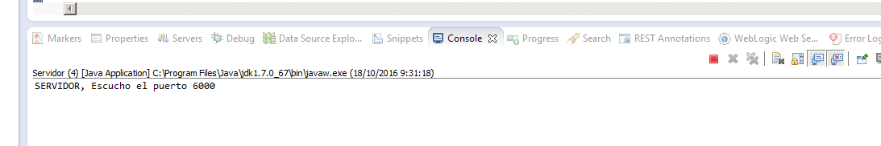

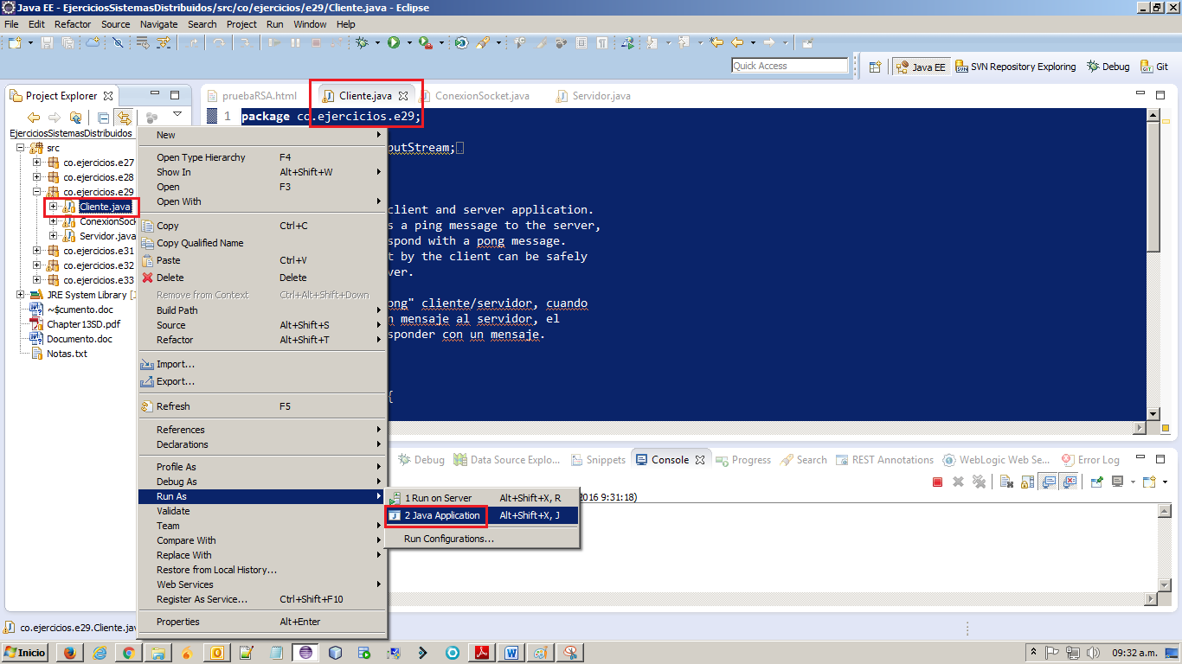

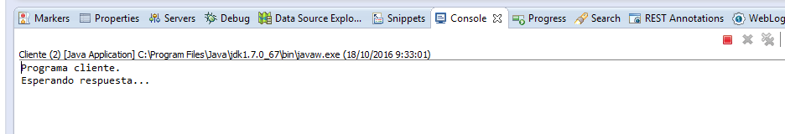
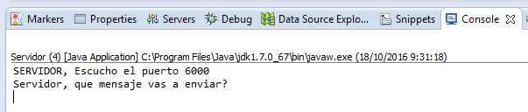

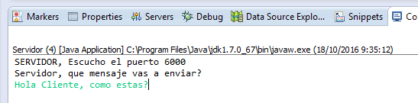

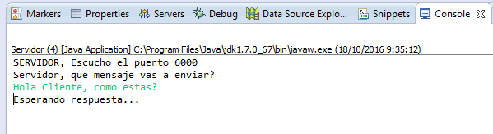

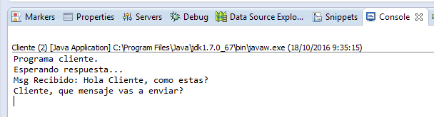

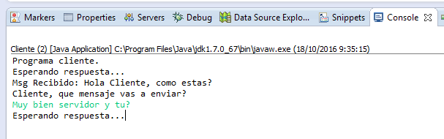

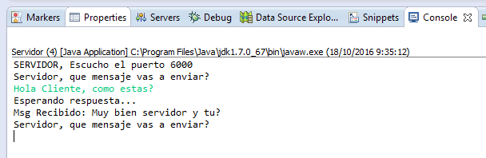

13.30 Rewrite the math server application, instead of using the TCP socket, use the UDP datagram socket.

13.31 Write an online dictionary application, users are able to search online dictionary and get the meaning of the words. The online dictionary should maintain its indexing in order to enhance the performance and scalability.

13.32 Write a simple crawler program that can parse certain HTML information and fi nd out the hyperlinks within the HTML. (Use the URLConnection class to implement this application).

13.33 Write a Socket-based Java server program that responds to client messages as follows: When it receives a message from a client, it simply converts the message into all uppercase letters and sends back the same to the client. Write both client and server programs demonstrating this

