GUÍA DEL PROFESOR · ROOKIE · PRESENTE VS. PASADO · 2 HORAS  Luisa & Ana C.: my week  Hora 1: contar su semana en pasado y preguntar con did. Hora 2: presente vs. pasado con fluidez + The Alibi. | Name: Profe  Partner: Luisa & Ana C.  Date: ______________  

Objetivos observables al final de la clase, cada una puede…
Hora 1 | Contar 5 cosas que hizo esta semana con verbos del kit y hacer preguntas con did sin decir "did you went".
Hora 2 | Contrastar "I usually…, but this week I…" y contar su semana 1 minuto con pocas pausas.
Materiales | Las 2 hojas personalizadas · cronómetro · 2 o 3 fotos de tu semana en el celular · audífonos o un espacio para separarlas en The Alibi.

Agenda minuto a minuto Hora 1: mi semana en pasado
Tiempo | Actividad | Qué haces tú | Qué hacen ellas
0:00 – 0:08 | 0 · Remember? | Cada una dice en 60 s la rutina de la otra (clase pasada). Celebra lo que recuerden. | Hablan y escriben una frase.
0:08 – 0:18 | Tu semana (modelo) | Cuenta tu semana con 2 o 3 fotos. Usa muchos verbos del kit. | Levantan la mano cada vez que oyen un verbo en pasado.
0:18 – 0:35 | 1 + 2 · Verb kit y did | Coro de los 15 verbos. Gestos de -ed: tap /t/, thumbs up /d/, dos aplausos /ɪd/. Regla: después de did, verbo normal. | Repiten con gesto y leen los ✓ / ✗.
0:35 – 0:55 | 3 · My week | Primero llenan la columna "Me" (5 min). Luego 7 min de entrevista cada una. Exige preguntas completas. | Preguntan, responden y anotan en "she…".
0:55 – 1:00 | Verb ping-pong | Pausa activa de pie: dices el presente, ellas el pasado lo más rápido posible. | Responden rápido, compiten.

Agenda minuto a minuto Hora 2: presente vs. pasado con fluidez
Tiempo | Actividad | Qué haces tú | Qué hacen ellas
1:00 – 1:15 | 4 · Normal vs. this week | Señala el contraste: present -s vs. past sin -s. Revisa 2 frases de cada una. | Escriben 3 frases propias y 2 de la compañera.
1:15 – 1:30 | 5 · 3 – 2 – 1 | Notas: máx. 8 palabras. Ronda 1: 3 min entre ellas. Ronda 2: 2 min contigo. Ronda 3: 1 min entre ellas. No corrijas durante las rondas. | Cuentan la misma historia cada vez más rápido.
1:30 – 1:38 | 6 · Report | 90 s cada una sobre la semana de la otra. Anota fix / good. | Presentan; la otra confirma o corrige.
1:38 – 1:56 | The Alibi | Prep 7 min. Interroga a cada una 4 min por separado con tu hoja de detective. Veredicto 3 min. | Inventan la coartada y responden bajo presión.
1:56 – 2:00 | Error Court + misión | Lee 3 frases "fix" sin decir quién las dijo. Asigna la misión. | Corrigen en voz alta.

Hoja del detective The Alibi: haz las mismas preguntas a las dos y anota sus respuestas
Pregunta | Luisa | Ana C. | ≠
Where were you last night at 7:00?
How did you get there?
What did you eat?
What did you drink?
Who paid? How much was it?
What did you talk about?
Did you see anybody you know?
What was the weather like?
What time did you go home?
What was your partner wearing?
Trampa: Who arrived first?
Trampa: What did the waiter look like?
≠ = marca una X si hay contradicción. Total de contradicciones: ______

Qué escuchar los errores más probables en hispanohablantes
Error típico | Corrección | Pista rápida
I go to the gym yesterday. | I went to the gym yesterday. | Señala atrás por encima del hombro: pasado.
Did you went…? / I didn't went. | Did you go…? / I didn't go. | did ya es pasado: verbo normal.
I work-ed (2 sílabas). | worked /t/ (1 sílaba). | Un solo tap en la mesa.
I was go to the party. | I went to the party. | No mezclar was + verbo.
Yesterday I am tired. | Yesterday I was tired. | be → was / were.
She wented / goed. | She went. | Irregular, sin -ed y sin -s.
In the weekend… | Last weekend… / On the weekend… | Collocation fija.

Mi cuaderno en vivo fix = corregir al final · good = felicitar
Estudiante | Fix (lo que dijo → mejor versión) | Good
Luisa
Luisa
Luisa
Ana C.
Ana C.
Ana C.

Tips
Si ya dominan el pasado: recorta el verb kit a 8 min y dale más tiempo a 3-2-1 y a The Alibi.
Si es la primera vez: no les pidas los 15 verbos de memoria. Que tengan la hoja a la vista toda la clase.
3-2-1: cada ronda debe ser la MISMA historia. La meta es menos pausas, no más contenido.
The Alibi: sé un detective dramático pero amable. El juego es la excusa para preguntar en pasado muy rápido.
Nota honesta: 3-2-1 adapta la técnica 4/3/2 de Paul Nation para fluidez. Si vas a citarla, verifica la referencia exacta; no la tengo confirmada.

ROOKIE · PAST SIMPLE · MY WEEK · HOUR 1  What did you do this week?  Goal: tell your week in the past and ask Ana C. about hers. | Name: Luisa  Partner: Ana C.  Date: ______________

TODAY'S CHUNKS
What did you do on Monday? ¿Qué hiciste el lunes? | Did you go to…? Yes, I did. / No, I didn't. ¿Fuiste a…? Sí. / No.
yesterday · last weekend · this morning ayer · el fin de semana pasado · esta mañana | Good news: I went · she went ¡En pasado NO hay -s!

0 · Remember Ana C.? say her routine in 60 seconds, then write one sentence
Ana C. usually
but she never

1 · The verb kit 15 verbs to tell almost any week: say each one 3 times
Present | Past | Present | Past
be | was / were | go | went
have | had | eat | ate
see | saw | buy | bought
meet | met | make | made
take | took | get up | got up
do | did | feel | felt
Irregular verbs: you need to memorize them. The good news: they are the same for I, you, she, we.

Regular -ed: 3 sounds | /t/ → one tap on the table | /d/ → thumbs up | /ɪd/ → two claps (extra syllable)
Examples | worked · watched · cooked | played · stayed · studied | visited · wanted · needed
Extra syllable /ɪd/ ONLY after t or d. worked = 1 syllable, never "work-ed".

2 · Questions and negatives with did after did, the verb goes back to normal
✓ What did you do? | ✗ What did you did?
✓ Did you go to the gym? | ✗ Did you went to the gym?
✓ I didn't go to work. | ✗ I didn't went to work.

3 · My week ask Ana C. "What did you do on…?" Follow-ups: Who with? Where? Was it good?
Day | Me (I…) | Ana C. (she…)
Last weekend
Monday
Tuesday
Wednesday
Thursday
Yesterday (Friday)
This morning

ROOKIE · PRESENT VS. PAST · HOUR 2  Normal week vs. this week  Goal: compare your routine with this week and tell your week with fluency. | Name: Luisa  Partner: Ana C.  Date: ______________  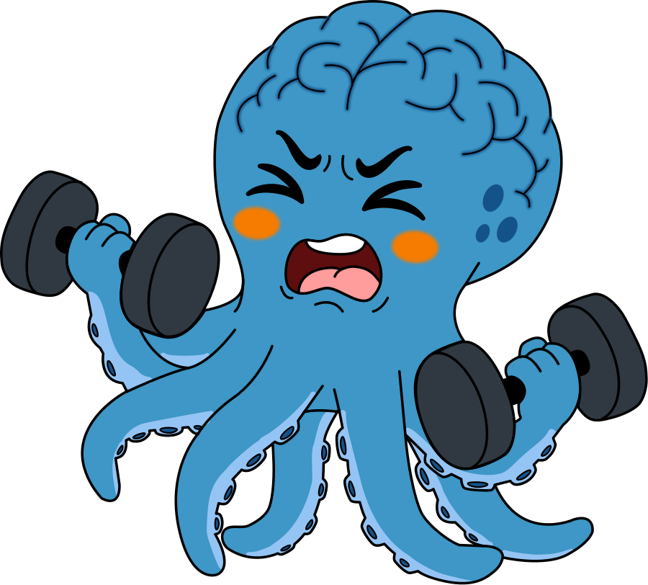

TODAY'S CHUNKS
I usually ___, but this week I ___. Normalmente…, pero esta semana… | She usually ___, but this week she ___. Ella normalmente…, pero esta semana…
It was great / boring / crazy. Fue genial / aburrido / una locura. | First… Then… After that… Finally… Primero… Luego… Después… Al final…

4 · Normal week vs. this week present (usually) + past (this week)
Normally (present) | But this week (past)
I usually go to the gym, | but this week I didn't go. I was tired.
I usually | but this week I
I always | but this week I
I never | but this week I
Ana C. usually | but this week she
Ana C. often | but this week she
Look: she usually works (present: -s) → this week she worked (past: no -s).

5 · 3 – 2 – 1 Fluency tell your week 3 times, faster each time: same story, less time
My key words (max. 8, no sentences):
Round | Listener | Time | How did it feel? (1 = hard · 5 = easy)
1 | Ana C. | 3 min | 1 2 3 4 5
2 | Teacher | 2 min | 1 2 3 4 5
3 | Ana C. | 1 min | 1 2 3 4 5

6 · Report Ana C.'s week complete with your notes from section 3, then present in 90 seconds
Let me tell you about Ana C.'s week. Last weekend, she ______________________.
On Monday, she ______________________. On Wednesday, she ______________________.
Yesterday she ______________________. Her best moment was ______________________.
She usually ______________________, but this week she ______________________.
It was a ______________________ week!

CLOSING GAME · PAST SIMPLE UNDER PRESSURE  The Alibi  Goal: answer questions in the past, fast and without contradictions. | Name: Luisa  Partner: Ana C.  Date: ______________

THE CASE Last night, between 7:00 and 9:00 pm, somebody stole all the Halloween candy from the Gimnasio del Cerebro!
The detective (your teacher) thinks it was you. Your alibi: you were together with Ana C. all the time. Prove it!

Step | What to do
1 · Prepare (7 min) | With Ana C., invent your evening. Agree on every detail and write key words below.
2 · Interrogation (4 min each) | The detective interviews you alone. Your partner waits outside or uses headphones.
3 · Verdict (3 min) | The detective compares answers. 0–2 contradictions = innocent! 3 or more = guilty.
Penalty if guilty | Tell your real week in 30 seconds with 5 past verbs.

Our alibi key words only: memorize them!
Question | Our answer
Where were you at 7:00?
How did you get there?
What did you eat?
What did you drink?
Who paid? How much was it?
What did you talk about?
Did you see anybody you know?
What was the weather like?
What time did you go home?
What was Ana C. wearing?
Survival chunks: "I don't remember exactly." "I think it was…" "We went to…" "Ana C. paid."

My check Past verbs I used today: ____ did questions I asked: ____ Contradictions: ____ Confidence: 1 2 3 4 5

VOCABULARY  was / were · went · had · ate · saw · bought · met · made · took · got up · did · felt · worked · played · visited · yesterday · last weekend | MISSION FOR HOME  ( ) Write your week in 6 sentences: 3 regular and 3 irregular verbs.  ( ) Tell your week to a family member in 1 minute.  ( ) Find 5 past verbs in an English song or video.

ROOKIE · PAST SIMPLE · MY WEEK · HOUR 1  What did you do this week?  Goal: tell your week in the past and ask Luisa about hers. | Name: Ana C.  Partner: Luisa  Date: ______________

TODAY'S CHUNKS
What did you do on Monday? ¿Qué hiciste el lunes? | Did you go to…? Yes, I did. / No, I didn't. ¿Fuiste a…? Sí. / No.
yesterday · last weekend · this morning ayer · el fin de semana pasado · esta mañana | Good news: I went · she went ¡En pasado NO hay -s!

0 · Remember Luisa? say her routine in 60 seconds, then write one sentence
Luisa usually
but she never

1 · The verb kit 15 verbs to tell almost any week: say each one 3 times
Present | Past | Present | Past
be | was / were | go | went
have | had | eat | ate
see | saw | buy | bought
meet | met | make | made
take | took | get up | got up
do | did | feel | felt
Irregular verbs: you need to memorize them. The good news: they are the same for I, you, she, we.

Regular -ed: 3 sounds | /t/ → one tap on the table | /d/ → thumbs up | /ɪd/ → two claps (extra syllable)
Examples | worked · watched · cooked | played · stayed · studied | visited · wanted · needed
Extra syllable /ɪd/ ONLY after t or d. worked = 1 syllable, never "work-ed".

2 · Questions and negatives with did after did, the verb goes back to normal
✓ What did you do? | ✗ What did you did?
✓ Did you go to the gym? | ✗ Did you went to the gym?
✓ I didn't go to work. | ✗ I didn't went to work.

3 · My week ask Luisa "What did you do on…?" Follow-ups: Who with? Where? Was it good?
Day | Me (I…) | Luisa (she…)
Last weekend
Monday
Tuesday
Wednesday
Thursday
Yesterday (Friday)
This morning

ROOKIE · PRESENT VS. PAST · HOUR 2  Normal week vs. this week  Goal: compare your routine with this week and tell your week with fluency. | Name: Ana C.  Partner: Luisa  Date: ______________

TODAY'S CHUNKS
I usually ___, but this week I ___. Normalmente…, pero esta semana… | She usually ___, but this week she ___. Ella normalmente…, pero esta semana…
It was great / boring / crazy. Fue genial / aburrido / una locura. | First… Then… After that… Finally… Primero… Luego… Después… Al final…

4 · Normal week vs. this week present (usually) + past (this week)
Normally (present) | But this week (past)
I usually go to the gym, | but this week I didn't go. I was tired.
I usually | but this week I
I always | but this week I
I never | but this week I
Luisa usually | but this week she
Luisa often | but this week she
Look: she usually works (present: -s) → this week she worked (past: no -s).

5 · 3 – 2 – 1 Fluency tell your week 3 times, faster each time: same story, less time
My key words (max. 8, no sentences):
Round | Listener | Time | How did it feel? (1 = hard · 5 = easy)
1 | Luisa | 3 min | 1 2 3 4 5
2 | Teacher | 2 min | 1 2 3 4 5
3 | Luisa | 1 min | 1 2 3 4 5

6 · Report Luisa's week complete with your notes from section 3, then present in 90 seconds
Let me tell you about Luisa's week. Last weekend, she ______________________.
On Monday, she ______________________. On Wednesday, she ______________________.
Yesterday she ______________________. Her best moment was ______________________.
She usually ______________________, but this week she ______________________.
It was a ______________________ week!

CLOSING GAME · PAST SIMPLE UNDER PRESSURE  The Alibi  Goal: answer questions in the past, fast and without contradictions. | Name: Ana C.  Partner: Luisa  Date: ______________

THE CASE Last night, between 7:00 and 9:00 pm, somebody stole all the Halloween candy from the Gimnasio del Cerebro!
The detective (your teacher) thinks it was you. Your alibi: you were together with Luisa all the time. Prove it!

Step | What to do
1 · Prepare (7 min) | With Luisa, invent your evening. Agree on every detail and write key words below.
2 · Interrogation (4 min each) | The detective interviews you alone. Your partner waits outside or uses headphones.
3 · Verdict (3 min) | The detective compares answers. 0–2 contradictions = innocent! 3 or more = guilty.
Penalty if guilty | Tell your real week in 30 seconds with 5 past verbs.

Our alibi key words only: memorize them!
Question | Our answer
Where were you at 7:00?
How did you get there?
What did you eat?
What did you drink?
Who paid? How much was it?
What did you talk about?
Did you see anybody you know?
What was the weather like?
What time did you go home?
What was Luisa wearing?
Survival chunks: "I don't remember exactly." "I think it was…" "We went to…" "Luisa paid."

My check Past verbs I used today: ____ did questions I asked: ____ Contradictions: ____ Confidence: 1 2 3 4 5

VOCABULARY  was / were · went · had · ate · saw · bought · met · made · took · got up · did · felt · worked · played · visited · yesterday · last weekend | MISSION FOR HOME  ( ) Write your week in 6 sentences: 3 regular and 3 irregular verbs.  ( ) Tell your week to a family member in 1 minute.  ( ) Find 5 past verbs in an English song or video.

