DR. PASCARELLI’S COMPLETE GUIDE TO REPETITIVE STRAIN INJURY (Summary)

What You Need to Know about RSI and Carpal Tunnel Syndrome

1. Understanding RSI

This disorder is insidious—it creeps up on you over a period of weeks, months, or even years. Often patients only recall the day they couldn’t take the pain anymore or couldn’t continue to work. The process is like a dam that slowly fills with water and then suddenly overflows.

Just as a combination of numbers in the right order is necessary to unlock a safe, so the successful combination in RSI requires the right procedures in the right order. This usually means a complete physical exam, biomechanical and ergonomic intervention, a prescribed treatment program of physical or occupational therapy including a home exercise program, and psychological intervention when needed.

Essentially, RSI is the result of stress, strain, overuse, and overloading of soft tissues, causing one muscle
group to work against another.

The Spinal Column
Nerve compression occurs in RSI, usually because of poor posture. After the nerves leave the spinal column they can get caught between tight muscles. This can happen in three areas: in muscles of the neck (scalene muscles), in a space between the collarbone and your first rib, or in a tight space under the smaller pectoral (chest) muscle. When this occurs it is called neurogenic thoracic outlet syndrome (TOS) or brachial plexopathy.

The Shoulder, Back, Neck, and Upper Arm
Usually, if posture is poor, the shoulder joint doesn’t function properly. When normal shoulder use is lost, the forearm and hand must do more work. Impaired shoulder movement is common in RSI and is a major contributor to symptoms.

The Forearm and the Elbow
Repetitive movement can irritate the ulnar nerve at several points, as it runs from the spinal column through the neck muscles, under the collarbone, then over the first rib and under the small pectoral muscle. The nerve then passes through a bony notch at the elbow joint on its way to the hand.

The ulnar nerve normally glides or moves in the neck area. If the nerve is pinched at the neck due to poor posture and tight muscles, then it loses its ability to glide and is pulled tightly through the elbow, causing traction and nerve damage. Think of the ulnar nerve as a long rubber band that is caught and stretched at the neck and that must stretch even tighter as you bend your elbow.

Nerves
Nerves play an important role in RSI because it is the nerves that get trapped or pulled in the injured soft tissues, causing pain, the most common symptom of RSI. Nerves carry pain messages from the site of tissue damage to the brain and have a critical role in muscle regeneration.

Anatomy Is Not Always Destiny
Steadfast attention to postural retraining, physical and occupational therapy, lifestyle changes, ergonomic and biomechanical modification, and a personal commitment to home exercise programs have proved very effective towards healing RSI in my patients.

The sooner RSI is diagnosed and treated, the quicker and more complete the comeback. Surgery should be the last resort in most cases.

Poor Posture
By far the most frequent physical finding in RSI is a characteristic postural misalignment. Typically the head, which weighs about 10 pounds (as much as a bowling ball), is thrust or cantilevered forward and stretches and weakens the upper back and neck muscles, which in turn react by going into a chronic state of
contraction. Changes occur in the upper back muscles as they attempt to compensate for this added, constant burden. This cascades into the shoulders, which become hunched and pulled forward. Other muscles in the front of the body such as the scalenes, sternocleidomastoids, and pectoralis minors react by shortening, which sets the stage for nerve damage.

Thoracic Outlet Syndrome
Poor posture causes a soft tissue obstacle as the nerves go through the shortened and tightened scalene muscles. These muscles act like a pair of pincers, squeezing the nerves and causing numbness, tingling, and weakness. This diminishes the ability of the muscles in the extremities to recuperate. In RSI there is a continuing cycle of poor posture leading to nerve damage, which leads to even worse posture and further nerve and muscle compromise. If you understand this process, then you understand how RSI can cascade from minor aches and pains to a totally disabling syndrome.

Myofascial Pain Syndrome
When muscles are injured, they release chemicals that stimulate nerve fibers, causing pain, soreness, and contraction in the hands, forearms, neck, and upper back. With more severe injury, swelling and inflammation occur. Myofascial pain syndrome is a common finding in people with RSI.

2 Getting the Diagnosis

Generally, RSI is a nonsurgical illness, and though many surgeons recognize this, not all do. Therefore, in choosing a physician, one should look for a specialist who can evaluate an occupational illness with an open mind.

In any case, you want a physician who understands your illness and is able to plan your treatment, refer you to the proper therapists, and follow you through your recovery.

Questions You Need to Get Answered
Does your physician believe RSI exists? This seems rather basic, but there are physicians (and many others) who don’t believe this is a disorder at all.

Is your physician listening to you, and is he or she sympathetic? This diagnosis depends heavily on reports from the patient. A health care professional who isn’t willing to listen carefully is unlikely to be of much help.

Is your physician willing to spend the time necessary to do a hands-on physical exam? A physical exam is an absolute necessity. If your doctor isn’t willing to undertake one, you have to find a doctor who is willing.

Is your physician willing to talk to you about his or her findings, explain them to you, and outline a treatment plan? You have to understand the plan to be able to carry it out. Half-baked or hasty explanations will not do the trick.

What Your Physician Should Be Looking For
Evaluation begins with a complete medical history. If you can, prior to your first visit write down all you know about how and when your symptoms began; this will be useful to your doctor and will create a common language between the two of you.

Patient Questionnaire
Patient name _________________________________ Age ______ Sex M ____ F ____
Occupation ____________________ Height ____ Weight ____
Hand dominance R ___ L ___ Eye dominance R ___ L ___

General health history
Please list any past or current health problems, surgeries, or upper-body injuries with dates.
_______________________________________________________

Current medications ______________________________________
Sleep well? ___ Yes ___ No Appetite good? ___ Yes ___ No Do you smoke? ___ Yes ___ No
Do you exercise? ___ Never ____#/day ___ Occasionally ___ Regularly
(describe) ____________________________________________

Current problem
Chief complaint (current symptoms) ________________________________________________________________________________
Date of onset ______ Initial symptoms ______________________

Description of circumstances
When are symptoms most prevalent ___ A . M . ___ P . M . ___ During work ___ After work ___ Constant

What doctors have you seen for this problem? (If more than two, please list on the back)
Date _____ M.D. name _____________ Specialty ____________
Diagnosis _______________ Treatment _____________________

Date _____ M.D. name _____________ Specialty ___________
Diagnosis _______________ Treatment _____________________

Please list any tests performed, and provide copies of results (e.g.,
EMG, MRI, blood work, X-rays) __________________________________________________________________________________________________________________________________________ ________________________________________

Did you ever wear splints? ___ No ___ Yes ____ At work ___ To sleep Duration_________________________

Do you drop things frequently? ___ No ___ Yes

Had physical or occupational therapy for this problem? ___ No ___ Yes Duration? _______________________

Have activities of daily living been affected? ___ No ___ Yes
___ Driving ___ Opening jars ___ Dressing ___ Vacuuming ___ Doing dishes ___ Opening doors
___ Carrying bags ___ Writing ___ Holding books/turning pages ___ Using scissors
Other __________________________________________________

Computer workload: Average hours at keyboard per day ________
___ Straight input ___ Bingework ___ Phone ___ Voice-activated ___ Editing ___ Mixed use ___ Filing
___ V.A. type ___ Intellectual use ___ Writing ___ Mouse

How often do you take breaks? _____________________________ Duration?__________________________
What do you do on a break? ________________________________

Workstation Setup:
Type of keyboard _________________________________________ Is it at keyboard height? ___ Yes ___ No Type of mouse _________________
Adjustable chair ___ Yes ___ No ___ Seat pan tilt ___ Lumbar support
Adjustable desk ___ Yes ___ No ___ Keyboard tray
Adjustable monitor ____ In front of keyboard ____ To right
Copy-holder ____ None ____ Left ____ To left ____ Right

Frequently on the phone while typing or writing? ___ Yes ___ No
Do you use a headset? ___ Yes ___ No

More than one workstation? ___ Yes ___ No Describe _____________________________________________

General work conditions (lighting, ventilation, stress factor, etc.) ___ Good ___ Fair ___ Poor
Have you reported your symptoms to your employer? ___ No ___ Yes
What was the response? ___ Good (open to changes) ___ Noncommittal ___ Hostile
Other intensive use of hand ___ Gardening ___ Musical instrument: _________________________________
___ Handcrafts ___ Other ______________________________ Hrs. per week _____

Injury: On the job ___ Date: ______ Sports ___ Date: ______ Auto accident ___ Date: ______
Other ___ Date ______

Additional comments _________________________________________________________________________________________

The Pain Pictogram

Since pain is the main reason why people seek help, a pain pictogram like the one below is very useful to graphically show your pain pattern to your physician and therapists. Many patients have told me that filling out the pictogram is the first visualization they have of their pain sites. By grading your pain level on a scale from 1 to 10 in each area on the pictogram you will give perspective to the examining physician about your condition.

The Physical Examination
Anterior Posterior
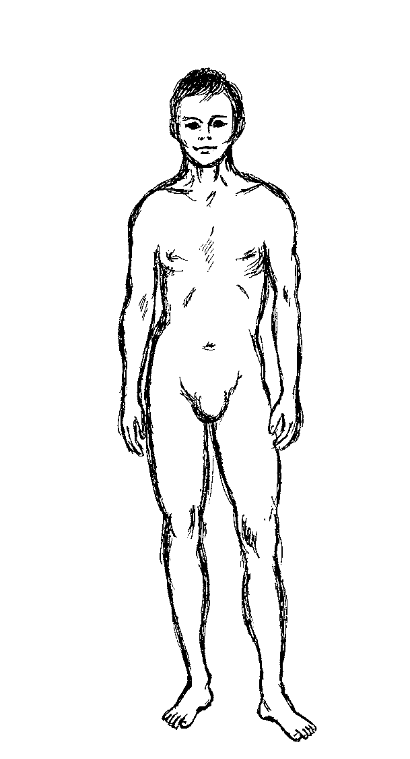
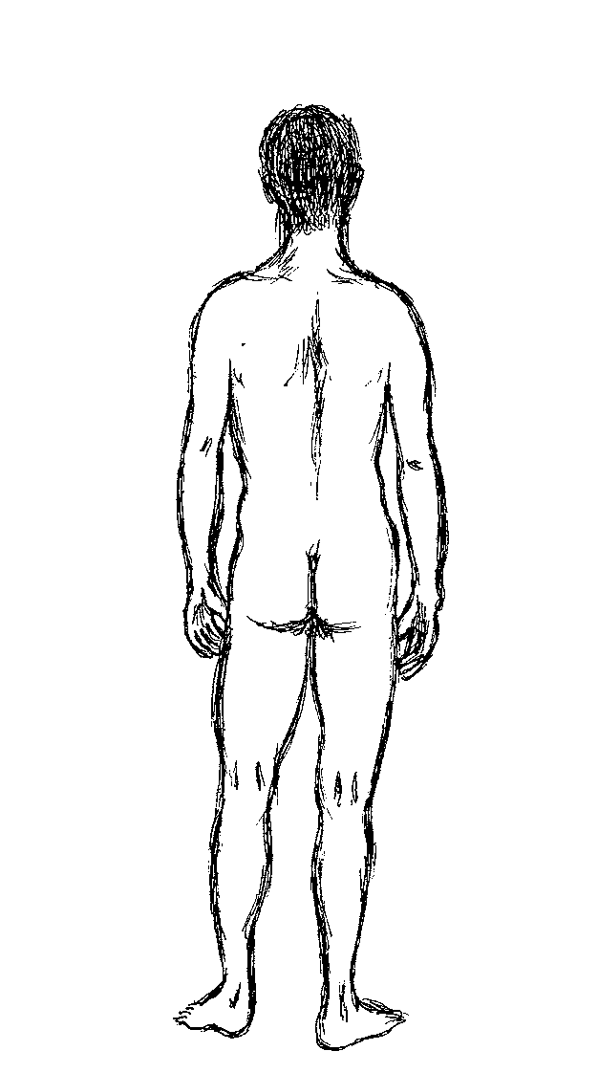
Patients are asked to mark the figures for pain (*), aching (**), burning (•), stiffness (+), and numbness (++).

In my view, the single factor having the most impact on the cost and quality of care in the diagnosis and treatment of RSI is the lack of clinical skills of the physician.

Elbows
The “carrying angle,” which is the angle between the humerus and ulna bones, is examined. This is important because your carrying angle determines how your arms are positioned at the keyboard. People with a carrying angle greater than ten degrees probably need an angled or split keyboard.

Shoulders
Rounded shoulders, often combined with a protruding neck or head, can lead to muscle imbalance that will compress and stretch nerves. This is the first step in a cascade that leads to the problems encountered in the forearms and hands of people with RSI.

Posture
Postural misalignment is one of the pivotal findings in persons with RSI. It is essential to check for shoulder protraction (round shoulders). Stiffness or immobility of the cervical or thoracic spine can frequently be found they become immobile because of spasm of the muscles supporting the spinal column. Protruding scapulas (winging) may be observed because of weakness of the muscles that stabilize the shoulder blades.

The road back will mean that posture should be corrected and poorly functioning muscles strengthened and brought back to full activity.

Roos Test
Also known as the EAST test, elevated arm stress test, this involves placing the patient’s arms in the “hold-up position” for three minutes. It is a reliable test for bringing out symptoms such as weakness, numbness, and tingling in people who have neurogenic thoracic outlet syndrome.

Wright’s Test
This has a similar rationale. It involves extending both arms straight up, which produces symptoms by stretching or pulling on the nerves in the neck, or possibly a loss or a diminution of the wrist pulse.

Profiles of Injury: The Significant Findings in RSI
In my group of RSI patients, 70 percent used the computer for most of their workday. About 25 percent were musicians who were injured primarily from playing their instruments. The remainder were in professions where repetitive tasks were common.

How RSI Begins
In RSI, early recognition and early treatment mean quicker recovery.

RSI usually develops slowly, so it is understandable that some people will not recall the early signs of their illness. However, most of my patients came to our facility within a year of the onset of their first symptoms. Increase in pain is the principal reason why people with RSI finally seek care. In some cases, a marked increase in numbness and tingling, weakness, and muscle tenderness and swelling is the trigger for seeking
help.

Postural Misalignment
The most frequent physical finding in patients seeking care for RSI is postural misalignment. I found this in almost 80 percent of my patients. Generally, as we age, our posture deteriorates, an outcome even more likely if we’ve spent years hunched over a keyboard or performing a variety of other repetitive tasks without preventive upper-body conditioning. In postural misalignment, the head, thrust forward, stretches and weakens the upper back and neck muscles. The shoulders are hunched and pulled forward, and muscles in the front of the body react by shortening, setting the stage for nerve damage.

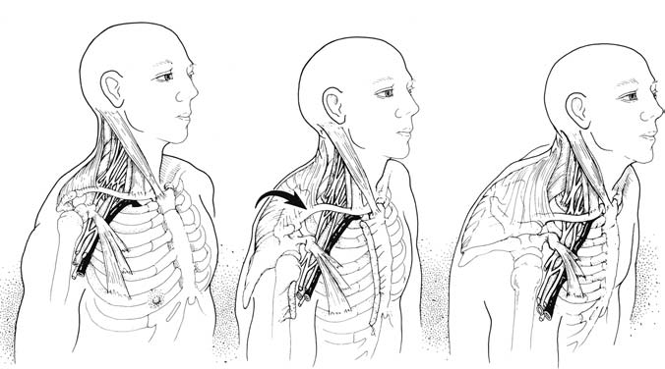
Figure: Progressive postural distortion/decompensation with neurovascular compression.
A: Normal resting posture.
B: Shoulder protraction beginning; sternomastoid muscles are shortening, drawing head anteriorly and inferiorly.
C: Advanced deformity with adaptive shortening of scalene and smaller pectoral muscles. Note narrowed costoclavicular space as well (ribs 1 through 5 have been relatively elevated). Neurovascular compression is evident at all three sites.

Neurogenic Thoracic Outlet
Syndrome (TOS)
In this syndrome, nerves encounter a series of tight spots as they travel from the neck to the arms and hands.
The brachial plexus nerves encounter what is their first soft-tissue obstacle in the scalene muscles. Two of the three scalenes act like a pair of pincers when they are shortened and tightened and can squeeze the brachial plexus nerves. Since the scalene muscles are also attached to the upper ribs, they can affect breathing if they are tight. Stretching these tightened muscles to relieve pressure on nerves is a basic component of treatment and should be accompanied by breathing exercises. About 70 percent of RSI patients will have this diagnosis.

Once the nerves emerge from between the scalene muscles, the next tight spot they encounter is between the collarbone (clavicle) and the first rib. With the tightened scalene muscles pulling the first rib up, the space between the collarbone and the first rib narrows, to become another area of potential pressure on48 Dr. Pascarelli’s Complete Guide to Repetitive Strain Injury the nerve bundle as it descends to the arm. At this point, the nerve bundle is joined by vascular structures and encounters another tight spot as it goes under the pectoralis minor muscle along the upper chest. With postural misalignment, these muscles will be shortened, tightened, and painful to pressure.

This can usually be remedied by a course of stretching and postural retraining. Migraine headaches can accompany TOS. In my experience this is a neglected cause of migraines. Inferior trunk injury causes dull aching pain in the forearm, with tingling or burning of the fourth and fifth fingers, as well as weakness of the thumb muscles and intrinsic hand muscles. This lesion is the most common form of neurogenic thoracic outlet syndrome.

Chest wall pain can be misdiagnosed as a cardiac event such as a heart attack.

There are many potential causes of ulnar tunnel syndrome, ranging from anatomic abnormalities to fracture of the hamate bone (a wrist bone), to riding bicycles with awkward handlebars, to arthritis. In typists and musicians, this may be due to repetitive wrist extension coupled with windshield-wiperlike bending of the hands at the wrist

Computer users should take a break every hour, get up, walk around, and do some basic foot and leg exercises. Taking hourly breaks will also benefit vision and general muscle function.

Getting the Diagnosis Right
long-necked with drooping shoulders, which are risk factors for neurogenic TOS. After several weeks of physical therapy and home exercises her symptoms abated, but even when symptom-free, when she did overhead chores she noted a “strange feeling,” which would go away if she did more intensive stretching. need for health professionals to know about the link between neurogenic thoracic outlet syndrome and migraine-like headaches.

The lesson: RSI and its complications can often be mistaken for emotional or neurological disease. If the cause of the symptoms is not obvious to the examiner it can easily be sorted out by a methodical clinical approach and some basic clinical tests. RSI is a very complex illness with many possible findings, which can usually be discerned through a thorough physical evaluation. These findings are the bases for diagnosis, which establishes the rationale for a focused, team-oriented treatment program.

Mr. C may not have been given a sufficient period of conservative management before resorting to surgery. Conservative management would have included a neck brace, rest, pain medication, and focused physical therapy including home exercises and possibly psychological intervention.

careful about pacing himself. Mr. C’s experience demonstrates the need to recognize that many factors are at play in those who present with work-related upper-body disorders.

3 RSI and Your Emotions

Repetitive strain injury is often associated with disabling emotional and psychological problems. Stress, chronic pain, complex chronic pain, anxiety, depression, and panic are all linked and can lead to a fearsome chain of events that needs to be broken before it causes or increases disability.

While most of the emotional and psychological problems we see result from RSI and the damage it causes, they also can be a contributing cause of RSI in the first place. Typically, while under minimal stress, you might be working long hours at an ergonomically poor workstation with awkward posture and positioning, when pain and other RSI symptoms develop. In this case, stress follows increasing pain, which then leads to anxiety. As the pain and discomfort become more difficult to control, severe emotional problems can develop.

Conversely, someone working long hours in a stressful environment, perhaps having problems with an employer or fellow employee, may become stressed and tense. With increasing stress levels, muscles can become tight, pain follows, muscle injury increases as work continues, and the harmful cycle has begun.

Rarely can you rise above the physical problems of RSI without having to deal with the emotional component as well.

Stress
Stress is your body’s reaction to any disturbing physical, mental, or emotional stimulus. In 1953, Hans Selye described stress as a basic defense mechanism characterized by fight or flight. Adrenaline levels rise and in turn stimulate the body to secrete hormones to prepare it for an encounter. Dr. Selye described two kinds of stress: eustress (good stress) and distress (bad stress). Stress is not always harmful. Eustress is beneficial to the body and can result from moderate physical exercise—the pleasant rush you feel after a vigorous workout. Distress is the extreme form of stress. Some examples of distress are excessive exercise, overwork, or lack of sleep. Distress is likely to lead to anxiety and depression and in severe instances to panic reactions.

Anxiety
Anxiety can be heightened by fear about the cause and outcome of your illness.

Understanding RSI can be very reassuring and will enable you to take charge of your situation and begin changing things. A common fear in RSI is that you can lose your job, your means of sustenance, and your health. Understanding that there is a process that you can go through to preserve your health will help you deal with the realistic worry and anger you may feel about these overwhelming occurrences. Anxiety can involve a variety of circumstances, including fears of social situations such as public speaking, physical environmental fears such as crowds or cramped spaces, and trauma such as the soft-tissue injury encountered in RSI or an auto accident. As if in double jeopardy, the RSI patient is at risk for the effects of job loss or the threat of job loss.

Drugs that can be misused or overused that can lead to anxiety include caffeine, cocaine, methamphetamines, thyroid medications, or bronchodilators used for asthma. Alcohol or benzodiazepines, particularly if they are discontinued abruptly, can result in acute anxiety.

Make sure you have corrected any ergonomic deficiencies at work and that you pace yourself by taking adequate rest breaks, which will relieve some stress.

4 RSI and Your Eyes

Like any fine and complex instrument, eyes need to be cared for and allowed to do their job under the best conditions possible.

Eye Checkups
Our eyes were not designed for the strains of office work. As a result, every year millions of people consult eye specialists for problems that begin with computer use.

James Sheedy, O.D., Ph.D., who is now director of professional development at Sola Optical USA, has reported that 75 percent of all computer users suffer from a variety of eyesight-related problems, which he ranks in order of frequency:
• eyestrain
• headache
• blurred vision
• temporary myopia (nearsightedness)
• dry or irritated eyes
• neck and backache
• photophobia (sensitivity to light)
• double vision
• afterimages

One of these functions is called accommodation. The closest distance that allows you to focus sharply on an object is called the near point of accommodation. Internal eye muscles adjust the lens to make focusing possible. As we age, lens elasticity diminishes, causing the near point to move farther away. This is why at about forty years of age, many of us need bifocals.

You can improve your accommodation by looking down slightly. If you look up or sideways, the ability to accommodate diminishes.

A slight chin tuck can relieve neck strain when looking down. Another important function is binocularity, which is the ability of our eyes to fuse the images from each eye into a single, three-dimensional image.

Another important but often neglected factor is the determination of your eye dominance. You may not be aware of it, but you probably favor one eye over the other, just as you may be right-handed or left-handed.

Knowing your eye dominance can help you adjust your workstation more efficiently. A right-handed person who is left-eye-dominant, yet places the bulk of documents used in his work on the right, will be turning his or her head sharply to the right to bring the left eye into focusing position.
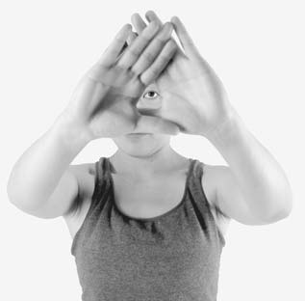
It’s easy to figure out your eye side may be more comfortable. dominance. Form a small hole between your index fingers and your thumbs, with arms If you offset the screen slightly fully extended. Look at a single object from center to favor your dominant eye you may feel more comfortable through the hole formed by your hands and draw your hands toward your face while keeping your eyes on the object. The hole, although LCD screens made by your hands will be in front of your dominant eye.

Using only dark letters on a light background can aid eye comfort. Rest your eyes for several minutes of each work hour by looking away from the screen or by gazing at distant objects. Keep your lenses and your monitor screen clean. To achieve a visually ergonomic workstation, a computer user should pay attention to positioning, angling his or her monitor correctly, controlling glare, distortion, reflection and flicker as well as modifying work lighting if necessary.

Avoid workplaces where there is no accommodation for some degree of ergonomic adjustment.

I usually recommend at least one session with a speech therapist, who can teach you to use your voice properly to prevent chronic hoarse voice.

5 Managing Pain

Pain is the most common complaint in RSI, both in the early and late stages of the disorder, and it’s the main reason why people come to see me. Pain tells us that injury is present, and it’s a warning signal that shouldn’t be ignored. Pain is something only you feel, and that’s why it is difficult to convey its nature and intensity to others. This is especially true with RSI, because the afflicted person generally looks healthy—there are no open wounds. If your physician is insensitive or skeptical about your pain, you risk a worsening of your condition. Seek someone who cares, who will listen and help guide you to recovery. As RSI progresses, it becomes more obvious that the pain associated with it has variable qualities. It may start as a periodic aching associated with work and may become more severe, constant, and burning as time goes on. To make matters worse, other symptoms may arise, such as weakness, numbness, depression, anxiety, and panic. As RSI progresses, pain becomes more difficult to manage, a good reason to begin early treatment.

The most common type of pain is acute pain, which is usually temporary. It is our first line of defense against further injury. If you continue to work with acute pain, tendons, muscles, or joints may become inflamed. If you rest and obtain appropriate treatment, your acute pain usually goes away. Pain is an important message from your body, and one you must listen to. If you allow pain to progress unattended, you are in for trouble as it moves toward a chronic condition.

Most RSI victims suffer from one or more forms of chronic pain, which tend to persist long after the onset of an injury, and health care providers often mismanage chronic pain. Chronic pain can be dull one day and sharp another as it moves throughout the body. The good news is that it can eventually subside with appropriate treatment. If allowed to persist or worsen, a vicious cycle ensues, leading to a more complicated form of pain, complex chronic pain.

Complex chronic pain differs from acute or chronic pain because it stimulates a part of the nervous system called the limbic system. The limbic system is a group of brain structures common to all mammals and associated with involuntary nerve function, behavior, and smell.

As RSI progresses, it can induce complex chronic pain by its effect on the sympathetic nervous system, over which we have little control. This dysfunction of the sympathetic nervous system perpetuates pain by beginning a vicious cycle of blood vessel instability accompanied by the release of pain-stimulating substances into the bloodstream that continue uncontrolled. Often it provokes the genesis of new pain fibers. One common sign of complex chronic pain is a cooling of the hands and forearms, often combined with sweating as the pain level increases. This is known as reflex sympathetic dysfunction.

When complex chronic pain occurs, treatment is usually more difficult and prolonged because circulatory changes diminish the blood supply to the soft tissues and delay healing.

If aggressive and focused treatment is not begun quickly, the condition can progress to the most serious form of complex chronic pain, which is reflex sympathetic dystrophy (RSD) or complex regional pain syndrome (CRPS). One of my patients is a good example of what can happen if RSD/CRPS is not recognized in time.

Continue your mobility and strengthening exercises to avoid a relapse.

Treatment of RSD/CRPS
Early diagnosis can produce a good outcome. Begin physical therapy to maintain flexibility, range of motion, and strength. People with CRPS tend to limit movement because of stiffness and pain. They should be encouraged to perform range-of-motion exercises, but too vigorous an exercise program can cause a flare-up of symptoms.

Make the necessary lifestyle changes, and provide ergonomic and biomechanical intervention.

In the RSI patient, the majority of whom have postural problems (rounded shoulders and head thrust forward), nerve injury from muscle imbalance combined with overuse of muscles are often enough to transform chronic pain into complex chronic pain because of sympathetic nervous system involvement. This may ultimately result in RSD/CRPS if treatment is not begun early enough to prevent it.

Self-Treatment
Learn from your pain, pay attention to your pain, and you should eventually conquer it. With RSI, rest may be the most important initial step toward healing. Here, rest is a relative term. Total rest, such as going to bed and lying there, quickly causes muscles to atrophy and contract. This is not the right type of rest. You need relative rest, avoiding anything that would stress your injured nerves and muscles. This means not only avoiding or diminishing computer use but also limiting other activities, such as playing musical instruments, knitting, gardening, cooking, or any upper-body activity that causes distress. While you may have to continue working to earn your living, you should take rest breaks, pace yourself, and stretch during the workday.

After making certain ergonomic and biomechanical changes and getting medically evaluated, you are ready to begin working with your physical or occupational therapist to conquer RSI.

Icing is an immediate and effective way to diminish the level of pain in RSI. It is most effective if the ice is put in direct contact with the skin for short intervals of forty to sixty seconds. It should be applied by moving it over painful tissues until the skin gets slightly numb and reddish. Do this for no more than a minute at a time and no more than ten times a day.

Don’t stretch the iced muscle because muscles tend to gel when cold. Wait at least fifteen minutes before you begin gentle stretching.

An easy way to apply ice is to fill a paper cup with water and let it freeze. When it is solid, tear off the lip, place your arm on a towel and apply it directly to the skin, rubbing back and forth gently. Place the cup back in the freezer for reuse.

Some treating physicians recommend application of topical creams and liquids to diminish muscle pain.

Transcutaneous Electrical Nerve Stimulator (TENS)
TENS is a noninvasive electrical device that stimulates the nerve fibers that travel to the neocortex of the brain. It is used for controlling pain at trigger points and is helpful particularly in the treatment of RSD/CRPS by applying stimulation at multiple locations.

Acupuncture and Acupressure
Acupuncture is a treatment that involves sticking small needles into key parts of the body that relate to the symptoms’ sites. Acupressure involves applying hand pressure to these sites. Acupuncture is useful for the treatment of pain driven by an overactive sympathetic nervous system (complex chronic pain) and works best for that condition by stimulating specific nerve fibers. One of its effects is to activate endorphins, which are the body’s natural pain suppressors.

Acupuncture is not a very useful treatment for simple chronic pain because it provides relief that lasts for only a few hours. Acupuncture is less effective if used as the sole therapy modality and should be used in conjunction with occupational and physical therapy. Acupuncture should be performed only by qualified, experienced practitioners.

Splints
The use of splints to control pain is usually a step in the wrong direction. Most of the injury and pain associated with RSI needs to heal actively. By this I mean that some gentle movement is necessary to encourage soft tissues to grow with the lines of force (proper direction) of the tissue. Immobilizing these tissues might relieve some of your pain, but splinting will simply encourage muscle weakness and random, chaotic tissue healing that will be less functional than the tissue was before the injury. Furthermore, with splinting, joints become stiff and muscles atrophy. More seriously, the immobilization of splinting can lead to, worsen, or predispose you to RSD/CRPS. If you have a broken bone, a splint or a cast is a logical treatment, but when it’s removed, the immobilized soft tissues always need to be rehabilitated. Unfortunately, too many physicians and therapists treat soft-tissue injury as if they were treating a broken bone, which can prolong the problem.

Many people splint themselves in a misguided attempt to prevent RSI or to keep it from developing or spreading. Wrist splints may cause pain to migrate to muscles that have not been immobilized by the splint. This increases muscle imbalance by causing atrophy in one group of muscles and overuse in another. If you are concerned about keeping your wrists straight, don’t do it with a splint. Instead, get a split keyboard, change your technique, and check the ergonomics of your workstation.

Occasionally, splinting may be necessary to overcome a severe, acute inflammation such as the thumb tendinitis of DeQuervain’s disease or to get relief from night pain if you are suffering from carpal tunnel syndrome. If your doctor gives you splints, ask what the rationale for the treatment is. Always use splints for the minimum amount of time, and never splint yourself.

Nonsteroidal Anti-inflammatory Medications (NSAIDs)
Since most RSI patients suffer from chronic pain, NSAIDs are likely to give only partial relief.

NSAIDs and NSAID derivatives are useful, but they should be used with great care, based on the treating physician’s decision. Even with gastroprotective NSAIDs there is still some risk of GI bleeding, which can increase with the simultaneous use of SSRI antidepressant medication.

Muscle Relaxants
These medications, while useful, have many potential side effects and should only be taken after careful assessment.

The Antidepressants’ Role in Pain Management
Recent investigations in sports medicine have shown that after an injury, athletes often suffer a period of depression. Depression and anxiety are common parts of RSI.

Physical Therapy, Occupational Therapy, and Home Exercises
Stretching, strengthening, postural exercises, and soft-tissue work under the guidance of your therapist are the front-line defenses against pain and ultimately the bases for healing and resolution of RSI.

6 Your Lower Back

Good posture is essential in preventing repetitive strain injury, and your lower back is the foundation on which the many other elements of posture are built. If you sit at your computer for long periods of time, you may think you are not doing much physical work. Yet the muscles of your lower back are hard at work maintaining you in this seated position. The kind of physical work your muscles are doing is defined as static loading, where the muscles act as braces for your frame. Static loading also forces these muscles to work with less nourishment in the form of blood supply, and therefore they are more vulnerable to fatigue. This is more likely to occur if you are poorly conditioned, or if you assume awkward postures as a result of poor workstation equipment or arrangement.

Static or awkward posture, anxiety, mental stress, depression, and job dissatisfaction are all strong risk factors.

Defining Low Back Pain
If acute pain persists for twelve weeks or more, it can be considered chronic.

Apart from bony involvement by deterioration or slippage of spinal elements, pain in the lower back is usually the pain of muscle spasm, where nerve fibers are irritated by a tightened muscle.

As an examining physician, a thorough history and physical examination or even a biomechanical and ergonomic analysis may be the kind of detective work needed.

7 Physical and Occupational Therapy for RSI

P physical and occupational therapy are the keystones of care in repetitive strain injury. Once you have been diagnosed with RSI, the treatment portion of your therapy should begin. To regain what you have lost in normal body function, you must concentrate on your body. This means total attention to your therapist’s instructions and your home program. Anything less prolongs your pain and your other symptoms. In most cases, treatment must begin gradually to avoid relapse. This is where your therapist becomes indispensable.

A common mistake at the beginning of therapy is to overdo it. Another is the false belief that without pain there is no gain. In RSI, pain should never be used as a guide to exercise progression. You must rely on your own awareness. Relying on the therapist to carry the workload of your recovery means that you will not recover. Your home program is what maintains your therapist’s mobilization effort while taking you to your next level of progress. And once you are better, you will maintain that condition only if you change your exercise habits permanently. Getting back to work requires constant vigilance in your exercise program. You can never return to indolence if you want to stay healthy.

The Right Therapy with the Right Therapist
You won’t recover from RSI unless you work hard at it. There is no quick fix or easy way out. This means participating in a program of exercises and other treatments under the guidance of your physician and your physical or occupational therapist.

Finding Treatment
The person in charge of your therapy should be a certified physical or occupational therapist with a bona fide interest in RSI.

Beware of the therapist who insists on the immediate use of weight training. Premature use of weights will only add to your symptoms, and this is one of the principal reasons why patients abandon treatment. You should not be using weights for forearm and wrist exercises when you start treatment, but only after healing has begun and your forearm and wrist pains have diminished. Poor management by the therapist can make you cynical about therapy and delay your recovery, and rotating therapists is not the best approach.

Personal Trainers
Trainers may be fine for the healthy, and many trainers are quite knowledgeable. But RSI is a serious medical condition. Trainers should not be considered a substitute for your physical or occupational therapist. Once your condition improves, a competent trainer could work with your therapist to continue your ongoing maintenance program.

Fight for Therapy Coverage
Unfortunately, managed care, workers’ compensation, and restricted insurance reimbursement have curtailed benefits for physical and occupational therapy. This therapy is important, and you should go to great lengths to secure your coverage benefits. Do not accept rejection of therapy claims without battling for what is a necessary and vital part of your treatment. Often, your insurance provider just does not understand RSI. Enlist your physician, therapist, benefits manager, and anyone else who can help you document your needs. Don’t give up!

Why You Need Your Exercise Program
Proper exercise is as critical to you as it is to a professional athlete. If you are recovering from RSI injury without active participation in home or gym exercises, you are not likely to get completely better. The same holds true if you want to prevent RSI. A physician and physical or occupational therapist working together is the best approach to your exercise program. Too much exercise or inappropriate exercise may increase pain or aggravate symptoms. Too little exercise could impede the progress of treatment.

A regular exercise program is important if you want to get rid of the pain, numbness, tingling, and disability of the disorder.
Remember: you are an upper body athlete. Any athlete needs training to use his or her body. Self-programming your exercise regimen could lead to injury, which could undermine your will to continue this essential part of your therapy.

The RSI Exercise Program

Warm-ups
Warm-ups are a critical prelude to your exercise program. Warm-ups enhance circulation and mobilization of the soft tissues, maximizing the benefits of the rest of your exercise program.

1. Wall angels
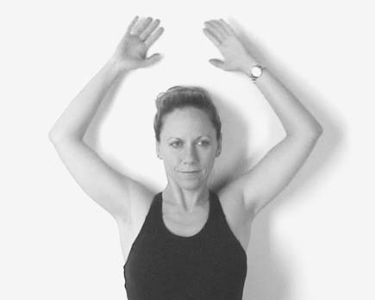
No gym equipment is necessary here. Wall angels, which can be done against a wall or on the floor, mobilize the joints of the upper back, shoulders, and neck, increasing mobility and circulation.

2. The UBE (Upper Body Ergometer)
This device is available in some gyms. If you are lucky enough to have access to one, it is an excellent upper body warm-up device.

3. Bodyblade
This is a device you can purchase for home use, since it is generally not available in gyms. It comes in two sizes. Start with the smaller length. Basically, Bodyblade is a flexible bow with a handle in the middle that makes the blade oscillate when you shake it.

General Body Warm-up

1. Bicycle Warm-up
The stationary bicycle can substitute as a warm-up device, improving circulation in the entire body.

2. Running and Walking
Slow running and walking are excellent total body warm-up exercises.

3. Stretches
Stretching the soft tissues prepares them for mobilization and strengthening. Stretching can improve muscle balance and diminish the pressure on nerves, joints, and other structures. Stretching should be done regularly and become an integral part of your treatment or prevention program. A stretch should be held for a minimum of thirty seconds to be effective.

Before beginning your stretches the guidance of your physician or therapist is essential to determine which of your joints are hypermobile and which are tight. The hypermobile joints should not be overstretched, since this could cause a reactive muscle tightness or spasm. Wrist stretches are necessary for tightened forearm muscles in people with RSI. Conditions such as carpal tunnel syndrome can improve slowly if stretching and soft-tissue work by your therapist are combined. Stretching should be done twice a day or more. Stretching during your rest breaks can lead to a regular routine that becomes a good habit.

a. Trapezius and scalene stretches
This important stretching exercise conditions the neck, back, and shoulder muscles, preparing them for strengthening and relieving pressure on nerves in the neck.
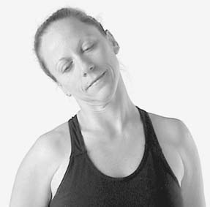
b. Wrist flexor stretches
These can be performed many times a day, especially during rest breaks.
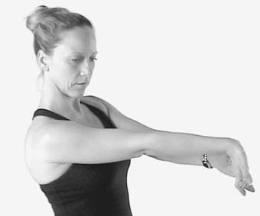

c. Wrist extensor stretches
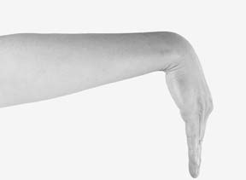
Wrist extensor stretches are performed with the arm extended. Keep the shoulder down on the side you are stretching.

d. Physioball/Resist-a-ball exercises
Most gyms have inflatable balls of various sizes that can be helpful for stretching certain difficult-to-get-at muscle groups.

Strengthening Exercises
After your initial evaluation, strengthening exercises usually begin with two sets of ten exercises, twice a day. These exercises should be tailored to your needs. At the beginning of strengthening exercises, do not use any weights. If soreness is experienced after exercises but does not continue into the next day, you may safely continue, but if soreness lasts into the following day, your exercises were too intense. In that case you should back off to one set of exercises twice daily.

Weights should be added to your program with caution, as they can cause injury if you are not prepared to tolerate them, and they should not be used until you can tolerate two sets of exercises twice a day. Weights should never be increased by more than half a pound per week.

If you have pain at rest in your hands or forearms, start with a cuff weight, not a dumbbell weight. There are cuff weights with pockets that take metal rods so you can gradually increase the weight. As pain decreases, switch to dumbbells, holding them lightly rather than gripping them. Pain is a signal not to be ignored.

1. The Basic 5
These exercises can help you begin the process of healing. For side-lying exercises you can use a pillow under your arm or trunk to elevate your body and decrease pressure on your shoulder.

a. Punching the ceiling (superior serratus anterior muscle)
Lying flat on your back, raise both arms toward the ceiling. Hold for three seconds.
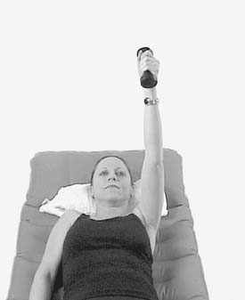

b. Side-lying whole arm raises (perform on both sides)
Lie on your side, with the top arm elbow extended. Raise and lower the arm so the palm touches the floor.
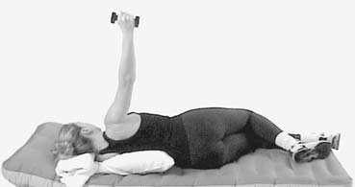
c. Side-lying external rotation
Lying on your side with the top arm along the edge of your body and with your elbow flexed to ninety degrees, rotate the shoulder in a continuous circular motion.
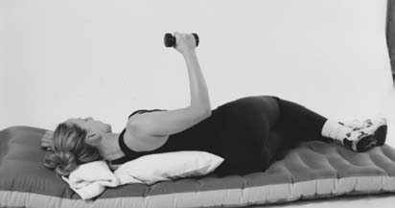
d. “Hold up” or prone scapula retraction
Lie prone (face down) with one or two pillows under your chest and a rolled towel under the forehead to allow space for breathing
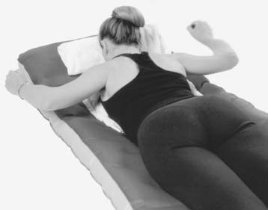
e. “V” exercises (Sitting or Standing Shoulder Abduction)
This exercise is best performed in front of a mirror. Sit or stand with both arms close to your body, positioning them slightly for-ward of your chest. Then bring the extended arms up 35 to 45 degrees while contracting only the deltoids (upper arm muscles). Try not to activate the upper trapezius (muscles between your neck and shoulder) too soon so that neck soreness is avoided.
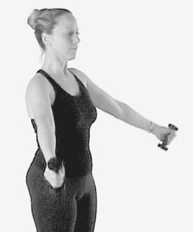
2. Advanced Strengthening Exercises
Advanced exercises can be incorporated into your treatment program after you have mastered the basic five and you feel comfortable with the strengthening program.

a. Latissimus dorsi pull-downs
Latissimus dorsi pull-downs are important to develop synchronous shoulder and arm movement as well as strength.

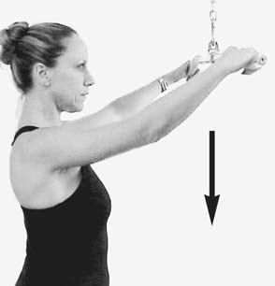
The latissimus dorsi muscle, a large triangular muscle in the back, plays a major role in shoulder and arm movement. It extends, rotates, and moves the arm toward the body and draws the shoulder down and back.

b. Wall push-ups
This exercise stretches, strengthens, and mobilizes front and back upper body muscles. By loosening these tight muscles, pressure is taken off the nerves and blood vessels supplying the arms and hands. Stand, placing your arms above your head and maintaining straight wrists, with your feet a bit out from the wall. Bend your elbows as your chest leans into the wall.
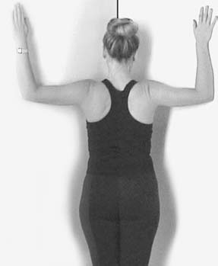
c. Abdominal exercises
These exercises are important for muscle balance and posture. RSI patients should avoid lifting the head off the floor because it irritates the cervical spine.
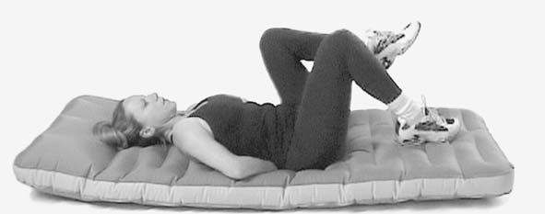
Abdominal exercises are necessary for developing muscle balance and power.
These are a critical component of lower back strengthening.

d. Wrist curls
These exercises will strengthen forearm extension and flexion. They should only be started when stretching and basic exercises have eliminated pain. Weights should start at one pound or less, reaching a maximum of four pounds for the forearm flexors and three pounds for the extensors.
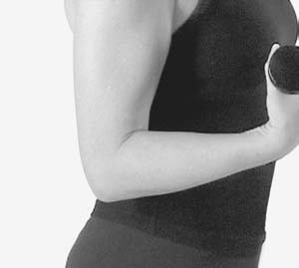
e. Supinator pronator exercises
I have found these exercises useful for those with golfer’s or tennis elbows. By stretching and strengthening these muscles, pressure is taken off the insertion of the muscles into bone at the elbow. A hammer can be used for this exercise. Start by holding it closest to the hammer’s head; work down the handle as you progress. With the elbow at your side flexed to ninety degrees, a two-pound weight is rotated back and forth, working both supinator and pronator muscles.
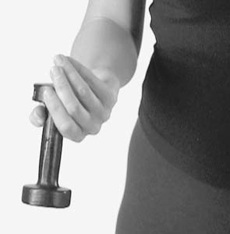
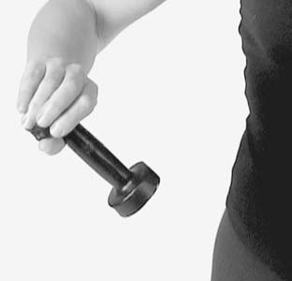

Supinator and pronator curls stretch and strengthen forearms and help to relieve medial and lateral epicondylitis. Weight should be added as tolerated. Elbow should be flexed to ninety degrees.

f. Shoulder shrugs
As an advanced exercise, begin with two-pound weights in each hand and progress according to the recommendation of your therapist.
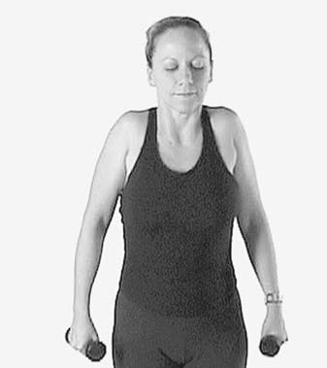
g. Hand intrinsics with putty
Using various grades of a special soft putty can strengthen them. Opposing each finger to the thumb, one at a time, squeeze the putty between the finger and the thumb. Do the same between each finger and the adjacent finger in a scissorslike motion. Do ten repetitions per finger.
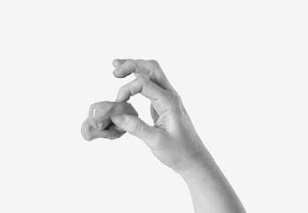
Manual Therapy: Soft-Tissue Work for RSI
Your therapist may use the terms soft tissue work, manual therapy, or myofascial release. By whatever name, this is the technique that therapists use to mobilize particularly tight muscles in the early stages of RSI treatment, when it is difficult for you to mobilize your soft tissues so you can do your exercises properly. Manual therapy is an important and helpful adjunct to both physical and occupational therapy. Not all therapists are skilled in manual therapy techniques.

The purpose of myofascial release is to locate tightened muscle groups that impinge on nerves, diminish circulation, and restrict mobility. In RSI it involves several levels of activity, which consist of passive stretching by placing thumb or hand pressure on muscles and tendons to produce tension. By applying tension, the therapist passively stretches muscle that, if you attempted to actively stretch yourself, would place too much pressure on the tendons and joints.

For RSI patients, the areas that most commonly benefit from manual therapy include the muscles of the palm, forearm, pectoralis minor and major, scalene, upper trapezius, subscapularis, latissimus dorsi, and scapula. There are also many painful trigger points in the upper and lower back that might need manual therapy

8 Ergonomics: Making Your Equipment Fit

It is unlikely that ergonomics will become redundant in the office of the information age. In general, experience has shown that with increasing productivity the intensity of human work increases. The load on the sensory organs and mental functions, environmental problems and constrained postures are likely to remain challenges for ergonomics in the future, too.

W would you intentionally buy a suit that doesn’t fit or run a marathon in one-size-fits-all shoes? Ergonomics is the science of making sure that things fit—that tools, keyboards, musical instruments, and a host of things we use in our daily lives don’t harm us.

Dr. Carl Zenz, a professor of medicine at the Medical College of Wisconsin, defines ergonomics as a combination of three things: engineering and physical sciences, behavioral sciences, and biological sciences.

Ergonomics at the Worksite
Ergonomics should be the responsibility of a specialist trained to choose and fit equipment so that each employee gets the right equipment and the right training to use that equipment. A major role for the ergonomist is to keep up with new developments in safety and design and to advise the employer when equipment becomes obsolete or dangerous or when employees are experiencing difficulty or injury at work.

If there is no staff ergonomist, or if you work at home, making the choice of good equipment becomes your job. New chairs, desks, trays, keyboards, input devices such as the mouse, track ball, joystick, and touch pad come on to the market every day. You need a basic understanding of how these products are supposed to function and what features you should look for. Fitting equipment is important for a number of reasons. First, it is essential to place your body in correct balance to do your work. Just improving ergonomics can begin to reverse the discomfort and pain of RSI. A good workstation setup fosters good posture, which starts you on the road to recovery. Although your body is flexible and adaptable, there is no reason why it should be contorted to fit a chair or a computer setup.
Your workstation should be fitted so your body is not subjected to strain and injury.

A well-thought-out ergonomic item should be adaptable to its user. A keyboard as well as a chair must be easily adjustable. Be critical when purchasing ergonomic equipment, as it may be ergonomic in name only. Thousands of products are on the market making claims ranging from curing carpal tunnel syndrome to solving all of your RSI problems, potential or actual. Make your purchase based solely on your need for a more healthful work space, and do it as an informed consumer. Many products such as wrist rests, splints, and other advertised self-treatment devices may be useless and in some cases even harmful. Remember that the best ergonomically designed workstation is useless to you if have bad technique or are in poor physical condition.

Chairs
When evaluating a workstation, I look at seating first and build the rest of the workstation around an ergonomically sound and comfortable chair. A good chair can do much to help your posture. The chair should be soft upholstered but not very soft and should have casters so you can move freely.

When selecting the chair, make sure that the seat pan supports you comfortably without your buttocks draping over the edges. The seat pan should not be so long that it digs into the back of your thighs, and its front should have a downward rolled edge. The seat pan should ideally be adjustable so it can tilt to allow the knees to be lower than the hips. Many chairs do not have seat pan tilt, as it requires that the seat pan be separated from the chair’s back. If seat pan tilt is not available, a wedge-shaped pillow can be placed on the seat. It is this tilt that carries some of the body weight to the feet and stabilizes the lower spine. Having a seat pan that can slide backward and forward is also desirable.

Avoid high-backed “executive” chairs if your work involves heavy keyboard use. These chairs, while imposing, tend to lock you in place and prevent free movement of the shoulder blades, which is essential for shoulder and arm mobility. Chair backs should be low enough to allow free shoulder movement.

Armrests
Avoid armrests entirely unless they can be moved out of the way while working. Leaning on them while keying prevents you from using the shoulder and upper back muscles, making your forearms and hands do all the work. If you need armrests, they should be the stubby kind, so you can’t lean on them when you type and they won’t bump into the desk.

Easy Adjustability
Look for a chair that has a simple mechanism. Adjust the chair properly for computer work, and sit in it for a few minutes before you buy it.

Standing
For those who are comfortable keying while standing or who have to stand, as at an airlines reservation counter, the height of your keyboard is important. Whenever you work without a neutral wrist position you are endangering your upper body.

Footrests
Avoid angled footrests unless they are fixed in place. If you need one, it is better to have a footrest that keeps your foot flat, though above the ground. The footrest should be big enough to move your feet around without falling off the edges. No foot-dangling. If your legs are too short to reach the floor, get the right footrest.

Desks
A standard desk height is appropriate for writing and sorting papers but is usually too high for keyboard placement. By placing the keyboard at desk height and resting your forearms on the desktop, you get no help from the strong muscles of the shoulders or the upper back. If your keyboard is at desk height, you are reaching too high, clearly a recipe for trouble. Those desks that come with a special keyboard pullout drawer that is in a fixed, flat position and cannot be tilted, also are troublesome. Since the height of most desks is fixed, adjustable pullout trays can overcome some of the height problems.

Pullout Trays
If you are doing more than one or two hours of keyboard work at a time, a pullout tray with an adjustable negative tilt capability as illustrated on the next page, is a good solution. These can usually be attached to the underside of a desk or table. The tray should be height-adjustable and should have negative tilt capability—that is, you should be able to tilt it away from you, and not just pull it out flat. A half-inch block or shim under the near end of your keyboard will give a negative tilt if your flat pullout tray is low enough to keep your wrists in a neutral position. The ideal position, particularly for a touch typist, is the negative tilt keyboard tray as shown. Note the neutral wrist position.
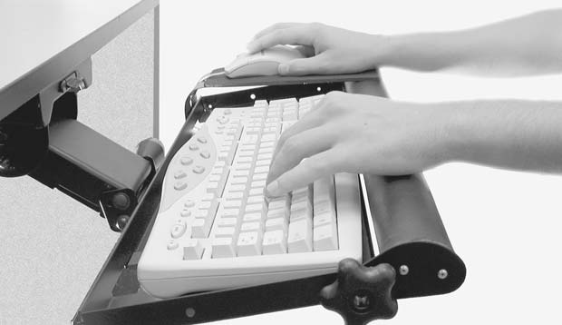
The tray should be large enough to accommodate a standard or split keyboard, with some space available for an input device such as a mouse, track ball, or touch pad. Make sure your knees clear the hinge attachment, since a central hinge can obstruct knee movement.

Some trays have an extra fixed or sliding mouse bridge that can be placed over the number keys. This feature is desirable, since it keeps your hands and arms comfortably close in to the keyboard. If you are not a touch typist, the pullout tray may be difficult for you, and you may be forced to keep it flat.

Computer Keyboards
Get one that suits your needs better., the elbow carrying angle, which varies from person to person, will affect the way you place your hands as you hit the keys. The greater your carrying angle, the greater the likelihood that you will need a split keyboard. In any case, I believe a split keyboard is generally a good choice for everyone. Virtually all keyboards now on the market have the cheaper-to-manufacture membrane cushioning for keys, rather than the more desirable individual spring loading for each key, which is best for good touch feedback.

Touch and Tactile Feedback
Research has shown that most of us press the keys with far greater force than we need to. Most keyboards no longer have spring-loaded keys, which are more costly to manufacture. Now a plastic or rubber membrane cushions the keys, so that the sense of contact is lost, as is the “click” that told you that you made contact. The effort required to be sure you’ve struck the key increases your workload and potential for injury.

Wrist Rests
The use of wrist rests is controversial. I prefer to call them wrist guides and ask my patients to use them only as guides. With the wrist fixed on the wrist rest, there is a tendency to use a windshield-wiperlike wrist motion, which is extra work and harmful. Finally, the wrist rest places pressure over the carpal tunnel area, which is not a good idea.

Movable cradles that attach to the desk to support your forearms, or chair arms that allow keying while you rest your arms on the chair are potentially just as harmful.

Laptop Computers
Laptops have a number of ergonomic disadvantages. They are small and have a constricted keyboard. They can be heavy when carried or actually used on your lap. The laptop screen is generally not separable from the keyboard, making ergonomic placement difficult. Input devices are miniaturized and difficult to operate. Special desks for laptops are now on the market; bring your laptop with you to try them out. Always attach a normal keyboard to your laptop when possible and set the screen at the proper height and angle.

The Mouse
The mouse is a significant source of injury for computer users.

Placement of the mouse is critical. When placed too high and too far to the side, the mouse can cause shoulder and bicep tendinitis as well as muscle fatigue. Ideally, the mouse should be at the same level as the keyboard and as central to the body as practically possible. Hold the with little or no gripping.

The Track Ball
As long as your hand is held slightly cupped and relaxed, the track ball is a good substitute for the mouse. Don’t overextend your fingers flat out over the track ball, because this will work the wrong muscles.

Pens and Pencils
The original “input device” is the pen or pencil, and almost everyone I have seen with RSI has difficulty with them. Holding the pen too tightly is a common problem. To break the tight grip, widen the barrel of the pen by purchasing sponge curlers used to set hair. Remove the plastic holder, then insert the pen through the hole in the middle of the curler. This provides a soft cushion for the fingers and widens the grip. Although there are also many expensive pens that you can buy with expanded cushioned bands, they are less effective than the curler, which is so cheap you can have one for each of your writing instruments.

Document Holders
Document holders are particularly helpful if used correctly. They attach to either side of the computer screen and have a clip to hold one or more papers. Always place the document holder on the side of your dominant eye.

Changing Workstations
Many people change workstations daily or share them. Carry a tape measure and use it to adjust your workstation so you have consistent work conditions. This applies to the entire workstation, not just your chair measurements.

Ergonomics and Stress
He points out that even if you have the best ergonomic setup possible, just sitting down at your desk can produce physical reactions that can increase stress. He theorizes that computers, for whatever reason, trigger a fight-or-flight response accompanied by an adrenaline rush. Inhaling slowly can trigger the body’s relaxation response and help to quiet this reaction. There are many stress reduction techniques that can be very helpful, but the main thing is not to drop your guard by thinking that good equipment alone will protect you from injury.

An Ergonomic Equipment Checklist
Here is a checklist of factors you should keep in mind as you set up or improve your workstation:

Seating
___ Proper size seat pan for your body ___ Seat pan has downward rolled front edge
___ Adjustable seat pan tilt ___ Wedge pillow if no pan tilt available
___ Seat pan moves both forward and backward
___ Seat back height adjustable to allow shoulder movement ___ Ease of adjustment
___ Adjustable armrests or no armrests ___ Short armrests that don’t bump into desk
___ Adjustable seat height ___ Adjustable backrest tilt ___ Soft seat
___ Movable on casters and swivels

Footrest
___ Flat ___ Angled

Desk
___ Desk height ___ Arrangement of desk equipment

Phone
___ Location ___ Phone jack ___ Phone headset

Pullout Tray
___ Adjustable with negative tilt ___ Knee room ___ Large enough to accommodate keyboard

Keyboard
___ Standard ___ Fixed split ___ Adjustable split

Input Devices
___ Placement ___ Mouse: standard or optical ___ Track ball ___ Touch pad ___ Joystick ___ Other

Monitor
___ CRT or LCD ___ Height ___ Size ___ Distance ___ Location ___ Tilt ___ Antiglare screen or shield
___ Flicker

Document Holder
___ Located closer to dominant eye

Writing Tools
___ Ergonomic pen or expander

9 Biomechanics: Using Your Body
Our body is a machine for living. It is organized for that, it is its nature. —Leo Tolstoy (1828–1910), War and Peace

Our focus, in biomechanics, is how we interact with our tools and how we can do so without incurring injury. There is an important relationship between ergonomics, the external factor or equipment, and biomechanics, the internal factor or the body. The essence of this relationship is that optimal biomechanical activity is easiest to achieve if the groundwork has been laid by using ergonomically sound equipment.

If you are not physically and mentally fit and your workstation is not adequately set up, you can’t expect to be able to use the equipment without injuring yourself, no matter how much you know about proper technique. Biomechanical training or retraining is the critical final step in a program that will help you recover from RSI.

The Importance of Training and Retraining
Musicians are taught technique, which is a form of biomechanical training, as well as the basic elements of music. Unfortunately, most music teachers have little or no background in the biomechanical or ergonomic aspects of musicianship and rely on what tradition has taught them. The same is true for training to use the computer, where emphasis is on learning to use software and not how to set up a workstation ergonomically and use your body in a biomechanically sound fashion.

A Personal Issue
Equipment used must fit the user properly, so that you can move in a biomechanically safe way. Biomechanics is a personal issue—a cookbook approach is not acceptable. A five-foot, two inch woman and a six-foot man cannot share equipment that is not adjusted for each of them.

A Dynamic Process
You can observe your movements, but you are likely to miss many of the subtleties of potential injurious moves and postures with the naked eye. Using videotape to document movement is a very useful way of studying work habits.

I routinely videotape my patients at work or in a simulated work setup. Time-lapse or real-time videotaping shows us what we are doing with our bodies. Both the trainer and the subject can study and correct awkward movements and positioning. With video evaluation, what had formerly been a matter of experience and a trained eye has become a partnership with the patient. People are usually surprised when they see how poorly they perform their work tasks. Try having someone videotape you at your workstation and see what I mean.

Workstation Biomechanics
Posture
When your mother told you to sit up straight, she was right! Throughout this book we have emphasized the importance of good posture. Good posture is best achieved by correcting muscle imbalances. This includes stretching and strengthening muscles that have either sagged or tightened, and thereby developing muscular balance among the neck, upper back, and chest. Even breathing can be affected because of tightened muscles that restrict rib cage movement.

Good posture is also helped by sitting in an easily adjustable chair, positioning the keyboard and the monitor comfortably, and having appropriate, specially corrected computer eyeglasses when necessary.

The postural deficiencies most often seen among computer users include rounded shoulders and a head thrust forward combined with shoulders that lack free range of motion. Postural deterioration evolves over time in those who don’t make efforts to prevent it from occurring.

Wearing a heavy backpack can damage your posture. For years, hikers and outdoor people have used backpacks to carry heavy loads of equipment, and now people are replacing handbags, briefcases, and schoolbags with backpacks. When used indiscriminately, backpacks can lead to postural misalignment. A particularly vulnerable group is young students, as we will see later in this chapter.

Correcting your postural deficiencies is one of the most important things you can do.

Positioning Yourself at the Computer
Dorsiflexion or Wrist Extension
Usually dorsiflexion happens when the keyboard is placed on a desk with the arms resting on the desk surface, which normally is too high for proper keying. In an attempt to do somehing ergonomic, many manufacturers have placed small, retractable legs at the far end of the keyboard—the wrong end! Using these makes matters worse by increasing the angle of the extended wrist as you key.

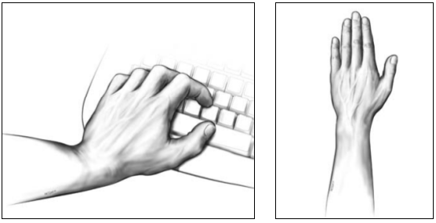
(1) The dorsiflexed (extended) wrist is a biomechanically harmful position (2) The neutral wrist position is biomechanically efficient.

There are clear reasons why dorsiflexion is harmful. First, with the wrist extended, one set of forearm muscles (the flexors) is stretched, while another (the extensors) is shortened. The shortened muscles have to pull against the stronger set of flexor muscles to keep the wrist in an extended position (static loading), causing fatigue from overuse. Static loading occurs when the muscle appears to be still, although it actually is working with the added disadvantage of decreased blood supply.

The extended wrist position also involves the flexor muscle group of the forearm in a detrimental way. The flexors are working to press the computer keys in a stretched state. This is an example of eccentric muscle contraction. It is like pulling on an already stretched rubber band, which is the most harmful way a muscle can be used.

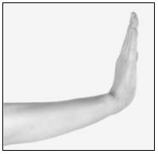
Dorsiflexion is a harmful posture for computer users.

It is very important to keep the wrist in a straight line (neutral position) so that tendons and other soft-tissue structures glide in a more or less straight direction. This is sometimes more easily achieved if an under-the-desktop pullout tray for your keyboard is used and put into a downward slope away from your body.

This position has an added advantage since it takes the elbow beyond the ninety-degree right angle that we so often see in ergonomic pictures. This right-angle position is incorrect because it places more pull on the ulnar nerve at the elbow.

If you are not a touch typist and feel you must keep your arms on the desk surface, make sure your chair is adjusted high enough so you can maintain a neutral wrist position and the shoulders feel comfortable. In any case, make sure you keep your feet firmly on the floor or on a raised platform if your feet don’t reach the floor. As you key and use the mouse or other input device, move your entire arm from the shoulder, instead of just activating the wrist.

Seat at the computer. with Wrists in a straight line, elbows slightly open past ninety degrees, good lower back support, feet on the floor, seat pan tilted downward, keyboard tray tilted downward, mouse close by.

Ulnar and radial deviation
(windshield wiper wrists)
The next most common harmful position is ulnar and radial deviation.

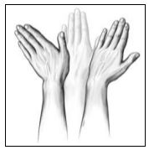
This position subjects the forearm tendons to twist and kink as they move the fingers. The consequences are strained and inflamed tendons, including lateral epicondylitis, DeQuervain’s tenosynovitis, and overworked muscles. Try to avoid the outer positions you see in figure 30, where the hands move like a pair of windshield wipers. From a biomechanical standpoint, these movements happen for a number of reasons. The most common is limited shoulder use, where placing the forearms on the desk surface restricts the large muscles of the shoulder from moving the arm. This is common in people who key, use a mouse, or play on a musical keyboard. The tendon kinking that results from ulnar and radial deviation probably also contributes Figure 30 (left to right). Radial to carpal tunnel syndrome, by increasing Deviation, Neutral, Ulnar friction and causing swelling and inflammation within the closed space of the carpal tunnel. Some of the new keyboards now available are angled to reduce the tendency to place the wrists in ulnar deviation. Other keyboards may have a central adjustment, which enables the angle of the keyboard to vary.

The Carrying Angle at the Elbow
Another factor that contributes to increasing the likelihood of ulnar and radial deviation relates to the carrying angle at the elbow. We are all born with different carrying angles of a fixed angle for each person between the humerus and the ulnar bones. Among my patients, this angle is usually 5 to 10 degrees for males. Women normally have a greater angle, usually 10 to 15 degrees.

People with an increased carrying angle tend to go into ulnar deviation at the standard keyboard.

Correction of the patient seen in Figure 33 uses a split keyboard, resulting in a neutral wrist position.

I recommend a split keyboard for persons with a carrying angle greater than 10 degrees. If you are overweight, your own body presents an obstacle to placing your arms against your sides. Flexed arms are pronated farther apart by the obese typist, who is forced to go into ulnar deviation.

Finger hyperextension
Another common but harmful keyboard technique is finger hyperextension, which means that instead of maintaining curved fingers (so that you can’t see your fingernails), the fingers are extended flat on the keyboard. People with short fingers often get into trouble, straining to reach a distant key. This straining is often the cause of pain in the forearm and elbow.

Women with long nails are more or less forced into hyperextension. Get rid of long nails, because they force you to hit the keys with fingers extended. The maximum nail length for a typist should be 1 ⁄ 16 inch.

If we study the function of the hand, we see why hyperextension (holding the fingers completely flat out) is harmful. This concept is often poorly understood because it involves knowing that the intrinsic muscles of the hand can have dual functions.

Try to flex your fingers while they are in extension and see how much harder it is! Curve your fingers slightly and you will have maximum finger mobility. It is important especially for pianists to understand this concept.

Finger hyperflexion
Hyperextension and hyperflexion are extremes that are inefficient for hand use. Between these two extreme hand positions is a middle ground where the hand operates efficiently and safely.

Alienated or hyperextended thumb
In observing many people typing, especially those who touch-type, I have found a significant percentage who are using only one thumb to press the space bar. The unused thumb is constantly held up and outward, alienating it from the rest of the typing fingers. Try holding one thumb in this position and you will see that the fingers tend to hyperextend, making it more difficult to flex them and placing greater strain on both hand and forearm muscles. This causes loss of dexterity and efficiency and can lead to tendinitis at the base of the thumb. The group action of the thumb and fingers is complex. To retrain yourself it may be necessary, at least temporarily, to eliminate both thumbs from keyboarding, which will slow your typing speed until you heal. Normally, the faster you type the more likely you are to get injured.

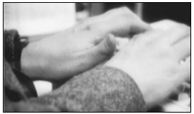
An alienated thumb, held away from the spacebar. This is an inefficient use of hand muscles.

Thumb hyperflexion
Moving the thumb downward and tucking it under the palm is commonly seen among musicians doing arpeggios and occasionally among typists. This repetitive thumb hyperflexion can cause DeQuervain’s tenosynovitis.

Unusual Biomechanical Actions
Kneading
Some keyboard users continually flex and extend their fingers while at the keyboard in a dough-kneading action. This is an inefficient movement that increases their workload substantially and predisposes them to greater likelihood of injury.

Incorrect mouse use
Another source of thumb tendinitis is the mouse. Although mouse placement is critical to prevent arm and shoulder problems, it is the gripping of the mouse that leads to a disabling thumb tendinitis. Having the mouse higher than the keyboard (flexion) or too far to the side (ulnar or radial deviation) or using it with the wrist bent up (extension) are all awkward positions that need to be corrected with biomechanical retraining. Some typists stretch their fingers flat out while using the mouse, the touch pad, or a track ball, which is very inefficient because it pits the flexor muscles against the extensors.

RSI and Kids
The American Academy of Orthopedic Surgeons recommends that a backpack should not exceed 20 percent of a child’s body weight. If you are feeling pain, try avoiding backpack use for two weeks; if the pain subsides, then the cause is probably the backpack. First, try to eliminate all unnecessary books. For any backpack user, an upper body exercise program should be part of the daily routine. Kids might not think they’re cool, but backpacks on wheels are now available and should be considered.

shoulders were rounded and their heads were thrust forward, a position that can compress the nerves of the brachial plexus between two scalene muscles of the neck.

10 . At Home with RSI

Mid pleasures and palaces though we may roam Be it ever so humble, there’s no place like home. —J. H. Payne (1791–1852)

When you are recovering from RSI, improvement in the ability to perform tasks is an important sign that you are getting better.

Most people with RSI can handle the activities of daily living to a limited degree if they pace themselves. Athletes are trained to pace themselves. The same should be true for those who perform ordinary everyday activities. Pacing your work over several hours may get you through the tasks of the day without incurring increasing pain that forces you to stop work entirely.

If You Live Alone
Be inventive in doing your household chores. Perhaps setting slightly lower standards of neatness by letting go for a while and pacing yourself would be a desirable means of coping.

The Telephone
If you are using the phone a lot, a headset should always be attached to the phone.

Sleeping
Sleep promotes healing. Normally, we all spend a third of our lives in bed. Unfortunately, the time you spend reading in bed can only contribute to your problems if you are injuring yourself while you do it. Most people with RSI have postural problems involving their necks. Curving your spine and neck to see the TV screen or reading a book when your hands hurt and you can’t support the book doubles your trouble. Learn to sit while you read or watch television. Save your bed for restorative sleep, sexual activity, and relaxation. Positioning yourself for restorative sleep involves protecting your arms, keeping them relaxed, and not bending at the elbow or wrist.

The words “restorative sleep” are to be taken seriously; get as close to eight hours a night as you can, but don’t spend all your time in bed.

Relaxation
The very fact that you have RSI may indicate that you are normally a busy, active, or tense person. Learning to let go and relax is one of your tasks. High stress levels can affect your recovery and your therapy. Some activities that have helped our patients relax include music, theater, dance, self-awareness programs, body awareness programs, meditation, modified yoga, retreats or vacations, and lifestyle changes that can mean anything from modifying the way you work, to changing your job, to moving to a new location, to changing your exercise and diet regimen

Reading
In my experience, the last activity to improve during recovery is the ability to read comfortably holding a book or newspaper. A reading stand or a special pillow to prop up the book is available

Hand and Finger Movement
Most of my patients who developed RSI doing computer work also have difficulty with handwriting. Here are a few pointers that can help. Certain pens are easier to use than others. A standard ballpoint requires uncomfortably tight gripping and pressing. Fat pens are available for better gripping. A fountain pen with a smooth-flowing point can be easier to use than a typical ballpoint pen.

A sponge hair curler also can help ease the strain of gripping the pen. As with any other activity, writing requires that you pace yourself.

Driving
Know your limitations—don’t wait for pain to tell you to stop.

You will have to add your own tips to the ones in this chapter. Be inventive about the things you absolutely must do, and give up the things you can dispense with. Above all, take help where you can get it, and remember to save your upper body for home exercises and the important work of getting better.

11 . Getting Back to Work

If an injury reporting system is set up to flag ergonomic trouble spots, the potential problems can be identified and corrected.

In my own experience, 60 percent of RSI patients continued to work despite the fact that they were injured.

Back to Work
Once you have RSI and are in treatment, you will have to start thinking about returning to full or part-time work, the most difficult nonhealth-related challenge you will face with RSI. To achieve a return to normal function, there are certain goals that you will need to meet.

You must participate actively in your rehabilitation. Passive participation simply will not be enough to get you through your treatment. No therapist can do your home therapy for you, and you make no progress without your home or gym work. Maintaining the stretching and strengthening exercises is what advances your professionally supervised therapy.

You will have to learn by trial and error to limit both work and nonwork activities before you feel pain. One way to do this is to time an activity and note when you begin to feel uncomfortable or feel pain. Limit this activity to a few minutes short of the onset of pain the next time you do the activity, and become aware of the feeling you get when pain is about to ensue. With activities of daily living, you have to discipline yourself so you don’t schedule more than you can achieve. Above all, you must attain and maintain good posture, because we know that bad posture is a trigger for harmful injuries of RSI.

An important part of retraining is to note what your upper body feels like when it is no longer tight, and when the larger muscles of your upper back begin to work in conjunction with the shoulder, arm, and hand muscles. This sense memory should be recalled whenever you are exercising. You must limit pressure on neck and shoulder muscles and nerves, which means you should no longer carry heavy knapsacks, shoulder bags, briefcases, or shopping bags.

You must become aware of awkward positioning and activities during retraining. Even seemingly minor things such as keeping your nails short is important so you avoid inefficient use of your hands. Take sufficient rest breaks from any potentially harmful activities. Five to ten minutes every hour for office workers is a good idea.

Retraining for work should be done in a structured and orderly fashion so there is a gradual resumption of activities that previously caused symptoms. Know your limits: getting an idea of the severity of your injury is very important and can be useful in helping you determine whether you are ready to return to work. Impulsive behavior and a rapid return to full activity because you are feeling better can lead to a flare-up and delay recovery.

Adherence to your rehabilitation program and your awareness of the extent of your injury will keep you from a major relapse. Rehabilitation will probably take longer than you like, and you may have an occasional relapse, but keep at it! People you work with may become problems. If they don’t understand what you are going through, they may resent having to pick up some of the slack from you. If you are recovering from RSI and have returned to work, you may feel pressure to resume your usual pace. Don’t do it. Instead, try to make your fellow workers understand what you are going through.

After about a month, Dr. M. reported improvement. After six months, he was able to resume a full work schedule while continuing his exercise and strengthening program.

Are You Ready to Return?
Completely Limited
Here you are unable to perform any activities of daily living or work activities without setting off symptoms that may last weeks or even months. These symptoms are usually constant and include aches, pain, numbness, tingling, and spasms. Obviously, return to work is out of the question.

Very Limited
You can awake pain-free and perform four or five arm-related activities before the onset of pain and other symptoms. These symptoms can last for several hours, decrease with rest, and increase with further hand activity. The symptoms are usually gone by the next day. Return to work cannot proceed easily under these circumstances.

Moderately Limited
For brief periods, you can perform activities of daily living and work-related activities without the onset of symptoms. You are free of pain most of the time except after strenuous hand and arm activity. A low level of sustained activity is tolerated, but if limits are exceeded, pain may last for the next day or two. If this is your situation, limited work with numerous rest breaks is possible provided discipline is maintained.

Mildly Limited
You are pain-free most of the time unless activities are pushed beyond ordinary functional levels. Accordingly, short deadlines and binge work must be avoided. Work is possible, but only after establishing the need for these limitations with the employer and fellow employees who may feel they are carrying your load.

Returning to work is not a decision to be taken lightly. Although most people are eager to get back, returning too early can be disastrous. It is worth the effort to give careful consideration to your physical state before you decide to go back.

12 . RSI and Musicians
Musicians need physical conditioning, but this fact is often ignored in the traditional music schools and conservatories. Music pedagogy is very traditional and still relies on the many years of experience passed down through generations. We are losing many talented musicians to injury early in their careers because they (and their teachers) ignore the need for physical conditioning and lack the necessary knowledge to use biomechanically correct technique to prevent injury.

By applying concepts of physical conditioning, ergonomics, and biomechanics, musicians can not only prevent injury but also gain a competitive edge: the quality of the music delivered will improve because of better positioning, greater strength, and finer muscular control.

When a physical examination is performed on an injured musician we are likely to find the same kinds of problems that we have described in this book for computer users and other workers, with only slight differences. Emotionally speaking, musicians are very caught up in their music; when an injury occurs it can be psychologically devastating, threatening to undo years of study and hard work.

The ergonomic and biomechanical aspects of the treatment of musicians are very specific.

With a combination of musical biomechanical retraining and the physical and occupational therapy that is always required in RSI injury, the results can be spectacular.

The Ergonomics of Musical Instruments
Many musicians find themselves trying to adapt to an instrument, instead of adapting the instrument to themselves.

You don’t wear one-size-fits-all shoes; a musician shouldn’t have to play a one-size-fits-all instrument.

Beyond some modest changes in the form of the instrument, the only practical way to avoid injury is to do what we are proposing for the non-musicians in this book. There is a myth among musicians that exercising may actually be harmful, making the musician “muscle-bound” and causing a loss of dexterity. Nothing could be farther from the truth. The musician must regard himself as an athlete, maintain proper posture and strength, and use a proper ergonomic and biomechanical approach. The less ergonomically adaptable the instrument, the more the instrumentalist will have to pay attention to the biomechanical aspects of playing.

Piano, Harpsichord, Organ
In this group of instruments, physical conditioning and posture need particular attention by the musician. Correct posture and distance from the keyboard as well as light touch and properly curved fingers are helpful in reducing soft-tissue trauma.

Computer keys, electronic keys, and organ keys bottom out to a hard surface with minimal cushioning, but piano keys don’t. Hitting uncushioned keys too hard is the equivalent of a ballet dancer working on a concrete surface, instead of a sprung or cushioned floor, which is now standard for dance stages (and wrestling rings!).

Clarinet, Oboe, French Horn, Trumpet, and Bassoon
Ideally the clarinet or oboe should be unloaded from the thumb.

Ergonomic principles apply to the French horn, where the levers are often not long enough. Soldering extensions to the levers can alleviate this problem. On the left hand, the fifth-finger open ring may be improperly placed and should be correctly positioned for this finger. A knee holder consisting of a sponge attached to the thigh will prevent discomfort from the notch that the horn usually presses into the thigh.

Both French horn and trumpet players can sustain complete or partial tears of the muscles surrounding the mouth. This is often referred to as “the Satchmo syndrome,” which is the result of playing the instrument for prolonged periods while hitting high notes. The French horn has a particularly narrow rim on the mouthpiece, which may need to be changed. Surgical repair is possible if long periods of rest do not cure it.

In examining injured musicians, it is critical to observe them playing their respective instruments; videotaping is very helpful in this regard. Modifications of ergonomic and biomechanical factors are extremely important with musical injuries. Therapy proceeds along the same lines as for any RSI patient.

13 . Other Causes of RSI

I n addition to those already mentioned, many other work-related upper extremity activities can lead to RSI. Although the sources of injury may differ, RSI is a common final pathway. In many cases these activities are carried out in addition to other repetitive functions, such as computer use. The complaints in this group are like those of many other RSI sufferers. The culprits are similar: repetition, sustained activity, awkward positioning, deconditioned state, poor ergonomics.

14 . Beating RSI: A Five-Step Protection Plan

There are obstacles to overcome even if you’ve undergone successful treatment. Relapses are not uncommon, especially if you revert to your old ways of doing things. These can be minimized and eventually eliminated as you learn how to cope with the illness. Keep in mind that with RSI you are recovering, not necessarily recovered. What follows is an outline of the steps you need to follow toward your goal of beating RSI for life. It won’t be easy, but it is certainly worth the effort.

Step 1: Examine Your Life
Assess your risk for injury by taking a good look at your activities both at work and elsewhere. You might find it useful to write down each of your daily activities, along with time spent and degree of intensity. The list can give you a good idea of your risk profile. Think about what’s going on in your life every day and ask yourself questions: Does your boss subject you to long hours, short deadlines, and binge work? Do you do this to yourself? Do you work more than two to four hours at a time at a computer? Do you use a mouse, laptop, phone, or other equipment intensely? Even pushing and pulling on filing cabinets can lead to backaches and postural problems and can contribute to RSI. Are your chair, workstation, and other equipment sources of obvious discomfort? Is your life full of enormous repetitive chores and responsibilities that put you under stress? Are you having trouble sleeping or eating? Has your work affected your sex life? Do you feel depressed? In doing this self-assessment, don’t forget to recognize the potential for injury from what you do when you are at home. While such activities may be a symptom of injury, they can also contribute to your problem. Dusting, vacuuming, washing floors and dishes, gardening, and writing can all tip you over the edge. Certain sports can contribute to injury. Golf, tennis, basketball, and skiing can all enhance risk of injury. If you think about these factors as you examine your list, you may notice that you are doing too much. This self-appraisal is the first step in helping you become informed about what is necessary to reach your goal.

Step 2: Get a Physical Evaluation
Although RSI is sometimes described as a musculoskeletal illness, it also involves nerves, muscles, tendons, ligaments, and vascular structures. Taking the trouble to learn about your own anatomy will help you understand how that information relates to other steps in this program.

If you have been working for years slumped over a desk, your posture is bound to deteriorate. These changes mark the beginning of a continuing process that can eventually result in RSI even before age thirty. The people I usually see in my practice are relatively young, otherwise healthy, but nevertheless disabled. This paradox of a healthy-looking patient with severe physical limitations is one cause of the abundant skepticism of health care professionals.

Step 3. Plan Prevention and Cure
measures have to include taking care of workstation deficiencies, problems at home, and other issues relating to your physical activities.

Once you have found the right treatment team, you can begin working with the physical or occupational therapist, who can guide you in a carefully orchestrated program of stretches and exercises.

your job is to do the stretches and exercises at home under the guidance of your therapist. I can’t overemphasize the importance of continuity and consistency in performing exercises and stretches on your own. This is where people who have improved get hung up—they stop the exercises because they think they don’t need to do them anymore, or because they’re simply bored with them. If you become too busy to do them, this may be a sign that you are headed for a relapse. Daily exercise accomplishes several things. It enables you to defeat the process of postural deterioration, which progresses insidiously over time and leads to RSI. Stretching and strengthening muscles improve blood supply to all soft tissues, the key to both avoiding relapse and preventing problems to begin with. The neuromuscular therapeutic program will emphasize upper body work, but you shouldn’t neglect the condition of your lower back and extremities. Problems below can affect the upper body, too, because muscles that are deconditioned can affect the function of muscles elsewhere.

Step 4: Pay Attention to Ergonomics
Fit the equipment to yourself, not yourself to the equipment. We should not be made to put ourselves in awkward positions to accommodate the instruments we work with. It is critical to embrace this concept because it will add to the likelihood that your recovery and RSI prevention will be permanent. Changes you make in your workstation or your musical instrument can play an extremely important role in keeping you out of trouble. They may even be enough to make a dramatic impact on recovery. This may require investing in new equipment, such as a chair, pullout tray, keyboard, or mouse. Musicians might have to modify their instruments or make other positional changes. We have looked at some of these issues in chapter 11. By doing this you’ve added an additional layer of protection against injury.

Another important component of ergonomics is what might be called intrinsic ergonomics or biomechanics—the ways in which you use your body to perform work tasks. To correct biomechanical deficiencies that, because of awkward positioning, place a strain on soft tissues

The trick is to use your body efficiently—in essence, getting more miles to the gallon. Many, but not all, physical and occupational therapists are adept at evaluating movement. If you can find someone skilled in this area, it can be very helpful.

What else can you do to make it easier to prevent RSI or improve your condition? Remember that you are essentially an athlete who has to remain in shape to work safely. Weight loss, proper diet, exercise, stretches, recreation, and rest breaks can all help you successfully manage your RSI program. Doing these things consistently for a lifetime is really a challenge, but it’s certainly worth the effort.

