Part 1
For part I, we are asked to design a fully-differential closed-loop programable gain Opamp with the following specifications:
Gain (closed-loop measurement):
- Programmable: 4, 8, 12, or 16 V/V
-3db Bandwidth (closed-loop measurement):
Phase Margin (open-loop measurement)
- Greater or equal to 70 degrees
Noise input referred (integrated input referred noise over bandwidth)
- Less or equal to 100uVrms at high-gain setting
Biasing Circuit
- All bias circuitry on-chip, with only 1 off-chip precision resistor available.

Topology Selection
Initially starting from the single-ended opamp design, the decision was whether the use of a single-stage, a single-stage approximation or 2-stage opamp. More stages normally are advantageous to enhance the gain of an amplifier (for example the standard diff pair + common source topology), however with more stages also comes more parasitics and hence reduced bandwidth, or said otherwise it becomes increasingly difficult to stabilize the opamp to achieve a larger bandwidth (recall the largest bandwidth that can be achieved is that of the ft of a single stage transistor amplifier)
Therefore in principle, for a single-stage:
- Gain is limited: by the gm x rout of one transistor (assuming single transistor amplifier)
- Bandwidth is maximum: only limited by ft of single-transistor and op. condition biasing
- Compensation is simpler: output compensation (dominant pole) is often sufficient
Special topologies (e.g. folded cascode opamp, or current-mirror opamp or telescopic cascode opamp) albeit by their own nature consisting of more than one pole can be effectively designed as single-pole approximations, this topologies can alleviate the gain limitations of a purely single-stage amplifier while still being approximated and designed as single dominant pole systems.
For 2-stage opamps:
- Gain is large: consisting of the gain of each stage
- Bandwidth is reduced: limited by the poles introduced by each stage (which now need to be compensated for)
- Compensation is more difficult: you need a compensation strategy for the additional node-poles introduced in the circuit
In the case of opamps which are meant to be used in a closed-loop configuration we require a high enough open-loop gain. (sometimes greater that what a single transistor can provide you)
I.e normally if you can “get away” with a single-stage, i.e. if you can meet your desired gain for your application with a single stage, this is often the way to go.
Single-stage amplifiers (e.g. for RF or high-speed amplifiers applications) have large bandwidth but gain may be insufficient for opamp applications. Single-stage “approximated” amplifiers have enhanced gain and sufficient bandwidth (often a good tradeoff for analog opamps): often a good compromise for analog opamps. Multi-stage amplifiers can yield larger gain but are difficult to compensate to attain the same bandwidth
In our case given a 3db bandwidth of 50MHz in the closed loop and a max gain of 16, we need to attain a intrinsic opamp bandwidth larger than approximately around >800MHz (precise calculation below) with sufficient intrinsic gain around 70dB (precise calculation below).
We opted to use a single-stage approximation design – a folded-cascode opamp – which should support a bandwidth larger than our requirement, an easier compensation procedure to attain our phase margin, noise primarily dependent on the input capacitor (which we have control over) and a maximum gain in the vicinity of around 70dB with the option of gain boosting if necessary to meet our gain error (this assumption was accurate as will be seen later, to maintain close loop error below 0.25% we required the use of gain boosting to meet the gain error spec).
Following the lecture material, there are some good example references to aid in understanding the design for programmable gain feedback amplifiers. In our case, if we limit our feedback to a capacitive network it is possible to employ the simpler single-stage “dominant pole” amplifiers, and the book reference (section 6.6) elaborates on calculating the effective load capacitance we need to account for in our bandwidth calculations for this kind of opamps (explained below). In addition, and perhaps most importantly we have a reference design procedure outlined in the book, and a reference design which we explored and gained insight for in assignment 1. The general topology for the closed-loop amplifier we decided to design for was:
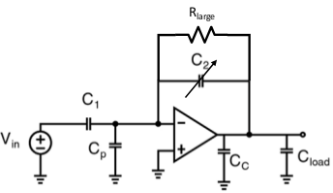
With, the general topology for the single-ended folded cascode opamp as:

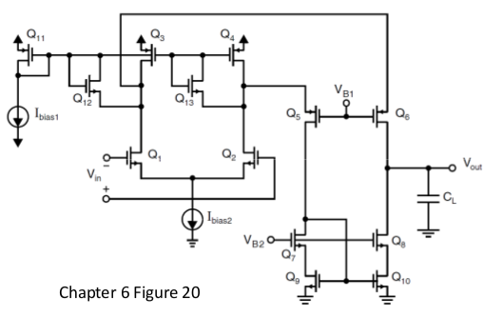
Design Procedure (for folded cascode Opamp)
Note (what didn’t work): for future reference
(1) Initially a lot of time was spent unnecessarily working backwards from the previous assignment 1 design to aim to increase current (while tabulating and measuring the devices operating region to maintain them in saturation) to increase gm of the input pair, this was very time consuming and lead to suboptimal results that ultimately we had little intuition for.
(2) After calculating our input capacitor given our noise spec, designing for said large capacitive load (and not the effective load) while meeting our bandwidth lead to unreasonably high gm values (order of gm around 13mS needed for the input par) which lead to unpractical current consumption values (on the order of 1mA for the tail current).
(3) After mis-calculating gm_in above and the necessary gain for our error spec, aiming to calculate the necessary output resistance and hence the gm and gds of transistors from first principles, to attain such gain spec – an unpractical experience.
After a lot of effort spent: the following is the design procedure that we ultimately followed to arrive at our final results.
1. NMOS and PMOS Characterization test-benches
Initially to get an idea for the performance we could get from our devices, we built two standard test-benches to find the (1) gm/Id per W to find our nominal device size, then (2) gm/Id curve to find the current necessary to bias our devices to attain the necessary gm spec (to be calculated later on).
We often went back to our characterization testbenches to size and bias transistors to achieve the necessary operating point.
2. Calculate C1 given the noise spec
Given our maximum input referred noise:and our equation for input referred noise therefore which we calculated to be Therefore we chose to use a value of C1= 2.7pF
Here our value of lambda was the average from that obtained for all transistors from spice simulations. (alternatively we could have used 2/3)
3. Calculate C2 given gain spec
From our maximum and minimum gain spec we can calculate the values of C2_min=168.75fF and C2_max=675fF.
4. From the bandwidth and capacitive network calculate necessary gm of input pair
(section 6.6 from reference textbook, and general topology diagram above)
The canonical expression for the intrinsic unity gain frequency of the amplifier:
Where Ceffective is important for the design of the folded cascode amplifiers: the effective load the amplifier needs to drive.
In our case, as our amplifier is operated without a subsequent load and we aim to use the effective capacitance itself to achieve dominant pole compensation (without the use of additional Cc), we can assume Cc = 0, Cload = 0, C2_max=675fF, C2_min=168.75fF, C1 = 2.7pF and we can calculate our parasitic capacitance as half of the Cgs of our input pair at max dimensions (W=180um) i.e. Cp=Cgs/2 where and hence Cp=204fF Therefore we can calculate Ceffective for two cases where C2 is max and min.
and similarly
At this point we need to calculate the necessary intrinsic Ft of the opamp, given:
Here it is important to remember that for the open-loop response (including the feedback network), wt is equal to the closed loop -3db bandwidth of the closed-loop amplifier i.e.
in our case then
Additionally the feedback factor of the network can be calculated as:
and
Now we can calculate the intrinsic unity gain for the opamp as:
giving and similarly therefore we should design for Fta in the vicinity of 900MHz to meet our bandwidth requirements.
Hence, at this point we can calculate the necessary gm for our input pair to meet our bandwidth as:

5. Calculate Id and sizing needed for input pair devices
Now that we know the necessary transconductance of the input pair, we want to choose the largest practical device (180um largest, from book reference) to yield the greatest gm and lowest Veff: this transistor is to be operated at the verge of sub-thresshold to attain a large transconductor efficiency (gm/Id).
We know the bias current for each input transistor must necessarily be larger than that achieved under sub-threshold operation (max limit for gm/id trans-conductor efficiency), in our case:

Now we went on to our NMOS characterization testbench to obtain the necessary Id current given gm1=3.133mS, W=180um and Veff=0. Our results show that we need to bias at Id1,2=151.7uA ~ 150uA.
6. Calculate bias currents based on input pair current requirements
Our input pair requires a total bias current of Ibias2~300uA. Furthermore we are recommended from the book to allocate the total current in a 4:1 ratio as: In our case this translates to Icasc = 75uA (I5,6=37.5uA), leading to a total current of 375uA (I3,4=187.5uA).
Setting the bias reference current to 1/10 that of I3,4 then yields Ibias1=18.75uA~20uA.

7. Calculate transistor sizes based on current estimates for each device
(enforce Veff~0.24 and saturation operating region)
Knowing the drain current required for each device, the effective overdrive voltage, the operating saturation region and the minimum length (Lmin=400nm) for each device, we can calculate approximate transistor sizes as:
M1,2: 180um (largest from book reference)
M3,4: similarly for the M5 and M6 PMOs devices,
M5,6:
M7,8=M9,10:
M11: W11=W3,4 / 10 = 3.76um ~ 4um (recall Ibias1 is ¼ of I3,4)
M12,13: these are the slew-rate helper clamp transistors (chosen to be minimum dimensions).
8. Determine bias voltages (vb1 and vb2)
(assuming Veff~0.24)
Vb2: Here M9 and M10 are part of our NMOS wide swing current mirror where it is desirable that they have the lowest Vds but without going into triode. From section 6.31 and assuming Veff=0.24
therefore since we bias right before entering triode Therefore we can calculate Vb2 as:
We choose our bias source Vb2 to be 1.05 (same as that for assignment 1)
Vb1: M5 and M6 are a symmetrical PMOS cascode (to M7 and M8) which we can take to have a PMOS cascode voltage of
9. Calculate required intrinsic amplifier gain given closed loop gain error
The opamp closed loop error can be given by:
N: is represent the additional open-loop intrinsic amplifier gain needed in order to achieve the gain error spec, therefore in our case (0.25% error):

And our maximum closed-loop gain at 16V/V is 24.082dB, therefore our minimum open loop gain we need to have to meet the error spec:
Unfortunately the folded cascode topology can reach up to approximately 70dB of gain, thus we will require a way of enhancing our gain through the use of gain boosting.
The final single ended amplifier design with sizes can be seen below:
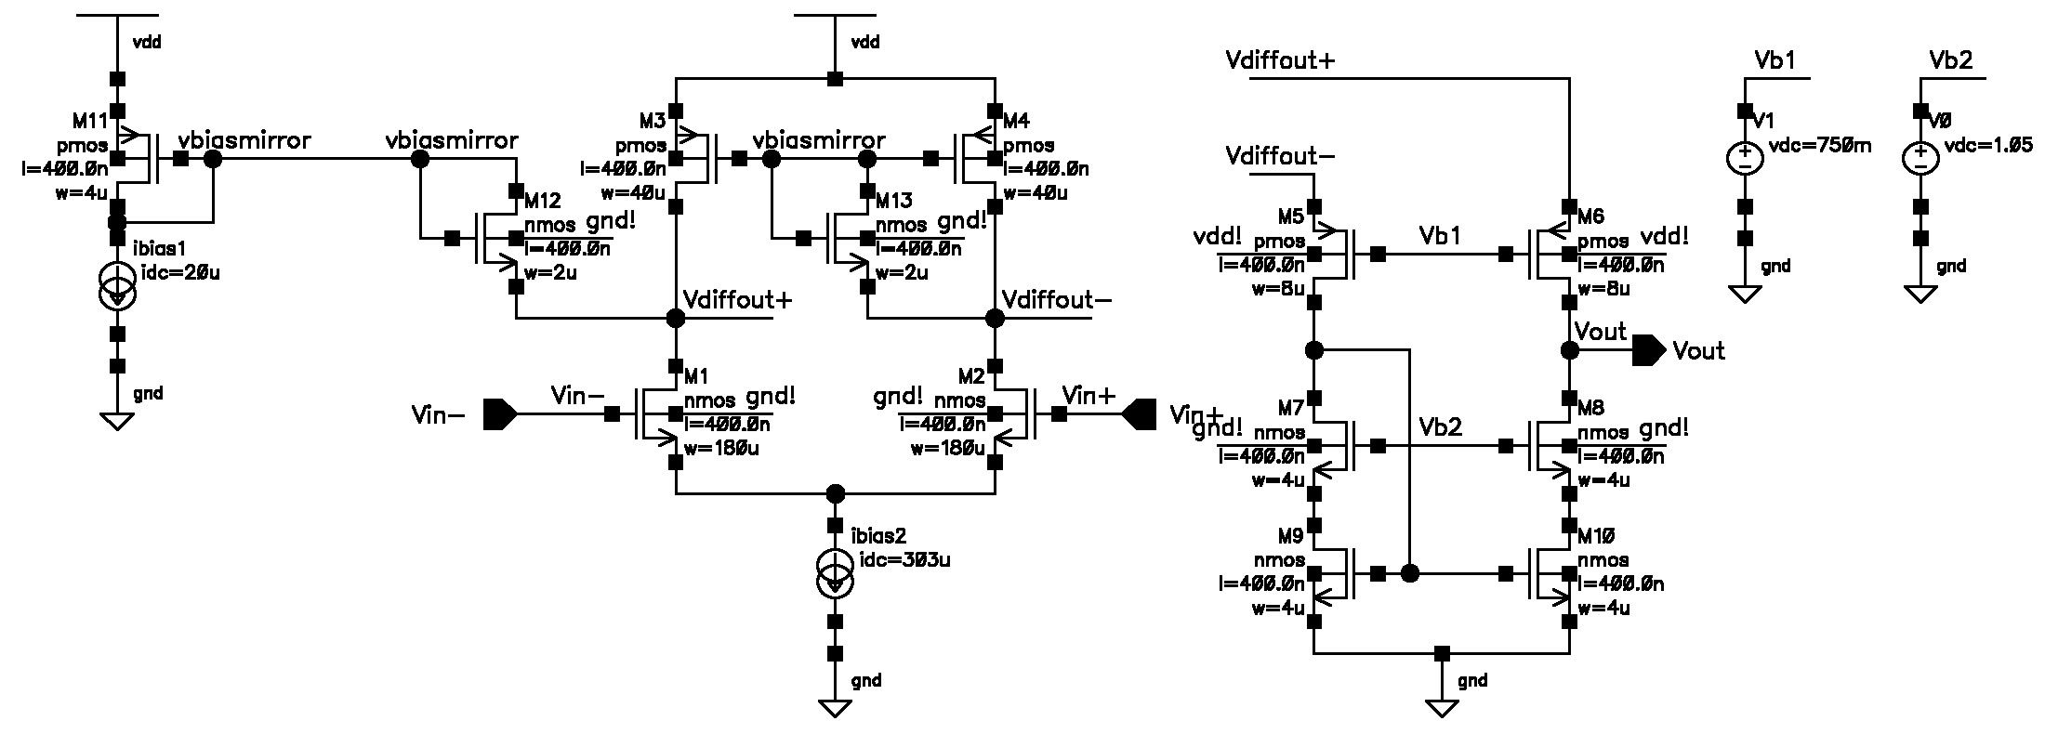
Note the M7-10 transistor sizes were increased to 4u, as this has a slight improvement in performance.

Single-ended Open Loop Response
The following is the open loop response of the single-ended amplifier at maximum gain setting and minimum gain setting (open-loop dc gain). Recall from our calculations the open loop unity gain frequency should be greater than 50MHz (Ft>=50MHz), and our phase margin greater than 70 degrees.

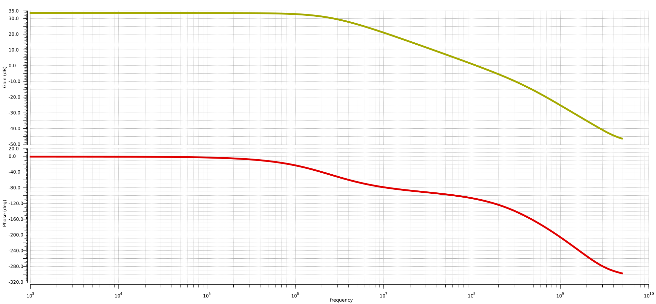
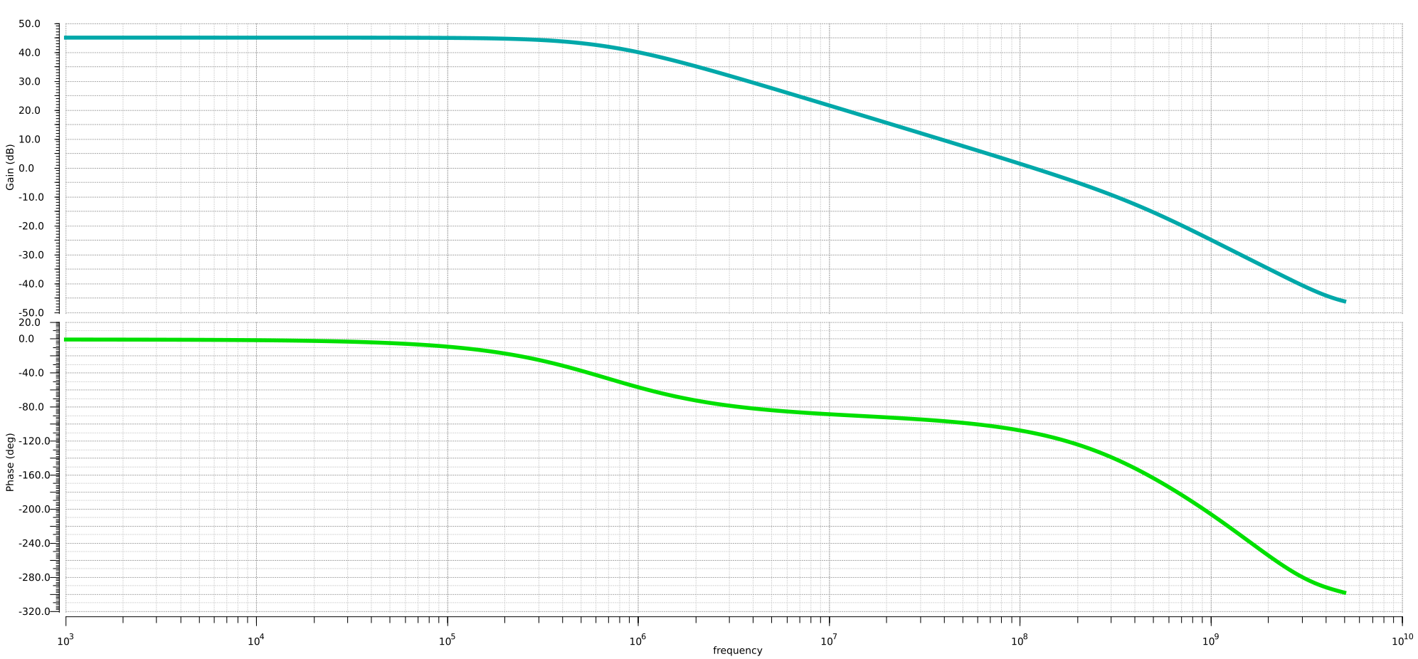
Results at max gain setting and min gain setting
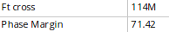
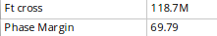

Our results indicate a open-loop unity gain frequency much larger than our required 50MHz and a phase margin of around 70 degrees.

Single-ended Closed Loop Response
Now we go on to the closed-loop amplifier testbench (same as assignment 1) and verify the performance of the Opamp.
The following is the closed loop response at all of the gain settings. A resistor Rlarge=95MΩ was used to help with convergence and to set the 10KHz lower bandwidth.
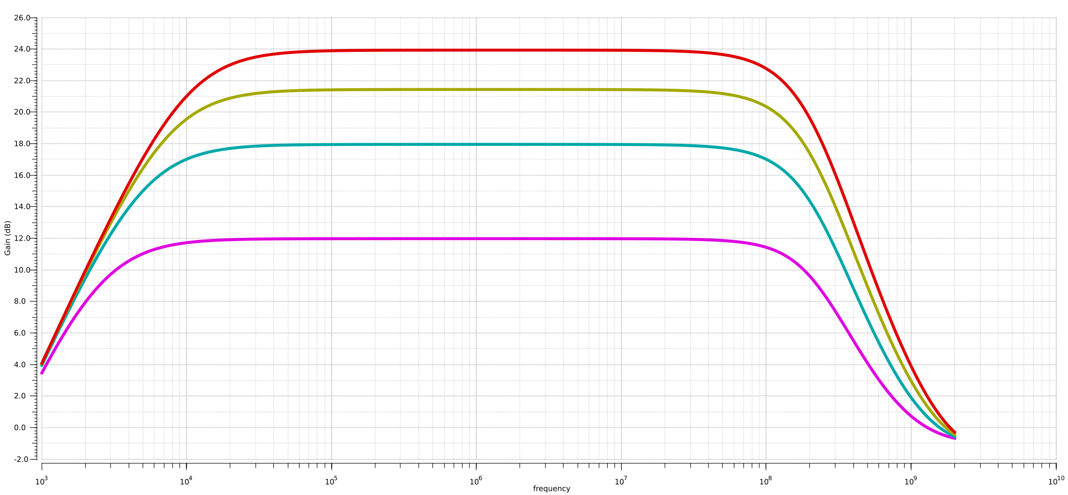
Note for the worst case (at max 24dB gain) the -3db bandwidth measured at 21dB is greater than 100MHz and larger than the necessary 50MHz – Meeting our bandwidth spec for the single ended opamp. The gain spec is very close but indeed if one zooms in, it is possible to see the gain error.

Fully Differential Folded Cascode Opamp
(see results at the bottom of this section)
Having our single-ended amplifier, now we moved incrementally towards making our opamp fully differential using our differential amplifier closed-loop response testbench (below), the following are the steps we followed sequentially:
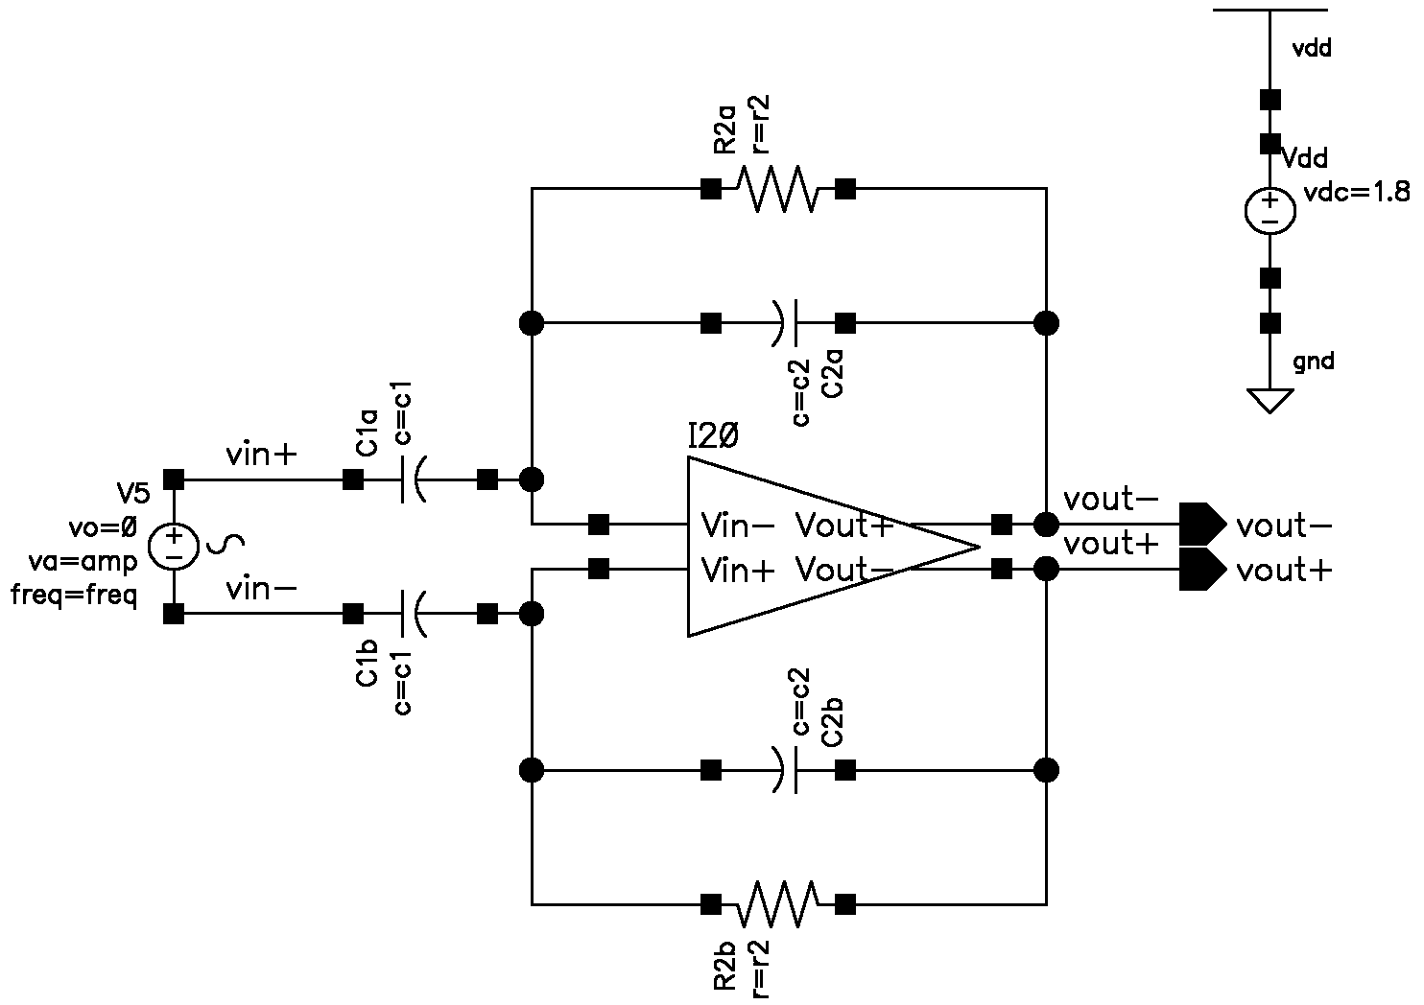
1. Initially we started from our single-ended design by disconnecting the gate for M9 and M10 and connecting it directly to be driven by an ideal current mirror NMOS bias voltage (with same dimensions), this means we provided the bias voltages for the bottom NMOS and cascode NMOS and upper PMOS and cascode PMOS with ideal sources (or mirrored sources).
2. Next we checked for the correct operating point for each transistor, otherwise updating the bias sources accordingly to have all transistors in saturation.
3. Next we applied a very small signal and measured the transient output response at time=t0, before common-mode slow drift to the supply rails took place.
- We verified the desired time-domain operation of the amplifier
4. Next we did an AC analysis identical to that for our single-ended closed loop amplifier to verify equal performance but now differential input and output.
The initial performance (without CMFB and ideal sources) of the differential design was thus tested.
5. At this point we proceeded to the design of the CMFB circuit, we decided to use a CMFB circuit presented in reference [1] which outlines the principles of operation and was intuitive to understand.
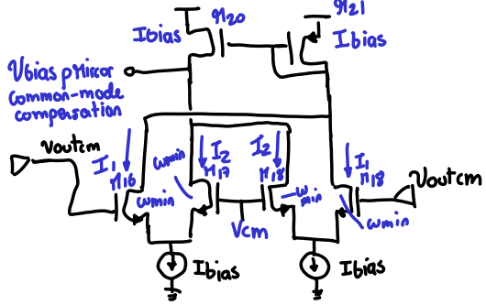
Intuitively we see that if Voutcm is equal to our desired setpoint of Vcm then we have no common-mode error and the branch currents divide equally, and I bias is mirrored (and scaled) to our upper PMOS devices in our Opamp.
If however Voutcm increases above the desired Vcm current I1 increases and correspondingly current I2 decreases. If Voutcm decreases above Vcm current I2 increases and I1 decreases. Hence we have where Vcm_error is: our sensed Voutcm minus our desired Vcm setpoint. This Ibias plus/minus ΔI is mirrored to our Opamp PMOS top mirror and introduces a negative feedback loop to reduce the common-mode error until I1=I2.
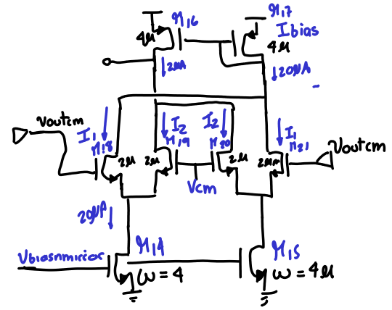
We size our mirror devices to have the same 4um dimensions as our M11 reference transistor to carry the same 20uA of bias current.
We size our differential pair devices with minimum dimensions to present a negligible load to the output and maintain the desired bandwidth spec.

The following is the CMFB circuit with sizes and annotated node voltages:
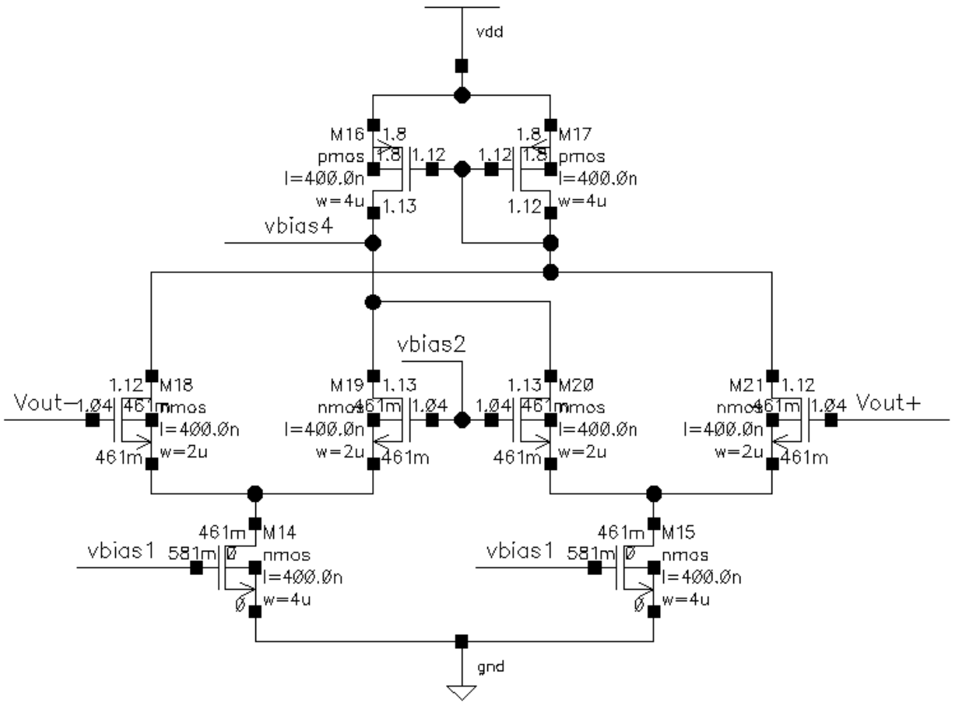
6. Next we define our Vcm voltage and test the operating point to make sure our CMFB circuit works at dc.
7. We then test our common-mode circuit by applying a common-mode step at the input and inspecting the settling time to the common-mode setpoint at the output.
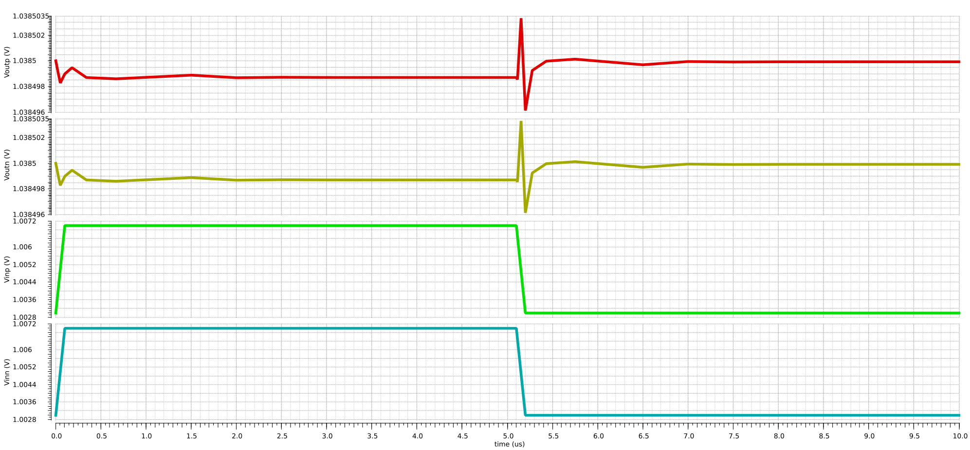
(note here a small common-mode 5mV step was applied with reasonable 100nS rise/fall times)
8. We next moved to replace all ideal biasing sources and utilize only one off-chip resistor.
Our main need here was to generate the biasing required for: (1) The bottom NMOS current mirrors and tail current source (2) The NMOS cascode in the wide-swing current mirror (3) The biasing for the PMOS cascode.
Note the PMOS current mirror is driven by the CMFB circuit directly, and the common-mode voltage setpoint can be chosen from one of the generated bias voltages.
In our case we decided to use a wide swing current mirror for generating most of the bias references needed in the Opamp. The following is the biasing circuit, as well as the generated voltages to be used for the circuit.
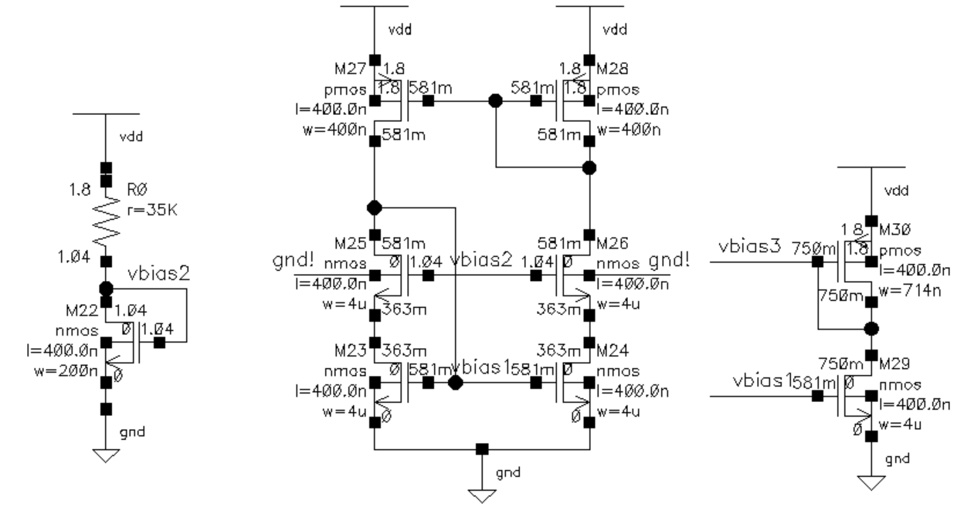
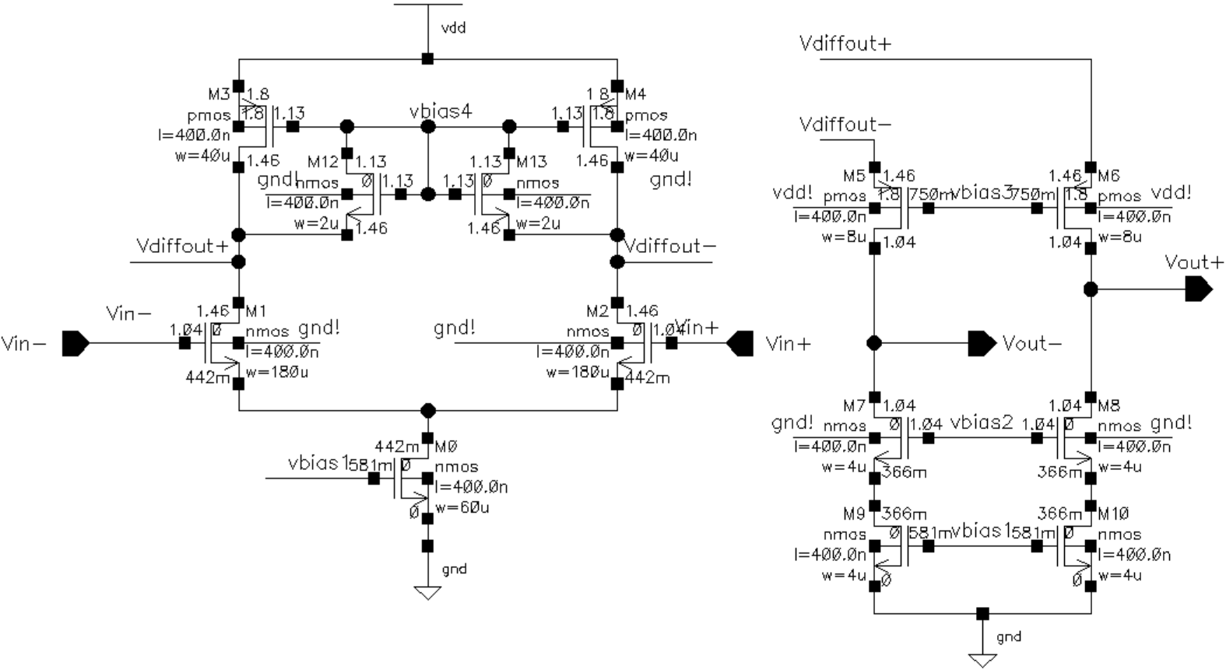
The following is the differential Opamp schematic with device sizes and annotated node voltages

The full schematic (without gain boosting) with device sizes and annotated node voltages:
(easier to see above)
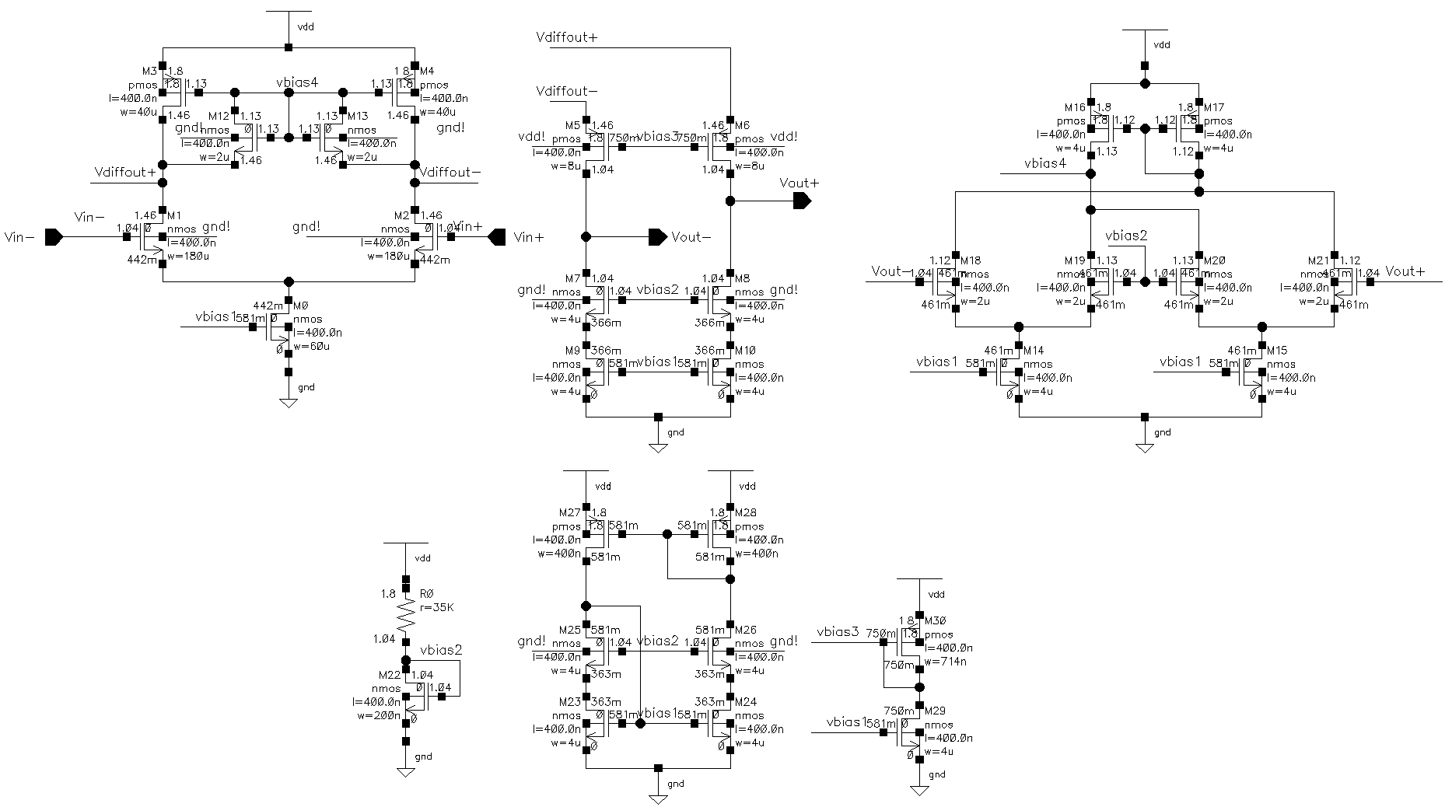
Operating point for each of the transistors (slew rate clamp transistors 12,13 normally in cuttoff)

In the next section we present the results, measurement testbenches and finally the gain-boosting additions to meet the gain error specifications

Measurement Test-benches and Results

Fully-differential Closed Loop Response Results
(note the closed-loop test-bench was presented in the section above)
-3db bandwidth measurement and gain
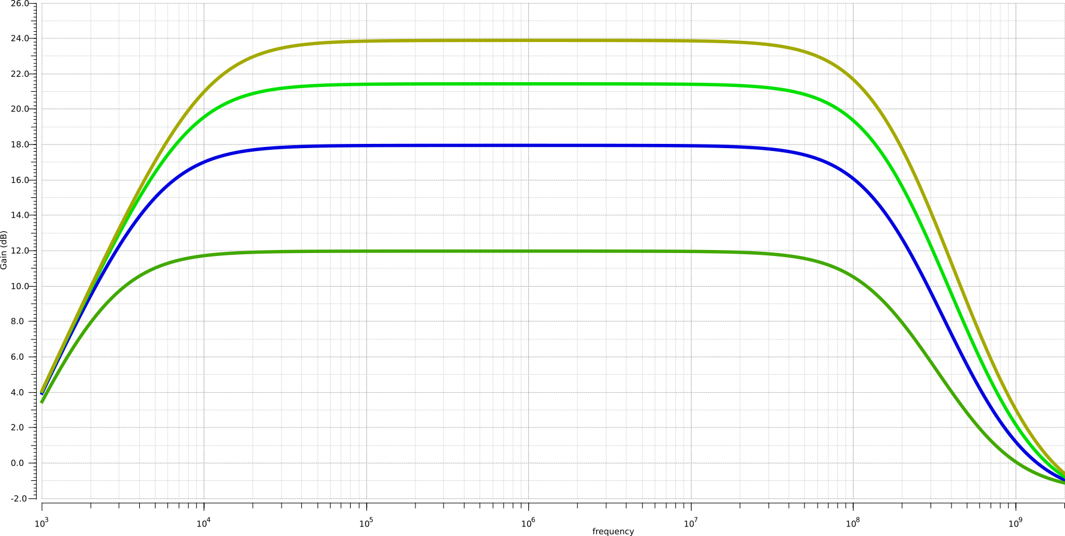
Precise results (4x gain) Precise results (8x gain) Precise results (12x gain)
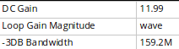
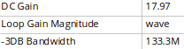
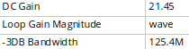

Gain: 11.99 dB Gain: 17.97dB Gain: 21.45 dB
-3dB BW: 159.2MHz -3dB BW: 133.3 MHz -3dB BW: 125.4MHz
Precise results (16x gain)
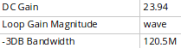
Note the gain figures are insufficient hence the use of gain boosting presented on next section
Gain: 23.94dB
-3dB BW: 120.5M
Note: The lower -3db Bandwidth was set precisely at 10KHz for the worst case (at 16x gain). For all other gains, the lower -3dB bandwidth is below 10KHz as required. (this result can be verified above).
Noise measurements
The input referred noise measurement was performed using the IRN – Simulation Setup presented from the lecture slides (58-62) over the frequency range of interest (10KHz – 500MHz) with the outputs taken differentially.
The input and output noise spectra are displayed below respectively (note the units are V/sqrt(Hz) and V^2/Hz respectively):
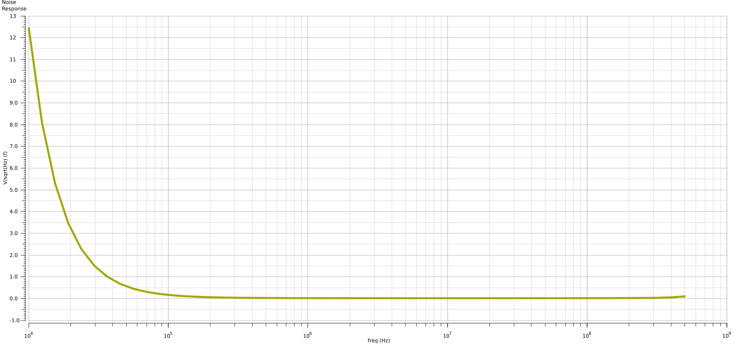
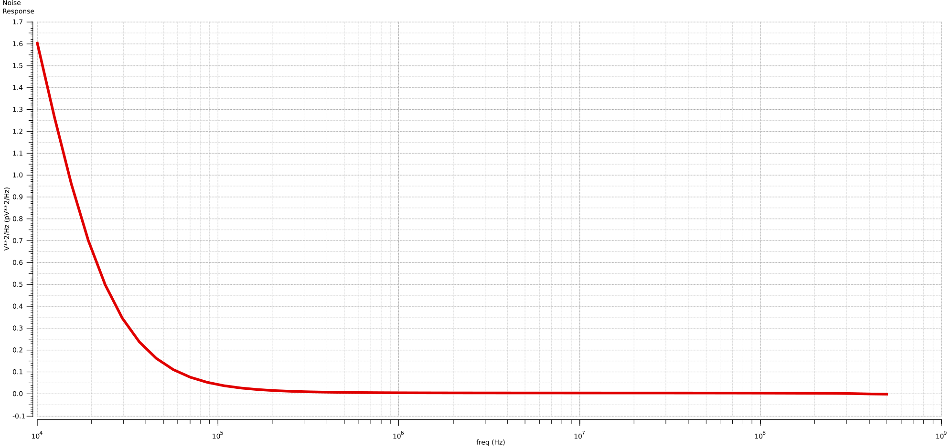
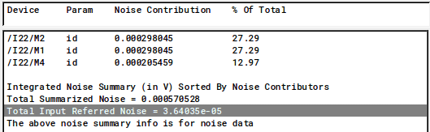
And finally the noise summary gives us our Input Referred Noise in uVrms integrated over our bandwidth. (Vn,in,ir = 36.404 uVrms)

Large Signal Step Response (Slew rate measurement)
For the slew rate measurement a 100mV input differential pulse was applied, and the opamp slewing was measured at the output in the linear region:
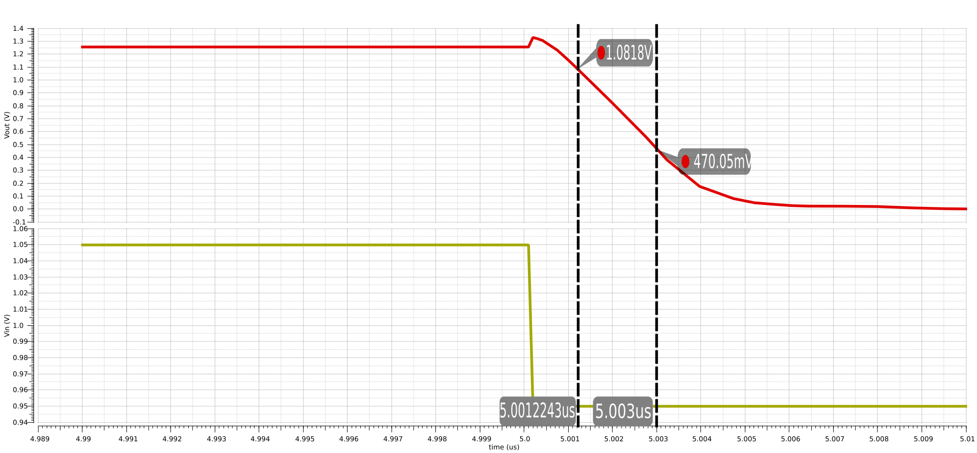
Slew Rate:

Fully-differential Open Loop Response Results
The open-loop measurement utilized for this section was as follows (with self-loading Zload applied at Vreturn):
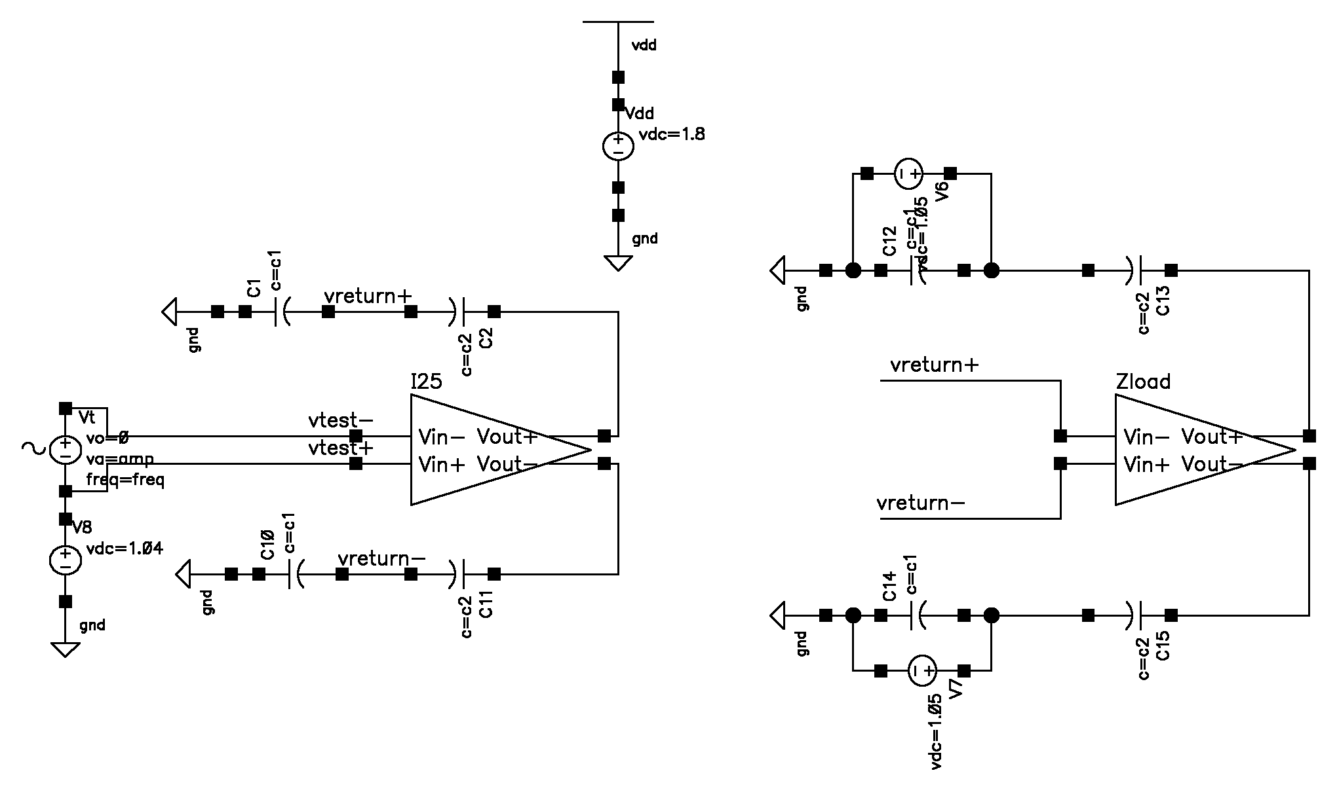
The bode-plot and phase-margin obtained from our open-loop testbench can be found below (both for maximum gain and minimum gain cases):
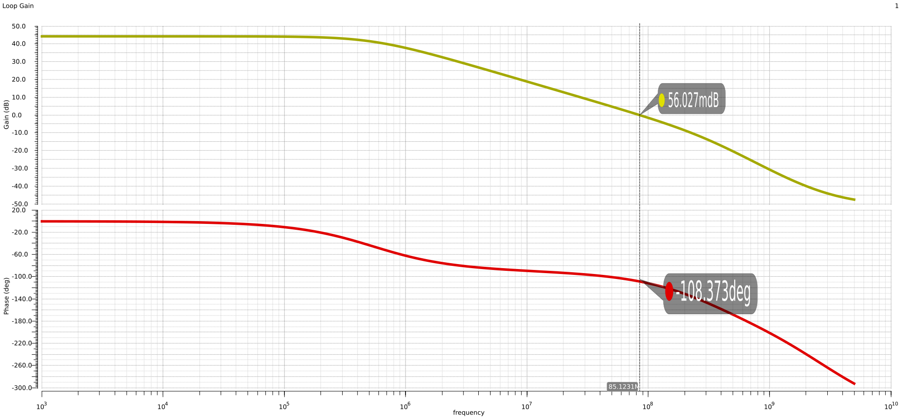
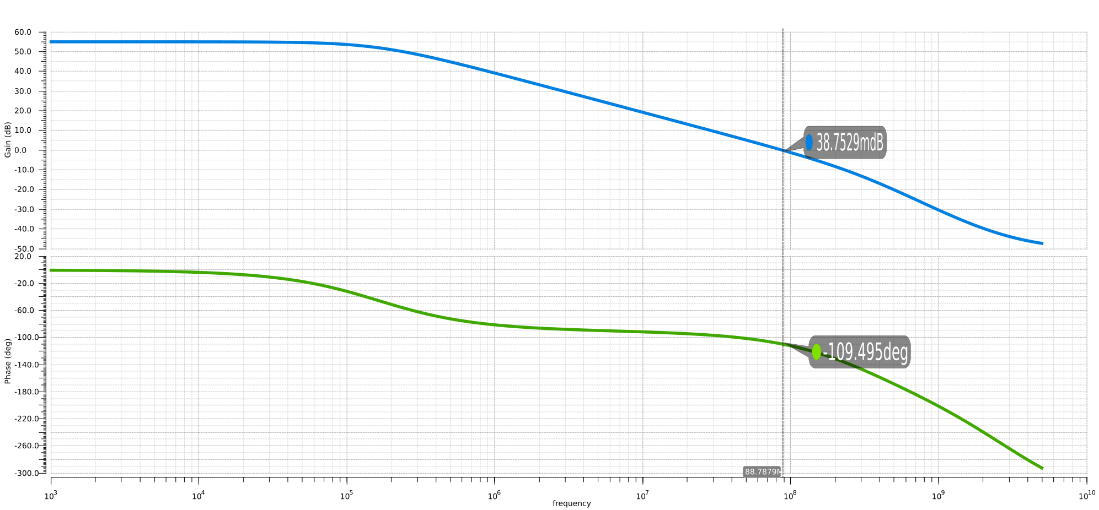
The precise phase margin results are (max and min gain respectively)
Upon measurement the min phase margin was found to be above the necessary 70 degrees.

Gain Enhancement Results (to meet gain error spec)
To be able to meet the gain error spec, we opted to add gain boosting amplifiers to both of our NMOS and PMOS cascode transistors (as the sense inverting inputs to the opamp are close to the rails; in each case we need to use a PMOS input-pair and NMOS input-pair opamps). We are using the same single ended Opamp from this assignment (above) and the PMOS input-pair 2-stage Opamp from assignment 1, with the bias voltages provided through external pins we avoid the use of resistors as required. The new schematic blocks are as follows:
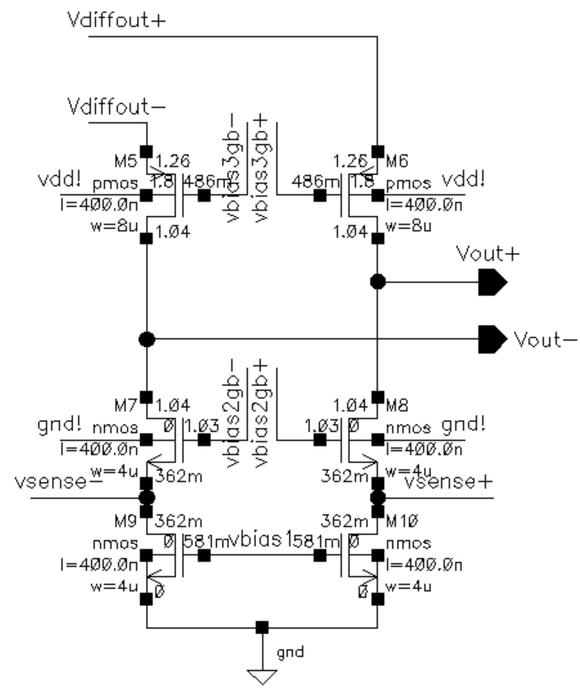
Output stage with cascode transistors and updated node voltages
Additional single ended opamps added to enforce our desired Vds across the NMOS and PMOS current mirrors. (top are
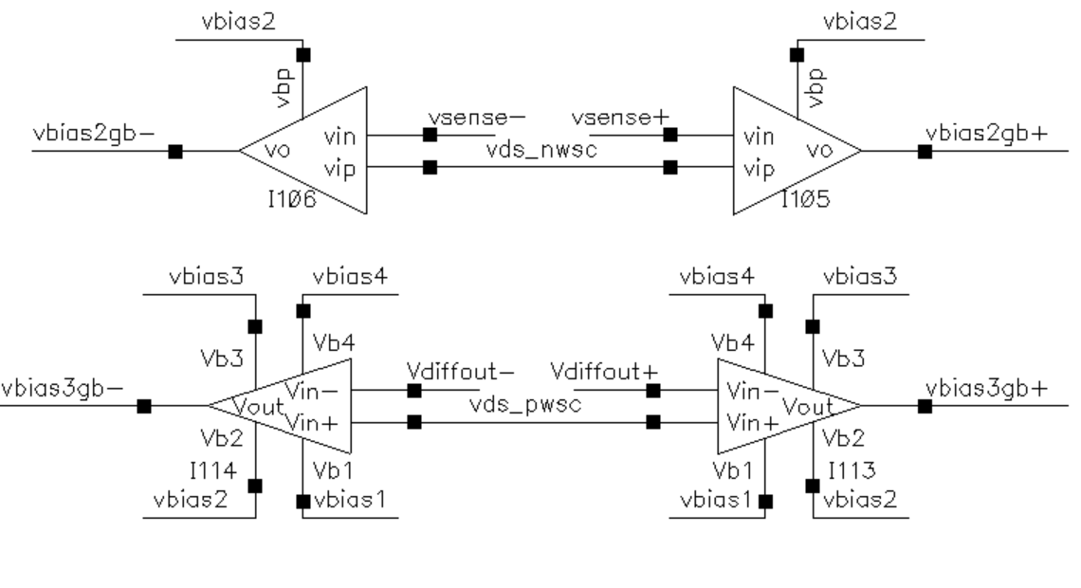
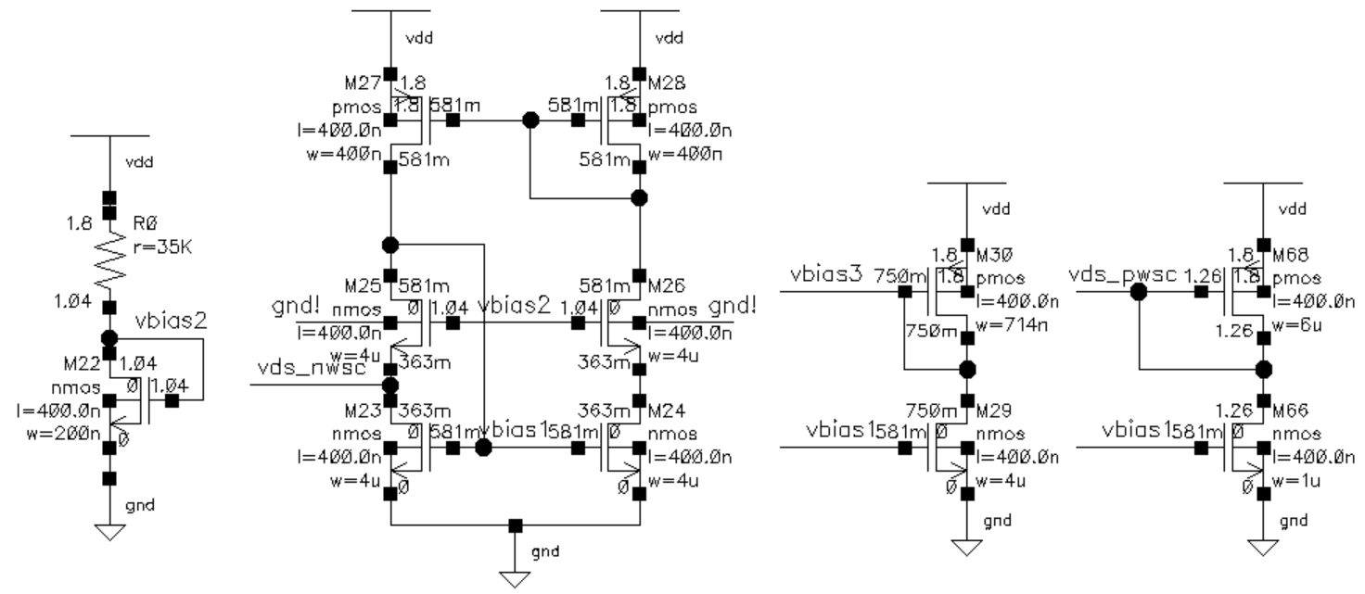
New bias circuits required to make use of the opamps without any internal resistors or dc sources
The schematics for the NMOS input-pair Opamp is the single-ended folded cascode design in the first section of this report, and the schematic for the PMOS input-pair 2-stage Opamp is displayed below:
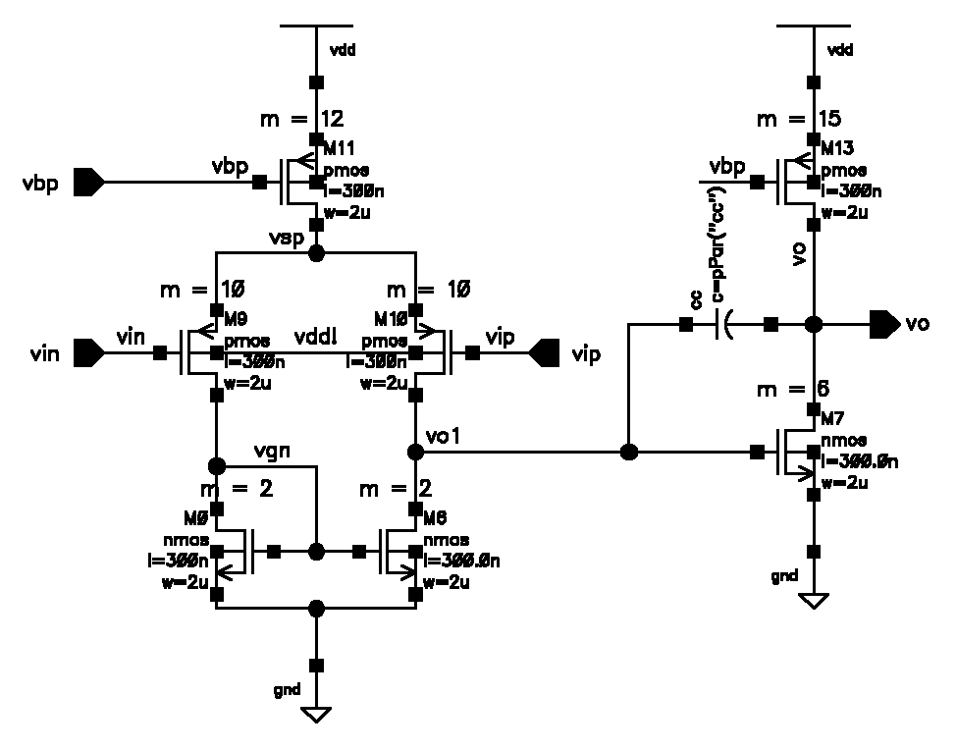
The following is the complete schematic including all blocks
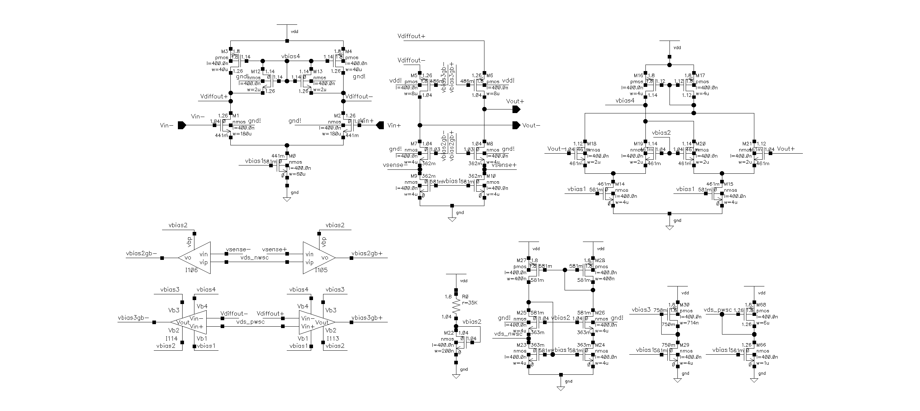
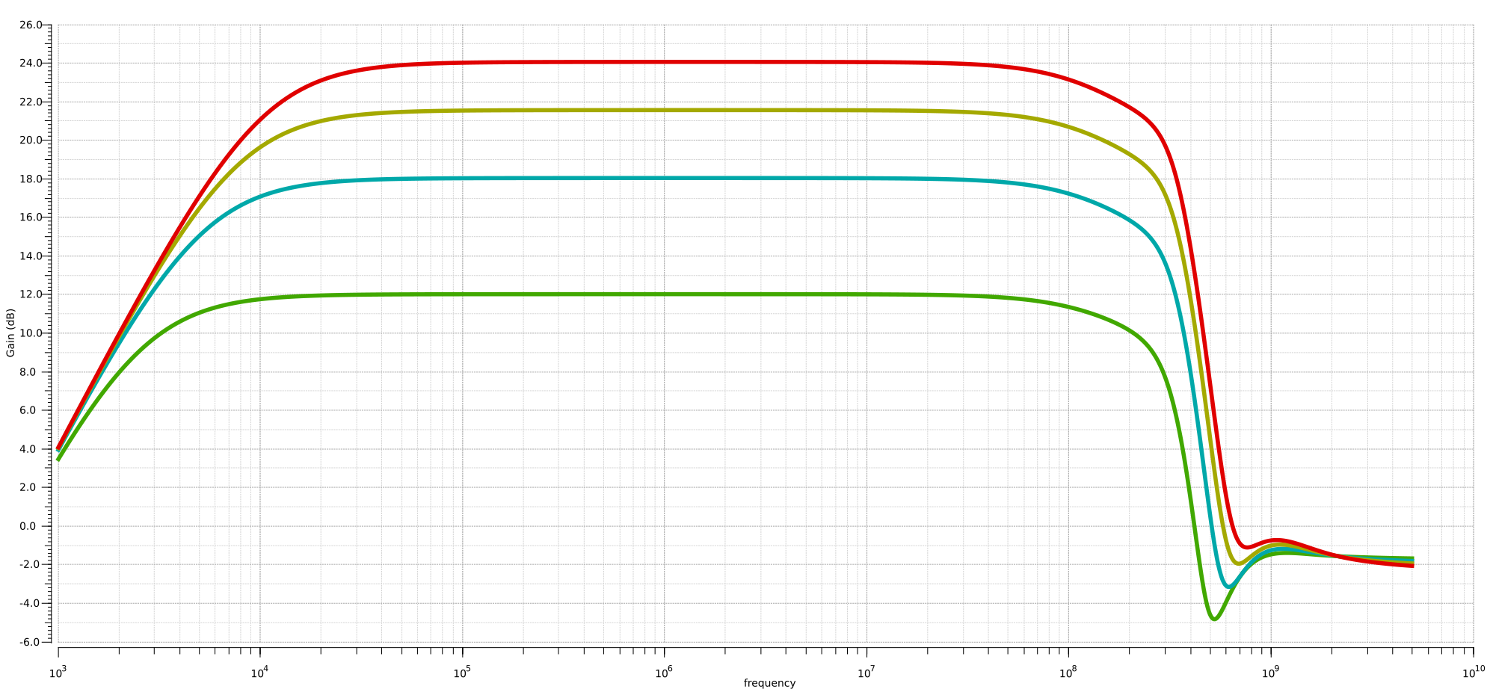
The following is the final gain plot for all gain settings (precise measurements below)
Precise results (4x gain) Precise results (8x gain) Precise results (12x gain)
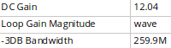
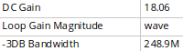
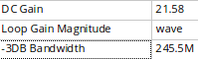
Precise results (16x gain)
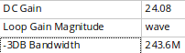
Note the Cadence calculator approximates to two decimal places. In this, case the results are within the 0.25% gain error spec.

The complete list of devices with their saturation operating points (except slew-rate helpers) can be found in the appendix.

Part 2
The comparator described in the netlist is the Strong-Arm comparator.
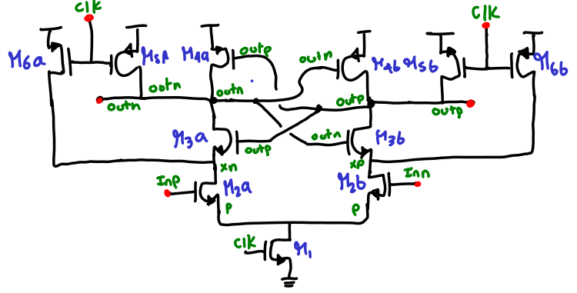
To analyze the operation of the comparator we first analyze what happens at each clock phase:
- Identify reset phase
- Identify initial condition after reset
- Analyze transient circuit operation until setpoint is reached.
Reset Phase: From the schematic we can see that the reset phase is when the clock goes low (i.e. reset=nclk)
In this case, on reset (clock low) we have:
- M6A,B and M5A,B act as reset switches and set : outn,p=Vdd and xn,p=Vdd.
- M3A,B also turns off as Vgs goes to 0V shortly thereafter
- M1 is switched off and node P slowly increase up to Vdd
  - Eventually M2A,B also turns Off
Therefore we have the starting condition of the comparator (initial condition after reset):
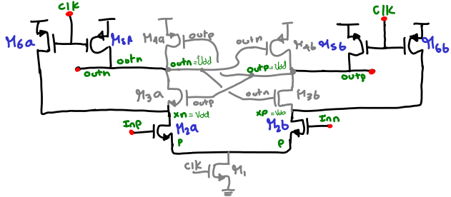
Comparison Phase: After clock goes high the comparison phase starts.
The process starts as soon as M1 turns on: node p starts decreasing, leading to M2A,B to start turning ON. Note that as Inp > Inn, more current will ten to flow through M2A and M2B. (this tilts the balance of the loop)
Node xn will be decreasing faster than node xp (due to larger branch current) in a “race to the bottom”. In turn, outn will decrease faster, decreasing both M3b and M4b gate voltages, this presents a positive feedback loop whereas M3B is driven weaker and weaker and starts carrying less and less current which together with M4B turning increasingly ON leads to an increase in outp node voltage; leading then to M3A turning further ON and M4A to start turning OFF.
The positive feedback process then continues until a stable condition is reached at each node close to the supply rails: outn close to 0V and outp close to Vdd.
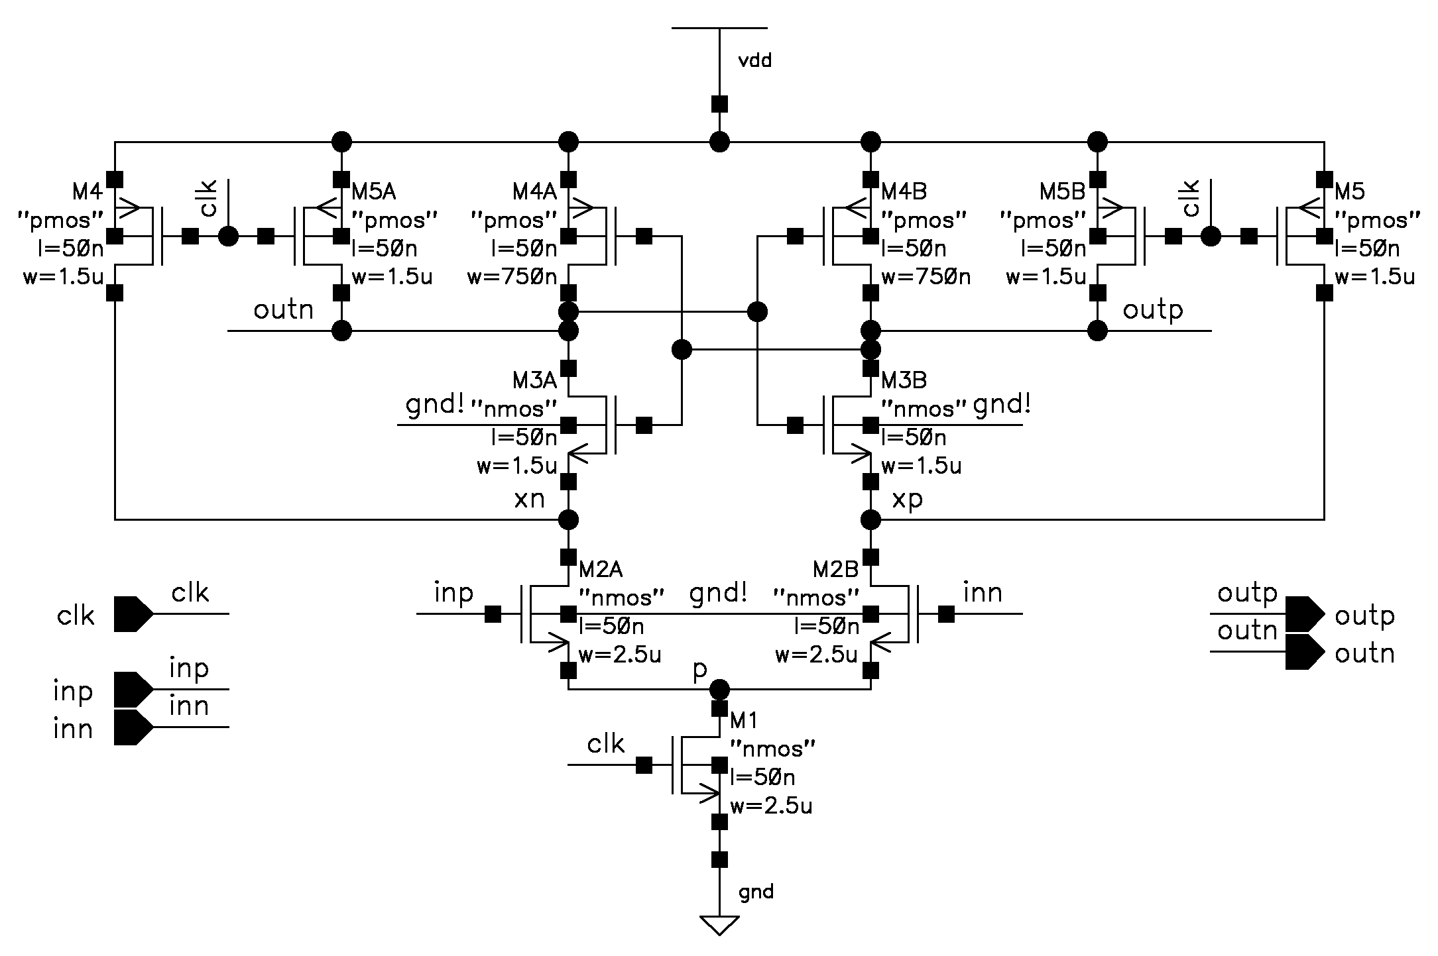
It is the starting condition set by Inp-Inn that determines the different in branch currents and thereafter the speed at which the output nodes reach the supply rails. (the propagation time, or time to latch). The complete comparator schematic is:
The initial operation of the comparator is assessed with the following testbench:
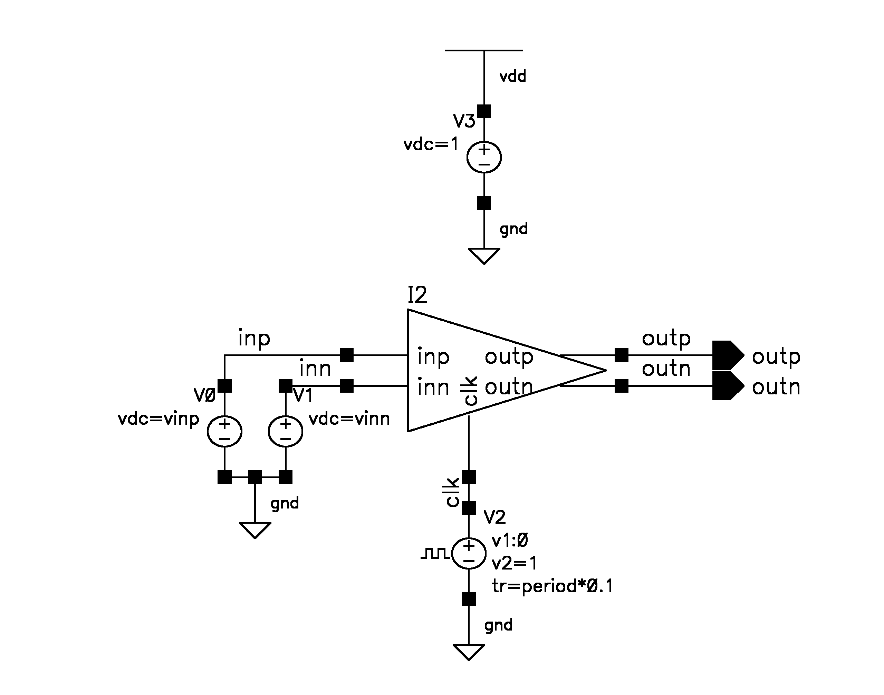
The following are the reset and compare phases
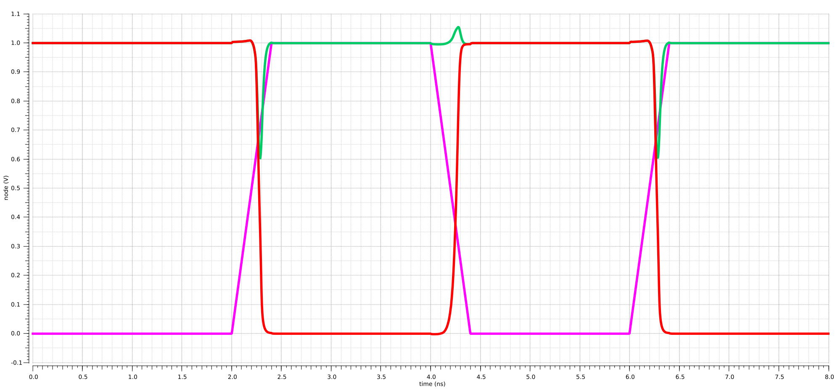
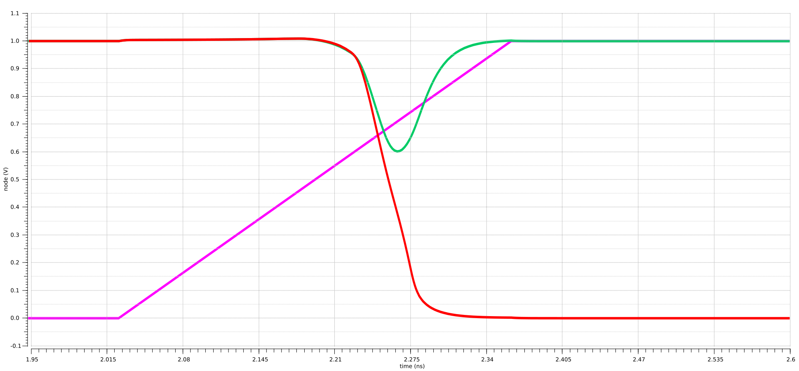
And the following is a close-up of the regeneration and positive feedback process

Regeneration Time Constant
The measurement of the regeneration time constant can be done by applying a small 50uV input and looking at the differential output waveform during the regeneration phase, specifically (reference [2] slides 10-16):
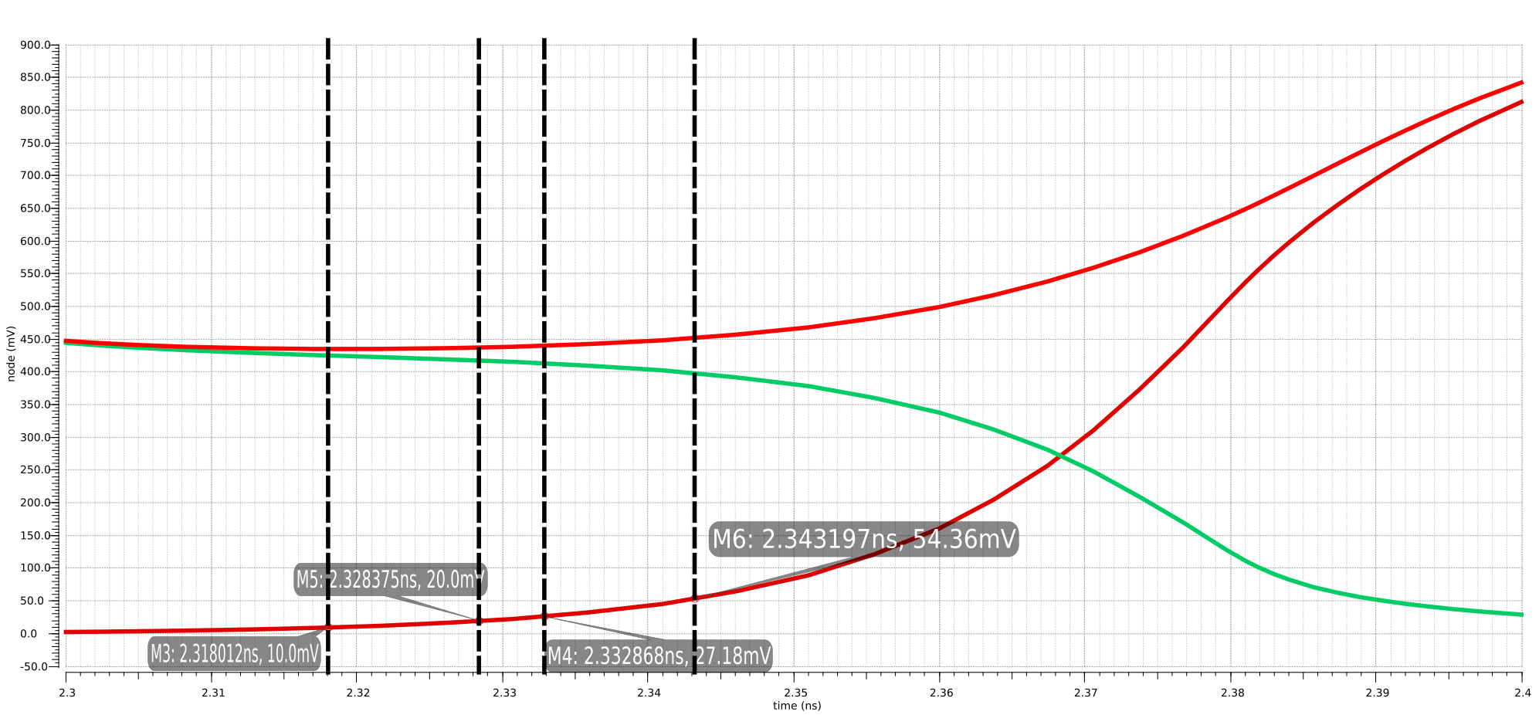
In this casewhere t1: time at Voutdiff=10mV, and t2: time at Voutdiff=27.18mV.
should be similar or equal to:
where t3: time at Voutdiff=20mV, and t3: time at Voutdiff=54.36mV.
Almost always if the Tau’s are not very close in value, the problem is that the comparator has offset or hysteresis.
In our case, we have and the other
These time constants are very close indicating that the comparator will most-likely have very small offset or comparator errors.

Propagation Delay (for 10mV input)
We can measure the large signal propagation delay by overdriving the input with a large signal and measure delay from clock input to output[2].
More formally propagation delay is defined as the difference between the moment the input signal crosses the reference voltage and the moment the output stage changes (usually when the output signal crosses 50% of Vdd if nothing is specified) [3]
This is one of the most important performance metrics denoting how quickly a comparator can resolve an applied input (see plot below)
In this case the propagation delay is:

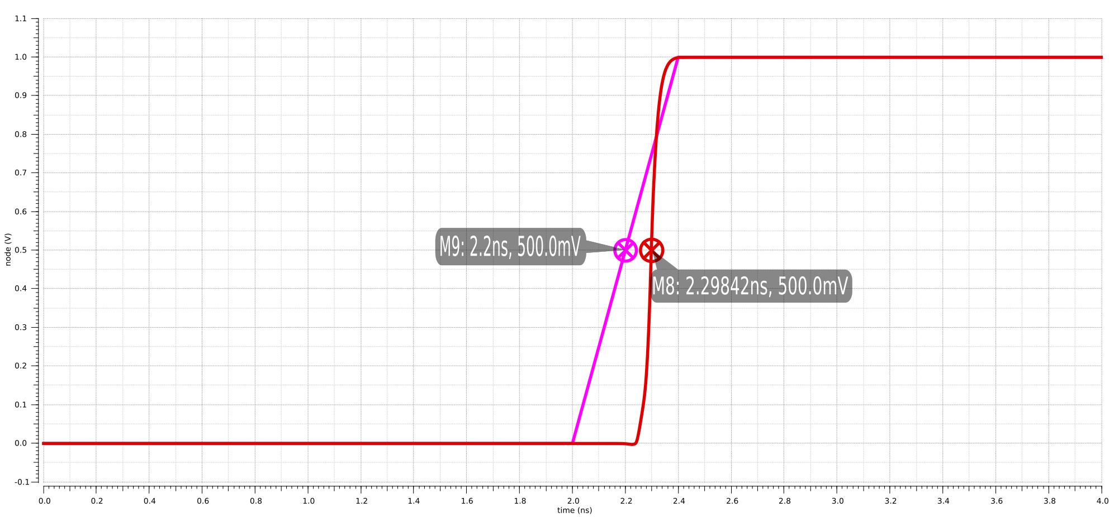
Energy Consumed per Comparison (Fclk=250MHz)
Energy per conversion is a measure of the efficiency of the comparator at our operating frequency, and is defined canonically as: Assuming a differential input voltage of 10mV, a set clock frequency of 250MHz, and an average current consumption of 8.490uA (averaged over one transient simulation), we can estimate:
Note this figure is small because our comparator is measured without the capacitive loading of the next stage which will increase significantly the current consumption of the comparator.

Sensitivity (when operated at a clock frequency of 100MHz)
is the minimum input voltage that produces a consistent output, i.e. the smallest input that can be resolved and results in a decision latched at the output: this is also referred to as input
offset.

The Iscas reference paper [2] reports an efficient simulation measurement for calculating comparator input offset, the process is as follows:
For this simulation measurement test-bench: we (1) apply a differential input to the comparator (100uV), subsequently (2) we measure the difference between the out_p and out_n metastable node voltages using a transient simulation. (3) next using an eye diagram tool we plot the the differential output with a period of one cycle. (4) Using the eye diagram diagram we pick a region in time where the difference between both waveforms is within 20mV to 100mV (this represents the exponential rise region of the waveform).
The simulation testbench used is as follows (this is the same testbench used for hysteresis and offset):
Initially we apply the recommended differential input square wave with +/-100uV
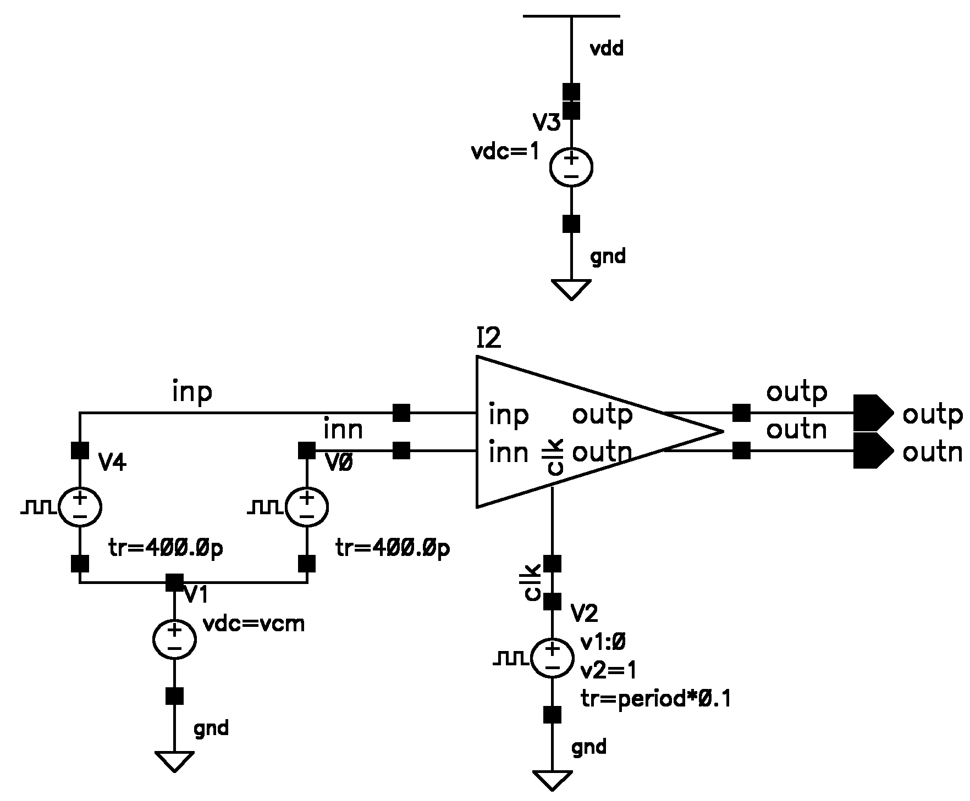
The offset simulation technique waveforms are applied as below
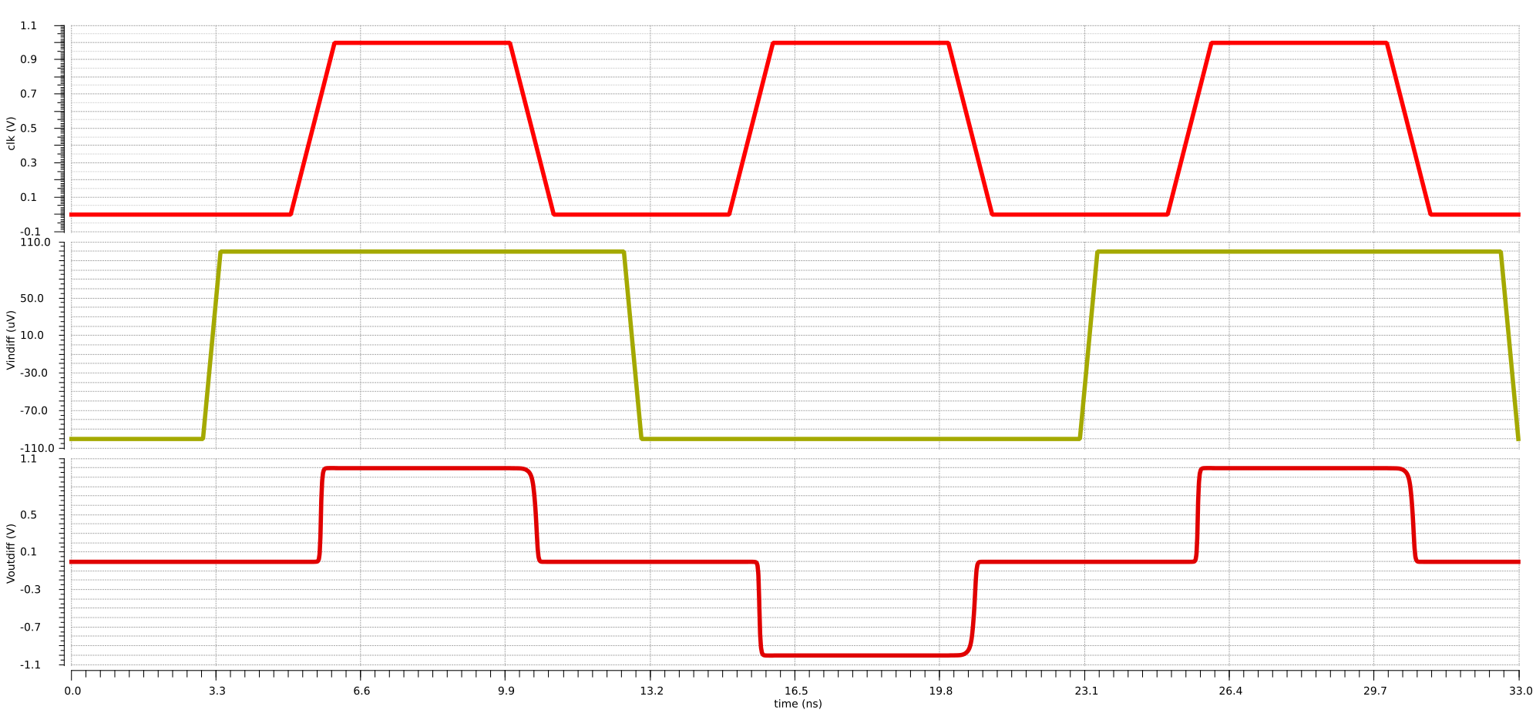
Subsequently we plot the eye diagram to find a two points with a difference of 20mV to 50mV
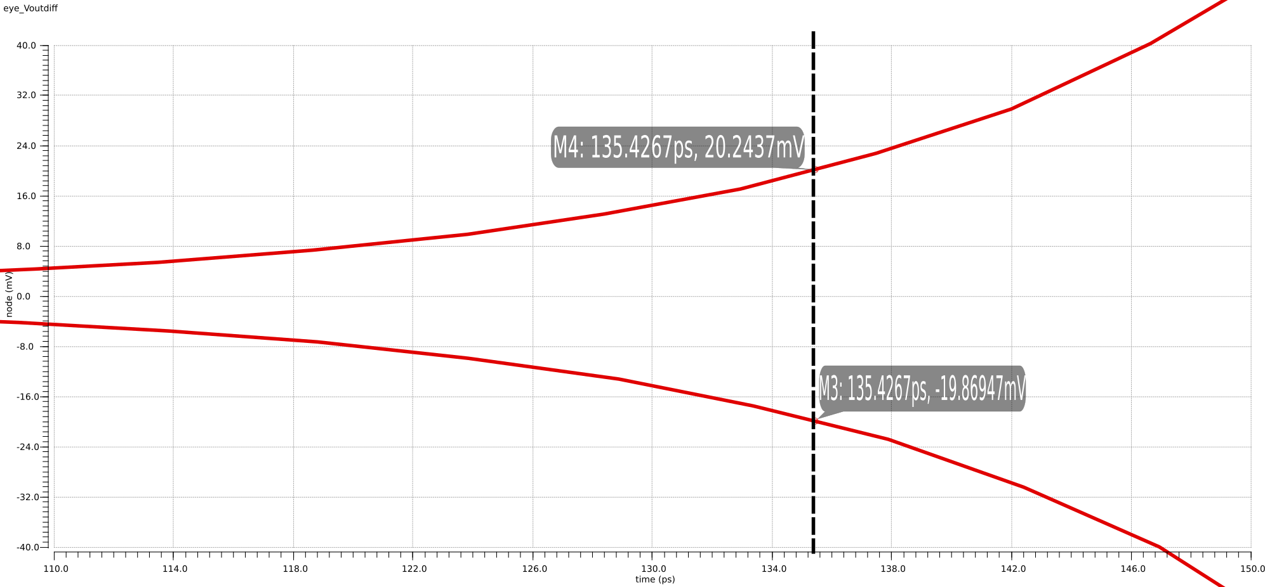
(note there is a visual-only artifact for the vector graphics exported from cadence)
In this case and we can calculate the comparator offset as =
This is a very small offset as hinted by the regeneration time constant calculation.

Hysteresis (nominal clock frequency of 250MHz)
Hysteresis is the normally undesirable memory effect of a comparator due to residual charge in nodes of the circuit (due to imperfect reset or kickback), whereby under an applied input when coming back from the opposite logic level the comparator trip-point differs from the ideal reference.
The Iscas reference paper mentions an efficient measurement procedure very similar to what we used for calculating the offset above, here we need only 5 clock cycles in order to be able to estimate our hysteresis as well as offset. The hysteresis simulation waveform is as follows (modeled exactly after the Iscas tutorial):
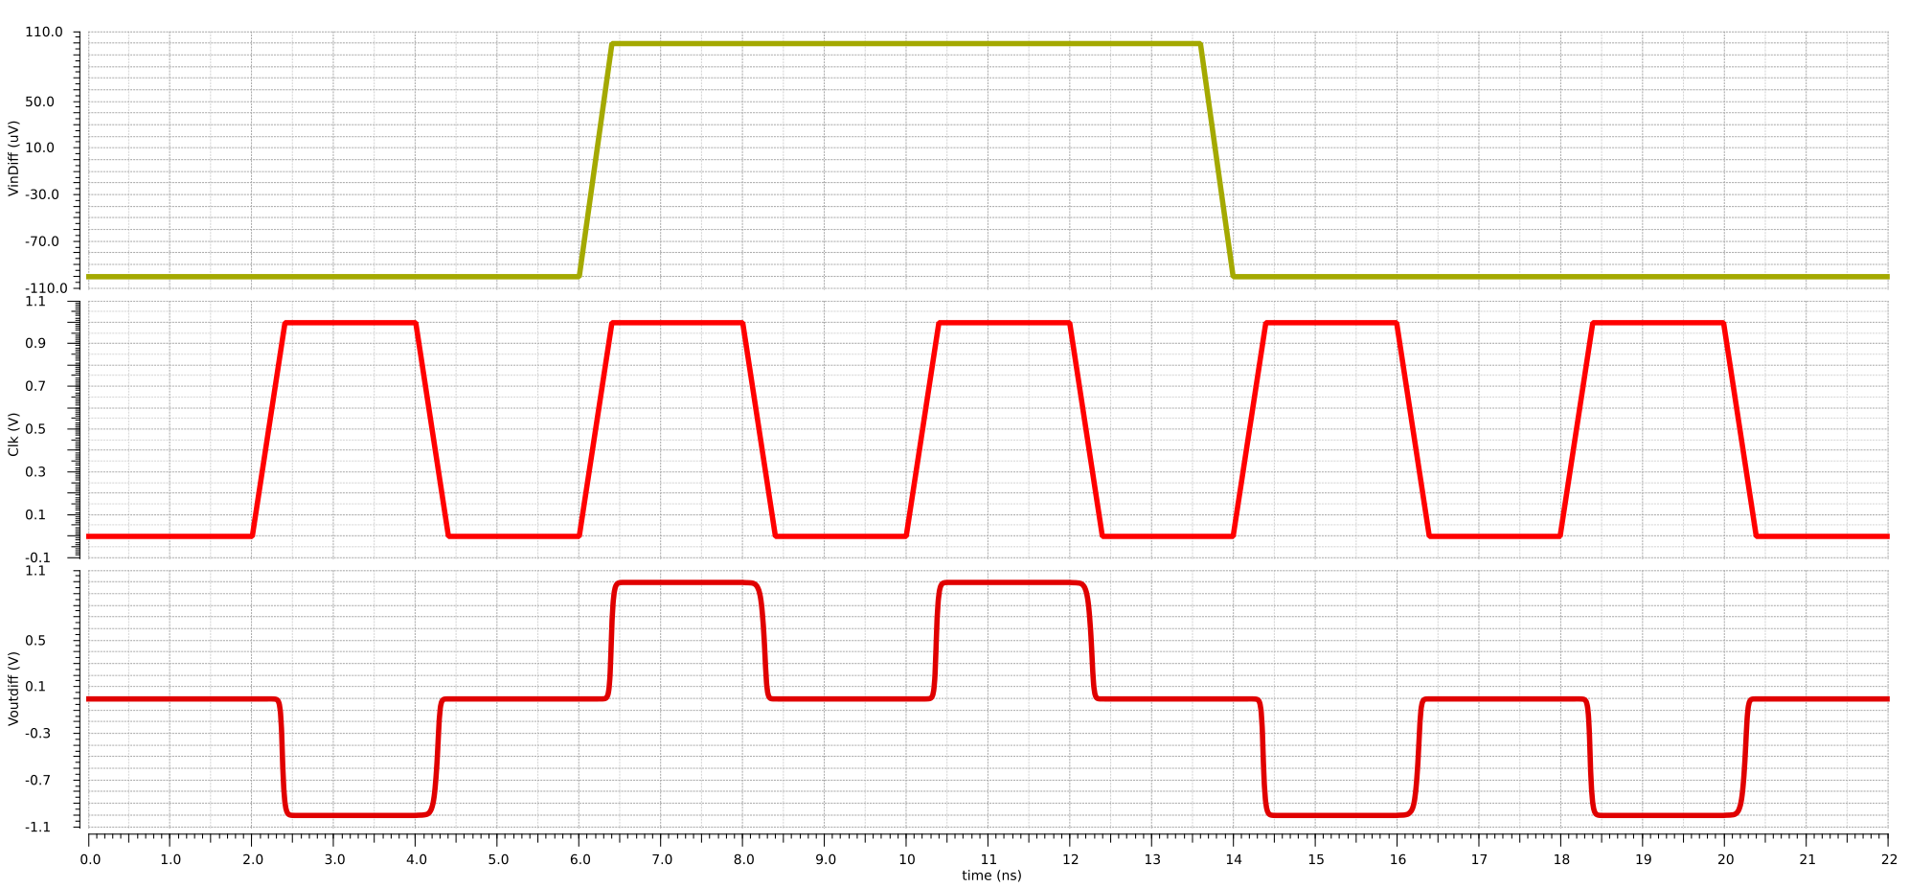
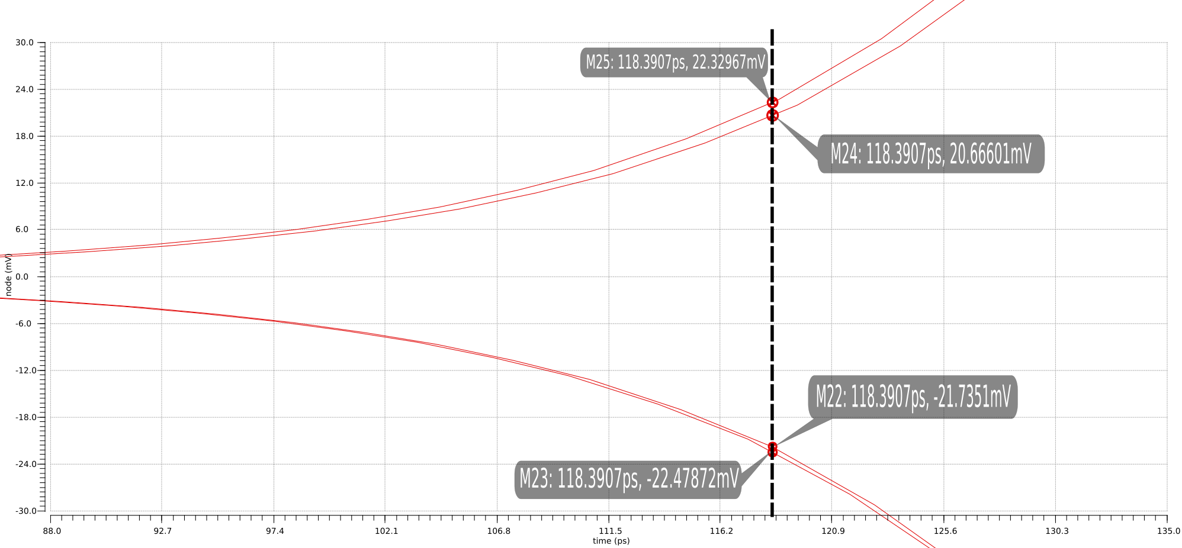
Subsequently we plot the eye diagram of the differential output
In this case: and
Offset1 (V low to high sensitivity):
Offset2 (V high to low sensitivity):
We can then calculate hysteresis as:
Hysteresis: Offset1 – Offset2 = 5.5796uV
and average offset as: (Offset1 + Offset 2) / 2 = -1.412uV
which is close to the comparator offset calculated before for a 100MHz clock.

Comparator Input Referred Noise
For the comparator noise analysis we are using the Periodic Steady State Analysis recommended in the ISCAS tutorial reference [2] as a better alternative to the standard transient noise simulation: simulation is faster and more accurate, displays sources of noise and allows us to select the noise bandwidth for integration.
The procedure outlined in the tutorial proceeds as follows: (1) apply a small DC input(100uV differential input), subsequently (2) clock comparator and measure noise in exponential region of rising vout differential waveform (we are choosing 50mV in our case). (3) we use the periodic steady state and Pnoise analysis choosing jitter for noise and setting a 50mV threshold to measure noise. (4) Finally we find the equivelent input referred noise by dividing the measured output noise by the calculated gain Voutdiff/Vindiff = 500.
We followed the detailed procedure from slide 57 to configure the pnoise and pss analyses being mindful over our 250MHz maximum clock frequency for our comparator. Subsequently we configured the direct plot form to add the expression to our outputs and finally (divide by our gain) to find our input referred noise.

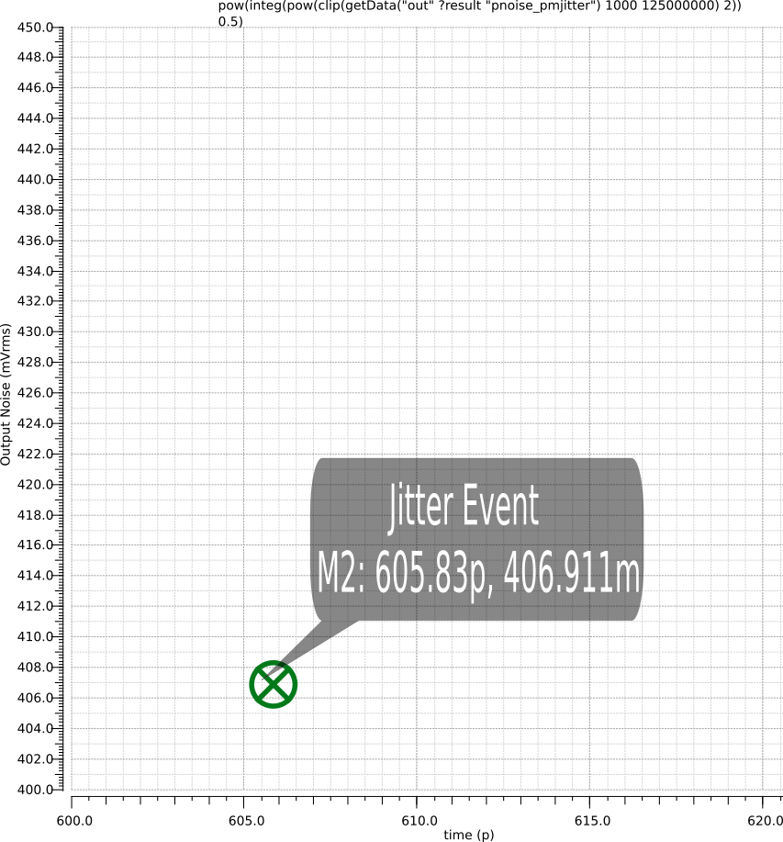

Output Integrated Noise: 406.911mVrms
Input-referred Integrated noise: 813.82uVrms
(integrated over 10K to 256MHz bandwidth)
In this case with a 100uV input and given our input offset of -1.412uV, we have a ~1.4% error in our noise measurement.

Finally we calculated the input referred noise for different input amplitudes (as exemplified in slide 52):
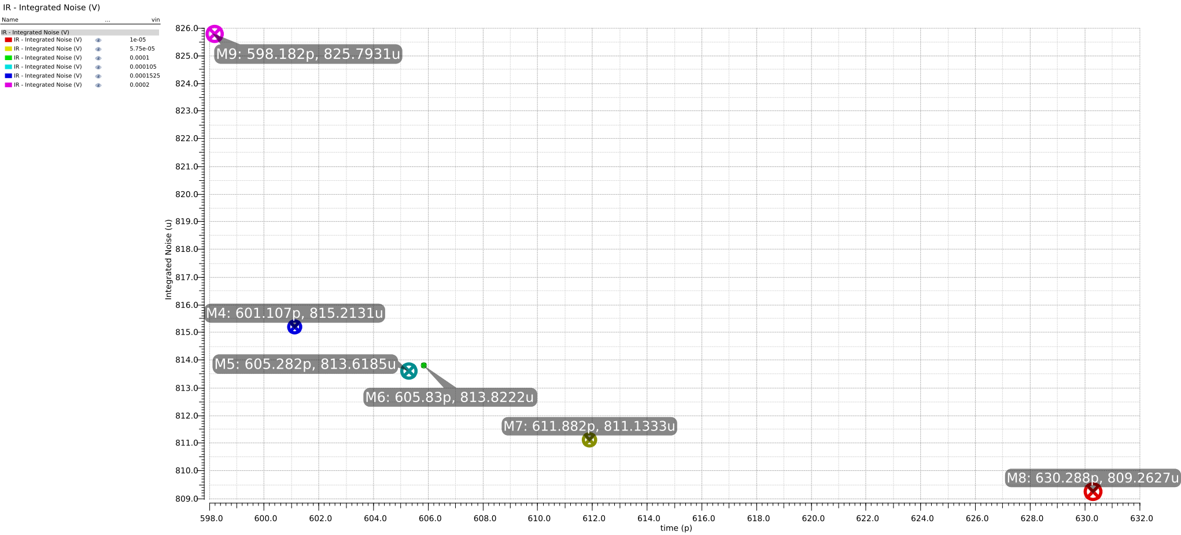
Here we can see that most values fall within 810 to 830uVrms, for smaller input values offset plays a more important role as % of error, at larger amplitudes the noise measurement technique starts to incur into other inaccuracies (as we leave the exponential region of the comparator differential output).

Discussion
In retrospect thinking back on our chosen topology and the large intrinsic gain necessary for the Opamp (to maintain the closed-loop gain error spec), it perhaps would have been simpler to pursue a 2-stage Opamp design with an inherently larger gain and requiring no extra gain-enhancing efforts as was required for the folded cascode Opamp.

References
[1] Design Procedures for a Fully Differential Folded-Cascode CMOS Operational Amplifier: https://ieeexplore.ieee.org/stamp/stamp.jsp?tp=&arnumber=45013
[2] Dynamic Comparator Noise and Metastability Simulation Techniques (ISCAS 2017, William Evans)
[3] Introduction to comparators, their parameters and basic applications: https://www.st.com/content/ccc/resource/technical/document/application_note/group0/88/5b/0a/e2/7d/39/4e/9e/DM00050759/files/DM00050759.pdf/jcr:content/translations/en.DM00050759.pdf
[4] Notes on Gain Error: https://www.elexp.com/Images/Notes_on_Gain_Error_in_Op-Amp_Amplifiers.pdf
[5] Cascode Opamps (CMOS Analog Circuit Design): https://aicdesign.org/wp-content/uploads/2018/08/lecture24-170907.pdf

ERRATA
Note in part 2: the use of transistors as pseudo-resistors to generate references should be avoided as it incurs large variations in reference current with changes in power supply voltage.

Appendix
Operating point of transistors in fully-differential opamp with gain boosting.

