APMM Landscape Project

Introduction

Landscape Application is a static visualization of the interactions among the applications of an enterprise. The application displays the interaction, its type, the relative dimension of the application in terms of its interaction with the rest of the application universe.

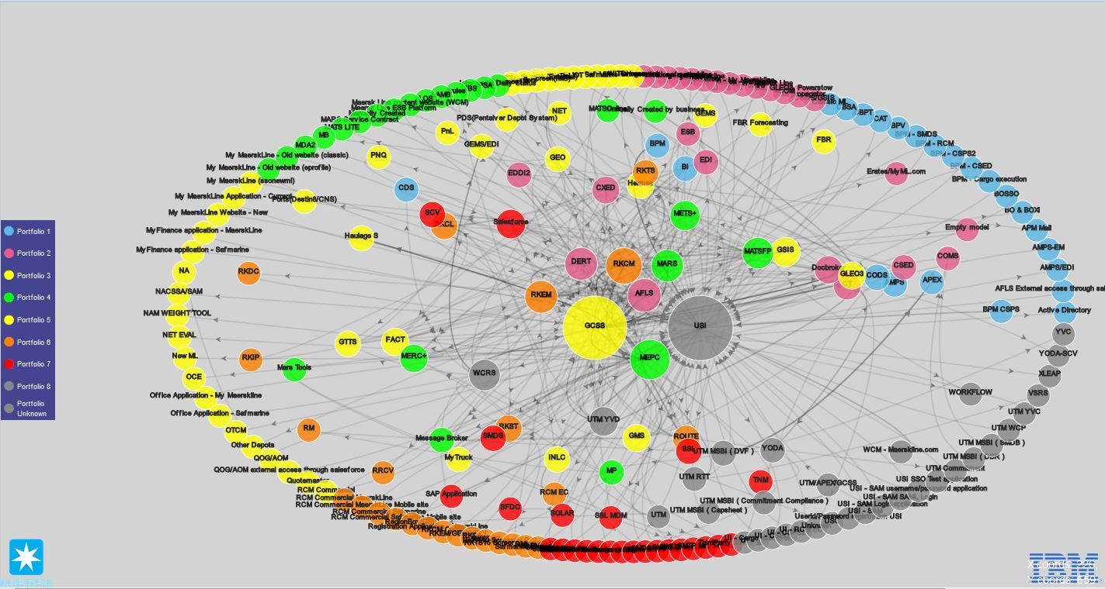

Technologies Used

- Simple Architecture – Javascript, Java and Excel
- FrontEnd : Javascript, jQuery, D3(http://d3js.org/) – Visualization of Data
- Conversion Routine : Java – Conversion of excel data into JSON using POI framework (version 3.13)
- Data Store : Excel

Project Structure

landscape/ - main application folder
css/ - folder containing all css files
landscapeStyles.css – custom css for landscape application. All styling goes here.
lib/ - folder for the css libraries used
bootstrap.min.css
excelToJson/ - BE project for conversion of xls to json
applications.xls - xls containing all application name and details along with ID
Interface_Dependency.xls- xls containing all interaction amongst the applications & their details
src/ - folder containing source code
amc/
excel2json/
Application.java
ExcelToJSON.java - main class which needs to be run for generating json files
Interaction.java
bin/ - folder containing compiled java classes
<<compiled_classes>>
.settings/ - eclipse settings file
org.eclipse.jdt.core.prefs
.classpath
.project
js/ - folder containing all javascript files
landscapeFunctions.js - js file containing all custom functions for landscape project
main.js - contains code for image preview
lib/ - folder containing js files of the libraries used
bootstrap.min.js
cola.js
d3.min.js
jquery.js
resources/ - folder containing all images and data jsons
aod_diagram/ - folder containing all aod diagrams. It’ll have list of folders, one folder for each project.
<<application_name>>/ - folder containing images for application context. Ex – cds, afls, usi etc
image1
image2
image3 etc.
images/ - folder containing images used in the landscape page
close-circle-512.png
ibm_logo.gif
icon-aod.png
Maersk_logo.png
json/ - folder containing generated json from BE, which is what the landscape application reads as data.
applications.json - contains application data which is displayed in popup on click of an application.
interactions.json - contains interaction data which is displayed in popup on click of an interaction path.
doc/
APMM_Landscape_Project.doc – documentation for Landscape project.
landscape.html - entry point for the application. Main html whose url needs to be hit in the browser to display the application.

Legends
Orange – folder name
Green – file name
Blue – details of the artifact.

Concept of the Landscape View

The landscape UI/View is a force directed graph created using the force layout of the D3 data visualization library. Force directed graph is a node-and-link graph. More specifically, it’s a network graph. Here, the applications are represented as nodes and the interactions (inbound/ outbound) between the applications as the link between them. The layout algorithm places the more interconnected nodes together.
The nodes are mapped to SVG circle elements, and links are mapped to SVG curved line elements. A text element is placed on each node element to display the name of the application. On click of the node element, a popup appears displaying all data available (from applications.json) for the node and on click of the path/link between two nodes, a popup appears displaying all data available (from interactions.json) for the path involving the two applications. The popups can be dismissed by using the close button or hitting the Escape key.
Screenshot:
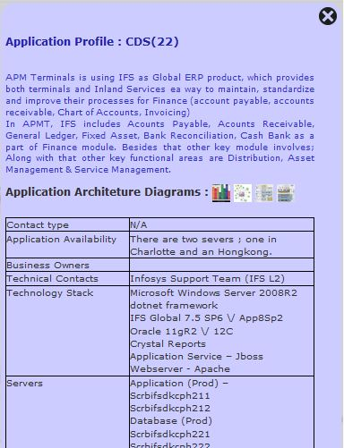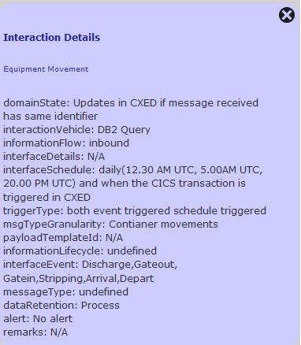
On double clicking of any node (application), the view enters the state where only the applications and interactions related to that particular application is highlighted and the rest of the landscape is blurred.
This helps to figure out the connectivity of each application in detail.
Screenshot:
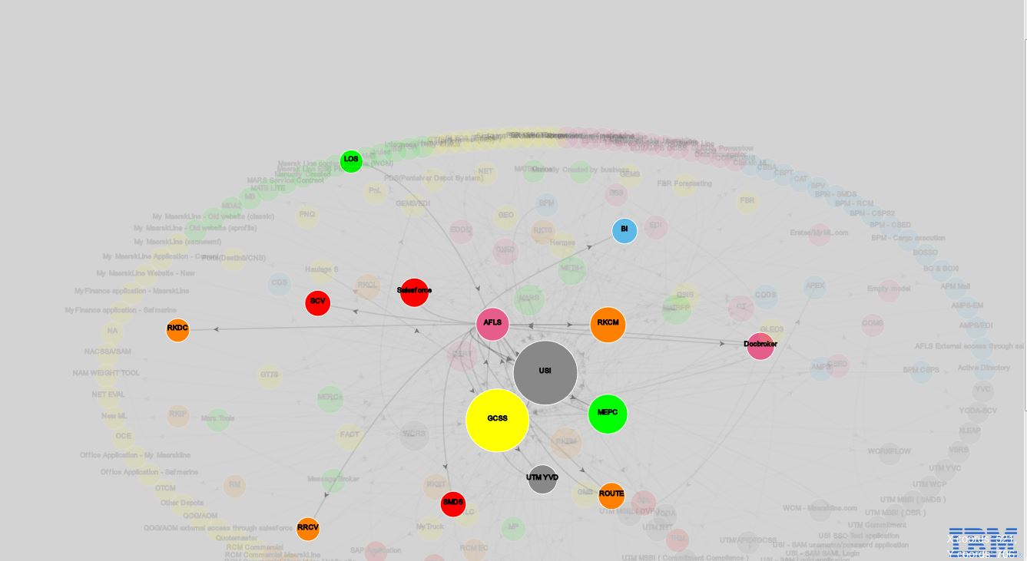

View Modes
There are four buttons present in the landscape view each representing a different view mode –
- Toggle tick: It toggles the state of the graph. If the tick is set to false, the nodes are fixed in their positions. If the tick is set to true, the nodes can be dragged to any other position and other nodes will re-position themselves. By default, the tick is set to true.
- Rectangular: In this view, the nodes will re-position themselves in a Rectangular layout starting alphabetically with respect to the name of the node (application). Internally, it uses a nest layout of D3.
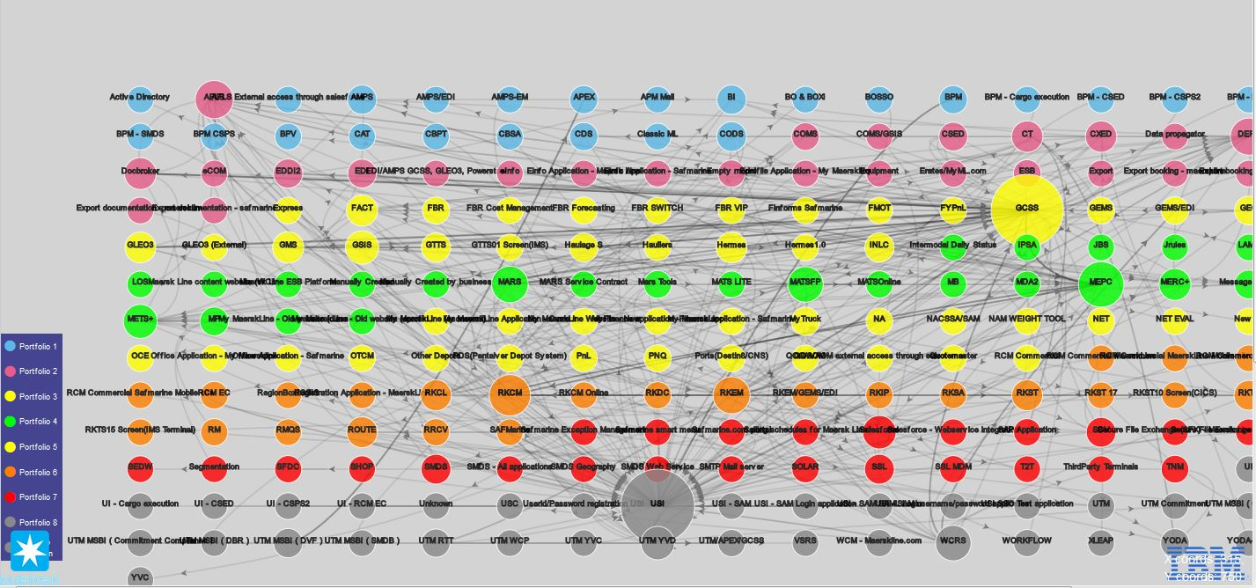
- Ellipse: In this view, the nodes position themselves in the ellipse with the greater connected nodes at the center and lesser connected nodes at the periphery of the ellipse. This is the default view of the landscape application.
- Tree: In this view, the most connected node acts as the root of the layout and the lesser connected nodes serves as leaves and are further apart, least connected nodes will be the farthest/ last leaf position.
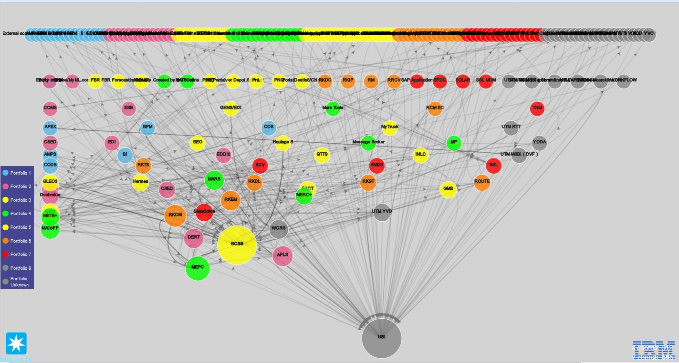

- About: This will enable user to download the APMM Landscape project documentation.

Concept of Excel to JSON conversion program

The java program uses POI framework for reading the MS excel files and read the rows and cell values from the provided file. The applications.xls is read and an application map is prepared which consists of application name and its id and then the whole of application.xls is converted to applications.json. Applications.json is a JSON array with each application as a json array element. Each excel header/column value is treated as a key/value pair associated with the json array element.
When the interaction xls is read, the applicationTo and applicationFrom columns values (application name) are read and replaced with the id of the respective application with the help of application map created earlier. The generated json array (interactions.json) contains these id values instead of the application names for the application to map the source and target for a link (path).
These json files are copied to the appropriate path in the project for the Landscape application to read and present the visual format.

Different stages of Landscape process
Landscape consists of 3 step process.
- Input File preparation – Getting the application.xls and Interaction_Dependency.xls ready.
- Data Conversion – Getting the data converted from xls to Json which the application can read and generate UI. [This is done by the ExcelToJson BE program].
- Data Visualization – Launching the application on browser and cross verifying the view with the data supplied. [This is the front-end javascript application based on D3 library]
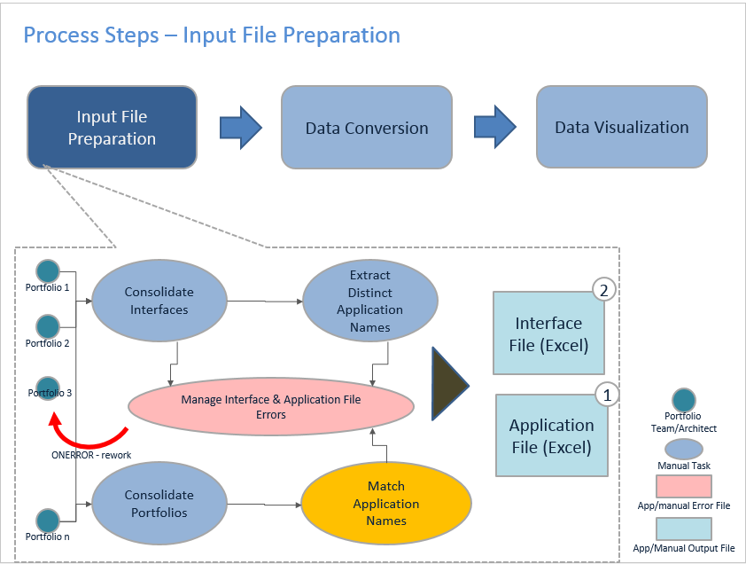

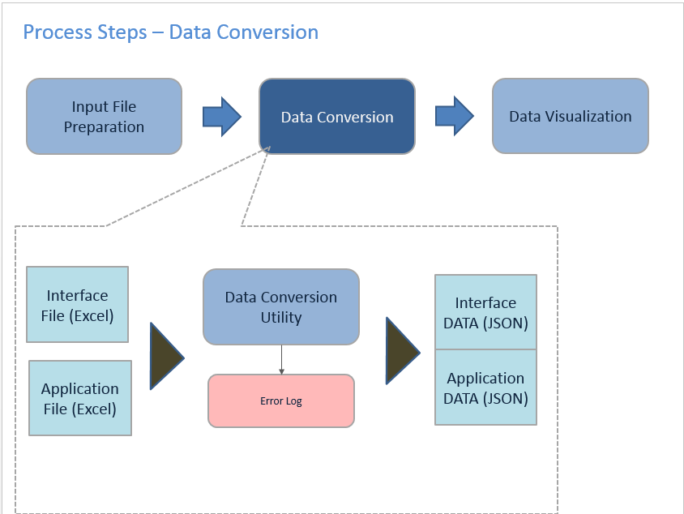

Setting up ExcelToJson project in Eclipse
- landscape/excelToJson project file needs to be Imported in Excel.
- It contains 2 zips. Poi.zip and JSON.zip. Both of them needs to be extracted.
- Import JSON project folder in eclipse. [Landscape uses JSON array, object etc. which this library provides].
- In the build path of ExcelToJson project add the jars from the poi directory. Following jars are required. [These jars provides java functionality to read the excel files in terms of rows and columns].
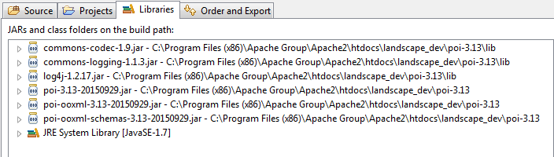
- Run the ExcelToJson.java in eclipse. It will generate applications.json and interactions.json in the resource/json/ path. Refresh the view on the browser. New changes will be reflected.

Landscape Data Model
Landscape application utilizes two excel files applications.xls and interaction_dependency.xls. They act as a primary data store. The data models of the excel sheets are attached below.
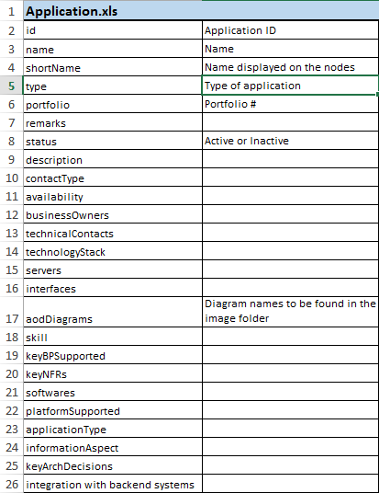

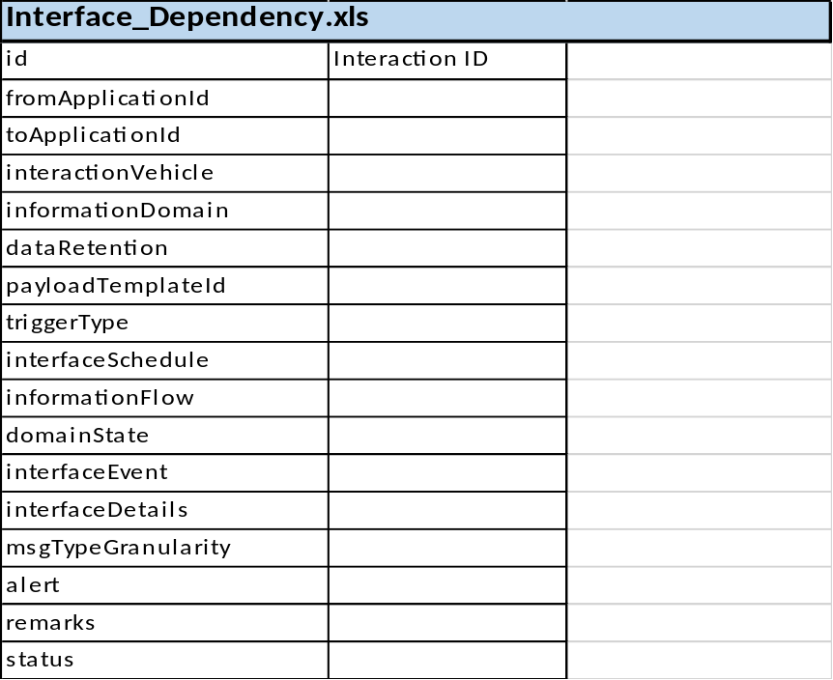

Updating Context/Architecture Diagrams for Applications
Application.xls has a column (P) ‘aodDiagrams’ where users can provide the folder name and file names for the images in the following format.
[folder_name]:[comma seperated file names]
Ex - amps:amps1.jpg,amps2.png,amps3.png,amps4.png,amps5.png
Note: the folder needs to be created in the path landscape/resources/aod_diagram/

Note about IE 11
D3 library uses HTML5 features and is incompatible with older browsers (specially <IE10). In IE11, if user faces issues with the display, it might be because of Compatibility view settings. Setting the compatibility settings displays the page in IE7 mode.
It could be fixed in the following way –
- Go to Settings > Compatibility View Settings
- Uncheck the “Display intranet sites in Compatibility view” and restart the browser.
- If the landscape hosting domain is added to the “Websites you’ve added” section, it needs to be removed too.
