Download the version of git for your operating system here: <https://www.git-scm.com/download>

That should give you an installer. If you have a Mac and you’re having a hard time opening the installer, please see the end of this document.

Note that git is not like other software. You will not have an app to launch. **To ensure the installation was successful**,open RStudio after running the installer, go to Tools => Terminal => New Terminal

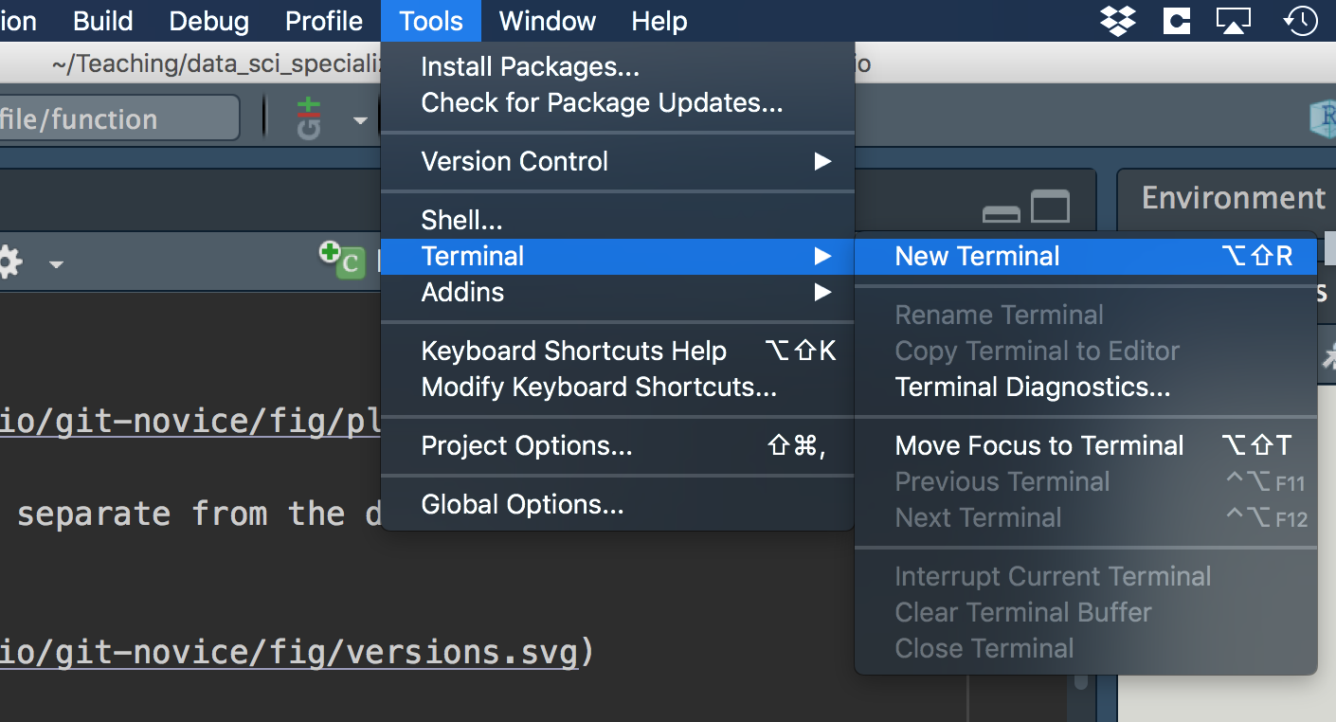

This will give you a new window down by your console. 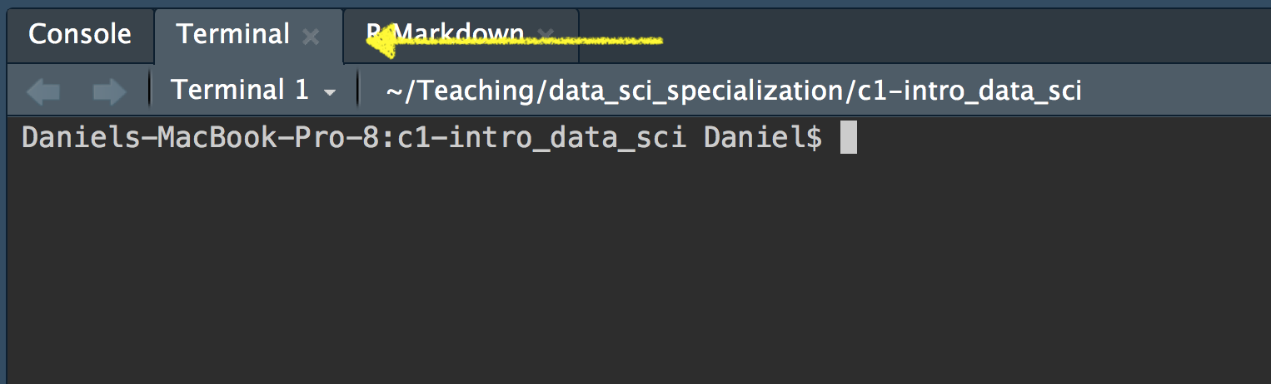

Type git –version into the terminal

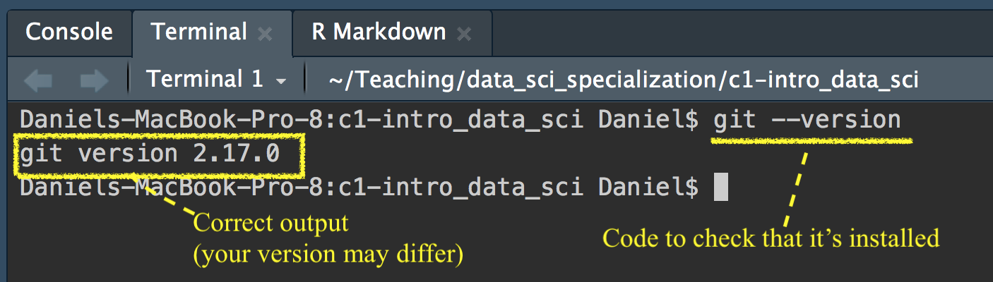

If git has been installed correctly, you should see output stating the version of git that is installed on your machine. If you get this output, you are set for Week 4 when we discuss git. **If you do not get similar output please let me know before Week 4**. It is critical that everyone be ready to go prior to class Week 4 so we don’t have to waste time in class on installation issues.

See below for issues related to Macs and permissions related to the developer.

**If you have a Mac**

Your computer will likely not trust the developer and you will get a message like the below when you try to run the installer. 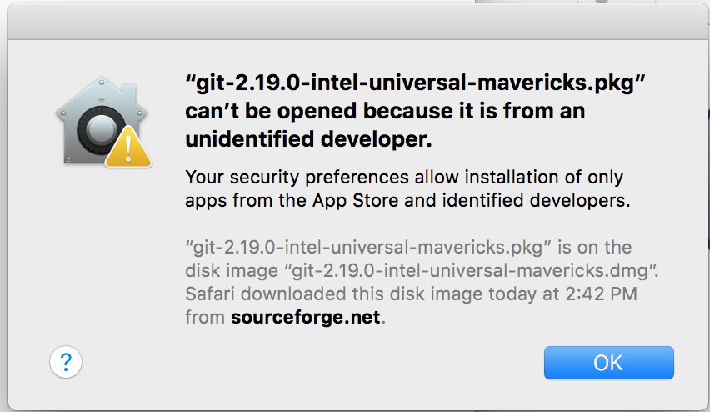

To get around this, you’ll need to right click (control + click) on the installer and select “Open”. Then you’ll be able to open and run the installer.

